
User Manual

EDID-HDMI4K
18G HDMI Manager with EDID & HDCP Manage
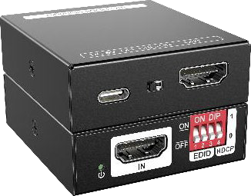

All Rights Reserved
Version: EDID-HDMI4K _2023V1.1

Product Introduction
The EDID-HDMI4K is a 18G HDMI manager with EDID&HDCP manage. It supports up to 4K@60 4:4:4 and HDCP2.2. The product is power by HDMI or USB-C, and it contains CEC block switch and support auto-downscaling.

Feature
  - 18G HDMI 2.0 4K@60 444 HDCP2.2;

  - Supports EDID & HDCP manage;

  - Power by HDMI or USB-C;

  - CEC block switch.

- Package
- 1x EDID- HDMI4K | - 1x User Manual

Specification
- Panel Description
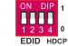
- Power LED: The LED indicates green when power on.
- HDMI IN: HDMI2.0 input, connect to source.
Video Input
Input | (1) HDMI 2.0
Input Connector | (1) Female type-A
HDMI Input Resolution | Up to 4K@60 4:4:4
Video Output
Output | (1) HDMI 2.0
Output Connector | (1) Female type-A
HDMI Output Resolution | Up to 4K@60 4:4:4
General
Bandwidth | 18Gbps
Power Supply | 5V 1A
Power Consumption | 2.4W(MAX)
Dimension (W*H*D) | 54x18x60mm
Net Weight | 85g

- DIP Switch: 4-pin dip switch for EDID and HDCP management.
- USB-C: USB-C is used to power the machine, upload EDID and firmware upgrade.
- CEC Switch: Turn on/off the CEC
- HDMI OUT: HDMI 2.0 output, connect to display.

System Connection
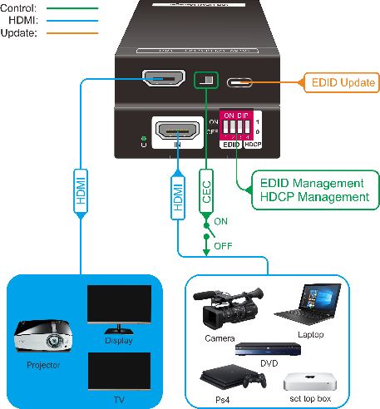
- EDID&HDCP management
Predefined EDID Setting
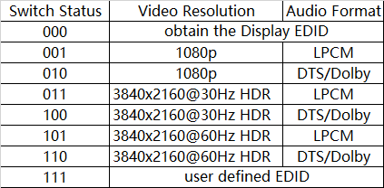
User Defined EDID Setting
- Rename the user defined EDID according the following format:

0803C000.DAT
- Connect the machine to the PC with USB cable, the PC will automatically detect a U- disk named of “BOOTDISK”.

- Copy the EDID file into the U-disk, and then open the U-disk. If there is a SUCCESS. TXT file, it means that the EDID upload is successful.
- Remove the USB cable, connect the adapter to power on the machine.

HDCP management

0 | Switch off HDCP management

Firmware Upgrade
- Rename the upgrade file according the following format:

08009000.APP
- Disconnect the HDMI and connect the PT- HM1 to the PC with USB cable, the PC will detect a U-disk named of “BOOTDISK”.
Switch Status | HDCP Function
1 | Show a identify code to Source that no HDCP is supported by the device, then the source will assume that no HDCP is supported by the device and will send the content without HDCP encryption if the signal format allows it.

- Copy the file into the U-disk, and then open the U-disk. If there is a SUCCESS.TXT file, it means upgrade is successful, and if there is an UNKNOW.TXT file, it means fail.



