SP24AUH2-8K

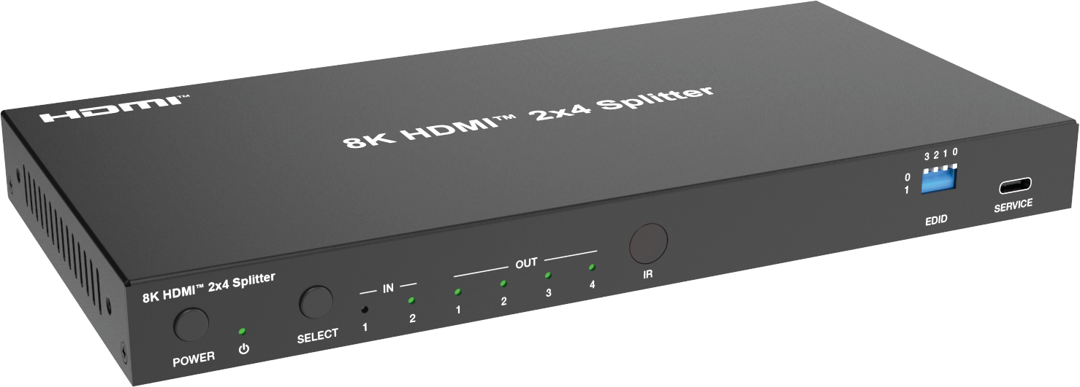



VER 1.0

Thank you for purchasing this product

For optimum performance and safety, please read these instructions carefully before connecting, operating or adjusting this product. Please keep this manual for future reference.

Surge protection device recommended

This product contains sensitive electrical components that may be damaged by electrical spikes, surges, electric shock, lighting strikes, etc. Use of surge protection systems is highly recommended in order to protect and extend the life of your equipment.

Table of Contents
- Introduction. 1
- Features. 1
- Package Contents. 1
- Specifications. 2
- Operation Controls and Functions. 3
- IR Pin Definition. 5
- IR Remote. 5
- API Commands. 6
- Application Example. 13

Introduction
This 2x4 splitter features 2 HDMI inputs switching and distributing to 4 HDMI outputs synchronously, with video resolution up to 8K@60 4:2:0 12bit. Each output port supports 8K->4K/2K downscaling and HDR to SDR conversion independently. Audio de-embedding is supported to digital optical audio and balanced/unbalanced analog audio with gain adjustment. Auto or manual input switching and EDID management are also included.
Built-in HDMI signal generator can easily diagnose the connection status of the external HDMI devices or cables. This product also can be controlled by front panel buttons, IR remote and API commands.

Features
☆ HDCP 2.3 compliant
☆ Support 48Gbps video bandwidth
☆ Support resolution up to 8K@60Hz 4:2:0 12bit, 8K@30Hz 4:4:4 12bit, 4K@120Hz 4:4:4 12bit, as specified in HDMI 2.1
☆ Support HDR, HDR10, HDR10+, Dolby Vision, ALLM/VRR pass-through
☆ Support 8K->4K/2K downscaling on each output for legacy display
☆ Support HDR to SDR conversion on each output for legacy display
☆ Support digital or analog audio de-embedding, and analog audio outputs with gain control
☆ Support auto switching and manual switching
☆ Support input switching via front panel buttons, IR remote, API commands
☆ Built-in equalizer, retiming and driver
☆ Advanced EDID management
☆ Controlled by front panel buttons, IR remote and API commands.

Package Contents
① 1× 48Gbps 2x4 HDMI Splitter ② 1× 12V/1A Multinational Locking Power Supply
③ 1× IR Remote ④ 1× IR Wideband Receiver (1.5m)
⑤ 1× 3pin-3.5mm Phoenix Connector ⑥ 1× 5pin-3.5mm Phoenix Connector
⑦ 2× Mounting Ear ⑧ 4× Machine Screw (KM3*6)
⑨ 1× User Manual

Specifications

Technical
HDMI Compliance | HDMI 2.1
HDCP Compliance | HDCP 2.3
Video Bandwidth | 48Gbps
Video Resolution | Up to 8K@60Hz 4:2:0 12bit, 8K@30Hz 4:4:4 12bit, 4K@120Hz 4:4:4 12bit
Color Depth | 8/10/12-bit
Color Space | RGB, YCbCr_4:4:4, YCbCr_4:2:2, YCbCr_4:2:0
HDR | HDR, HDR10, HDR10+, Dolby Vision, HLG
Audio Formats | HDMI input/output:  LPCM, Dolby Digital/Plus/EX, Dolby True HD, Dolby Atmos, DTS, DTS-EX, DTS-96/24, DTS High Res, DTS-HD Master Audio, DSD Audio de-embedding output:  Optical: Up to LPCM/ Dolby/ DTS 5.1CH L/R Out: LPCM 2CH
Audio Parameters | Output Impedance | 300 Ohm
Audio Parameters | Output Level (Maximum) | 8.2dBu(2Vrms) @balanced audio 2.2dBu(1Vrms) @unbalanced audio
Audio Parameters | Frequency Response | (+0.5dB，-1dB) 20Hz to 20KHz
Audio Parameters | Audio Output Sync Delay | 0 to 2.2ms
Audio Parameters | Audio S/N Ratio | 99dB@2Vrms, 1KHz, A-weighted
Audio Parameters | Audio THD+N | <0.2%@0dBV, 1KHz
IR Level | 12Vp-p
IR Frequency | Wideband 20K-60KHz
Transmission Distance | 3m/9.8ft over HDMI cable
ESD Protection | IEC 61000-4-2: ±8kV (Air-gap discharge) & ±4kV (Contact discharge)
Connection
Input | 2× IN [HDMI type A, 19-pin female]
Output | 4× OUT [HDMI type A, 19-pin female] 1× OPTICAL [S/PDIF]  1× L/R [5pin-3.5mm phoenix connector]
Control | 1× RS-232 [3pin-3.5mm phoenix connector] 1× IR CTL [3.5mm stereo mini-jack]  1× SERVICE [USB type C, upgrade port]

Mechanical
Housing | Metal Enclosure
Color | Black
Dimensions | 220mm [W] × 110mm [D] × 21.5mm [H]
Weight | 620g
Power Supply | DC 12V/1A
Power Consumption | 6.24W (Max)
Operation Temperature | 0°C ~ 40°C / 32°F ~ 104°F
Storage Temperature | -20°C ~ 60°C / -4°F ~ 140°F
Operating Humidity | 20%~80% relative humidity, non-condensing
Storage Humidity | 10%~90% relative humidity, non-condensing

Operation Controls and Functions

Front Panel
8K HDMI™ 2x4 Splitter
3 2 1 0
IN
OUT
0
1
POWER SELECT 1 2
1 2 3 4
IR
EDID
SERVICE
1 2
3
4
5
6
7
8

No. | Name | Function Description
1 | POWER button | Press to power on; Press and hold to enter standby mode.
2 | POWER LED | When the device is powered on, the power LED is green; When the device is standby, the power LED is red.
3 | SELECT button | Press to select input source IN 1/IN 2 circularly.
4 | IN LED (1~2) | When the IN 1/IN 2 port is selected as an input channel, the corresponding green LED will be on.
5 | OUT LED (1~4) | When the OUT 1/2/3/4 port is connected to an active display device, the corresponding green LED will be on.
6 | IR | IR signal receiving window.
7 | EDID DIP  switch | Use the DIP switch to set EDID.  *EDID list is as follow.
8 | SERVICE | USB-C port, used for firmware update.

Rear Panel
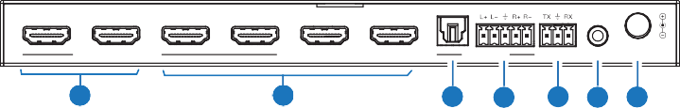
OPTICAL
1
2
1
2
3
4
IN
OUT AUDIO OUT
RS-232 IR CTL DC 12V
1
2
3
4
5 6 7

No. | Name | Function Description
1 | IN (1~2) | HDMI signal input ports, connected to source devices such as PC or PS5 with HDMI cable.
2 | OUT (1~4) | HDMI signal output ports, connected to display devices such as TV or Monitor with HDMI cable.
3 | OPTICAL (AUDIO OUT) | Digital audio output port, connected to an audio device.
4 | L/R  (AUDIO OUT) | Analog audio output port, supporting balanced audio output  (with a maximum support of 2Vrms) and unbalanced audio output (with a maximum support of 1Vrms).  Balanced connection method: L+, L -, , R+, R Unbalanced connection method: L+, , R+
5 | RS-232 | RS-232 serial port, connected to a PC or control system for API command control.
6 | IR CTL | 12V IR input port, connected with the IR receiver cable.
7 | DC 12V | DC 12V/1A power input port.


* EDID Setting List:
DIP_0000: EDID pass-through (Copy from Sink 1) (default) DIP_0001: HDMI 1080p@60Hz, Audio 2CH PCM DIP_0010: HDMI 1080p@60Hz, Audio 5.1CH DTS/DOLBY DIP_0011: HDMI 4K@60Hz 4:4:4, 8-bit, Audio 2ch PCM
DIP_0100: HDMI 4K@60Hz 4:4:4, 8-bit, Audio 5.1CH DTS/DOLBY DIP_0101: HDMI 4K@120Hz 4:4:4, 10-bit HDR/DV, Audio 2ch PCM
DIP_0110: HDMI 4K@120Hz 4:4:4, 10-bit HDR/DV, Audio 5.1CH DTS/DOLBY DIP_0111: HDMI 4K@120Hz 4:4:4, 12-bit HDR/DV, Audio 2ch PCM DIP_1000: HDMI 4K@120Hz 4:4:4, 12-bit HDR/DV, Audio 5.1CH DTS/DOLBY

（Continued）
DIP_1001: HDMI 8K@60Hz 4:2:0, 10-bit HDR/DV, Audio 2ch PCM DIP_1010: HDMI 8K@60Hz 4:2:0, 10-bit HDR/DV, Audio 5.1CH DTS/DOLBY DIP_1011: HDMI 8K@60Hz 4:2:0, 12-bit HDR/DV, Audio 2ch PCM DIP_1100: HDMI 8K@60Hz 4:2:0, 12-bit HDR/DV, Audio 5.1CH DTS/DOLBY
DIP_1101: HDMI 8K@60Hz 4:2:0, 12-bit HDR/DV, Audio 2ch PCM- Inc VRR/DSC DIP_1110: HDMI 8K@60Hz 4:2:0, 12-bit HDR/DV, Audio 5.1CH DTS/DOLBY- Inc VRR/DSC
DIP_1111: EDID Software if possible or HDMI 1080p@60Hz, Audio 2ch PCM

IR Pin Definition

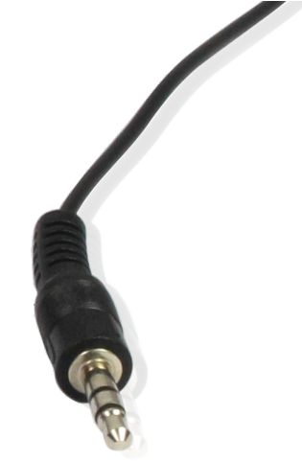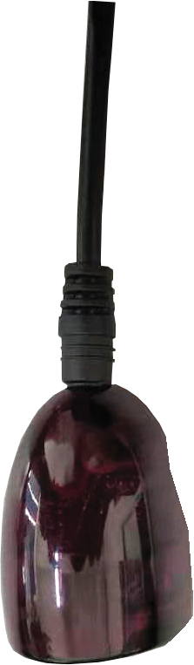IR Signal
IR Receiver

Grounding

IR RECEIVER
Power

IR Remote

: Power on the product or set it to standby mode.
INPUT

1/2 : Press 1/2 button to select HDMI signal source IN 1/2.

: Press this button to cyclically switch HDMI signal source IN 1/2.

API Commands

The product supports API commands control. Connect the SERVICE or RS-232 port of the product to a PC, then open a Serial Command tool on PC to send API commands to control the product. The API commands list is shown below.

ASCII Commands
- Service port (USB-C virtual RS-232) communication protocol (Internal debug) Baud rate: 115200 (fixed), Data bit: 8, Stop bit: 1, Parity bit: none
The end mark of command is “<CR><LF>”
- Phoenix RS-232 port communication protocol (Connect to control system) Baud rate: 4800~115200 (configurable), Data bit: 8, Stop bit: 1, Parity bit: none The end mark of command is “<CR><LF>”
Commands | Function | Example | Feedback | Default
? | Get the list of all commands | ?
help | Get the list of all commands | help
get fw version | Get firmware version | get fw version | 1.0.0
set power on/off | Set device power on/off | set power on set power off | Power on… System Initializing...  Initialization Finished! FW: 1.0.0  Power off…
get power | Get device power status | get power | Power on
set reboot | Reboot the device | set reboot | Reboot…  System Initializing... Initialization Finished! FW: 1.0.0
set reset | Reset to factory defaults | set reset | Sure to RESET to default settings? Type "Yes" after next prompt to confirm…
get status | Get system status | get status | Please refer to the note at the end of the list.
set IR on/off | Set IR on/off | set IR on set IR off | Set IR on Set IR off | on
get IR | Get IR on/off status | get IR | IR on

Commands | Function | Example | Feedback | Default
set key on/off | Set front panel key on/off | set key on set key off | Set key on Set key off | on
get key | Get front panel key on/off status | get key | Key on
set baud x | Set RS-232 baud rate to x bps x=1: 4800  x=2: 9600  x=3: 19200  x=4: 38400  x=5: 57600  x=6: 115200 | set baud 6 | Set baud rate 115200 | 115200
get baud | Get RS-232 baud rate | get baud | Baud rate 115200
set input x | Set input video (x=0~2) x=0: Off  x=1~2: HDMI input 1~2 | set input 1 | Set input HDMI 1 | 1
get input | Get input port | get input | Input HDMI 1
get hdmi5v | Get input HDMI 5V | get hdmi5v | HDMI 1: 5V  HDMI 2: none
set autoswitch x | Set auto-switching on/off (HDMI 5V detection) x=On, Off | set autoswitch on | Set autoswitch on | on
get autoswitch | Get auto-switching status | get autoswitch | Autoswitch on
set output x downscale y | Set output (x=0~4) downscaling mode (y=0~2) x=0: all outputs  x=1~4: HDMI output 1~4  y=0: Automatically according to display's capability  y=1: Bypass video  y=2: Force 1080p | set output 0  downscale 0 | Set all outputs downscale auto | 0
get output x downscale | Get output (x=0~4) downscaling mode | get output 0 downscale | HDMI output 1 downscale auto HDMI output 2 downscale auto HDMI output 3 downscale auto HDMI output 4 downscale auto

Commands | Function | Example | Feedback | Default
set output x display y | Set output (x=0~4) display mode (y=0~3)  x=0: all outputs  x=1~4: HDMI output 1~4  y=0: Off (disable TMDS output) y=1: Input video  y=2: AVMUTE  y=3: Internal pattern | set output 0  display 2 | Set all outputs display internal pattern | 1
get output x display | Get output (x=0~4) display mode | get output 0 display | HDMI output 1 display internal pattern  HDMI output 2 display internal pattern  HDMI output 3 display internal pattern  HDMI output 4 display  internal pattern
set output x HDCP y | Set output (x=0~4) HDCP mode (y=0~4)  x=0: all outputs  x=1~4: HDMI output 1~4 y=0: Reserved  y=1: Follow sink y=2: Follow source  y=3: Force HDCP 1.4  y=4: Force HDCP 2.2 | set output 0  HDCP 1 | Set all outputs HDCP follow sink | 1
get output x HDCP | Get output (x=0~4) HDCP mode | get output 0 HDCP | HDMI output 1 HDCP follow sink  HDMI output 2 HDCP follow sink  HDMI output 3 HDCP follow sink  HDMI output 4 HDCP  follow sink
get generator | Get internal signal generator output resolution and pattern | get generator | Generator 8K30Hz color bar
set analog mute x | Set analog audio mute on/off x=On, Off | set analog mute on | Set analog mute on | off
get analog mute | Get analog audio mute status | get analog mute | off
set analog gain x | Set analog audio gain (x=0dB ~ -79dB) | set analog gain  -79dB | Set analog gain -79dB | 0dB

Commands | Function | Example | Feedback | Default
get analog gain | Get analog audio gain value | get analog gain | Analog gain -79dB
set generator x y | Set internal signal generator resolution (x=1~15) pattern (y=1~13)  x=01: 8K30Hz x=02: 4K120Hz x=03: 4K100Hz x=04: 5K60Hz x=05: 5K50Hz x=06: 5K30Hz x=07: 5K25Hz x=08: 5K24Hz x=09: 4K60Hz x=10: 4K50Hz x=11: 4K25Hz x=12: 4K24Hz x=13: 1080P60Hz x=14: 480P60Hz x=15: 576P50Hz  y=01: Color bar y=02: Checkboard y=03: Strip  y=04: Red y=05: Green y=06: Blue y=07: White y=08: Ramp y=09: Red ramp  y=10: Green ramp y=11: Blue ramp y=12: PRBS  y=13: Black | set generator 1 1 | Set generator 8K30Hz color bar
set edid x to y | Set input ports (x=0~2) to EDID (y=0~32)  x=0: all inputs  x=1~2: HDMI input 1~2 y=00: HDMI 1080p@60Hz,  Audio 2CH PCM (default) y=01: HDMI 1080p@60Hz, Audio 5.1CH DTS/DOLBY y=02: HDMI 1080p@60Hz,  Audio 7.1CH DTS/DOLBY/HD | set edid 0 to 0 | Set all inputs EDID to SDF_00: HDMI  1080p@60Hz, Audio 2CH PCM (default) | 0

Commands | Function | Example | Feedback | Default
 | (Continued)
 | y=03: HDMI 4K@60Hz 4:4:4, 8-bit,
 | Audio 2ch PCM
 | y=04: HDMI 4K@60Hz 4:4:4, 8-bit,
 | Audio 5.1CH DTS/DOLBY
 | y=05: HDMI 4K@60Hz 4:4:4, 8-bit,
 | Audio 7.1CH DTS/DOLBY/HD
 | y=06: HDMI 4K@120Hz 4:4:4, 8-bit,
 | Audio 2ch PCM
 | y=07: HDMI 4K@120Hz 4:4:4, 8-bit,
 | Audio 5.1CH DTS/DOLBY
 | y=08: HDMI 4K@120Hz 4:4:4, 8-bit,
 | Audio 7.1CH DTS/DOLBY/HD
 | y=09: HDMI 4K@120Hz 4:4:4, 10-bit
 | HDR/DV, Audio 2ch PCM
 | y=10: HDMI 4K@120Hz 4:4:4, 10-bit
 | HDR/DV, Audio 5.1CH DTS/DOLBY
set edid x to y | y=11: HDMI 4K@120Hz 4:4:4, 10-bit HDR/DV, Audio 7.1CH DTS/DOLBY/HD y=12: HDMI 4K@120Hz 4:4:4, 12-bit  HDR/DV, Audio 2ch PCM  y=13: HDMI 4K@120Hz 4:4:4, 12-bit HDR/DV, Audio 5.1CH DTS/DOLBY y=14: HDMI 4K@120Hz 4:4:4, 12-bit HDR/DV, Audio 7.1CH DTS/DOLBY/HD | set edid 0 to 0 | Set all inputs EDID to SDF_00: HDMI 1080p@60Hz,  Audio 2CH PCM (default) | 0
 | y=15: HDMI 4K@120Hz 4:4:4, 12-bit
 | HDR/DV, Audio 2ch PCM - Inc
 | VRR/DSC
 | y=16: HDMI 4K@120Hz 4:4:4, 12-bit
 | HDR/DV, Audio 5.1CH DTS/DOLBY -
 | Inc VRR/DSC
 | y=17: HDMI 4K@120Hz 4:4:4, 12-bit
 | HDR/DV, Audio 7.1CH DTS/DOLBY/HD
 | - Inc VRR/DSC
 | y=18: HDMI 8K@60Hz 4:2:0, 10-bit
 | HDR/DV, Audio 2ch PCM
 | y=19: HDMI 8K@60Hz 4:2:0, 10-bit
 | HDR/DV, Audio 5.1CH DTS/DOLBY
 | y=20: HDMI 8K@60Hz 4:2:0, 10-bit
 | HDR/DV, Audio 7.1CH DTS/DOLBY/HD
 | y=21: HDMI 8K@60Hz 4:2:0, 12-bit
 | HDR/DV, Audio 2ch PCM

Commands | Function | Example | Feedback | Default
(Continued)
y=22: HDMI 8K@60Hz 4:2:0,
12-bit HDR/DV, Audio 5.1CH DTS/DOLBY
y=23: HDMI 8K@60Hz 4:2:0,
12-bit HDR/DV, Audio 7.1CH DTS/DOLBY/HD
y=24: HDMI 8K@60Hz 4:2:0,
12-bit HDR/DV, Audio 2ch PCM -
Inc VRR/DSC
y=25: HDMI 8K@60Hz 4:2:0,
12-bit HDR/DV, Audio 5.1CH DTS/DOLBY - Inc VRR/DSC y=26: HDMI 8K@60Hz 4:2:0,
12-bit HDR/DV, Audio 7.1CH DTS/DOLBY/HD - Inc VRR/DSC y=27: DVI 1920x1080@60Hz,
Audio None
y=28: DVI 1920x1200@60Hz,
Audio None
y=29: HDMI 1920x1200@60Hz,
Audio 2ch PCM y=30: User EDID 1 y=31: User EDID 2
y=32: EDID pass-through (Copy
from Sink 1)
get edid x | Get input ports EDID x=0: all inputs  x=1~2: HDMI input 1~2 | get edid 0 | HDMI input 1 EDID SDF_00: HDMI  1080p@60Hz, Audio 2CH PCM (default) HDMI input 2 EDID SDF_00: HDMI  1080p@60Hz, Audio  2CH PCM (default)
get edid data x | Get input ports EDID data x=0: all inputs  x=1~2: HDMI input 1~2 | get edid data 0 | HDMI input 1 EDID  <00 FF FF FF….>  HDMI input 2 EDID  <00 FF FF FF….>
set user edid x <y> | Set user defined EDID (x=1~2) x=1: User Defined 1  x=2: User Defined 2 y = 00 FF FF FF …..  (y is 256 bytes EDID data) | set user edid 1  <00 FF FF FF….> | User defined 1 EDID is loaded successfully

Commands | Function | Example | Feedback | Default
get user edid x | Get user defined EDID (x=1~2) x=1: User Defined 1  x=2: User Defined 2 | get user edid 1 | User defined 1 EDID  <00 FF FF FF….>

Note: The feedback of the command of “get status” is as follow. (The middle line ends with <LF><CR> and the last line ends with <CR><LF>.)

===================================================================
Status Info 8K 2x4 Splitter FW 1.0.0

Power  On | Key  On | IR  On | Baud  115200 | Autoswitch  On
Input | Cable | EDID
01 | Connected | DIP_0000:EDID pass-through
02 | Connected | DIP_0000:EDID pass-through

Output FromIn Cable Resolution ColorSpace ColorDepth Scaler HDCP 01 01 Connected 3840x2160p60Hz YUV 4:2:0 12bit Off Sink
02 01 Connected 1920x1080p60Hz YUV 4:4:4 8bit On Sink 03 AVMUTE Connected 3840x2160p60Hz YUV 4:2:0 12bit Off Sink 04 Pattern Connected 7680x4320p30Hz RGB 4:4:4 8bit Off Sink
===================================================================

Application Example

8K TV 2 2K TV 4

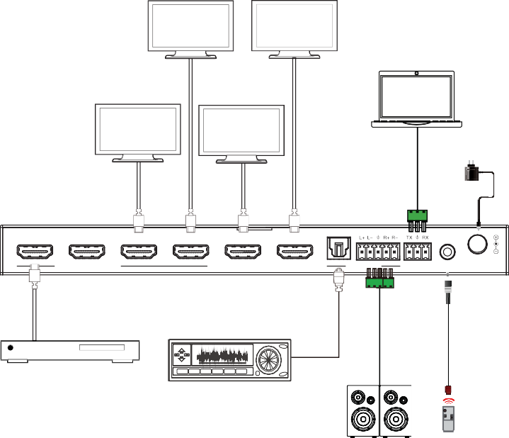
PC

8K TV 1 4K TV 3

Power Supply

1 2 1 2 3 4

OPTICAL

IN OUT

AUDIO OUT

RS-232

IR CTL

DC 12V

IR Receiver

DVD or Blu-ray Player
Amplifier

IINPNPUTUT

2.0 Speakers

The terms HDMI and HDMI High-Definition Multimedia interface, and the HDMI Logo are trademarks or registered trademarks of HDMI Licensing LLC in the United States and other countries.

