WFH-140

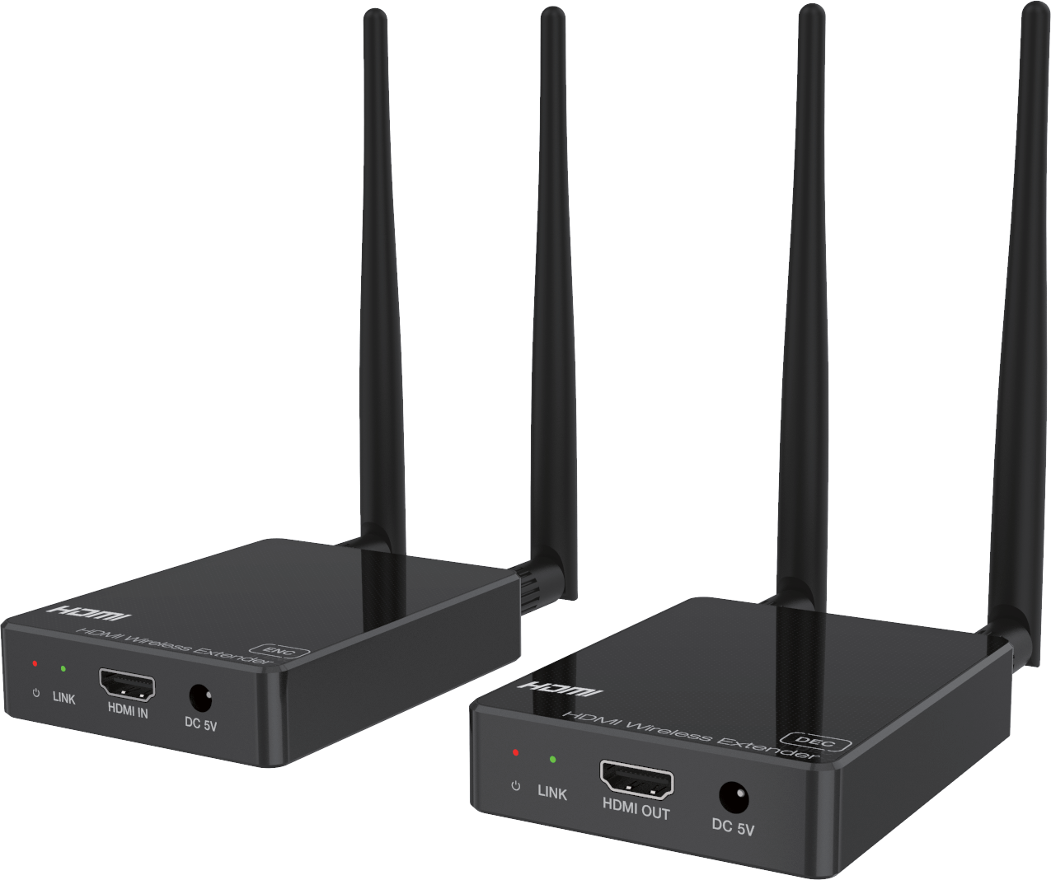


VER 1.2

Thank you for purchasing this product
For optimum performance and safety, please read these instructions carefully before connecting, operating or adjusting this product. Please keep this manual for future reference.

Surge protection device recommended
This product contains sensitive electrical components that may be damaged by electrical spikes, surges, electric shock, lighting strikes, etc. Use of surge protection systems is highly recommended in order to protect and extend the life of your equipment.

Table of Contents
- Introduction. 1
- Features. 1
- Package Contents. 1
- Specifications. 2
- Operation Controls and Functions. 3
  - Encoder Panel. 3
  - Decoder Panel. 4
  - Pairing Instruction. 4
  - IR Pin Definition. 5
- Application Example. 7

Introduction
This product is based on H.265 standard solution for transmitting one HD source signal to one HD display. It extends distance up to 330ft/100 meters (In an open environment without Wi-Fi interference) between the encoder
and decoder via wireless transmission. It supports one-way IR control. It offers high quality configurable and low-bandwidth H.265 compression video. Input video resolution is up to 1920×1080@60Hz; Output video resolution is up to 1080P@60Hz. This wireless extender is designed special to transmit high definition video & audio within one environment.

Features
☆ HDMI 1.3, HDCP 1.4 and DVI 1.0 compliant
☆ Transmit one HDMI HD source signal to one HDMI HD display via wireless technology
☆ With one-way IR control
☆ Input video resolution is up to 1920×1080@60Hz YCbCr 4:4:4; Output video resolution is up to 1080P@60Hz YCbCr 4:4:4
☆ HDMI wireless transmission distance up to 330ft/100m. (In an open
environment without Wi-Fi interference.)
☆ Supported HDMI audio formats:
Input: LPCM 2.0CH 32KHz/44.1KHz/48KHz/88.2KHz/96KHz/176.4KHz/ 192KHz
Output: LPCM 2.0CH 48KHz
☆ Adopt H.265 high performance codec technology
☆ End-to-end delay is less than 120Ms
☆ Compact design for easy and flexible installation.

Package Contents

Qty | Item
1 | HDMI Wireless Extender (Encoder)
1 | HDMI Wireless Extender (Decoder)
1 | IR Blaster cable (1.5 meters)
1 | 20~60KHz IR Receiver cable (1.5 meters)
4 | 5G Wi-Fi Antenna
2 | 5V/2A Multinational Power Supply
1 | User Manual

Specifications

Technical
HDMI Compliance | HDMI 1.3
HDCP Compliance | HDCP 1.4
Video Bandwidth | 4.95Gbps
Video Resolution | Input: Up to 1920×1080@60Hz Output: Up to 1080P@60Hz
Color Space | RGB, YCbCr 4:4:4 / 4:2:2
Color Depth | 8/10/12-bit (1080P@60Hz)
HDMI Audio Formats | Input: LPCM 2.0CH 32KHz/44.1KHz/48KHz/ 88.2KHz/96KHz/176.4KHz/192KHz  Output: LPCM 2.0CH 48KHz
ESD Protection | Human body model — ±8kV (Air-gap discharge) &  ±4kV (Contact discharge)
Connection
Encoder | Inputs: 1 x HDMI IN [Type A, 19-pin female] Outputs: 1 x IR OUT [3.5mm Stereo Mini-jack]  2 x Wi-Fi OUT [Wi-Fi antenna]  Control: 1 x SERVICE [Micro USB, Update port]
Decoder | Inputs: 1 x IR IN [3.5mm Stereo Mini-jack] 2 x WiFi IN [Wi-Fi antenna]  Outputs: 1 x HDMI OUT [Type A, 19-pin female] Control: 1 x SERVICE [Micro USB, Update port]
Mechanical
Housing | Plastic Enclosure
Color | Black
Dimensions | Encoder / Decoder:  76mm [W] x 98mm [D] x 21mm [H]
Weight | Encoder / Decoder: 100g
Power Supply | Input: AC100 - 240V 50/60Hz  Output: DC 5V/2A
Power Consumption | Encoder: 3.5W, Decoder: 2.6W (Max)
Operating Temperature | 32 - 104°F / 0 - 40°C

Storage Temperature | -4 - 140°F / -20 - 60°C
Relative Humidity | 20 - 90% RH (no condensation)
Resolution / Cable Length | 1080P60Hz -  Feet / Meters
HDMI IN / OUT | 42ft / 15M
The use of “Premium High Speed HDMI” cable is highly recommended.

Operation Controls and Functions

Encoder Panel
LINK
HDMI IN
DC 5V
1 2 3
4
8
8
5 6 7

PAIR SERVICE IR OUT

No. | Name | Function Description
1 | Power LED | The LED will illuminate red when the encoder is powered on.
2 | LINK LED  (Green) | The LINK LED flashing means that the encoder and decoder are paired successfully. (Please refer to “5.3 Pairing Instruction” for details)
3 | HDMI IN | HDMI source input port for connecting the HDMI source device.
4 | DC 5V | Connect the DC 5V/2A power adapter.
5 | PAIR button | - Press and hold the PAIR button, then power on the encoder,  the encoder will enter the upgrade mode.  - Press and hold the PAIR button for 5 seconds after powering on the encoder, the encoder will restore factory settings, then it needs to pair with the decoder again.
6 | SERVICE port | Firmware update port.
7 | IR OUT | Connect the IR blaster cable. The IR blaster signal is from the IR IN port on the Decoder.
8 | Antenna port | Connect the Wi-Fi antenna.

Decoder Panel
8
8
LINK HDMI OUT
DC 5V
1 2 3
4
5 6 7

PAIR SERVICE IR IN

No. | Name | Function Description
1 | Power LED | The LED will illuminate red when the decoder is powered on.
2 | LINK LED  (Green) | The LINK LED flashing means that the encoder and decoder are transmitting video signals. (Please refer to “5.3 Pairing Instruction” for details)
3 | HDMI OUT | HDMI output port for connecting the HDMI display device.
4 | DC 5V | Connect the DC 5V/2A power adapter.
5 | PAIR button | - Press and hold the PAIR button, then power on the decoder,  the decoder will enter the upgrade mode.  - Press and hold the PAIR button for 5 seconds after powering  on the decoder, the decoder will restore factory settings.
6 | SERVICE port | Firmware update port.
7 | IR IN | Connect the IR receiver cable. The IR signal is sent to the IR OUT port on the encoder.
8 | Antenna port | Connect the Wi-Fi antenna.

Pairing Instruction
Follow steps below to pair the encoder and decoder:
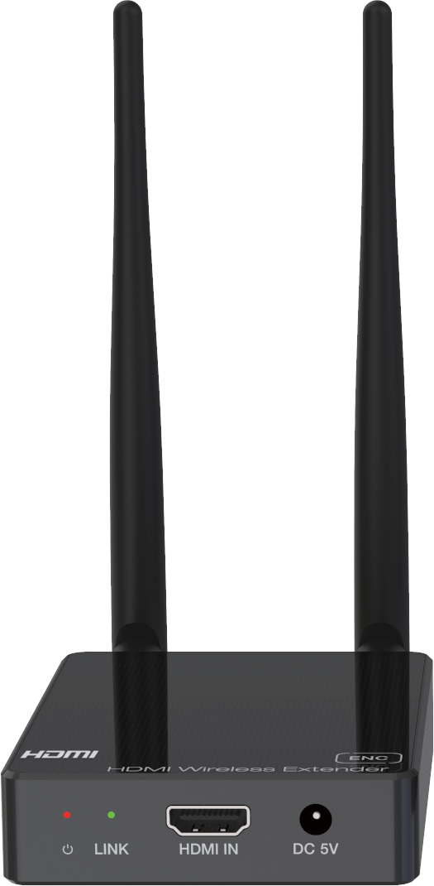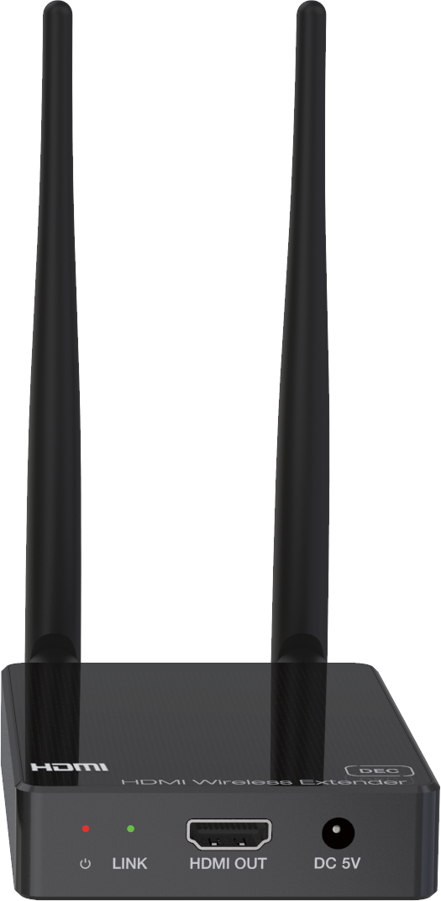Step 1, Connect the encoder and decoder with an HDMI cable, as shown in the figure below.

HDMI cable

Step 2, Power on the decoder, then the power LED and LINK LED of the decoder will be always on.
Step 3, Power on the encoder. After successful pairing, the LINK LED of the decoder will flash. (If the pairing fails, return to Step 2.)
If the LINK LED of encoder is always on, it indicates that the encoder and decoder has not been connected or paired. When there is video signal transmission, the LINK LED of decoder will flash; When there is no video signal transmission, the LINK LED of decoder will be always on.
The specific instructions are shown in the following table.

Encoder’s LINK LED status (Green) | Decoder’s LINK LED status (Green) | Description
Always on | Always on | The encoder and decoder are not paired or connected.
Flash | Always on | Successful pairing.
Flash | Flash | The encoder and decoder are paired successfully, and there is video signal transmission.
Note: After successful pairing, if the encoder restores factory settings, the encoder and decoder need to be re-paired.

IR Pin Definition
IR Receiver and Blaster pin’s definition is as below:
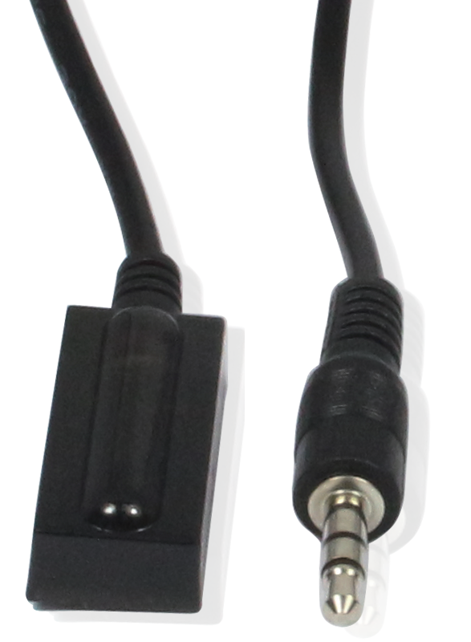
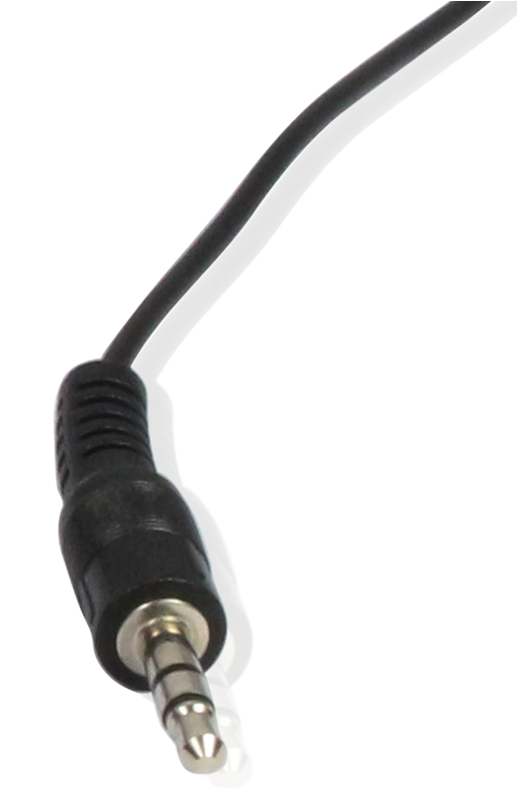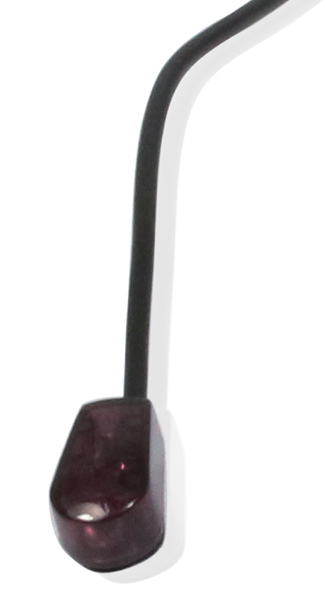
IR RECEIVER IR BLASTER

IR Blaster Signal Power
IR Blaster
IR Receiver
NC

IR Signal

Power Grounding

Connection diagram of using IR cables.

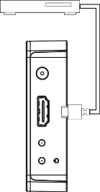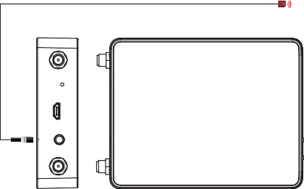DVD
Encoder
PAIR SERVICE IR OUT
LINK HDMI IN DC 5V



Decoder

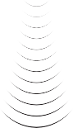

DVD remote
TV
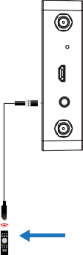
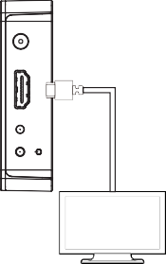
Note that when the angle between the IR receiver and the remote control is ± 45 °, the transmission distance is 0-5 meters; when the angle between the IR receiver and the remote control is ± 90 °, the transmission distance is 0-8 meters.
PAIR SERVICE IR IN
LINK HDMI OUT DC 5V

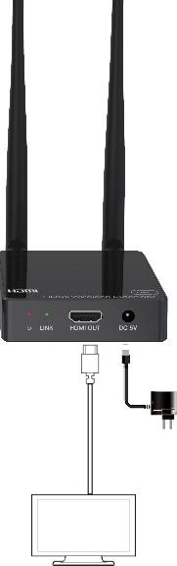
Application Example

The transmission distance extends up to 100m.
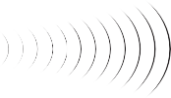
Encoder Decoder

Power Supply

Power Supply

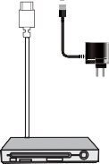
DVD or Blu-ray Player

TV


The terms HDMI and HDMI High-Definition Multimedia interface, and the HDMI Logo are trademarks or registered trademarks of HDMI Licensing LLC in the United States and other countries.

