TP.USB32

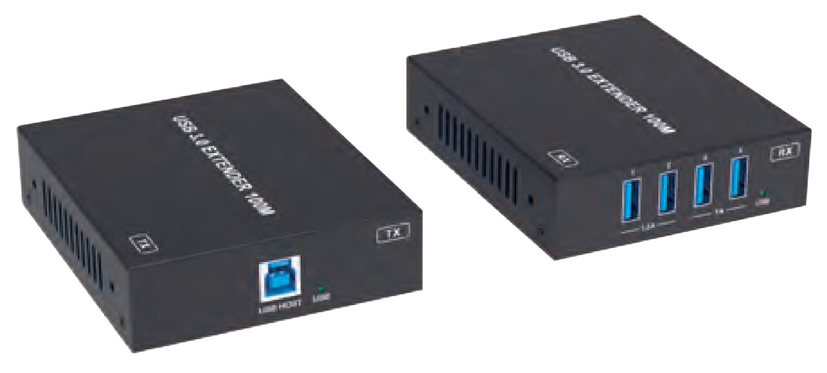


VER 1.0

Thank you for purchasing this product
For optimum performance and safety, please read these instructions carefully before connecting, operating or adjusting this product. Please keep this manual for future reference.
Surge protection device recommended
This product contains sensitive electrical components that may be damaged by electrical spikes, surges, electric shock, lighting strikes, etc. Use of surge protection systems is highly recommended in order to protect and extend the life of your equipment.
Caution
The product requires the use of UTP connectors. Please connect in direct interconnection method and do not cross connect.

White and Orange Orange
White and Green Blue
White and Blue Green
White and Brown Brown

Direct Interconnection Method
Table of Contents
- Introduction. 1
- Features. 1
- Package Contents. 1
- Specifications. 2
- Operation Controls and Functions. 3
  - Transmitter Panel. 3
  - Receiver Panel. 4
- Application Example 5

Introduction
The USB 3.0 Extender can extend USB signal to a distance up to 100m/328ft via a single CAT6a cable. Transmitter features with one USB 3.0 Type B input, one FSYSNC GPIO input and one RS-232 pass-through. Receiver features with four USB 3.0 Type A outputs, one FSYSNC GPIO output and one RS-232 pass-through. Bi-directional 24V PoC is also supported.
The product can be widely used for long distance signal transmission between a PC and USB devices.

Features
☆ Extension of USB 3.0 up to 100m/328ft over CAT6a cable
☆ USB 3.0 connectivity with data transfer rate up to 5Gbps
☆ Backwards compatible with USB 2.0 and 1.1
☆ Hardware acceleration for isochronous and bulk transfer
☆ USB-A port 1 and 2 support 5V/1.5A, port 3 and 4 support 5V/1A on the Receiver
☆ Support RS-232 pass-through and FSYNC GPIO pass-through (for industry camera use)
☆ Support bi-directional 24V PoC
☆ Simple plug and play, no driver and setting installation required

Package Contents
① 1× USB 3.0 Extender (Transmitter)
② 1× USB 3.0 Extender (Receiver)
③ 1× 24V/2A Locking Power Supply
④ 2× 4pin-3.5mm Phoenix Connector (Male)
⑤ 4× Mounting Ear
⑥ 8× Machine Screw (KM3*4)
⑦ 1× User Manual

Specifications

Technical
USB Protocol | USB 3.0
Transmission Rate | Up to 5Gbps
Network Bandwidth | 10G
Transmission Distance | 100m/328ft over CAT6a (F/FTP) cable
ESD Protection | IEC 61000-4-2:  ±8kV (Air-gap discharge), ±4kV (Contact discharge)
Connections
Transmitter | Input: 1 × USB HOST [USB-B, 9pin Female] Output: 1 × HDBT OUT [RJ45, Female]  Control: 1 × RS-232 [3pin-3.5mm Phoenix Connector] 1 × FSYNC [1pin-3.5mm Phoenix Connector]  1 × SERVICE [USB-C, Update Port]
Receiver | Input: 1 × HDBT IN [RJ45, Female]  Output: 4 × USB Devices [USB-A, 9pin Female] Control: 1 × RS-232 [3pin-3.5mm Phoenix Connector]  1 × FSYNC [1pin-3.5mm Phoenix Connector]  1 × SERVICE [USB-C, Update Port]
Mechanical
Housing | Metal Enclosure
Color | Black
Dimensions | Transmitter / Receiver: 85mm [W] × 100mm [D] × 25.5mm [H]
Weight | Transmitter: 253g, Receiver: 260g
Power Supply | Input: AC 100~240V 50/60Hz Output: DC 24V/2A
Power Consumption | PoC Power Supply: 40W (Max)
Operating Temperature | 0°C ~ 40°C / 32°F ~ 104°F
Storage Temperature | -20°C ~ 60°C / -4°F ~ 140°F
Relative Humidity | 20~90% RH (non-condensing)

Operation Controls and Functions

Transmitter Panel
TX RX IO
SERVICE
HDBT OUT RS-232 FSYNC
DC 24V
3 4 5 6 7 8 9
LINK
USB HOST
TX
USB
1 2

No. | Name | Function Description
1 | USB HOST | Host port, supporting USB 3.0. Connects to a PC or host.
2 | USB LED | USB signal indicator.  - On: USB signal is detected.  - Off: USB signal is not detected.
3 | HDBT OUT | Connects to the HDBT IN port on Receiver with CAT cable.
4 | LINK LED | Connection signal indicator.  - On: Transmitter and Receiver are connected and linked.  - Flashing: Transmitter and Receiver link is off due to USB low power mode.  - Off: Transmitter and Receiver are not connected.
5 | RS-232 | 3pin phoenix connector, connected to a PC or control system for RS-232 command pass-through.
6 | FSYNC | FSYNC port, used for level pass-through to the Receiver, and synchronizing the external devices. The default level is 3.3V.
7 | SERVICE | Firmware update port.
8 | POWER LED | The LED will be on when the Transmitter is powered on.
9 | DC 24V | DC 24V/2A power input port.

Receiver Panel
TX RX IO
SERVICE
HDBT IN RS-232 FSYNC
DC 24V
4
5 6 7 8 9 10
LINK
1
2
3
4
RX
USB
1.5A
1A
1
2
3

No. | Name | Function Description
1 | USB 1/2 | Connect to USB devices, and max output power is up to 5V/1.5A.
2 | USB 3/4 | Connect to USB devices, and max output power is up to 5V/1A.
3 | USB LED | USB signal indicator.  - On: USB signal is detected.  - Off: USB signal is not detected.
4 | HDBT IN | Connects to the HDBT OUT port on Transmitter with CAT cable.
5 | LINK LED | Connection signal indicator.  - On: Transmitter and Receiver are connected and linked.  - Flashing: Transmitter and Receiver link is off due to USB low power mode.  - Off: Transmitter and Receiver are not connected.
6 | RS-232 | 3pin phoenix connector, connected to a PC or control system for RS-232 command pass-through.
7 | FSYNC | FSYNC port, receiving level pass-through from the Transmitter, and synchronizing the external devices. Default level is 3.3V.
8 | SERVICE | Firmware update port.
9 | POWER LED | The LED will be on when the Receiver is powered on.
10 | DC 24V | DC 24V/2A power input port.

Application Example

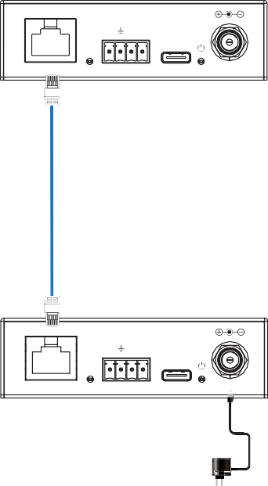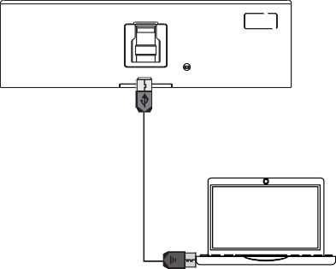USB HOST

TX

USB

TX RX IO

SERVICE

HDBT OUT

RS-232 FSYNC

DC 24V
LINK

Transmitter

CAT6a

PC

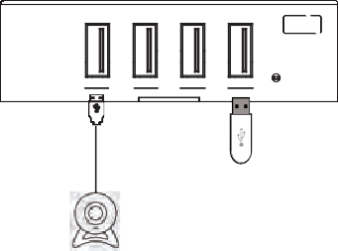
1 2 3 4
RX
TX RX IO

SERVICE
USB
LINK

1.5A 1A

HDBT IN
RS-232 FSYNC
DC 24V

Receiver

U Disk

Power Supply
USB Camera

