TP70H2-EU

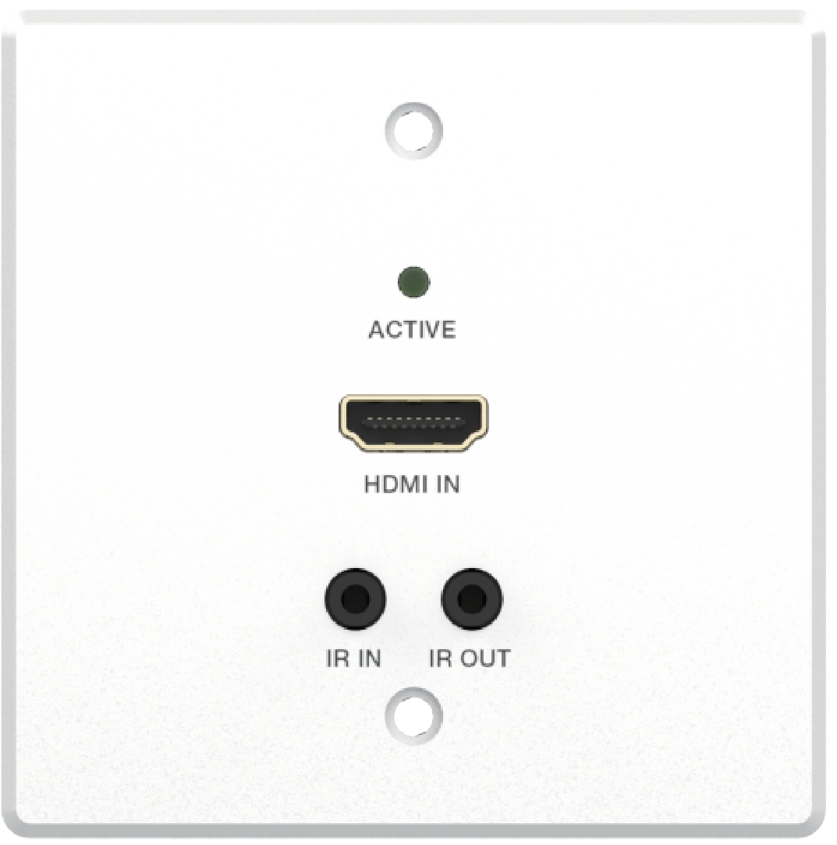
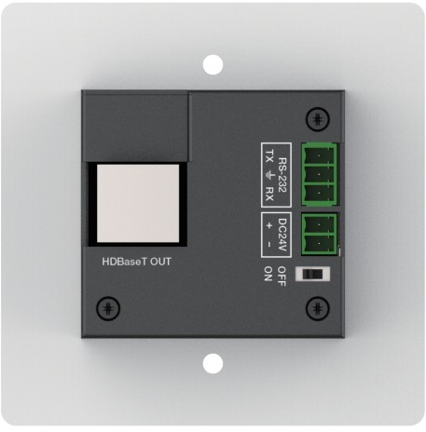


VER 1.0

Thank you for purchasing this product
For optimum performance and safety, please read these instructions carefully before connecting, operating or adjusting this product. Please keep this manual for future reference.

Surge protection device recommended
This product contains sensitive electrical components that may be damaged by electrical spikes, surges, electric shock, lighting strikes, etc. Use of surge protection systems is highly recommended in order to protect and extend the life of your equipment.

Table of Contents
- Introduction. 1
- Features. 1
- Package Contents. 2
- Specifications. 2
- Operation Controls and Functions. 4
  - Transmitter Panel. 4
  - Receiver Panel. 5
- Product Dimensions 6
- Application Example. 7

Introduction
This HDMI Wall-plate supports one HDMI input within a standard EU- 1GANG wall box. The HDBaseT port over a single CAT6/6A cable can extend signal transmission distance up to 230ft / 70m for 1080P signal or 131ft / 40m for 4K signal. The video resolution is up to 4K@60Hz 4:4:4. The product supports two-way IR and RS-232 signal control and 24V POC function (with POC switch). It can be directly connected with an HDBT projector via a CAT cable.

Features
☆ HDMI 2.0b and HDCP 2.2 compliant
☆ Support 18Gbps video bandwidth
☆ Video resolution up to 4K@60Hz 4:4:4
☆ HDBaseT 1.0 VS010 transmitter
☆ HDBaseT output can extend signal transmission distance up to 230ft / 70m for 1080P or 131ft / 40m for 4K@60Hz via a single CAT6/6A cable
☆ HDMI Audio formats support LPCM, Dolby Digital/Plus/EX, Dolby True HD, DTS, DTS-EX, DTS-96/24, DTS High Res, DTS-HD Master Audio, DSD
☆ Support HDR, HDR10, HDR10+, Dolby Vision, HLG
☆ Support two-way IR and RS-232 control
☆ POC 24V or local DC 24V power supply
☆ Built-in POC switch for protecting HDBaseT projector

Package Contents
Qty | Item
1 | HDMI Wall-plate Transmitter
1 | HDBaseT Receiver
2 | 3pin-3.81mm Phoenix Connector (male)
1 | 2pin-3.81mm Phoenix Connector (male)
1 | IR Blaster Cable (1.5 meters)
1 | IR Receiver Cable (1.5 meters)
4 | Machine Screw (KM3*4)
2 | Mounting Ear
1 | 24V/1A Locking Power Adapter
1 | User Manual

Qty | Item
1 | HDMI Wall-plate Transmitter
1 | 3pin-3.81mm Phoenix Connector (male)
1 | 2pin-3.81mm Phoenix Connector (male)
1 | IR Blaster Cable (1.5 meters)
1 | IR Receiver Cable (1.5 meters)
1 | 24V/1A Power Adapter (with 2pin-3.81mm male Phoenix Connector)
1 | User Manual

or

Specifications

Technical
HDMI Compliance | HDMI 2.0b
HDCP Compliance | HDCP 2.2
Video Bandwidth | 18Gbps
Video Compression Standard | HDBT
Video Resolution | Up to 4K@60Hz 4:4:4
Color Space | RGB, YCbCr 4:4:4 / 4:2:2, YCbCr 4:2:0
Color Depth | 8/10/12bit
IR Level | 5Vp-p
HDR | HDR, HDR10, HDR10+, Dolby Vision, HLG
HDMI Audio Formats | LPCM, Dolby Digital/Plus/EX, Dolby True HD, DTS, DTS-EX, DTS-96/24, DTS High Res, DTS-HD  Master Audio, DSD

Transmission Distance | Max distance (1080p) : 230ft / 70m over CAT6/6A Max distance (4K@60): 131ft / 40m over CAT6/6A
ESD Protection | Human body model — ±8kV (Air-gap discharge) &  ±4kV (Contact discharge)
Connection
Transmitter | Input: 1x HDMI IN [Type A, 19-pin female] Output: 1x HDBaseT Out [RJ45, 8-pin female] Control: 1×RS-232 [Phoenix jack]  1×IR IN [3.5mm Stereo Mini-jack] 1×IR OUT [3.5mm Stereo Mini-jack] 1×SERVICE [Micro-USB jack]
Receiver | Input: 1x HDBT IN [RJ45, 8-pin female] Output: 1x HDMI OUT [Type A, 19-pin female]  1x AUDIO OUT [3.5mm Stereo Mini-jack] Control: 1x IR IN [3.5mm Stereo Mini-jack]  1x IR OUT [3.5mm Stereo Mini-jack] 1x RS-232 [Phoenix jack]  1x SERVICE [Mini-USB, Update port]
Mechanical
Housing | Aluminium Enclosure — Front Panel Metal Enclosure — Rear Case
Color | White — Front Panel Black — Rear Case
Dimensions | Wall plate: 80mm [W] x 80mm [D] x 38mm [H] Receiver: 140mm [W] x 65mm [D] x 18mm [H]
Weight | Wall plate: 157g, Receiver: 249g
Power Supply | Input: AC100 - 240V 50/60Hz,  Output: DC 24V/1A  (US/EU standards, CE/FCC/UL certified)
Power Consumption | Wall plate: 3.36W, Receiver: 5.6W
Operating  Temperature | 32 - 104°F / 0 - 40°C
Storage Temperature | -4 - 140°F / -20 - 60°C
Relative Humidity | 20 - 90% RH (no condensation)

Operation Controls and Functions

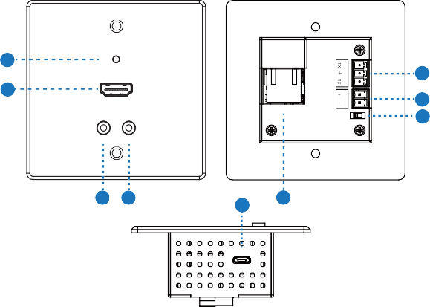Transmitter Panel
1
ACTIVE
8
2
HDMI IN
HDBaseT OUT
7
6
IR IN IR OUT
3 4
9
5
SERVICE
RS-232 DC24V OFF
ON

No. | Name | Function Description
1 | ACTIVE LED  (Green) | - Light on: There is HDMI signal, and the HDBT  connection is normal;  - Light off: There is no HDMI signal, and the HDBT  connection is normal;  - Light flashing: HDBT connection is abnormal.
2 | HDMI IN  port | HDMI signal input port, connected to HDMI source  device with HDMI cable.
3 | IR IN | IR input port for receiving the signal of IR remote.
4 | IR OUT | IR output port for control of source device. This IR output signal is from the IR IN port of receiver.
5 | HDBaseT OUT | HDBaseT signal output port, connected to the  HDBaseT receiver with a CAT cable.

No. | Name | Function Description
6 | POC switch | Use the switch to turn on/off POC function.
7 | DC 24V | DV 24V power input port.
8 | RS-232 | Use the phoenix connector for connecting with PC or control system to transmit RS-232 serial port commands.
9 | SERVICE | MCU update port.

Receiver Panel
SERVICE
1
2
HDMI OUT
AUDIO OUT IR IN IR OUT
3
5 4 6
7
8
9 10 11
DC 24V
HDBT IN

No. | Name | Function Description
1 | Power LED | Red LED indicates that the receiver is powered on.
2 | SERVICE | MCU update port.
3 | DC 24V | DC 24V/1A power supply input port.  Note: Both the transmitter and receiver support POC function, it means that either transmitter or receiver is powered on by 24V/1A power adapter, the other one doesn’t need power supply.
4 | HDBT IN | RJ45 connector for connecting the HDBT OUT port of transmitter with a CAT6/6A cable.
5 | Link Signal Indicator | - Illuminating: Transmitter and Receiver are in good connection status.  - Flashing: Transmitter and Receiver are in poor  connection status.  - Dark: Transmitter and Receiver are not connected.

No. | Name | Function Description
6 | Data Signal Indicator | - Illuminating: HDMI signal with HDCP.  - Flashing: HDMI signal without HDCP.  - Dark: No HDMI signal.
7 | HDMI OUT | HDMI signal output port.
8 | AUDIO  OUT | 3.5mm stereo connector for analog audio output.
9 | IR IN | IR input port for receiving the signal of IR remote.
10 | IR OUT | IR output port for control of display device. This IR output  signal is from the IR IN port of transmitter.
11 | RS-232 | 3-pin Phoenix connector for RS-232 command  transmission. The RS-232 command will pass-through between the transmitter and receiver.

Product Dimensions
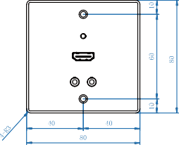
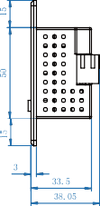
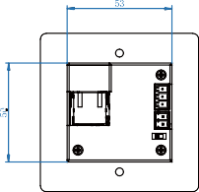

Front
Side
Back
Unit: mm

Application Example

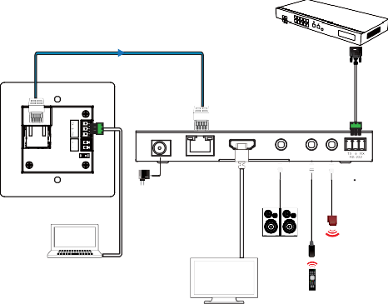
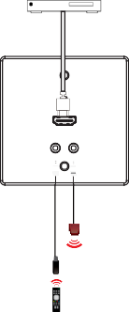
DVD or Blu-ray Player

Transmitter

CAT6/6A Cable

HDMI Matrix with RS-232 function

ACTIVE
DC 24V
Receiver

HDMI IN

HDBaseT OUT

HDMI OUT
HDBT IN

AUDIO OUT

IR IN IR OUT

IR IN IR OUT

RS-232 DC24V OFF
ON

IR Blaster IR Receiver

Notebook

Power Adapter

Speakers

IR
Blaster IR Receiver

TV or Monitor

