TP100WP2HU-UK

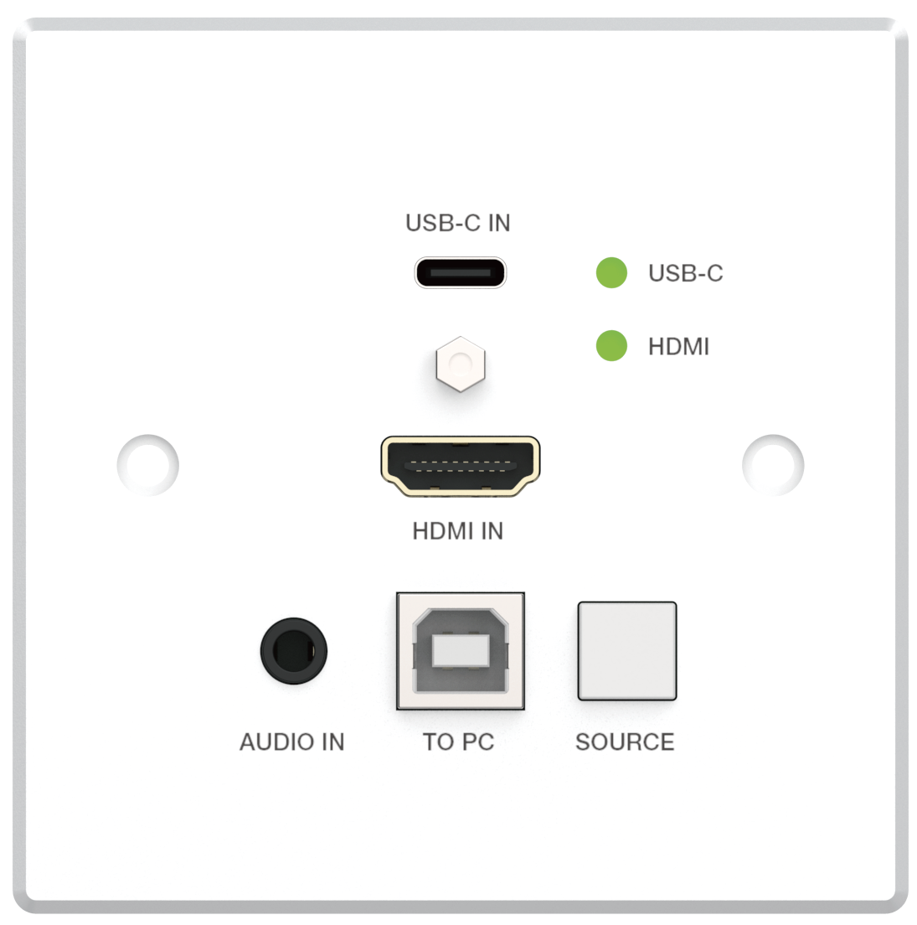
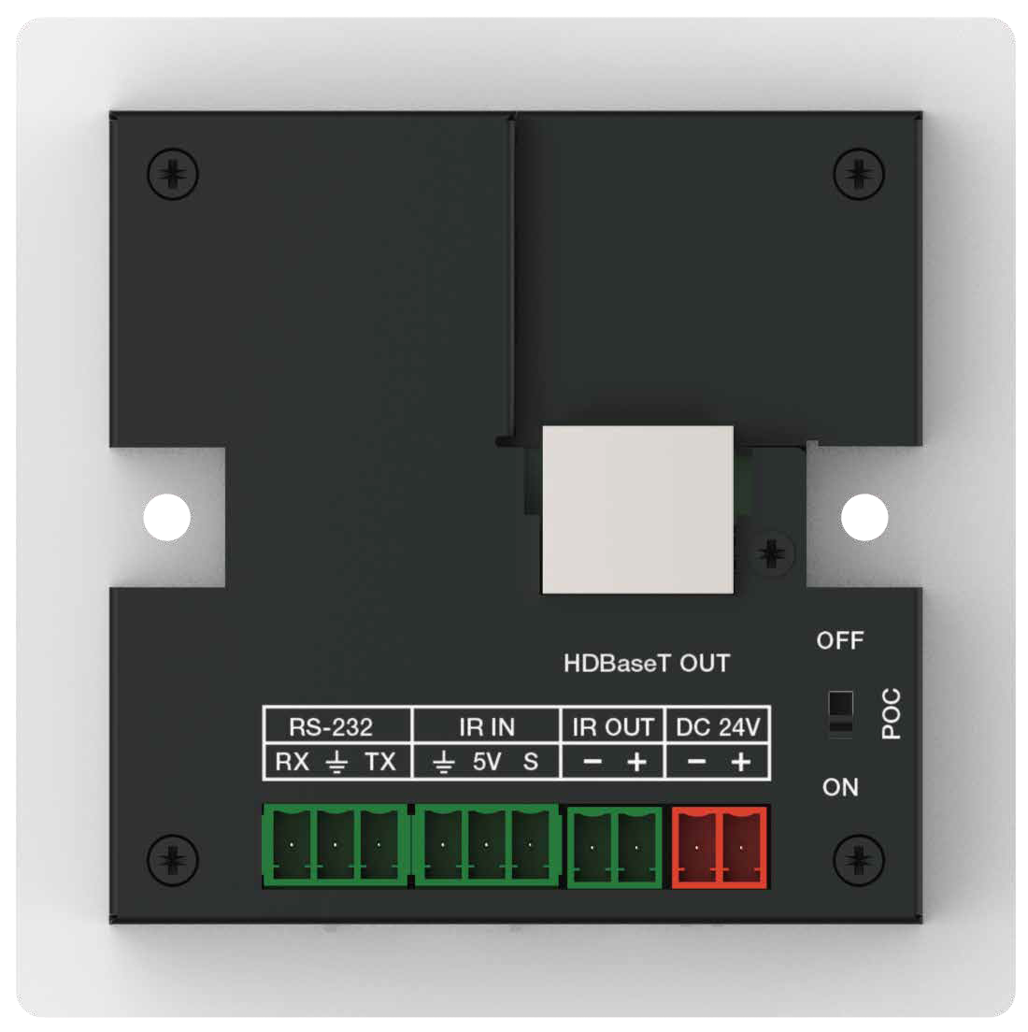
Wall-plate Transmitter
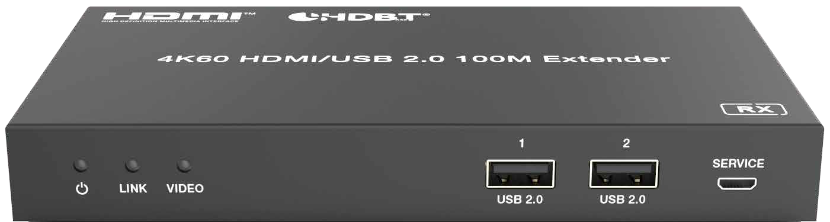
HDBT Receiver

VER 1.0

Thank you for purchasing this product
For optimum performance and safety, please read these instructions carefully before connecting, operating or adjusting this product. Please keep this manual for future reference.
Surge protection device recommended
This product contains sensitive electrical components that may be damaged by electrical spikes, surges, electric shook, lighting strikes, etc. Use of surge protection systems is highly recommended in order to protect and extend the life of your equipment.

Table of Contents
- Introduction. 1
- Features. 1
- Package Contents. 2
- Specifications. 2
- Operation Controls and Functions. 3
  - Transmitter Panel. 3
  - Receiver Panel. 5
  - Dimensions of Wall Box. 6
- Application Example. 8

Introduction
The 4K60 HDMI/USB-C 2x1 HDBT Wall-plate Transmitter supports one HDMI input and one USB-C input within a standard 86mm×86mm wall box. It can transmit HDMI high-definition signal, bidirectional IR control signal, bidirectional RS-232 control signal and USB 2.0 signal over CAT6 to the distance up to 328ft/100m (HBT mode) or 492ft/150m (LRM mode). Video resolution is up to 4K2K@60Hz (4:4:4).
This product converts HDMI signal to standard HDBaseT signal and transmits it through LAN cable. It can easily control signal source device or display device from the remote end through bi-directional IR signal pass- through function. It also supports POC function with POC control switch.
The Extender can be widely used in other fields such as video conference system, multimedia signal broadcasting, HDMI signal extension, etc.

Features
☆ HDMI 2.0b, HDCP 2.2/1.x and DP 1.2a compliant
☆ HDMI input supports 18Gbps video bandwidth USB input supports 5.4Gbps video bandwidth
☆ Support video resolution up to 4K2K@60Hz (4:4:4)
☆ Up to 7.1 channels HD audio
☆ Input signal source selection supports button switching
☆ Built-in mode DIP switch for selecting the HBT mode or LRM mode
HBT mode: Audio and video signals can be transmitted up to 328ft/100m for 4K60/4K30/1080P
LRM mode: Audio and video signals can be transmitted up to 492ft/150m for 4K30/1080P
☆ Built-in EDID DIP switch supports intelligent EDID management
☆ Built-in audio DIP switch supports analog audio embedding
☆ Built-in POC switches, when both POC switches of TX and RX are turned on, the Extender supports bidirectional 24V POC function, that is, either TX or RX is powered by 24V1A power supply, the another does not need power supply from the DC jack. (See the Description 1)
☆ Transmit bidirectional Infrared control signal together with the HDMI signal. (See the Description 2)
IR IN is a 5V power supply level
☆ Transmit bidirectional RS-232 control signal together with the HDMI signal. (See the Description 3)
☆ The Receiver supports USB 2.0 signal transmission
☆ Standard 86mm×86mm wall box

Package Contents
① 1 x 4K60 HDMI/USB-C 2x1 HDBT Wall-plate Transmitter
② 1 x HDBT Receiver
③ 2 x 2pin-3.81mm Phoenix connector (male)
④ 4 x 3pin-3.81mm Phoenix connector (male)
⑤ 1 x Wideband IR Receiver cable (1.5 meters)
⑥ 1 x IR Blaster cable (1.5 meters)
⑦ 2 x Mounting Ears
⑧ 4 x Machine Screws-M3*4
⑨ 1 x 24V/1A Locking Power Supply
⑩ 1 x User Manual

Specifications
Technical
HDMI Compliance | HDMI 2.0b
HDCP Compliance | HDCP 2.2
Video Bandwidth | HDMI: 18Gbps; USB-C：5.4Gbps
HDMI Video Resolution | Up to 4K2K@60Hz 4:4:4
Color Space | RGB 4:4:4, YCbCr 4:4:4, YCbCr 4:2:2, YCbCr 4:2:0
Color Depth | 8/10/12bit
HDMI Audio Formats | LPCM 7.1CH, Dolby True HD and DTS-HD Master (Full format)
Analog Audio Embedding | 48KHz
Transmission Distance | LRM mode: 492ft/150m (4K30/1080P)  STD-HBT mode: 328ft/100m (4K60/4K30/1080P)
ESD Protection | Human body model—±8kV (Air-gap discharge) &±4kV (Contact discharge)
Connections
Transmitter | Input: 1 x HDMI IN [Type A, 19-pin female] 1 x USB-C IN [USB Type C]  1 x AUDIO IN [3.5mm Stereo Mini-jack] Output: 1 x HDBaseT OUT [RJ45]  Control: 1 x TO PC [USB Type B]  1 x RS-232 [3pin-3.81mm Phoenix connector] 1 x IR IN [3pin-3.81mm Phoenix connector]  1 x IR OUT [2pin-3.81mm Phoenix connector]
Receiver | Input: 1 x HDBT IN [RJ45]  Output: 1 x HDMI OUT [Type A, 19-pin female]  1 x AUDIO OUT [3pin-3.81mm Phoenix connector] Control: 2 x USB 2.0 [USB Type A]  1 x RS-232 [3pin-3.81mm Phoenix connector] 1 x IR IN [3pin-3.81mm Phoenix connector]  1 x IR OUT [2pin-3.81mm Phoenix connector] 1 x SERVICE [Micro USB]

Mechanical
Housing | Metal Enclosure
Color | Front panel: White; Rear case:Black
Dimensions | Transmitter: 86mm [W] x 86mm [D] x 38.5mm [H] Receiver: 157.2mm [W] x 88mm [D] x 20mm [H]
Weight | Transmitter: 234g; Receiver: 377g
Power Supply | 24V/1A (supporting bidirectional POC power supply)
Power Consumption | 12.48W (Max)
Operating Temperature | 32 - 104°F / 0 - 40°C
Storage Temperature | -4 - 140°F / -20 - 60°C
Relative Humidity | 20 - 90% RH (no condensation)

Operation Controls and Functions

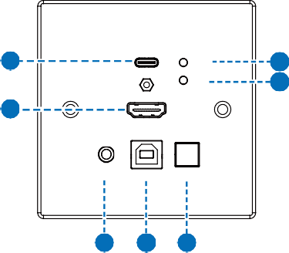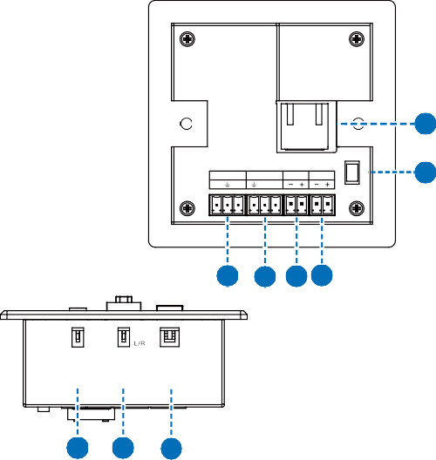Transmitter panel
USB-C IN
1
USB-C

HDMI
2
4
3
13
HDMI IN
OFF
HDBaseT OUT

RS-232 IR IN IR OUT DC 24V RX TX 5V S
12
ON
AUDIO IN TO PC SOURCE
5
6
7
8
9 10 11
LRM
STD
HDMI
0
1
MODE AUDIO IN 1 2
EDID
14
15
16
POC

No. | Name | Function Description
1 | USB-C IN port | USB-C signal input port, supporting video signal (up to 4K60) and USB2.0 signal, connected to USB-C signal source device.
2 | USB-C LED | USB-C signal input indicator. When the USB-C signal is  selected as the input source, the green indicator light on.
3 | HDMI IN port | HDMI signal input port, connected to HDMI source device, such as Blu-ray or PS4.
4 | HDMI LED | HDMI signal input indicator. When the HDMI signal is selected as the input source, the green indicator light on.
5 | AUDIO IN port | Analog audio input port for audio embedding.
6 | TO PC port | USB-B port, connected to PC. This port can be switched along with the HDMI IN port, that is, when switching to the HDMI signal source, the USB HOST can be selected simultaneously.
7 | SOURCE button | Used to switch HDMI/USB-C input signal source.
8 | RS-232 port | Connected to PC or control system through 3-pin Phoenix connector for RS-232 serial command pass-through.
9 | IR IN port | Connected to IR wideband receiver cable, receiving the  remote control signal and then send it to the receiving end.
10 | IR OUT port | Connected to IR blaster cable, sending the remote control signal from the receiving end.
11 | DC 24V port | DC 24V/1A power input port.  Note that the extender supports POC function, it means that either transmitter or receiver is powered on by 24V/1A power adapter, the other one doesn’t need power supply.
12 | POC switch | Use the switch to turn on/off POC function.
13 | HDBaseT OUT port | HDBaseT signal output port, connected to the HDBT IN port of Receiver with a CAT6 cable.
14 | MODE  DIP switch | Used to select the working mode:  LRM-long reach mode: Extend the signal up to 492ft/150m through a single CAT6 network cable.  STD-HBT mode: Extend the signal up to 328ft/100m through  a single CAT6 network cable.
15 | AUDIO IN  DIP switch | Used to select the signal source for the audio output of Receiver:  HDMI: Output the de-embedded audio from the HDMI IN port of Transmitter.  L/R: Output the analog audio embedded from the AUDIO IN port of Transmitter.

No. | Name | Function Description
 |  | Used to set the EDID information:
16 | EDID  DIP switch | 00- Copy RX display’s EDID (as factory default) 01- 4K30 4:4:4  10- 1080p60 4:4:4
 |  | 11- 1200p60 4:4:4

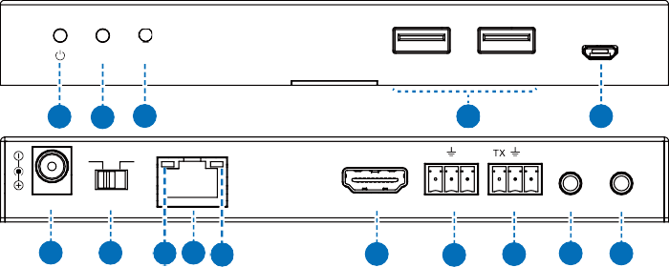Receiver panel
1
2
SERVICE
LINK VIDEO
USB 2.0
USB 2.0
1 2 3
4
5
ON OFF
L R
RX
DC 24V POC
HDMI OUT AUDIO OUT RS-232 IR IN IR OUT
6
7
9 8 10
11
12
13
14 15
HDBT IN

No. | Name | Function Description
1 | Power LED | Red LED indicates that the Receiver is powered on.
2 | LINK LED  (Green) | - Light on: Transmitter and Receiver are in good connection  status.  - Light Flashing: Transmitter and Receiver are in poor  connection status.  - Light off: Transmitter and Receiver are not connected.
3 | VIDEO LED  (Green) | Signal indicator  - Light Flashing: There is valid signal input.  - Light off: There is no signal or the signal is invalid.
4 | USB 2.0 port | USB Type A port for connecting USB 2.0 devices, such as USB Flash Drive, Mouse and Keyboard.
5 | SERVICE port | Software update port. Send command “s switch uart 0!” to switch MCU; send command “s switch uart 1!”to switch VALENS.
6 | DC 24V port | DC 24V/1A power input port.  Note that the extender supports POC function, it means that either transmitter or receiver is powered on by 24V/1A power adapter, the other one doesn’t need power supply.

No. | Name | Function Description
7 | POC switch | Use the switch to turn on/off POC function.
8 | HDBT IN  port | HDBaseT signal input port, connected to the HDBaseT OUT port of Transmitter with a CAT6 cable.
9 | Link Signal Indicator (Green) | - Light on: Transmitter and Receiver are in good connection  status.  - Light Flashing: Transmitter and Receiver are in poor  connection status.  - Light off: Transmitter and Receiver are not connected.
10 | Data Signal Indicator (Yellow) | - Light Flashing: There is data transmission.  - Light off: There is no data transmission.
11 | HDMI OUT  port | HDMI signal output port, connected to HDMI display device such as TV or monitor.
12 | AUDIO OUT  port | Analog audio output port.
13 | RS-232 port | Connected to PC or control system through 3-pin Phoenix  connector for RS-232 serial command pass-through.
14 | IR IN port | Connected to IR wideband receiver cable, receiving the remote control signal and then send it to the transmitting end.
15 | IR OUT port | Connected to IR blaster cable, sending the remote control signal from the transmitting end.

Dimensions of Wall Box
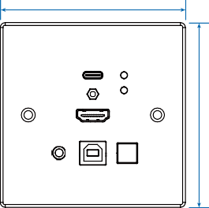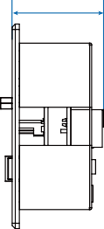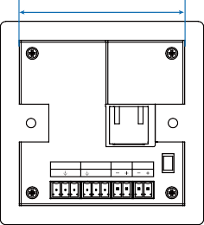86mm
38.5mm
70mm
OFF
HDBaseT OUT

RS-232 IR IN IR OUT DC 24V RX TX 5V S
ON

USB-C IN
USB-C

HDMI IN

HDMI

86mm

AUDIO IN

TO PC

SOURCE
POC

Front panel

Side Panel

Rear Panel

※ Description 1
POC (Power over Cable) Application Example
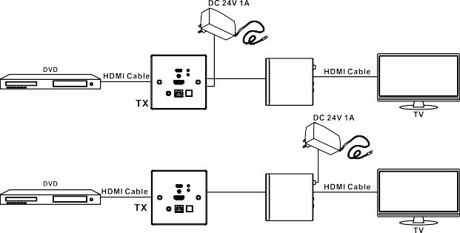
USB-C IN
CAT5e/6/7
USB-C

HDMI
HDMI IN

AUDIO IN TO PC SOURCE
USB-C IN
USB-C

HDMI
CAT5e/6/7
HDMI IN

AUDIO IN TO PC SOURCE

※ Description 2
Bidirectional Infrared control Application Example
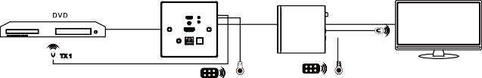
USB-C IN
HDMI Cable
TX
TX 1
USB-C

HDMI
UTP Cable
HDMI Cable
RX
HDMI IN
TX 2
AUDIO IN TO PC SOURCE
TV
TV Remote
DVD Remote
Rx2
Rx1

※ Description 3
Bidirectional RS-232 control Application Example
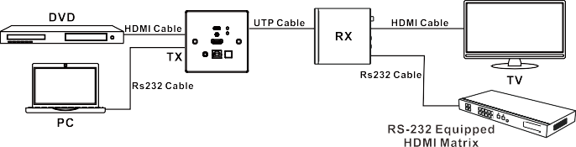
USB-C IN
USB-C

HDMI
HDMI IN

AUDIO IN TO PC SOURCE

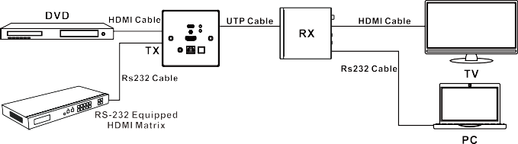
USB-C IN

USB-C

HDMI

HDMI IN

AUDIO IN TO PC SOURCE

Application Example

Transmitter

CAT6 Cable
Projector

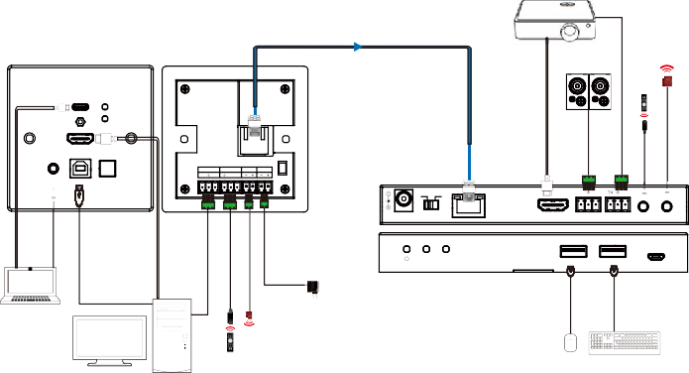Speakers

IR Blaster

USB-C IN

USB-C HDMI

IR Receiver

HDMI IN

HDBaseT OUT

OFF

AUDIO IN TO PC SOURCE

RS-232 IR IN IR OUT DC 24V RX TX 5V S
ON

POC

ON OFF

L R RX

DC 24V

POC

HDMI OUT AUDIO OUT RS-232 IR IN IR OUT
HDBT IN

Notebook

Power Supply IR Blaster

LINK VIDEO

Receiver

Mouse

1 2

USB 2.0 USB 2.0

SERVICE

Desktop
IR Receiver
Keyboard

