TP100UH2

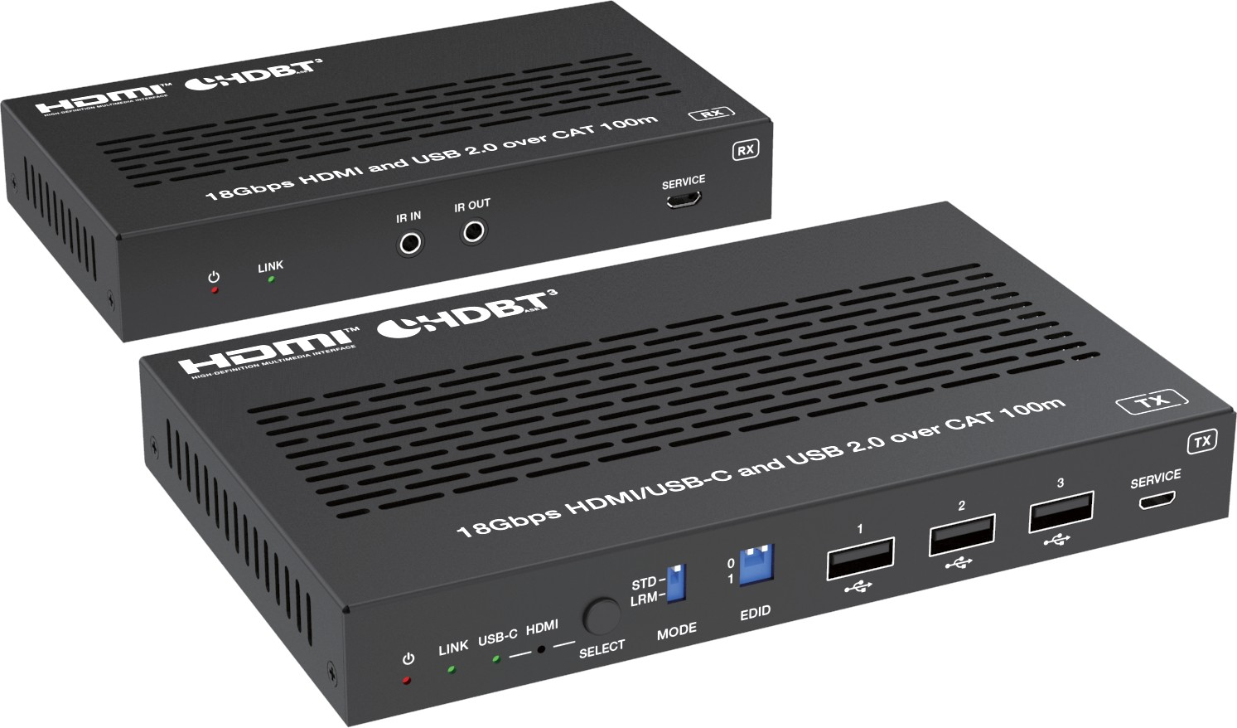


VER 1.1

Thank you for purchasing this product
For optimum performance and safety, please read these instructions carefully before connecting, operating or adjusting this product. Please keep this manual for future reference.

Surge protection device recommended
This product contains sensitive electrical components that may be damaged by electrical spikes, surges, electric shock, lighting strikes, etc. Use of surge protection systems is highly recommended in order to protect and extend the life of your equipment.

Caution
The product requires the use of UTP connectors. Please connect in direct interconnection method and do not cross connect.

White and Orange Orange
White and Green Blue
White and Blue Green
White and Brown Brown

Direct Interconnection Method

Table of Contents
- Introduction. 1
- Features. 1
- Package Contents. 2
- Specifications. 2
- Operation Controls and Functions. 4
  - Transmitter Panel. 4
  - Receiver Panel. 6
- IR Pin Definition. 7
- API Commands. 8
- Application Example. 11

Introduction
This 18Gbps HDBaseT 3.0 Extender can extend uncompressed HDMI/USB-C signals, bi-directional IR, RS-232, and USB 2.0 signals up to 328ft/100m via a single CAT6A/7 cable. Video resolution is up to 4K2K@60Hz YUV 4:4:4.
The transmitter features with 1x HDMI input, 1x USB-C input (60W charging), 1x USB Host and 3x USB Device ports. It can switch between HDBT Standard Mode (as factory default) and HDBT Long Reach Mode. The receiver features with 1x HDMI output, 2x USB Device ports. Both transmitter and receiver support 3.5mm analog audio de-embedding, EDID management, bi-directional IR and RS-232 signal pass-through. This product supports bi-directional 24V POC function.
The Extender offers the most convenient solution for video extension via a single CAT cable with long distance capability, and it is the perfect solution for home/commercial application.

Features
☆ Compliant with HDCP 2.3, 18Gbps video bandwidth
☆ HDBaseT 3.0 VS3000 chipset based design
☆ Support video resolution up to 4K2K@60Hz (YUV 4:4:4) as specified in HDMI 2.0b
☆ 4K60/4K30/1080P signal transmission distance up to 328ft/100m via a single CAT6A/7 cable (HDBT Standard Mode)
☆ 1080P 8bit signal transmission distance up to 492ft/150m via a single CAT6A/7 cable (HDBT Long Reach Mode)
☆ TX features with 1x HDMI input, 1x USB-C input, 1x HDBT output, 1x USB 2.0 host and 3x USB 2.0 clients
☆ RX features with 1x HDMI output, 2x USB 2.0 clients
☆ USB-C and HDMI signal inputs support auto or manual switching mode
☆ Auto switching supports HDMI 5V or signal detect selection
☆ USB-C supports DP-ALT mode for A/V, USB 2.0 data and power charging up to 60 watts
☆ TX/RX USB-A client ports VBUS on or off depends on USB host is connected or not
☆ HDR, HDR10, HDR10+, Dolby Vision LLM and HLG pass-through
☆ 4K to 1080p downscaling features on HDMI output, no frame rate conversion
☆ Both TX and RX support analog audio de-embedding
☆ RS-232 signal pass-through and guest-mode control
☆ Support bi-directional IR signal pass-through, USB 2.0 signal transmission
☆ Advanced EDID management
☆ Each USB-A port provides power up to 5V/500mA
☆ Support bi-directional 24V POC, with POC switch
☆ Compact design for easy and flexible installation

Package Contents
① 1 × 18Gbps HDMI/USB-C over HDBaseT 3.0 Extender (Transmitter)
② 1 × 18Gbps HDMI/USB-C over HDBaseT 3.0 Extender (Receiver)
③ 1 × IR Blaster Cable (1.5 meters)
④ 1 × IR Wideband Receiver Cable (1.5 meters)
⑤ 2 × 3pin-3.81mm Phoenix Connector (male)
⑥ 4 × Mounting Ear
⑦ 8 × Machine Screw (KM3*4)
⑧ 1 × 24V/3.75A Desktop Power Supply
⑨ 1 × User Manual

Specifications

Technical
HDMI Compliance | HDMI 2.0b
HDCP Compliance | HDCP 2.3
USB Compliance | USB 2.0
Video Bandwidth | 18Gbps
Video Resolution | Up to 4K@60Hz 4:4:4
Color Space | RGB, YCbCr 4:4:4, YCbCr 4:2:2, YCbCr 4:2:0
Color Depth | 8/10/12bit
IR Level | 12Vp-p
IR Frequency | Wideband 20K-60KHz
HDR | HDR, HDR10, HDR10+, Dolby Vision, HLG
Audio Formats | HDMI/USB-C/HDBT:  LPCM 2/5.1/7.1CH, Dolby Digital/Plus/EX, Dolby True HD, DTS, DTS-EX, DTS-96/24, DTS High Res, DTS-HD Master  Audio, DSD  3.5mm Analog Audio:  LPCM 2CH
Transmission Distance | HDBT Standard Mode (4K60/4K30/1080P): 328ft/100m (CAT6A/7)  HDBT Long Reach Mode (1080P 8bit): 492ft/150m (CAT6A/7)
ESD Protection | Human body model — ±8kV (Air-gap discharge) &  ±4kV (Contact discharge)

Connection
Transmitter | Input: 1 x HDMI IN [Type A, 19-pin female]  1 x USB-C IN [USB Type C, 24-pin female] Output: 1 x HDBaseT OUT [RJ45, 8-pin female]  1 x L/R OUT [3.5mm Stereo Mini-jack] Control: 1 x IR IN [3.5mm Stereo Mini-jack]  1 x IR OUT [3.5mm Stereo Mini-jack]  1 x RS-232 [3pin-3.81mm phoenix connector] 1 x SERVICE [Micro USB, 5-pin female]  1 x USB HOST [USB Type B, 4-pin female] 3 x USB Devices [USB Type A, 4-pin female]
Receiver | Input: 1 x HDBaseT IN [RJ45, 8-pin female] Output: 1 x HDMI OUT [Type A, 19-pin female]  1 x L/R OUT [3.5mm Stereo Mini-jack] Control: 1 x IR IN [3.5mm Stereo Mini-jack]  1 x IR OUT [3.5mm Stereo Mini-jack]  1 x RS-232 [3pin-3.81mm phoenix connector]  1 x SERVICE [Micro USB, 5-pin female]  2 x USB Devices [USB Type A, 4-pin female]
Mechanical
Housing | Metal Enclosure
Color | Black
Dimensions | Transmitter: 170mm [W] x 102mm [D] x 22mm [H] Receiver: 144mm [W] x 78mm [D] x 23mm [H]
Weight | Transmitter: 484g, Receiver: 318g
Power Supply | Input: AC 100 - 240V 50/60Hz  Output: DC 24V/3.75A (US/EU standard, CE/FCC/UL certified)
Power Consumption (Max) | 94.32W (Power supply from TX, 60W USB-C charging, POC to RX) 10.8W (Power supply from TX or RX, without USB-C charging)
Operating  Temperature | 32 - 104°F / 0 - 40°C
Storage Temperature | -4 - 140°F / -20 - 60°C
Relative Humidity | 20 - 90% RH (no condensation)
Resolution / Cable Length | 4K60 -  Feet / Meters | 4K24 -  Feet / Meters | 1080P60 -  Feet / Meters
HDMI IN / OUT | 26ft / 8M | 39ft / 12M | 50ft / 15M
The use of “Premium High Speed HDMI” cable is highly recommended.

Operation Controls and Functions

Transmitter Panel
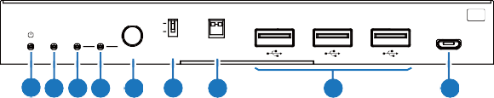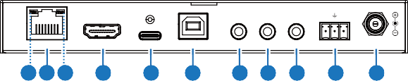
LINK USB-C HDMI
STD LRM
0
1
1
2
3
TX
SERVICE
SELECT MODE EDID
1 2 3 4 5
6
7
8
9
60W
TX RX

HDBaseT OUT HDMI IN USB-C IN USB HOST L/R OUT IR IN IR OUT RS-232 DC 24V
11 10 12 13
14
15
16 17 18 19
20
ON OFF
21
POC

No. | Name | Function Description
1 | Power LED | Red LED indicates that the transmitter is powered on.
2 | LINK LED  (Green) | - Light on: Transmitter and receiver are in good connection status.  - Light flashing: Transmitter and receiver are in poor connection status.  - Light off: Transmitter and receiver are not connected.
3 | USB-C LED  (Green) | When the USB-C IN port is selected as the video signal input channel, the USB-C LED will be on.
4 | HDMI LED  (Green) | When the HDMI IN port is selected as the video signal input channel, the HDMI LED will be on.
5 | SELECT  button | Press this button to switch HDMI/USB-C signal input.
6 | MODE  switch | Used to switch HDBT mode.  Switch to "STD": The HDBT Standard Mode (as factory default) is enabled, it can extend 4K60/4K30/1080P signal between the transmitter and the receiver up to 100m via a single CAT6A/7 cable. Switch to "LRM": The HDBT Long Reach Mode is enabled, it can extend 1080P 8bit signal between the transmitter and the receiver up to 150m via a single CAT6A/7 cable.
Note: In the HDBT Long Reach Mode, due to bandwidth limitations, USB cannot transmit USB 2.0 devices, but only can transmit USB HID devices (such as mice and keyboards). When using the USB pass-through function, the serial baud rate may also be limited.

No. | Name | Function Description
7 | EDID DIP  switch | Used for EDID setting:  00- Copy display’s EDID (as factory default) 01- 4K30 4:4:4  10- 1080p60 4:4:4  11- 1200p60 4:4:4
8 | USB Device ports | Three USB extension ports, connected to mouse, keyboard, USB  Flash Drive or other USB devices, with a maximum power supply of 500mA.
9 | SERVICE | Firmware update and API command control port.
10 | HDBaseT OUT | HDBaseT output port, connected to the HDBaseT IN port of receiver with a CAT6A/7 cable. It is used for various signals pass-through.
11 | Data Signal Indicator (Yellow) | - Light on: There is video signal transmission with HDCP encryption.  - Light flashing: There is video signal transmission without HDCP  encryption.  - Light off: There is no video signal transmission.
12 | Link Signal Indicator (Green) | - Light on: Transmitter and receiver are in good connection status.  - Light flashing: Transmitter and receiver are in poor connection  status.  - Light off: Transmitter and receiver are not connected.
13 | HDMI IN | HDMI signal input port, connected to HDMI source device.
14 | USB-C port | USB Type C port with following three functions:  - USB-C video signal input port, connected to source device.  - USB-C host port. When the USB-C port is selected as the video signal input channel, the USB-C port can be used as a USB 2.0 signal transmission port simultaneously.  - USB-C charging port. Only when TX is connected to the 24V/  3.75A power supply, the USB-C port can provides 60W charging power for external USB-C devices. When TX is not connected to the power supply and RX is connected to the power supply, the USB-C port can not provide charging function.
15 | USB HOST | USB host port, connected to PC. It follows the HDMI IN port. When the HDMI IN port is selected as the input channel, the USB 2.0 signal can only be output through the USB HOST port.
16 | L/R OUT | Analog audio output port, used for audio de-embedding output.
17 | IR IN | IR signal input port, connected with the IR Receiver cable.
18 | IR OUT | IR signal output port, connected with the IR Blaster cable.
19 | RS-232 | RS-232 serial port, used for RS-232 command pass-through and API command control.

No. | Name | Function Description
20 | DC 24V | DC 24V/3.75A power supply input port.  Note that the extender supports POC function, it means that either transmitter or receiver is powered on by 24V/3.75A power adapter, the other one doesn’t need power supply.
21 | POC switch | Use the switch to turn on/off the POC function.

Receiver Panel
1
2
3
4
5

IR IN IR OUT RX
LINK SERVICE
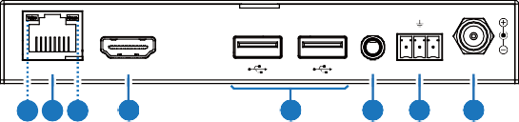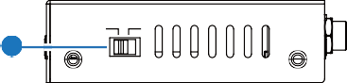
TX RX
HDMI OUT
L/R OUT RS-232 DC 24V
7 6 8
9
10
11 12
13
HDBaseT IN
ON OFF
14
POC

No. | Name | Function Description
1 | Power LED | Red LED indicates that the receiver is powered on.
2 | LINK LED  (Green) | - Light on: Transmitter and receiver are in good connection status.  - Light flashing: Transmitter and receiver are in poor connection status.  - Light off: Transmitter and receiver are not connected.
3 | IR IN | IR signal input port, connected with the IR Receiver cable.
4 | IR OUT | IR signal output port, connected with the IR Blaster cable.
5 | SERVICE | Firmware update and API command control port.
6 | HDBaseT IN | HDBaseT input port, connected to the HDBaseT OUT port of transmitter with a CAT6A/7 cable. It is used for various signals pass-through.

No. | Name | Function Description
7 | Data Signal Indicator (Yellow) | - Light on: There is video signal transmission with HDCP encryption.  - Light flashing: There is video signal transmission without HDCP  encryption.  - Light off: There is no video signal transmission.
8 | Link Signal Indicator (Green) | - Light on: Transmitter and receiver are in good connection status.  - Light flashing: Transmitter and receiver are in poor connection  status.  - Light off: Transmitter and receiver are not connected.
9 | HDMI OUT | HDMI signal output port, connected to HDMI display device, such as TV or monitor.
10 | USB Device ports | Two USB extension ports, connected to mouse, keyboard, USB Flash Drive or other USB devices.
11 | L/R OUT | Analog audio output port, used for audio de-embedding output.
12 | RS-232 | RS-232 serial port, used for RS-232 command pass-through and API command control.
13 | DC 24V | DC 24V power supply input port.  Note that the extender supports POC function, it means that either transmitter or receiver is powered on by 24V power adapter, the other one doesn’t  need power supply.
14 | POC switch | Use the switch to turn on/off the POC function.

IR Pin Definition
IR Receiver and Blaster pin’s definition as below:
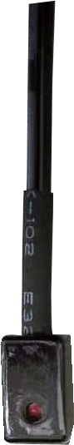
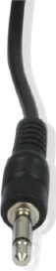
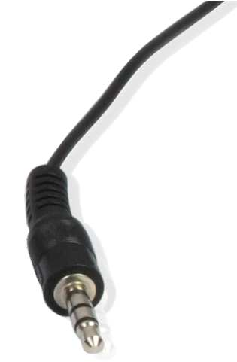
IR BLASTER IR RECEIVER

+
IR RECEIVER
Power 12V
IR BLASTER
-

Note: When the angle between the IR receiver and the remote control is ± 45 °, the transmission distance is 0-5 meters; when the angle between the IR receiver and the remote control is ± 90 °, the transmission distance is 0-8 meters.

API Commands
The product also supports API commands control. Connect the RS-232 port of the product to a PC or control system with a 3-pin phoenix connector cable, or connect the SERVICE port of the product to a PC with a Micro USB cable. Then, open a serial command tool on PC to send ASCII commands to control the product. The ASCII commands list about the product is shown as below.

ASCII Commands
RS-232 Communication Protocol
Baud rate: 115200; Data bit: 8; Stop bit: 1; Parity bit: none. The end mark of command is “<CR><LF>”.
Command Code | Function Description | Example | Feedback | Default
help | Get the list of all commands | help | ======================  Help Info  FW Version:TX 1.00.02  RX 1.00.02  - help  - r fw version  - s reboot  - s reset  - r status  - s tx input x  - r tx input  - s tx autoswitch x  - r tx autoswitch  - s tx autoswitch mode x  - r tx autoswitch mode  - s rx downscale x  - r rx downscale  - s tx audio mute x  - r tx audio mute  - s rx audio mute x  - r rx audio mute  - s edid x to y  - r edid x  - r edid data x  - s user edid x <y>  - r user edid x  ======================
r fw version | Get the firmware version | r fw version | TX 1.0.0 RX 1.0.0
s reboot | Reboot the device | s reboot | Reboot…  System Initializing... Initialization Finished! TX 1.0.0 RX 1.0.0
s reset | Reset to factory defaults | s reset | Sure to RESET to default settings? Type "Yes" after next prompt to confirm…

Command Code | Function Description | Example | Feedback | Default
r status | Get system status | r status | Input: USB-C  Video: 1920x1080p60 Audio: 48K PCM 2CH HDCP: 1.4  USB Host: Connected HDBT Link: ON  HDBT Signal: ON EDID: DIP_00 (Copy  display's EDID)
s tx input x | Set TX input video  x = USBC, HDMI, AVMUTE, OFF | s tx input USBC | Set tx input from USBC | USBC
r tx input | Get TX input port | r tx input | USBC
s tx autoswitch x | Set TX auto-switching on/off  x = ON, OFF | s tx autoswitch ON | Set tx autoswitch ON | ON
r tx autoswitch | Get TX auto-switching status | r tx autoswitch | ON
s tx autoswitch mode x | Set TX auto-switching mode  x = 0: 5V detection 1: signal detection | s tx autoswitch mode 1 | Set tx autoswitch mode 1: signal detection | 1: signal detection
r tx autoswitch mode | Get TX auto-switching mode status | r tx autoswitch mode | TMDS
s rx downscale x | Set RX downscaling mode, x=  AUTO: automatically according to display's capability  ON: force 4K to 1080p OFF: bypass video | s rx downscale AUTO | Set rx downscale AUTO | AUTO
r rx downscale | Get RX downscaling mode | r rx downscale | AUTO
s tx audio mute x | Set TX de-embedding audio mute on/off  x = ON, OFF | s tx audio mute ON | Set tx audio mute ON | OFF
r tx audio mute | Get TX de-embedding audio mute status | r tx audio mute | OFF
s rx audio mute x | Set RX de-embedding audio mute on/off  x = ON, OFF | s rx audio mute ON | Set rx audio mute ON | OFF
r rx audio mute | Get RX de-embedding audio mute status | r rx audio mute | OFF

Command Code | Function Description | Example | Feedback | Default
s edid x to y | Set input ports EDID x = USBC, HDMI, ALL  y =  - - EDID dip switch (default)  - - 1920x1080@60 8bit  Stereo  - - WUXGA 1920x1200  - - 1920x1080@60 8bit  High Definition Audio 04 - 3840x2160@60Hz  4:2:0 Deep Color Stereo Audio  05 - 3840x2160@60Hz  Deep Color Stereo Audio 06 - 3840x2160@30Hz  8bit Stereo Audio  07 - 3840x2160@60Hz Deep  Color High Definition Audio 08 - 3840x2160@60Hz Deep Color HDR LPCM 6CH  09 - copy EDID from RX HDMI output  - - User Defined 1  - - User Defined 2 | s edid USBC to 00 | Set edid USBC to 00 - EDID dipswitch (default) | 00
r edid x | Get input ports EDID x = USBC, HDMI | r edid USBC | 00 - EDID dipswitch (default)
r edid data x | Get input ports EDID data x = USBC, HDMI | r edid data USBC | USBC EDID  <00 FF FF FF….>
s user edid x  <y> | Set user defined EDID x = 1 (User Defined 1)  x = 2 (User Defined 2) y = 00 FF FF FF …..  (y is 256 bytes EDID data) | s user edid 1  <00 FF FF FF….> | User edid 1 is loaded
r user edid x | Get user defined EDID x = 1 (User Defined 1)  x = 2 (User Defined 2) | r user edid 1 | User edid 1  <00 FF FF FF….>
s hdbt update | Set Micro USB (UART) to HDBT UART for FW  update | s hdbt update | Hdbt update
Note: The API command “s hdbt update” is for internal use only .

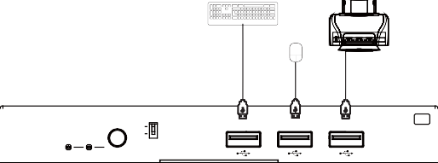Application Example
Keyboard
Mouse
Printer
1
TX
LINK USB-C HDMI
STD 0
LRM 1
2
3
SERVICE
SELECT MODE EDID

Transmitter

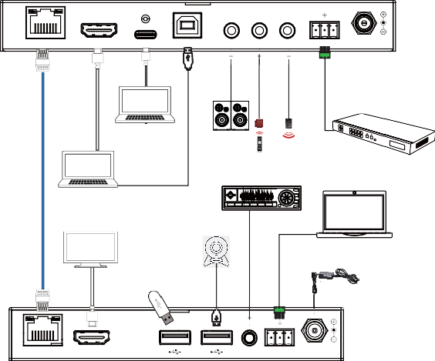
60W

TX RX

HDBaseT OUT

HDMI IN

USB-C IN

USB HOST

L/R OUT IR IN

IR OUT

RS-232

DC 24V

LAN

Laptop 2 (with USB-C port)

Speakers

IR Blaster

HDMI Matrix with RS-232 function

CAT6A/7 cable

Laptop 1
TV or Monitor
IR Receiver Amplifier

USB Camera
PC or Control System

Power Supply
USB Flash Drive

TX RX

Receiver

HDBaseT IN

HDMI OUT

L/R OUT RS-232

DC 24V

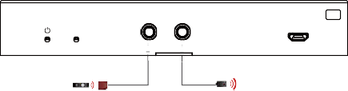
IR IN IR OUT
RX
SERVICE
LINK
IR Receiver IR Blaster

The terms HDMI and HDMI High-Definition Multimedia interface, and the HDMI Logo are trademarks or registered trademarks of HDMI Licensing LLC in the United States and other countries.

