TP100UCH2
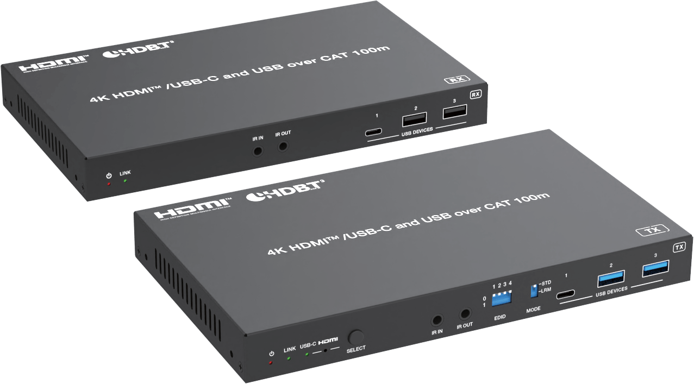



VER 1.0

Thank you for purchasing this product

For optimum performance and safety, please read these instructions carefully before connecting, operating or adjusting this product. Please keep this manual for future reference.
Surge protection device recommended

This product contains sensitive electrical components that may be damaged by electrical spikes, surges, electric shock, lighting strikes, etc. Use of surge protection systems is highly recommended in order to protect and extend the life of your equipment.

Caution

The network cable connection method required for this product is direct connection. Please do not cross connect.



White and Orange Orange
White and Green Blue
White and Blue Green
White and Brown Brown

Direct Interconnection Method

Table of Contents
1. Introduction 1
2. Features 1
3. Package Contents 2
4. Specifications 2
5. Operation Controls and Functions 5
5.1 Transmitter Panel 5
5.2 Receiver Panel 7
6. IR Pin Definition 9
7. API Commands 9
8. Application Example 20

Introduction
This 4K HDBaseT 3.0 Extender can extend uncompressed HDMI/USB-C signals, bi-directional IR, RS-232, and USB signals up to 328ft/100m via a single CAT6A/7 cable. Video resolution is up to 4K2K@60Hz YUV 4:4:4.
The transmitter features 1x HDMI input, 1x USB-C input (A/V+USB 3.2+1G+ 100W charging), 1x USB 3.2 Host and 3x USB 3.2 Device ports. It can switch between HDBT Standard Mode (as factory default) and HDBT Long Reach Mode. It supports EDID management. The receiver features 1x HDMI output, 1x USB-C output (DP output + USB 2.0 device port), 3x USB 2.0 Device ports. Transmitter and receiver support analog audio de-embedding, bi-directional IR, RS-232 and 1G LAN pass-through. This product supports bi-directional 24V PoC function.
The Extender offers the most convenient solution for video extension via a single CAT cable with long distance capability, and it is a perfect solution for home/commercial applications.

Features
☆ Compliant with HDCP 2.2 and DisplayPort 1.4a, 18Gbps video bandwidth
☆ HDBaseT 3.0 VS3000 chipset based design
☆ Support video resolution up to 4K2K@60Hz (YUV 4:4:4), as specified in HDMI 2.0b
☆ 4K60/4K30/1080P signal transmission distance up to 328ft/100m via a single CAT6A/7 cable (HDBT Standard Mode)
☆ 1080P 8bit signal transmission distance up to 492ft/150m via a single CAT6A/7 cable (HDBT Long Reach Mode)
☆ TX features 1x HDMI input, 1x USB-C input, 1x HDMI/HDBT output, 1x USB 3.2 host and 3x USB 3.2 clients
☆ RX features 1x HDBT input, 1x HDMI output, 1x USB-C output, 3x USB 2.0 clients
☆ USB-C and HDMI signal inputs support auto or manual switching mode
☆ Auto switching supports HDMI 5V or signal detect selection
☆ TX USB-C host port supports DP-ALT mode for A/V, USB 3.2 data, 1G Ethernet and power charging up to 100 watts
☆ RX USB-C OUT port supports AV signal output and USB 2.0 signal transfer
☆ TX/RX USB-A client ports VBUS on or off depends on USB host is connected or not
☆ HDR, HDR10, HDR10+, Dolby Vision LLM and HLG pass-through
☆ 4K to 1080p downscaling on HDMI output, no frame rate conversion
☆ Both TX and RX support analog audio de-embedding
☆ RS-232 signal pass-through and API control
☆ RS-232/CEC control external device power on/off
☆ 1G Ethernet and bi-directional IR signal pass-through
☆ Advanced EDID management
☆ Support bi-directional 24V PoC, with PoC switch (USB-C charging only from TX power supply)

Package Contents

① 1× 4K HDMI/USB-C over HDBaseT 3.0 Extender (Transmitter)

② 1× 4K HDMI/USB-C over HDBaseT 3.0 Extender (Receiver)

③ 2× 3pin-3.5mm Phoenix Connector (male)

④ 2× 5pin-3.5mm Phoenix Connector (male)

⑤ 4× Mounting Ear

⑥ 8× Machine Screw (KM3*6)

⑦ 1× IR Blaster Cable (1.5m)

⑧ 1× IR Receiver Cable (1.5m)

⑨ 1× 24V/7.5A Desktop Power Supply

⑩ 1× User Manual

Specifications

Technical
HDMI Compliance | HDMI 2.0b
HDCP Compliance | HDCP 2.2
DP Compliance | DisplayPort 1.4a
Video Bandwidth | 18Gbps
Video Resolution | 640x480p60Hz, 800x600p60Hz, 1024x768p60Hz, 1280x1024p  60Hz, 1360x768p60Hz, 1440x900p60Hz, 1440x1050p60Hz,  1600x1200p60Hz, 720x480i59.94Hz(480i59), 720x480p59.94Hz (480p59), 720x576i50Hz(576i50), 720x576p50Hz(576p50), 1280x720p50Hz(720p50), 1280x720p59.94Hz(720p59),  1280x720p60Hz(720p60), 1920x1080i50Hz(1080i50),  1920x1080i59.94Hz(1080i59), 1920x1080i60Hz(1080i60),  1920x1080p23.98Hz(1080p23), 1920x1080p24Hz(1080p24),  1920x1080p25Hz(1080p25), 1920x1080p29.97Hz(1080p29),  1920x1080p30Hz(1080p30), 1920x1080p50Hz(1080p50),  1920x1080p59.94Hz(1080p59), 1920x1080p60Hz(1080p60),  3840x2160p23.98Hz(2160p23), 3840x2160p24Hz(2160p24),  3840x2160p25Hz(2160p25), 3840x2160p29.97Hz(2160p29),  3840x2160p30Hz(2160p30), 3840x2160p50Hz(2160p50),  3840x2160p59.94Hz(2160p59), 3840x2160p60Hz(2160p60),  3840x2160p100Hz(2160p100), 3840x2160p120Hz(2160p120),  4096x2160p23.98Hz, 4096x2160p24Hz, 4096x2160p25Hz,  4096x2160p29.97Hz, 4096x2160p30Hz, 4096x2160p50Hz,  4096x2160p59.94Hz, 4096x2160p60Hz

Color Space | RGB, YCbCr 4:4:4 / 4:2:2, YUV 4:2:0
Color Depth | 8/10/12bit
HDR | HDR, HDR10, HDR10+, Dolby Vision, HLG
IR Level | 12Vp-p
Audio Formats | HDMI/USB-C/HDBT :  LPCM 2/5.1/7.1CH, Dolby Digital/Plus/EX, Dolby True HD, Dolby Atmos, DTS, DTS-EX, DTS-96/24, DTS High Res, DTS-HD  Master Audio, DSD  Analog Audio:  LPCM 2CH (sample rate 32~192kHz)
Audio Parameters | Output Impedance | 600 Ohm balanced  300 Ohm unbalanced
Audio Parameters | Output Level (Max) | Max 8.2dBu (2Vrms) balanced audio Max 2.2dBu (1Vrms) unbalanced audio
Audio Parameters | Frequency Response | 20Hz to 20kHz (-/+0.5dB)
Audio Parameters | Dynamic Range | > 90dB@0dBu, 1kHzA-weighted
Audio Parameters | Audio S/N Ratio | > 90dB@0dBu, 1kHzA-weighted
Audio Parameters | Audio THD+N | < 0.01% at +4dBu, 1KHz
Audio Parameters | Audio Output Delay | <1ms
USB Support | TX: USB 3.2 Gen 1 5Gbps, compatible with USB 2.0 480Mbps RX: USB 2.0 350Mbps
USB Host Ports | TX: 1x USB-C 3.2 Gen 1 + 1 USB-B 3.2 Gen 1  RX: None
USB Device Ports | TX: 1x USB-C 3.2 Gen 1 + 2x USB-A 3.2 Gen 1 RX: 2x USB-C 2.0 + 2x USB-A 2.0
USB Power Supply | Host ports:  TX: 1x USB-C port (100W charging) Device ports:  TX: 1x USB-C port (1A) + 2x USB A port (1.5A)  RX: 2x USB-C port (1A) + 2x USB A port (1A)
Transmission Distance | HDMI/USB-C passive cable: 16.4ft/5m  USB 3.2 Gen 1 5Gbps passive cable: 5.9ft/1.8m  CAT6A/7 cable: 328ft/100m@4K60 (HDBT Standard Mode) CAT6A/7 cable: 492ft/150m@1080P (HDBT Long Reach Mode)
ESD Protection | IEC 61000-4-2:  ±8kV (Air-gap discharge) & ±4kV (Contact discharge)

Connection
Transmitter | Input: 1x HDMI IN [Type A, 19-pin female]  1x USB-C IN [USB Type C, 24-pin female]  Output: 1x HDBaseT OUT [RJ45, HDBT output with 24V PoC] 1x HDMI OUT [Type A, 19-pin female]  1x AUDIO OUT [5pin-3.5mm phoenix connector] Control: 1x LAN [RJ45 connector, 1G Ethernet pass-through]  1x RS-232 [3pin-3.5mm phoenix connector]  1x SERVICE [USB-C with USB 2.0 only, 12-pin female] 1x USB HOST [USB Type B, 9-pin female]  1x USB DEVICES [USB 3.2 Type C, 24-pin female] 2x USB DEVICES [USB 3.2 Type A, 9-pin female] 1x IR IN [3.5mm audio jack, 12V level]  1x IR OUT [3.5mm audio jack]
Receiver | Input: 1x HDBaseT IN [RJ45, HDBT input with 24V PoC] Output: 1x HDMI OUT [Type A, 19-pin female]  1x USB-C OUT [USB Type C, 24-pin female]  1x AUDIO OUT [5pin-3.5mm phoenix connector] Control: 1x LAN [RJ45 connector, 1G Ethernet pass-through]  1x RS-232 [3pin-3.5mm phoenix connector]  1x SERVICE [USB-C with USB 2.0 only, 12-pin female] 1x USB DEVICE [USB 2.0 Type C, 12-pin female]  2x USB DEVICES [USB 2.0 Type A, 4-pin female] 1x IR IN [3.5mm audio jack, 12V level]  1x IR OUT [3.5mm audio jack]
Mechanical
Housing | Metal Enclosure
Color | Black
Dimensions | Transmitter/Receiver: 208mm [W] x 122mm [D] x 22mm [H]
Weight | Transmitter: 687g, Receiver: 636g
Power Supply | Input: AC 100 - 240V 50/60Hz  Output: DC 24V/7.5A (US/EU standard, CE/FCC/UL certified)
Power Consumption  (Max) | 173W (Power supply from TX, 100W USB-C charging, PoC to RX) 73W (Power supply from TX or RX, without USB-C charging)
Operating  Temperature | 32°F ~ 104°F / 0°C ~ 40°C
Storage Temperature | -4°F ~ 140°F / -20°C ~ 60°C
Operating Humidity | 20% ~ 80% (relative humidity, no condensation)
Storage Humidity | 10% ~ 90% (relative humidity, no condensation)
Recommended HDMI Cable Length
Video Resolution | 4K60 | 4K24 | 1080P60
HDMI IN / OUT | 16.4ft/5m | 33ft/10m | 49ft/15m
The use of “Premium High Speed HDMI” cable is highly recommended.

Operation Controls and Functions

Transmitter Panel
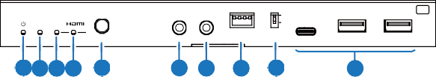
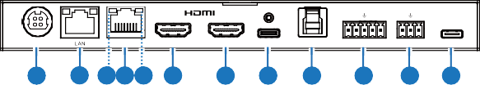
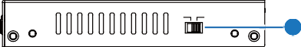
1 2 3 4
1
2
3
T X
LINK USB-C
0
1
STD LRM
SELECT
IR IN IR OUT EDID
MODE USB DEVICES
1 2 3 4 5
6 7
8
9
10
11 12 14 13 15 16
17 18 19
20
21 22
USB-C IN USB HOST AUDIO OUT RS-232 SERVICE
IN
T OUT
L+ L- R+ R- TX RX
100W

HDBaseT OU
DC 24V
23
POC
ON OFF

No. | Name | Function Description
1 | Power LED | Red LED indicates that the transmitter is powered on.
2 | LINK LED  (Green) | - Light on: Transmitter and receiver are in good connection status.  - Light flashing: Transmitter and receiver are in poor connection status.  - Light off: Transmitter and receiver are not connected.
3 | USB-C LED  (Green) | When the USB-C IN port is selected as the video signal input channel, the USB-C LED will be on.
4 | HDMI LED  (Green) | When the HDMI IN port is selected as the video signal input channel, the HDMI LED will be on.
5 | SELECT  button | Press this button to switch HDMI/USB-C signal input.
6 | IR IN | IR signal input port, connected to IR Receiver cable.
7 | IR OUT | IR signal output port, connected to IR Blaster cable.
8 | EDID DIP  switch | Used for EDID setting. The EDID setting list is shown as follow. Note: Only when the EDID DIP switch is set to 1111, the EDID settings through API commands are valid.
9 | MODE  switch | Used to switch HDBT mode.  Switch to "STD": The HDBT Standard Mode (as factory default) is enabled, it can extend 4K60/4K30/1080P signal between the transmitter and the receiver up to 100m via a single CAT6A/7 cable. Switch to "LRM": The HDBT Long Reach Mode is enabled, it can extend 1080P 8bit signal between the transmitter and the receiver up to 150m via a single CAT6A/7 cable.

No. | Name | Function Description
10 | USB Device ports | Three USB 3.2 device ports (two USB-A ports and one USB-C port) connected to mouse, keyboard, USB Flash Drive or other USB devices.
11 | DC 24V | DC 24V/7.5A power supply input port.  Note that the extender supports PoC function, it means that either transmitter or receiver is powered on by 24V/7.5A power adapter, the other one doesn’t need power supply.
12 | LAN | 1G Ethernet pass-through port. When it switches to 1000Mbps Ethernet, the yellow indicator flashes; When it switches to 100Mbps Ethernet, the green indicator flashes.
13 | HDBaseT OUT | HDBaseT output port, connected to the HDBaseT IN port of receiver with a CAT6A/7 cable. It is used for HDMI, network and USB signals pass-through.
14 | Data Signal Indicator (Yellow) | - Light on: There is video signal transmission with HDCP encryption.  - Light flashing: There is video signal transmission without HDCP  encryption.  - Light off: There is no video signal transmission.
15 | Link Signal Indicator (Green) | - Light on: Transmitter and receiver are in good connection status.  - Light flashing: Transmitter and receiver are in poor connection  status.  - Light off: Transmitter and receiver are not connected.
16 | HDMI OUT | HDMI signal loop output port, connected to HDMI display device.
17 | HDMI IN | HDMI signal input port, connected to HDMI source device.
18 | USB-C IN | USB Type C port with following four functions:  - USB-C video signal input port, connected to source device.  - USB-C host port. When the USB-C port is selected as the video signal input channel, the USB-C port can be used as the USB 3.2 Gen 1 signal transmission port simultaneously.  - USB-C charging port. Only when TX is connected to the 24V/  7.5A power supply, the USB-C port can provides 100W charging power for external USB-C devices. When TX is not connected to the power supply and RX is connected to the power supply, the USB-C port can not provide charging function.  (4) 1G Ethernet access port.
19 | USB HOST | USB 3.2 Gen 1 host port, connected to PC.
20 | AUDIO OUT | Analog audio output port, supporting balanced audio output (with a maximum support of 2Vrms) and unbalanced audio output (with a maximum support of 1Vrms).  Balanced connection method: L+, L -, GND, R+, R - Unbalanced connection method: L+, GND, R+

No. | Name | Function Description
21 | RS-232 | RS-232 serial port, used for RS-232 signal pass-through and API commands control.
22 | SERVICE | USB 2.0 Type C port, used for firmware upgrade and API  commands control.
23 | POC switch | 24V PoC on/off switch.  ON: PoC is enabled (as factory default).  OFF: PoC is disabled (need local DC/24V power supply).
Note: In the HDBT Long Reach Mode, due to bandwidth limitations, USB cannot transmit USB 2.0 devices, but only can transmit USB HID devices (such as mice and keyboards). When using the USB pass-through function, the serial baud rate may also be limited.
* EDID Setting List:
[DIP]=0000: EDID Auto (default)
[DIP]=0001: HDMI 1080p@60Hz, Audio 2CH PCM [DIP]=0010: HDMI 4K@30Hz 4:4:4, 8-bit, Audio 2CH PCM [DIP]=0011: HDMI 4K@60Hz 4:4:4, 8-bit, Audio 2CH PCM [DIP]=0100: HDMI 1080p@60Hz, Audio 5.1CH DTS/DOLBY
[DIP]=0101: HDMI 1080p@60Hz, Audio 7.1CH DTS/DOLBY/HD [DIP]=0110: HDMI 4K@60Hz 4:4:4, 8-bit, Audio 5.1CH DTS/DOLBY [DIP]=0111: HDMI 4K@60Hz 4:4:4, 8-bit, Audio 7.1CH DTS/DOLBY/HD [DIP]=1000: HDMI 1920x1200@60Hz, Audio 2CH PCM
[DIP]=1001: DVI 1920x1080@60Hz, Audio None [DIP]=1010: DVI 1920x1200@60Hz, Audio None
[DIP]=1011: EDID pass-through (Copy from TX HDMI OUT) [DIP]=1100: EDID pass-through (Copy from RX HDMI OUT) [DIP]=1101: User Defined 1
[DIP]=1110: User Defined 2 [DIP]=1111: Software EDIDs

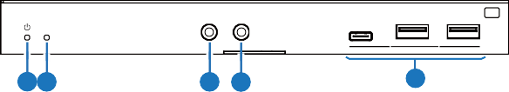
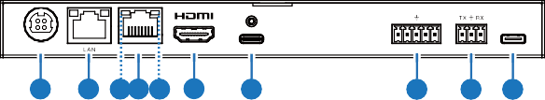
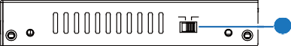
Receiver Panel
1 2
3 4
5
USB DEVICES
LINK
R X
2 3
1
IR IN IR OUT
L+ L- R+ R-
DC 24V
HDBaseT IN
OUT
USB-C OUT
AUDIO OUT RS-232 SERVICE
6
7 9 8 10 11
12
13
14 15
POC
ON OFF
16

No. | Name | Function Description
1 | Power LED | Red LED indicates that the receiver is powered on.
2 | LINK LED  (Green) | - Light on: Transmitter and receiver are in good connection status.  - Light flashing: Transmitter and receiver are in poor connection status.  - Light off: Transmitter and receiver are not connected.
3 | IR IN | IR signal input port, connected to IR Receiver cable.
4 | IR OUT | IR signal output port, connected to IR Blaster cable.
5 | USB Device ports | Three USB 2.0 device ports (two USB-A ports and one USB-C port) connected to mouse, keyboard, USB Flash Drive or other USB devices.
6 | DC 24V | DC 24V/7.5A power supply input port.  Note that the extender supports PoC function, it means that either transmitter or receiver is powered on by 24V/7.5A power adapter, the other one doesn’t need power supply.
7 | LAN | 1G Ethernet pass-through port. When it switches to 1000Mbps Ethernet, the yellow indicator flashes; When it switches to 100Mbps Ethernet, the green indicator flashes.
8 | HDBaseT IN | HDBaseT input port, connected to the HDBaseT OUT port of transmitter with a CAT6A/7 cable. It is used for HDMI, network and USB signals pass-through.
9 | Data Signal Indicator (Yellow) | - Light on: There is video signal transmission with HDCP encryption.  - Light flashing: There is video signal transmission without HDCP  encryption.  - Light off: There is no video signal transmission.
10 | Link Signal Indicator (Green) | - Light on: Transmitter and receiver are in good connection status.  - Light flashing: Transmitter and receiver are in poor connection  status.  - Light off: Transmitter and receiver are not connected.
11 | HDMI OUT | HDMI signal output port, connected to HDMI display device, such as TV or monitor.
12 | USB-C OUT | USB Type C port with following two functions:  - AV signal output port, supporting DP signal, connected to the display device with USB-C port.  - USB 2.0 device port, with 1A power supply, connected to USB devices such as USB Flash Drive and Hard Disk.
13 | AUDIO OUT | Analog audio output port, supporting balanced audio output (with a maximum support of 2Vrms) and unbalanced audio output (with a maximum support of 1Vrms).  Balanced connection method: L+, L -, GND, R+, R - Unbalanced connection method: L+, GND, R+

No. | Name | Function Description
14 | RS-232 | RS-232 serial port, used for RS-232 signal pass-through and API commands control.
15 | SERVICE | USB 2.0 Type C port, used for firmware upgrade and API  commands control.
16 | POC switch | 24V PoC on/off switch.  ON: PoC is enabled (as factory default).  OFF: PoC is disabled (need local DC/24V power supply).

IR Pin Definition

IR Receiver and Blaster pin’s definition as below:
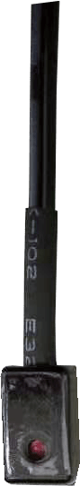
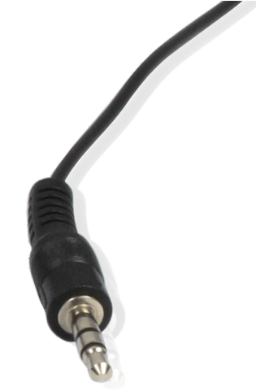

IR BLASTER IR RECEIVER





+
IR RECEIVER
Power 12V
IR BLASTER
-

Note: When the angle between the IR receiver and the remote control is ± 45 °, the transmission distance is 0-5 meters; when the angle between the IR receiver and the remote control is ± 90 °, the transmission distance is 0-8 meters.

API Commands

The product also supports API commands control. Connect the RS-232 port of the product to a PC or control system with a 3-pin phoenix connector cable, or connect the SERVICE port of the product to a PC with a USB-C cable.

Then, open a serial command tool on PC to send ASCII commands to control the product. The ASCII commands list about the product is shown as below.

ASCII Commands
- Service port (USB-C virtual RS-232) communication protocol (Internal debug supports command line operations)
Baud rate: 115200 (Fixed) Data bit: 8 Stop bit: 1 Parity bit: none
- Phoenix RS-232 port communication protocol (Connect to control system)
Baud rate: 2400~115200 (Configurable) Data bit: 8 Stop bit: 1 Parity bit: none
Command Code | Function Description | Example | Feedback | Default
? | Get the list of all commands | ? | List all commands
help | Get the list of all commands | help | List all commands
get fw version | Get the firmware version | get fw version | TX FW v1.00.00 RX FW v1.00.00
set reboot | Reboot the device | set reboot | Reboot…  System Initializing... Initialization Finished! TX FW v1.00.00  RX FW v1.00.00
set reset | Reset to factory defaults | set reset | Sure to RESET to default settings? Type "Yes" after next prompt to confirm…
get status | Get system status | get status | Please refer to the note at the end of the list.
set tx key on/off | Set TX front panel key on/ off | set tx key on set tx key off | Set TX key on Set TX key off | On
get tx key | Get TX front panel key on/ off status | get tx key | On
set tx Usbc AccessNetwork | Set TX USB-C input port access network on/off | set tx Usbc AccessNetw | Set TX USB-C access network on  Set TX USB-C access network off | On
get tx Usbc AccessNetwork | Get TX USB-C input port access network on/off status | get tx Usbc AccessNetwork | On
set tx source x | Set TX input source (x=0~4)  x=0: OFF  x=1: USB-C input x=2: HDMI input x=3: AVMUTE  x=4: Internal pattern | set tx source 1 set tx source 0 | Set TX source to USB-C Set TX source to off | 1
get tx source | Get TX input source | get tx source | USB-C

Command Code | Function Description | Example | Feedback | Default
set tx pattern x y | Set TX internal signal generator resolution (x=1~6) pattern (y=1~12) x=01: 4K60Hz  x=02: 4K50Hz x=03: 4K25Hz x=04: 4K24Hz x=05: 1080P60Hz x=06: 480P60Hz  y=01: Black  y=02: Checkboard y=03: Strip  y=04: Red y=05: Green y=06: Blue y=07: White y=08: Ramp y=09: Red ramp  y=10: Green ramp y=11: Blue ramp y=12: PRBS | set tx pattern 1 2 | Set TX pattern 4K60Hz checkboard
get tx pattern | Get TX internal pattern generator output resolution and pattern | get tx pattern | TX pattern 4K60Hz checkboard
set tx input x hdcp y | Set TX input (x=0~2) HDCP to (y=0~2) x=0: All inputs  x=1: USB-C input x=2: HDMI input y=0: HDCP OFF y=1: HDCP 1.4  y=2: HDCP 2.2 | set tx input 0 hdcp 2  set tx input 2 hdcp 0 | Set TX all inputs HDCP 2.2 Set TX HDMI input HDCP off | HDCP 2.2
get tx input x hdcp | Get TX input (x=0~2)  HDCP status x=0: All inputs x=1: USB-C input x=2: HDMI input | get tx input 0 hdcp | TX USB-C input HDCP 2.2 TX HDMI input HDCP 2.2
set tx output x hdcp y | Set TX output (x=0~2) HDCP mode to (y=0~3) x=0: All outputs  x=1: HDBT output x=2: HDMI output  y=0: Signal management y=1: Auto (default, Follow sink)  y=2: Force HDCP 1.4 y=3: Force HDCP 2.2 | set tx output 2 hdcp 1 | Set TX HDMI output HDCP to auto | 1

Command Code | Function Description | Example | Feedback | Default
get tx output x hdcp | Get TX output (x=0~2)  HDCP mode x=0: All outputs  x=1: HDBT output x=2: HDMI output | get tx output 0 hdcp | HDBT output HDCP auto HDMI output HDCP auto
set tx usb x | Set TX USB source (x=0~2) x=0: Follow video  x=1: USB-C host  x=2: USB-B host | set tx usb 0 set tx usb 2 | Set TX USB source follow video  Set TX USB source USB-B host | 0
get tx usb | Get TX USB source | get tx usb | Follow video
get tx usbh5v x | Get TX USB host (x=0~2) input 5V status  x=0: All USB host inputs x=1: USB-C input  x=2: USB-B input | get tx usbh5v 0 | TX USB-C host 5V on TX USB-B host 5V off
set tx usbd5v x to y | Set TX USB device output (x=0~3) 5V to (y=0~2) x=0: All USB device ports x=1: USB device 1  x=2: USB device 2 x=3: USB device 3 y=0: Disable 5V output y=1: Follow host  y=2: Force 5V always  output | set tx usbd5v 0 to 1 | Set TX all USB device output 5V follow host | 1
get tx usbd5v x | Get TX USB device output (x=0~3) 5V status  x=0: All USB device ports x=1: USB device 1  x=2: USB device 2 x=3: USB device 3 | get tx usbd5v 0 | TX USB device 1 output 5V follow host  TX USB device 2 output 5V follow host  TX USB device 3 output 5V  follow host
set tx autoswitch on/off | Set TX auto-switching on/off | set tx autoswitch on  set tx autoswitch  off | Set TX autoswitch on Set TX autoswitch off | on
get tx autoswitch | Get TX auto-switching status | get tx autoswitch | On
set tx autoswitch mode x | Set TX auto-switching mode  x=0: 5V detection x=1: signal detection | set tx autoswitch mode 1 | Set TX autoswitch mode to signal detection | signal detection
get tx autoswitch mode | Get TX auto-switching mode | get tx autoswitch mode | Signal detection

Command Code | Function Description | Example | Feedback | Default
set tx edid x to y | Set TX input ports (x=0~2) EDID to (y=1~19)  x=0: All inputs x=1: USB-C input x=2: HDMI input  y=01: HDMI 1080p@60Hz,  Audio 2CH PCM  y=02: HDMI 1080p@60Hz, Audio 5.1CH DTS/DOLBY y=03: HDMI 1080p@60Hz, Audio 7.1CH DTS/DOLBY/HD y=04: HDMI 4K@30Hz 4:4:4,  8-bit, Audio 2CH PCM  y=05: HDMI 4K@30Hz 4:4:4,  8-bit, Audio 5.1CH DTS/DOLBY y=06: HDMI 4K@30Hz 4:4:4,  8-bit, Audio 7.1CH DTS/ DOLBY/HD  y=07: HDMI 4K@60Hz 4:4:4,  8-bit, Audio 2CH PCM  y=08: HDMI 4K@60Hz 4:4:4,  8-bit, Audio 5.1CH DTS/DOLBY y=09: HDMI 4K@60Hz 4:4:4,  8-bit, Audio 7.1CH DTS/ DOLBY/HD  y=10: HDMI 4K@60Hz 4:2:0,  8-bit, Audio 2CH PCM  y=11: HDMI 4K@60Hz 4:2:0,  8-bit, Audio 5.1CH DTS/DOLBY y=12: HDMI 4K@60Hz 4:2:0,  8-bit, Audio 7.1CH DTS/ DOLBY/HD  y=13: HDMI 1920x1200@60Hz,  Audio 2CH PCM  y=14: DVI 1920x1080@60Hz,  Audio None  y=15: DVI 1920x1200@60Hz,  Audio None  y=16: EDID pass-through (Copy from TX HDMI OUT) y=17: EDID pass-through (Copy from RX HDMI OUT) y=18: User Defined 1 y=19: User Defined 2 | set tx edid 0 to 1 | Set TX all EDID to 01: HDMI 1080p@60Hz,  Audio 2CH PCM | 1

Command Code | Function Description | Example | Feedback | Default
get tx edid x | Get TX input ports (x=0~2) EDID  x=0: All inputs x=1: USB-C input x=2: HDMI input | get tx edid 0 | TX USB-C EDID 01: HDMI  1080p@60Hz, Audio 2CH PCM  TX HDMI EDID 01: HDMI  1080p@60Hz, Audio 2CH PCM
get tx edid data x | Get TX input ports (x=0~2)  EDID data x=0: All inputs  x=1: USB-C input x=2: HDMI input | get tx edid data 0 | TX USB-C EDID  <00 FF FF FF….> TX HDMI EDID  <00 FF FF FF….>
set user edid x <y> | Set user defined EDID (x=0~2) to y  x=0: User Defined 1 and User Defined 2  x=1: User Defined 1 x=2: User Defined 2 y=00 FF FF FF …..  (y is 256 bytes EDID data) | set user edid 1  <00 FF FF FF….> | User Defined 1 EDID is loaded
get user edid x | Get user defined EDID (x=0~2) data  x=0: User Defined 1 and User Defined 2  x=1: User Defined 1  x=2: User Defined 2 | get user edid 1 | <00 FF FF FF….>
set tx downscale auto/on/off | Set TX HDMI output downscale mode auto: Automatically according to display's capability  on: Force 1080p off: Bypass | set tx downscale auto | Set TX downscale mode to auto | auto
get tx downscale | Get RX downscale mode | get tx downscale | Auto
set tx audio mute on/off | Set TX de-embedding audio mute on/off | set tx audio mute on set tx audio mute off | Set TX de-embedding audio mute on  Set TX de-embedding audio mute off | off
get tx audio mute | Get TX de-embedding audio mute on/off status | get tx audio mute | Mute on
set rx output display y | Set RX output display mode (y=0~3)  y=0: Off (disable TMDS output)  y=1: Input video y=2: AVMUTE  y=3: Internal pattern | set rx output display 1 | Set RX output display input video

Command Code | Function Description | Example | Feedback | Default
get rx output display | Get RX output display mode | get rx output display | Input video
set rx output hdcp y | Set RX output HDCP mode to (y=0~3)  y=0: Signal management y=1: Auto (default, Follow sink)  y=2: Force HDCP 1.4 y=3: Force HDCP 2.2 | set rx output hdcp 1 | Set RX output HDCP to auto | 1
get rx output hdcp | Get RX output HDCP mode | get rx output hdcp | Auto
set rx pattern x y | Set RX internal signal generator resolution (x=1~6) pattern (y=1~13) x=01: 4K60Hz  x=02: 4K50Hz x=03: 4K25Hz x=04: 4K24Hz x=05: 1080P60Hz x=06: 480P60Hz  y=01: Black  y=02: Checkboard y=03: Strip  y=04: Red y=05: Green y=06: Blue y=07: White y=08: Ramp y=09: Red ramp  y=10: Green ramp y=11: Blue ramp y=12: PRBS | set rx pattern 1 2 | Set RX pattern 4K60Hz checkboard
get rx pattern | Get RX internal pattern generator output resolution and pattern | get rx pattern | RX pattern 4K60Hz checkboard
set rx downscale auto/on/off | Set RX downscale mode auto: Automatically according to display's capability  on: Force 1080p off: Bypass | set rx downscale auto | Set RX downscale mode to auto | auto
get rx downscale | Get RX downscale mode | get rx downscale | Auto

Command Code | Function Description | Example | Feedback | Default
set rx audio mute on/off | Set RX de-embedding audio mute on/off | set rx audio mute on set rx audio mute off | Set RX de-embedding audio mute on  Set RX de-embedding audio mute off | off
get rx audio mute | Get RX de-embedding audio mute on/off status | get rx audio mute | Mute on
set rx usbd5v x to y | Set RX USB device output (x=0~4) 5V to (y=0~2) x=0: All USB device ports x=1: USB device 1  x=2: USB device 2 x=3: USB device 3 x=4: USB device 4 y=0: Disable 5V output y=1: Follow host  y=2: Force 5V always output | set rx usbd5v 0 to 1 | Set RX all USB device output 5V follow host | 1
get rx usbd5v x | Get RX USB device output (x=0~4) 5V status  x=0: All USB device ports x=1: USB device 1  x=2: USB device 2 x=3: USB device 3 x=4: USB device 4 | get rx usbd5v 0 | RX USB device 1 output 5V follow host  RX USB device 2 output 5V follow host  RX USB device 3 output 5V follow host  RX USB device 4 output 5V follow host
set display x auto power function on/off | Set display (x=0~2) auto power function on/off when input signal is on/off  x=0: All outputs  x=1: TX HDMI output x=2: RX HDMI output | set display 0 auto power function on | Set all outputs auto power function on | off
get display x auto power function | Get display (x=0~2) auto power function on/off status x=0: All outputs  x=1: TX HDMI output x=2: RX HDMI output | get display 0 auto power function | All outputs auto power function on
set display x auto power on/off time y | Set display (x=0~2) auto power on/off after period time y when input signal is on/off  x=0: All outputs  x=1: TX HDMI output x=2: RX HDMI output y= 0~1200sec | set display 0 auto power on time 5  set display 0 auto power off time 50 | Set all outputs auto power on after 5sec when input signal is on  Set all outputs auto power off after 50sec when input signal is off | 5

Command Code | Function Description | Example | Feedback | Default
get display x auto power on/ off time | Get display (x=0~2) auto power on/off after period time y when input signal is on/off  x=0: All outputs  x=1: TX HDMI output x=2: RX HDMI output | get display 0 auto power on time | All outputs auto power on time 5sec
set display x power on/off | Set display (x=0~2) power on/off  x=0: All outputs  x=1: TX HDMI output x=2: RX HDMI output output | set display 0 power on set display 0 power off | Set all outputs power on Set all outputs power off | off
set display x control type y | Set display (x=0~2) power on/off control type (y=1~3) x=0: All outputs  x=1: TX HDMI output x=2: RX HDMI output y=1: CEC  y=2: RS-232  y=3: CEC and RS-232 | set display 0  control type 1 | Set all outputs control type CEC | CEC
get display x control type | Get display (x=0~2) power on/off control type  x=0: All outputs  x=1: TX HDMI output x=2: RX HDMI output | get display 0 control type | All outputs control type CEC
set display x cec y | Set display (x=0~2) CEC command (y=1~5)  x=0: All outputs  x=1: TX HDMI output x=2: RX HDMI output y=1: Power on  y=2: Power off y=3: Volume up y=4: Volume down y=5: Mute | set display 0  cec 1  set display 0  cec 2 | Set all outputs CEC power on  Set all outputs CEC power off
set serial x setting y | Set serial port (x=0~2) setting to y  x=0: TX/RX RS-232 x=1: TX RS-232 x=2: RX RS-232  y= 115200-8n1  Baud rate: 115200/57600/ 56000/38400/19200/9600/  4800/2400  Data bits: 9/8  Parity: n(None)/ o(Odd) / e(Even)  Stop bits: 1/2 | set serial 2  setting 115200-8n1 | Set RX RS-232 115200-8n1 | 115200-  8n1

Command Code | Function Description | Example | Feedback | Default
get serial x setting | Get serial port (x=0~2) setting  x=0: TX/RX RS-232 x=1: TX RS-232 x=2: RX RS-232 | get serial 0 setting | TX RS-232 115200-8n1 RX RS-232 115200-8n1
set serial x HEX/ ASCII power on  <y1> delay <y2> input <y3>  delay <y4> | Set serial port (x=0~2) HEX/ASCII power on <y1> delay <y2> input <y3> x=0: TX/RX RS-232  x=1: TX RS-232 x=2: RX RS-232  Command format is HEX or ASCII  y1= RS-232 power on command, support multiple commands using comma separated(,)  y2= 0~1200sec  y3= RS-232 input port selection, support multiple commands using comma separated(,)  y4= 0~1200sec  NOTE: delay <y2> input  <y3> delay <y4> can be NULL | set serial 1 ASCII power on <PWR ON1> delay <10> input <INPUT2> delay<1>  set serial 2 ASCII power on <PWR ON>  set serial 2 hex power on <50 4f 57 45 52,4f 4e,36  36 36> delay <1>  input <49 4e 50  55 54 31,49 4e 50  55 54 32> delay  <4> | Set TX RS232 ASCII power on <PWRON1> delay <10> input <INPUT2> delay <1> Set RX RS-232 ASCII power on <PWRON>  Set RX RS232 HEX power on <50 4f 57 45 52,4f 4e,36  36 36> delay <1> input <49  4e 50 55 54 31,49 4e 50 55  54 32> delay <4>
get serial x power on command | Get serial port (x=0~2) power on command x=0: TX/RX RS-232 x=1: TX RS-232  x=2: RX RS-232 | get serial 0 power on command | TX RS-232 ASCII power on  <PWRON> delay <10> input  <INPUT1>  RX RS-232 ASCII power on  <PWRON>
set serial x HEX/ ASCII power off  <y1> delay <y2> | Set serial port (x=0~2) HEX/ASCII power off <y1> delay <y2>  x=0: TX/RX RS-232 x=1: TX RS-232 x=2: RX RS-232  Command format is HEX or ASCII  y1= RS-232 power off command, support multiple commands using comma separated(,)  y2= 0~1200sec  NOTE: delay <y2> can be NULL | set serial 1 ASCII power off  <PWROFF>  set serial 2 HEX power off  <66 77, 88 99> | Set TX RS-232 ASCII power off <PWROFF>  Set RX RS-232 HEX power off <66 77, 88 99>

Command Code | Function Description | Example | Feedback | Default
get serial x power off command | Get serial port (x=0~2) power off command x=0: TX/RX RS-232 x=1: TX RS-232  x=2: RX RS-232 | get serial 0 power off command | TX RS-232 ASCII power off  <PWROFF> delay <1> RX RS-232 HEX power off  <66 77, 88 99>
set hdbt update | Set SERVICE to HDBT  UART for FW update | set hdbt update | HDBT update…

Notes:
- The API command “set hdbt update” is for internal use only.
- The feedback of the command of “get status” is as following.

==========================================================================================
Status Info 4K HDMI/USB-C Extender TX FW V1.00.01 RX FW V1.00.01

TX_Key USB-C_5V USB-B_5V TX_Baud RX_Baud AutoSwitch AutoSwitch_Mode On On On 115200 115200 On Signal_detection USB-C_AccessNetwork
On

TxOutputFrom RxOutputFrom USB_Source USB-C Input video Follow video

Input Cable Resolution ColorSpace ColorDepth HDCP EDID
01_USB_C Connected 3840x2160p60 RGB 8bit 2.2 DIP_0000: EDID Auto 02_HDMI Connected 3840x2160p60 RGB 8bit Off DIP_0000: EDID Auto

Output Cable Resolution ColorSpace ColorDepth Downscale HDCP
TX_HDMI_Out Connected RX_HDMI_Out Connected | 3840x2160p60 RGB  3840x2160p60 RGB | 8bit 8bit | Auto Auto | Off Off
Display_AutoPower On/Off TX_HDMI_Out On  RX_HDMI_Out On | Time(s) Control_Mode  1 RS232  1 RS232

USB_Device USB_5V TX_Device_1 Follow_host TX_Device_2 Follow_host TX_Device_3 Follow_host RX_Device_1 Follow_host RX_Device_2 Follow_host RX_Device_3 Follow_host RX_Device_4 Follow_host
==========================================================================================

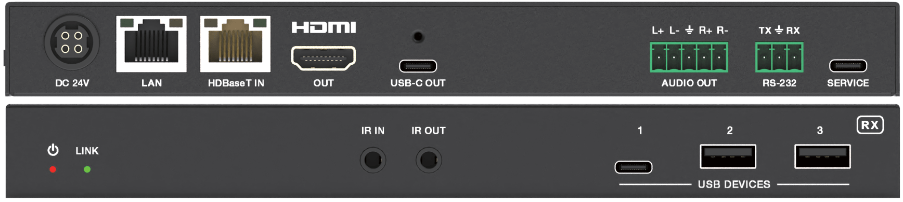
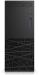
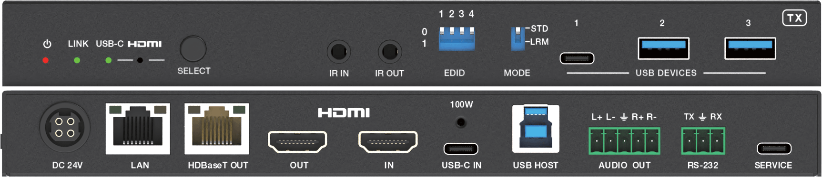
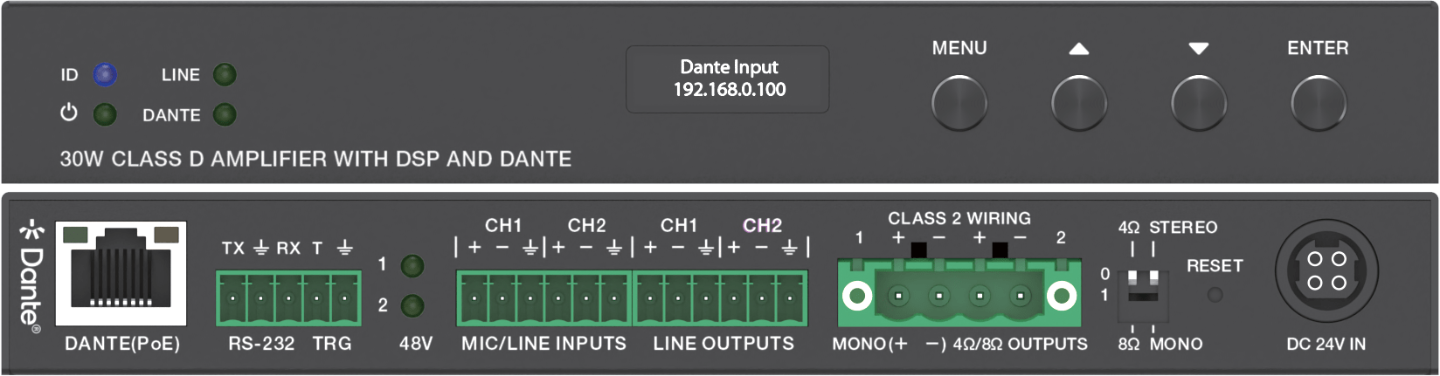
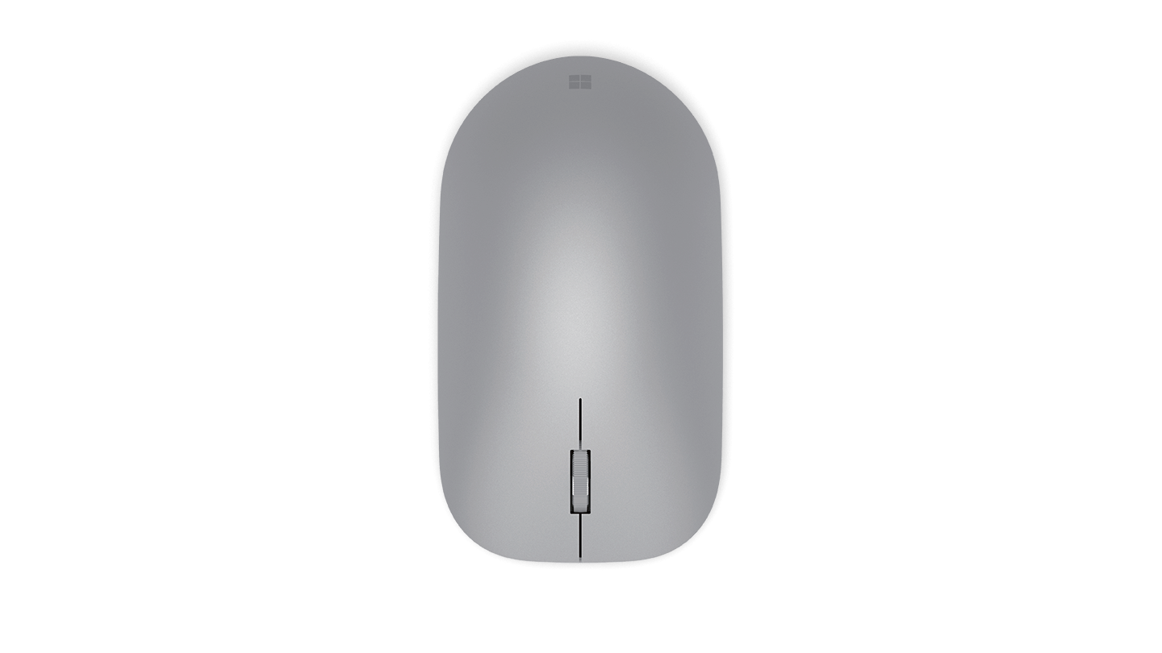
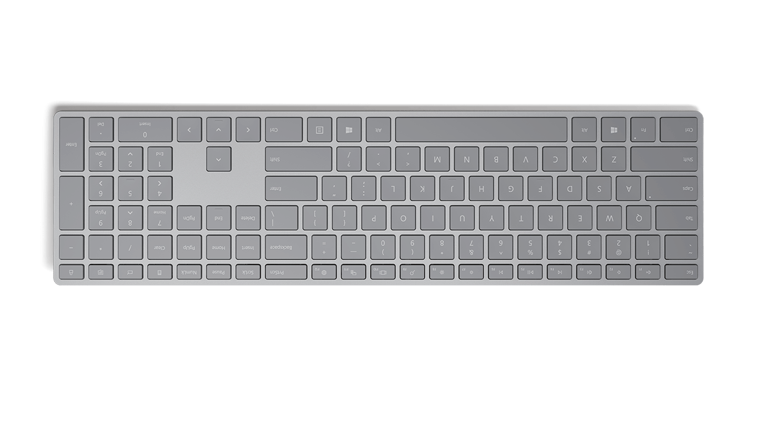
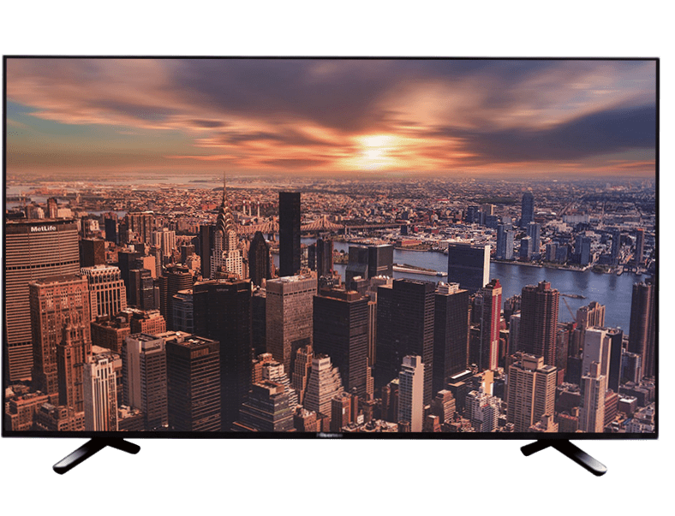

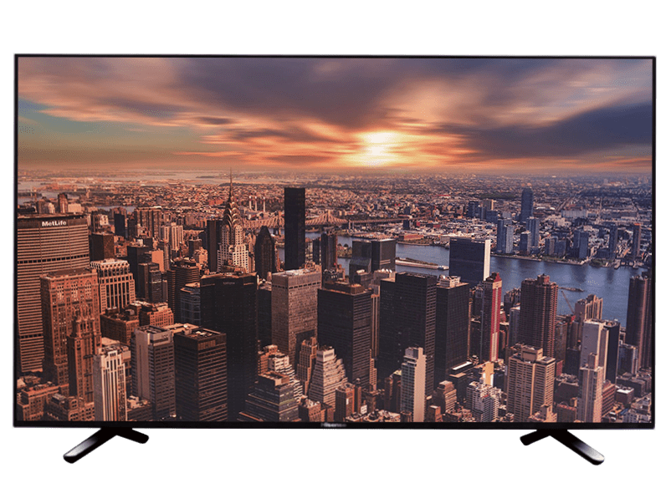


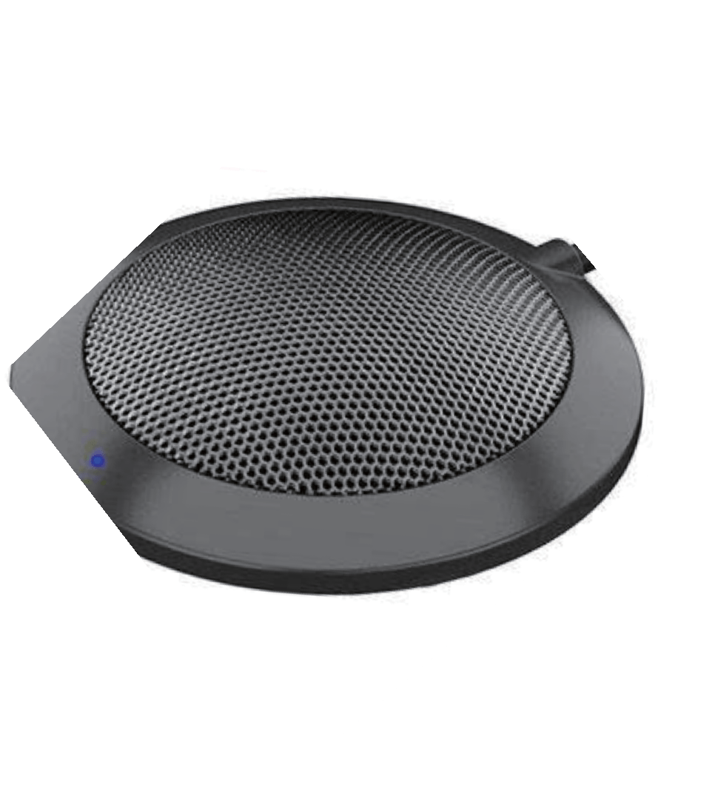
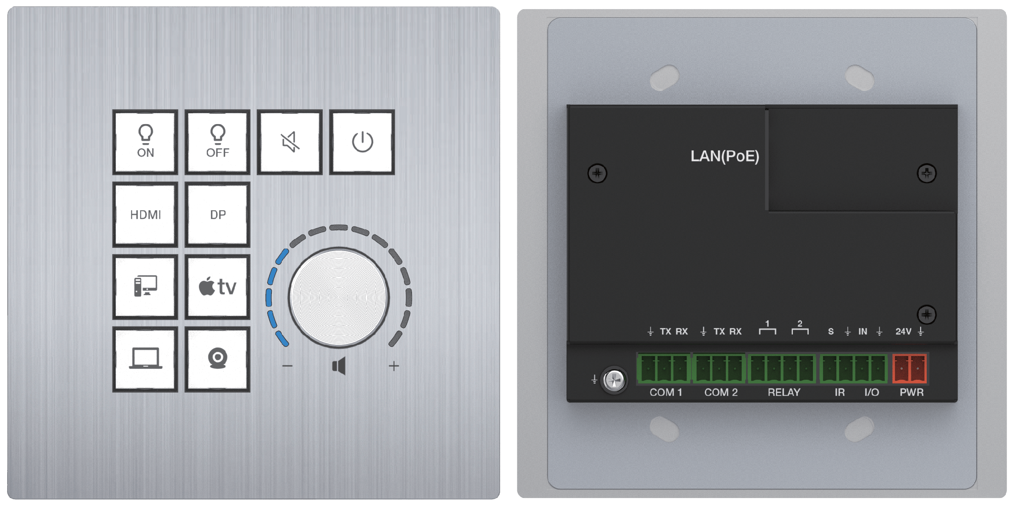
Application Example

Keyboard Mouse

USB Cable USB Cable

UTP Cable
HDMI
Cable
HDMI
Cable
USB
Cable

HDMI
Cable

RS-232
Cable
Control Panel

TP-LINK

Router

CAT6A/7 Cable

TV 1

Room PC

Laptop 1 (with USB-C port)

Amplifier

TV 2

UTP Cable

HDMI
Cable

USB Camera

USB Cable

Audio Cable

Audio Cable

Speakers

USB Cable
USB Microphone

The terms HDMI and HDMI High-Definition Multimedia interface, and the HDMI Logo are trademarks or registered trademarks of HDMI Licensing LLC in the United States and other countries.

