TP100P-H2

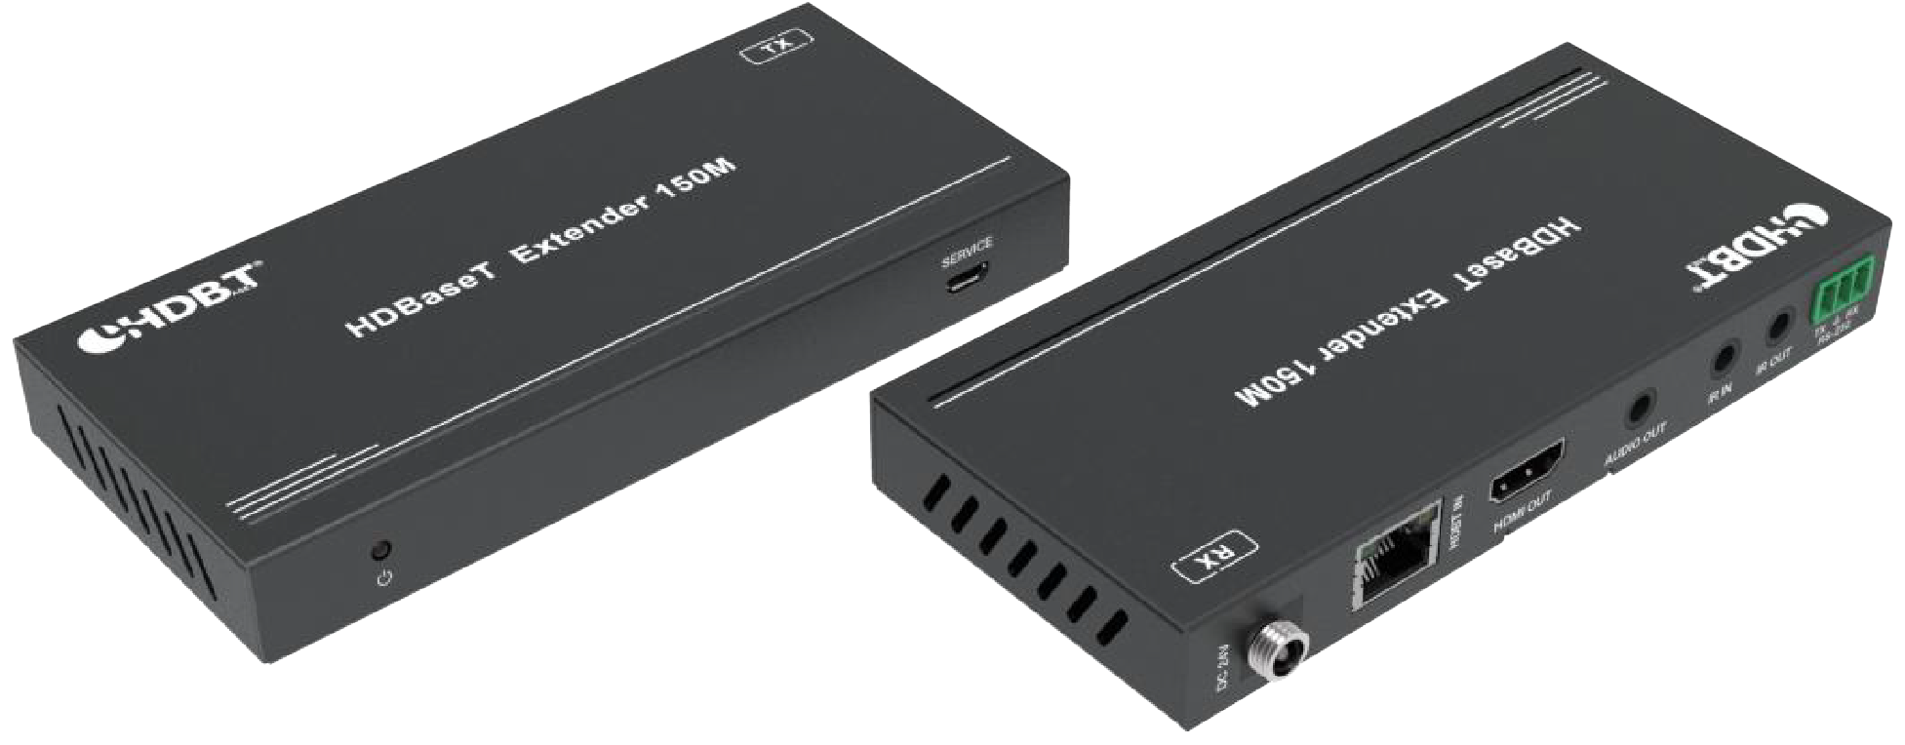


VER 1.0

Thank you for purchasing this product
For optimum performance and safety, please read these instructions carefully before connecting, operating or adjusting this product. Please keep this manual for future reference.

Surge protection device recommended
This product contains sensitive electrical components that may be damaged by electrical spikes, surges, electric shock, lighting strikes, etc. Use of surge protection systems is highly recommended in order to protect and extend the life of your equipment.

Table of Contents
- Introduction. 1
- Features. 1
- Package Contents. 2
- Specifications. 2
- Operation Controls and Functions. 4
  - Transmitter Panel. 4
  - Receiver Panel. 5
  - IR Pin Definition. 6
- Application Example. 8

Introduction
This 18Gbps HDMI Extender can extend high definition video / audio signal, RS-232, bi-directional IR, and the distance is up to 492ft / 150 meters between transmitter and receiver via a single CAT cable. It supports resolution up to 4K2K@60Hz 4:4:4, 18Gbps and HDCP 2.2. One HDMI loop port is available for output. The extender also supports de-embeded audio for L/R audio output. In addition, the extender is equipped with two-way IR pass-through which allows for source and display control.

This HDMI extender includes two units: transmitter unit and receiver unit. The transmitter unit is responsible for capturing HDMI input signal and carrying the signal via one cost effective Cat5e/6 cable, and transmitting / emitting IR control signals. The receiver unit is responsible for receiving the HDMI signal and transmitting / emitting IR control signal.

The extender offers the most convenient solution for HDMI extension via a single Cat5e/6 with long distance capability, and is the perfect solution for any application.

Features
☆ HDCP 2.2 / HDCP 1.4 and DVI 1.0 compliant
☆ Support 18Gbps video bandwidth
☆ The maximum extended transmission distance via a single Cat5e/6 cable: 394ft / 120 meters for 4K2K signal;
492ft / 150 meters for 1080P signal
☆ Support one HDMI loop output on the transmitter
☆ De-embeded audio to analog stereo output on receiver
☆ With bi-directional IR, RS-232 and CEC pass-through
☆ HDR, HDR10+, Dolby Vision and HLG function supported
☆ Support PoC (Power over Cable) function
☆ Compact design for easy and flexible installation

Package Contents

Qty | Item
1 | 18Gbps HDMI over HDBaseT Extender (Transmitter)
1 | 18Gbps HDMI over HDBaseT Extender (Receiver)
1 | IR Blaster cable (1.5 meters)
1 | 20~60KHz IR Receiver cable (1.5 meters)
4 | Mounting Ear
2 | 3-pin Phoenix connector
1 | 24V/1A Locking Power adapter
1 | User Manual

Specifications

Technical
HDCP Compliance | HDCP 2.2 / HDCP 1.4
Video Bandwidth | 18Gbps
Video Resolution | 4K2K 50/60Hz 4:4:4  4K2K 50/60Hz 4:2:2  4K2K 50/60Hz 4:2:0  4K2K 30Hz 4:4:4  1080p, 1080i, 720p, 720i, 480p, 480i  All HDMI 3D TV formats  All PC resolutions including 1920 x 1200
Color Space | RGB / YCbCr 4:4:4, YCbCr 4:2:2, YCbCr 4:2:0
Color Depth | 8/10/12-bit (1080P60Hz, 4K30Hz, 4K60Hz YCbCr  4:2:2/4:2:0)  8-bit (4K60Hz 4:4:4 )
HDMI Audio Formats | LPCM 2.0/2.1/5.1/6.1/7.1, Dolby Digital, Dolby TrueHD, Dolby Digital Plus(DD+), DTS-ES, DTS HD Master, DTS HD-HRA, DTS-X
L/R Audio Formats | PCM 2.0
ESD Protection | Human body model — ±8kV (Air-gap discharge) &  ±4kV (Contact discharge)

Connection
Transmitter | Inputs: 1x HDMI Type A [19-pin female] Outputs: 1x HDMI Type A [19-pin female]  1x HDBT OUT [RJ45, 8-pin female] Control: 1x IR IN [3.5mm Stereo Mini-jack]  1x IR OUT [3.5mm Stereo Mini-jack] 1x RS-232 [Phoenix jack]  1x SERVICE [Mini-USB, Update port]
Receiver | Inputs: 1x HDBT IN [RJ45, 8-pin female] Outputs: 1x HDMI Type A [19-pin female]  1x AUDIO OUT [3.5mm Stereo Mini-jack] Control: 1x IR IN [3.5mm Stereo Mini-jack]  1x IR OUT [3.5mm Stereo Mini-jack] 1x RS-232 [Phoenix jack]  1x SERVICE [Mini-USB, Update port]
Mechanical
Housing | Metal Enclosure
Color | Black
Dimensions | Transmitter / Receiver:  140mm [W] x 65mm [D] x 18mm [H]
Weight | Transmitter: 160g, Receiver: 155g
Power Supply | Input: AC 100 - 240V 50/60Hz  Output: DC 24V/1A (Locking connector)
Power Consumption | 9.36 W
Operating  Temperature | 32 - 104°F / 0 - 40°C
Storage Temperature | -4 - 140°F / -20 - 60°C
Relative Humidity | 20 - 90% RH (no condensation)
Resolution / Distance
4K2K | 394ft / 120M
1080P | 492ft / 150M
Resolution / Cable Length | 4K60 -  Feet / Meters | 4K30 -  Feet / Meters | 1080P60 -  Feet / Meters
HDMI IN / OUT | 16ft / 5M | 32ft / 10M | 50ft / 15M
The use of “Premium High Speed HDMI” cable is highly recommended.

Operation Controls and Functions

Transmitter Panel
SERVICE
1
2
HDMI OUT
HDMI IN
IR IN IR OUT
3
5 4 6
7
8
9 10
11
DC 24V
HDBT OUT

No. | Name | Function Description
1 | Power LED | Red LED indicates that the transmitter is powered on.
2 | SERVICE port | Firmware update port.
3 | DC 24V | DC 24V/1A power supply input port.  Note that the extender supports PoC function, it means that either transmitter or receiver is powered on by 24V/1A power adapter, the other one doesn’t need power supply.
4 | HDBT OUT | RJ45 connector for connecting the HDBT IN port of receiver with a CAT 5e/6 cable.
5 | Connection Signal Indicator lamp | - Illuminating: Transmitter and Receiver are in good connection status.  - Flashing: Transmitter and Receiver are in poor connection  status.  - Dark: Transmitter and Receiver are not connected.
6 | Data Signal Indicator lamp | - Illuminating: HDMI signal with HDCP.  - Flashing: HDMI signal without HDCP.  - Dark: No HDMI signal.
7 | HDMI OUT | HDMI loop output for display.
8 | HDMI IN | HDMI source input.
9 | IR IN | IR input port for receiving the signal of IR remote.
10 | IR OUT | IR output port for control of source device. This IR output signal is from the IR IN port of receiver.

11 | RS-232 | 3-pin Phoenix connector for RS-232 command transmission. The RS-232 command will pass-through from transmitter to receiver or from receiver to transmitter.

Receiver Panel
SERVICE
1
2
HDMI OUT
AUDIO OUT
IR IN IR OUT
3
5 4 6
7
8
9 10
11
DC 24V
HDBT IN

No. | Name | Function Description
1 | Power LED | Red LED indicates that the receiver is powered on.
2 | SERVICE port | Firmware update port.
3 | DC 24V | DC 24V/1A power supply input port.  Note that the extender supports PoC function, it means that either transmitter or receiver is powered on by 24V/1A power adapter, the other one doesn’t need power supply.
4 | HDBT IN | RJ45 connector for connecting the HDBT OUT port of transmitter with a CAT 5e/6 cable.
5 | Connection Signal Indicator lamp | - Illuminating: Transmitter and Receiver are in good connection status.  - Flashing: Transmitter and Receiver are in poor connection  status.  - Dark: Transmitter and Receiver are not connected.
6 | Data Signal Indicator | - Illuminating: HDMI signal with HDCP.  - Flashing: HDMI signal without HDCP.  - Dark: No HDMI signal.
7 | HDMI OUT | HDMI output for display.
8 | AUDIO OUT | 3.5mm stereo connector for analog audio output.

9 | IR IN | IR input port for receiving the signal of IR remote.
10 | IR OUT | IR output port for control of display device. This IR output signal is from the IR IN port of transmitter.
11 | RS-232 | 3-pin Phoenix connector for RS-232 command transmission. The RS-232 command will pass-through from transmitter to receiver or from receiver to transmitter.

IR Pin Definition
IR Receiver and Blaster pin’s definition is as below:
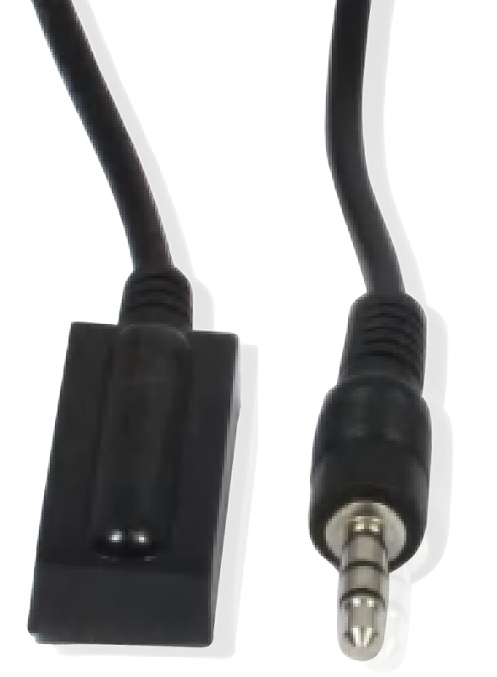
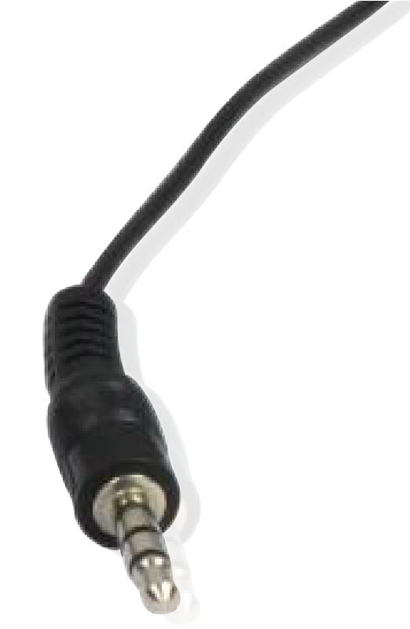
IR RECEIVER IR BLASTER

IR Blaster Signal Power
IR Blaster
NC
IR Receiver

IR Signal

Power Grounding

The following is IR system diagram about IR cable use method.
TV remote
DVD remote
IR Receiver cable
CAT 5e/6 cable
HDMI OUT HDMI IN IR IN IR OUT
HDMI OUT AUDIO OUT IR IN IR OUT
Transmitter
Receiver
IR Blaster cable
DVD

TV
DC 24V
HDBT OUT
DC 24V
HDBT IN

Note: When the angle between the IR receiver and the remote control is ± 45 °, the transmission distance is 0-5 meters; when the angle between the IR receiver and the remote control is ± 90 °, the transmission distance is 0-8 meters.

Application Example

DVD or Blu-ray Player

HDMI Matrix with RS-232 function

Transmitter
DC 24V
HDBT OUT

LAN

HDMI OUT HDMI IN

IR IN IR OUT

IR Blaster

Power Supply IR Receiver

CAT 5e/6 cable

UHDTV

IR Receiver

IR Blaster

Receiver

H T AUDIO OUT IR IN IR OUT
DMI OU
DC 24V
HDBT IN

2.0 Speakers PC

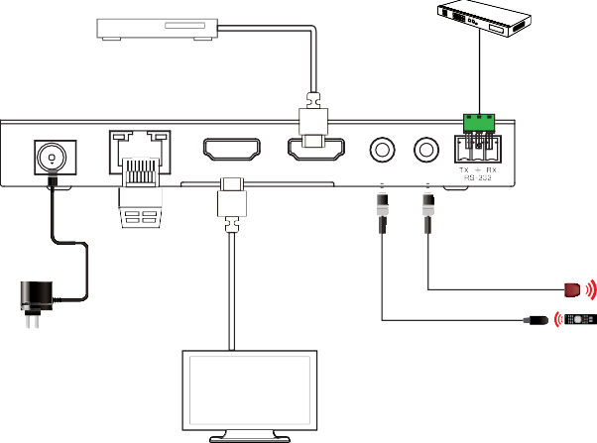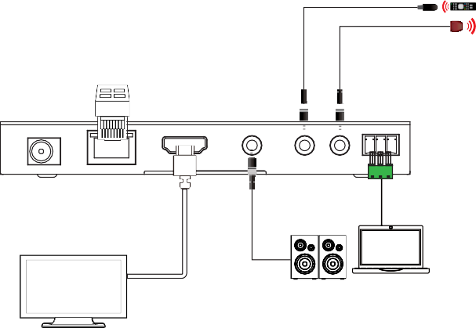UHDTV

