TP100P-ARC

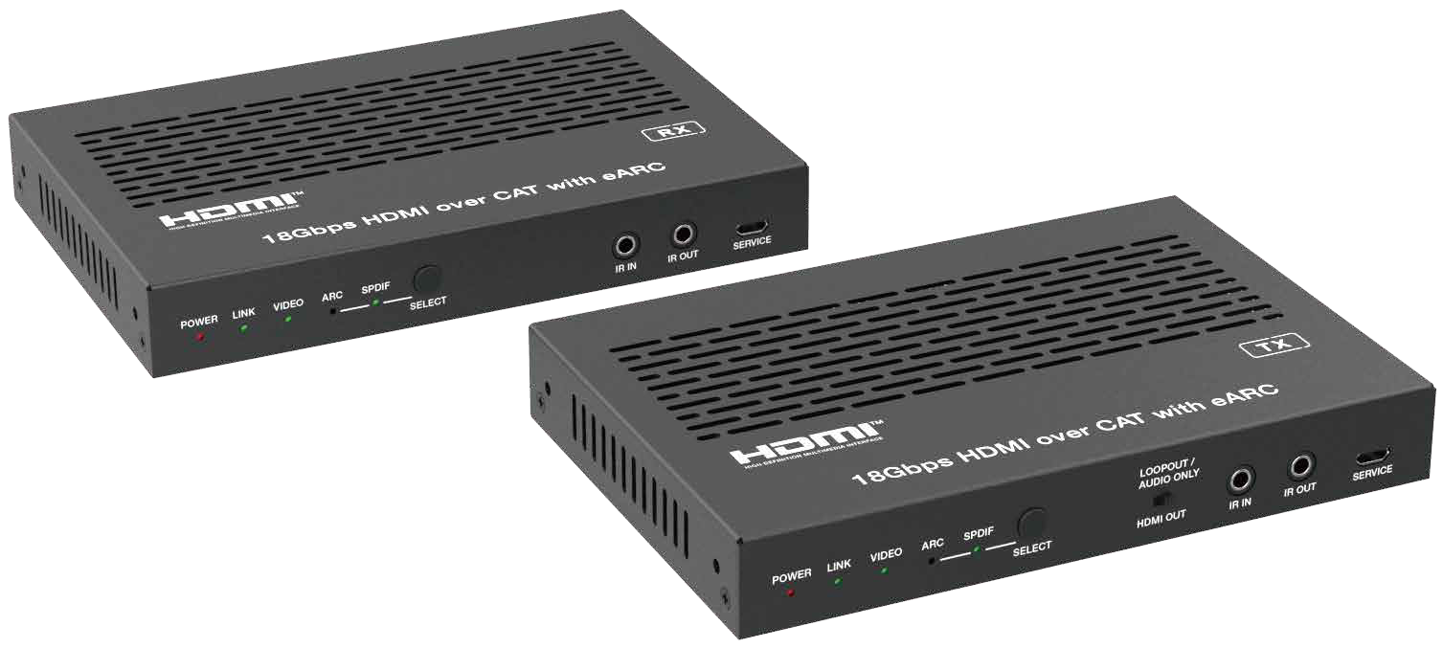


VER 1.1

Thank you for purchasing this product
For optimum performance and safety, please read these instructions carefully before connecting, operating or adjusting this product. Please keep this manual for future reference.

Surge protection device recommended
This product contains sensitive electrical components that may be damaged by electrical spikes, surges, electric shock, lighting strikes, etc. Use of surge protection systems is highly recommended in order to protect and extend the life of your equipment.

Table of Contents
- Introduction. 1
- Features. 1
- Package Contents. 1
- Specifications. 2
- Operation Controls and Functions. 4
  - Transmitter Panel. 4
  - Receiver Panel. 6
  - Input & Output Switching. 7
  - Audio De-embedding 10
  - IR Pin Definition. 10
- Application Example. 11

Introduction
This 18Gbps HDMI over CAT Extender, which is based on SDVoE technology, can extend uncompressed HD/UHD video and audio signals, eARC/ARC,
RS-232, bi-directional IR, and 1GbE Ethernet signals up to 100m/328ft via a single CAT6A/7 cable. Video resolution is up to 4K2K@50/60Hz 4:4:4. Both transmitter and receiver support audio de-embedding. The Extender supports eARC/ARC from RX's HDMI output pass through to TX's HDMI input or de- embedding to TX's HDMI output and SPDIF output ports. It also supports CEC pass-through and bi-directional POC function.
The Extender offers the most convenient solution for HDMI extension via a single CAT cable with long distance capability, and is the perfect solution for home/commercial application.

Features
☆ HDMI 2.0b and HDCP 2.3 compliant
☆ Uncompressed 4K2K@50/60Hz 4:4:4 up to 18Gbps video bandwidth
☆ HDR, HDR10, HDR10+, Dolby Vision and HLG pass through
☆ LPCM, Dolby Digital/Plus/EX, Dolby True HD, DTS, DTS-EX, DTS-96/24, DTS High Res, DTS-HD Master Audio, DSD pass through
☆ Signal extended distance up to 328ft/100 meters via a single CAT6A/7 cable
☆ Supports eARC/ARC function (the eARC/ARC audio is returned to the HDMI IN port, HDMI OUT port and SPDIF OUT port of the transmitter.)
☆ Supports SPDIF audio from RX to TX transmission
☆ Bi-directional IR, RS-232 (only supports 115200bps) and 1G Ethernet signal pass-through
☆ Supports CEC pass-through
☆ Bi-directional 24V POC function

Package Contents
① 1 x HDMI Extender (Transmitter)
② 1 x HDMI Extender (Receiver)
③ 1 x IR Blaster Cable (1.5 meters)
④ 1 x IR Receiver Cable (1.5 meters)
⑤ 2 x 3pin-3.81mm Phoenix Connectors
⑥ 2 x Mounting Ears
⑦ 4 x Machine Screws (KM3*6)
⑧ 1 x 24V/1A Locking Power Supply
⑨ 1x User Manual

Specifications

Technical
HDMI Compliance | HDMI 2.0b
HDCP Compliance | HDCP 2.3
Video Bandwidth | 18Gbps
Video Compression Standard | SDVoE
Video Network Bandwidth | 10G
Video Resolution | 480i ~1080p50/60Hz, 4Kx2K@24/30Hz, 4k2k@60Hz
HDR | HDR, HDR10, HDR10+, Dolby Vision, HLG
Color Space | RGB, YCbCr 4:4:4, YCbCr 4:2:2, YCbCr 4:2:0
Color Depth | 8/10/12-bit (up to 4K30Hz) 8-bit (4K60Hz)
Audio Formats | LPCM, Dolby Digital/Plus/EX, Dolby True HD, DTS, DTS-EX, DTS-96/24, DTS High Res, DTS-HD Master Audio, DSD
L/R Audio Formats | PCM 2.0
SPDIF Audio Formats | LPCM 2.0, LPCM5.1, Dolby Digital 2.0/5.1CH
IR Level | 12Vp-p
IR Bandwidth | Wideband 20K - 60KHz
RS-232 | Only supports 115200bps
Transmission  Distance | MAX: CAT6A/7--100m/328ft; CAT6--55m/180ft
ESD Protection | Human body model — ±8kV (Air-gap discharge) &  ±4kV (Contact discharge)
Connection
Transmitter | Input: 1 x HDMI IN [Type A, 19-pin female] Output: 1 x HDMI OUT [Type A, 19-pin female]  1 x CAT OUT [RJ45, 8-pin female] 1 x SPDIF OUT [S/PDIF]  1 x L/R OUT [3.5mm Stereo Mini-jack] Control: 1 x IR IN [3.5mm Stereo Mini-jack]  1 x IR OUT [3.5mm Stereo Mini-jack]  1 x RS-232 [3pin-3.81mm Phoenix jack] 1 x SERVICE [Micro USB, 5-pin female] 1 x LAN [RJ45]

Receiver | Input: 1 x CAT IN [RJ45, 8-pin female] 1 x SPDIF IN [S/PDIF]  Output: 1 x HDMI OUT [Type A, 19-pin female] 1 x L/R OUT [3.5mm Stereo Mini-jack]  Control: 1 x IR IN [3.5mm Stereo Mini-jack]  1 x IR OUT [3.5mm Stereo Mini-jack]  1 x RS-232 [3pin-3.81mm Phoenix jack] 1 x SERVICE [Micro USB, 5-pin female] 1 x LAN [RJ45]
Mechanical
Housing | Metal Enclosure
Color | Black
Dimensions | Transmitter / Receiver: 155mm [W] x 103mm [D] x 21.5mm [H]
Weight | Transmitter: 440g, Receiver: 436g
Power Supply | Input: AC 100 - 240V 50/60Hz  Output: DC 24V/1A (US/EU standard, CE/FCC/UL certified)
Power Consumption | 21.12W (Full load POC total power consumption)
Operating  Temperature | 32 - 104°F / 0 - 40°C
Storage Temperature | -4 - 140°F / -20 - 60°C
Relative Humidity | 20 - 90% RH (no condensation)
Resolution / Cable Length | 4K60 -  Feet / Meters | 4K30 -  Feet / Meters | 1080P60 -  Feet / Meters
HDMI IN / OUT | 16ft / 5M | 32ft / 10M | 50ft / 15M
The use of “Premium High Speed HDMI” cable is highly recommended.

Operation Controls and Functions

Transmitter Panel
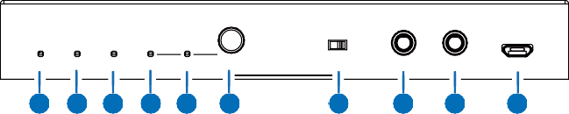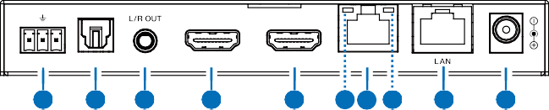
LOOPOUT / AUDIO ONLY
POWER LINK VIDEO ARC SPDIF
SELECT
HDMI OUT
IR IN IR OUT SERVICE
1 2 3 4 5
6
7
8
9
10
TX RX
HDMI IN
HDMI OUT
RS-232 SPDIF OUT
(eARC/ARC)
CAT OUT
DC 24V
11
12
13
14
15
17 16 18
19
20

No. | Name | Function Description
1 | POWER LED  (Red) | - Light on: The system is powered on.  - Light off: The system is powered off.
2 | LINK LED  (Green) | - Light on: Transmitter and Receiver are in good connection status.  - Light off: Transmitter and Receiver are not connected, or the  system is powered off.
3 | VIDEO LED  (Green) | - Light on: There is video signal input.  - Light off: There is no video signal input, or the system is  powered off.
4 | ARC LED  (Green) | - Light on: The device is switched to the ARC mode.  - Light off: The device is switched to the SPDIF mode, or the  system is powered off.
5 | SPDIF LED  (Green) | - Light on: The device is switched to the SPDIF mode.  - Light off: The device is switched to the ARC mode, or the system  is powered off.
6 | SELECT  button | Reverse audio signal selection button, used for switching the ARC mode and SPDIF mode.
7 | LOOP OUT/ AUDIO ONLY  switch | Switch to left (LOOPOUT), the HDMI OUT port is the loopout port for the HDMI IN port;  Switch to right (AUDIO ONLY), the HDMI OUT port outputs 720P  black screen image, and the audio is from ARC or SPDIF.
8 | IR IN | IR signal input port, connected with IR Receiver cable.

No. | Name | Function Description
9 | IR OUT | IR signal output port, connected with IR Blaster cable.
10 | SERVICE | Firmware update port.
11 | RS-232 | Bi-directional RS-232 signal pass-through port (only supports  115200bps).
12 | SPDIF OUT | Optical fiber audio output port.
13 | L/R OUT | Analog audio output port. It can be used for audio de-embedding.
14 | HDMI IN (eARC/ARC) | HDMI signal input port. In video pass-through mode, this port is connected to HDMI source device; In ARC/eARC mode, this port is connected to audio amplifier (supporting eARC/ARC).
15 | HDMI OUT | HDMI signal output port. It can choose to be a LOOP OUT or AUDIO ONLY port through the LOOP OUT/AUDIO ONLY switch.
16 | CAT OUT | 10G BASE-T port, connected to the CAT IN port of Receiver with a CAT6/6A/7 cable. It is used for various signals pass-through.
17 | Link Signal Indicator (Green) | - Illuminating: Transmitter and Receiver are in good connection status.  - Flashing: Transmitter and Receiver are in poor connection status.  - Dark: Transmitter and Receiver are not connected.
18 | Data Signal Indicator (Orange) | - Illuminating: HDMI signal with HDCP.  - Flashing: HDMI signal without HDCP.  - Dark: No HDMI signal.
19 | LAN | Network port, supporting autonomic switching between 100 Mbit/s and Gigabit rate. When this port switches to Gigabit Ethernet, the green indicator lights on and the orange indicator flashes; When this port switches to 100M Ethernet, the green indicator lights off and the orange indicator flashes.
20 | DC 24V | DC 24V/1A power input port.  Note that the extender supports POC function, it means that either transmitter or receiver is powered on by 24V/1A power adapter, the other one doesn’t need power supply.

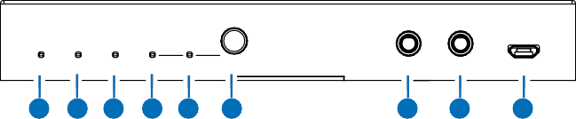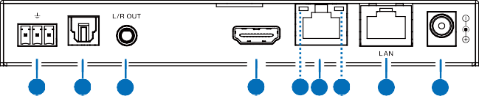Receiver Panel
POWER LINK VIDEO ARC SPDIF
SELECT
IR IN IR OUT SERVICE
1 2 3 4 5
6
7
8
9
TX RX
HDMI OUT
RS-232 SPDIF IN
(eARC/ARC) CAT IN
DC 24V
10
11
12
13
15 14 16
17
18

No. | Name | Function Description
1 | POWER LED  (Red) | - Light on: The system is powered on.  - Light off: The system is powered off.
2 | LINK LED  (Green) | - Light on: Transmitter and Receiver are in good connection status.  - Light off: Transmitter and Receiver are not connected, or the  system is powered off.
3 | VIDEO LED  (Green) | - Light on: There is video signal input.  - Light off: There is no video signal input, or the system is  powered off.
4 | ARC LED  (Green) | - Light on: The device is switched to the ARC mode.  - Light off: The device is switched to the SPDIF mode, or the  system is powered off.
5 | SPDIF LED  (Green) | - Light on: The device is switched to the SPDIF mode.  - Light off: The device is switched to the ARC mode, or the system  is powered off.
6 | SELECT  button | Reverse audio signal selection button, used for switching the ARC mode and SPDIF mode.
7 | IR IN | IR signal input port, connected with 12V IR Receiver cable.
8 | IR OUT | IR signal output port, connected with IR Blaster cable.
9 | SERVICE | Firmware update port.
10 | RS-232 | Bi-directional RS-232 signal pass-through port (only supports 115200bps).
11 | SPDIF IN | Optical fiber audio input port.
12 | L/R OUT | Analog audio output port, connected to audio amplifier.

No. | Name | Function Description
13 | HDMI OUT (eARC/ARC) | In video pass-through mode, this port outputs the video signal from the HDMI IN port of Transmitter;  In ARC/eARC mode, this port receives the audio signal returned from the connected display devices.
14 | CAT IN | 10G BASE-T port, connected to the CAT OUT port of Transmitter  with a CAT6/6A/7 cable. It is used for various signals pass-through.
15 | Link Signal Indicator (Green) | - Illuminating: Transmitter and Receiver are in good connection status.  - Flashing: Transmitter and Receiver are in poor connection status.  - Dark: Transmitter and Receiver are not connected.
16 | Data Signal Indicator (Orange) | - Illuminating: HDMI signal with HDCP.  - Flashing: HDMI signal without HDCP.  - Dark: No HDMI signal.
17 | LAN | Network port, supporting autonomic switching between 100 Mbit/s and Gigabit rate. When this port switches to Gigabit Ethernet, the green indicator lights on and the orange indicator flashes; When this port switches to 100M Ethernet, the green indicator lights off and the orange indicator flashes.
18 | DC 24V | DC 24V/1A power input port.  Note that the extender supports POC function, it means that either transmitter or receiver is powered on by 24V/1A power adapter, the other one doesn’t need power supply.

Input & Output Switching
The Extender can switch to ARC/SPDIF mode by pressing the SELECT button on the front panel of both transmitter and receiver. The HDMI OUT port of the transmitter can turn to LOOP OUT or AUDIO ONLY through the LOOP OUT/AUDIO ONLY switch. The input and output routing are different for different scenarios, as shown in the diagrams below:

Scene 1: Set the Extender to SPDIF Mode. Then switch the LOOP OUT/ AUDIO ONLY switch to right, the HDMI OUT port of the transmitter is set to AUDIO ONLY.
DVD
HDMI IN
ARC
AUDIO ONLY
HDMI OUT
UTP Cable
Audio Amplifier
SPDIF OUT
SPDIF IN
TV

Speakers

Scene 2: Set the Extender to SPDIF Mode. Then switch the LOOP OUT/ AUDIO ONLY switch to left, the HDMI OUT port of the transmitter is set to LOOP OUT.
DVD
HDMI IN
ARC
LOOP OUT
HDMI OUT
UTP Cable
SPDIF OUT
SPDIF IN
TV
TV

Audio Amplifier

Scene 3: Set the Extender to ARC Mode. Then switch the LOOP OUT/ AUDIO ONLY switch to right, the HDMI OUT port of the transmitter is set to AUDIO ONLY.

Soundbar with ARC

Audio Amplifier

HDMI IN ARC
AUDIO ONLY SPDIF OUT

UTP Cable HDMI OUT ARC

TV with ARC

Speakers

Scene 4: Set the Extender to ARC Mode. Then switch the LOOP OUT/ AUDIO ONLY switch to left, the HDMI OUT port of the transmitter is set to LOOP OUT.

Soundbar with ARC

HDMI IN ARC

SPDIF OUT

UTP Cable HDMI OUT ARC

Audio Amplifier

TV with ARC

Scene 5: Set the Extender to eARC Mode. Then switch the LOOP OUT/ AUDIO ONLY switch to right, the HDMI OUT port of the transmitter is set to AUDIO ONLY.

Soundbar with eARC

Audio Amplifier

HDMI IN eARC
AUDIO ONLY

SPDIF OUT
≤ 5.1CH

UTP Cable HDMI OUT eARC

TV with eARC

Speakers

Scene 6: Set the Extender to eARC Mode. Then switch the LOOP OUT/ AUDIO ONLY switch to left, the HDMI OUT port of the transmitter is set to LOOP OUT.

Soundbar with eARC

HDMI IN
eARC
UTP Cable
HDMI OUT
eARC
SPDIF OUT
≤ 5.1CH
TV with eARC

Audio Amplifier

Note: In eARC mode, the SPDIF OUT port can only output the audio up to 5.1CH.

Audio De-embedding
Both the transmitter and receiver support audio de-embedding function. In video pass-through mode, the TX’s L/R OUT port outputs the audio signal de-embedded from the TX’s HDMI IN port, and the RX’s L/R OUT port outputs the audio signal de-embedded from the RX’s HDMI OUT port.
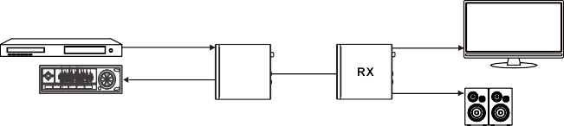
DVD
HDMI IN
HDMI OUT
L/R OUT
UTP Cable
L/R OUT
TV
Audio Amplifier
Speakers

IR Pin Definition
IR Receiver and Blaster pin’s definition as below:

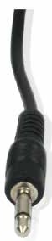
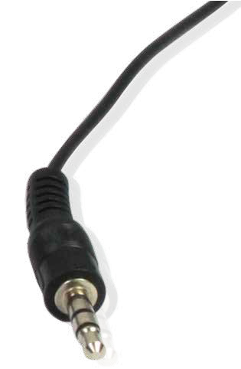
IR BLASTER IR RECEIVER

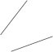+
IR BLASTER
-

IR RECEIVER
Power 12V
Note: When the angle between the IR receiver and the remote control is ± 45 °, the transmission distance is 0-5 meters; when the angle between the IR receiver and the remote control is ± 90 °, the transmission distance is 0-8 meters.

Application Example
Mode 1: Video Pass-through Mode

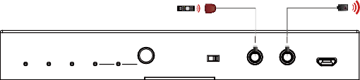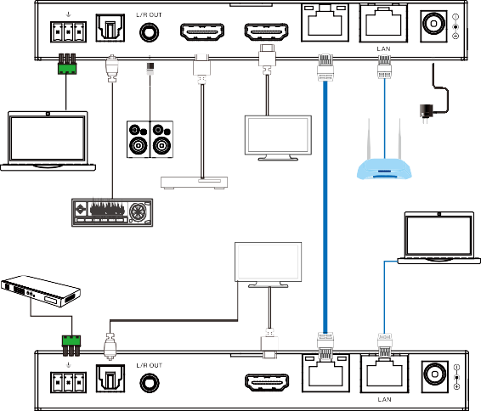Transmitter
IR Receiver
IR Blaster
LOOPOUT / AUDIO ONLY
POWER LINK VIDEO ARC SPDIF
SELECT
HDMI OUT
IR IN IR OUT SERVICE

TX RX

HDMI IN

HDMI OUT

RS-232

SPDIF OUT

(eARC/ARC)

CAT OUT DC 24V

LAN

LAN

Power Supply

PC1

Speakers

DVD or Blu-ray Player

Audio Amplifier

TV or Amplifier

TV

TP-LINK

Router CAT6A/7 Cable

HDMI Matrix with RS-232 function

PC2

TX RX HDMI OUT

Receiver

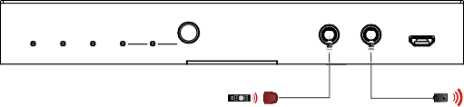RS-232
POWER LINK VIDEO ARC SPDIF
SELECT
IR IN IR OUT SERVICE
IR Receiver
IR Blaster

SPDIF IN (eARC/ARC) CAT IN

DC 24V

Mode 2: eARC/ARC Mode

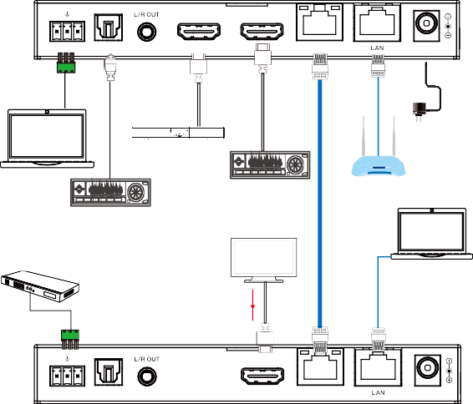
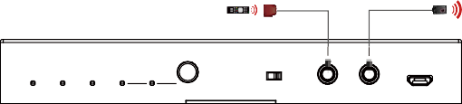Transmitter
IR Receiver
IR Blaster
LOOPOUT / AUDIO ONLY
POWER LINK VIDEO ARC SPDIF
SELECT
HDMI OUT
IR IN IR OUT SERVICE

TX RX

HDMI IN

HDMI OUT

RS-232

SPDIF OUT

(eARC/ARC)

CAT OUT DC 24V

LAN
LAN

PC1

Soundbar with eARC/ARC function

Audio Amplifier

Audio Amplifier

TV with eARC/ ARC function

TP-LINK

Router CAT6A/7 Cable

Power Supply

HDMI Matrix with RS-232 function

PC2

eARC

TX RX HDMI OUT

Receiver

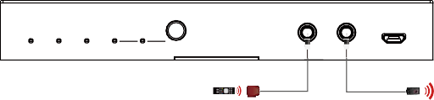RS-232
POWER LINK VIDEO ARC SPDIF
SELECT
IR IN IR OUT SERVICE
IR Receiver
IR Blaster

SPDIF IN (eARC/ARC) CAT IN

DC 24V


The terms HDMI and HDMI High-Definition Multimedia interface, and the HDMI Logo are trademarks or registered trademarks of HDMI Licensing LLC in the United States and other countries.

