TP100P-8K

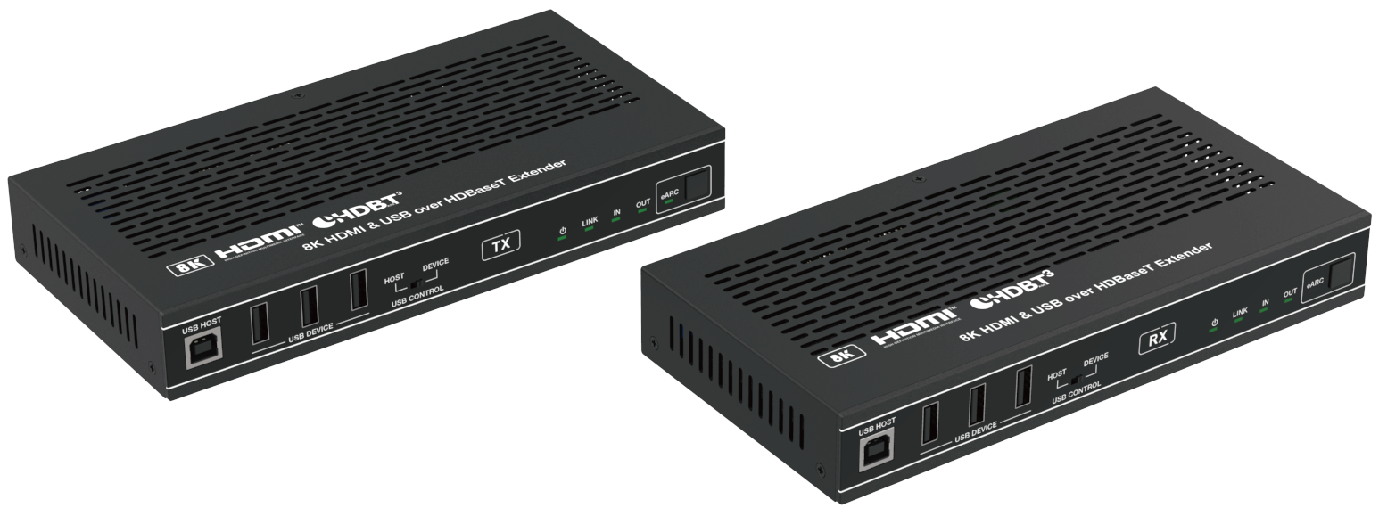


VER 1.1

Thank you for purchasing this product
For optimum performance and safety, please read these instructions carefully before connecting, operating or adjusting this product. Please keep this manual for future reference.

Surge protection device recommended
This product contains sensitive electrical components that may be damaged by electrical spikes, surges, electric shock, lighting strikes, etc. Use of surge protection systems is highly recommended in order to protect and extend the life of your equipment.

Table of Contents
- Introduction. 1
- Features. 1
- Package Contents. 2
- Specifications. 2
- Operation Controls and Functions. 4
  - Transmitter Panel. 4
  - Receiver Panel. 7
  - USB Mode Applications. 10
  - IR Pin Definition. 11
- Application Example. 12

Introduction
This 8K HDMI & USB over HDBaseT Extender can extend uncompressed HD/UHD video and audio signals, eARC/ARC, RS-232, bi-directional IR, 1GbE Ethernet and USB2.0 signals up to 90m/295ft via a single CAT 6A/7 cable. Video resolution is up to 8K@30 4:4:4 10bit, 4K@120Hz 4:4:4 10bit, 4K60Hz 4:4:4. It supports eARC/ARC from RX's HDMI output pass-through to TX's HDMI input or de-embedding to TX's HDMI output port. Besides, it supports USB 2.0 signal transmission (Host/Device is configurable) and bi- directional POC function.
The Extender offers the most convenient solution for HDMI extension via a single CAT cable with long distance capability, and is the perfect solution for home/commercial application.

Features
☆ HDMI 2.1, HDCP 2.3 and HDBaseT 3.0 compliant
☆ Support up to 40Gbps FRL and 18Gbps TMDS video bandwidth
☆ Video resolution is up to 8K@30 4:4:4 10bit, 4K@120Hz 4:4:4 10bit
☆ Support all industry standard video resolutions including VGA-WUXGA and 480i-8K30
☆ VRR, FVA, ALLM support
☆ HDR, HDR10, HDR10+, Dolby Vision and HLG pass-through
☆ HDMI audio formats: Dolby Atmos, Dolby TrueHD, Dolby Digital Plus and DTS-HD Master Audio
☆ Signal transmission distance can be extended up to 90m/295ft via a single CAT 6A/7 cable
☆ Support eARC/ARC from RX to TX sound system
☆ Advanced EDID management through EDID DIP switch
☆ With CONFIG DIP switch, allowing the RS-232 serial port to feature different functions
☆ Support USB2.0 transmission (with speeds up to 350Mbps), Host/Device is configurable
☆ Bi-directional Ethernet (1Gb), analog audio, IR & RS-232 signal pass-through
☆ HDMI re-clocking on the HDBaseT™ Receiver to help solve HDMI HDCP, compatibility and handshaking issues
☆ Bi-directional 24V POC function

Package Contents
① 1 x HDBaseT Extender (Transmitter)
② 1 x HDBaseT Extender (Receiver)
③ 1 x IR Blaster Cable (1.5 meters)
④ 1 x IR Wideband Receiver Cable (1.5 meters)
⑤ 2 x 3pin-3.81mm Phoenix Connectors
⑥ 4 x Mounting Ears
⑦ 8 x Machine Screws (KM3*4)
⑧ 8 x Rubber Feet
⑨ 1 x 24V/2.7A Locking Power Supply
⑩ 1 x User Manual

Specifications

Technical
HDMI Compliance | HDMI 2.1
HDCP Compliance | HDCP 2.3
Video Bandwidth | Up to 40Gbps FRL and 18Gbps TMDS
Video Resolution | Up to 8K@30 4:4:4 10bit, 4K@120Hz 4:4:4 10bit
USB Bandwidth | Up to 350Mbps
HDR | HDR, HDR10, HDR10+, Dolby Vision, HLG
Color Space | RGB 4:4:4, YCbCr 4:4:4 / 4:2:2, YCbCr 4:2:0
Color Depth | 8/10/12-bit
Audio Formats | HDMI: PCM2.0, LPCM5.1, LPCM7.1, (32K/44.1K/48K/88.2K/96K/176.4K/192K)(16/20/24);  Dolby Digital, Dolby Digital plus, Dolby TrueHD, Dolby Atmos; DTS Surround, 96/24, ES, DTS Express, DTS-HD HRA, DTS HD Master, DTS:X  Analog: PCM 2.0 48K
IR Level | 5Vp-p/12Vp-p
IR Bandwidth | 20K - 60KHz
Transmission Distance | MAX: CAT 6 -- 60m/197ft CAT 6A/7 -- 90m/295ft
ESD Protection | Human body model — ±8kV (Air-gap discharge) &  ±4kV (Contact discharge)

Connection
Transmitter | Input: 1 x HDMI IN [Type A, 19-pin female]  1 x AUDIO IN [3.5mm Stereo Mini-jack] Output: 1 x HDMI OUT [Type A, 19-pin female]  1 x HDBT OUT [RJ45, 8-pin female]  1 x AUDIO OUT [3.5mm Stereo Mini-jack] Control: 1 x IR IN [3.5mm Stereo Mini-jack]  1 x IR OUT [3.5mm Stereo Mini-jack]  1 x RS-232 [3pin-3.81mm Phoenix jack] 1 x USB HOST [USB Type B]  3 x USB DEVICE [USB Type A]  1 x ETHERNET [RJ45]
Receiver | Input: 1 x HDMI IN [Type A, 19-pin female] 1 x HDBT IN [RJ45, 8-pin female]  1 x AUDIO IN [3.5mm Stereo Mini-jack] Output: 1 x HDMI OUT [Type A, 19-pin female]  1 x AUDIO OUT [3.5mm Stereo Mini-jack] Control: 1 x IR IN [3.5mm Stereo Mini-jack]  1 x IR OUT [3.5mm Stereo Mini-jack]  1 x RS-232 [3pin-3.81mm Phoenix jack] 1 x USB HOST [USB Type B]  3 x USB DEVICE [USB Type A]  1 x ETHERNET [RJ45]
Mechanical
Housing | Front Panel — Aluminium Enclosure; Case — Metal Enclosure
Color | Black
Dimensions | Transmitter / Receiver: 200mm [W] x 100mm [D] x 30mm [H]
Weight | Transmitter: 571g, Receiver: 571g
Power Supply | Input: AC 100 - 240V 50/60Hz  Output: DC 24V/2.7A (US/EU standard, CE/FCC/UL certified)
Power Consumption | Total power consumption: 20.4W (POC)  TX/RX full load: 9.36W/9.84W; TX/RX no-load: 2.46W/3.36W
Operating  Temperature | 32 - 104°F / 0 - 40°C
Storage Temperature | -4 - 140°F / -20 - 60°C
Relative Humidity | 20 - 90% RH (no condensation)
Resolution / Cable Length | 8K30 -  Feet / Meters | 4K60 -  Feet / Meters | 4K24 -  Feet / Meters | 1080P60 -  Feet / Meters
HDMI IN / OUT | 9.8ft / 3m | 16ft / 5m | 32ft / 10m | 66ft / 20m
The use of “Premium High Speed HDMI” cable is highly recommended.

Operation Controls and Functions

Transmitter Panel
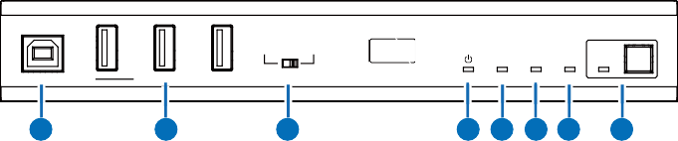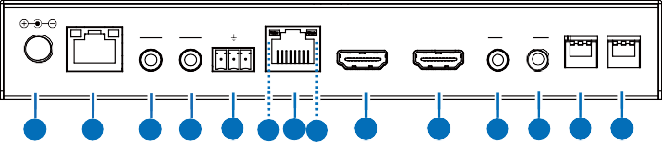
USB HOST
HOST DEVICE
TX
LINK IN OUT eARC
USB DEVICE
USB CONTROL
1
2
3
4 5 6 7
8
IR
TX RX
eARC
AUDIO
0
1
0
1
DC 24V ETHERNET IR IN IR OUT RS-232 HDBT OUT HDMI IN
HDMI OUT IN OUT EDID CONFIG
9
10
11 12 13 15 14 16 17
18
19 20 21 22

No. | Name | Function Description
1 | USB HOST | USB Host port, connected to PC.
2 | USB DEVICE | Three USB extension ports, connected to U disk, mouse or keyboard.
3 | HOST/ DEVICE USB CONTROL  switch | Switch to left (HOST), the USB HOST mode is enabled; Switch to right (DEVICE), the USB DEVICE mode is enabled.  Note: If the transmitter is set to USB HOST mode, the receiver must be set to USB DEVICE mode.
4 | Power LED | - Light on: The transmitter is powered on.  - Light off: The transmitter is powered off.
5 | LINK LED | - Light on: Transmitter and receiver are in good connection status.  - Light flashing: Transmitter and receiver are in poor connection  status or connected to the same device.  - Light off: Transmitter and receiver are not connected.
6 | IN LED | Video signal input indicator.  - Light on: There is HDMI signal input.  - Light off: There is no HDMI input or the system is powered off.
7 | OUT LED | Video signal output indicator.  - Light on: There is HDMI signal output.  - Light off: There is no HDMI output or the system is powered off.

No. | Name | Function Description
8 | eARC LED  & button | Press the eARC button to enable/disable the eARC/ARC function, and the eARC LED will indicate the status as following.  - Light on: The eARC/ARC mode is enabled, and the device is  working normally.  - Light flashing: The eARC/ARC mode is enabled, but the device  is working abnormally.  - Light off: The eARC/ARC mode is disabled.
9 | DC 24V | DC 24V/2.7A power supply input port.  Note that the extender supports POC function, it means that either transmitter or receiver is powered on by 24V/2.7A power adapter, the other one doesn’t need power supply.
10 | ETHERNET  port & indicators | Ethernet port with adaptive broadband rate. For example, if the transmitter is connected to a PC with a 100M rate, and the receiver is connected to a Gigabit router, the device can automatically switch the 100M rate of the transmitter to Gigabit rate. (Note: If the connected device only supports 100M rate, the extender cannot switch to Gigabit rate.)  Ethernet Indicators:  - Light in green: the Ethernet rate is 1000 Mbit/s.  - Light in yellow: the Ethernet rate is 100 Mbit/s.
11 | IR IN port | IR signal input port, connected to IR Receiver cable.
12 | IR OUT port | IR signal output port, connected to IR Blaster cable.
13 | RS-232 port | The RS-232 serial port features different functions through the setting of the CONFIG DIP switch:  - RS-232 signal pass-through  - Control & FW upgrade  - VS3000 FW upgrade  - Dubug
14 | HDBT OUT  port | HDBaseT Network port, connected to the HDBT IN port of the receiver with a CAT 6A/7 cable. It is used for various signals pass-through.
15 | Data Signal Indicator (Yellow) | - Light on: HDMI signal with HDCP.  - Light flashing: HDMI signal without HDCP.  - Light off: No HDMI signal.
16 | Link Signal Indicator (Green) | - Light on: Transmitter and receiver are in good connection status.  - Light flashing: Transmitter and receiver are in poor connection  status or connected to the same device.  - Light off: Transmitter and receiver are not connected.

No. | Name | Function Description
17 | eARC/HDMI  IN port | This port features two functions:  - HDMI signal input port, connected to HDMI source device;  - eARC/ARC audio port, connected to eARC/ARC amplifier.
18 | HDMI OUT  port | HDMI video signal output port. It can loop out the local video signal or output the video signal returned from the receiver.
19 | AUDIO IN  port | Analog audio input port. The audio from this port can be output through the AUDIO OUT port of the receiver.
20 | AUDIO OUT  port | Analog audio output port. It can output the audio from the AUDIO IN port of the receiver.
21 | EDID DIP  switch | The DIP switch is used for EDID setting. (Set to 000 by default.) [DIP]=000: Copy RX HDMI OUT port sink EDID  (Note: If there is no TV connected to the receiver, it will copy the EDID of the local loopout video.)  [DIP]=001: HDMI 1080p@60Hz, Audio 2ch PCM [DIP]=010: HDMI 4K@60Hz 4:4:4, Audio 2ch PCM  [DIP]=011: HDMI 4K@60Hz 4:4:4, Audio 5.1ch PCM/DTS/DOLBY [DIP]=100: HDMI 4K@60Hz 4:4:4, Audio 7.1ch PCM/DTS/  DOLBY/HD  [DIP]=101: HDMI 8K@30Hz 4:4:4+4K@120Hz 4:4:4, Audio 2ch PCM  [DIP]=110: HDMI 8K@30Hz 4:4:4+4K@120Hz 4:4:4, Audio 5.1ch PCM/DTS/DOLBY  [DIP]=111: HDMI 8K@30Hz 4:4:4+4K@120Hz 4:4:4, Audio 7.1ch PCM/DTS/DOLBY/HD
22 | CONFIG DIP  switch | The DIP switch is used to set IR level and serial port access. DIP SW1=0: The IR level is set to 12V.  DIP SW1=1: The IR level is set to 5V.  DIP SW2/SW3=00: The RS-232 port is used for RS-232 signal  pass-through.  DIP SW2/SW3=01: The RS-232 port is used for Control & FW  upgrade.  DIP SW2/SW3=10: The RS-232 port is used for VS3000 FW  upgrade.  DIP SW2/SW3=11: The RS-232 port is used for dubuging.

Receiver Panel
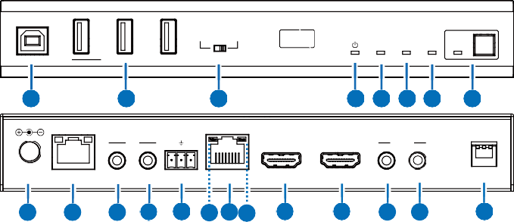
USB HOST
HOST DEVICE
RX
LINK IN
OUT eARC
USB DEVICE USB CONTROL
1
2
3
4 5 6 7
8
IR
TX RX
eARC
AUDIO
0
1
DC 24V
ETHERNET IR IN IR OUT RS-232
HDMI IN
HDMI OUT
IN OUT
CONFIG
9
10
11 12 13 15 14 16 17
18
19 20
21
HDBT IN

No. | Name | Function Description
1 | USB HOST | USB Host port, connected to PC.
2 | USB DEVICE | Three USB extension ports, connected to U disk, mouse or keyboard.
3 | HOST/ DEVICE USB CONTROL  switch | Switch to left (HOST), the USB HOST mode is enabled; Switch to right (DEVICE), the USB DEVICE mode is enabled.  Note: If the transmitter is set to USB HOST mode, the receiver must be set to USB DEVICE mode.
4 | Power LED | - Light on: The receiver is powered on.  - Light off: The receiver is powered off.
5 | LINK LED | - Light on: Transmitter and receiver are in good connection status.  - Light flashing: Transmitter and receiver are in in poor connection  status or connected to the same device.  - Light off: Transmitter and receiver are not connected.
6 | IN LED | Video signal input indicator.  - Light on: There is HDMI signal input.  - Light off: There is no HDMI input or the system is powered off.
7 | OUT LED | Video signal output indicator.  - Light on: There is HDMI signal output.  - Light off: There is no HDMI output or the system is powered off.

No. | Name | Function Description
8 | eARC LED  & button | Press the eARC button to enable/disable the eARC/ARC function, and the eARC LED will indicate the status as following.  - Light on: The eARC/ARC mode is enabled, and the device is  working normally.  - Light flashing: The eARC/ARC mode is enabled, but the device  is working abnormally.  - Light off: The eARC/ARC mode is disabled.
9 | DC 24V | DC 24V/2.7A power supply input port.  Note that the extender supports POC function, it means that either transmitter or receiver is powered on by 24V/2.7A power adapter, the other one doesn’t need power supply.
10 | ETHERNET  port & indicators | Ethernet port with adaptive broadband rate. For example, if the transmitter is connected to a PC with a 100M rate, and the receiver is connected to a Gigabit router, the device can automatically switch the 100M rate of the transmitter to Gigabit rate. (Note: If the connected device only supports 100M rate, the extender cannot switch to Gigabit rate.)  Ethernet Indicators:  - Light in green: the Ethernet rate is 1000 Mbit/s.  - Light in yellow: the Ethernet rate is 100 Mbit/s.
11 | IR IN port | IR signal input port, connected to IR Receiver cable.
12 | IR OUT port | IR signal output port, connected to IR Blaster cable.
13 | RS-232 port | The RS-232 serial port features different functions through the setting of the CONFIG DIP switch:  - RS-232 signal pass-through  - Control & FW upgrade  - VS3000 FW upgrade  - Dubug
14 | HDBT IN  port | HDBaseT Network port, connected to the HDBT OUT port of the transmitter with a CAT 6A/7 cable. It is used for various signals pass-through.
15 | Data Signal Indicator (Yellow) | - Light on: HDMI signal with HDCP.  - Light flashing: HDMI signal without HDCP.  - Light off: No HDMI signal.
16 | Link Signal Indicator (Green) | - Light on: Transmitter and receiver are in good connection status.  - Light flashing: Transmitter and receiver are in poor connection  status or connected to the same device.  - Light off: Transmitter and receiver are not connected.

No. | Name | Function Description
17 | HDMI IN port | HDMI signal input port, connected to HDMI source device. It can transmit video with resolution of 1080P 24Hz in reverse to the HDMI OUT port of the transmitter.  Note: It is a reserved port, being closed by default. Before using this port, you need to turn on it through command control, and make sure that the eARC function is disabled.
18 | eARC/HDMI  OUT port | This port features two functions:  - HDMI signal output port, connected to HDMI display device;  - eARC/ARC audio port, connected to TV with eARC/ARC function.
19 | AUDIO IN  port | Analog audio input port. The audio from this port can be output through the AUDIO OUT port of the transmitter.
20 | AUDIO OUT  port | Analog audio output port. It can output the audio from the AUDIO IN port of the transmitter.
21 | CONFIG DIP  switch | The DIP switch is used to set IR level and serial port access. DIP SW1=0: The IR level is set to 12V.  DIP SW1=1: The IR level is set to 5V.  DIP SW2/SW3=00: The RS-232 port is used for RS-232 signal  pass-through.  DIP SW2/SW3=01: The RS-232 port is used for Control & FW  upgrade.  DIP SW2/SW3=10: The RS-232 port is used for VS3000 FW  upgrade.  DIP SW2/SW3=11: The RS-232 port is used for dubuging.

USB Mode Applications
The Extender supports USB2.0 transmission, and Host/Device is configurable.
Mode 1: USB forward from TX to RX
Switch the HOST/DEVICE USB CONTROL switch to left, then power off and reboot the transmitter to set to USB Host mode. Meanwhile, switch the HOST/ DEVICE USB CONTROL switch to right, then power off and reboot the receiver to set to USB Device mode.

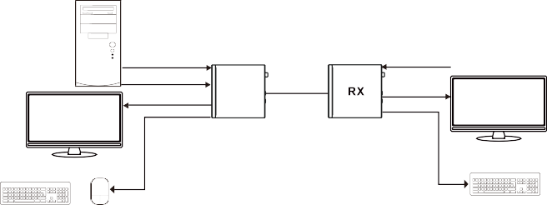Computer Host

HDMI IN
USB Host LOOPOUT

USB / Host USB / Device USB Host UTP Cable HDMI OUT

No Function

Local Monitor

&

Keyboard Mouse

USB Devices

USB Devices

Remote Monitor

Keyboard

&
Mouse

Mode 2: USB reverse from RX to TX
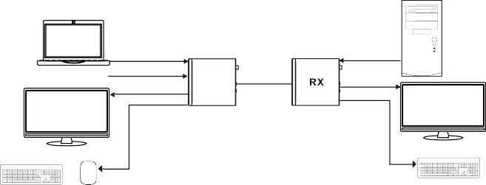Switch the HOST/DEVICE USB CONTROL switch to right, then power off and reboot the transmitter to set to USB Device mode. Meanwhile, switch the HOST/DEVICE USB CONTROL switch to left, then power off and reboot the receiver to set to USB Host mode.
NoteBook
HDMI IN
USB / Device
USB / Host USB Host
Computer Host
No Function
USB Host
LOOPOUT
UTP Cable
HDMI OUT
USB Devices
USB Devices
Local Monitor
Remote Monitor
&
&

Keyboard Mouse
Keyboard Mouse

IR Pin Definition
IR Receiver and Blaster pin’s definition as below:
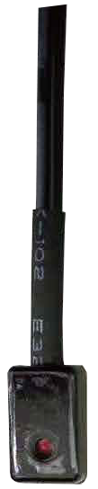
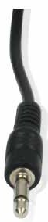
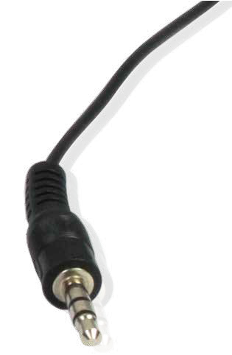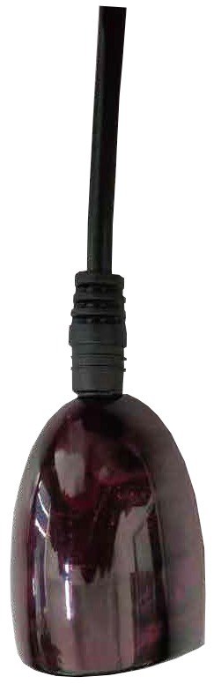
IR BLASTER IR RECEIVER

+
IR BLASTER
-


IR RECEIVER
Power 12V

Note: When the angle between the IR receiver and the remote control is ± 45 °, the transmission distance is 0-5 meters; when the angle between the IR receiver and the remote control is ± 90 °, the transmission distance is 0-8 meters.

Application Example

Mode 1: eARC/ARC Application
The Audio Return Channel (ARC) in HDMI 2.1 enables a TV, via a single HDMI cable or audio cable, to send audio data “upstream” to an A/V receiver, the extender will continue the upstream audio all the way to the transmitter. There it can be connected via HDMI ARC.

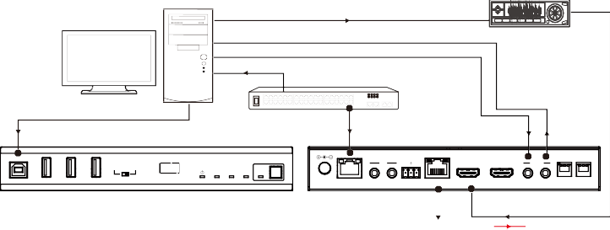Desktop Computer
IR TX RX
eARC
AUDIO 0
1
0
1
DC 24V ETHERNET IR IN IR OUT RS-232 HDBT OUT HDMI IN HDMI OUT IN OUT EDID CONFIG
USB DEVICE USB CONTROL
LINK IN OUT eARC
TX
HOST DEVICE
USB HOST

HDMI Cable

Network Cable
Switch

Audio Amplifier with eARC/ARC Function

USB Cable

Network Cable

Audio Cable

Audio Cable

Transmitter

Receiver

HDBaseT Cable

HDMI Cable eARC

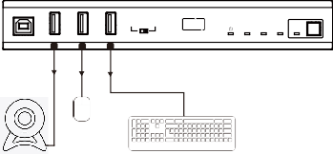
USB HOST

HOST DEVICE RX

LINK IN OUT eARC

IR TX RX eARC AUDIO 0
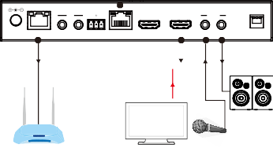
1

USB DEVICE

USB CONTROL

DC 24V ETHERNET IR IN IR OUT RS-232

HDBT IN

HDMI IN

HDMI OUT IN OUT

CONFIG

USB
Cable

Mouse

USB Cable

Network Cable

HDMI Cable eARC

Audio Cable

Speakers

USB Camera
Keyboard

TP-LINK

Router

TV with eARC/ MIC ARC Function

Note: Please press the eARC buttons on the front panel of the transmitter and receiver to enable the eARC/ARC function before operating the system.

Mode 2: Ordinary Connection Application
Desktop Computer

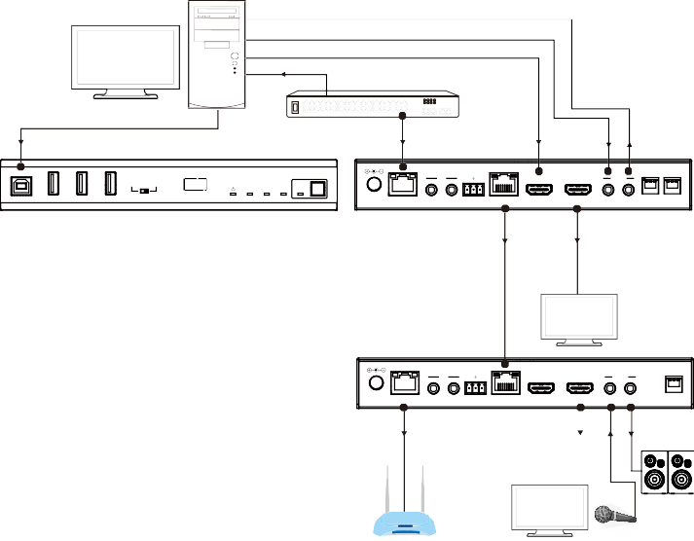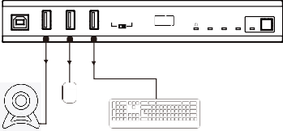Network Cable
IR TX RX
eARC AUDIO
0
1
DC 24V ETHERNET IR IN IR OUT RS-232 HDBT IN HDMI IN HDMI OUT IN OUT CONFIG

Switch

USB Cable

Network Cable

HDMI Cable Audio Cable

Audio Cable

USB HOST
IR TX RX
TX
HOST DEVICE

eARC AUDIO 0 0
1 1

USB DEVICE USB CONTROL

Transmitter

Receiver
LINK IN OUT eARC

DC 24V ETHERNET IR IN IR OUT RS-232 HDBT OUT

HDBaseT Cable

HDMI IN

HDMI OUT IN OUT EDID CONFIG

HDMI Cable

TV

USB HOST

HOST DEVICE RX

LINK IN OUT eARC

USB

USB DEVICE

USB CONTROL

USB Cable

Network Cable

HDMI Cable

Audio

Cable Cable

Mouse USB Camera

Keyboard

TP-LINK

Router

TV MIC

Speakers

Note: Please press the eARC buttons on the front panel of the transmitter and receiver to disable the eARC/ARC function before operating the system.


The terms HDMI and HDMI High-Definition Multimedia interface, and the HDMI Logo are trademarks or registered trademarks of HDMI Licensing LLC in the United States and other countries.

