SP8EH2-4KV2

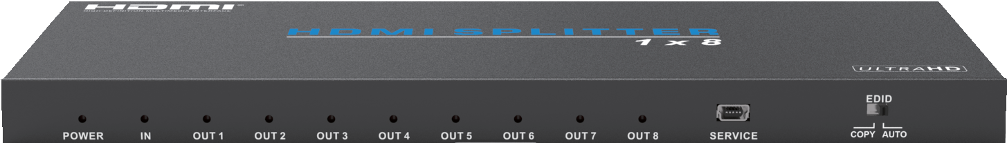



VER 1.0

Thank you for purchasing this product
For optimum performance and safety, please read these instructions carefully before connecting, operating or adjusting this product. Please keep this manual for future reference.

Surge protection device recommended
This product contains sensitive electrical components that may be damaged by electrical spikes, surges, electric shock, lighting strikes, etc. Use of surge protection systems is highly recommended in order to protect and extend the life of your equipment.

Table of Contents
- Introduction. 1
- Features. 1
- Package Contents. 1
- Specifications. 2
- Operation Controls and Functions. 3
- Application Example. 4
- FAQ. 4

Introduction
18Gbps 1x8 HDMI Splitter is an advanced solution for splitting single HDMI signal to 8 HDMI outputs synchronously. It supports up to 18Gbps bandwidth, HDMI 2.0b/HDCP 2.2 content up to 4K@60Hz 4:4:4. It can be set the COPY/ AUTO EDID configuration. Supporting the latest features you can be assured of reliable and high quality HDMI distribution.

Features
☆ HDMI 2.0b, HDCP 2.2 compliant
☆ Supports 18Gbps bandwidth
☆ Supports resolution up to 4K@60Hz 4:4:4
☆ Supports HDR function
☆ Supports COPY/AUTO EDID control via dialling the dip switch
☆ Compact design for easy and flexible installation

Package Contents
① 1× 18Gbps 1×8 HDMI Splitter
② 1× 12V/1A DC Locking Power Adapter
③ 1× User Manual

Specifications

Technical
HDMI Compliance | HDMI 2.0b
HDCP Compliance | HDCP 2.2
Video Bandwidth | 594MHz/18Gbps
Video Resolution | 480i ~1080p50/60Hz, 4Kx2K@24/30Hz, 4k2k@60Hz
HDMI Audio Formats | PCM 2CH, LPCM 7.1/5.1CH, Dolby Digital, DTS 5.1,  Dolby Digital+, Dolby TrueHD, DTS-HD Master Audio, Dolby Atmos and DTS:X
ESD Protection | Human body model—±8kV (Air-gap discharge) &  ±4kV (Contact discharge)
Connections
Input Ports | 1×HDMI Type A (19-pin female) 1×SERVICE (Micro USB, Update port)
Output Ports | 8×HDMI Type A (19-pin female）
Mechanical
Housing | Metal Enclosure
Silkscreen Color | Black
Dimensions | 243mm (W) × 102mm (D) × 16mm (H)
Weight | 572g
Power Supply | Input: AC100 - 240V 50/60Hz, Output: DC 12V/1A (US/EU standards, CE/FCC/UL certified)
Power Consumption | 6.15W
Operation  Temperature | -10°C ~ 50°C / 14°F ~ 122°F
Storage Temperature | -20°C ~ 60°C / -4°F ~ 140°F
Relative Humidity | 20~90% RH (non-condensing)

Operation Controls and Functions
1/5
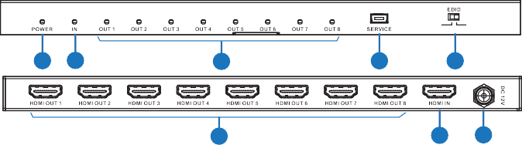
1 2
3
4
5
6
7 8
COPY AUTO

Number | Name | Function description
1 | POWER LED | This blue LED will illuminate when the device connects power supply.
2 | IN LED | This blue LED will illuminate when HDMI IN port  connects an active source device.
3 | OUT LED | These blue LEDs will illuminate when HDMI OUT ports connects an active display device.
4 | SERVICE | Firmware update use only.
5 | EDID COPY | When dial switch is dialled the ‘COPY’ position, the unit will read the EDID setting of the HDMI OUT 1 display device to source deveice, the source deveice will send again matching the OUT 1 display device signal to all HDMI outputs. If no HDMI OUT 1 capable EDID is detected then the unit will read the EDID setting of the HDMI OUT 2 display device to source device...etc. The priority order is OUT 1 to OUT 8.
5 | EDID AUTO | When dial switch is dialled the ‘AUTO’ position, the unit will compare the EDID setting of the HDMI OUT 1~8 port displays device then send the best EDID signal to source device, the source device will send again matching the display device signal to all outputs.
6 | HDMI OUT 1~8 | Connect to the HDMI display devices such as  TVs or Monitors with an HDMI cable.
7 | HDMI IN | Connect to the HDMI source device such as DVD player or set-top box with an HDMI cable.
8 | DC 12V | Plug the DC 12V power supply into the unit and connect the adaptor to an AC outlet.

Application Example

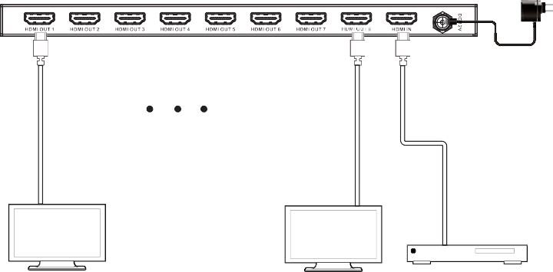
Power Supply

UHDTV
UHDTV
DVD or Blu-ray Player

FAQ
  - Q: Where is this product usually used?
A: It can be used in many place such as Entertainment Room / Home Theater / Lecture Room / Hall Presentation / Show Room / Demo Room / Public Commercial Display etc.
  - Q: Which input source and output devices can this product connect to?
A: Input source devices such as Blu-ray / DVD / PS3 / PS4 player or Set-Top- Box or any 6G with HDCP2.2 source etc. Output with 6G HDMI TV / Display or audio amplifier etc.
Note: To achieve 6G performance will need to collocation with particular HDMI cable to get the better quality.
  - Q: Does this product require an HDMI line length for the connection interface? A: According to HDMI line length test, 4K2K@60Hz / 8 bit YUV 4:4:4 is the longest line length up to 3m, 4K2K@30Hz / 8-bit is the longest line length up to 10m, 1080p@60Hz / 8-bit is the longest line length up to 15m.
The use of “Premium High Speed HDMI” cable is highly recommended.

