SP4EH2-4KV2



VER 1.2

Thank you for purchasing this product
For optimum performance and safety, please read these instructions carefully before connecting, operating or adjusting this product. Please keep this manual for future reference.
Surge protection device recommended
This product contains sensitive electrical components that may be damaged by electrical spikes, surges, electric shook, lighting strikes, etc. Use of surge protection systems is highly recommended in order to protect andextend the life of your equipment.

Table of Contents
- Introduction. 2
- Features. 2
- Package Contents. 2
- Specifications. 3
- Operation Controls and Functions. 3
- Application Example. 5

Introduction
1x4 HDMI 18Gbps Splitter is an advanced solution for splitting a single HDMI signal to 4 HDMI displays. It provides high performance audio and video output through HDMI cables up to 4K2K@60Hz 4:4:4 and is capable of receiving and transmitting up to 18Gbps of bandwidth with no data loss.
（Supporting the latest features you can be assured of reliable and high quality HDMI distribution.）

Features
☆ HDMI 2.0b, HDCP 2.2 compliant
☆ Supports video format up to 4K2K@60Hz with 8 bit RGB/YCBCR 4:4:4/YCBCR 4:2:2
☆ Support 3D frame sequential video format up to 1080p@60;
☆ Supports 3D frame sequential video format up to 4K2K@30Hz
☆ Supports high resolution VESA mode video format up to QSXGA@60Hz
☆ Supports LPCM 7.1CH, Dolby TrueHD, and DTS-HD Master Audio
☆ Supports smart EDID control
☆ Compact design for an easy and flexible installation

Package Contents
① 1× 1×4 HDMI 18Gbps Splitter
② 1× 5V/1A DC Power Adapter
③ 1× User Manual

Specifications

Technical
Video Bandwidth | 600MHz/18Gbps
Input Ports | 1×HDMI Type A[19-pin female]
Output Ports | 4×HDMI Type A[19-pin female]
Output Resolution | 480i ~1080p50/60, 4Kx2K@24/30, 4k2k@60Hz
ESD Protection | Human Body model: ±8kV (Air-gap discharge) ,  ±4kV (Contact discharge)
Power Supply | 5V/1A DC (US/EU standards，CE/FCC/UL certified)
Dimensions | 63mm (W) × 163mm (D) × 16mm (H)
Weight | 260g
Chassis Material | Metal
Silkscreen Color | Black
Operating Temperature | 0°C ~ 40°C / 32°F ~ 104°F
Storage Temperature | -20°C ~ 60°C / -4°F ~ 140°F
Relative Humidity | 20~90% RH (non-condensing)
Power Consumption | 2W

Operation Controls and Functions
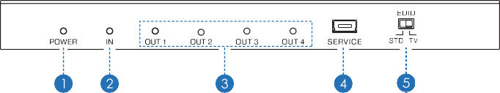
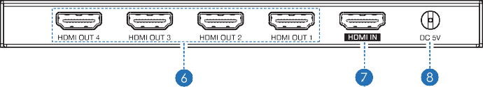

Number | Name | Function description
1 | POWER LED | This blue LED illuminate when the device is connected with power supply.
2 | IN LED | This blue LED illuminate when the Source  connected to the device.
3 | OUT LED | These blue LEDs will light up to indicate which HDMI outputs are connected to an active TV/ display/monitor.
4 | SERVICE | Firmware update use only.
5 | EDID STD | When in 'STD' mode, the unit will use its own built-in EDID settings. In this mode, the video output will be set to 1080p@60Hz and the audio output at LPCM 2CH Stereo. Use this mode if there are display problems in TV Mode.
5 | EDID TV | When in 'TV' mode, the unit will read the EDID settings of the display device connected to HDMI OUT 1. If it detects a 4K2K capable EDID setting it will transmit the signal in that format to all outputs. If no 4K2K capable EDID is detected then the unit will output the best  resolution that all displays can support.
6 | HDMI OUT 1~4 | Connect each of the HDMI outputs to an HDMI display for simultaneous HDMI distribution, or cascade the output to another transmitter to extend the operating distance.
7 | HDMI IN | Connect the input port to the HDMI splitter output of your source device such as a DVD player or set-top box with an HDMI cable.
8 | DC 5V | Plug the 5V DC power supply into the unit and  connected the adaptor to an AC outlet.

Application Example
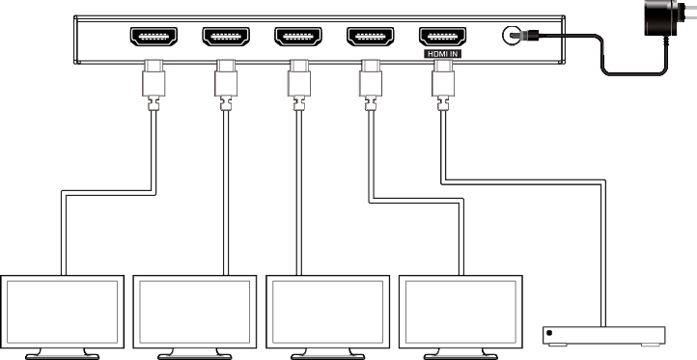
Power Supply
UHDTV UHDTV UHOTV UHOTV DVD or Blu-ray Ployer

