SP2EH2-4KV2

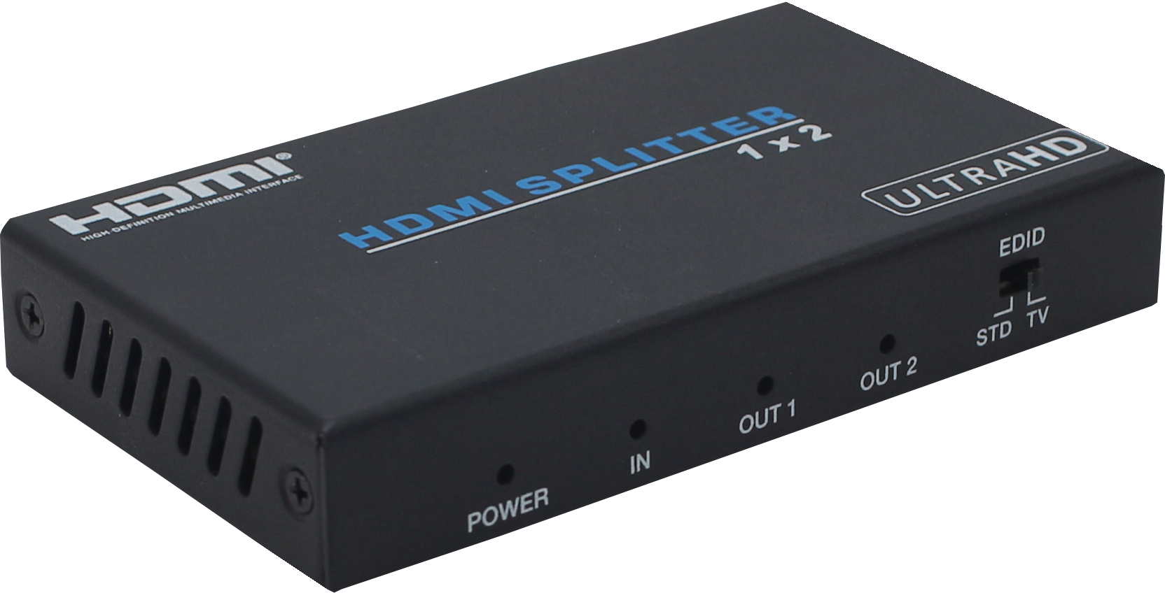



VER 2.0

Thank you for purchasing this product
For optimum performance and safety, please read these instructions carefully before connecting, operating or adjusting this product. Please keep this manual for future reference.

Surge protection device recommended
This product contains sensitive electrical components that may be damaged by electrical spikes, surges, electric shook, lighting strikes, etc. Use of surge protection systems is highly recommended in order to protect andextend the life of your equipment.

Table of Contents
- Introduction. 1
- Features. 1
- Package Contents. 1
- Specifications. 2
- Operation Controls and Functions. 3
- Application Example. 4

Introduction
1x2 HDMI 18Gbps Splitter is an advanced solution for splitting a HDMI content to 2 HDMI outputs synchronously. It provides high performance audio and video up to 4K2K@60Hz (4:4:4) and is capable of receiving, retiming and transmitting up to 18Gbps of bandwidth with no data loss.

Features
☆ HDMI 2.0b, HDCP 2.2 compliant
☆ Up to 4K2K@60Hz with 24bit RGB/YCBCR 4:4:4
☆ VESA format up to QSXGA@60Hz
☆ Supports LPCM 7.1CH, Dolby TrueHD, and DTS-HD Master Audio
☆ Built-in equalizer, retiming and driver
☆ Smart EDID, STD(1080p) mode and TV(copy OUT1) mode
☆ Compact design for an easy and flexible installation

Package Contents
① 1× 1×2 HDMI 18Gbps Splitter
② 1× 5V/1A Power Adapter
③ 1× User Manual

Specifications

Technical
Video Bandwidth | 600MHz/18Gbps
Input Port | 1×HDMI Type A (19-pin female)
Output Ports | 2×HDMI Type A (19-pin female）
Video Resolution | 4K2K@24/25/30/60Hz
ESD Protection | Human body model—±8kV (Air-gap discharge)  &±4kV (Contact discharge)
Mechanical
Chassis Material | Metal
Silkscreen Color | Black
Power Consumption | 2W
Weight | 165g
Power Supply | Input: AC100 - 240V 50/60Hz, Output: DC 5V/1A  (US/EU standards, CE/FCC/UL certified)
Dimensions | 56 mm(W)×100 mm(D)×16mm(H)
Operating Temperature | 0°C ~ 40°C / 32°F ~ 104°F
Storage Temperature | -20°C ~ 60°C / -4°F ~ 140°F
Relative Humidity | 20~90% RH (non-condensing)

Operation Controls and Functions
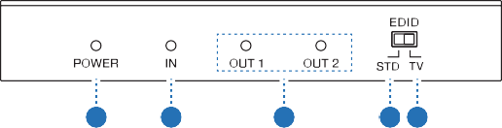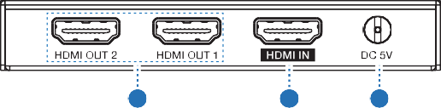
1
2
3
4 5
6
7
8

Number | Name | Function description
1 | Power LED | This blue LED illuminate when the device is connected with power supply.
2 | IN LED | This blue LED illuminate when the Source connected to the device.
3 | OUT LED | These blue LEDs will light up to indicate which HDMI outputs are connected to an active TV/ display/monitor.
4 | EDID STD | When in 'STD' mode, the unit will use its own built-in EDID settings. In this mode, the video output will be set to 1080p@60Hz and the audio output at LPCM 2CH Stereo.
5 | EDID TV | When in 'TV' mode, the unit will read the EDID settings of the display device connected to HDMI OUT 1.
6 | HDMI OUT  1~2 | Connect each of the HDMI outputs to an HDMI display for simultaneous HDMI distribution, or cascade the output to another splitter to extend  the operating distance.

7 | HDMI IN | Connect the input port to the HDMI output of your source device such as a DVD player or  set-top box with an HDMI cable.
8 | DC 5V | Plug the 5V DC power supply into the unit and connected the adaptor to an AC outlet.

Application Example
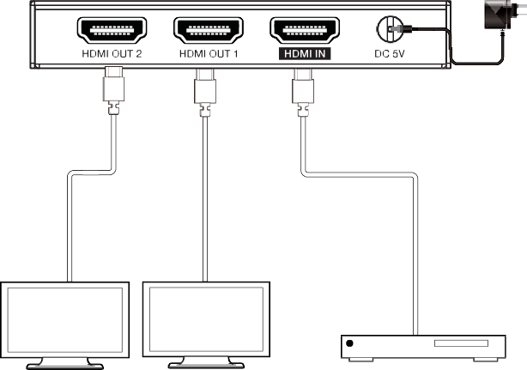
Power Supply
UHDTV
UHDTV

