SP181TH2-4K

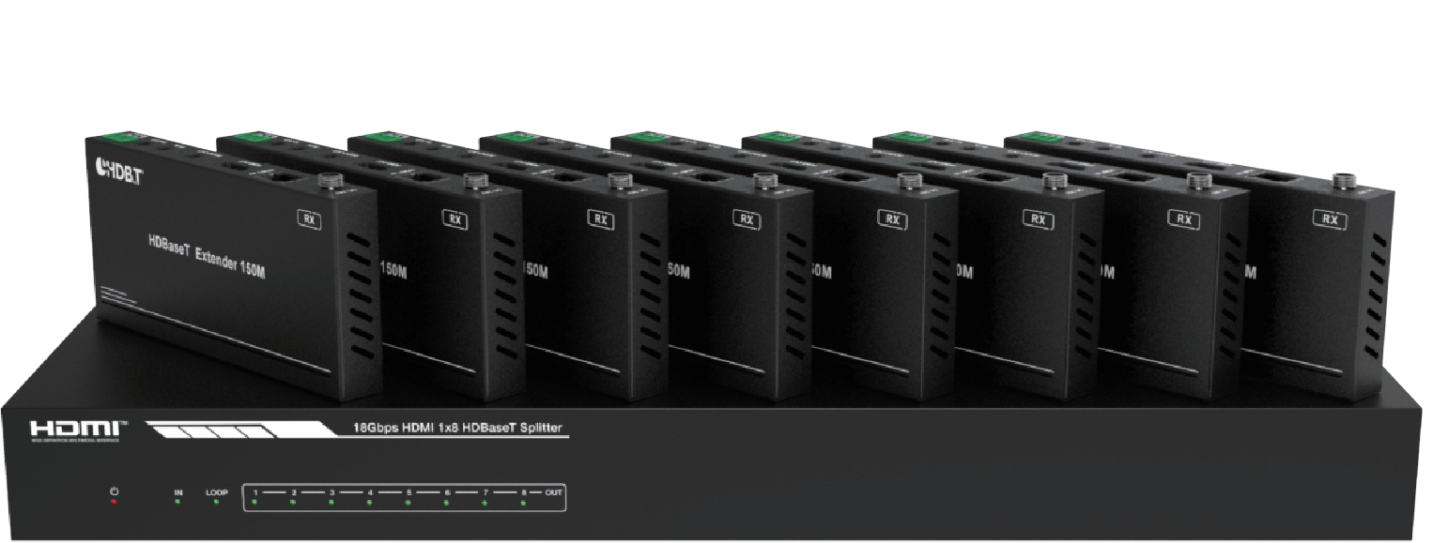


VER 1.1

Thank you for purchasing this product
For optimum performance and safety, please read these instructions carefully before connecting, operating or adjusting this product. Please keep this manual for future reference.

Surge protection device recommended
This product contains sensitive electrical components that may be damaged by electrical spikes, surges, electric shock, lighting strikes, etc. Use of surge protection systems is highly recommended in order to protect and extend the life of your equipment.

Table of Contents
- Introduction. 1
- Features. 1
- Package Contents. 1
- Specifications. 2
- Operation Controls and Functions. 3
  - Transmitter. 3
  - HDBaseT Receiver. 5
  - IR Pin Definition 6
- EDID Mode. 7
- ASCII Commands. 8
- Application Example. 12

Introduction
This 18Gbps HDMI 1x8 HDBaseT Splitter can distribute 1 source signal to any 8 display devices. Support video resolution up to 4K2K@60Hz 4:4:4. It is designed with 1 HDMI loop output and 8 HDBaseT outputs. The HDMI signal transmission distance can be extended up to 120 meters at the
resolution of 4K2K@60Hz, or 150 meters at 1080P@60Hz via a single CAT6/ 6a/7 cable. The product supports IR and RS-232 signal pass-through, audio extract function and advanced EDID management.

Features
☆ HDMI 2.0b, HDCP 2.2 and HDCP 1.x compliant
☆ Support 18Gbps video bandwidth
☆ Support video resolution up to 4K2K@60Hz 4:4:4
☆ Support HDR, HDR10+, HLG and Dolby vision
☆ Support up to 7.1CH HD audio pass-through
☆ Support digital and analog audio de-embedded output
☆ Extend the signal transmission distance up to 120 meters at the resolution of 4K2K@60Hz, 150 meters at 1080P@60Hz via a single CAT6/6a/7 cable
☆ Support 1 HDMI input, 1 HDMI loop output and 8 HDBaseT outputs.
☆ IR, RS-232 routed to HDBaseT output
☆ Advanced EDID management
☆ Support one-way POC function (only from transmitter to receiver)
☆ Compact design for easy and flexible installation

Package Contents
① 1 × 18Gbps HDMI 1×8 HDBaseT Splitter
② 8 × HDBaseT Receiver
③ 9 × IR Blaster Cable (1.5 meters)
④ 9 × 20K~60KHz IR Receiver Cable (1.5 meters)
⑤ 9 × 3-pin Phoenix Connector
⑥ 1 × 5-pin Phoenix Connector
⑦ 18 × Mounting Ear
⑧ 1 × 24V/3.75A DC Locking Power Adapter
⑨ 1 × User Manual

Specifications

Technical
HDMI Compliance | HDMI 2.0b
HDCP Compliance | HDCP 2.2/1.x
Video Bandwidth | 594MHz/18Gbps
Video Resolution | Up to 4k2k@60Hz 4:4:4
Color Depth | 8-bit,10-bit,12-bit(1080p@60Hz) 8-bit (4K2K@60Hz YUV4:4:4)  8-bit,10-bit,12-bit(4K2K@60Hz YCbCr 4:2:2/4:2:0)
Color Space | RGB 4:4:4, YCbCr 4:4:4 / 4:2:2 / 4:2:0
HDR | Support HDR, HDR10+, HLG, Dolby vision
HDMI Audio Formats | LPCM 2.0/2.1/5.1/6.1/7.1, Dolby Digital, Dolby TrueHD, Dolby Digital Plus(DD+), DTS-ES, DTS HD Master, DTS HD-HRA, DTS-X
Coaxial Audio Formats | PCM2.0, Dolby Digital / Plus, DTS 2.0/5.1
Analog Audio Formats | PCM 2.0CH
ESD Protection | Human body model—±8kV (Air-gap discharge) &  ±4kV (Contact discharge)
Connection
Input | 1×HDMI Type A (19-pin female)
Output | 1×HDMI Type A (19-pin female） 8x HDBaseT OUT [RJ45]  1x Coaxial Audio OUT [RCA]  1x L/R Audio OUT [5-pin phoenix connector]
Control | 1×RS-232 (3-pin phoenix connector） 1x EDID DIP switch [5-pin]  1x IR IN [3.5mm Stereo Mini-jack] 1x IR OUT [3.5mm Stereo Mini-jack]

Mechanical
Housing | Metal Enclosure
Silkscreen Color | Black
Dimensions | Transmitter: 440mm (W) × 130mm (D) × 44mm (H) Receiver: 140mm (W) × 65mm (D) × 18mm (H)
Weight | Transmitter: 1.62kg Receiver: 246g
Power Supply | Input: AC100 - 240V 50/60Hz, Output: DC 24V/3.75A  (US/EU standards, CE/FCC/UL certified)
Power Consumption | 72W
Operation  Temperature | 0°C ~ 40°C / 32°F ~ 104°F
Storage Temperature | -20°C ~ 60°C / -4°F ~ 140°F
Relative Humidity | 20~90% RH (non-condensing)
1/5

Operation Controls and Functions

Transmitter
Front Panel

18Gbps HDMI 1x8 HDBaseT Splitter

IN LOOP 1 2 3 4 5 6 7 8 OUT
1 2 3
4

No. | Name | Function Description
1 | POWER LED | When the device is powered on, the red power LED will  be on.
2 | IN LED | When the HDMI IN port connects an active source device,  the green LED will be on.
3 | LOOP LED | When the HDMI LOOP OUT port connects an active display device, the green LED will be on.
4 | OUT(1~8) LED | When the HDBT OUTPUT port connects an HDBaseT Receiver, the corresponding green OUT LED will be on.

Rear Panel
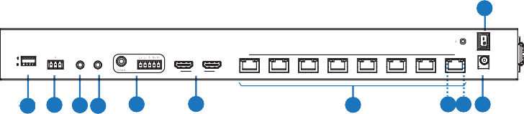
11
ON

OFF
AUDIO OUT
1
2
3
4 HDBT OUTPUT 5
6
7
8
TX RX
IN OUT
IN LOOP OUT
EDID
HDMI
RS-232
IR
DC 24V
1 2 3 4
5
6
7
8 9 10

No. Name |  | Function Description
1 | EDID DIP  switch | Used to set EDID mode. Please refer to Section “6. EDID Mode” for details.
2 | RS-232 | Connect to a PC or control system via a 3-pin phoenix connector cable for three functions:  1, Firmware update;  2, Control the Splitter via RS-232 commands;  3, RS-232 signal pass-through (from transmitter to receiver or from receiver to transmitter).
3 | IR IN | Connect to IR receiver cable, the IR receive signal will emit to “IR OUT” port of the HDBaseT Receiver.
4 | IR OUT | Connect to IR blaster cable, the IR emit signal is from “IR IN” port of the HDBaseT Receiver.
5 | AUDIO OUT  (COAX, L/R) | Coaxial/balanced audio output port, connect to amplifer or speaker.
6 | HDMI port | IN: HDMI input port, connect to HDMI source device such  as DVD or set-top box with an HDMI cable.  LOOP OUT: HDMI loop output port, connect to the HDMI display device such as TV or Monitor with an HDMI cable.
7 | HDBT OUTPUT  port (1~8) | Connect to the HDBT IN port of the HDBaseT receiver  with a CAT cable.
8 | Connection Signal Indicator lamp (Green) | - Illuminating: Transmitter and Receiver are in good connection status.  - Flashing: Transmitter and Receiver are in poor  connection status.  - Dark: Transmitter and Receiver are not connected.
9 | Data Signal Indicator lamp  (Orange) | - Illuminating: HDMI signal with HDCP.  - Flashing: HDMI signal without HDCP.  - Dark: No HDMI signal.
10 | DC 24V | Plug the DC 24V power supply into the unit and connect the adaptor to an AC outlet. (Note: The transmitter can power the receiver via a CAT cable.)
11 | POWER switch Press this switch to power on/off the device.

HDBaseT Receiver
HDMI OUT
AUDIO OUT
IR IN IR OUT
3
5 4 6
7
8
9
10
11
DC 24V
HDBT IN
SERVICE
1
2

No. | Name | Function Description
1 | Power Indicator | When the receiver is powered on, the power indicator will be on.
2 | SERVICE port | Used for firmware update.
3 | DC 24V | Plug DC 24V/1A power supply into the unit and connect the adapter to an AC outlet.  (Note: The HDBaseT receiver also can be powered by the transmitter via a CAT cable.)
4 | HDBT IN | Connect to the HDBT OUTPUT port on the transmitter  with a CAT cable.
5 | Connection Signal Indicator lamp (Green) | - Illuminating: Transmitter and Receiver are in good connection status.  - Flashing: Transmitter and Receiver are in poor  connection status.  - Dark: Transmitter and Receiver are not connected.
6 | Data Signal Indicator lamp  (Orange) | - Illuminating: HDMI signal with HDCP.  - Flashing: HDMI signal without HDCP.  - Dark: No HDMI signal.
7 | HDMI OUT | HDMI output port, connect to HDMI display device such as TV or Projector with an HDMI cable.
8 | AUDIO OUT | Audio output port, connect to amplifer or speaker.
9 | IR IN | Connect to the IR Receiver cable. The IR signal will send to the IR OUT port of the transmitter.

10 | IR OUT | Connect to the IR blaster cable, the IR signal is from IR  IN port of the transmitter.
11 | RS-232 | 3-pin Phoenix connector for RS-232 command transmission. The RS-232 command will pass-through from transmitter to receiver or from receiver to transmitter.

IR Pin Definition
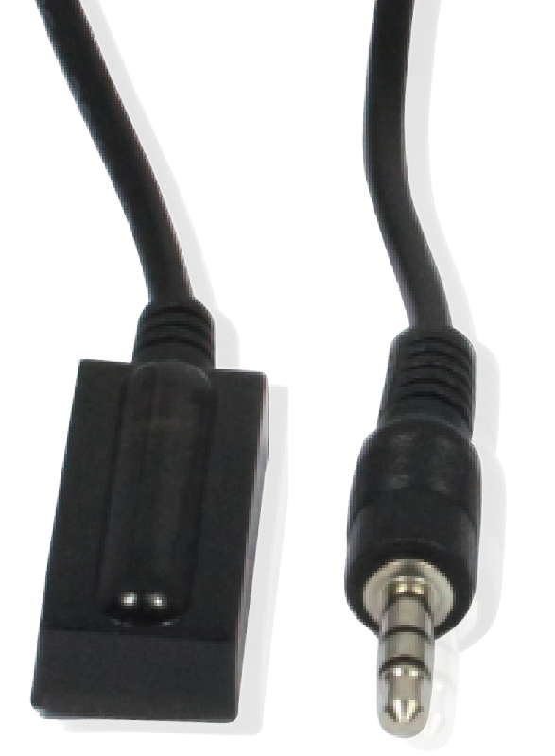
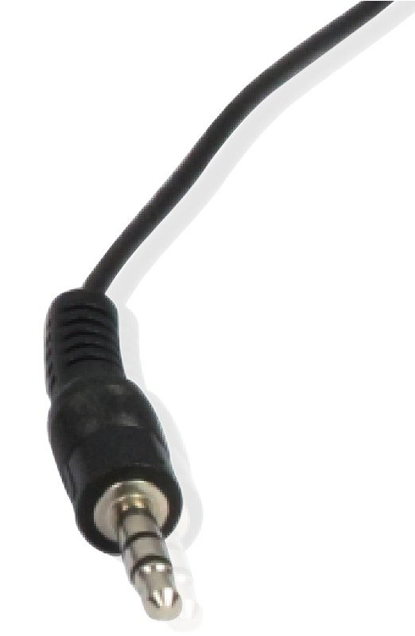
IR Receiver IR Blaster

IR Blaster Signal Power
IR Blaster
NC
IR Receiver

IR Signal

Power Grounding

Note: When the angle between the IR receiver and the remote control is ± 45 °, the transmission distance is 0-5 meters; when the angle between the IR receiver and the remote control is ± 90 °, the transmission distance is 0-8 meters.

EDID Mode
The defined EDID setting list of the product is shown as below:
EDID Mode | EDID Description
11111 | 1080P, Stereo Audio 2.0
11110 | 1080P, Dolby/DTS 5.1
11101 | 1080P, HD Audio 7.1
11100 | 1080I, Stereo Audio 2.0
11011 | 1080I, Dolby/DTS 5.1
11010 | 1080I, HD Audio 7.1
11001 | 1080P 3D, Stereo Audio 2.0
11000 | 1080P 3D, Dolby/DTS 5.1
10111 | 1080P 3D, HD Audio 7.1
10110 | 4K2K30Hz_444, Stereo Audio 2.0
10101 | 4K2K30Hz_444, Dolby/DTS 5.1
10100 | 4K2K30Hz_444, HD Audio 7.1
10011 | 4K2K60Hz_420, Stereo Audio 2.0
10010 | 4K2K60Hz_420, Dolby/DTS 5.1
10001 | 4K2K60Hz_420, HD Audio 7.1
10000 | 4K2K60Hz_444, Stereo Audio 2.0
01111 | 4K2K60Hz_444, Dolby/DTS 5.1
01110 | 4K2K60Hz_444, HD Audio 7.1
01101 | 4K2K60Hz_444, Stereo Audio 2.0 HDR
01100 | 4K2K60Hz_444, Dolby/DTS 5.1 HDR
01011 | 4K2K60Hz_444, HD Audio 7.1HDR
01010 | COPY_FROM_LOOP OUT
01001 | COPY_FROM_HDBT OUT1
01000 | COPY_FROM_HDBT OUT2
00111 | COPY_FROM_HDBT OUT3
00110 | COPY_FROM_HDBT OUT4
00101 | COPY_FROM_HDBT OUT5
00100 | COPY_FROM_HDBT OUT6
00011 | COPY_FROM_HDBT OUT7
00010 | COPY_FROM_HDBT OUT8
00001 | 1080P, Stereo Audio 2.0
00000 | PC control mode

ASCII Commands
The product also supports ASCII command control. Connect the RS-232 port of the product to a PC with a 3-pin phoenix connector cable. Then, open a Serial Command tool on PC to send ASCII commands to control the product. The ASCII command list about the product is shown as below.

ASCII Commands
Serial port protocol. Baud rate: 115200, Data bits: 8bit, Stop bits:1, Check bit: 0
x - Parameter 1 y - Parameter 2
! - Delimiter
Command Code | Function Description | Example | Feedback | Default Setting
Power
s power z! | Power on/off the device,z=0~1 (z=0 power off, z=1 power on) | s power 1! | Power on  System Initializing... Initialization Finished! FW version x.xx.xx | power on
r power! | Get current power state | r power! | power on/power off
s reboot! | Reboot the device | s reboot! | Reboot…  System Initializing... Initialization Finished! FW version x.xx.xx
System Setup
help! | List all commands | help!
r type! | Get device model | r type! | HDC-SPB18H150
r status! | Get device current status | r status! | Get the unit all status: power,  in/out connection, edid mode
r fw version! | Get Firmware version | r fw version! | MCU BOOT: Vx.xx.xx MCU APP: Vx.xx.xx
r link in! | Get the connection status of the input port | r link in! | HDMI IN: connect
r link out y! | Get the connection status of the y output port, y=0~9(0=all, 1~8=HDBT 1~8, 9=loop out) | r link out 1! | hdmi loop out:  connect  hdbt output 1: connect
s reset! | Reset to factory defaults | s reset! | Reset to factory defaults  System Initializing... Initialization Finished! FW version x.xx.xx

Command Code | Function Description | Example | Feedback | Default Setting
Output Setting
s hdmi stream z! | Set hdmi loop output stream on/off z=0~1(0:disable,1:enable) | s hdmi stream 1 ! | Enable hdmi loop out stream  Disable hdmi loop out  stream | enable
s hdmi hdcp z! | Set hdmi loop output hdcp on/ off  z=0~1(0:disable,1:enable) | s hdmi hdcp 1! | Enable hdmi loop out hdcp  Disable hdmi loop out  hdcp | enable
s hdbt y hdcp z! | Set hdbt output y hdcp on/off, y=0~8(0=all) z=0~1(0:disable, 1:enable) | s hdbt 1 hdcp 1 !  s hdbt 0 hdcp 1 ! | Enable hdbt output 1  hdcp  Disable hdbt output 1 hdcp  Enable hdbt all outputs hdcp Disable hdbt all  outputs hdcp | enable
s hdbt y stream z! | Set hdbt output y stream on/ off, y=0~8(0=all) z=0~1 (0:disable,1:enable) | s hdbt 1 stream 1 !  s hdbt 0 stream 1 ! | Enable hdbt output 1 stream  Disable hdbt output 1 stream  Enable hdbt all outputs stream Disable hdbt all outputs stream | enable
r hdmi stream! | Get hdmi loop out stream status | r hdmi stream! | Enable hdmi output stream
r hdmi hdcp! | Get hdmi loop out hdcp status | r hdmi hdcp! | Enable hdmi output hdcp
r hdbt y hdcp! | Get hdbt output y hdcp status, y=0~8(0=all) | r hdbt 1 hdcp! | Enable hdbt output 1 hdcp
r hdbt stream! | Get hdbt output y stream status, y=0~8(0=all) | r hdbt 1 stream! | Enable hdbt output 1 stream

Command Code | Function Description | Example | Feedback | Default Setting
EDID Setting
s edid in from z! | Set input EDID from default EDID z, z=1~32  1, 1080p,Stereo Audio 2.0  2, 1080p,Dolby/DTS 5.1  3, 1080p,HD Audio 7.1  4, 1080i,Stereo Audio 2.0  5, 1080i,Dolby/DTS 5.1  6, 1080i,HD Audio 7.1  7, 3D,Stereo Audio 2.0  8, 3D,Dolby/DTS 5.1  9, 3D,HD Audio 7.1  10, 4K2K30_444,  Stereo Audio 2.0  11, 4K2K30_444,  Dolby/DTS 5.1  12, 4K2K30_444,HD Audio 7.1  13, 4K2K60_420,  Stereo Audio 2.0  14, 4K2K60_420,  Dolby/DTS 5.1  15, 4K2K60_420,HD Audio 7.1  16, 4K2K60_444,  Stereo Audio 2.0  17, 4K2K60_444,  Dolby/DTS 5.1  18, 4K2K60_444,HD Audio 7.1  19, 4K2K60_444,  Stereo Audio 2.0 HDR 20, 4K2K60_444,  Dolby/DTS 5.1 HDR  21, 4K2K60_444,  HD Audio 7.1 HDR 22, copy from hdmi loop out 23, copy from hdbt output 1  24, copy from hdbt output 2  25, copy from hdbt output 3  26, copy from hdbt output 4  27, copy from hdmi output 5  28, copy from hdbt output 6  29, copy from hdbt output 7  30, copy from hdbt output 8  31, 1080p,Stereo Audio 2.0 32, use user1 EDID | s edid in from 1! | input EDID:1080p, Stereo Audio 2.0  Please toggle EDID dip switch to 00000! | 1080p,Stereo Audio 2.0

Command Code | Function Description | Example | Feedback | Default Setting
s edid user1 00 FF FF FF FF …! | Set user1 EDID data | s edid user1 00 ff ff ff ff …. ! | user1 EDID data: 00 FF FF ….
r edid user1! | Get user1 EDID data | r edid user1! | user1 EDID data : 00 FF FF FF FF FF FF  00 ………
r edid in! | Get EDID status of the input | r edid in! | input EDID: 4K2K60_ 444,Stereo Audio 2.0
r edid in data! | Get the EDID data of the hdmi input | r edid in data! | EDID data : 00 FF FF  FF FF FF FF 00 ……
RS-232 BYPASS Setting
s rs232 bypass hdbt y! | Set RS-232 port connect to HDBT out1 Receiver RS-232 port, y=0~9( 0=all,  1~8= hdbt out 1~8, 9=NC) | s rs232 bypass hdbt 1! | RS-232 connect to HDBT OUT1  RS-232 not connect  to HDBT OUT | y=0
r rs232 bypass! | Get RS-232 port connect to HDBT out receiver RS-232 port | r rs232 bypass! | RS-232 connect to HDBT OUT1  RS-232 connect to all HDBT OUT  RS-232 not connect  to HDBT OUT
s device baud w size x stop y parity z! | Set receiver control device COM port setting, w=2400, 4800,9600,19200,38400,  57600,115200, x=7,8  y=1,2, z=none, even,odd | s device baud 57600 size 8  stop 1 parity none! | receiver device COM port setting baudrate: 57600  data size :8, stop:1 parity: none
s rs232 time x! | set send RS232 command  wait time x=200~5000ms | s rs232 time 200! | send RS-232 command wait time 200ms | 200ms

Application Example
DVD or Blu-ray Player

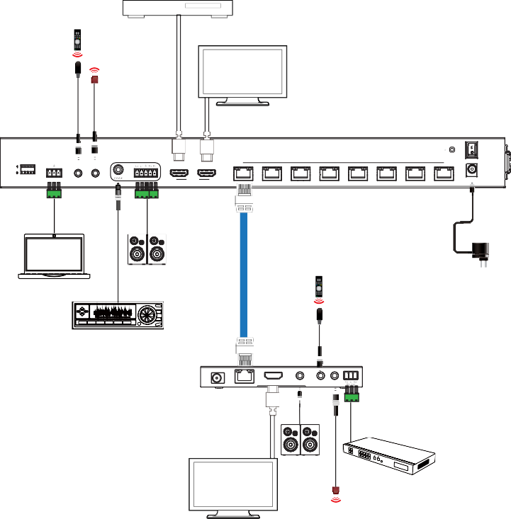UHDTV

IR Receiver
IR Blaster

Transmitter

ON

OFF

EDID

TX RX

RS-232

IN OUT

IR

AUDIO OUT

IN LOOP OUT

HDMI
1 2 3 4 HDBT OUTPUT 5 6 7 8
DC 24V

LAN

Speakers
PC

Amplifier

Cat 6/6a/7

IR Receiver

Power Supply

HDMI OUT
DC 24V
HDBT IN

AUDIO OUT

IR IN IR OUT
Receiver

HDMI Matrix with RS-232 function

Speakers

IR Blaster

UHDTV

The terms HDMI and HDMI High-Definition Multimedia interface, and the HDMI Logo are trademarks or registered trademarks of HDMI Licensing LLC in the United States and other countries.

