SCA42U-DA

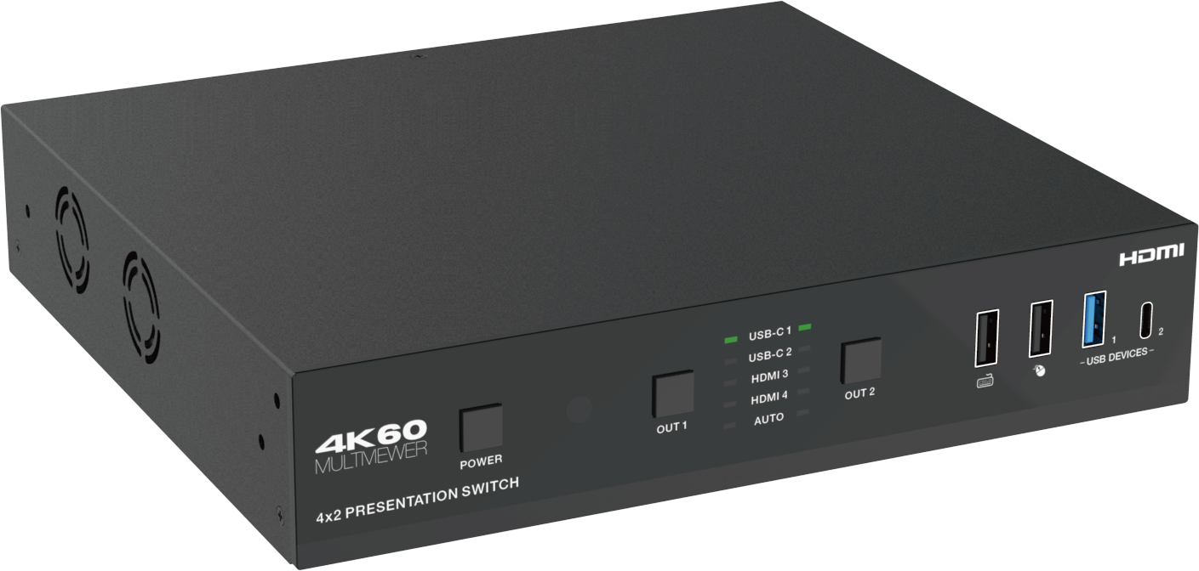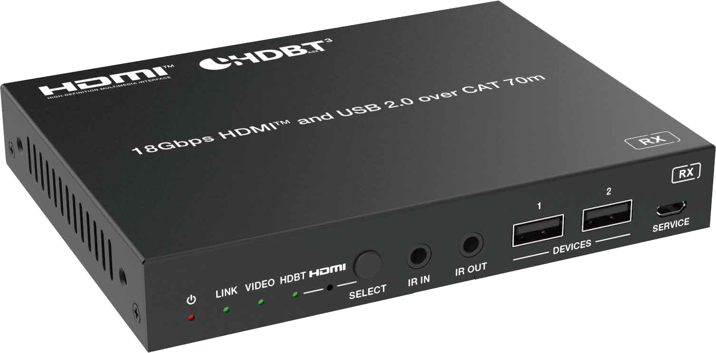



VER 1.0

Thank you for purchasing this product
For optimum performance and safety, please read these instructions carefully before connecting, operating or adjusting this product. Please keep this manual for future reference.

Surge protection device recommended
This product contains sensitive electrical components that may be damaged by electrical spikes, surges, electric shock, lighting strikes, etc. Use of surge protection systems is highly recommended in order to protect and extend the life of your equipment.

Caution
The product requires the use of UTP connectors. Please connect in direct interconnection method and do not cross connect.

White and Orange Orange
White and Green Blue
White and Blue Green
White and Brown Brown

Direct Interconnection Method

Table of Contents
- Introduction. 1
- Features. 1
- Package Contents. 2
- Specifications. 2
- Operation Controls and Functions. 4
  - Switch Panel. 4
  - HDBaseT Receiver Panel. 7
- IR Remote 8
- IR Cable Pin Assignment. 9
- Multiview. 9
- Keyboard & Mouse Hotkey Function 10
- Web GUI Operation Guide 11
- RS-232 Control Command 23
- Connection Diagram. 40

Introduction
The 4x2 seamless presentation switch supports video resolutions up to 4K@60Hz 4:4:4 8bit deep color and HDCP 2.3 compliant, it features multi-view function for multi sources can be displayed on single screen. This presentation switch supports two HDMI outputs and one HDBaseT 3.0 mirrored with HDMI OUT2 output and HDBaseT 3.0 extending uncompressed 4K60Hz 4:4:4 up to 132ft/40m or 4K30Hz/1080P60Hz up to 230ft/70m via single Cat6A cable.

This presentation switch features four video inputs: two USB-C and two HDMI inputs. Each USB-C input supports DisplayPort alternate mode A/V up to 4K@60Hz 4:4:4 8bit deep color, USB 3.2 Gen 1 5Gbps data and up to 60 watts power charging to USB-C source device. It also features 1Gbps Ethernet over USB-C functionality to allow USB-C source device to access internet seamlessly. Local USB 3.2 KVM switching and extending USB 2.0 high speed over HDBaseT 3.0 can be allowed to connect external USB 2.0 devices or cameras from RX remote side for video conference.

This presentation switch supports audio embedded and de-embedded, it built-in audio DSP with audio mixing, matrixing, independent EQ/volume/delay adjustment. It also supports Dante 2x2 audio input and output interface, and it can be seamlessly connected to any existing audio processing system with Dante enabled.

This presentation switch can be controlled via front panel buttons, IR remote control, API commands using RS-232 or TCP/IP. A Web server / GUI is built in that features A/V control, automatic display control and input EDID management. The product is ideal for software- based video teleconference rooms.

Features
Video resolution up to 4K@60Hz 4:4:4, as specified in HDMI 2.0b HDCP 2.3, DP 1.4 and HDBase 3.0 compliant
USB 3.2 Gen 1 up to 5Gbps
4x2 seamless switching (single screen) and fast switching (multiview) function Manual switching or auto switching mode
Multiple multiview display modes: Auto/Single/PIP/PBP/Triple/Quad/Custom Input: 2x USB-C, 2x HDMI, 1x Analog audio, 1x Dante 2ch
Output: 1x HDMI, 1x HDMI + HDBaseT mirrored, 1x Analog audio, 1x Dante 2ch
USB-C supports DisplayPort Alternate mode for A/V, USB 3.2, 1G LAN and 60W charging Local USB 3.2 switching and extending USB 2.0 over HDBaseT 3.0
Local USB KVM hotkeys and mouse switching
Uncompressed 4K60 4:4:4 over HDBaseT 3.0 up to 132ft/40m via single CAT6A cable Uncompressed 1080P&4K30 over HDBaseT 3.0 up to 230ft/70m via single CAT6A cable Audio embedded and de-embedded
Audio DSP for gain, equalizer, volume and delay Dante 2x2 audio input and output
CEC/RS-232 control external devices ON/OFF Advanced EDID management
Support standard PoE power supply from TX to RX (TX_PSE, RX_PD)
Flexible control via front panel buttons, IR remote, RS-232, TCP/IP or Web GUI

1 / 40

Package Contents
1x 4x2 Seamless Presentation Switch 1x HDBaseT Receiver

11
1x IR Blaster Cable (1.5 meters)
1x IR Wideband Receiver Cable (1.5 meters) 3x 3pin-3.5mm Phoenix Connector (male)
3x 5pin-3.5mm Phoenix Connector (male) 4x Mounting Ear
8x Machine Screw
1x 24V/8A Desktop Power Supply & 1 x AC Power Cord (1.5 meters) 1x IR Remote
1x User Manual

