Quick Start Guide
SCA31-BYOM

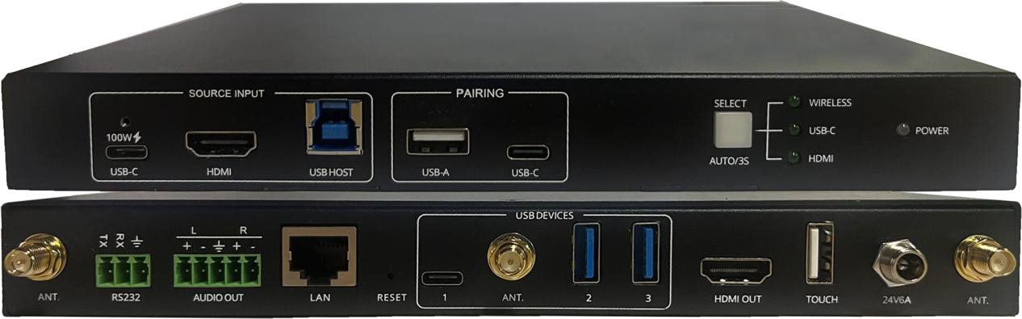

Description:
VC31 is a 3x1 BYOM switcher, it provides A/V and USB auto switching between HDMI, USB-C and wireless connected sources, with one device it can meet different people with different preference, people can choose wired connection if they want a high quality and reliable video conference, meantime it also enables wireless connection if people prefer convenient and cable-free BYOM experience.

VC31 Interfaces:

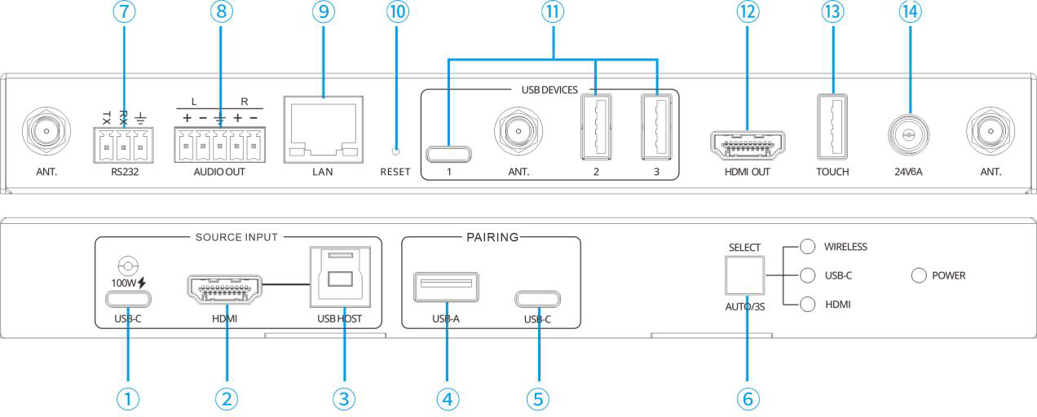

① USB-C port to connect with PC
② HDMI port to connect with PC
③ USB-B to connect with HDMI PC
④ USB-A for HDMI dongle for paring
⑤ USB-C for USB-C dongle pairing
⑥ Button to switch the source
⑦ RS232 for control
⑧ Balanced analog audio
⑨ RJ45 for LAN and control
⑩ Reset hole
⑪ 2x USB-A 3.0 ports, 1x USB-C for USB devices like camera or speakerphone
⑫ HDMI out
⑬ Touch HID for HDMI screen
⑭ 24V/6A power

Specification:

Video:
Input video: 1x USB-C input, DisplayPort alt mode 4K@60Hz 4:4:4. 18Gbps, 100W charging; 1x HDMI 2.0b input, 4K@60Hz 4:4:4. 18Gbps CEC, HDR
Output video: 1x HDMI 2.0b output, 4K@60Hz 4:4:4. 18Gbps CEC, HDR, Max data rate: 18Gbps
Max pixel clock: 600Mhz
Resolution: Up to 4K (4096x2160) @60 Hz 4:4:4 HDCP compliance: HDCP 2.2 and 1.4 compatible
Wireless: IEEE 802.11n/ac 2.4 GHz / 5 GHz, WPA, WPA2, PSK

IP:
Supports Static IP and DHCP (with no DHCP server available in DHCP mode it will use auto IP 169.254.x.x). Static IP is default and 192.168.0.178. Toggle between static and DHCP easy by pressing and holding select button for 10 sec (power led will blink twice to confirm)
Supports following protocol: DHCP, HTTP, Telnet, TCP/IP Security: IEEE 802.1x, HTTPS, TLS , PEAP/TTLS

Control/Data:
TCP/IP: 1x RJ45 port, 10/100/1000Base-T half/full duplex with auto negotiation. Serial RS232: 1x 3 pin Phoenix connector RX-TX-GND BAUD 2400-115200 Ethernet: 1x RJ45, 10/100/1000Base-T, half/full duplex with auto negotiation
USB: 2x USB 3.2 Gen 1 Type A ports, 1x USB-C (USB 3.0) for USB devices up to 5Gbps. 1x USB 3.2 Gen 1 Type B port for USB Host in link with the HDMI input. Up to 5Gbps
1x USB-C for host, support USB 3.0
USB-C: USB2.0 for USB-C dongle pairing USB-A: USB2.0 for HDMI dongle pairing

System Diagram:
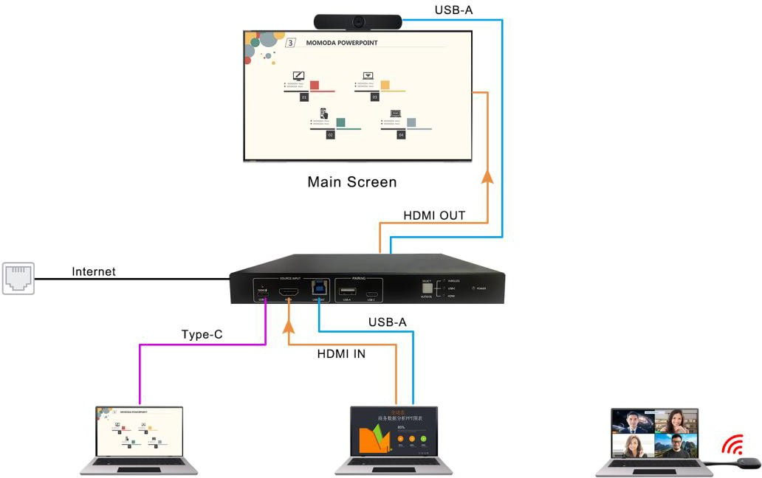

Features:
-Enable wireless sharing from Airplay, Miracast, Chromecast, App and 4K dongles
-Enable wireless BYOM with both Windows and Macbook
-Enable wired BYOM with HDMI and USB connection, getting 4K@60 A/V, USB 3.0 devices and 1G network
-Enable wired BYOM with single USB-C connection, getting 4K@60 A/V, 100W power charging, USB 3.0 devices and 1G network
-Enable A/V and USB auto switching between HDMI, USB-C and wireless connected sources
-Enable touch back control with both wired and wireless connected PC
--Provide balanced audio breakout
-Provide both RS232 and Telnet control

Quick to Start

Wireless Casting

  - Wireless Casting by Dongle
- Make sure the dongle is already paired with VC31
- Plug the dongle into the USB port of laptop
- When the connection is completed, the LED becomes static green
- Then press the main button and the screen is shared
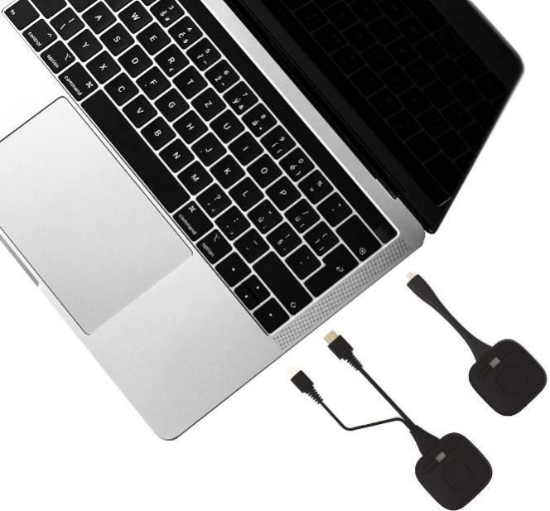

  - Wireless Casting by APP
    - Ensure the laptop and base unit are in the same network, there are 2 options, option 1, the laptop can connect with the base unit directly via the SSID and password indicated in the home page as below, optional 2, the laptop can connect with the wifi router which is in the same LAN that base unit is connected.

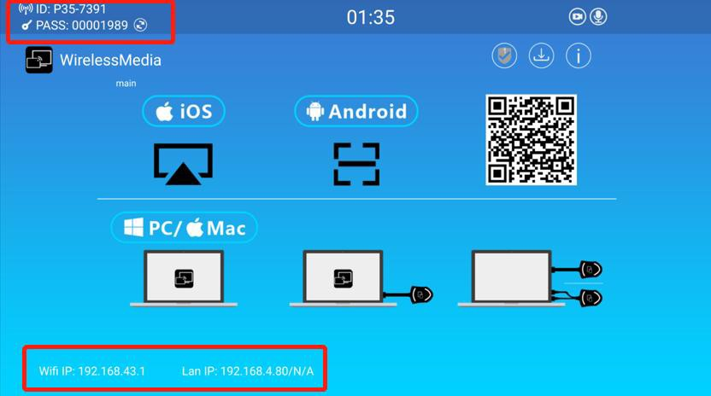

    - For option 1 network, please use the wifi IP address indicated in the home page to enter the Web UI. For option 2 network, please use the LAN IP address indicated in the home page to enter the Web UI.
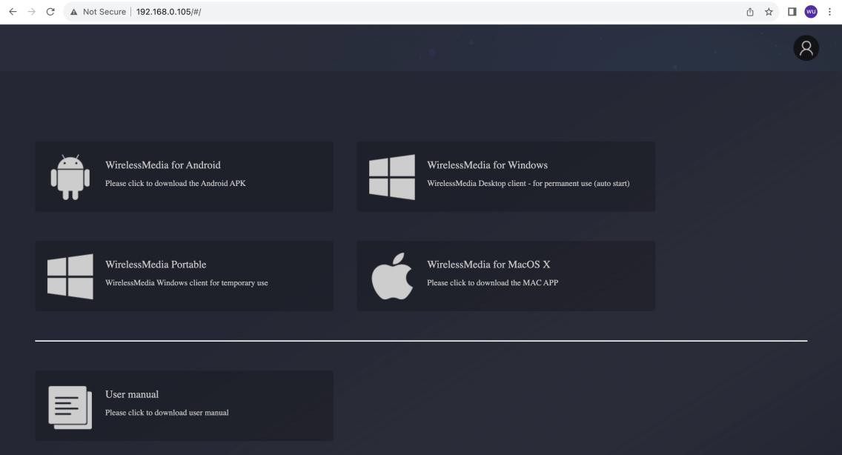
    - Download WirelessMedia App from Web UI.
    - Click the “WirelessMedia App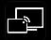 to start to share content
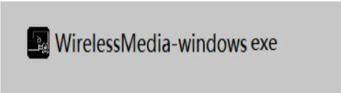

    - Click the WirelessMedia App “Ready to share” and the content is shared

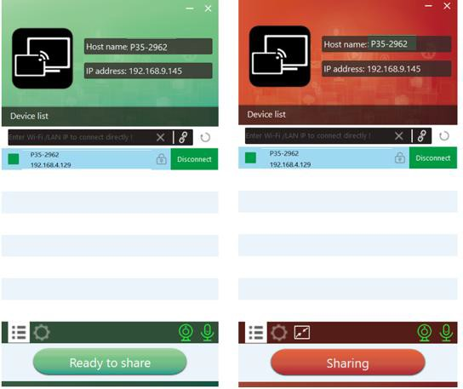

  - Screen Casting by Android App
Download the application namely “WirelessMedia” (for example scan QR-Code in Home screen) in Android Google Play market for Android mobile device.
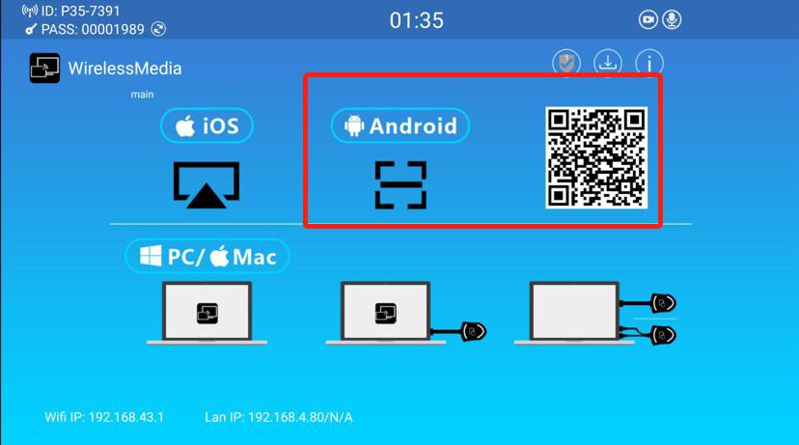

  - Screen Casting by Miracast
    - Make sure the Wi-Fi or WLAN is enabled. Click the PC bottom right corner operation zone icon as below.

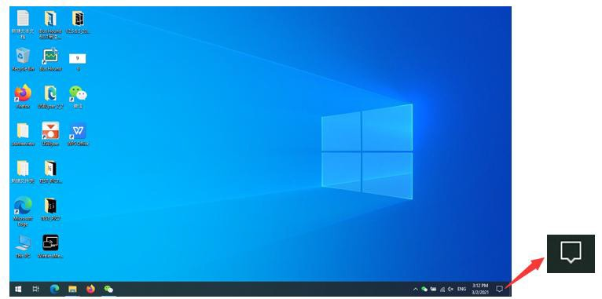
    - Click “project” icon to enter password on home screen to connect and mirror.
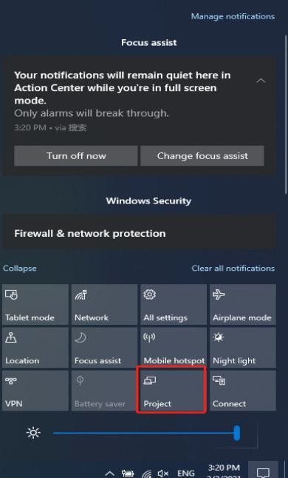
    - Click the “project” icon again, disconnect to stop mirroring.

  - Screen Casting by Airplay
For IOS devices, use Airplay to mirror the screen.
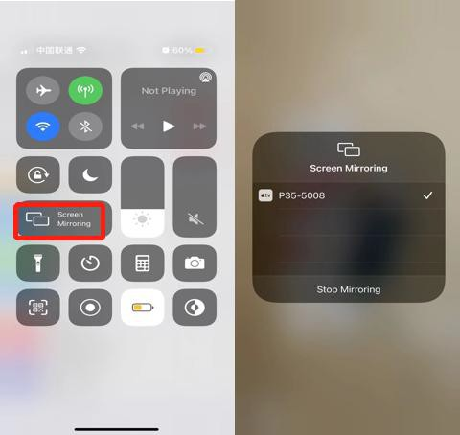

Wired input

You can also choose to connect HDMI or USB-C cable to your PC or other sources for local content share

Wireless BYOM via dongle

-Make sure the dongle is already paired with VC31
-Connect the transmitter to the computer and then launch Video Conferencing application.
-Select “Meeting Camera” as video device:
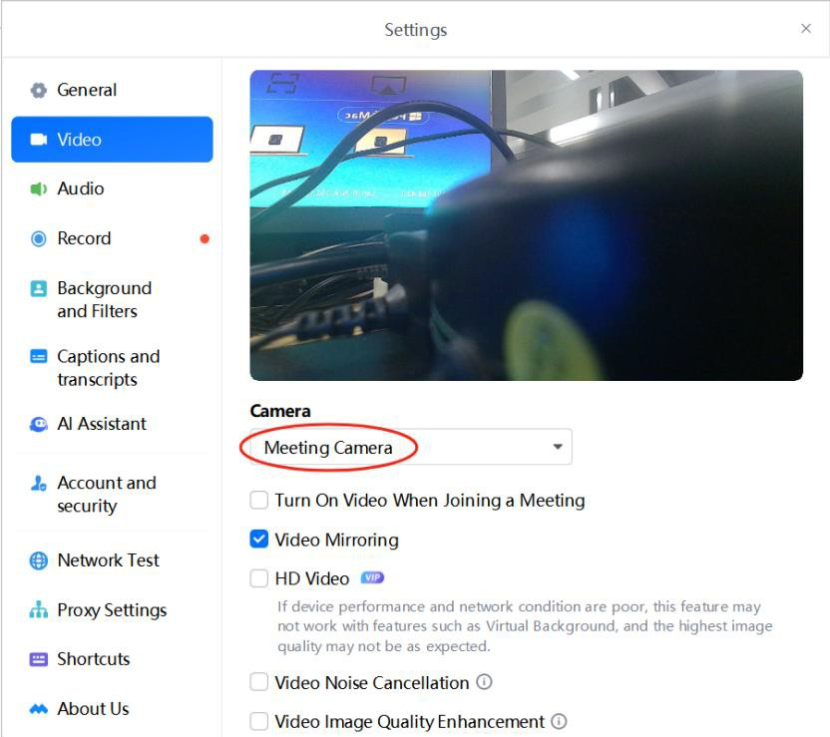

For Speaker & Microphone, select “ Meeting Audio” .
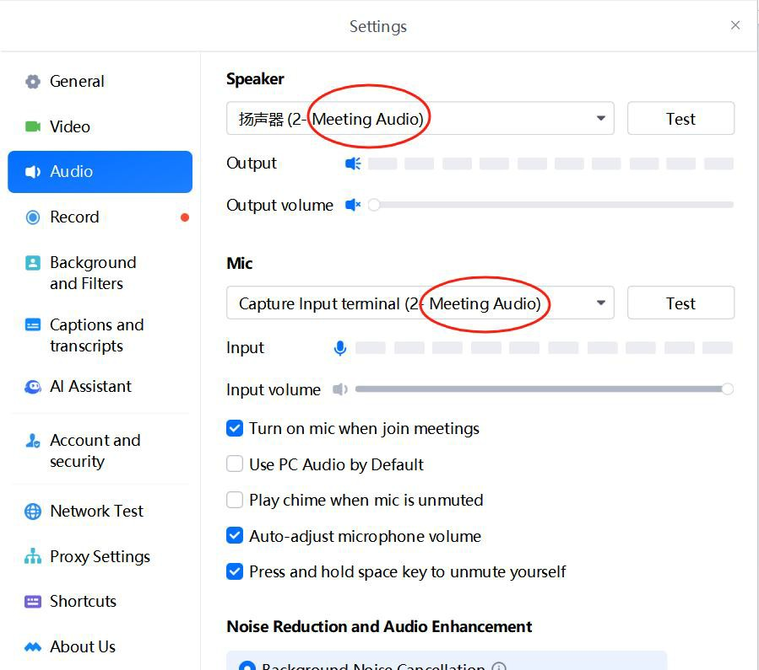

Wired BYOM

  - For PC with HDMI port, you can connect it with VC31 by HDMI cable plus USB cable; for PC with USB-C port that supports DP Alt mode, you can connect it with VC31 by single USB-C cable.
  - Launch the video conference App like Teams/Zoom, select the camera device name.
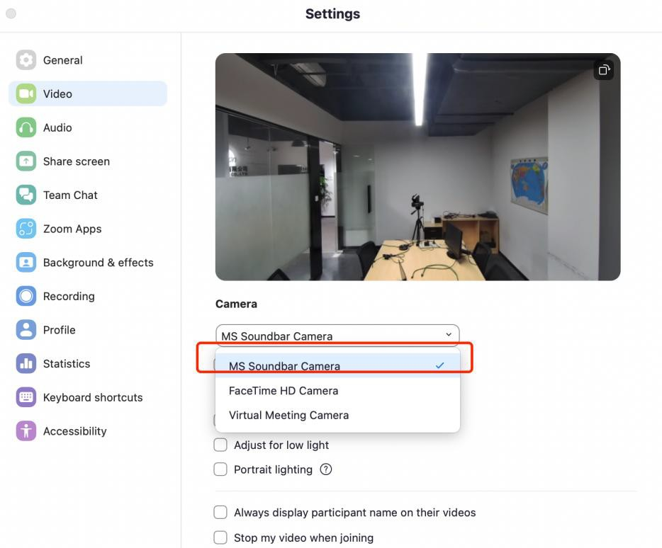

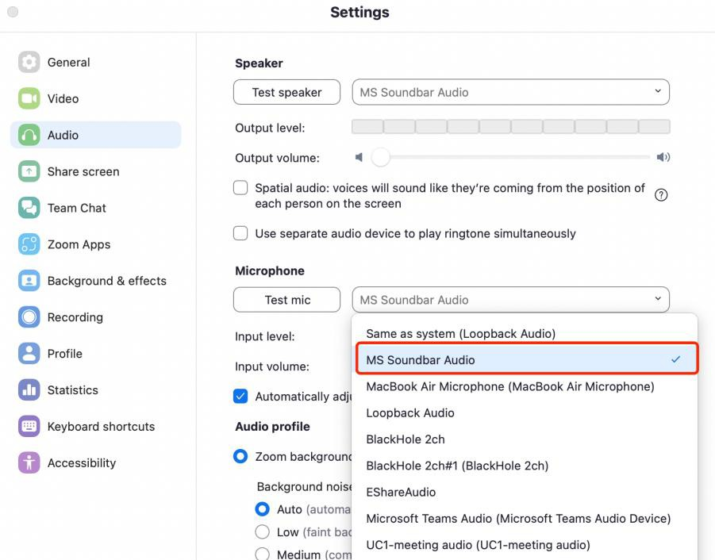
Select the speaker/mic device name from the Audio list:
Note:
-When the LAN port of VC31 is connected with internet cable, then your PC can access internet by default with USB-A or USB-C cable connection.
-If your PC’s USB-C port supports PD charging, it can get up to 100 W power charging.

Video Switching Logic
-Auto (default)
Auto means last connect in, but if no wired source connected, then go back to welcome page.
Priority settings between USB-C and HDMI, means when both HDMI and USB-C sources are connected and device is rebooted, which source should be displayed on the screen.
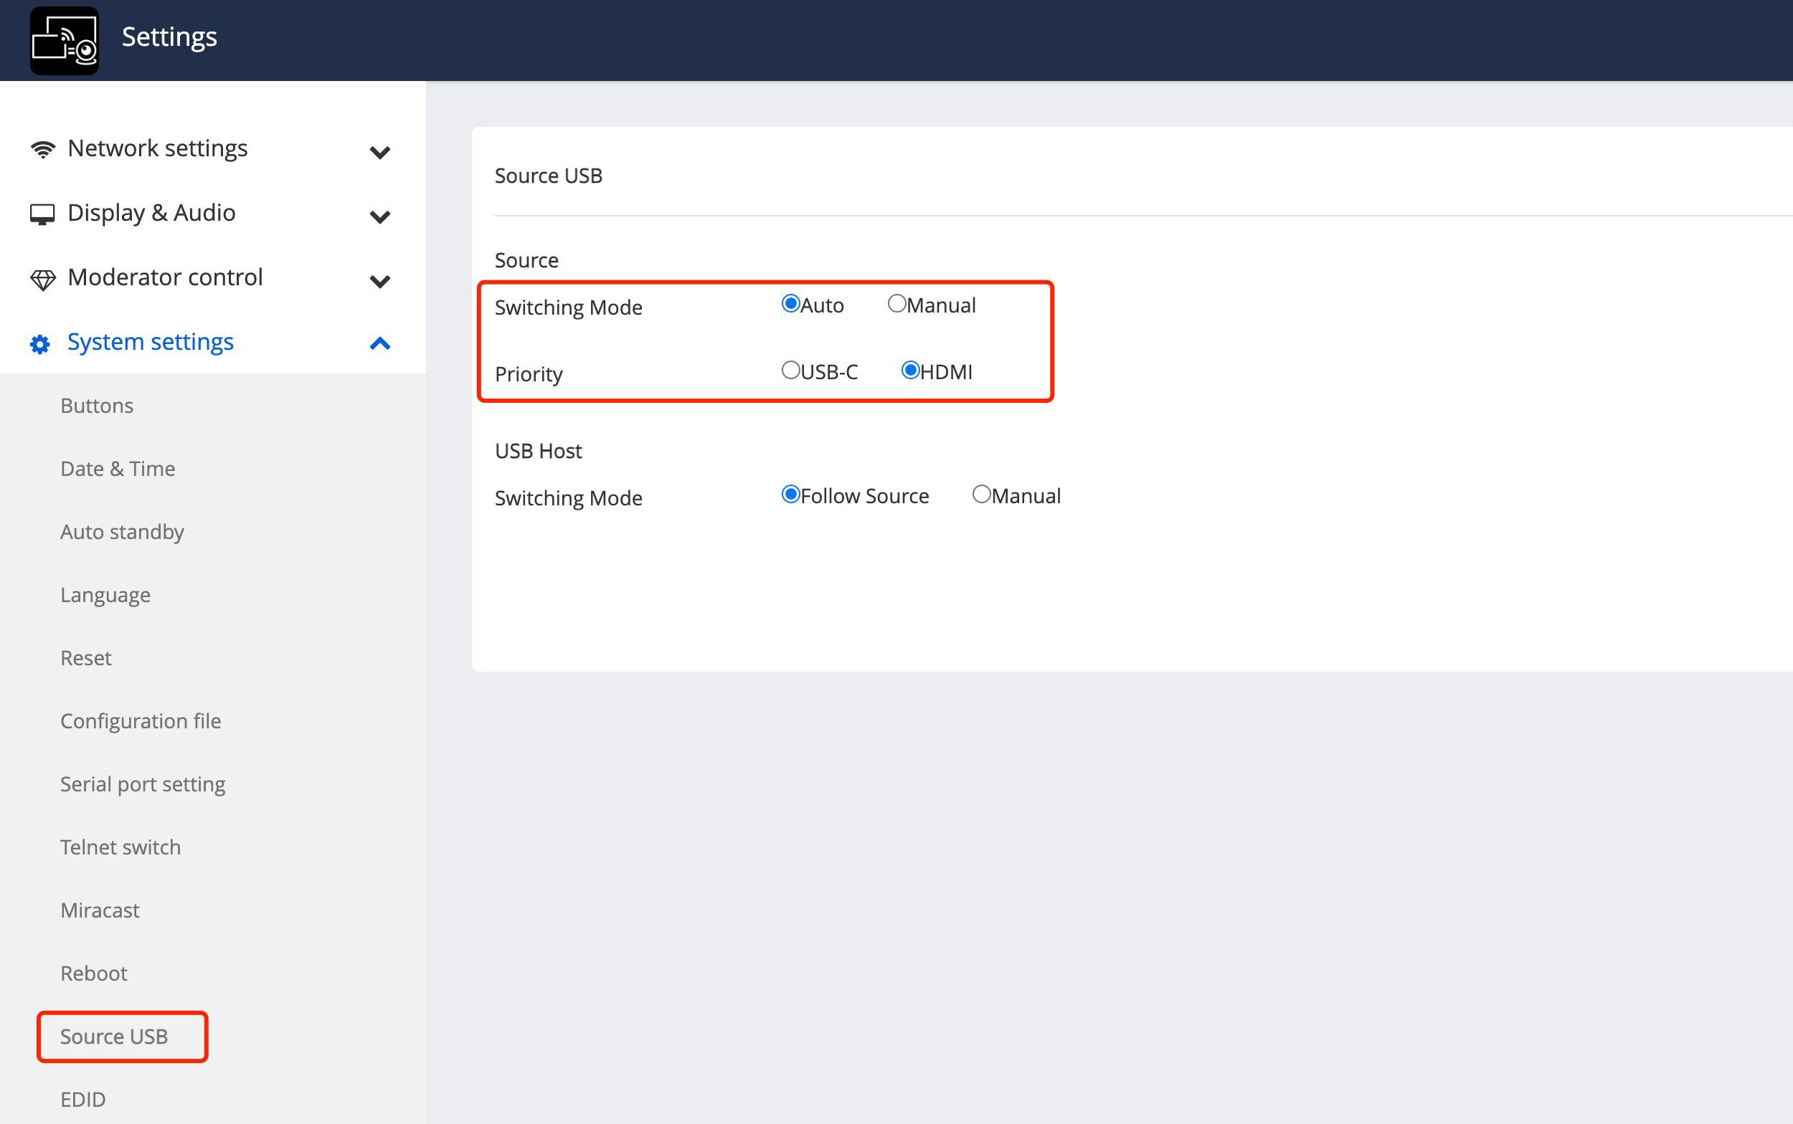

-Manual
Manual switching the sources by loop pressing the button or choose in the web, long press the button for 3 seconds and then release to activate the auto mode

USB Switching Logic
-Follow the source
Means the usb devices will follow the source that is active on the screen
-Manual
Manual switching the USB host in the web or by API commands

