MAT.USB44U3C

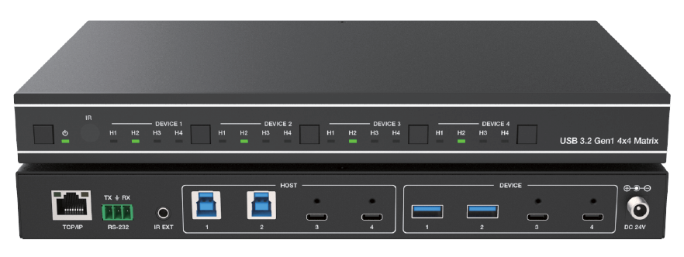


VER 1.0

Thank you for purchasing this product
For optimum performance and safety, please read these instructions carefully before connecting, operating or adjusting this product. Please keep this manual for future reference.

Surge protection device recommended
This product contains sensitive electrical components that may be damaged by electrical spikes, surges, electric shock, lighting strikes, etc. Use of surge protection systems is highly recommended in order to protect and extend the life of your equipment.

Caution
The product requires the use of UTP connectors. Please connect in direct interconnection method and do not cross connect.

White and Orange Orange
White and Green Blue
White and Blue Green
White and Brown Brown
Direct Interconnection Method

Table of Contents
- Introduction 1
- Features 1
- Package Contents. 1
- Specifications. 2
- Operation Controls and Functions. 3
- IR Remote. 4
- IR Cable Pin Assignment. 4
- Web GUI User Guide. 5
- API Commands. 9
- Application Example. 13

Introduction
This is a 4x4 matrix allowing 4 USB devices to be shared between 4 host computers. It supports plug-and-play, and allows for a neat and tidy installation - the connecting cables are bundled to save the extra cost of purchasing USB cables. It is USB 3.2 Gen 1 compliant, which can support data transfer rate up to 5Gbps and backwards compatible with USB 2.0 and USB 1.1. It is perfect for high-bandwidth devices, such as USB docking stations or HD cameras. In addition, It also features TCP/IP port, RS-232 command port and select buttons, which can simplify desktop layout and allow the desired routes to be selected manually. With its compact and all-in-one design, you can create a space saving, convenient and productive work environment.

Features
☆ Enables 4 computers to share 4 USB 3.2 Gen1 devices
☆ USB 3.2 Gen 1 compliant, supporting data transfer rates of up to 5Gbps
☆ LED indicates which host is active
☆ Over-current protection
☆ Two USB-A device ports with 5V/1.5A power output and two USB-C device ports with 5V/3A power output
☆ USB device ports compliant with USB 3.2 Gen 1, USB 2.0 and USB 1.1
☆ Support USB Multiple Transaction Translator architecture
☆ Plug and Play – no drivers or external power adapter needed
☆ Multiplatform support – Windows, Linux and Mac
☆ Control via front panel buttons, IR remote, RS-232, and Web GUI

Package Contents
① 1 × 4x4 USB 3.2 Gen 1 Matrix
② 1 × 24V/2.7A Multinational Locking Power Supply
③ 1 × IR Remote
④ 1 × IR Wideband Receiver Cable (1.5m)
⑤ 2 × USB Cable (USB 3.0 Type A to Type B, 1.8m)
⑥ 1 × 3pin-3.81mm Phoenix Connector
⑦ 4 × Machine Screw (KM3*4)
⑧ 2 × Mounting Ear
⑨ 1 × User Manual

Specifications

Technical
USB Protocol | USB 3.2 Gen 1
Data Transfer Rate | 5Gbps
IR Level | 5Vp-p
IR Frequency | Fixed 38KHz
Transmission Distance | 3m/9.8ft for USB 3.2 Gen 1 5Gbps over passive cable
ESD Protection | IEC 61000-4-2:  ±8kV (Air-gap discharge) & ±4kV (Contact discharge)
Connection
Input ports | 2× USB Host [USB 3.2 Gen 1 Type B, 9-pin female] 2× USB Host [USB 3.2 Gen 1 Type C, 24-pin female]
Output ports | 2× USB Device [USB 3.2 Gen 1 Type A, 9-pin female] 2× USB Device [USB 3.2 Gen 1 Type C, 24-pin female]
Control ports | 1 × TCP/IP [RJ45]  1 × RS-232 [3pin-3.81mm phoenix connector] 1 × IR EXT [3.5mm stereo mini-jack]
Mechanical
Housing | Metal Enclosure
Color | Black
Dimensions | 270mm [W] × 166mm [D] × 30mm [H]
Weight | 1.16kg
Power Supply | Input: AC 100-240V 50/60Hz, Output: DC 24V/2.7A  (US/EU standard, CE/FCC/UL certified)
Power Consumption | 13.2W (Max)
Operating Temperature | 32 - 104°F / 0 - 40°C
Storage Temperature | -4 - 140°F / -20 - 60°C
Operating Humidity | 20%~80% relative humidity, non-condensing
Storage Humidity | 10%~90% relative humidity, non-condensing

Operation Controls and Functions

Front & Rear Panel
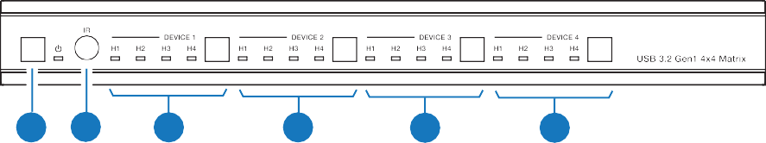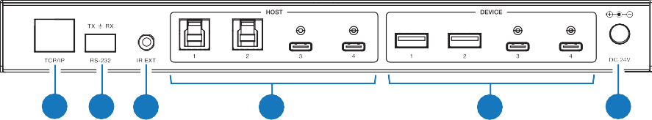
1 2
3
4
5
6
7 8 9
10
11
12

NO. | Name | Function Description
1 | Power button & indicator | Short press the button to power on the matrix, and at this moment the LED is green;  Long press the button for 3 seconds to set it to standby mode, and at this moment the LED is red.
2 | IR | IR signal receiver, receiving the signal from the IR remote.
3 | DEVICE 1 button  & H1~H4 indicators | Press the button to switch the host in order of H1~H4 circularly for device 1.  When the host is selected, the corresponding LED will be on.
4 | DEVICE 2 button  & H1~H4 indicators | Press the button to switch the host in order of H1~H4 circularly for device 2.  When the host is selected, the corresponding LED will be on.
5 | DEVICE 3 button  & H1~H4 indicators | Press the button to switch the host in order of H1~H4 circularly for device 3.  When the host is selected, the corresponding LED will be on.
6 | DEVICE 4 button  & H1~H4 indicators | Press the button to switch the host in order of H1~H4 circularly for device 4.  When the host is selected, the corresponding LED will be on.
7 | TCP/IP | 100M LAN port for Web GUI and TCP/IP control, connected to a router or network switch.
8 | RS-232 | RS-232 serial port, connected to a PC or control system for RS-232 command control.
9 | IR EXT | IR signal receiving port, connected with 38KHz IR Receiver cable. If the IR signal receiving window of the unit is blocked or the unit is installed in a closed area out of infrared line of sight, the IR receiver cable can be inserted to the “IR EXT” port to receive the IR remote signal.
10 | HOST 1~2 | USB-B host ports, connected to PC or host.

NO. | Name | Function Description
11 | HOST 3~4 | USB-C host ports, connected to PC or host.
12 | DEVICE 1~2 | USB-A device ports, with output power up to 5V/1.5A, connected to USB devices such as U disk, keyboard or mouse.  Note: The USB 3.2 Gen 1 ports do not support DisplayPort™ Video (DP Alt Mode) or Power Delivery (PD).
13 | DEVICE 3~4 | USB-C device ports, with output power up to 5V/3A, connected to USB devices such as U disk, keyboard or mouse.  Note: The USB 3.2 Gen 1 ports do not support DisplayPort™ Video (DP Alt Mode) or Power Delivery (PD).
14 | DC 24V | DC 24V/2.7A power input port.

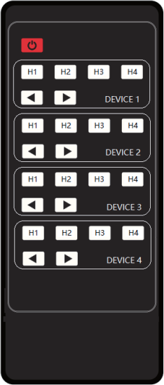
IR Remote

:
Power on the Matrix or set it to standby mode.

DEVICE 1:
Press H1\H2\H3\H4 button to select the host for DEVICE 1.

DEVICE 2:
Press H1\H2\H3\H4 button to select the host for DEVICE 2.

DEVICE 3:
Press H1\H2\H3\H4 button to select the host for DEVICE 3.

DEVICE 4:
Press H1\H2\H3\H4 button to select the host for DEVICE 4.
◄ ►:
Press to select the last or next host.

IR Cable Pin Assignment
IR Receiver
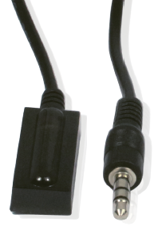
IR RECEIVER

IR Signal

Power Grounding

Web GUI User Guide
The Matrix can be controlled by Web GUI. The operation method is shown as below:
Step 1: Get the current IP Address.
The default IP address is 192.168.0.100. You can get the current Matrix IP address via API command. Send the command “get ip addr” through an ASCII Command tool, then you’ll get the feedback information as shown below:

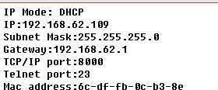IP Mode: Static
IP: 192.168.0.100
Subnet Mask: 255.255.255.0 Gateway: 192.168.0.1
TCP/IP port=8000 Telnet port=23
Mac address: 00:1c:91:03:80:01
IP:192.168.0.100 in the above figure is the IP Address of the Matrix (the IP address is variable, depending on what the specific machine returns).
For the details of ASCII control, please refer to “9. API Commands”.
Step 2: Connect the TCP/IP port of the Matrix to a PC with an UTP cable, and set the IP address of the PC to be in the same network segment with the Matrix.
For example, if its IP address is 192.168.62.106, the IP address of PC must be set to 192.168.62.xxx; if its IP address is 192.168.0.100, the IP address of PC must be set to 192.168.0.xxx.
Step 3: Enter the IP address of the Matrix into your browser on the PC. After entering the Web GUI page, there will be a Login page, as shown below:
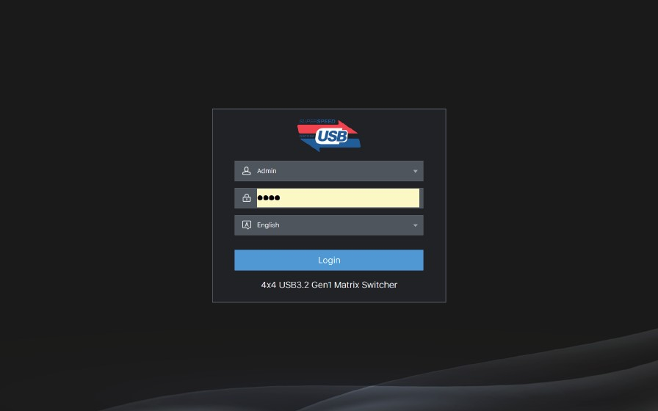

Select the username "Admin", enter the default password "1234", select the desired language, and then click "Login". The web page provides the following tabs for navigating the interface:

Information Page
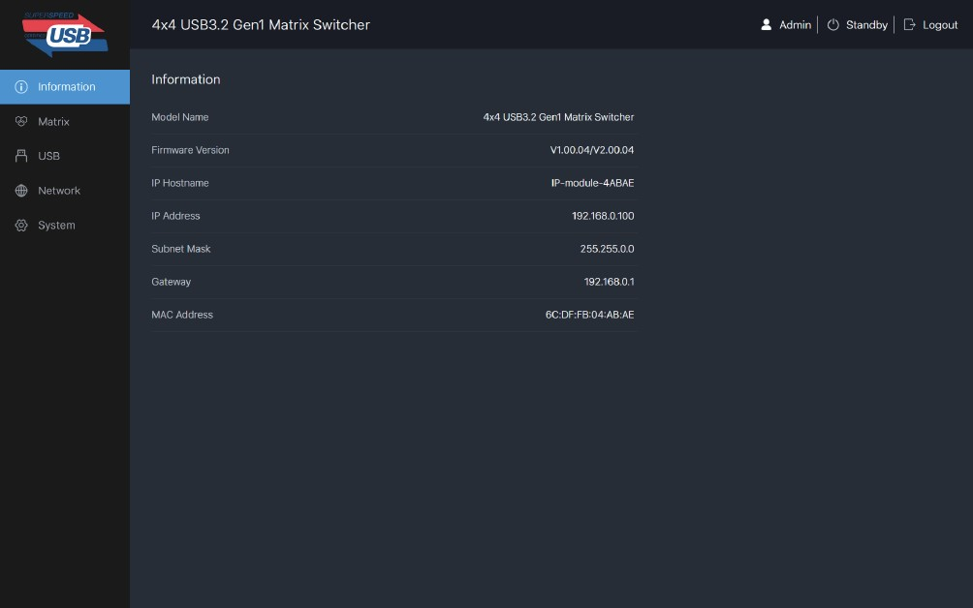
The Information page provides basic information about the Model, the installed
firmware version and the network settings of the device.
The buttons at the top right of the web interface are always available:
- Clicking the Logout button will log out of current user.
- Clicking the Standby button will set the matrix to standby mode.

Matrix Page
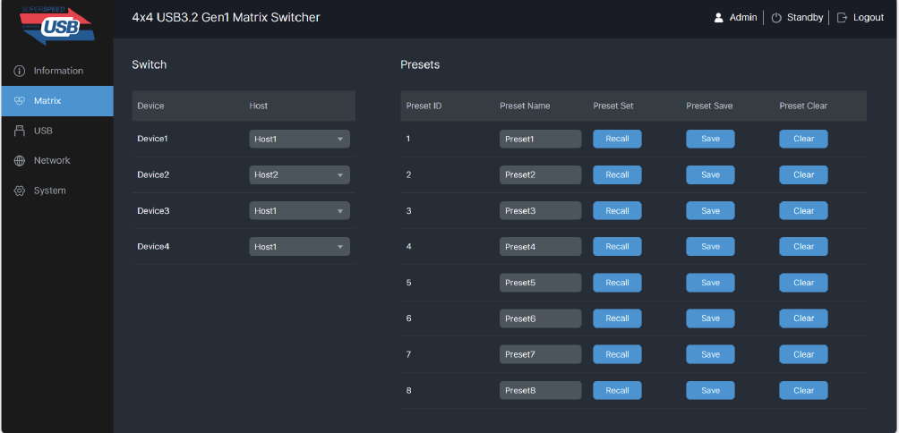

You can do the following operations on the Matrix page:
① Switch: Select the host for device1/2/3/4.
② Presets: Recall, save and clear the presets. 8 presets are allowed to be set. For example, a group of devices and hosts is configured, and click "Save" button to save this preset and name it "Preset1" or other. Then you can recall or clear it via clicking Recall or Clear if needed.

USB Page
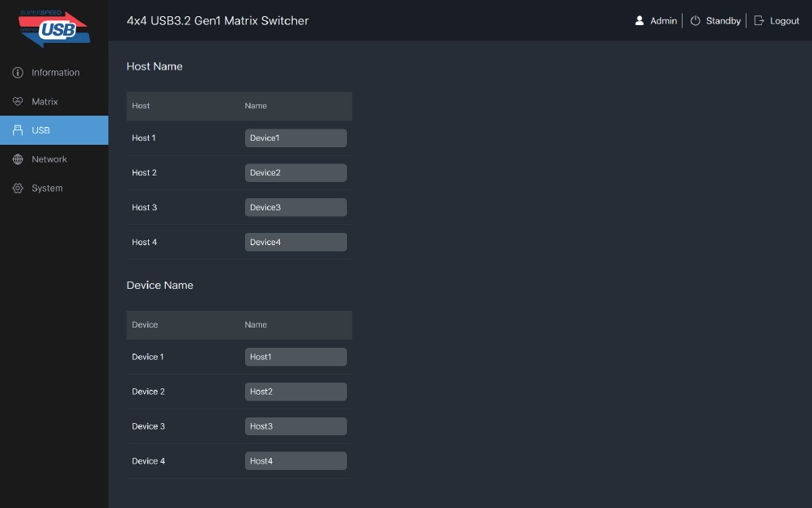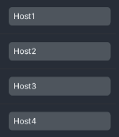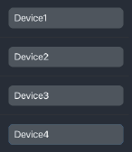

You can rename each host or device on the USB page. The maximum length of Name is 16 characters.

Network Page
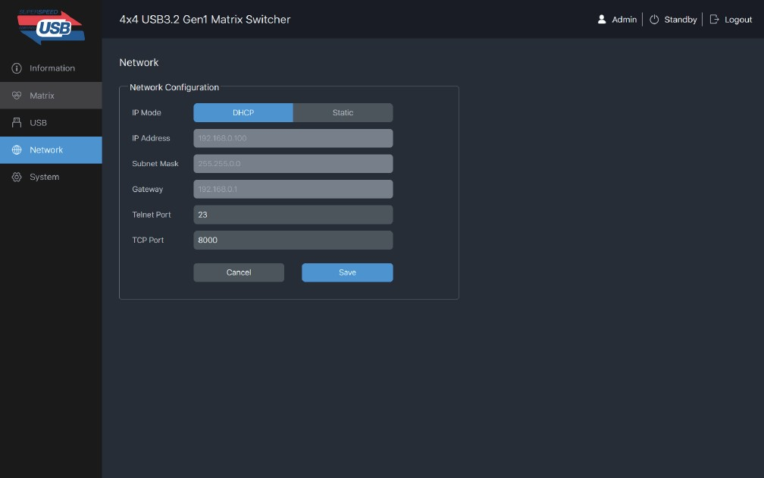

You can modify the IP Mode/IP Address/Gateway/Subnet Mask/Telnet Port/ Domain Name as required on the Network page. Click “Save” to save the settings, and then it will come into effect.
If the Mode is “DHCP”, it will search and be filled with the IP Address assigned by the router automatically. You can't modify it now.
If the Mode is “Static”, you can set manually the IP Address/Gateway/Subnet/Telnet Port as required.

System Page
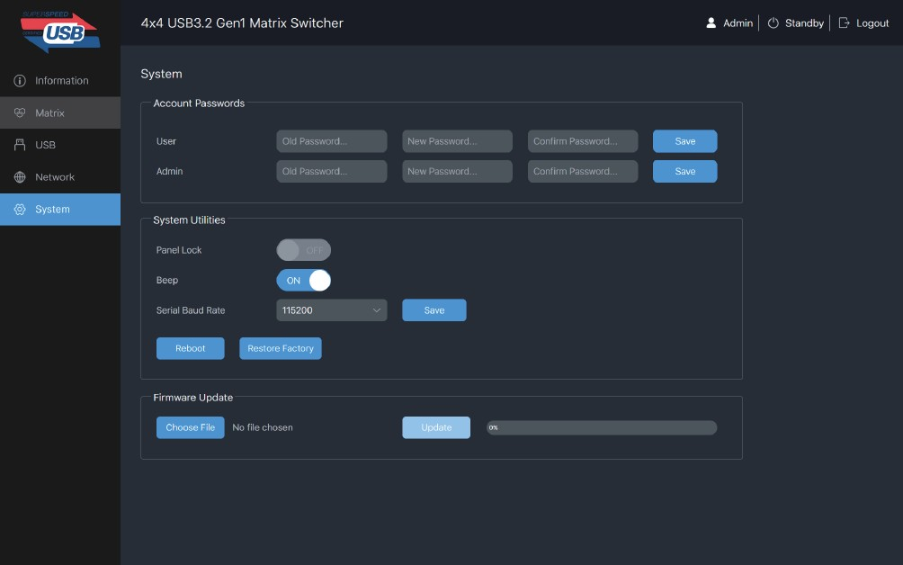

You can do the following operations on the System page:
① Account Passwords: Enter the correct Old Password, New Password, and Confirm Password, and then click “Save”.
Note: Input rules for changing passwords:
- The password can’t be empty.
- New Password can’t be the same as Old Password.
- New Password and Confirm Password must be the same.

② System Utilities:
Panel Lock: Enable or disable the select buttons on the front panel.
Beep: Turn on or turn off the beep.
Serial Baud Rate: Set and save the baud rate: 4800/9600/19200/38400/115200/57600. You can also reboot or restore factory via clicking the corresponding buttons.
③ Firmware Update: Support update for MCU and Web. Choose the update file first,
and then click Update.

API Commands
The product also supports API commands control. Connect the RS-232 port of the matrix to a control system. The connection method is as follows.
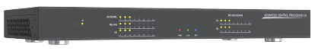
Integrated Control System
PC

Then, open a Serial Command tool on PC connected to the control system and send ASCII command to control the Matrix. The ASCII command list is shown below.

ASCII Command
Serial port protocol. Baud rate: 115200 (default), Data bits: 8bit, Stop bits:1, Check bit: 0
x,y,z, XXX are parameters
Error Code describe:
E00 -> unkown command, E01 -> parameter out of range
Command Code | Function Description | Example | Feedback | Default
System Setting
? | List all commands | ?
help | List all commands | help
status | Get device current status | status | get the unit all status: power, beep, USB crosspoint, network status
get model | Get device model | get model | 4x4 USB 3.2 Gen 1  Matrix
get version | Get firmware version | get version | mcu fw version: 1.00.00  web gui version: 1.00.00
set power x | Power on/off the  device(z=0~1) | set power x | power on  system initializing... mcu fw version: 1.00.00  web gui version: 1.00.00  initialization finished! | power 1
get power | Get current power state | get power | power on /power off

Command Code | Function Description | Example | Feedback | Default
System Setting
set beep x | Enable/disable buzzer function,z=0~1(z=0 beep off, z=1 beep on) | set beep 0 | beep on  beep off | beep on
get beep | Get buzzer state | get beep | beep on / beep off
set lock x | Lock/unlock front panel button,z=0~1(z=0 lock off,z=1 lock on) | set lock 0 | panel button lock on  panel button lock off | panel button lock off
get lock | Get panel button lock state | get lock | panel button lock on/off
set baud rate x | Set RS232 baudrate x=1~6(1:115200, 2:57600,  3:38400, 4:19200, 5:9600,  6:4800) | set baud rate 1 | baudrate:115200 | baudrate: 115200
get baud rate | Get the serial port baud rate of rs02 module | get baud rate | baudrate:115200
reboot | Reboot the device | reboot | reboot...  system initializing... mcu fw version: 1.00.00  web gui version: 1.00.00  initialization finished!
reset | Reset to factory defaults | reset | reset to factory defaults system initializing... mcu fw version: 1.00.00  web gui version: 1.00.00  initialization finished!
USB Matrix Setting
set device x in host y | Route usb device x to host y (x=1~4, y=1~4)  x=1. device 1  x=2. device 2  x=3. device 3  x=4. device 4  y=1. host1 y=2. host2 y=3. host3 y=4. host4 | set device 1  in host 1 | set device 1 in host 1 | device  - >host 1 device  - >host 1 device  - >host 1 device  - >host 1
get device x in host | Get device x selected host(x=1~4) | get device 1 in host | device 1 in host 3
set save preset x | Save matrix state of all device and the host to preset z, z=1~8 | set save preset 1 | save to preset 2: device1 connect to host1 device2 connect to host1 device3 connect to host1 device4 connect to host1 | no preset

Command Code | Function Description | Example | Feedback | Default
USB Matrix Setting
set recall preset x | Call saved preset z scenarios, z=1~8 | set recall preset 1 | recall from preset 1: device1 connect to host1  device2 connect to host1  device3 connect to host1  device4 connect to host1 | no preset
set clear preset x | Clear stored preset z scenarios, z=1~8 | set clear preset 1 | clear preset 1 | no preset
get preset x | Get preset z information, z=1~8 | get preset 1 | preset 1:  device 1->host 1  device 2->host 2  device 3->host 3  device 4->host 4
Network Setting
get ipconfig | Get the current ip  configuration | get ipconfig | ip mode: static ip: 192.168.0.100  subnet mask: 255.255.255.0  gateway: 192.168.0.1  tcp/ip port=8000 telnet port=23 mac address: 00:1c:91:03:80:01
get mac addr | Get network mac address | get mac addr | mac address: 00:1c:91:03:80:01
set ip mode z | Set network ip mode to static ip or dhcp, z=0~1 (z=0 static, z=1 dhcp ) | set ip mode 0 | set ip mode:static. (please use "s net reboot!" command or repower device to apply new config!) | ip mode:dhcp
get ip mode | Get network ip mode | get ip mode | ip mode: static
set ip addr xxx. xxx.xxx.xxx | Set network ip address | set ip addr 192.168.0.100 | set ip address: 192.168.0.100  (please use "s net reboot!" command or repower device to apply new config!)  dhcp on, device can't config static address, set dhcp off first. | ip address: 192.168.0.100
get ip addr | Get network ip address | get ip addr | ip address: 192.168.0.100

Command Code | Function Description | Example | Feedback | Default
Network Setting
set subnet xxx. xxx.xxx.xxx | Set network subnet mask | set subnet 255.255.255.0 | set subnet mask: 255.255.255.0  (please use "s net reboot!" command or repower device to apply new config!)  dhcp on, device can't config subnet mask, set dhcp off first. | subnet mask: 255.255.0.0
get subnet | Get network subnet mask | get subnet | subnet mask: 255.255.255.0
set gateway xxx. xxx.xxx.xxx | Set network gateway | set gateway 192.168.0.1 | set gateway: 192.168.0.1  (please use "s net reboot!" command or repower device to apply new config!)  dhcp on, device can't config gateway, set dhcp off first. | gateway: 192.168.0.1
get gateway | Get network gateway | get gateway | gateway:192.168.0.1
set tcp/ip port x | Set network tcp/ip port (x=1~65535) | set tcp/ip port 8000 | set tcp/ip port:8000 | tcp/ip port: 8000
get tcp/ip port | Get network tcp/ip port | get tcp/ip port | tcp/ip port:8000
set telnet port x | Set network telnet port(x=1~65535) | set telnet port 23 | set telnet port:23 | telnet port:23
get telnet port | Get network telnet port | get telnet port | telnet port:23
set net reboot | Reboot network modules | set net reboot | network reboot… ip mode: static ip: 192.168.0.100  subnet mask: 255.255.255.0  gateway: 192.168.0.1  tcp/ip port=8000 telnet port=23 mac address: 00:1c:91:03:80:01

Application Example

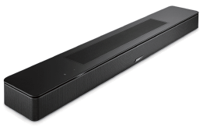
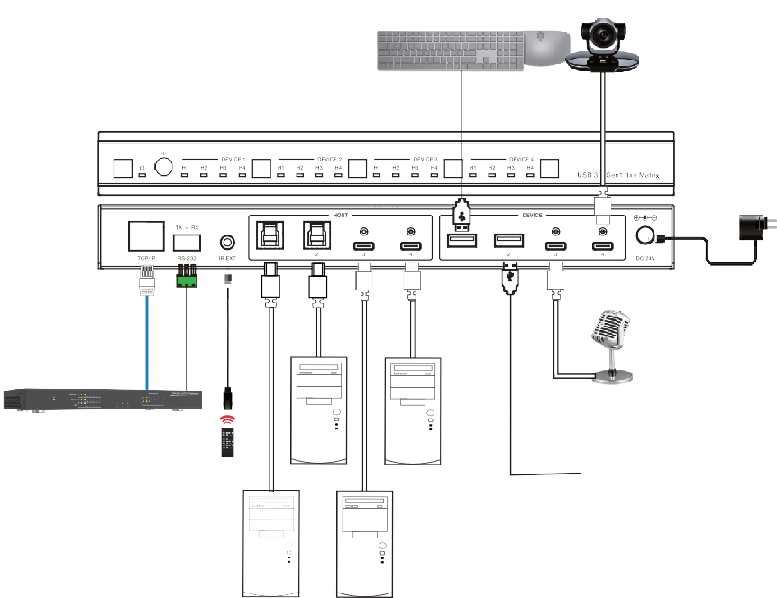Host 1 Host 3
Keyboard & Mouse
Camera
Power Supply
Table Mic
Integrated Control System
IR Receiver
Host 2
Host 4

