MAT.HDMI44MVUC

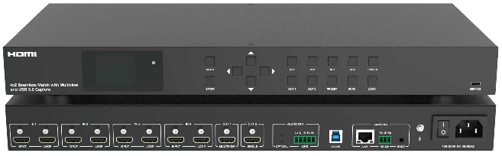



VER 1.0

Thank you for purchasing this product
For optimum performance and safety, please read these instructions carefully before connecting, operating or adjusting this product. Please keep this manual for future reference.
Surge protection device recommended
This product contains sensitive electrical components that may be damaged by electrical spikes, surges, electric shock, lighting strikes, etc. Use of surge protection systems is highly recommended in order to protect and extend the life of your equipment.
Caution
The network cable connection method required for this product is direct connection. Please do not cross connect.

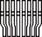
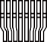
White and Orange Orange
White and Green Blue
White and Blue Green
White and Brown Brown

Direct Interconnection Method

Table of Contents
- Introduction. 1
- Features. 1
- Package Contents. 1
- Specifications. 2
- Operation Controls and Functions. 4
  - Front Panel. 4
  - Rear Panel. 5
- IR Cable Pin Assignment. 6
- LCD Display Navigation. 7
- IR Remote 9
- Multiview 10
- Web GUI Operation Guide 11
- RS-232 Control Command 24
- Connection Diagram. 37

Introduction
The 4x2 seamless matrix switcher supports video resolutions up to 4K@60Hz 4:4:4 8bit deep color and HDCP 2.2 and 1.x compliant, it features multi-view function for multi sources can be displayed on single screen. This matrix switcher supports two HDMI™ outputs and one USB 3.2 capture output.

This matrix switcher features four HDMI™ inputs and each input with loop out port for cascading connection. One local USB 3.2 host for UVC/UAC capture usage case.

This matrix switcher can be controlled via front panel buttons, remote control, API commands using RS-232 or TCP/IP. A Web server / GUI is built in that features A/V control, and input EDID management. The product is ideal for video conference rooms.

Features
☆ Video resolutions up to 4K@60Hz 4:4:4, as specified in HDMI™ 2.0b
☆ HDCP 2.2 and HDCP 1.x compliant
☆ USB 3.2 Gen 1 up to 5Gbps
☆ 4x2 seamless switching (single screen) and fast switching (multiview) function
☆ 4K video capture over USB 3.2 Gen 1 with standard UVC/UAC protocol
☆ Seamless switching without black screen or tearing screen (matrix mode)
☆ Multiple multiview display modes: Auto/Single/PIP/PBP/Triple/Quad view and customized layouts
☆ Supports HDR10, HDR10+, HLG and Dolby Vision pass-through
☆ Supports HDR to SDR conversion
☆ Auto or manual switching mode
☆ Input: 4x HDMI™, 1x USB 3.2 Gen 1 host
☆ Output: 4x HDMI™ loop, 2x HDMI™, 1x Optical audio, 1x Analog audio
☆ Audio de-embedded
☆ Advanced EDID management
☆ Flexible control via front panel buttons, IR remote, RS-232, TCP/IP or Web GUI

Package Contents
① 1x 4x2 Seamless Matrix Switcher
② 1x IR Remote Control
③ 1x USB 3.0 Host Cable (USB-A to USB-B, 0.5m)
④ 1x IR Wideband Receiver Cable (1.5m)
⑤ 1x 3pin-3.5mm Phoenix Connector (male)
⑥ 1x 5pin-3.5mm Phoenix Connector (male)
⑦ 2x Mounting Ear
⑧ 8x Machine Screw
⑨ 1x Multinational AC Power Cord (1.5m, optional)
⑩ 1x User Manual

Specifications

Technical
HDMI Compliance | HDMI™ 2.0b
HDCP Compliance | HDCP 2.2 and 1.x
Video Bandwidth | 18Gbps
USB Bandwidth | USB 3.2 Gen 1 up to 5Gbps
Input Video Resolution | 640x480p60Hz, 800x600p60Hz, 1024x768p60Hz,  1280x1024p60Hz, 1360x768p60Hz, 1440x900p60Hz,  1440x1050p60Hz, 1600x1200p60Hz, 720x480i59.94Hz (480i59),  720x480p59.94Hz (480p59), 720x576i50Hz (576i50),  720x576p50Hz (576p50), 1280x720p50Hz (720p50),  1280x720p59.94Hz (720p59), 1280x720p60Hz (720p60),  1920x1080i50Hz (1080i50), 1920x1080i59.94Hz (1080i59),  1920x1080i60Hz (1080i60), 1920x1080p23.98Hz (1080p23),  1920x1080p24Hz (1080p24), 1920x1080p25Hz (1080p25),  1920x1080p29.97Hz (1080p29), 1920x1080p30Hz (1080p30),  1920x1080p50Hz (1080p50), 1920x1080p59.94Hz (1080p59),  1920x1080p60Hz (1080p60), 3840x2160p23.98Hz (2160p23),  3840x2160p24Hz (2160p24), 3840x2160p25Hz (2160p25),  3840x2160p29.97Hz (2160p29), 3840x2160p30Hz (2160p30),  3840x2160p50Hz (2160p50), 3840x2160p59.94Hz (2160p59),  3840x2160p60Hz (2160p60), 4096x2160p23.98Hz,  4096x2160p24Hz, 4096x2160p25Hz, 4096x2160p29.97Hz,  4096x2160p30Hz, 4096x2160p50Hz, 4096x2160p59.94Hz,  4096x2160p60Hz
Output Video Resolution | HDR Bypass Mode: Video passthrough from input  HDR to SDR Mode:  1024x768p60Hz, 1280x720p50Hz, 1280x720p60Hz,  1280x800p60Hz, 1360x768p60Hz, 1920x1200p60Hz,  1920x1080i50Hz (1080i50), 1920x1080i60Hz (1080i60),  1920x1080p50Hz (1080p50), 1920x1080p60Hz (1080p60),  3840x2160p25Hz (2160p25), 3840x2160p30Hz (2160p30),  3840x2160p50Hz (2160p50), 3840x2160p60Hz (2160p60),  4096x2160p50Hz, 4096x2160p60Hz
IR Level | 12Vp-p
IR Frequency | Wideband 20K-60KHz
Color Depth | 8/10/12-bit
Color Space | RGB, YCbCr_4:4:4, YCbCr_4:2:2, YCbCr_4:2:0
HDR | HDR, HDR10, HDR10+, Dolby Vision, HLG
Audio Formats | HDMI™ Passthrough:  LPCM, Dolby Digital/Plus/EX, Dolby True HD, Dolby Atoms, DTS, DTS-HD, DTS-HD Master Audio, DTS-96/24, DTS High Res Audio Breakout:  Optical Out: Up to LPCM/Dolby/DTS 5.1CH  Line Out: Only LPCM 2CH (sample rate 32~192kHz)

Transmission Distance | HDMI™ passive cable: 9.8ft/3m  USB 3.2 Gen 1 5Gbps passive cable: 4.9ft/1.5m
LINE Analog Audio Out
Output Impedance | 600 Ohm balanced  300 Ohm unbalanced
Output Level (Maximum) | 8.2dBu (2Vrms) @ balanced audio  2.2dBu (1Vrms) @ unbalanced audio
Frequency Response | 20Hz to 20kHz (-/+0.5dB)
Dynamic Range | >90dB@0dBu, 1kHzA-weighted
Audio S/N Ratio | >90dB@0dBu, 1kHzA-weighted
Audio THD+N | <0.01% @ +4dBu, 1kHz
Audio Output Delay | <1ms
ESD Protection | IEC 61000-4-2:  ±8kV (Air-gap discharge) , ±4kV (Contact discharge)
Connection
Input ports | 4x IN [HDMI™ Type A, 19-pin female]
Output ports | 1x OUT 1 [HDMI™ Type A, 19-pin female, single/multiview output] 1x OUT 2 [HDMI™ Type A, 19-pin female, single screen output] 4x LOOP [HDMI™ Type A, 19-pin female]  1x LINE AUDIO OUT [5pin-3.5mm phoenix connector] 1x OPTICAL AUDIO OUT [S/PDIF]  1x UVC/4K [9-pin USB Host Type B, USB 3.2 Gen 1 5Gbps, supporting UVC/UAC]
Control ports | 1x RS-232 [3pin-3.5mm phoenix connector, RS-232 API control] 1x LAN [RJ45 connector, TCP/IP and Web GUI]  1x SERVICE [USB-C with USB 2.0 only, 12-pin female, FW upgrade port]  1x IR EXT [3.5mm audio jack, IR IN 12V level]
Mechanical
Housing | Front panel: Aluminum; Rear case: Metal Enclosure
Color | Black
Dimensions | 440mm [W] × 200mm [D] × 44mm [H]
Weight | 2.65kg
Power Supply | AC100 - 240V 50/60Hz
Power Consumption | 61.6W (Max)
Operating Temperature | 0°C ~ 40°C / 32°F ~ 104°F
Storage Temperature | -20°C ~ 60°C / -4°F ~ 140°F
Operating Humidity | 20%~80% (relative humidity, non-condensing)
Storage Humidity | 10%~90% (relative humidity, non-condensing)

Operation Controls and Functions

Front Panel





1 2
3
4
5 6
7
IR
MENU
IN 1 IN 2 IN 3 IN 4 POWER
4x2 Seamless Matrix with Multiview and USB 3.2 Capture
ENTER
OUT 1 OUT 2 PRESET FUNC LOCK
SERVICE

No. | Name | Function Description
1 | LCD screen | 1.8-inch LCD panel, with 284*240 resolution and IPS (Intrusion Prevention System). After powering on, the LCD screen will display the current input/output channel mapping of the matrix by default. In addition, information such as EDID, output resolution, baud rate, and IP address can be displayed/set by pressing menu buttons.
2 | IR window | IR signal receiving window, receiving the IR remote signal to control certain functions of the machine.
3 | LCD screen operation buttons (Each black button with blue indicator light) | MENU: Press the MENU button to enter the primary menu, with five primary items (INPUT SETTINGS/OUTPUT SETTINGS/AUDIO BREAKOUT/SETUP/FIRMWARE), which can view/set various functions of the matrix, including input EDID, output resolution/ HDR/USB/mute/stream, audio source/mute, LCD ontime, baud rate, network configuration, reboot, reset and firmware version.  UP: Press the UP button to select the previous item. DOWN: Press the DOWN button to select the next item. LEFT: Left directional operation button.  RIGHT: Right directional operation button.  ENTER: Press the ENTER button to confirm and take effect.  For example: Switch the resolution of output channel 2 to resolution 1920x1080p60.  On the condition that the LCD screen is in default display state and the front panel buttons are not locked,  Step 1: Press MENU button to enter the primary menu interface, then press UP/DOWN button to select “OUTPUT SETTINGS”, and press ENTER button to enter the next-level menu.  Step 2: Press UP/DOWN button to select “RESOLUTION”, then press ENTER button to enter the next-level menu.  Step 3: Press UP/DOWN button to select “OUTPUT 2”, then press ENTER button to enter the next-level menu.  Step 4: Press UP/DOWN button to select “1920x1080p60”, then press ENTER button to confirm, the LCD screen will display “Successfully Set”, and the switching is completed.  Notes：  - Pressing the MENU button will return to the previous menu.  - In any level menu, it will return to the initial display screen if no operation goes on within 10 seconds.  - For detailed menu contents, please refer to “7. LCD Display Navigation”.

No. | Name | Function Description
4 | Matrix operation buttons  (Each black button with blue indicator light) | IN 1/IN 2/IN 3/IN 4: Input channel selection buttons.  OUT 1/OUT 2: Output channel selection buttons.  PRESET: Press the PRESET button to recall the presets circularly.  FUNC: Function button.  The specific operations of the above buttons are as follows. On the condition that the LCD screen is in default display state and the front panel buttons are not locked,  OUT + IN: Firstly press the OUT 1/2 button to select the output channel, then press the IN 1/2/3/4 button to select the input channel to complete the matrix mapping. For example, “OUT 1 + IN 1” indicates switching the input 1 signal source to output 1.  FUNC + IN: Switch the input source to all outputs. For example, “FUNC + IN 1” indicates switching the input 1 signal source to all output ports.  FUNC + FUNC + IN 1: View the IP address.  FUNC + FUNC + IN 2: View the baud rate of the serial port. FUNC + FUNC + IN 3: Turn on signal management mode. FUNC + FUNC + IN 4: Turn off signal management mode. Note：  - The quick information will disappear automatically after being  displayed for 3 seconds.
5 | POWER button (Black button with red button light) | - Short press the POWER button to power on the unit, the button  light is off.  - Press and hold the POWER button for 3 seconds, the unit will  enter the standby mode, and the red button light is on.
6 | LOCK button (Black button with blue button light) | Press and hold the LOCK button for 3 seconds to lock front panel buttons (except the power button), the blue button light is on; Press it again to unlock, and the button light is off.
7 | SERVICE port | USB-C port with USB 2.0 only, used for firmware upgrade.

Rear Panel
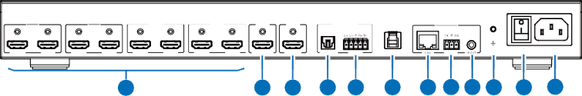
IN 1
IN 2
IN 3
IN 4
OUT 1
OUT 2
AUDIO OUT
CONTROL
INPUT
LOOP
INPUT
LOOP
INPUT
LOOP
INPUT
LOOP
MULTIVIEW
SINGLE
OPTICAL LINE
UVC/4K
RS-232
100-240V AC 50/60HZ
1
2 3 4 5 6 7 8 9 10 11 12

No. | Name | Function Description
1 | IN 1/2/3/4 ports | INPUT: Four HDMI signal input ports, supporting auto switching, connected to HDMI source devices such as DVD or Blu-ray player with HDMI cable.  LOOP: Four HDMI signal loop output ports, supporting bypass and downscale, connected to HDMI display devices such as TV or monitor with HDMI cable.

No. | Name | Function Description
2 | MULTIVIEW  OUT 1 port | HDMI signal output port, supporting single screen or multiview display.
3 | SINGLE OUT 2  port | HDMI signal output port, only supporting single screen display. Besides, it supports HDR bypass, and HDR to SDR conversion.
4 | OPTICAL port | Optical fiber audio output port, supporting audio de-embedding up to 5.1CH.
5 | LINE port | Analog audio output port, supporting balanced/unbalanced 2CH audio output (with a maximum output level of 2Vrms).  Balanced connection method: L+, L -, GND, R+, R-Unbalanced connection method: L+, GND , R+
6 | UVC/4K port | USB 3.2 Gen 1 capture port, supporting UVC/UAC.
7 | LAN port | Ethernet port, used for TCP/IP and Web GUI control.  - Green light on: The unit is linked with PC.  - Green light off: The unit is not linked with PC.  - Yellow light flashing: There is data transmission.  - Yellow light off: There is no data transmission.
8 | RS-232 port | RS-232 serial port, with baud rate of 115200, used for upgrade and API commands transmission.
9 | IR EXT port | IR signal receiving port, with a default IR level of 12V, connected with the 12V IR Receiver cable. If the IR signal receiving window of the unit is blocked or the unit is installed in a closed area out of infrared line of sight, the IR receiver cable can be inserted to the “IR EXT” port to receive the IR remote signal.
10 | GND | Connect the unit housing to the ground.
11 | Power Switch | Press the power switch to turn on/off the power.
12 | Power port | Universal AC power outlet, connected to the 100-240V AC 50/ 60Hz power supply.

IR Cable Pin Assignment
The pin assignment of the IR Receiver cable and IR Blaster cable is as below:

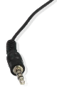
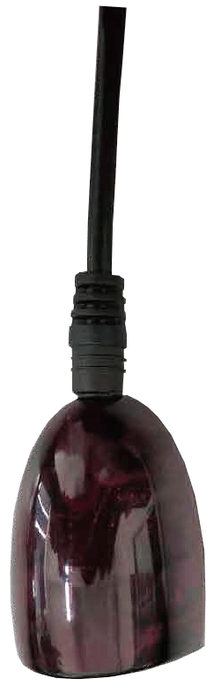


IR Signal Grounding Power 12V
IR RECEIVER
IR RECEIVER
Note: When the angle between the IR receiver and the remote control is ± 45 °, the transmission distance is 0-5 meters; when the angle between the IR receiver and the remote control is ± 90 °, the transmission distance is 0-8 meters.

LCD Display Navigation
Various functions of the matrix can be set through the operation of buttons on the front panel, and the corresponding content can be displayed on the LCD screen.
The LCD display navigation consists of five primary menus “INPUT SETTINGS/OUTPUT SETTINGS/AUDIO BREAKOUT/SETUP/FIRMWARE”. The specific contents are as follows.

Level 1 | Level 2 | Level 3 | Level 4
INPUT SETTINGS | EDID | INPUT 1/2/3/4 | - Auto  - Copy HDMI Out 1  - Copy HDMI Out 2  - 4K2K60_444 2.0CH  - 4K2K60_444 5.1CH  - 4K2K60_444 7.1CH  - 4K2K30_444 2.0CH  - 4K2K30_444 5.1CH  - 4K2K30_444 7.1CH  - 1080p60_444 2.0CH  - 1080p60_444 5.1CH  - 1080p60_444 7.1CH  - 720P60_444 2.0CH  - 1920x1200 2.0CH  - 1680x1050 2.0CH  - 1600x1200 2.0CH  - 1440x900 2.0CH  - 1360x768 2.0CH  - 1280x1024 2.0CH  - 1024x768 2.0CH  - User Defined 1  - User Defined 2
OUTPUT SETTINGS | RESOLUTION | OUTPUT 1/2 | - Auto  - 3840x2160p60  - 3840x2160p50  - 4096x2160p60  - 4096x2160p50  - 3840x2160p30  - 1920x1080p60  - 1920x1080p50  - 1920x1080i60  - 1920x1080i50  - 1280x720p60  - 1280x720p50  - 1360x768p60  - 1280x800p60  - 1920x1200p60RB  - 1024x768p60
OUTPUT SETTINGS | HDR | OUTPUT 2 | - HDR Bypass  - HDR to SDR

Level 1 | Level 2 | Level 3 | Level 4
OUTPUT SETTINGS | USB | UVC/UAC | UVC:  - Copy HDMI Out 1 UAC:  - Copy HDMI Out 1  - HDMI In 1 Audio  - HDMI In 2 Audio  - HDMI In 3 Audio  - HDMI In 4 Audio
OUTPUT SETTINGS | MUTE | OUTPUT 1/2 | - ON  - OFF
OUTPUT SETTINGS | STREAM | OUTPUT 1/2 | - ON  - OFF
AUDIO BREAKOUT | SOURCE | OPTICAL/LINE | - Follow HDMI Out 1  - Follow HDMI Out 2  - HDMI In 1  - HDMI In 2  - HDMI In 3  - HDMI In 4
AUDIO BREAKOUT | MUTE | OPTICAL/LINE | - ON  - OFF
SETUP | LCD ONTIME | OFF/ALWAYS ON/  15 SECONDS/30 SECONDS/  60 SECONDS | /
SETUP | BAUD RATE | 4800/9600/19200/38400/  57600/115200 | /
SETUP | NETWORK | DHCP ON | DHCP ON  IP 192.168.0.100  SM 255.255.0.0  GW 192.168.0.1  MAC 11:22:33:44:55:66
SETUP | NETWORK | DHCP OFF | /
SETUP | REBOOT | Are you sure you want to REBOOT the system?  Yes, press “FUNC” No, press “MENU” | /
SETUP | RESET | Are you sure you want to RESET the system to default?  Yes, press “FUNC” No, press “MENU” | /
FIRMWARE | BOOT FW V1.00.XX MCU FW V1.00.XX WEB GUI V1.00.XX LCD FW V1.00.XX USB FW V1.00.XX

IR Remote

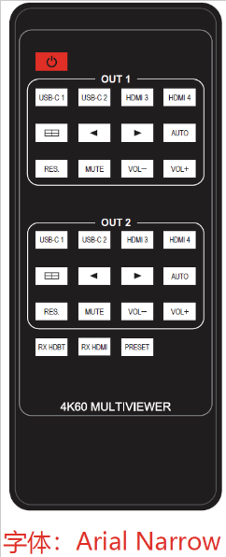
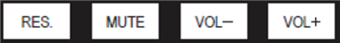

① Power button: Press this button to power on the unit or set it to standby mode.
IN 1 IN 2 IN 3 IN 4
PIP PBP TRIPLE QUAD
IN 1 IN 2 IN 3 IN 4
PRESET 1
PRESET 2
PRESET 3
PRESET 4
PRESET 5
PRESET 6
PRESET 7
PRESET 8
② OUT 1 buttons:
IN 1/IN 2/IN 3/IN 4: Press to select input source for the OUT 1
port.
AUTO: Press this button to enable/disable the auto switching function in single screen display mode.
: Press to circularly select the previous or next input source for OUT 1 in single screen display mode, or for WIN 1 in multiview display mode.
RES.: Press this button to cycle through the output resolution for the OUT 1 port.
PIP: Press this button to switch output 1 to PIP display mode.
PBP: Press this button to switch output 1 to PBP display mode. TRIPLE: Press this button to switch output 1 to Triple display mode. QUAD: Press this button to switch output 1 to Quad display mode.
③ OUT 2 buttons:
IN 1/IN 2/IN 3/IN 4: Press to select input source for the OUT 2
port.
AUTO: Press this button to enable/disable the auto switching function.
: Press to circularly select the previous or next input source for the OUT 2 port.
RES.: Press this button to cycle through the output resolution for the OUT 2 port.
④ Preset buttons:
PRESET 1/2/3/4/5/6/7/8: Press to recall the saved preset scenes.

The matrix switcher supports two methods to receive the IR remote control signal.
Method 1: The IR window receives the IR remote signal. When using the IR remote, the furthest distance is 7 meters and the angle is ± 45°. The diagram is shown as below:
IN 1 IN 2 IN 3 IN 4 POWER
MENU
ENTER
OUT 1 OUT 2 PRESET FUNC LOCK
SERVICE
4x2 Seamless Matrix with Multiview and USB 3.2 Capture
IR

IR remote of the matrix switcher

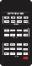
Method 2: If the IR receiver window of the matrix switcher is blocked or the matrix switcher is installed in a closed area out of infrared line of sight, the IR receiver cable can be inserted to the “IR EXT” port to receive the IR remote signal. The furthest distance of using the IR remote is 7 meters and the IR remote is directly faced to the IR receiver head. The diagram is shown as below.


IR remote of the matrix switcher

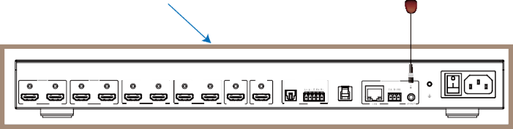
Machine cabinet
IR receiver cable
IN 1
IN 2
IN 3
IN 4
OUT 1 OUT 2 AUDIO OUT
CONTROL
INPUT LOOP
INPUT LOOP
INPUT LOOP
INPUT LOOP
MULTIVIEW SINGLE OPTICAL LINE
100-240V AC 50/60HZ
UVC/4K
RS-232

Multiview
The OUT 1 port of the matrix switcher supports multiple multiview display modes:
Auto: When the Auto mode is selected, the multiview display modes set through Web GUI will be recalled automatically.
Single: Single screen display mode.
PBP: Dual screen display modes, including Dual-LR and Dual-TB.
PIP: PIP screen display modes, including PIP-LT, PIP-LB, PIP-RT and PIP-RB
Triple: Triple screen display modes, including Triple-L, Triple-R, Triple-T and Triple-B
Quad: Quad screen display modes, including Quad-L, Quad-R, Quad-T, Quad-B and Quad-S
Custom Layout: Five customized multiview display modes are supported.
Copy HDMI Out 2: Copy the display mode selected by the OUT 2 port.
Multiview window distributions are as following:

Auto
Single
Dual-LR Dual-TB
PIP-LT
PIP-LB PIP-RT



PIP-RB Triple-L Triple-R
Triple-T
Triple-B
Quad-L
Quad-R



Quad-T Quad-B
Quad-S
Custom 1/2/3/4/5 Copy HDMI Out 2



You can set/select multiview display modes for OUT 1 via Web GUI. For details, please refer to the Video and System interface operation of “10. Web GUI Operation Guide”.
In addition, you can select multiview display modes for OUT 1 via IR remote control or RS-232 commands.

Web GUI Operation Guide
The matrix switcher can be controlled by Web GUI. The operation steps are shown as below:
Step 1: Get the current IP Address.
The default IP address is 192.168.0.100 (when the system is not connected to a router). You can get the current IP address in two methods.
Method 1: LCD screen and menu buttons
You can press the shortcut menu buttons “FUNC + FUNC + IN 1” on the front panel to check the IP address on the LCD screen.
Method 2: RS-232 command control.
Send the ASCII command “get ip addr” through a Serial Command tool, then you’ll get the current IP address (The IP address is variable, depending on what the specific machine returns).

For the details of RS-232 control, please refer to “11. RS-232 Control Command”.
Step 2: Connect the LAN port of the matrix switcher to a PC with an UTP cable (as shown in the following figure), and set the IP address of the PC to be in the same network segment with the matrix switcher.
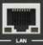

PC
Step 3: Input the current IP address of matrix switcher into your browser on the PC to enter Web GUI interface.
After entering the Web GUI page, there will be a Login interface, as shown below:
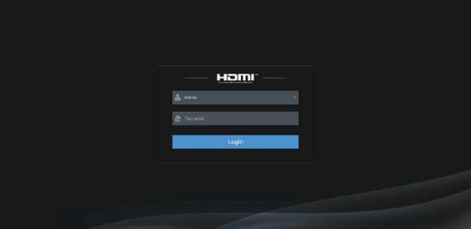

The default usernames and passwords are as below:

Username | Password
Admin | 1234
User | 1234
Select the username “User” and input the password “1234”, then click the “Login” button to enter the User page.

User Page

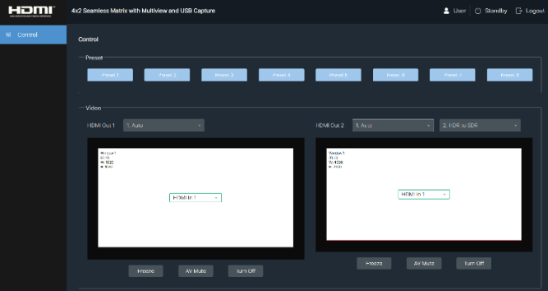
You can do the following operations on the User page:
① Preset: Recall the preset application scenes (up to 8 preset scenes).
② Video: Set the window display mode for HDMI Out 1 and HDMI Out 2, select input source for each screen, freeze the screen, mute the audio and display black screen, or turn off the
output stream.
Notes:
- HDMI Out 1 supports multiple multiview display modes (Auto/Single/PIP/PBP/Triple/Quad
/Custom). Moreover, it can copy the display of HDMI Out 1 when selecting “Copy HDMI Out 2”.
- HDMI Out 2 supports Auto and Single screen display mode. Selecting “Copy HDMI Out 1” allows HDMI Out 2 to output the same multiview as HDMI Out 1. In addition, you can click the drop-down list to set HDR Bypass/HDR to SDR for HDMI Out 2.
- When HDMI Out 2 is in HDR Bypass mode, copying HDMI Out 1 and HDMI Out 2 display are not available.
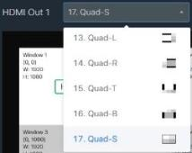
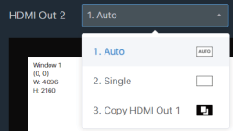
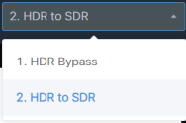

In the Login interface, select the username “Admin” and input the password “1234”, then click the “Login” button to enter the Information page of the Admin interface.

Information Page
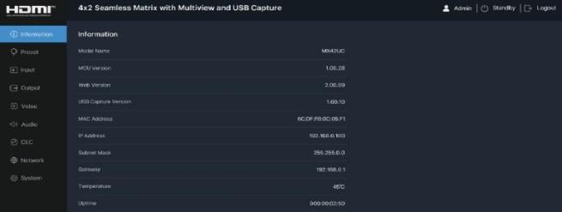
① ② ③
The Information page provides basic information about the model name, software version, Web version, USB capture version, network configuration, the current machine temperature and online time.
Besides, you can do the following operations in the upper right corner of each page.
① Display the current username (User or Admin).
② Click the power icon to power on the matrix switcher or set it in standby mode.
③ Click the logout icon to logout and return to the login interface.

Preset Page
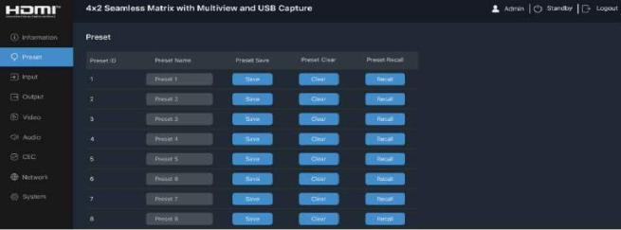
You can set up to 8 preset scenes on the Preset page.
① Preset Name: You can name the preset scene. The maximum length of the name is 32 English characters or 16 Chinese characters (numbers are supported).
② Preset Save: Click the Save button to save the scene.
③ Preset Clear: Click the Clear button to clear the saved scene.
④ Preset Recall: Click the Recall button to recall the saved scene.

Input Page
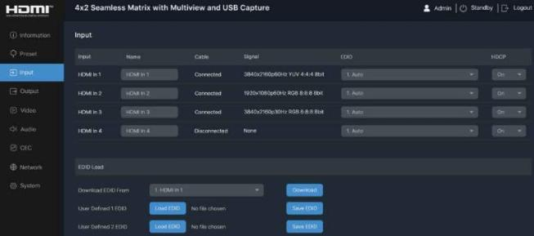
You can do the following operations on the Input page:
① Input: Input channel of the device.
② Name: The input channel’s name. You can modify the name with a maximum length of 32 English characters or 16 Chinese characters (numbers are supported).
③ Cable: It indicates whether the channel is connected/disconnected to the signal source.
④ Signal: It indicates the signal status or displays the input signal resolution.
⑤ EDID: Click the drop-down list to set EDID for each input port. The EDID list is as below.
No. | EDID Mode | No. | EDID Mode
1 | Auto | 12 | 1080P60_444, Audio 7.1CH DTS/DOLBY/HD
2 | Copy HDMI Out 1 | 13 | 720P60_444, Audio 2CH PCM
3 | Copy HDMI Out 2 | 14 | 1920x1200, Audio 2CH PCM
4 | 4K2K60_444, Audio 2CH PCM | 15 | 1680x1050, Audio 2CH PCM
5 | 4K2K60_444, Audio 5.1CH DTS/DOLBY | 16 | 1600x1200, Audio 2CH PCM
6 | 4K2K60_444, Audio 7.1CH DTS/DOLBY/HD | 17 | 1440x900, Audio 2CH PCM
7 | 4K2K30_444, Audio 2CH PCM | 18 | 1360x768, Audio 2CH PCM
8 | 4K2K30_444, Audio 5.1CH DTS/DOLBY | 19 | 1280x1024, Audio 2CH PCM
9 | 4K2K30_444, Audio 7.1CH DTS/DOLBY/HD | 20 | 1024x768, Audio 2CH PCM
10 | 1080P60_444, Audio 2CH PCM | 21 | User Defined 1
11 | 1080P60_444, Audio 5.1CH DTS/DOLBY | 22 | User Defined 2
Notes:
- When the EDID is set to “Auto”, it depends on the EDID of TV. The optimal resolution will be selected based on the EDID of the back-end TV with the lowest resolution.
- Please import the user-defined EDID before selecting User Defined 1/2 as the EDID.
⑥ HDCP: Click the drop-down menu to turn on/off HDCP for each input port.
⑦ Export EDID to your computer: Click the drop-down menu of “Download EDID From” to select the input/output/user-defined EDID, then click “Download”.

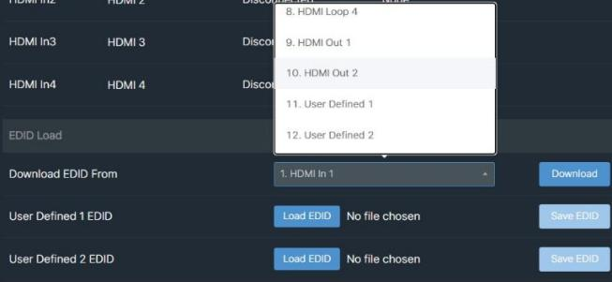
⑧ Import user-defined EDID: Click “Load EDID” to load User Defined 1/2 EDID, then click “Save EDID”.
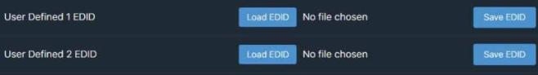

Output Page
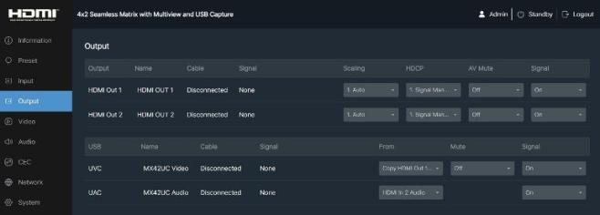

HDMI Out 1/2
① Output: Output channel of the device.
② Name: The current output channel’s name. You can modify the name with a maximum length of 32 English characters or 16 Chinese characters (numbers are supported).
③ Cable: It indicates the connection status of the output channel.
④ Signal: It indicates the signal status or displays the output signal resolution.
⑤ Scaling: Click the drop-down list to select the output resolution. The output resolution list is as following.

No. | Output Resolution | No. | Output Resolution
1 | Auto | 9 | 1920x1080i60
2 | 3840x2160p60 | 10 | 1920x1080i50
3 | 3840x2160p50 | 11 | 1280x720p60
4 | 4096x2160p60 | 12 | 1280x720p50
5 | 4096x2160p50 | 13 | 1360x768p60
6 | 3840x2160p30 | 14 | 1280x800p60
7 | 1920x1080p60 | 15 | 1920x1200p60RB
8 | 1920x1080p50 | 16 | 1024x768p60
Notes:
- When the output resolution is set to “Auto”, the matrix switcher will output the matching resolution based on the EDID of the back-end TV.
- When HDMI Out 1 is in the multiview display mode, and HDMI Out 2 copies the display of HDMI Out 1, only the output resolution of HDMI Out 1 can be set.
⑥ HDCP: Click the drop-down list to set the HDCP (Signal Management/Auto/HDCP 1.4/ HDCP 2.2).
⑦ AV Mute: Click the drop-down list to turn on/off the AV Mute function (mute the audio and display black screen).
⑧ Signal: Click the drop-down list to turn on/off the signal output.
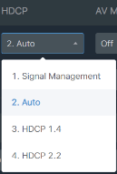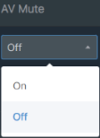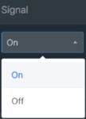

USB Capture
① UVC/UAC: The type of the connected USB device. UVC (USB Video Class) is a category of video devices used for controlling and transmitting video data. UAC (USB Audio Class) is
a category of audio devices used for controlling and transmitting audio data.
② Name: The name of the connected USB device. You can modify the name by entering the corresponding name (16 characters max) in the input box.
③ Cable: It indicates the connection status of the USB device.
④ Signal: It indicates the signal status or displays the signal resolution.
⑤ From: Click the drop-down list to select the signal source for USB capture.
⑥ Mute: Click the drop-down list to mute/unmute the audio (only available for UVC devices).
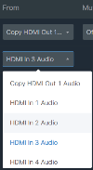
⑦ Signal: Click the drop-down list to turn on/off the signal output.
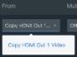
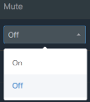
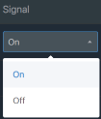

Video Page
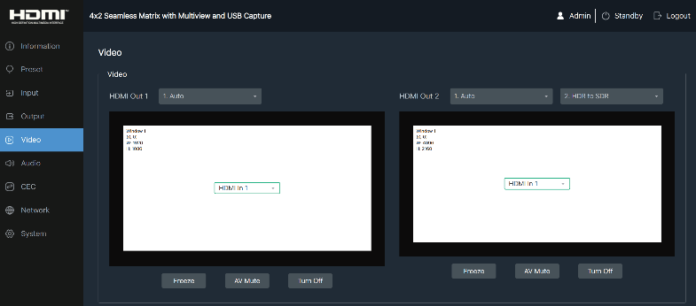

Window layout
HDMI Out 1 can configure Auto/Single/PIP/PBP/Triple/Quad/Custom Layout display mode, or copy HDMI Out 2 display. HDMI Out 2 can be configured with Auto/Single screen display mode, or copy HDMI Out 1 display, as well as HDR Bypass mode and HDR to SDR mode, as shown in the following figures.

Note: When HDMI Out 2 is in HDR Bypass mode, copying HDMI Out 1 and HDMI Out 2 display are not available.
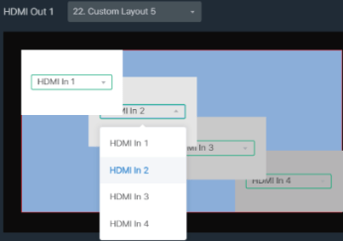
If you select the custom window layout (Custom 1/2/3/4/5), you can freely set the window size, position and input source, as shown in the following figure.
Moreover, after selecting a window in Custom 1/2/3/4/5, you can perform additional settings.

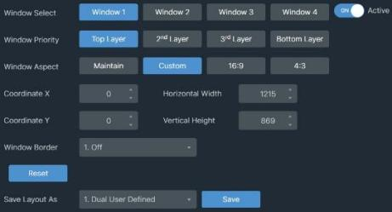
- Window Select: Click the Window 1/2/3/4 button to select the window, or direct click the window in the window layout.
- Active: This switch is used to hide the window. Select the window, and turn off the Active switch, then the window will be hidden; Select the hidden window, and turn on the Active switch, then the window will appear again.
- Window Priority: Click the corresponding button to set the window display priority.
- Window Aspect: Click the corresponding button to set the window display aspect ratio. Maintain: Adaptively adjust the window display aspect ratio based on the ratio provided by the signal source.
Custom: Adjust the window display aspect ratio according to user customization.
16:9/4:3: Fixed window display aspect ratio.
- Coordinate X/ Coordinate Y: Click the up/down icon to set the window coordinate.
- Horizontal Width/Vertical Height: Click the up/down icon to set the ratio of window width to height.
- Window Border: Click the drop-down list to set the color of the window border (Off/Black/ Red/Green/Blue/Yellow/Magenta/Cyan/White/Gray).
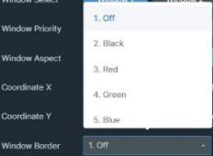
- Reset: Click the Reset button to clear the settings of the custom window.
- Save Layout As: Click the drop-down list to select the layout mode according to the number of windows, then click “Save” to save the current custom window layout as dual/ triple/quad user-defined screen, which can be selected and recalled in the Auto Switch interface on the System page.
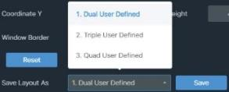

Signal Source Selection
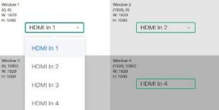
Click the drop-down list of the input source in the window layout area to select the signal source for each window, as shown in the following figure.

Freeze the screen
- When both outputs are in the single screen display mode, you can click the Freeze button to separately freeze the display screen of HDMI Out 1 and HDMI Out 2.
- HDMI Out 1 is in the multiview display mode, and HDMI Out 2 copies the display of HDMI Out 1, clicking the Freeze button will freeze both the screens of HDMI Out 1 and HDMI Out 2.

- When HDMI Out 1 is in the multiview display mode, and HDMI Out 2 is in the single screen display mode, the freeze function is only available for the multiview display mode.

AV MUTE
Clicking the AV MUTE button, the corresponding output device will display black screen and mute the audio.

Turn off the output stream
Click the Turn Off button to turn off the output port, and there is no signal output.

Audio Page
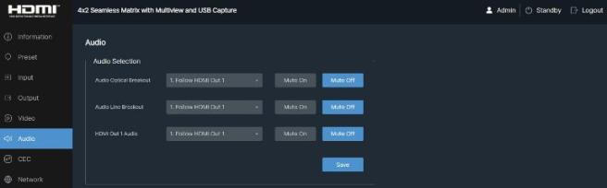
On the Audio page, you can click the drop-down list to select the audio source for optical fiber digital audio de-embedding, Line analog audio de-embedding, or the audio output of HDMI Out 1.
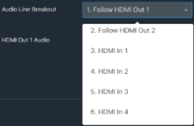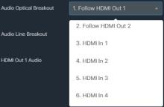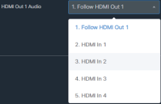
Click Mute On/Mute Off button to mute on/off the corresponding audio output. After setting, please click Save button to take effect.

CEC Page
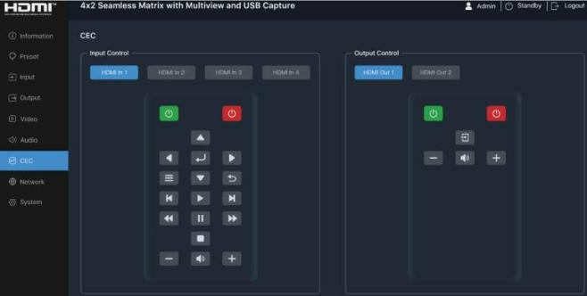
You can select one or multiple inputs/outputs to perform CEC control simultaneously. Inputs and Outputs can be controlled by clicking on the corresponding icons.

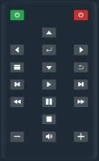
① Input Control: Select the input channel on the left, and then click on the icons to Power On/Power Off, Menu/Select/Up/Down/
Left/Right/Exit, Play/Stop/Pause/Rewind/Fast Forward/Forward/ Backward/Previous/Next, Volume Up/Volume Down/Mute, etc.

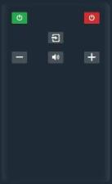
② Output Control: Select the output channel on the left, and then click on the icons to control the operation of the display, such as
Power On/Power Off, Active Source/Image View On/Text View On, Volume Up/Volume Down/Mute, etc.

Network Page
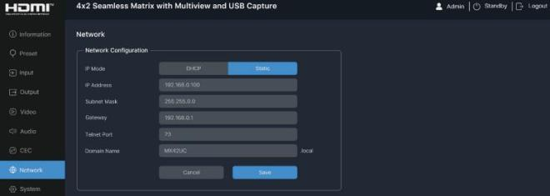

Network Configuration
You can set the IP Mode (Static/DHCP). If the mode is set to “Static”, you can manually set the IP Address, Subnet Mask, Gateway, Tenet Port and Domain Name as required, then click “Save” to take effect. If the mode is set to “DHCP”, the system will search and fill the IP Address with the one assigned by the router automatically. You can't modify it now.
Note: The Domain Name “MX42UC.local” can be used to login the Web GUI.

System Page
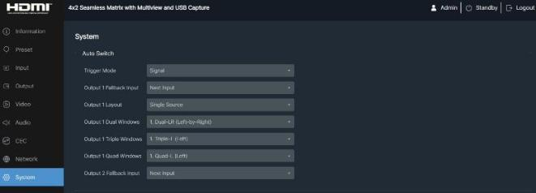

Auto Switch
① Trigger Mode: Click the drop-down list to select Signal/Source 5V as the trigger mode for auto switching.
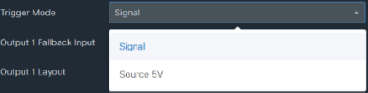

② Output 1/2 Fallback Input: The input port switching settings for Output 1 and Output 2. Click the drop-down list to select Next Input/HDMI In 1/HDMI In 2/HDMI In 3/HDMI In 4 as the signal source of Fallback input. With the auto switching function enabled, when connecting
signal sources, the output signal will switch to the last connected signal source automatically. When the current signal source is disconnected, if the Fallback input is set to “Next Input”, the output signal will switch according to the order of input ports. For example, when Input 1 is disconnected, the output signal will switch to Input 2. If the Fallback input is set to a fixed input, the output signal will switch to the selected input.
Note: The auto switching function is available only in single screen display mode.
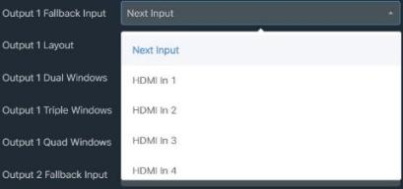
③ Output 1 Layout: Set the display mode of the output 1 port, which can be configured
as single screen or multiview. In multiview mode, dual screen/triple screen/quad screen can
be displayed according to the number of connected sources.
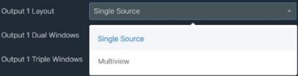
④ Output 1 Dual/Triple/Quad Windows: Dual/Triple/Quad screen window setting, allowing users to freely choose the layout of dual/triple/quad screen display and customize the layout.
User customized layout can be saved as a dual/triple/quad screen window in the layout customization (Custom 1/2/3/4/5) of the Video page, and then selected and called in the Output 1 Dual/Triple/Quad Windows column of the System page.
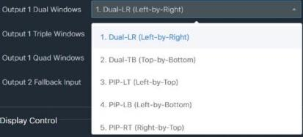

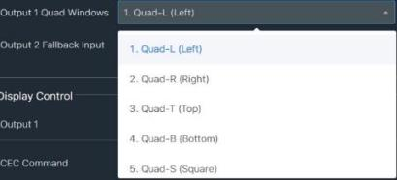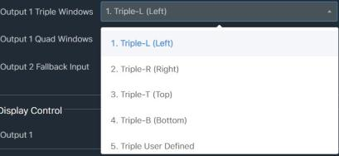

Display Control
You can control the display of Output 1 and Output 2 respectively as required.
① CEC Command: Click the corresponding button to power on/off the display device.
② Display Auto Power: Click the switch to turn on the Display Auto Power, when the matrix is manually put into standby mode, the TV that supports CEC control will be put into standby
simultaneously. When the matrix is turned on, it will detect whether there is signal input. If there is signal input, the TV will be turned on; if there is no signal input, the TV will remain off.
③ Auto Power off Timer: On the condition that the Display Auto Power switch is turned on, click the drop-down list to set the time (5 Sec/10 Sec/30Sec/1 Min/5 Min/10 Min). When there
is no input signal for the selected time, the TV will automatically turn off.
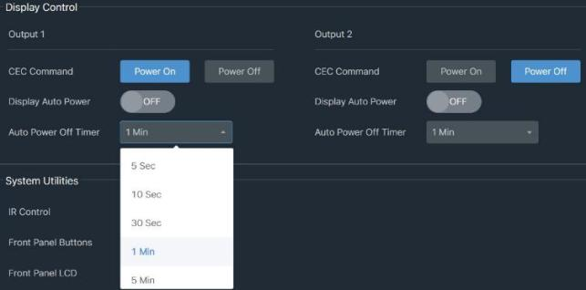

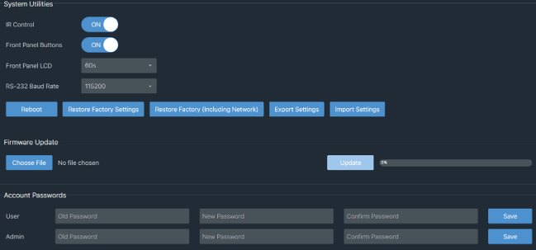

System Utilities
① IR Control: Click “ON/OFF” to turn on/off the IR control function.
② Front Panel Buttons: Click “ON/OFF” to lock/unlock panel buttons. “ON” indicates that panel buttons are available; “OFF” indicates panel buttons are unavailable.
③ Front Panel LCD: Click the drop-down list to set LCD display time (On/Off/15s/30s/60s).
④ RS-232 Baud Rate: Click the drop-down list to set the baud rate of the RS-232 port.
⑤ Reboot: Click this button to reboot the matrix switcher.
⑥ Restore Factory Settings: Click this button to restore the switcher to factory settings.
⑦ Restore Factory (Including Network) : Click this button to restore the switcher to factory settings (including the network configuration).
⑧ Export Settings: Click this button to export system configuration files.
⑨ Import Settings: Click this button to import system configuration files.
Firmware Update: You can update the software of MCU, Web, Scaler or receiver. Click “Choose File” to select the update file, then click “Update” to start update. When the progress bar reaches 100%, the update is complete.
Account Passwords: You can modify the login password (16 characters max) for User and Admin.
After setting up, click “Save” to take effect.

RS-232 Control Command
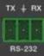
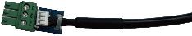
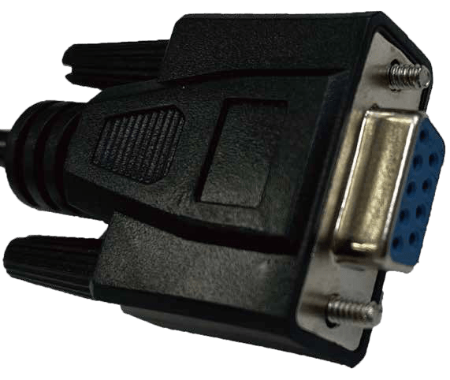
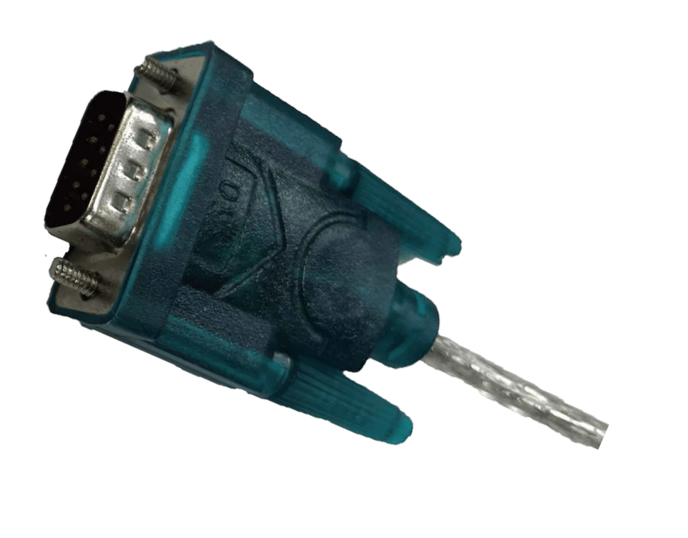
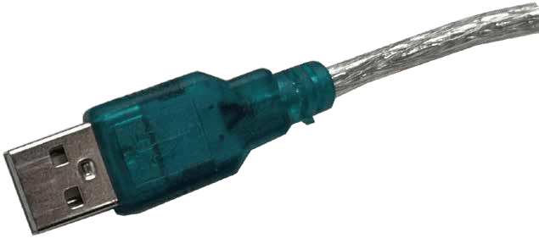
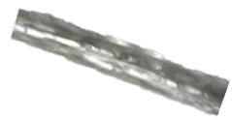
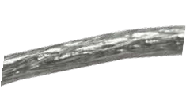
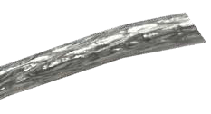
The product also supports RS-232 command control. Connect the RS-232 port of the product to a PC with a 3-pin phoenix connector cable and a USB to RS-232 serial cable. The connection method is as follows.

G
TX
round RX

3-pin Phoenix connector
RS-232 DB9 connector

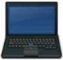
USB to RS-232 serial cable
PC
Then open a Serial Command tool on PC to send ASCII commands to control the product. The ASCII command list about the product is shown as below.

ASCII Command
RS-232 Baud rate: 115200, Data bits: 8bit, Stop bits:1, Parity bit: none TCP/IP port: 8000
x - Parameter 1. y - Parameter 2.
Command Code | Function Description | Example | Feedback | Default Setting
System Setting
? | Get the list of all commands | ? | List all API commands
help | Get the list of all commands | help | List all API commands
get model | Get device model | get model | MX42UC
status | Get device current status | status | Please refer to the note at the end of the list.
get version | Get firmware version | get version | BOOT: V1.00.01 MCU: V1.00.01 WEB: V1.00.01 LCD: V1.00.01 USB: V1.00.01
power on | Power on the device | power on | Power: on  System initializing... Initialization finished! BOOT: V1.00.01 MCU: V1.00.01 WEB: V1.00.01
power off | Power off the device | power off | Power: off
get power | Get current power state | get power | Power: off
reboot | Reboot the device | reboot | Reboot…  System initializing... Initialization finished! BOOT: V1.00.01 MCU: V1.00.01 WEB: V1.00.01
reset | Reset system settings to default (Should type "Yes" to confirm, "No" to discard) | reset | Sure to reset system settings to default? Type "yes" after next prompt to confirm…
reset all | Reset system and network settings to default (Should type "Yes" to confirm, "No" to discard) | reset all | Sure to reset system and network settings to default? Type "yes" after next prompt to confirm…
set front button x | Set front button locked on/off (x=0~1)  x=0: Unlocked x=1: Locked | set front button 0 | Button: unlocked | 0
get front button | Get front button locked on/off status | get front button | Button: unlocked
set lcd on/off/15/ 30/60 | Set LCD always on or auto turn off in power on state or turn on 15s/30s/60s | set lcd on set lcd off set lcd 15 | LCD: always on LCD: always off LCD: 15s | 60s
get lcd | Get LCD on/off status | get lcd | LCD: 15s
set ir x | Set IR on/off (x=0~1) x=0: Off x=1: On | set ir 1 | IR: on | 1
get ir | Get IR on/off status | get ir | IR: on
set baud x | Set RS-232 baud rate to x bps x=1: 4800  x=2: 9600  x=3: 19200  x=4: 38400  x=5: 57600  x=6: 115200 | set baud 6 | Baudrate: 115200 | 115200

Command Code | Function Description | Example | Feedback | Default Setting
get baud | Get RS-232 baud rate | get baud | Baudrate: 115200
get temp | Get device internal temperature | get temp | 65C
get uptime | Get device running time (Day:Hour:Min:Sec) | get uptime | 000:00:13:04
Input Setting
set input x edid y | Set input (x=0~4) EDID (y=0~21) x=0: All Inputs  x=1~4: HDMI Input 1~4 y=00: Auto (HDMI Output 1 + HDMI Output 2)  y=01: Copy HDMI Output 1 y=02: Copy HDMI Output 2  y=03: 4K2K60_444, Audio 2CH PCM y=04: 4K2K60_444, Audio 5.1CH DTS/DOLBY  y=05: 4K2K60_444, Audio 7.1CH DTS/DOLBY/HD  y=06: 4K2K30_444, Audio 2CH PCM y=07: 4K2K30_444, Audio 5.1CH DTS/DOLBY  y=08: 4K2K30_444, Audio 7.1CH DTS/DOLBY/HD  y=09: 1080P60_444, Audio 2CH PCM  y=10: 1080P60_444, Audio 5.1CH DTS/DOLBY  y=11: 1080P60_444, Audio 7.1CH DTS/DOLBY/HD  y=12: 720P60_444, Audio 2CH PCM y=13: 1920x1200, Audio 2CH PCM y=14: 1680x1050, Audio 2CH PCM y=15: 1600x1200, Audio 2CH PCM y=16: 1440x900, Audio 2CH PCM y=17: 1360x768, Audio 2CH PCM y=18: 1280x1024, Audio 2CH PCM y=19: 1024x768, Audio 2CH PCM  y=20: User Defined 1 y=21: User Defined 2 | set input 0 edid 0 | HDMI input 1 EDID: copy HDMI output 1  HDMI input 2 EDID: auto HDMI input 3 EDID: auto HDMI input 4 EDID: auto | 0
get input x edid | Get input (x=0~4) EDID mode x=0: All Inputs  x=1~4: HDMI Input 1~4 | get input 0 edid | HDMI input 1 EDID: copy HDMI output 1  HDMI input 2 EDID: auto HDMI input 3 EDID: auto HDMI input 4 EDID: auto
set user edid x <y> | Set user defined EDID (x=1~2) x=1: User Defined 1  x=2: User Defined 2 y = 00 FF FF FF …..  (y is 256 bytes EDID data) | set user edid 1  <00 FF FF FF….> | User defined 1 EDID is loaded successfully
get edid data x | Get EDID data (x=1~12) x=1~4: HDMI Input 1~4 x=5~8: HDMI Loop 1~4 x=9~10: HDMI Output 1~2 x=11~12: User Defined 1~2 | get edid data 1 | HDMI input 1 EDID data  <00 FF FF FF….>
set input x hdcp y | Set input (x=0~4) HDCP on/off x=0: All Inputs  x=1~4: HDMI Input 1~4 y=0: Off  y=1: On | set input 0 hdcp 1 | HDMI input 1 HDCP: on HDMI input 2 HDCP: on HDMI input 3 HDCP: on HDMI input 4 HDCP: on | 1
get input x hdcp | Get input (x=0~4) HDCP on/off status  x=0: All Inputs  x=1~4: HDMI Input 1~4 | get input 0 hdcp | HDMI input 1 HDCP: on HDMI input 2 HDCP: on HDMI input 3 HDCP: on HDMI input 4 HDCP: on

Command Code | Function Description | Example | Feedback | Default Setting
Output Setting
set output x res y | Set output (x=0~2) resolution (y=1~16)  x=0: All Outputs (HDMI/HDBT) x=1: HDMI Output 1  x=2: HDMI Output 2 (single screen)  y=1: Auto  y=2: 3840x2160p60 y=3: 3840x2160p50 y=4: 4096x2160p60 y=5: 4096x2160p50 y=6: 3840x2160p30 y=7: 1920x1080p60 y=8: 1920x1080p50 y=9: 1920x1080i60 y=10: 1920x1080i50 y=11: 1280x720p60 y=12: 1280x720p50 y=13: 1360x768p60 y=14: 1280x800p60 y=15: 1920x1200p60RB y=16: 1024x768p60 | set output 0 res 1 | HDMI output 1 resolution: auto  HDMI output 2 resolution: auto | 1
get output x res | Get output (x=0~2) resolution x=0: All Outputs (HDMI/HDBT) x=1: HDMI Output 1  x=2: HDMI Output 2 | get output 0 res | HDMI output 1 resolution: auto  HDMI output 2 resolution:  auto
set output x hdcp y | Set output (x=0~2) hdcp mode (y=1~3)  x=0: All Outputs x=1: HDMI Output 1 x=2: HDMI Output 2  y=0: Signal management y=1: Auto  y=2: HDCP 1.4  y=3: HDCP 2.2 | set output 0 hdcp 1 | HDMI output 1 HDCP: auto  HDMI output 2 HDCP: auto | 1
get output x hdcp | Get output (x=0~2) hdcp mode x=0: All Outputs  x=1: HDMI Output 1 x=2: HDMI Output 2 | get output 0 hdcp | HDMI output 1 HDCP: auto  HDMI output 2 HDCP:  auto
set output x enable y | Set output (x=0~2) enable on/off x=0: All Outputs  x=1: HDMI Output 1 x=2: HDMI Output 2 y=0: Off  y=1: On | set output 0 enable 1 | HDMI output 1 enable: on HDMI output 2 enable: on | 1
get output x enable | Get output (x=0~2) enable on/off status  x=0: All Outputs x=1: HDMI Output 1 x=2: HDMI Output 2 | get output 0 enable | HDMI output 1 enable: on HDMI output 2 enable: on
set output x avmute y | Set output (x=0~2) avmute on/off x=0: All Outputs  x=1: HDMI Output 1 x=2: HDMI Output 2 y=0: Off  y=1: On | set output 0  avmute 1 | HDMI output 1 avmute: on HDMI output 2 avmute: on | 0
get output x avmute | Get output (x=0~2) avmute on/off status  x=0: All Outputs x=1: HDMI Output 1 x=2: HDMI Output 2 | get output 0 avmute | HDMI output 1 avmute: on HDMI output 2 avmute: on

Command Code | Function Description | Example | Feedback | Default Setting
set output x freeze y | Set output (x=0~2) freeze on/off x=0: All Outputs  x=1: HDMI Output 1 x=2: HDMI Output 2 y=0: Off  y=1: On | set output 0  freeze 1 | HDMI output 1 freeze: on HDMI output 2 freeze: on | 0
get output x freeze | Get output (x=0~2) freeze on/off status  x=0: All Outputs x=1: HDMI Output 1 x=2: HDMI Output 2 | get output 0 freeze | HDMI output 1 freeze: on HDMI output 2 freeze: on
set loop x hdcp y | Set HDMI loop (x=0~4) hdcp mode (y=1~3)  x=0: All Loop Outputs x=1~4: Loop Output 1~4 y=0: Reserved  y=1: Auto  y=2: HDCP 1.4  y=3: HDCP 2.2 | set loop 0 hdcp 1 | Loop output 1 HDCP: auto Loop output 2 HDCP: auto Loop output 3 HDCP: auto Loop output 4 HDCP: auto | 1
get loop x hdcp | Get HDMI loop (x=0~4) hdcp mode  x=0: All Loop Outputs x=1~4: Loop Output 1~4 | get loop 0 hdcp | Loop output 1 HDCP: auto Loop output 2 HDCP: auto Loop output 3 HDCP: auto Loop output 4 HDCP: auto
set loop x avmute y | Set HDMI loop (x=0~4) avmute on/off  x=0: All Loop Outputs x=1~4: Loop Output 1~4 y=0: Off  y=1: On | set loop 0 avmute 0 | Loop output 1 avmute: off Loop output 2 avmute: off Loop output 3 avmute: off Loop output 4 avmute: off | 0
get loop x avmute | Get HDMI loop (x=0~4) avmute on/off  x=0: All Loop Outputs x=1~4: Loop Output 1~4 | get loop 0 avmute | Loop output 1 avmute: off Loop output 2 avmute: off Loop output 3 avmute: off Loop output 4 avmute: off
set loop x enable y | Set HDMI loop (x=0~4) enable on/off  x=0: All Loop Outputs x=1~4: Loop Output 1~4 y=0: Off  y=1: On | set loop 0 enable 1 | Loop output 1 enable: on Loop output 2 enable: on Loop output 3 enable: on Loop output 4 enable: on | 1
get loop x enable | Get HDMI loop (x=0~4) enable on/off status  x=0: All Loop Outputs x=1~4: Loop Output 1~4 | get loop 0 enable | Loop output 1 enable: on Loop output 2 enable: on Loop output 3 enable: on Loop output 4 enable: on
set loop x downscale y | Set HDMI loop (x=0~4) downscale mode (y=0~2) x=0: All Loop Outputs x=1~4: Loop Output 1~4 y=0: Automatically according to display's capability  y=1: Bypass  y=2: Force 1080p | set loop 0  downscale 1 | Loop output 1 downscale: bypass  Loop output 2 downscale: bypass  Loop output 3 downscale: bypass  Loop output 4 downscale: bypass | 1
get loop x downscale | Get HDMI loop (x=0~4) downscale mode  x=0: All Loop Outputs x=1~4: Loop Output 1~4 | get loop 0 downscale | Loop output 1 downscale: bypass  Loop output 2 downscale: bypass  Loop output 3 downscale: bypass  Loop output 4 downscale: bypass

Command Code | Function Description | Example | Feedback | Default Setting
Video Setting
set output x display y | Set output (x=1~2) display mode (y=1~23)  x=1: HDMI Output 1 y=1: Auto  y=2: Single y=3: Dual-LR y=4: Dual-TB y=5: PIP-LT y=6: PIP-LB y=7: PIP-RT y=8: PIP-RB  y=9: Triple-L y=10: Triple-R y=11: Triple-T y=12: Triple-B y=13: Quad-L y=14: Quad-R y=15: Quad-T y=16: Quad-B y=17: Quad-S  y=18: Custom Layout 1 y=19: Custom Layout 2 y=20: Custom Layout 3 y=21: Custom Layout 4 y=22: Custom Layout 5 y=23: Copy HDMI Output 2  x=2: HDMI Output 2 y=1: Auto  y=2: Single  y=3: Copy HDMI Output 1 | set output 1  display 1  set output 2  display 1 | HDMI output 1 display: auto  HDMI output 2 display: auto | 1
get output x display | Get output (x=1~2) display mode x=1: HDMI Output 1  x=2: HDMI Output 2 | get output 1 display get output 2 display | HDMI output 1 display: auto  HDMI output 2 display:  auto
set output auto switch mode y | Set output auto switch detection mode (y=1~2)  y=1: Signal y=2: Source 5V | set output auto switch mode 1 | Auto switch mode: signal | 1
get output auto switch mode | Get output auto switch detection mode | get output auto switch mode | Auto switch mode: signal
set output x fallback input y | Set output (x=0~2) fallback input source (y=0~4) when active signal is removed in single source auto switching mode x=0: All Outputs  x=1: HDMI Output 1 x=2: HDMI Output 2 y=0: Next Input y=1: HDMI Input 1 y=2: HDMI Input 2 y=3: HDMI Input 3 y=4: HDMI Input 4 | set output 1  fallback input 1 | HDMI output 1 fallback: next input | 0
get output x fallback input | Get output (x=0~2) fallback input source  x=0: All Outputs x=1: HDMI Output 1 x=2: HDMI Output 2 | get output 1 fallback input | HDMI output 1 fallback: next input

Command Code | Function Description | Example | Feedback | Default Setting
set output x auto layout y | Set output (x=1) auto switch layout mode (y=1~2)  x=1: HDMI Output 1 y=1: Single Source y=2: Multiview | set output 1 auto layout 1 | HDMI output 1 auto layout: single source | 1
get output x auto layout | Get output (x=1) auto switch layout mode  x=1: HDMI Output 1 | get output 1 auto layout | HDMI output 1 auto layout: single source
set output x auto dual y | Set output (x=1) auto switch dual layout mode (y=1~7)  x=1: HDMI Output 1  y=1: Dual-LR (Left-by-Right) y=2: Dual-TB (Top-by-Bottom) y=3: PIP-LT (Left-by-Top) y=4: PIP-LB (Left-by-Bottom) y=5: PIP-RT (Right-by-Top)  y=6: PIP-RB (Right-by-Bottom) y=7: Dual User Defined | set output 1 auto dual 1 | HDMI output 1 auto dual: Dual-LR (Left-by-Right) | 1
get output x auto dual | Get output (x=1) auto switch dual layout mode  x=1: HDMI Output 1 | get output 1 auto dual | HDMI output 1 auto dual: Dual-LR (Left-by-Right)
set output x auto triple y | Set output (x=1 auto switch triple layout mode (y=1~5)  x=1: HDMI Output 1 y=1: Triple-L (Left) y=2: Triple-R (Right) y=3: Triple-T (Top) y=4: Triple-B (Bottom)  y=5: Triple User Defined | set output 1 auto triple 1 | HDMI output 1 auto triple: Triple-L (Left) | 1
get output x auto triple | Get output (x=1) auto switch triple layout mode  x=1: HDMI Output 1 | get output 1 auto triple | HDMI output 1 auto triple: Triple-L (Left)
set output x auto quad y | Set output (x=1) auto switch quad layout mode (y=1~6) x=1: HDMI Output 1  y=1: Quad-L (Left) y=2: Quad-R (Right) y=3: Quad-T (Top) y=4: Quad-B (Bottom) y=5: Quad-S (Square)  y=6: Quad User Defined | set output 1 auto quad 5 | HDMI output 1 auto quad: Quad-S (Square) | 5
get output x auto quad | Get output (x=1) auto switch quad layout mode  x=1: HDMI Output 1 | get output 1 auto quad | HDMI output 1 auto quad: Quad-S (Square)
set output x source y  set output x source y1 y2 y3 y4 | Set output (x=0~2) video source from (y=1~4)  x=0: All Outputs x=1: HDMI Output 1 x=2: HDMI Output 2 y=1: HDMI Input 1 y=2: HDMI Input 2 y=3: HDMI Input 3 y=4: HDMI Input 4 y1 For Window 1  y2 For Window 2 y3 For Window 3 y4 For Window 4  NOTE: HDMI output 2 only have window 1 (single screen) | set output 1 source 1  set output 1 source 1 2 3 4 | HDMI output 1 video source: HDMI 1 HDMI output 1 video  source: HDMI 1 HDMI 2  HDMI 3 HDMI 4 | 1

Command Code | Function Description | Example | Feedback | Default Setting
get output x source | Get output (x=0~2) video source x=0: All Outputs  x=1: HDMI Output 1 x=2: HDMI Output 2 | get output 1 source | HDMI output 1 video source: HDMI 1
set custom layout x  <x1,y1,h1,v1>  <x2,y2,h2,v2>  <x3,y3,h3,v3>  <x4,y4,h4,v4> layer l1 l2 l3 l4 display d1 d2 d3 d4 source s1 s2 s3 s4 | Set custom layout (x=1~5) parameters  x=1: Custom Layout 1 x=2: Custom Layout 2 x=3: Custom Layout 3 x=4: Custom Layout 4 x=5: Custom Layout 5  <x,y,h,v>  x1/x2/x3/x4=[-4095~4095]:  X coordinate of window 1/2/3/4 top-left corner  y1/y2/y3/y4=[-2159~2159]:  Y coordinate of window 1/2/3/4 top-left corner h1/h2/h3/h4=[1~4096]: The horizontal size of window 1/2/3/4 v1/v2/v3/v4=[1~2160]: The vertical size of window 1/2/3/4 Layer: l1/l2/l3/l4  l1/l2/l3/l4=[1~4]: The layer of window 1/2/3/4  (1 is the topmost layer, 4 is the bottommost layer)  Display: d1/d2/d3/d4 d1/d2/d3/d4=[1111]: Set window 1/2/3/4 display(1) or hidden(0) Source: s1/s2/s3/s4 s1/s2/s3/s4=[1~4]: Select window 1/2/3/4 input source  s=1: HDMI 1 s=2: HDMI 2  s=3: HDMI 3 s=4: HDMI 4 | set custom layout 1  <0,0,1920,1080>  <320,320,1920,  1080> <640,640,  1920,1080> <960,  960,1920,1080>  layer 1 2 3 4  display 1 1 1 1  source 1 2 3 4 | Custom layout 1  Window 1:  <0,0,1920,1080>  layer: 1 display: on source: HDMI 1  window 2:  <320,320,1920,1080>  layer: 2 display: on source: HDMI 2  window 3:  <640,640,1920,1080>  layer: 3 display: on source: HDMI 3  window 4:  <960,960,1920,1080>  layer: 4 display: on source: HDMI 4
set window x border y | Set the border (y=0~9) mode of the specified window (x=0~4) x=0: All Windows  x=1: Window 1  x=2: Window 2  x=3: Window 3  x=4: Window 4 y=0: Off  y=1: Black y=2: Red y=3: Green y=4: Blue y=5: Yellow y=6: Magenta y=7: Cyan y=8: White y=9: Gray | set window 0  border 0 | Window 1 border: off Window 2 border: off Window 3 border: off Window 4 border: off | 0, 0
get window x border | Get the border mode of the specified window (x=0~4) x=0: All Windows  x=1: Window 1  x=2: Window 2  x=3: Window 3  x=4: Window 4 | get window 0 border | Window 1 border: off Window 2 border: off Window 3 border: off Window 4 border: off

Command Code | Function Description | Example | Feedback | Default Setting
set output x hdr y | Set output (x=2) HDR mode (y=1~2)  x=2: HDMI Output 2 y=1: HDR Bypass y=2: HDR to SDR | set output 2 hdr 2 | HDMI output 2 HDR: bypass | 2
get output x hdr | Get output (x=2) HDR mode x=2: HDMI Output 2 | get output 2 hdr | HDMI output 2 HDR: bypass
Audio Setting
set output x audio from y | Set output (x=1) audio from (y=1~5)  x=1: HDMI Output 1  y=1: Follow HDMI Output 1 y=2: HDMI Input 1  y=3: HDMI Input 2 y=4: HDMI Input 3 y=5: HDMI Input 4 | set output 1 audio from 1 | HDMI output 1 audio from: follow HDMI output 1 | 1
get output x audio from | Get output (x=1) audio source x=1: HDMI Output 1 | get output 1 audio from | HDMI output 1 audio from: follow HDMI output 1
set output x audio mute y | Set output (x=1) audio mute on/ off (y=0~1)  x=1: HDMI Output 1 y=0: Mute Off  y=1: Mute On | set output 1 audio mute 1 | HDMI output 1 audio mute: on
get output x audio mute | Get output (x=1) audio mute on/ off status  x=1: HDMI Output 1 | get output 1 audio mute | HDMI output 1 audio mute: on
set audio breakout x from y | Set audio breakout (x=0~2) from (y=0~6)  x=0: All Breakouts x=1: Optical Breakout x=2: Line Breakout  y=1: Follow HDMI Output 1 y=2: Follow HDMI Output 2 y=3: HDMI Input 1  y=4: HDMI Input 2 y=5: HDMI Input 3 y=6: HDMI Input 4 | set audio breakout 0 from 1 | Audio breakout 1 from: follow HDMI output 1 Audio breakout 2 from: follow HDMI output 1 | 1
get audio breakout x from | Get audio breakout (x=0~2) source  x=0: All Breakouts  x=1: Optical Breakout x=2: Line Breakout | get audio breakout 0 from | Audio breakout 1 from: follow HDMI output 1 Audio breakout 2 from: follow HDMI output 1
set audio breakout x mute y | Set audio breakout (x=0~2) mute on/off (y=0~1)  x=0: All Breakouts x=1: Optical Breakout x=2: Line Breakout y=0: Mute Off  y=1: Mute On | set audio breakout 0 mute 1 | Audio breakout 1 mute: on  Audio breakout 2 mute: on | 0
get audio breakout x mute | Get audio breakout (x=0~2) mute on/off status  x=0: All Breakouts x=1: Optical Breakout x=2: Line Breakout | get audio breakout 0 mute | Audio breakout 1 mute: on  Audio breakout 2 mute: on

Command Code | Function Description | Example | Feedback | Default Setting
CEC Setting
set input x cec <y> | Set input (x=0~4) CEC command  <y>  x=0: All Inputs  x=1~4: HDMI Input 1~4 y=Power On/Power Off y=Menu/Select/Up/Down/Left/ Right/Exit y=Play/Stop/Pause/Rewind/  Fast Forward/Forward/Backward/ Previous/Next  y=Volume Up/Volume Down/Mute | set input 1 cec  <power on> | HDMI input 1 CEC: power on
set output x cec  <y> | Set output (x=0~3) CEC command <y>  x=0: All Outputs x=1: HDMI Output 1 x=2: HDMI Output 2  y=Power On/Power Off  y=Active Source/Image View On/ Text View On  y=Volume Up/Volume Down/Mute | set output 1 cec  <power off> | HDMI output 1 CEC: power off
set output x auto power feature on/off | Set output (x=0~2) auto power feature on/off when input signal is on/off  x=0: All Outputs x=1: HDMI Output 1 x=2: HDMI Output 2 | set output 1 auto power feature on set output 1 auto power feature off | HDMI output 1 auto power feature: on HDMI output 1 auto power feature: off | off
get output x auto power feature | Get output (x=0~2) auto power feature on/off status  x=0: All Outputs x=1: HDMI Output 1 x=2: HDMI Output 2 | get output 1 auto power feature | HDMI output 1 auto power feature: on
set output x auto power off timer y | Set output (x=0~2) auto power off after period time (y=1~6) when input signal is off  x=0: All Outputs x=1: HDMI Output 1 x=2: HDMI Output 2 y=1: 5 sec  y=2: 10 sec  y=3: 30 sec  y=4: 1 min  y=5: 5 min  y=6: 10 min | set output 1 auto power off timer 4 | HDMI output 1 auto power off timer: 1 min | 1 min
get output x auto power off timer | Get output (x=0~2) auto power off timer  x=0: All Outputs x=1: HDMI Output 1 x=2: HDMI Output 2 | get output 1 auto power off timer | HDMI output 1 auto power off timer: 1 min
USB Setting
set UVC mute x | Set USB UVC mute on/off x=0: Off  x=1: On | set UVC mute 1 | UVC mute: on | 0
get UVC mute | Get USB UVC mute on/off status | get UVC mute | UVC mute: on
set UVC signal x | Set USB UVC signal on/off x=0: Off  x=1: On | set UVC signal 1 | UVC signal: on | 1
get UVC signal | Get USB UVC signal on/off status | get UVC signal | UVC signal: on

Command Code | Function Description | Example | Feedback | Default Setting
set UAC source x | Set USB UAC source (x=1~5) x=1: Follow HDMI Output 1 x=2: HDMI Input 1  x=3: HDMI Input 2 x=4: HDMI Input 3 x=5: HDMI Input 4 | set UAC source 1 | UAC source: follow HDMI output 1 | 1
get UAC source | Get USB UAC source | get UAC source | UAC source: follow HDMI output 1
set UAC signal x | Set USB UAC signal on/off x=0: Off  x=1: On | set UAC signal 1 | UAC signal: on | 1
get UAC signal | Get USB UAC signal on/off status | get UAC signal | UAC signal: on
get host5v | Get USB host power 5V | get host5v | Host5v: on
set UVC name x | Set USB UVC name to x (16 characters max) | set UVC name MX42UC Video | UVC name: MX42UC  Video | MX42UC Video
get UVC name | Get USB UVC name | get UVC name | UVC name: MX42UC  Video
set UAC name x | Set USB UAC name to x (16 characters max) | set UAC name MX42UC Audio | UAC name: MX42UC  Video | MX42UC Video
get UAC name | Get USB UAC name | get UAC name | UAC name: MX42UC  Video
get UVC resolution | Get UVC video resolution | get UVC resolution | UVC resolution: 3840x 2160p60 YUV 4:4:4 8bit
get UVC format | Get UVC video compression format | get UVC format | UVC format: MJPEG
reset USB | Reset USB UVC/UAC device | reset USB | Reset USB
Preset Setting
set preset save x | Save the current unit’s settings to the specified preset (x=1~8)  All settings except network setting. x=1~8: Preset 1 ~ Preset 8 | set preset save 1 | Preset 1: save
set preset recall x | Recall a specified preset into unit (x=1~8)  All settings except network setting. x=1~8: Preset 1 ~ Preset 8 | set preset recall 1 | Preset 1: recall
set preset clear x | Clear a specified preset into unit (x=1~8)  All settings except network setting.  x=1~8: Preset 1 ~ Preset 8 | set preset clear 1 | Preset 1: clear
Network Setting
get ipconfig | Get the current IP configuration | get ipconfig | IP mode: DHCP IP address: 192.168.62.106  Subnet mask: 255.255.255.0  Gateway: 192.168.62.1  TCP/IP port: 8000  Telnet port: 23 MAC address: 6C:DF:FB:0C:B3:8E  (Static: 169.254.100.200  255.255.0.0 169.254.100.1) | default static IP is 192.168.0.100/ 255.255.0.0/  192.168.0.1
get mac addr | Get network MAC address | get mac addr | MAC address: 6C:DF:FB:0C:B3:8E

Command Code | Function Description | Example | Feedback | Default Setting
set ip mode x | Set network IP mode to static IP or DHCP (x=0~1)  x=0: Static x=1: DHCP | set ip mode 0 | IP mode: static (Please use "set net reboot!" command or repower device to apply new config!) | 1
get ip mode | Get network IP mode | get ip mode | IP mode: static
set ip addr xxx.xxx. xxx.xxx | Set network IP address | set ip addr 192.168.1.100 | IP address: 192.168.1.100 (Please use "set net reboot!" command to apply new config!)  DHCP on, device can't config static address, set DHCP off first.
get ip addr | Get network IP address | get ip addr | IP address: 192.168.1.100
set subnet xxx.xxx.xxx.xxx | Set network subnet mask | set subnet 255.255.255.0 | Subnet mask: 255.255.255.0  (Please use "set net reboot!" command to apply new config!) DHCP on, device can't config subnet mask, set DHCP off first.
get subnet | Get network subnet mask | get subnet | Subnet mask: 255.255.255.0
set gateway xxx.xxx.xxx.xxx | Set network gateway | set gateway 192.168.1.1 | Gateway: 192.168.1.1 (Please use "set net reboot!" command to apply new config!) DHCP on, device can't config gateway, set DHCP off first.
get gateway | Get network gateway | get gateway | Gateway: 192.168.1.1
set tcp/ip port x | Set network TCP/IP port (x=1~65535) | set tcp/ip port 8000 | TCP/IP port: 8000 | 8000
get tcp/ip port | Get network TCP/IP port | get tcp/ip port | TCP/IP port: 8000
set telnet port x | Set network telnet port (x=1~65535) | set telnet port 23 | Telnet port: 23 | 23
get telnet port | Get network telnet port | get telnet port | Telnet port: 23
set net reboot | Reboot network modules | set net reboot | Network reboot… Search for IP, Please wait ...!  IP mode: DHCP IP address: 192.168.62.106  Subnet mask: 255.255.255.0  Gateway: 192.168.62.1  TCP/IP port: 8000  Telnet port: 23 MAC address:  6C:DF:FB:0C:B3:8E (Static: 169.254.100.200  255.255.0.0  169.254.100.1)
set net hostname xxxx | Set network hostname to xxxx (x=[32 characters max]) | set net hostname 1234 | Hostname: 1234
get telnet port | Get network telnet port | get telnet port | Hostname: 1234

Command Code | Function Description | Example | Feedback | Default Setting
Password Setting
set admin password x | Set admin login password (x=[16 characters max]) | set admin password 1234 | Admin password: 1234 | 1234
get admin password | Get admin login password | get admin password | Admin password: 1234
set user password x | Set user login password (x=[16 characters max]) | set user password 1234 | User password: 1234 | 1234
get user password | Get user login password | get user password | User password: 1234

Note: The feedback of the command of “status” is as following.

==========================================================================================
Status Info MX42UC
MCU: V1.00.01 WEB: V1.00.01 LCD: V1.00.01 USB: V1.00.01

Power | Key | IR | LCD | Baud Temp(C) | Uptime (Day:Hour:Min:Sec)
On | On | On | On | 115200 72 | 0000:00:05:45

Input Cable Resolution ColorSpace ColorDepth HDCP EDID
HDMI In 1 Connected 1920x1080p50 YUV 4:2:2 8 2.2 Auto (HDMI Output 1 + HDMI Output 2) HDMI In 2 Connected 3840x2160p60 RGB 8:8:8 8 Off Auto (HDMI Output 1 + HDMI Output 2) HDMI In 3 Connected 1920x1080p60 RGB 8:8:8 8 Off 4K2K60_444, Audio 7.1CH DTS/DOLBY/HD
HDMI In 4 Connected 1280x720p60 YUV 4:4:4 8 2.2 Auto (HDMI Output 1 + HDMI Output 2)

Output | Cable | Resolution | ColorSpace | ColorDepth | HDCP | Freeze | AVMute | Enable | Source
HDMI Out 1 | Connected | 3840x2160p30 | YUV 4:4:4 | 8 | 2.2 | Off | Off | On | 1/2/3/4
HDMI Out 2 | Connected | 1280x720p60 | YUV 4:4:4 | 8 | 2.2 | Off | Off | On | 4
HDMI Loop 1 | Disconnected | None | None | None | Off | - | Off | On | 1
HDMI Loop 2 | Disconnected | None | None | None | Off | - | Off | On | 2
HDMI Loop 3 | Disconnected | None | None | None | Off | - | Off | On | 3
HDMI Loop 4 | Disconnected | None | None | None | Off | - | Off | On | 4
USB_Name | Cable | USB_Signal |  | Format | From |  |  | Mute | Signal
MX42UC Video | Connected | 3840x2160p30 YUV 4:4:4 8bit |  | NV12 | Copy HDMI Output 1 |  |  | Off | On
MX42UC Audio | Connected | PCM 2CH 48kHz 24bit |  | PCM | Follow HDMI Output 1 |  |  | - | On

TCP/IP Telnet MAC
8000 23 34:D0:B8:11:22:33

DHCP | IP | Gateway | SubnetMask
On | 169.254.100.100 | 169.254.100.001 | 255.255.255.000
(Static: | 192.168.000.100 | 192.168.000.001 | 255.255.000.000)
==========================================================================================

Connection Diagram

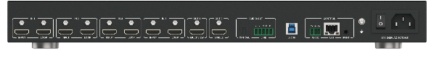
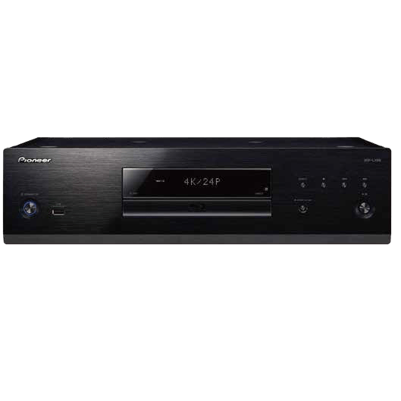

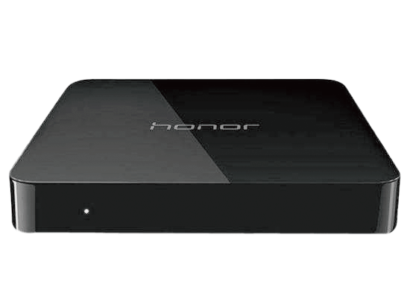
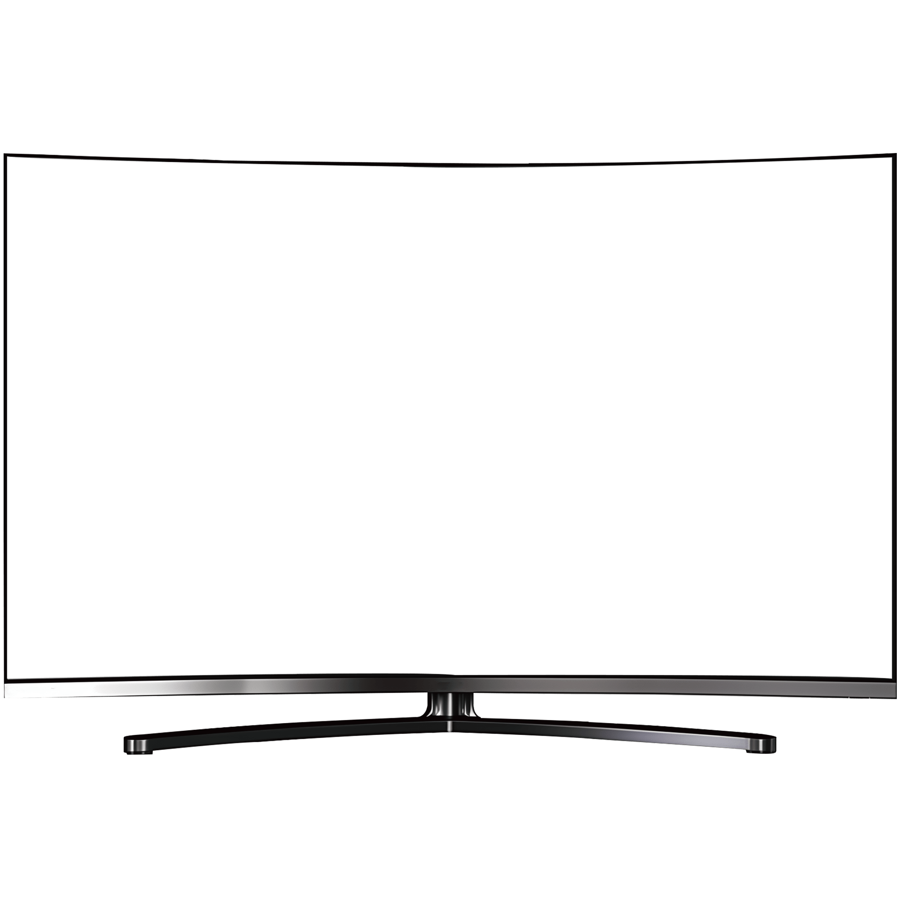

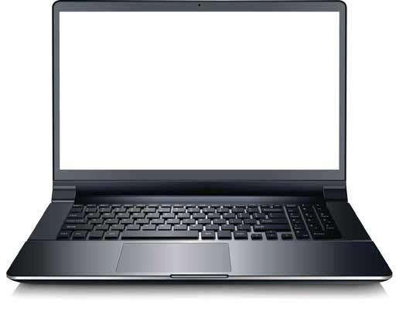
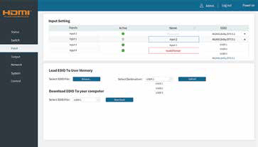




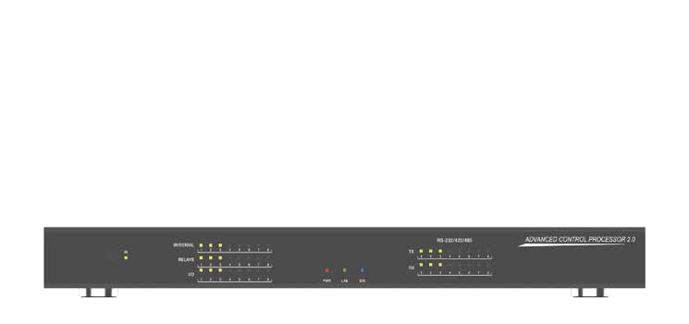
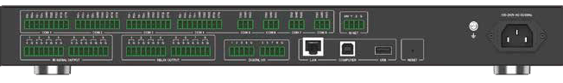
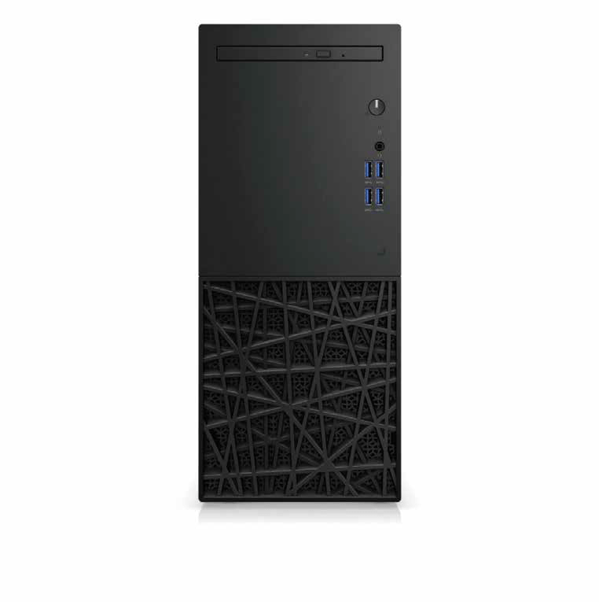
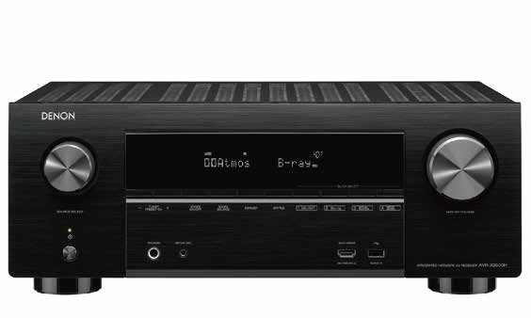
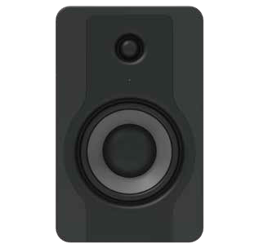


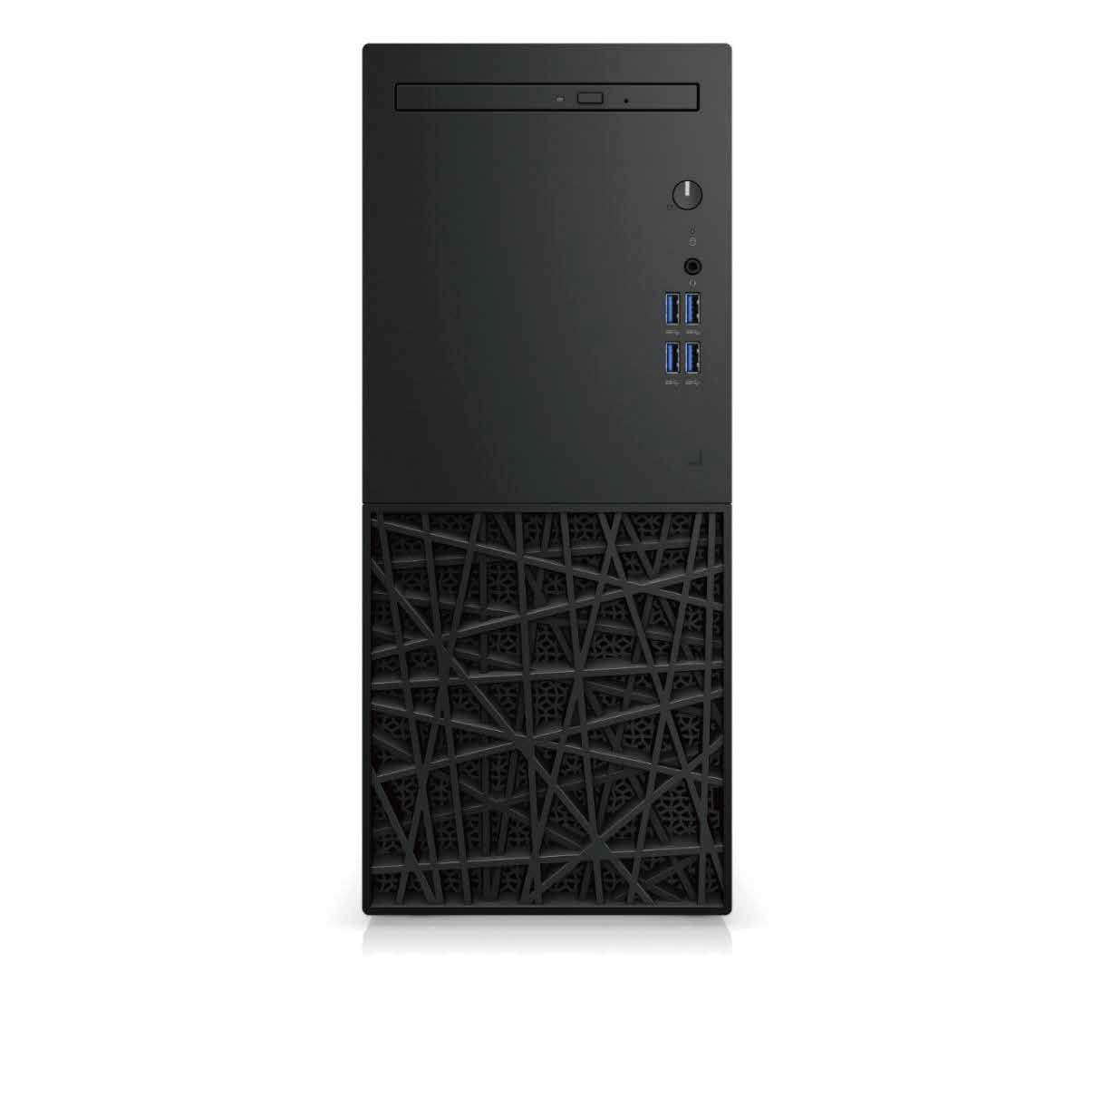
Connection Diagram 1: General Application

HDMI
Cable

PC

USB Cable

Laptop

RS-232
Cable

Central Control System

CAT
Cable

Audio Cable
HDMI Cable CAT Cable RS-232 Cable Optical Cable Audio Cable USB Cable

DVD Player

Laptop

HDMI
Cable

HDMI
Cable

HDMI
Cable

HDMI
Cable

Optical Cable

HDMI Cable

Amplifier Active Speakers

TV Box

TV TV
Network Camera

Desktop Computer

Connection Diagram 2: Cascading Application

TV HDMI Cable
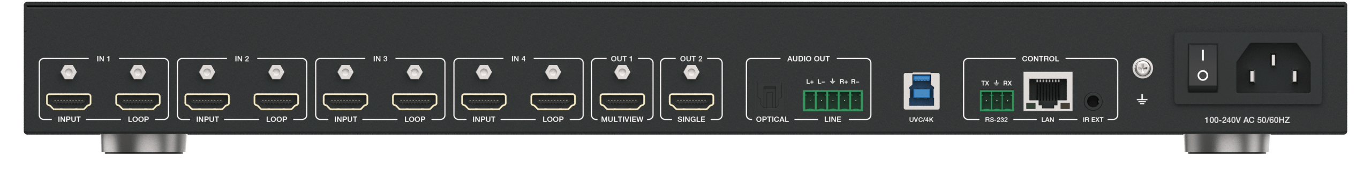


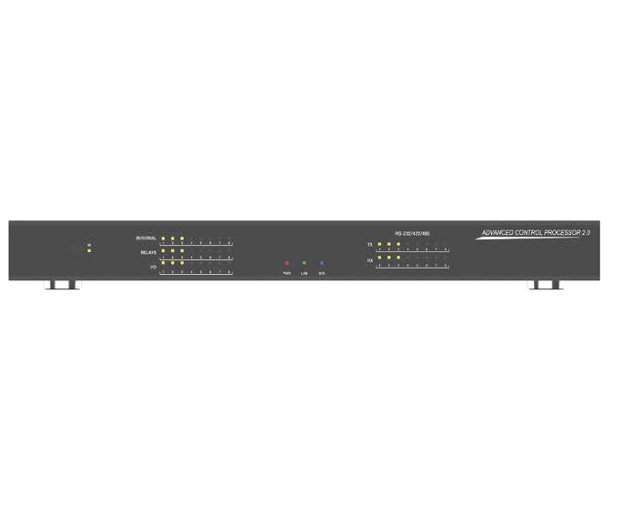

CAT Cable RS-232 Cable Optical Cable Audio Cable USB Cable
HDMI Cable

PC Laptop
Central Control System

HDMI
Cable

HDMI
Cable

HDMI
Cable

USB Cable

RS-232
Cable

CAT
Cable

HDMI
Cable

Audio Cable

DVD Player

Laptop

HDMI
Cable

HDMI
Cable

HDMI
Cable

HDMI
Cable

Optical Cable

HDMI Cable

Amplifier Active Speakers

TV Box

TV TV
Network Camera

Desktop Computer

Connection Diagram 3: AV over IP Application
Network Camera

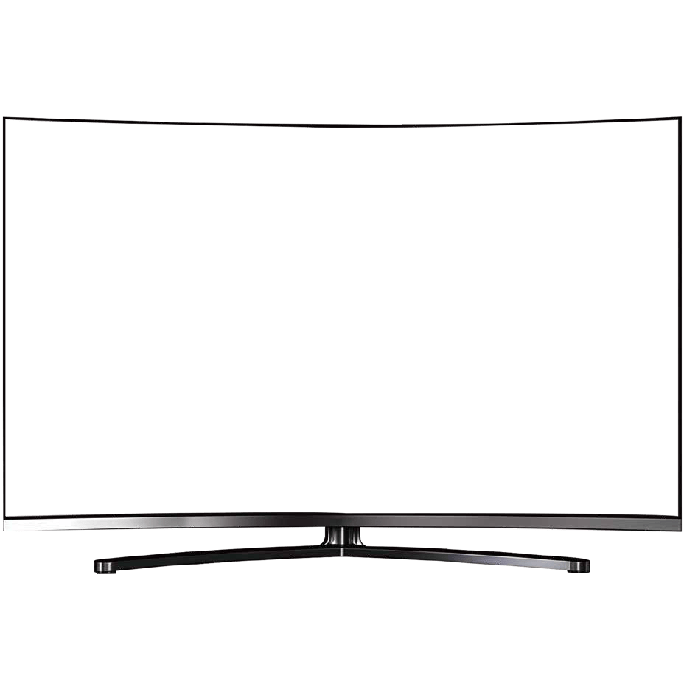



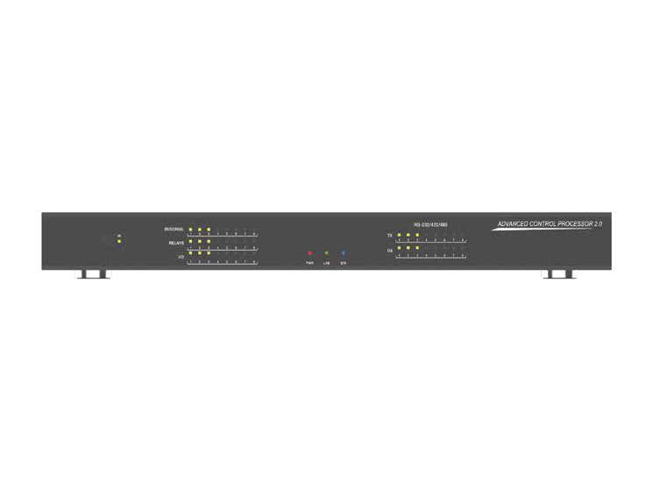
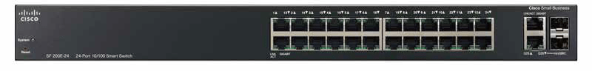
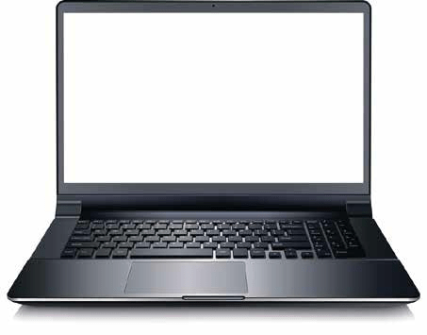
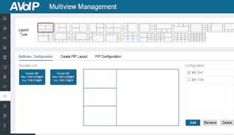
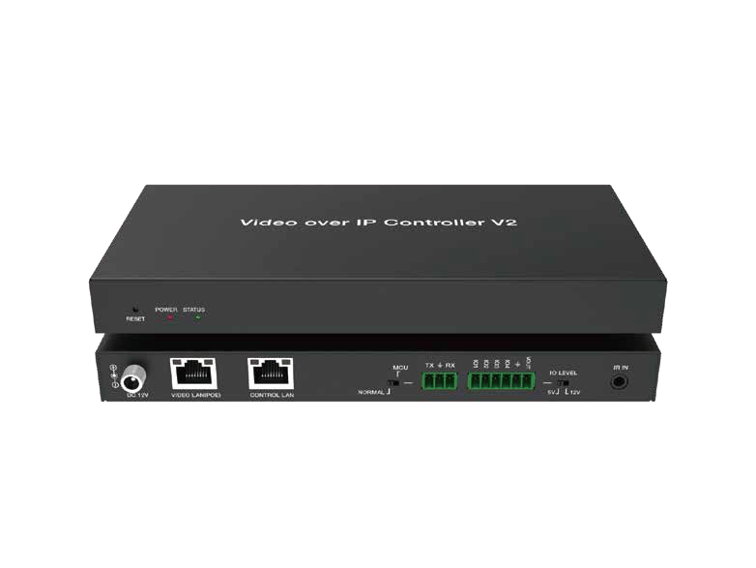
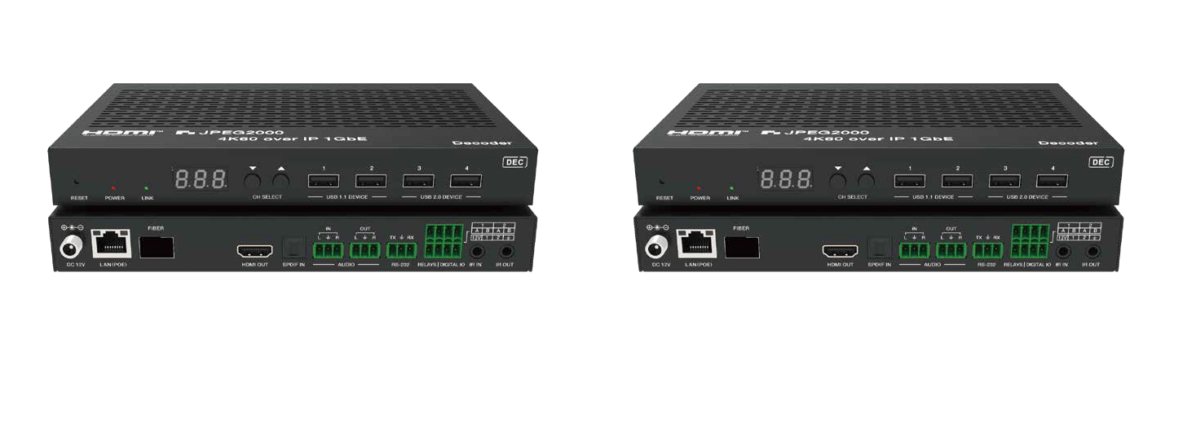
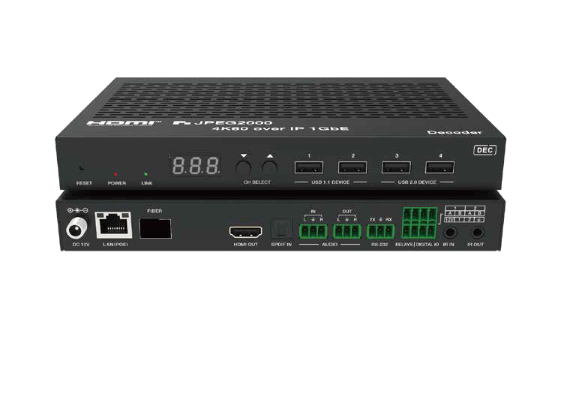
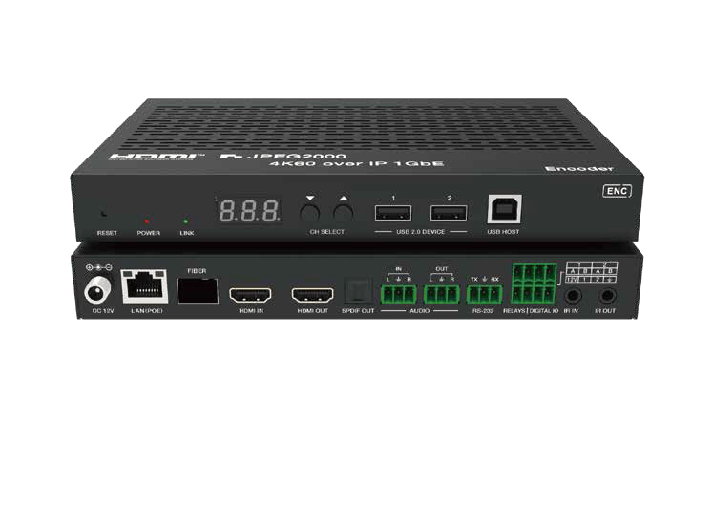
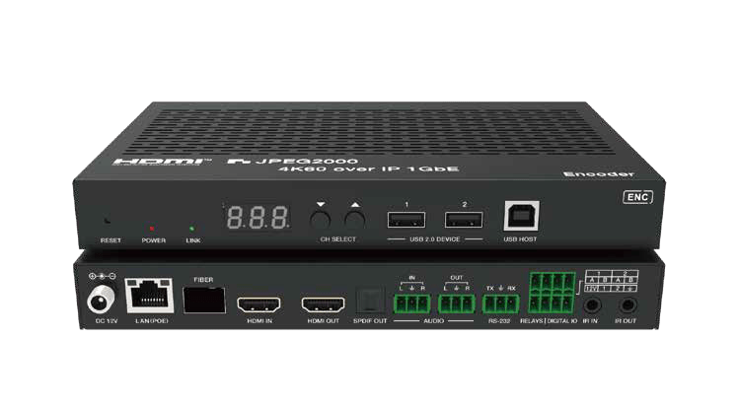
HDMI Cable CAT Cable RS-232 Cable Optical Cable Audio Cable USB Cable
TV
TV
PC
Laptop
Central Control System
USB Cable RS-232
Cable
CAT Cable
HDMI Cable
HDMI Cable
HDMI Cable
HDMI Cable
Audio Cable
Optical Cable
DEC
DEC
DEC
DEC
CAT Cable
CAT Cable

CAT Cable 1G Switch CAT Cable
Amplifier
Active Speakers
Controller
ENC
HDMI Cable
ENC
HDMI Cable
ENC
HDMI Cable
ENC
HDMI Cable
CAT Cable
DVD Player
Laptop
TV Box
Laptop
Phone
Desktop Computer

Pad

The terms HDMI, HDMI High-Definition Multimedia Interface, HDMI trade dress and the HDMI Logos are trademarks or registered trademarks of HDMI Licensing Administrator, Inc.

