MAT.HDMI42H2-4KV2

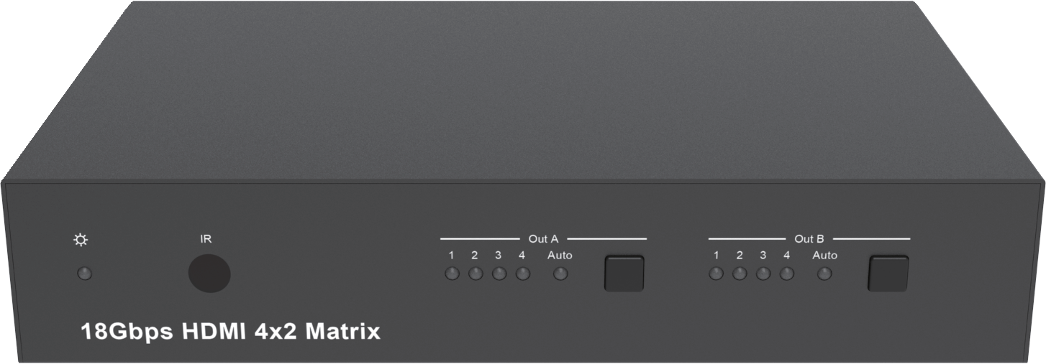


VER 1.0

Thank you for purchasing this product
For optimum performance and safety, please read these instructions carefully before connecting, operating or adjusting this product. Please keep this manual for future reference.

Surge protection device recommended
This product contains sensitive electrical components that may be damaged by electrical spikes, surges, electric shock, lighting strikes, etc. Use of surge protection systems is highly recommended in order to protect and extend the life of your equipment.

Table of Contents
- Introduction. 1
- Features. 1
- Package Contents. 1
- Specifications. 2
- Operation Controls and Functions. 3
  - Front Panel. 3
  - Rear Panel. 4
  - Connecting to the Matrix. 5
  - Using the Matrix. 6
  - IR Pin Definition. 7
- IR Remote. 8
- Using the Built-In Web Interface 9
- ASCII control command. 18
- Application Example. 24

Introduction
This product is an 18G HDMI video switcher with 4 HDMI inputs and 2 scaling HDMI outputs. Each input and output supports up to 4K60 444 HDMI 18G video. The outputs can be individually scaled for 1080p or HDBaseT compatibility. De-embedded audio as analogue L+R and optical TosLink is available for both outputs. The Matrix Switcher can automatically control the display device using RS232, CEC or IR when the last input signal is lost, or when the first video input is detected. This switcher can be controlled from the front panel, RS232, IR, or LAN.

Features
☆ HDMI 2.0, HDCP 2.2 / HDCP 1.4 and DVI 1.0 compliant
☆ Four 18G HDMI 2.0 video inputs supporting up to 4K60 444 resolution
☆ Two 18G HDMI 2.0 video outputs supporting up to 4K60 444 resolution
☆ Both outputs can be individually scaled for 4K→1080p or HDBaseT mode
☆ Automatic RS232, CEC and IR control of the display device power state
☆ Two sets of de-embedded audio analogue and TosLink outputs, for both outputs
☆ ARC decoding to the TosLink audio outputs only
☆ Test Pattern mode for testing output signal integrity to the display
☆ Built-in Web GUI for LAN control
☆ Four methods of control: Front panel, RS232, IR and LAN

Package Contents

Qty | Item
1 | 4×2 HDMI 2.0 18Gbps Matrix Switcher
1 | 12V/1A Locking Power Adapter
1 | IR Remote
2 | Mounting Ears
2 | IR Blaster Cables (1.5 meters)
1 | 20~60KHz IR Receiver Cable (1.5 meters)
5 | 3-pin Phoenix Connectors
1 | User Manual

Specifications

Technical
HDMI Compliance | HDMI 2.0
HDCP Compliance | HDCP 2.2 and HDCP 1.4
Video Bandwidth | 18 Gbps
Video Resolution | 4K2K 50/60Hz 4:4:4  4K2K 50/60Hz 4:2:0  4K2K 30Hz 4:4:4  1080p, 1080i, 720p, 720i, 480p, 480i  All HDMI 3D TV formats  All PC resolutions including 1920 x 1200
3D Support | Yes
Output Scaling | 4K to 1080p  4K to HDBaseT (Down-scale to no more than 10.2Gbps)
Color Space | RGB, YCbCr4:4:4, YCbCr4:2:2, YCbCr 4:2:0
Color Depth | 8-bit, 10-bit, 12-bit [1080P, 4K30Hz, 4K60Hz (YCbCr 4:2:0)]  8-bit [4K60Hz (YCbCr4:4:4)]
HDMI Audio Formats | PCM2.0/5.1/7.1CH, Dolby Digital/Plus/EX, Dolby True HD, DTS, DTS-EX,DTS-96/24, DTS High Res, DTS-HD Master  Audio, DSD
HDR formats | HDR10, HDR10+, Dolby Vision, HLG
L/R Audio Formats | PCM2.0CH  (Note: If ARC function is turned on, the audio port will mute.)
Optical Audio Formats | PCM2.0, Dolby Digital / Plus, DTS
Audio Frequency Response | 20Hz to 20kHz, ±3dB
RS232 Control | 57600, No parity, 8 data bits, 1 stop bit, No handshaking
RS232-A and RS232-B | Configurable from 4800 to 115200 baud; 7 or 8 bits; none, odd or even parity and 1 or 2 stop bits.
ESD Protection | Human-body Model: ±8kV (Air-gap discharge),  ±4kV (Contact discharge)

Connections
Input Ports | 4×HDMI Type A [19-pin female]
Output Ports | 2×HDMI Type A [19-pin female]  2×L/R audio out [3-pin phoenix connector] 2×OPTICAL audio out [S/PDIF]  2×RS232 A/B [3-pin phoenix connector]
Control port | 1×LAN [RJ45]  3×RS232 [3-pin phoenix connector] 1×IR IN [3.5mm Stereo Mini-jack]  2×IR OUT A/B [3.5mm Stereo Mini-jack]
Mechanical
Housing | Metal Enclosure
Color | Black
Dimensions | 218mm(W)×140mm(D)×43mm(H)
Weight | 1050g
Power Supply | Input: AC100~240V 50/60Hz  Output: DC12V/1A (Locking connector)
Power Consumption | 4.3W (max)
Operating Temperature | 0°C ~ 40°C / 32°F ~ 104°F
Storage Temperature | -20°C ~ 60°C / -4°F ~ 140°F
Relative Humidity | 20~90% RH (non-condensing)
Resolution / Cable length | 4K60 -  Feet / Meters | 4K30 -  Feet / Meters | 1080P60 -  Feet / Meters
HDMI IN / OUT | 16ft / 5M | 32ft / 10M | 50ft / 15M
The use of “Premium High Speed HDMI” cable is highly recommended.

Operation Controls and Functions

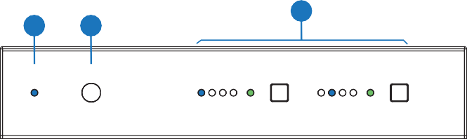Front Panel
1
2
3
IR
Out A
1 2 3 4 Auto
Out B
1 2 3 4 Auto
18Gbps HDMI 4x2 Matrix

Number | Name | Function description
1 | Power LED | Blue LED indicates that the unit is powered.  Red LED indicates that the unit is in standby mode.
2 | IR Sensor | IR input for remote control of the switcher
3 | Out A / Out B | LED and button for each output  - LED 1 to LED 4: Blue LED Indicates when the input is  selected for the respective output.  - Auto LED: Green when Auto detection mode is enabled.  - Press to select the desired input.  - Press and hold for 3 seconds to toggle the Auto  detection mode.

Rear Panel
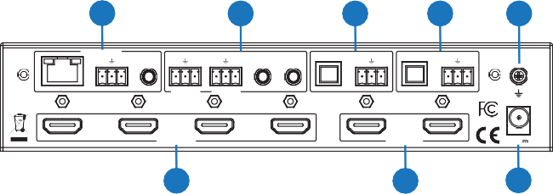
4
5
6
7
8
CONTROL
Tx Rx
OPTICAL
OPTICAL
Tx Rx Tx Rx
A B
L R
L R
LAN RS232
IR IN RS232-A RS232-B
IR OUT
AUDIO OUT A
AUDIO OUT B
1
2
3
4
A
B
SOURCE
DISPLAY
12V
1
2
3

Number | Name | Function description
1 | SOURCE | HDMI Source inputs 1 to 4
2 | DISPLAY | HDMI outputs for displays A and B.
3 | 12V | Plug DC 12V/1A power supply into the unit and connect the adapter to an AC outlet.
4 | CONTROL | LAN (RJ45): Control port for LAN control or accessing the built-in Web GUI.
4 | CONTROL | RS232: 3-pin pluggable connector for RS232 control of the Matrix.
4 | CONTROL | IR IN: IR Eye input for IR control of the Matrix.
5 | RS232-A / RS232-B | 3-pin pluggable connectors for RS232 of the display devices.
5 | IR OUT A / IR OUT B | IR eye output for IR control of the display devices.
6 | AUDIO OUT A | TosLink connector for optical audio from HDMI Output A
6 | AUDIO OUT A | 3-pin pluggable connector for stereo audio from HDMI Output A
7 | AUDIO OUT B | TosLink connector for optical audio from HDMI Output B.
7 | AUDIO OUT B | 3-pin pluggable connector for stereo audio from HDMI Output B.
8 | Earthing Point | Screw terminal for earthing the Matrix.

Connecting to the Matrix
- Connect the desired HDMI input sources.
- Connect the desired HDMI display devices.
- Connect any CONTROL inputs that may be required: LAN, RS232, or IR IN.
- Connect any Display control port: RS232-A, RS232-B, IR OUT A or IR OUT B.
- Connect any audio devices to either the Optical or L+R outputs.
- Connect the 12V DC PSU.

Using the Matrix
    - Power LED and Standby Mode
The Power LED provides the following indications:

Colour | Description
Blue | The Matrix is active and fully controllable
Red | The Matrix is in standby mode, this state can be changed by using RS232 or LAN commands, or from the Web GUI interface.

    - Auto LED and Button
The green AUTO LED for both outputs A and B is lit when that channel has its Auto Detection mode active. Auto Detection mode will detect any new HDMI signals and immediate switch to the input. If the currently selected input is removed then the switcher will switch to the next available input, or remain on the current input if there are no active HDMI input signals.

The change the Auto Detection mode, press and hold the button for that channel for 3 seconds until the Auto LED changes state.

    - Selecting Inputs
Manual Selection of the inputs is done by briefly pressing the push button repeatedly for that channel until the desired input is selected. Manual selection is always possible, irrespective of the Auto LED state. Selected inputs that have no signal will be indicated by a flashing LED.

IR Pin Definition
IR Receiver and Blaster pin’s definition as below:
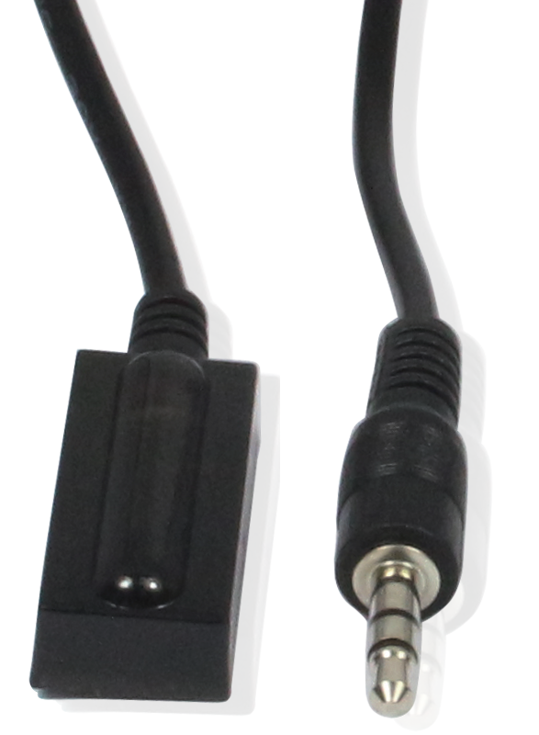
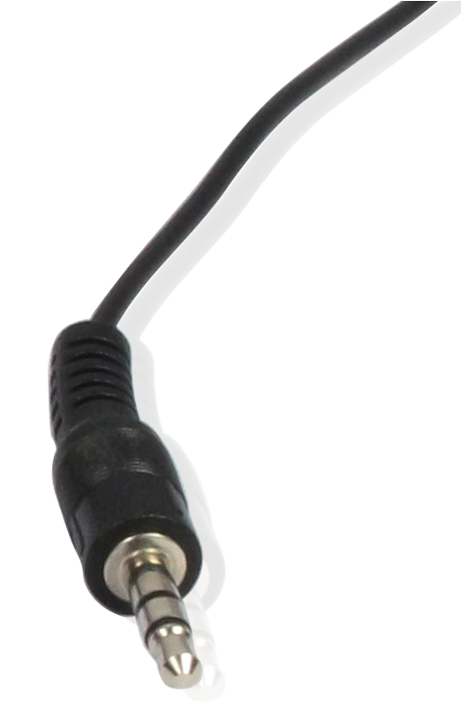
IR RECEIVER IR BLASTER

IR Blaster Signal Power
IR Blaster
NC
IR Receiver

IR Signal

Power Grounding

IR Remote
Output A
1 2 3 4
AUTO
4K/HD
Output B
1 2 3 4
AUTO
4K/HD
HDMI Matrix Remote
 | Power on the product or set it to standby mode.
Output A / B
1/2/3/4 | Select input source signal to Out A / B port output, corresponding Out A / B LED on the front panel illuminates in blue.
 | Select the last or next input source signal to OUT A / B port output, corresponding Out A / B LED on the front panel illuminates in blue.
AUTO | Turn on / off AUTO function.
4K/HD | Select Out A / B 4k→1080P downscale output. For example, if source is 4K but TV only supports 1080P, the input resolution with 4K will downscale to 1080P to TV output.

Using the Built-In Web Interface
The Matrix has a built-in web interface to provide a means of controlling or configuring various settings. There are seven pages available, each of which will be outlined in detail in the following sections.
The seven pages are:

- Status – Displays information about the firmware and IP settings
- Switch – Control the video routing and enabling the test pattern mode
- Input – Displays information about the input signals and EDID settings
- Output – Displays information about the output signals and scaler options
- Network – Allows basic network setting management and login options
- System – Serial baudrate, test pattern setting and firmware update
- Control – Auto Power Control Settings and Commands
Note these seven pages are only accessible in Admin mode, when User
mode is used only the Status and Switch pages are available.
To access the web interface, enter the IP address of the Matrix into
the address bar of any web browser. If the IP address is not known, use the RS232 commands given in the Network Settings section “r ip addr!” to discover the IP address of the Matrix or set the product to factory default status and IP address reset to default 192.168.1.100. After entering the IP address the following log in screen will appear:
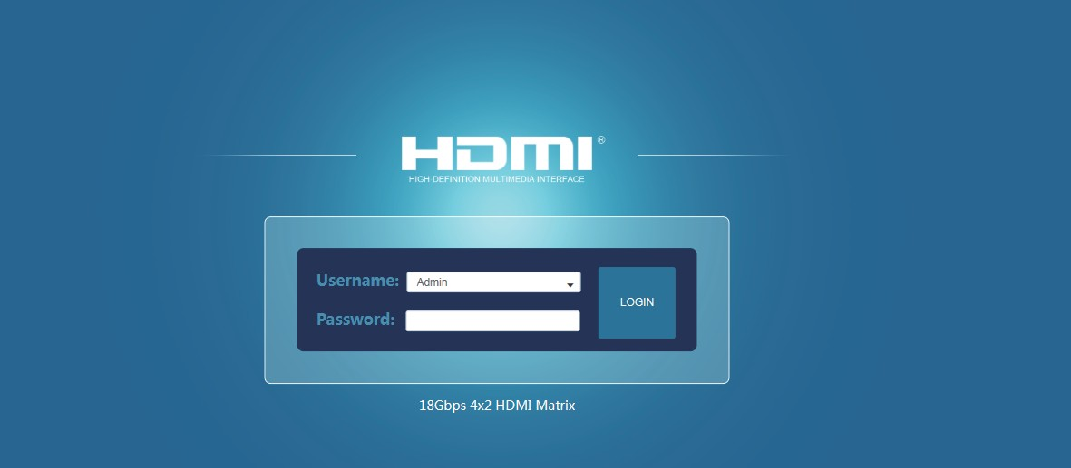

Select the Username from the list and enter the password. The default passwords are:
Username User Admin
Password user admin
After entering the log in details, click the LOGIN button and the following Status page will appear.

- Status Page
The Status page provides basic information about the product Model name, the installed firmware versions and the network settings. This page is visible in both User and Admin modes.
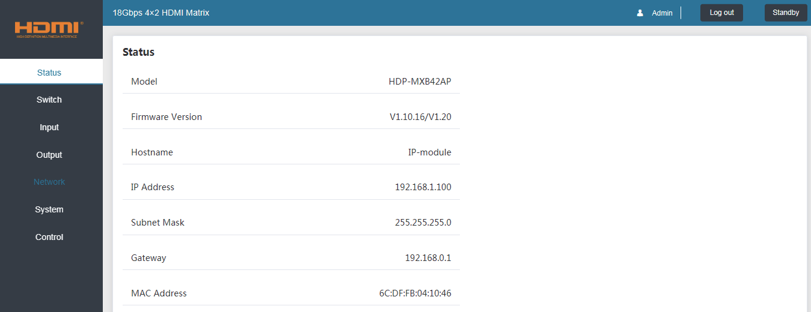
The buttons at the top right of the web interface are always available and provide the following functions:
  - The Log out button will disconnect the current user from the session and display the log in screen.
  - The Power On button changes the power status of the Matrix between On and Stand-by mode.

- Switch page
The Switch page allows selection of the inputs sources, set the Auto Switch mode and to enable the test pattern mode.
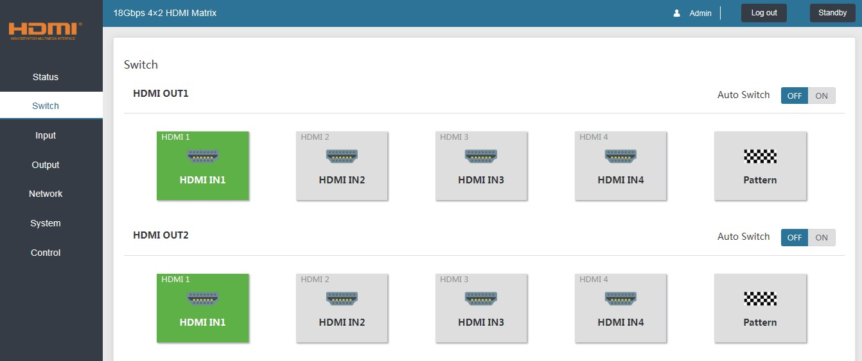

- Input page
The Input page provide information about which inputs are connected and have a signal present. The inputs can be giving more meaningful names, if desired. The EDID column provides a list of EDID options for each individual input.
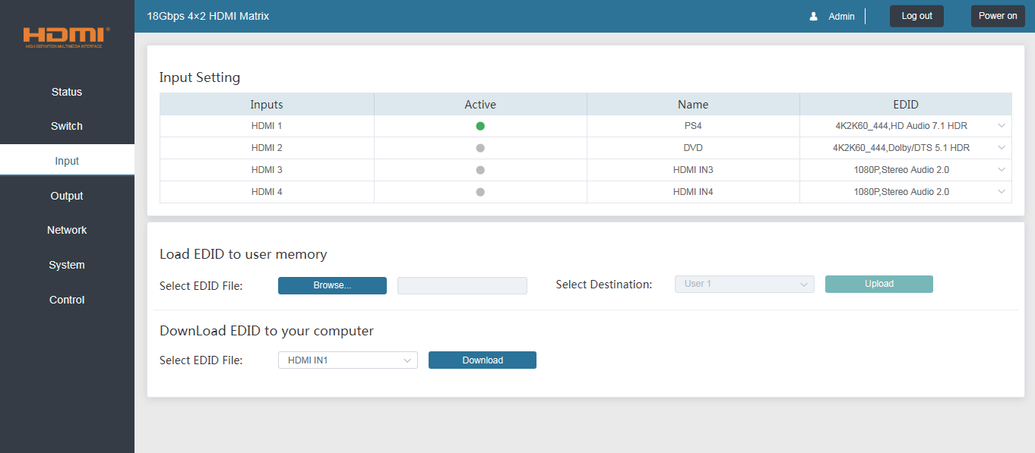

The following EDID options are available in any of the EDID drop-down lists:
1080P, Stereo Audio 2.0 1080P, Dolby/DTS 5.1
1080P, HD Audio 7.1
1080I, Stereo Audio 2.0 1080I, Dolby/DTS 5.1
1080I, HD Audio 7.1
3D, Stereo Audio 2.0 3D, Dolby/DTS 5.1 3D, HD Audio 7.1
4K2K30_444, Stereo Audio 2.0 4K2K 30Hz_444 Dolby/DTS 5.1
4K2K 30Hz_444 HD Audio 7.1
4K2K 60Hz_420 Stereo Audio 2.0 4K2K 60Hz_420 Dolby/DTS 5.1
4K2K 60Hz_420 HD Audio 7.1
4K2K 60Hz_444 Stereo Audio 2.0 4K2K 60Hz_444 Dolby/DTS 5.1
4K2K 60Hz_444 HD Audio 7.1
4K2K60_444,Stereo Audio 2.0 HDR 4K2K60_444,Dolby/DTS 5.1 HDR
4K2K60_444,HD Audio 2.0 HDR USER1
USER2
Copy from OUT 1 Copy from OUT 2
Note that the User 1 and User 2 are global EDID memories only. Any inputs that is set to one of these memories will always use the same EDID data from User 1 or User 2 respectively.

This page also provides a means of sending a binary EDID image file to either User 1 or User 2 EDID memories:
- Select the binary EDID image file on your PC by click on the Browse button.
- Select either User 1 or User 2 from the drop-down list.
- Click the Upload button.
The EDID data from any input or from the User 1 and User 2 locations can be read and stored on your PC.

  - Output page
The Output page provides information about the signal status of the outputs. The outputs can also be assigned meaningful names, is desired.
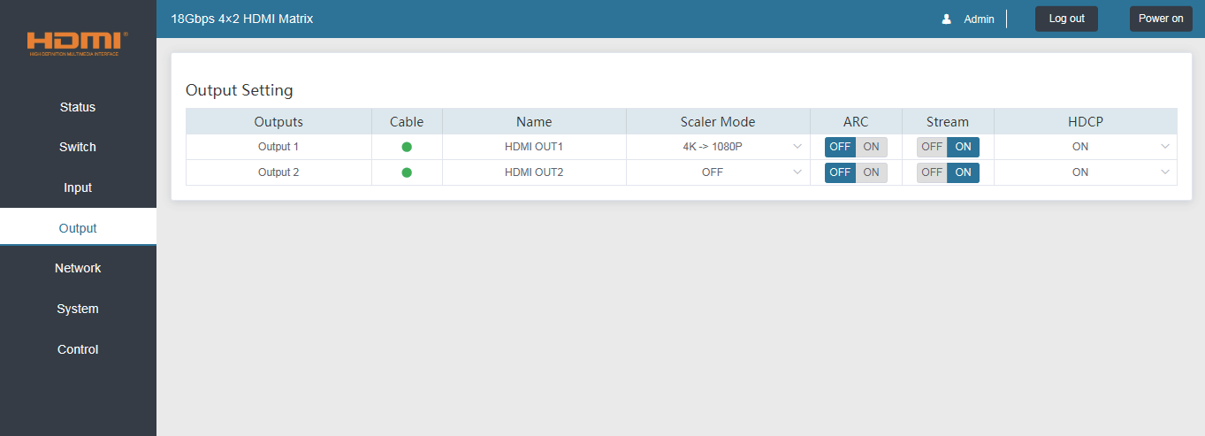

The scaler mode menu provides the following options:

Off | No scaling.
4K→1080P | Downscale to 1080p, if needed.
HDBT Mode | Downscale to no more than 10.2Gbps for HDBaseT compliance.
Auto | Scale to match the display requirements.
The ARC buttons enable or disable the ARC decoding to the analogue audio outputs.
The Stream buttons enable or disable the output signal for the respective output.
The HDCP buttons enable or disable HDCP at the respective HDMI output.

  - Network page
The Network page allows the configuration of the network settings. Note that the IP address boxes are only accessible when the Mode button is set to Static.
The log in passwords can be changed s on this page.
Note that any changes to this page will require the new details into the web browser and/or the log in screen.
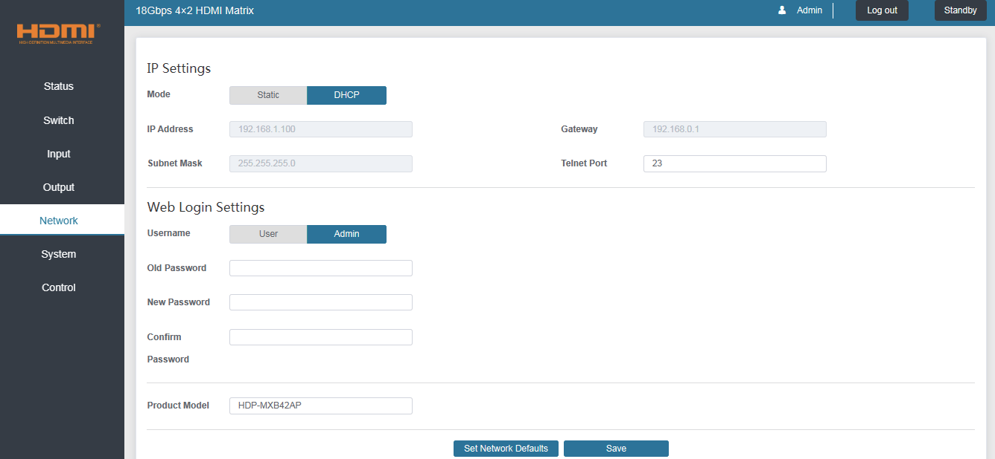

  - System page
The system page allows setting of the control RS232 port baud rate and changing the test pattern output.
This page is also used to install new firmware updates, restore the factory default settings and reboot the Matrix.

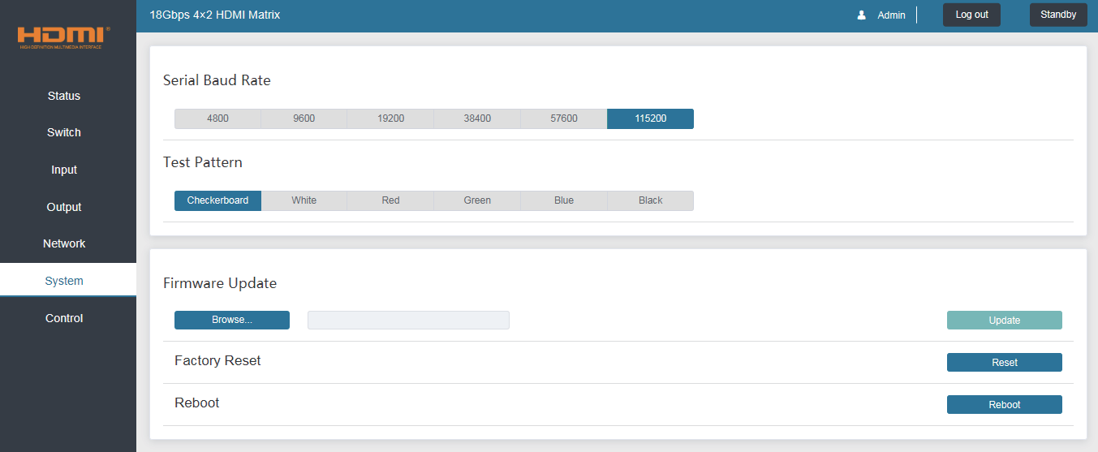

  - Control page
The Control page is used to set the RS232 or IR display device power on/off commands for the Automatic Power Switching mode. When this mode is enabled, the display power off and power on commands will be sent from RS232-A/RS232-B or IR-A/IR-B outputs after the defined Power Off Timeout and Power On Timeout values respectively.

The Control page has three modes: RS232, CEC or IR. Power On and Power Off commands can only be entered for the RS232 and IR modes. The
CEC mode power on and power off commands are provided by default and cannot be changed. Only use CEC mode with displays that support CEC commands.

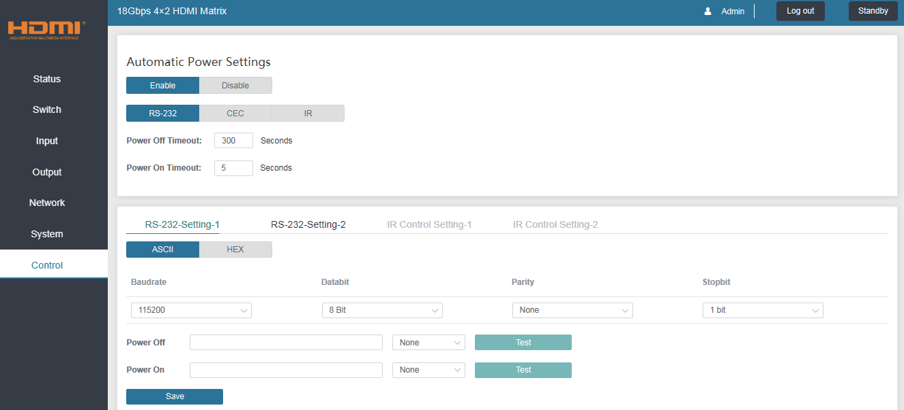
- RS232 Setting 1 and RS232 Setting 2
Select the desired tab and configure the RS232 port settings to match the display device requirements. Select either ASCII or HEX for the command format and enter the Power Off and Power On commands with the appropriate command termination mode: None, CR, LR or CRLF.

If the display device is connected to the respective RS232-A or RS232-B port, use the Test buttons to confirm that the command is correct. Once the command is valid, use the Save button to store those commands in the Matrix.

Note that ASCII commands can use any ASCII character, but HEX command must use hexadecimal notation using hexadecimal value pairs separated by spaces.

- IR Setting 1 and IR Setting 2
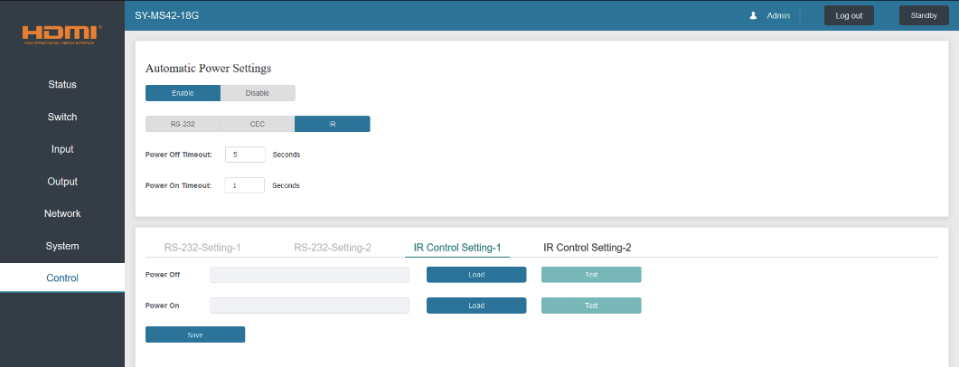
This page requires that the IR commands are available in plain text files using the CCF IR code format.
  - Select the desired IR Control Setting tab.
  - Click the Load button to load the respective IR command. If the display device only support a power toggle IR command, then use the same file for both the Power On and Power Off modes.
  - Use the Test button to confirm that the command functions.
  - Click the Save button to save both IR commands to the Matrix.

ASCII control command
The Matrix also supports ASCII control. You need to a RS-232 phoenix conn- ector male head to RS-232 female head with DB9 serial cable and a RS-232 male head with DB9 to USB male head serial cable. The phoenix connector male head is connected the RS-232 port of the Matrix, and the USB head of the serial cable is connected a PC. Open any of a Serial Command tool on PC such as “Docklight” to send command to control the Matrix. Please see the following connection diagram.
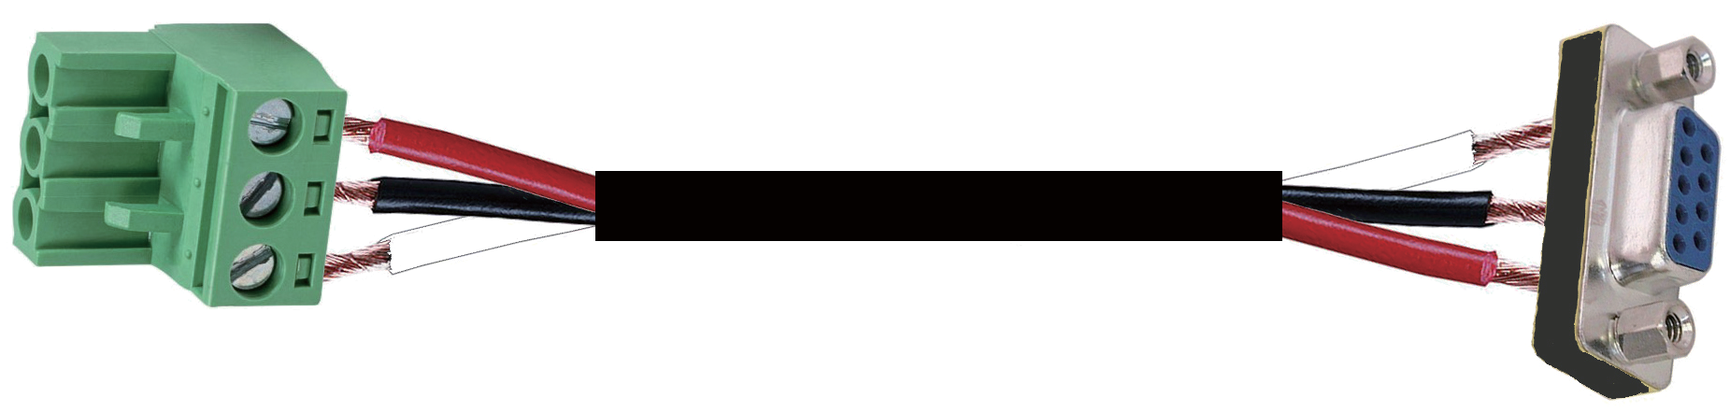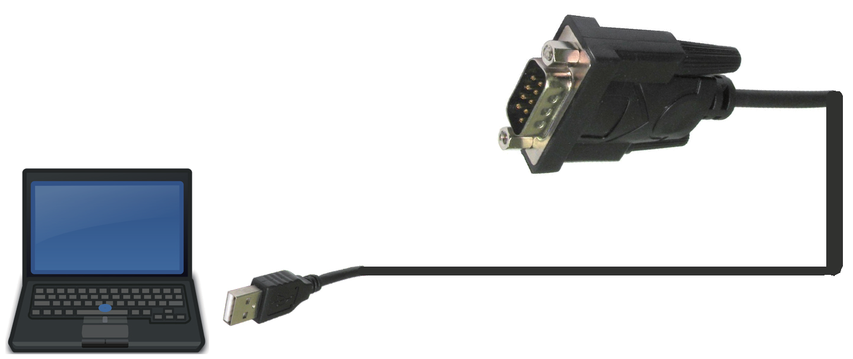
LAN RS232 IR IN

TX
Gound
RX

3-pin Phoenix Connector
RS-232

RS-232 to USB cable
CONTROL
Tx Rx
PC
Figure 1: 3-pin phoenix connector to USB

Important:
- All messages sent to the Matrix must be terminated with an exclamation mark (!). Any carriage return that is present after the end of the command will be ignored.
- All spaces shown in the commands are required.
- All response messages are terminated by a CR/LF sequence.
- When all four inputs are requested by the same command, the response will report each input on a separate line.
- When both outputs are requested by the same command, the response will report each output on a separate line.

The ASCII list about the product is shown as below.

ASCII Command
Serial port protocal: Baud rate：115200 (default), Data bits: 8bit, Stop bits:1, Check bit: 0 TCP/IP protocol port: 8000. The x, y, z, XXX are parameter.
RS-232 Command | Function description | Feedback
System Setting
r type! | Get device model | HDP-MXB42AP
r status! | Get device current status | Get the unit all status: power, in/out connection, video/audio crosspoint, edid, scaler,hdcp, network status
r fw version! | Get Firmware version | MCU BOOT: V1.00.01 MCU APP : V1.10.05
r link in x! | Get the connection status of the x input port， x=0~4(0=all) | HDMI IN1: connect
r link out y! | Get the connection status of the y output port, y=0~2(0=all) | HDMI OUT1: connect
s reset! | Reset to factory defaults | Reset to factory defaults System Initializing...  Initialization Finished!
s power z! | power on/off the device,z=0~1(z=0 power off, z=1 power on) | Power on  System Initializing... Initialization Finished! power off
r power! | get current power state | power on /power off
s reboot! | reboot the device | Reboot…  System Initializing... Initialization Finished!
Output Setting
s in x av out y! | Set input x to output y，x=1~4，y=0~2(0=all) | input 1 -> output 2
r av out y! | Get output y signal status y=0~2(0=all) | input 1 -> output 1  input 2 -> output 2
s hdmi y stream z ! | Set hdmi output y stream on/off, y=0~2(0=all) z=0~1(0:disable,1:enable) | Enable HDMI out1 stream Disable HDMI out1 stream
r hdmi y stream! | Get hdmi output y stream status, y=0~2(0=all) | Enable HDMI out1 stream
s hdmi y scaler z! | Set hdmi output y port output mode, y=0~2(0=all),  z=1~4(1=off,2=4k->1080p,3=hdbt mode, 4=Auto) | hdmi output 1 set to bypass  mode
r hdmi y scaler ! | Get hdmi output y port output mode y=0~2(0=all) | hdmi output 1 set to bypass  mode
s hdmi y hdcp z! | set hdmi output y port hdcp status y=0~2(0=all) z=0~1(1=on,0=off) | hdmi out 1 hdcp on

r hdmi y hdcp! | Get HDCP status of HDMI out y, y=0~2(0=all) | hdmi out 1 hdcp active
s hdmi y pattern z! | Set hdmi output y test pattern on/off.y=0~2(0=all, 1=OUT 1,2=OUT 2) z=0~1 (0=off ,1=on) | hdmi output 1 test pattern on
r hdmi y pattern! | Get hdmi output y test pattern on/off status. y=0~2 (0=all 1=OUT 1, 2=OUT 2) | hdmi output 1 test pattern on
s pattern mode z! | Set test patterns type. z=1~6 (1- Checkerboard 2-White 3-Red 4-Green 5-Blue 6-Black) | set pattern White!
r pattern mode! | Get test pattern mode. | set pattern White!
EDID Setting
s edid in x from z! | Set input x EDID from default EDID z, x=0~4(0=all),z=1~25  1=1080p,Stereo Audio 2.0  2=1080p,Dolby/DTS 5.1  3=1080p,HD Audio 7.1  4=1080i,Stereo Audio 2.0  5=1080i,Dolby/DTS 5.1  6=1080i,HD Audio 7.1  7=3D,Stereo Audio 2.0  8=3D,Dolby/DTS 5.1  9=3D,HD Audio 7.1  10=4K2K30_444,Stereo Audio 2.0  11=4K2K30_444,Dolby/DTS 5.1  12=4K2K30_444,HD Audio 7.1  13=4K2K60_420,Stereo Audio 2.0  14=4K2K60_420,Dolby/DTS 5.1  15=4K2K60_420,HD Audio 7.1  16=4K2K60_444,Stereo Audio 2.0  17=4K2K60_444,Dolby/DTS 5.1  18=4K2K60_444,HD Audio 7.1  19=4K2K60_444,Stereo Audio 2.0 HDR  20=4K2K60_444,Dolby/DTS 5.1 HDR  21=4K2K60_444,HD Audio 7.1 HDR  22=User1 23=User2 | IN1 EDID:1080p,Stereo Audio 2.0
r edid in x! | Get EDID status of the input x, x=0~4(0=all input) | IN1 EDID: 4K2K60_444,  Stereo Audio 2.0  IN2 EDID: 4K2K60_444,  Stereo Audio 2.0  IN3 EDID: 4K2K60_444,  Stereo Audio 2.0  IN4 EDID: 4K2K60_444,  Stereo Audio 2.0

r edid data hdmi y! | Get the EDID data of the hdmi output y port,y=1~2 | EDID : 00 FF FF FF FF FF  FF 00 ………
Audio Setup
s hdmi y arc z! | Turn on/off arc of HDMI output y ，y=0~2(0=all) z=0~1(z=0,off,z=1 on) | hdmi output 1 arc on hdmi output 1 arc off
r hdmi y arc! | Get the arc state of HDMI output y, y=0~2(0=all) | hdmi out1 arc on
s spdif x mute y! | Enable/disable the audio outputs . x=1~2(1=spdif 1 ,2=spdif 2 ) ,y=0~1( 0=unmute , 1=mute) | spdif 1 mute
r spdif x mute! | Read the audio output state. x=1~2(1=spdif 1, 2=spdif 2 ) | spdif 1 mute
Network setting
r ipconfig! | Get the Current IP Configauration | IP Mode: Static IP: 192.168.1.72  Subnet Mask: 255.255.255.0  Gateway: 192.168.1.1  TCP/IP port: 23 Mac address: 00:1C:91:03:80:01
r mac addr! | Get network MAC address | Mac address: 00:1C:91:03: 80:01
s ip mode z! | Set network IP mode to static IP or DHCP, z=0~1 (z=0 Static, z=1 DHCP ) | Set IP mode:Static. Please use "s net reboot!"  command or repower device to apply new config!
r ip mode! | Get network IP mode | IP mode: Static
s ip addr xxx.xxx. xxx.xxx! | Set network IP address | Set IP address:192.168.1.  100. Please use "s net reboot!" command or repower device to apply new config! DHCP on, Device can't config static address, set DHCP off first.
r ip addr! | Get network IP address | IP address:192.168.1.100
s subnet xxx.xxx. xxx.xxx! | Set network subnet mask | Set subnet Mask:255.255.  255.0. Please use "s net reboot!" command or repower device to apply new config! DHCP on, Device can't config subnet mask, set DHCP off first.

r subnet! | Get network subnet mask | Subnet Mask:255.255.255.0
s gateway xxx. xxx.xxx.xxx! | Set network gateway | Set gateway:192.168.1.1 Please use "s net reboot!" command or repower device to apply new config!  DHCP on, Device can't config gateway, set DHCP  off first.
r gateway! | Get network gateway | Gateway:192.168.1.1
s tcp/ip port x! | Set network TCP/IP port (x=1~65535) | Set tcp/ip port:8000
r tcp/ip port! | Get network TCP/IP port | tcp/ip port: 8000
s telnet port x! | Set network telnet port(x=1~65535) | Set telnet port:23
r telnet port! | Get network telnet port | telnet port:23
s net reboot! | Reboot network modules | Network reboot… IP Mode: Static IP: 192.168.1.72  Subnet Mask: 255.255.255.0  Gateway: 192.168.1.1 Mac address: 00:1C:91:03:80:01
Control setting
s autopower z! | Set display auto power on/off control z=0~1(z=0 disable, z=1 enable) | Display autopower control enable
r autopower! | Get display auto power state | Display autopower control  enable
s autopower mode z! | Set display auto power control mode z=1~3(z=1 RS-232, z=2 CEC, z=3 IR) | Display autopower control by RS-232
r autopower mode! | Get display auto power mode | Display autopower control by RS-232
s autopower on time y! | Set auto power on timeout y=0~600 seconds | Display autopower on timeout is 100 seconds
r autopower on time! | Get auto power on timeout | Display autopower on timeout is 100 seconds
s autopower off time y! | Set auto power off timeout y=0~600 seconds | Display autopower off timeout is 100 seconds
r autopower off time! | Get auto power off timeout | Display autopower off timeout is 100 seconds

 | CEC command sending.
 | (PORT) is 1 byte;
 | [PORT] =01~02 is hdmi output 1~2;
s cec cmd (PORT) | (SOURCE+DESTINATION) is 1 byte,4~7bit is  [SOURCE],0~3bit is [DESTINATION] | PORT:HAMI OUT 1
(SOURCE+ | [SOURCE] is command Initiator LogicAddress, | SOURCE:05
DESTINATION) | [DESTINATION] is command Follower LogicAddress. | DESTINATION:0F
(OPCODE)(ARGS) | [OPCODE] is Operating code for CEC， | OPCODE:82
end! | [ARGS] is The parameters for the CEC opcode,  Some of the CEC commands have parameters | ARGS:10 00
 | and some have no parameters，so [ARGS] is
 | Optional
 | end! Is the terminator
 | port=(01=RS232-A,02=RS232-B) | Port: RS232-A  Format: ASCII Baudrate: 115200 Databit: 8bit Parity: none Stopbit: 1bit Terminator: none Data:r ipconfig!
 | format=(00=ASCII,01=HEX)
s rs232 (port) | baudrate=(00-4800 01-9600 02-19200 03-38400
(format)(baudrate) | 04-57600 05-115200)
(databit)(parity) | databit=(00-7bit 01-8bit)
(stopbit)(cmdterm- | parity=(00-none 01-odd 02-even)
inating)[cmddata]! | stopbit=( 00-1bit 01-2bit)
 | cmdterminating=( 00-none 01-cr 02-lf 03-cr+lf)
 | cmddata=cmd data

Note that you can send ‘RS232 command’ to control the Matrix via Serial Command tool. The ‘Function description’ explains function about the command. The “Feedback” displays whether the command sends success or not and feedback the information you need to.

Application Example
Notebook

Notebook
IR Extender

Amplifier 2.0 Speakers

CONTROL
Tx Rx

Tx Rx

Tx Rx

OPTICAL
A B

OPTICAL
L R L R

LAN

RS232

IR IN

RS232-A

RS232-B

IR OUT

AUDIO OUT A

AUDIO OUT B

1 2 3 4 A B

SOURCE

DISPLAY

12V

Power Supply

DVD

PC
Projector

SONY
UHDTV

MI box

PS4

