FOE04H2-4K

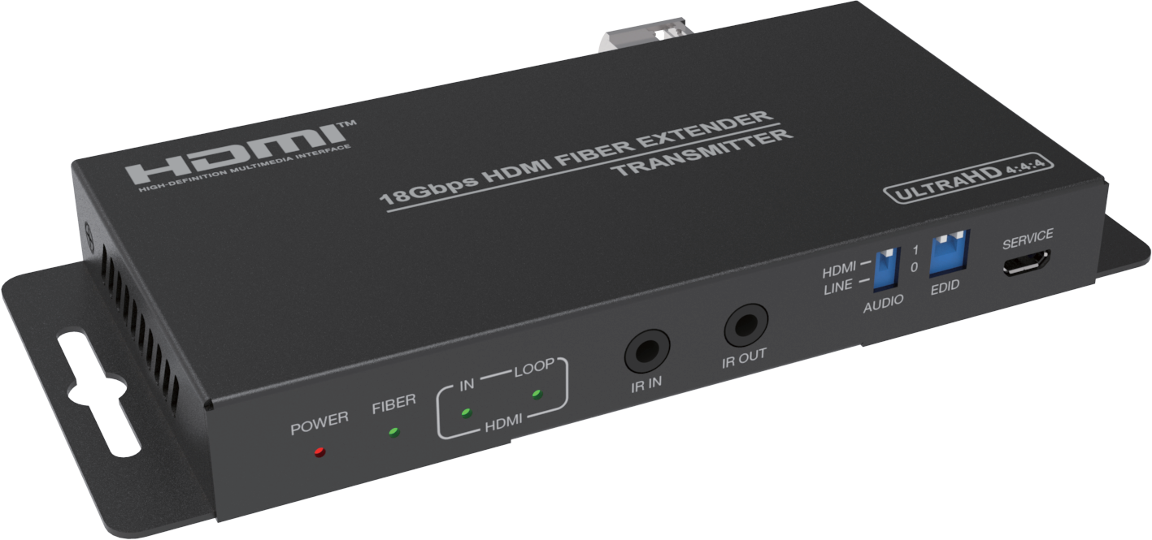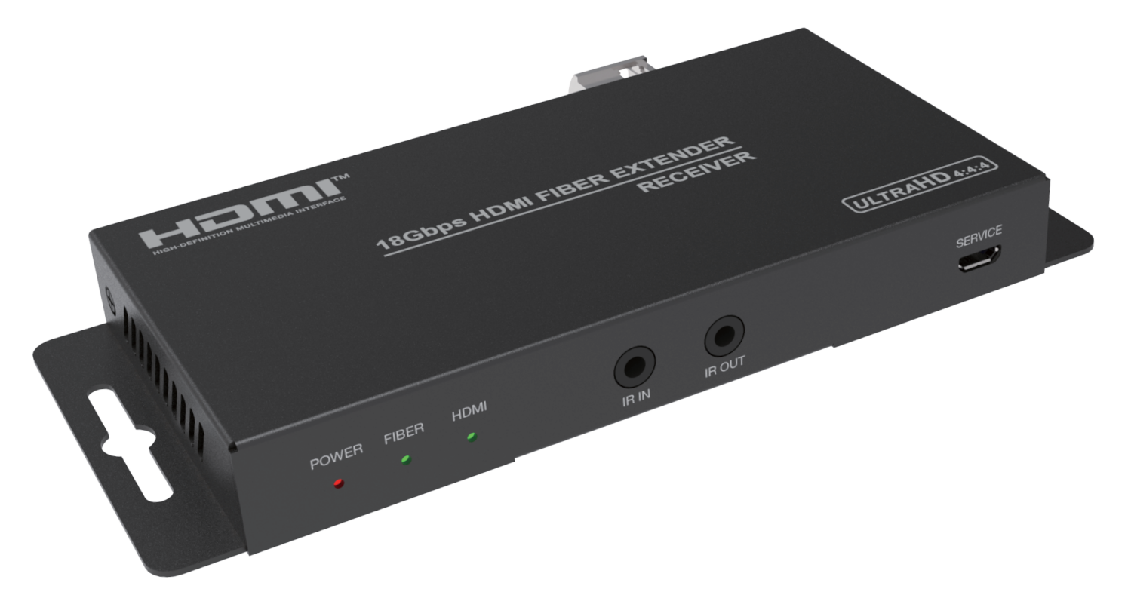


VER 2.1

Thank you for purchasing this product
For optimum performance and safety, please read these instructions carefully before connecting, operating or adjusting this product. Please keep this manual for future reference.

Surge protection device recommended
This product contains sensitive electrical components that may be damaged by electrical spikes, surges, electric shock, lighting strikes, etc. Use of surge protection systems is highly recommended in order to protect and extend the life of your equipment.

Table of Contents
- Introduction. 1
- Features. 1
- Package Contents. 2
- Specifications. 2
- Operation Controls and Functions. 3
  - Transmitter Panel. 3
  - Receiver Panel. 5
  - IR Pin Definition. 6
  - Optical Fiber Module. 6
- Application Example. 7

Introduction
This HDMI Extender can extend HDMI signal up to 33000 feet/10 km (over single-mode fiber cable). It supports video resolution up to 4K2K@60Hz 4:4:4. Transmitter supports loop output, audio embedding and EDID management function. Receiver supports audio extracting function. In addition, the extender supports bidirectional IR control and RS-232 signal pass-through. It can allow you to easily control the display device on the signal source side or control the signal source device on the display side when using this extender.

Features
☆ HDMI 2.0b, HDCP 2.2 and DVI 1.0 compliant
☆ Support 18Gbps video bandwidth
☆ Video resolution up to 4K2K@50/60Hz 4:4:4
☆ HDMI audio formats: LPCM2/5.1/7.1CH, Dolby Digital/Plus/EX, Dolby True HD, DTS, DTS-EX, DTS-96/24, DTS High Res, DTS-HD Master
Audio, DSD
☆ Support 3D and HDR format video, does not support CEC control
☆ Transmission distance up to 33000 feet/10 km (over single-mode fiber cable)
*It is possible to use multi-mode fiber with these SFP modules but the distance can not be guaranteed.
☆ Support bidirectional IR control, RS-232 pass-through and EDID
management for simple and convenient control
☆ Transmitter supports loop output (sharing local HD video and audio) and audio embedding function
☆ Receiver supports audio extracting output function
☆ Compact design for easy and flexible installation

Package Contents
① 1× 18Gbps HDMI over Optical Fiber Extender (Transmitter)
② 1× 18Gbps HDMI over Optical Fiber Extender (Receiver)
③ 1× IR Blaster cable (1.5 meters)
④ 1× IR Receiver cable (1.5 meters)
⑤ 2× 5V/1A Power adapter
⑥ 2× 3-pin 3.81mm Phoenix connector
⑦ 1× User Manual

Specifications

Technical
HDMI Compliance | HDMI 2.0b
HDCP Compliance | HDCP 2.2
Video Bandwidth | 18Gbps
Video Resolution | 480i ~1080p50/60Hz, 4Kx2K@24/30Hz, 4K2K@60Hz
Color Space | RGB, YCbCr 4:4:4 / 4:2:2, YUV 4:2:0
Color Depth | 8-bit, 10-bit, 12-bit
HDMI Audio Formats | LPCM2/5.1/7.1CH, Dolby Digital/Plus/EX, Dolby True HD, DTS, DTS-EX,DTS-96/24, DTS High Res, DTS-HD  Master Audio, DSD
Transmission Distance | Up to 33000 feet/10 km over single-mode fiber cable
IR Frequency | 20KHz-60KHz
RS-232 Baud Rate | 4800-115200bps
ESD Protection | Human body model — ±8kV (Air-gap discharge) &  ±4kV (Contact discharge)
Connection
Transmitter | Input: 1 x HDMI IN [Type A, 19-pin female] 1 x LINE IN [3.5mm Stereo Mini-jack] 1 x IR IN [3.5mm Stereo Mini-jack]  1 x RS-232 [3.81mm Phoenix connector] 1 x SERVICE [Micro USB, Update port]  Output: 1 x HDMI OUT [Type A, 19-pin female] 1 x Optical Fiber Out [LC female]  1 x IR OUT [3.5mm Stereo Mini-jack]

Receiver | Input: 1 x Optical Fiber In [LC female]  1 x IR IN [3.5mm Stereo Mini-jack]  1 x SERVICE [Micro USB, Update port] Output: 1 x HDMI OUT [Type A, 19-pin female]  1 x RS-232 [3.81mm Phoenix connector] 1 x IR OUT [3.5mm Stereo Mini-jack]  1 x AUDIO OUT [3.5mm Stereo Mini-jack]
Mechanical
Housing | Metal Enclosure
Color | Black
Dimensions | Transmitter / Receiver:  134mm [W] x 68mm [D] x 18mm [H]
Weight | Transmitter: 280g, Receiver: 278g
Power Supply | Input: AC 100 - 240V 50/60Hz  Output: DC 5V/1A  (US/EU standards, CE/FCC/UL certified)
Power Consumption | Transmitter: 3.85W (Max.), Receiver: 2.7W (Max.)
Operating  Temperature | 32 - 104°F / 0 - 40°C
Storage Temperature | -4 - 140°F / -20 - 60°C
Relative Humidity | 20 - 90% RH (no condensation)

Operation Controls and Functions

Transmitter Panel
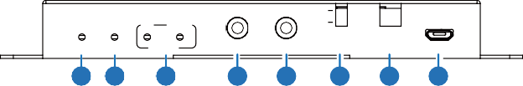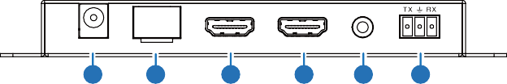
POWER FIBER IN LOOP
HDMI 1
LINE 0
SERVICE
AUDIO EDID
HDMI
IR IN IR OUT
1 2
3
4
5
6
7
8
DC 5V
FIBER
HDMI OUT
HDMI IN
LINE IN
RS-232
9
10
11
12
13
14

No. | Name | Function Description
1 | POWER LED | The power indicator is always on when the Transmitter is powered on.
2 | FIBER LED | The optical fiber connection indicator is always on when the Transmitter and Receiver establish a normal optical fiber signal connection.
3 | HDMI LED | IN: The HDMI signal input indicator is always on when there is signal input on the HDMI IN port.
3 | HDMI LED | LOOP: The HDMI loop output indicator is always on when the HDMI OUT port of the Transmitter outputs signals to the HDMI display device.
4 | IR IN | Connect to IR Receiver cable. The IR signal will send to the IR OUT port of the Receiver.
5 | IR OUT | Connect to IR Blaster cable. The IR signal is from the IR IN  port of the Receiver.
6 | AUDIO switch | Switch to select audio signal source (HDMI IN or LINE IN). When there is no video signals input, audio signals can be transmitted separately.
7 | EDID DIP  switch | Dial the switch to set EDID. 11: Copy RX HDMI OUT  10: Copy TX HDMI LOOP OUT  01: 4K60_2CH  00: 1080P_2CH
8 | SERVICE port | Firmware update port.
9 | DC 5V | DC 5V/1A power input port.
10 | FIBER | Connect the Transmitter optical fiber module, and transmit signals to the Receiver via an optical fiber cable.
11 | HDMI OUT | HDMI signal loop output port, connected to HDMI display device such as TV or Projector with an HDMI cable.
12 | HDMI IN | HDMI signal input port, connected to HDMI source device  such as DVD or PC with an HDMI cable.
13 | LINE IN | Audio signal input port, connected to audio source device such as MP3.
14 | RS-232 | RS-232 signal pass-through port for transmitting RS-232 command signals between the Transmitter and Receiver.

Receiver Panel
POWER FIBER HDMI
SERVICE
IR IN IR OUT
1 2 3
4
5
6
DC 5V
FIBER
HDMI OUT AUDIO OUT RS-232
7
8
9
10
11

No. | Name | Function Description
1 | POWER LED | The power indicator is always on when the Receiver is powered on.
2 | FIBER LED | The optical fiber connection indicator is always on when the Transmitter and Receiver establish a normal optical fiber signal connection.
3 | HDMI LED | The HDMI signal output indicator is always on when the HDMI OUT port of the Receiver outputs signals to the HDMI display device.
4 | IR IN | Connect to IR Receiver cable. The IR signal will send to the IR OUT port of the Transmitter.
5 | IR OUT | Connect to IR Blaster cable. The IR signal is from the IR IN  port of the Transmitter.
6 | SERVICE port | Firmware update port.
7 | DC 5V | DC 5V/1A power supply port
8 | FIBER | Connect the Receiver optical fiber module, and receive signals from the Transmitter via an optical fiber cable.
9 | HDMI OUT | HDMI signal output port, connected to HDMI display device such as HDTV or Projector with an HDMI cable.
10 | AUDIO OUT | Audio signal extracting output port (extract the HDMI OUT audio signal), connected to audio output device such as amplifier or speaker.
11 | RS-232 | RS-232 signal pass-through port for transmitting RS-232 command signals between the Transmitter and Receiver.

IR Pin Definition
IR Receiver and Blaster pin’s definition as below:
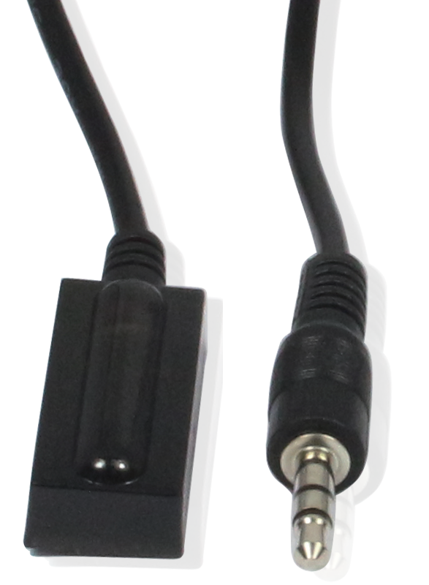
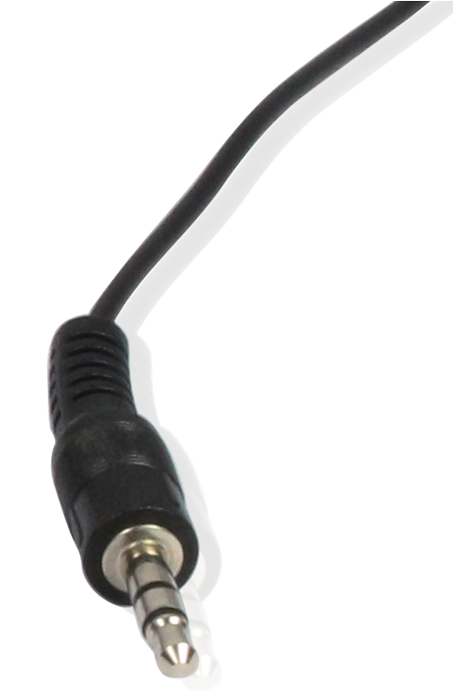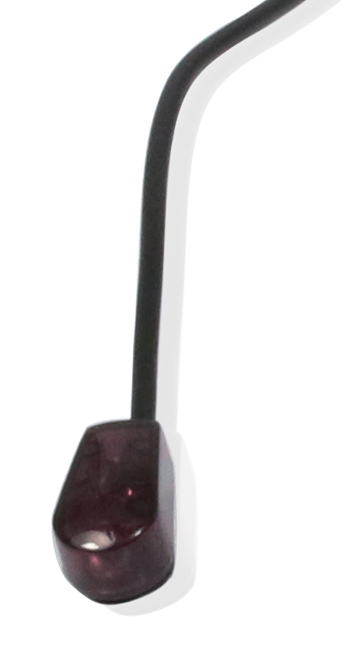
IR RECEIVER IR BLASTER

IR Blaster Signal Power
IR Blaster
NC
IR Receiver

IR Signal

Power Grounding

Optical Fiber Module
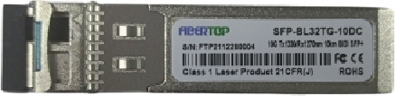
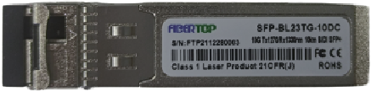
1
2

① SFP-BL32TG-10DC is the optical fiber module of the Transmitter.
② SFP-BL23TG-10DC is the optical fiber module of the Receiver.

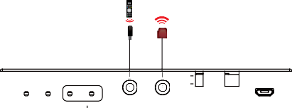Application Example
IR Receiver
IR Blaster

 | POWER FIBER | IN | LOOP HDMI | IR IN | IR OUT | HDMI LINE | AUDIO | 1  0 | EDID | SERVICE

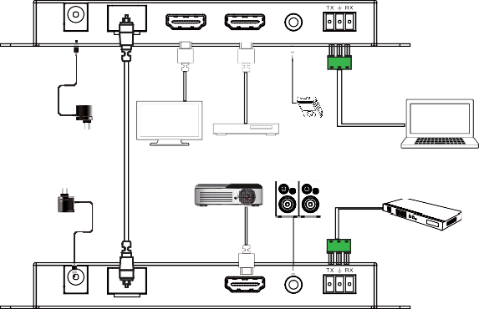
Transmitter

OP

DC 5V

TICAL

FIBER

HDMI OUT

HDMI IN

LINE IN

RS-232

Power Supply

Optical fiber cable

UHDTV

MP3
DVD or Blu-ray Player

Speaker

Laptop

Power Supply

Projector

HDMI Matrix or other device with RS-232 port

DC 5V

FIBER

HDMI OUT

AUDIO OUT

RS-232

Receiver

POWER FIBER HDMI SERVICE
IR IN IR OUT

IR Receiver

IR Blaster


The terms HDMI and HDMI High-Definition Multimedia interface, and the HDMI Logo are trademarks or registered trademarks of HDMI Licensing LLC in the United States and other countries.

