CVAD-V2

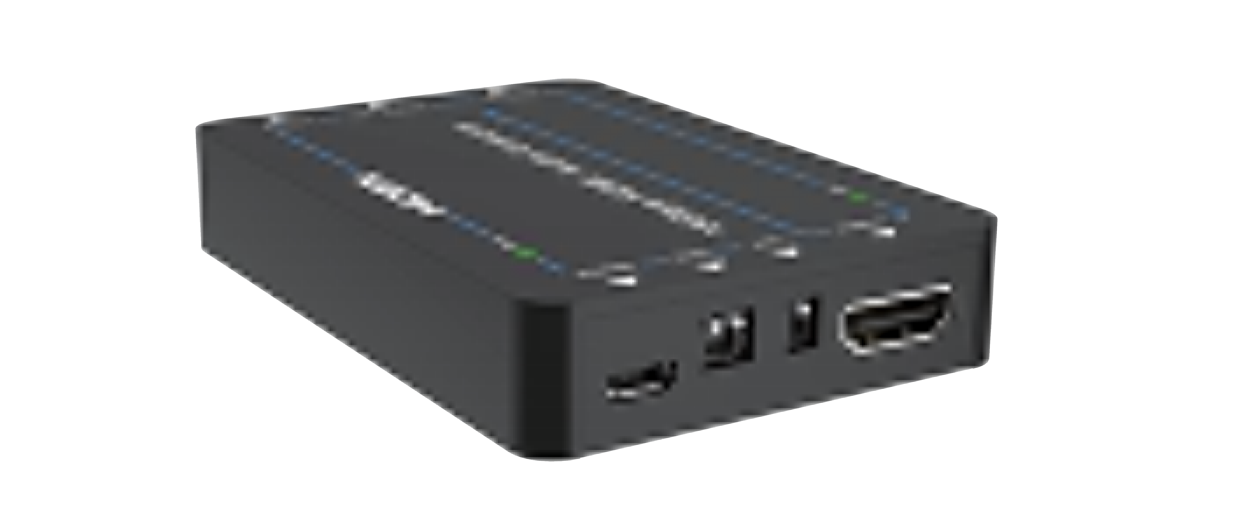

VER 1.0

Thank you for purchasing this product
For optimum performance and safety, please read these instructions carefully before connecting, operating or adjusting this product. Please keep this manual for future reference.

Surge protection device recommended
This product contains sensitive electrical components that may be damaged by electrical spikes, surges, electric shook, lighting strikes, etc. Use of surge protection systems is highly recommended in order to protect and extend the life of your equipment.

Table of Contents
- Introduction. 1
- Features. 1
- Package Contents. 2
- Specifications. 2
- Operation Controls and Functions. 4
- Application Example. 7

Introduction
This 18Gpbs HDMI Audio Extractor can extract audio signals from the HDMI source to output to A/V receivers via the Optical port and L/R analog audio port. The device also has a built-in HDMI output port which can connect to an ARC-compatible display and return the received audio to the amplifier or speaker via the optical port when the ARC is enabled. The input and output video resolution can reach up to 4K×2K@60Hz (YUV 4:4:4). The product supports smart EDID management, and both EDID and ARC functions can be controlled via DIP switches on the front panel.

Features
☆ HDMI 2.0b, HDCP 2.2 and DVI 1.0 compliant
☆ Support 18Gbps video bandwidth
☆ Video resolution up to 4K2K@60Hz (YUV 4:4:4)
☆ Support extracting audio from HDMI source device to multi- channel optical fiber (SPDIF) and L/R analog audio output
☆ Support ARC function. when ARC is enabled, the audio will be returned to the A/V receiver via the optical port
☆ Supported optical audio formats: LPCM 2CH, Dolby Digital 2/ 5.1CH, and DTS 2/5.1CH
☆ Support HDMI high bit rate (HBR) audio pass through
☆ Audio sampling rate up to 192KHz

☆ Support HDR, HDR10, HDR10+, Dolby Vision and HLG
☆ When ARC is enabled, CEC pass through is supported
☆ Compact in size, easy to install

Package Contents
① 1× 18Gbps HDMI Audio Extractor
② 1× Micro-USB Cable (0.3m)
③ 1× User Manual

Specifications

Technical
HDMI Compliance | HDMI 2.0b
HDCP Compliance | HDCP 2.2
Video Bandwidth | 18 Gbps
Video Resolution | Up to 4k2k@60Hz 4:4:4
Color Depth | 8/10/12 bit（1080P）  8/10/12 bit（4K@24/30Hz） 8 bit（4K@60Hz）
Color Space | RGB, YCbCr 4:4:4/4:2:2

HDR | HDR, HDR10, HDR10+, Dolby Vision, HLG
HDMI Audio Format | LPCM 7.1CH, Dolby TrueHD, and DTS-HD Master
ESD Protection | Human body model —  ±8kV (air-gap discharge) &  ±4kV (contact discharge)
Connection
Input | 1 × HDMI IN [Type A, 19-pin female]
Output | 1 × HDMI OUT [Type A, 19-pin female] 1 × OPTICAL OUT [S/PDIF]  1 × L/R OUT [3.5mm, Stereo Mini-jack]
Mechanical
Housing | Plastic Enclosure
Color | Black
Dimensions | 90mm[W] × 60mm[D] × 16mm[H]
Weight | 48g
Power Supply | DC 5V / 1A
Power Consumption | 2W (Max)
Operation Temperature | 32 - 104°F / 0 - 40°C
Storage temperature | -4 - 140°F / -20 - 60°C
Relative Humidity | 20 - 90% RH (no condensation)

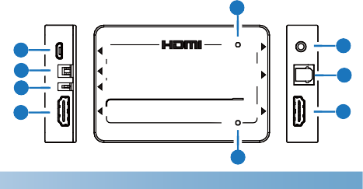Operation Controls and Functions
5
1
2
3
4
PWR
7
18Gbps HDMI Audio Extractor
8

9
ARC
6
DC 5V EDID ARC IN
OUT OPTICAL L/R

No. | Name | Function Description
1 | DC 5V | DC 5V/1A Micro USB power supply port.
 |  | The EDID 2-PIN DIP switch is set to adjust the
 |  | audio format of output signals. Turning a pin
2 | EDID 2-PIN  DIP Switch | upward refers to 1, downward to 0.  Here are audio options for EDID management. 11: TV (copy the audio format of TV signals) 10: 2.0CH
 |  | 01: 5.1CH
 |  | 00: 7.1CH

No. | Name | Function Description
3 | ARC 1-PIN DIP  Switch | The ARC 1-PIN DIP switch is set to enable/ disable the ARC function. Turning the pin upward means ARC disabled, downward meaning ARC enabled.  When ARC is disabled, the audio signal will be extracted from HDMI source to output to A/V receivers via the optical port and L/R audio port.  When ARC is enabled, the audio returned from the HDMI display device will be output to the A/V receiver via the optical port.
4 | HDMI IN | The HDMI signal input port, used for connecting to the HDMI source device with an HDMI cable, such as DVD player or Set Top  Box.
5 | PWR | The power indicator, when the device is powered on, the green LED will light on.
6 | ARC | The ARC function indicator.  Illuminating: The ARC is enabled with a normal CEC communication. The audio is returned to output via the optical port.  Flashing: The ARC is enabled with an abnormal CEC communication. The audio is failed to return to the output optical port. Dark: The ARC is disabled.

No. | Name | Function Description
7 | L/R OUT | The analog stereo audio output port, connect to a headset via the 3.5mm mini-jack.
8 | OPTICAL  OUT | The optical digital audio output port, connect to an amplifier or speaker with a fiber.
9 | HDMI OUT | The HDMI signal output port, connect to a TV set or monitor with an HDMI cable.

Application Example
DVD or Blu-ray Player

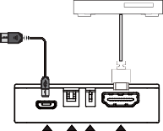
USB Power Cable

DC 5V EDID ARC IN

OUT
OPTICAL
L/R

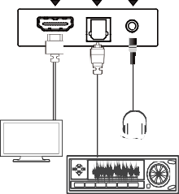
Headset
HDTV
Amplifier

