Quick Start Guide
Dual Screen Wireless Conferencing Solution

Model: AVP300SD, DONG-USBC300, DONG-HDMI300

Receiver：AVP300SD
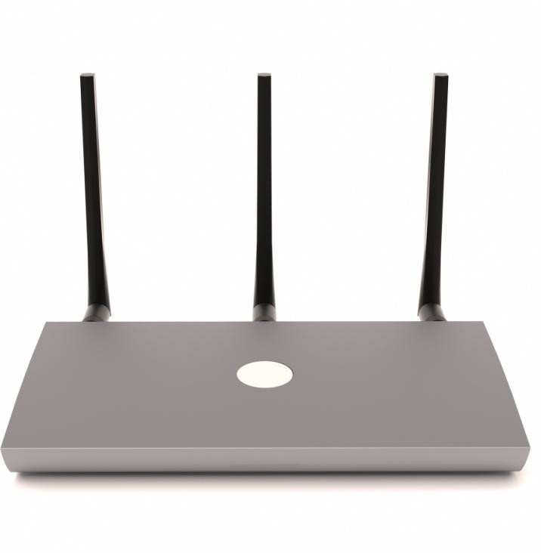

Transmitter: DONG-USBC300, DONG-HDMI300
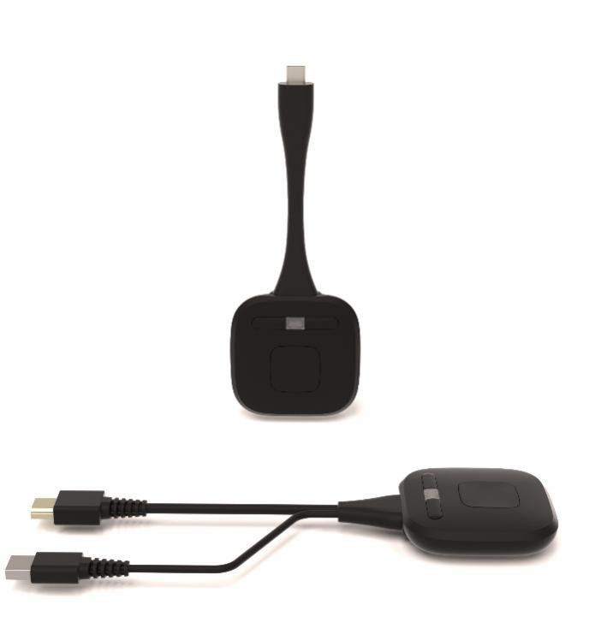

Interface/button description：DONG-USBC300, DONG-HDMI300 button:

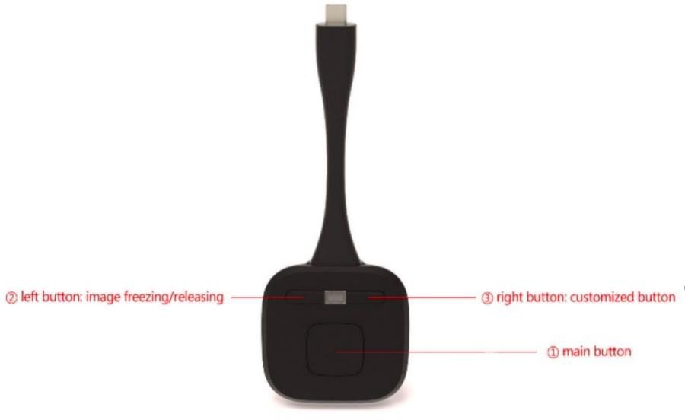

① Main button: Start to Share / Stop Sharing
② Left button for image freezing/releasing
③ Right button for customized function( Switch Camera/Switch USB Hub)

AVP300SD rear panel:
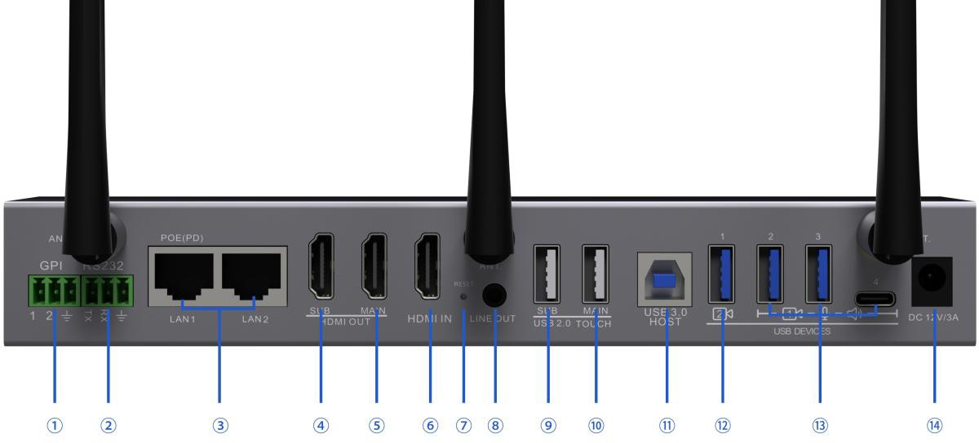

AVP300SD side panel:

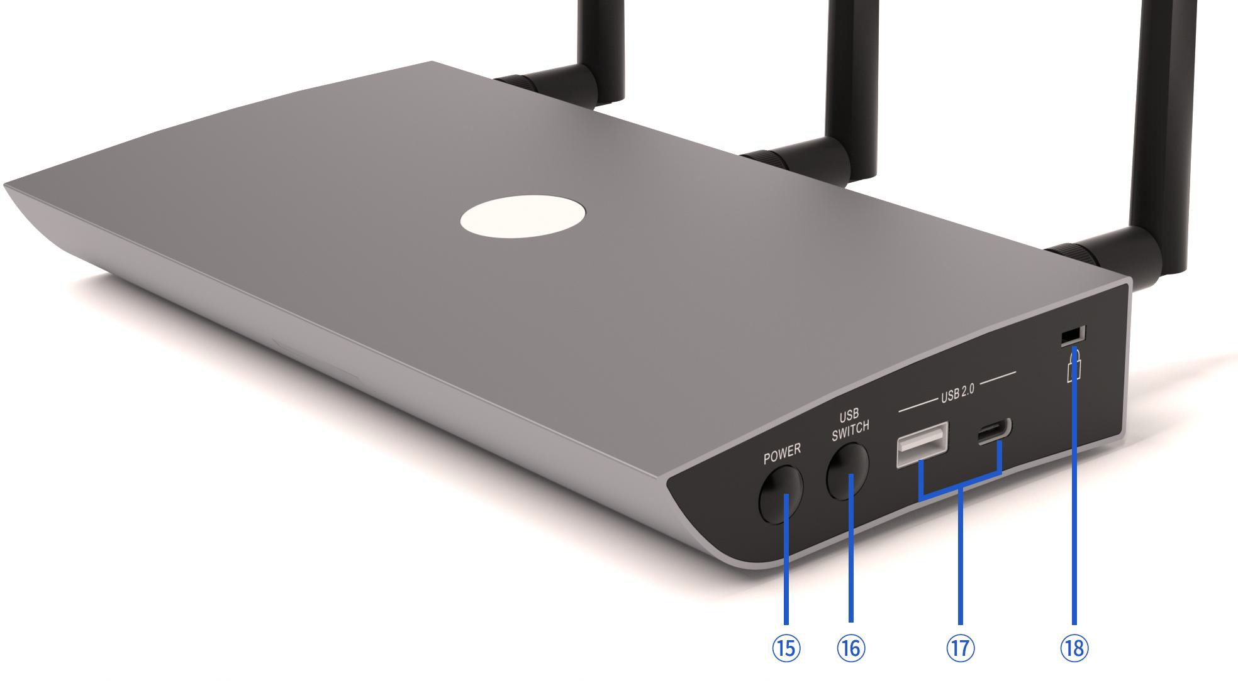

① GPIO interface
② RS232 for control
③ 2x 1000M LAN port, for network connection and telnet control
④ Sub HDMI output
⑤ Main HDMI output
⑥ HDMI input
⑦ Reset
⑧ 3.5mm jack
⑨ Touch HID for sub output
⑩ Touch HID for main output
⑪ USB-B port for connection with room PC
⑫ 1x USB-A 2.0 port for Camera 2
⑬ 2x USB-A 3.0 ports, 1x USB-C for USB devices like camera 1 or speakerphone
⑭ 12V/3A power
⑮ Power standby
⑯ USB switching button
⑰ USB-A for HDMI dongle for paring, USB-C for USB-C dongle pairing

System Diagram:

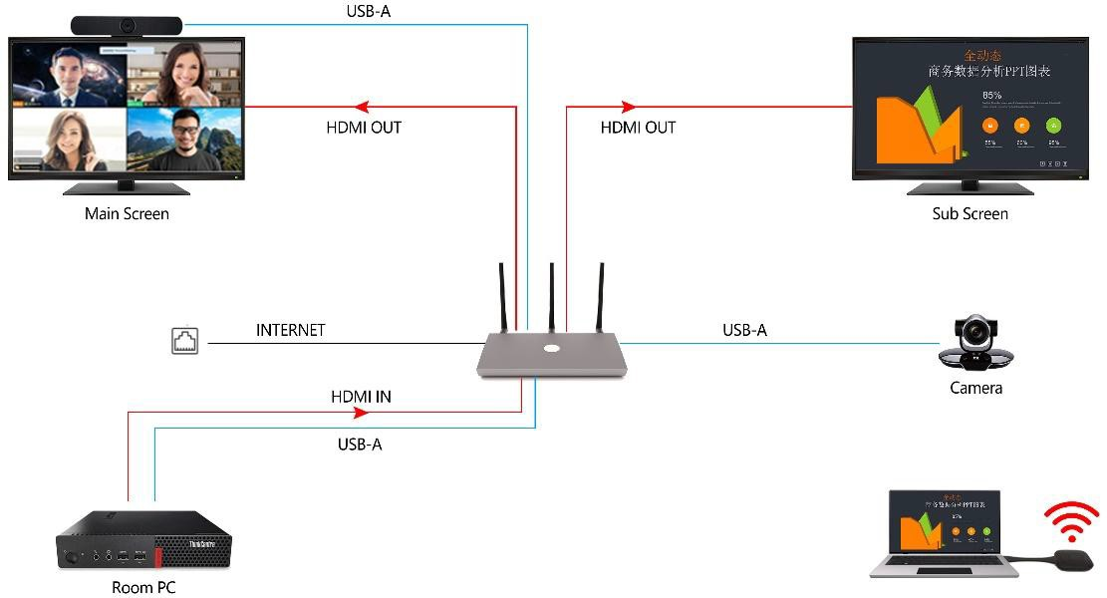

Specifications:
-Dual outputs support content sharing from same source or different sources
-Support up to 4 sources shared in a single screen
-Support wireless sharing from Airplay, Miracast, Chromecast, App, dongles
-Support both 1080P and 4K dongles
-Support 4K HDMI input as content sharing
-Support USB cam/mic/speaker transmission over WiFi
-Support camera switching
-Support USB devices switching between local room PC and wireless laptop
-Support display content sharing to participant over video conference
-Support 2 LAN ports for network isolating between staff and guest
-Touch back function supported with both wired and wireless connection (App and dongles)
-Provide analog audio breakout
-Provide both RS232 and Telnet control
-Support OTA FW upgrade

Quick to Start

Power on & Pairing the 4k dongle with Base Unit

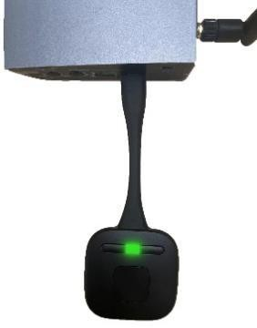
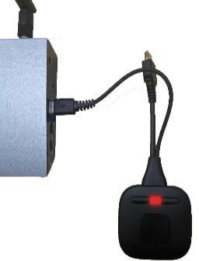
  - 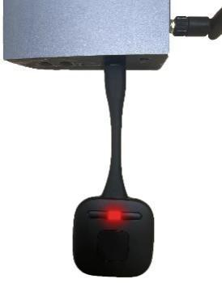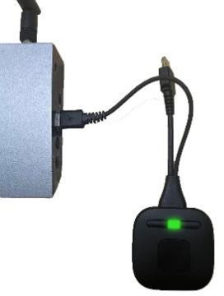Insert the dongle to the USB port of the Base Unit you are using USB A for HDMI dongle for pairing, USB C for USB-C dongle pairing

Pairing Paired Pairing Paired
  - Wait until the LED stop flashing.
When the dongle LED become steady red, the dongle is paired to the Base Unit and the homepage shows “succeeded to pair”

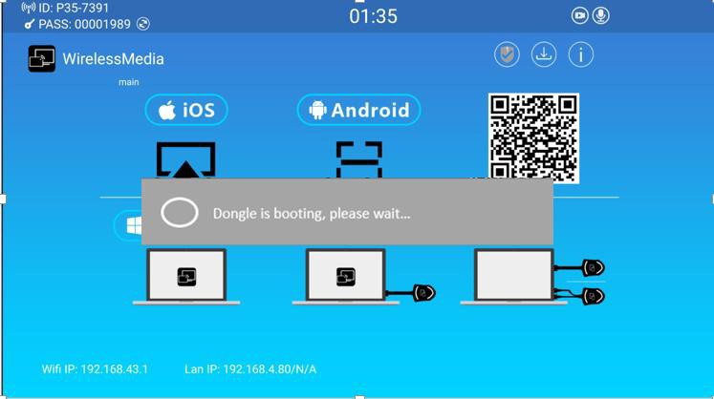

Screen Casting

  - Screen Casting by Dongle
- Plug the dongle into the USB port of laptop
- When the connection is completed, the LED becomes static green
- Then press the main button and the screen is shared
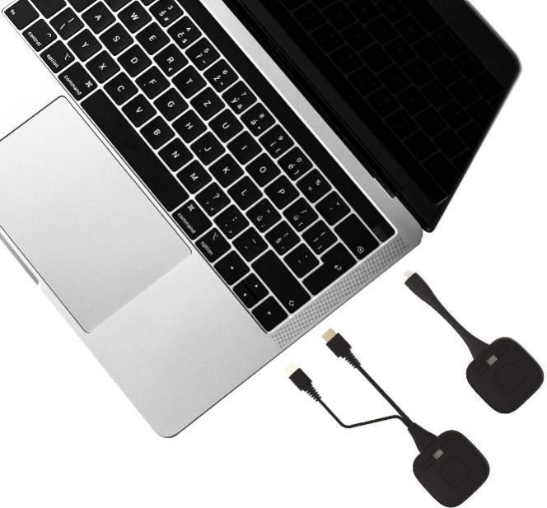

  - Screen Casting by APP
  - Ensure the laptop and base unit are in the same network, there are 2 options, option 1, the laptop can connect with the base unit directly via the SSID and password indicated in the home page as below, optional 2, the laptop can connect with the wifi router which is in the same LAN that base unit is connected.

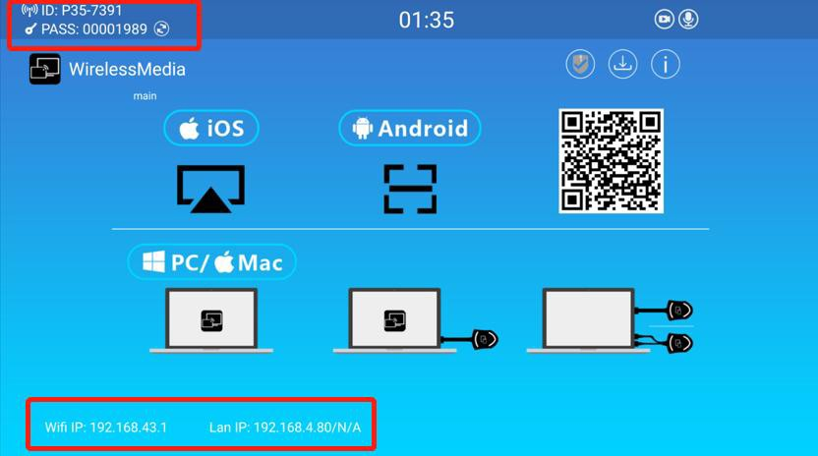

  - For option 1 network, please use the wifi IP address indicated in the home page to enter the Web UI. For option 2 network, please use the LAN IP address indicated in the home page to enter the Web UI.
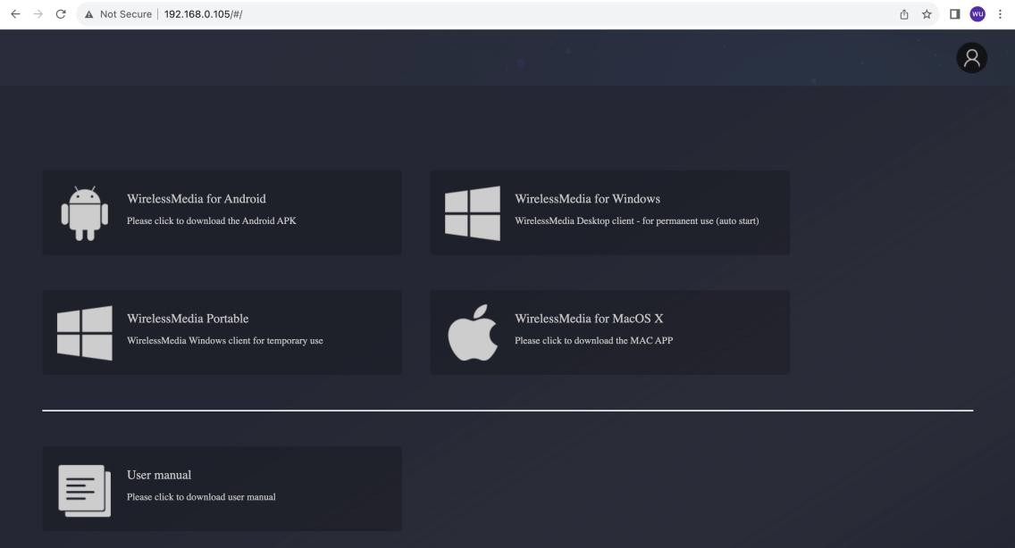
  - Download WirelessMedia App from Web UI.
  - Click the “WirelessMedia App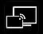 to start to share content
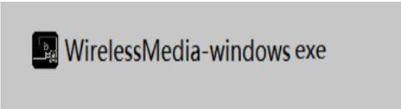

  - Click the WirelessMedia App “Ready to share” and the content is shared

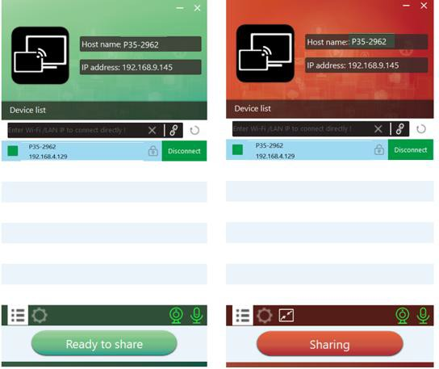

  - Screen Casting by Android App
Download the application namely “WirelessMedia” (for example scan QR-Code in Home screen) in Android Google Play market for Android mobile device.
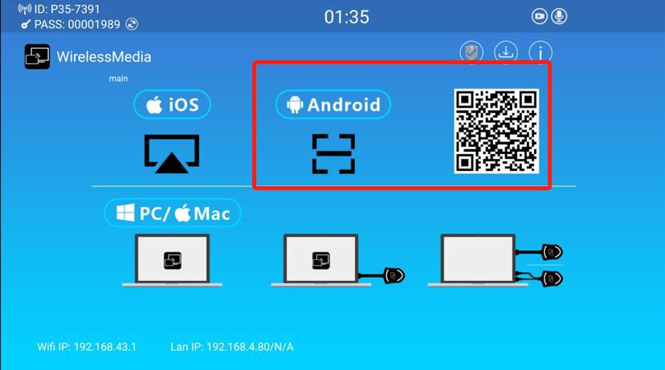

  - Screen Casting by Miracast
    - Make sure the Wi-Fi or WLAN is enabled. Click the PC bottom right corner operation zone icon as below.

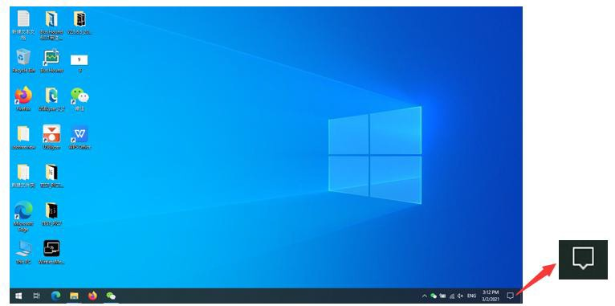
    - Click “project” icon to enter password on home screen to connect and mirror.
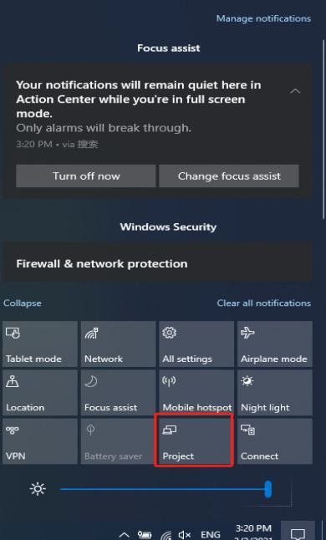
    - Click the “project” icon again, disconnect to stop mirroring.
  - Screen Casting by Airplay
For IOS devices, use Airplay to mirror the screen.
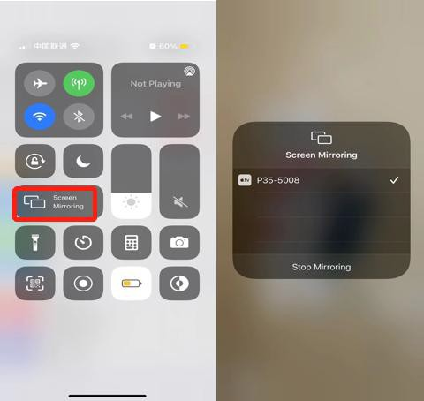

- Dual Display Mode

Log in web UI→ Display & Audio→Dual-display layout to set different display mode
  - 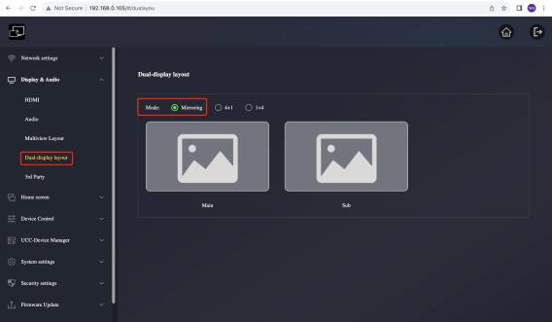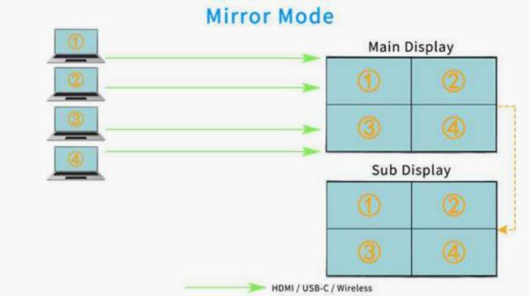“Mirroring” Mode show the same content on both display, and follow auto layout up to 4-split view on each view

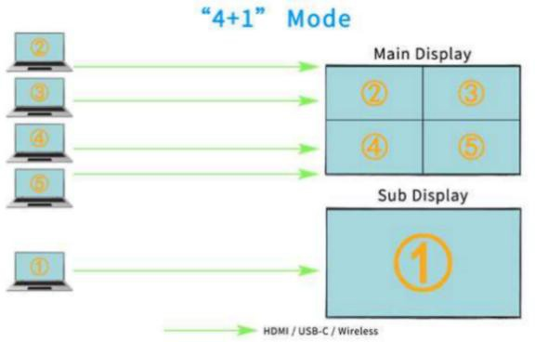
  - “4+1” Mode: The first connected source/content will go to Sub Display, and since the second connected sources will go to Main Display for multi-view and supports auto-layout
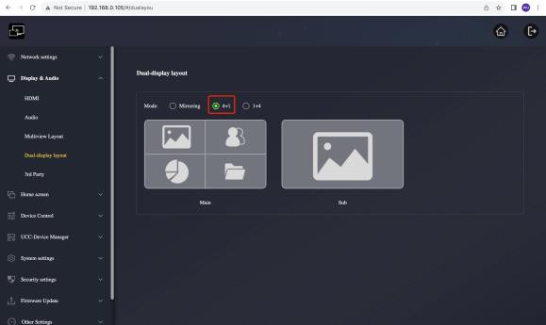

  - “1+4” Mode: The first connected source/content will go to Main Display for full screen view, and since the second connected sources will go to Sub Display for multi-view and supports auto layout
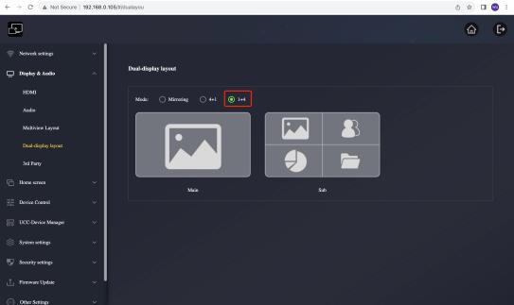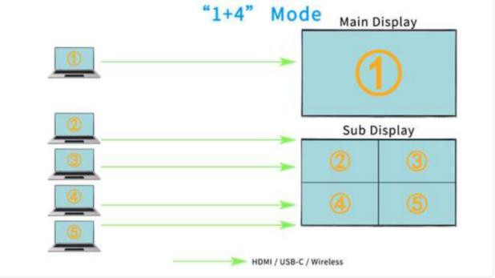

Annotation

- Click the arrow on the home page to activate the side bar

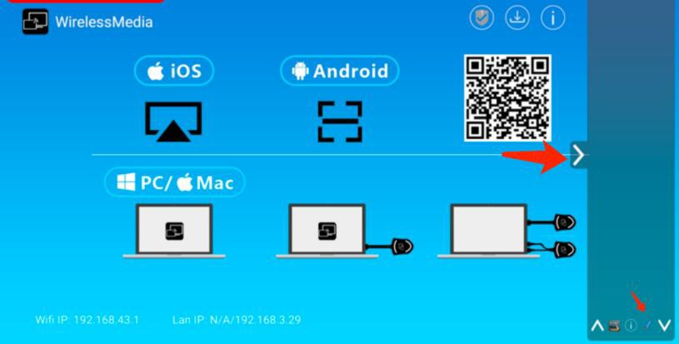

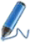
- Click the icon to active the annotation function.
- Annotation on two screens can be separately in 1+4 or 4+1 mode
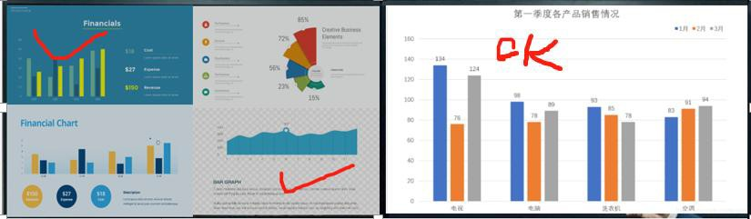

How to start a wireless conferencing via dongle

  - Plug the dongle into the USB port of your laptop.
When the connection is competed, the LED ring becomes static green. Then touch the dongle and your screen is shared.
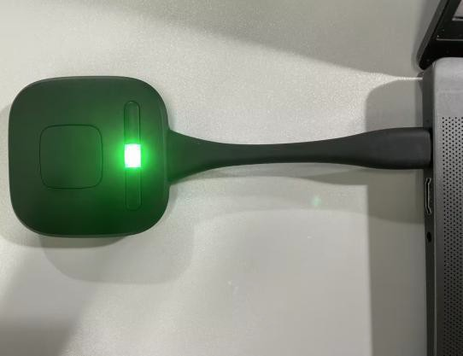

  - Open the WirelessMedia CD Drive

When the dongle is inserted into PC，“WirelessMedia”CD Drive will automatically pop up on the PC’s desktop, click the ‘WirelessMedia’ CD Drive.

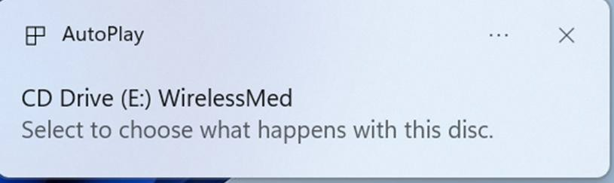

  - Double click the “WirelessMedia”CD Drive to run Application for the first time use only. The App will be run in you PC automatically for next time use, no need to do this step again.
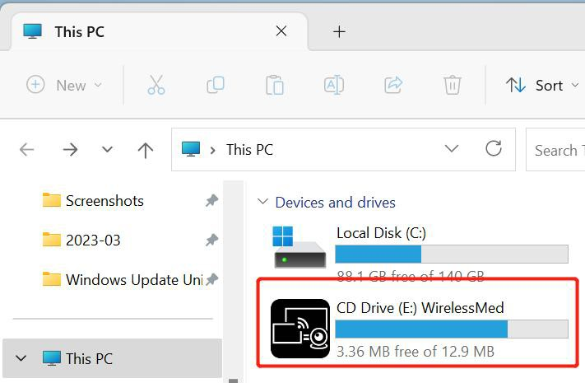

  - WMMeeting virtual driver is required to install in PC to support USB over Wifi . Note: User only need install the driver for the 1st time
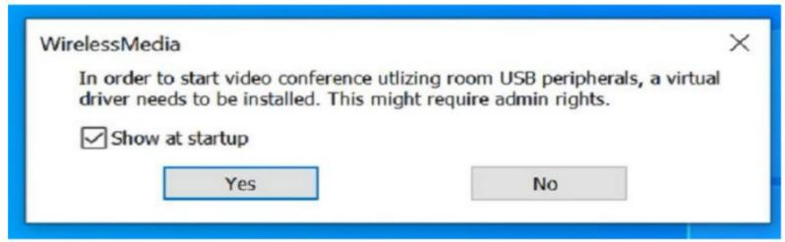
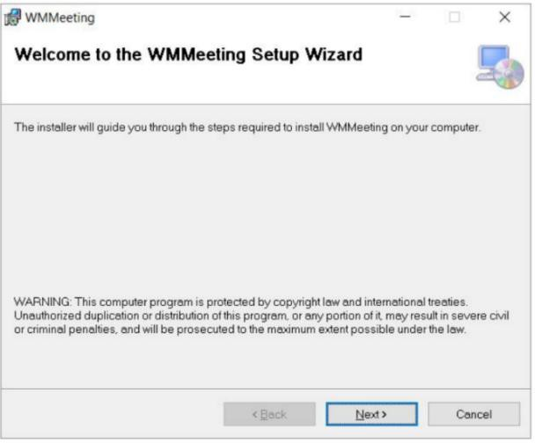

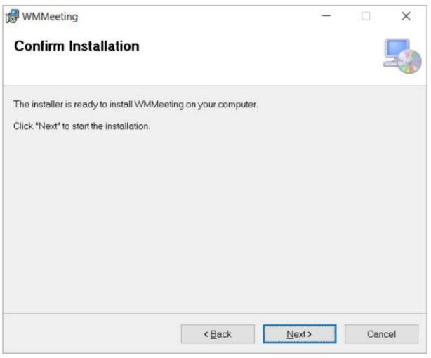

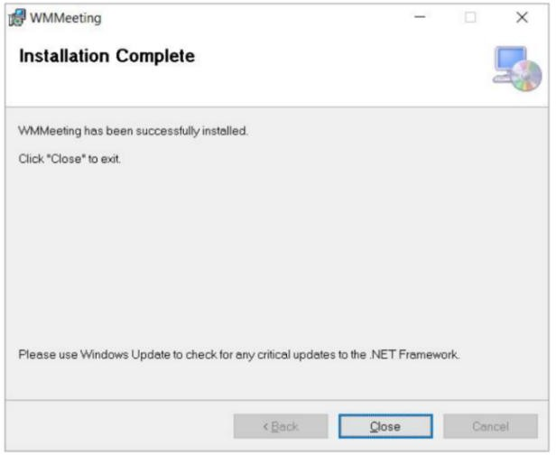

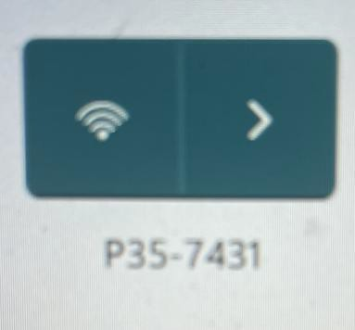
  - Set your PC’s Wi-Fi and select the Base Unit’s SSID from the network list, or select SSID which is in the same LAN with base unit

  - The App is processing to get the USB data of camera and speakerphone from base unit.

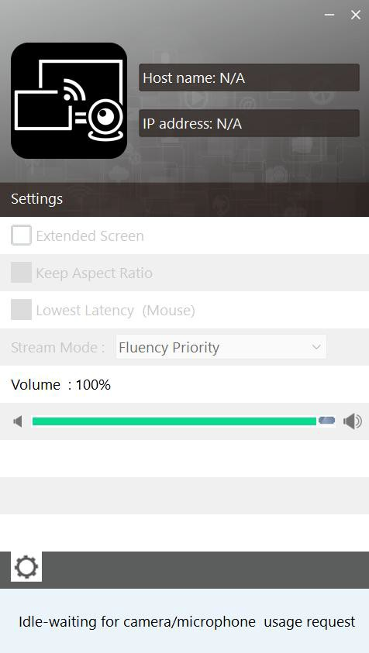

  - Launch VC such as Zoom from desktop
Select Settings>Video>Camera>Virtual Meeting Camera. Settings>Audio > Speaker and Microphone, select Virtual Meeting Audio
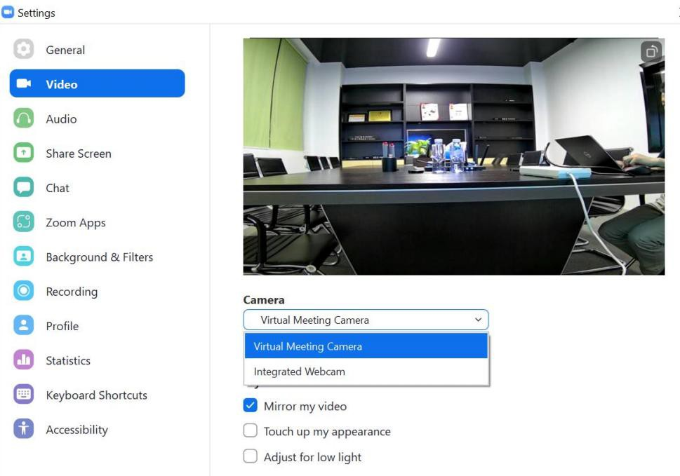

Noted：
- Double check the room USB devices, display and company Internet are well connected with

Base Unit by cables.
- Make sure your PC WiFi is select the Base Unit SSID or select the same enterprise network with Base Unit.
- Make sure the “WirelessMedia” App is run and virtual driver is installed.

How to switch the cameras in a wireless conferencing?

Note:
- If you connect 2 cameras, at least 1 of them need be connected with USB port 1
- you need make sure now the USB hub is switched to the wireless source
- the camera switching feature is only for wireless conferencing, not working with wired USB-B room PC mode

  - Switching the cameras through Web GUI.
Click the UCC Device Manager> USB camera, then you’re able to select the camera from the device list and preview them
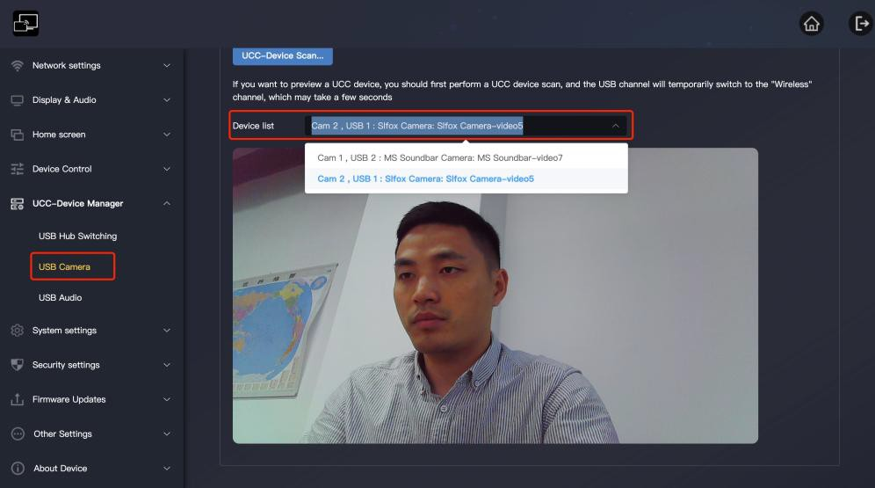

  - Switching the cameras via dongle.

By defaut, the right small button is set as camera switch function, if not you can log into the web, and Click the Device Control> Button Definition> select “Camera Switch”

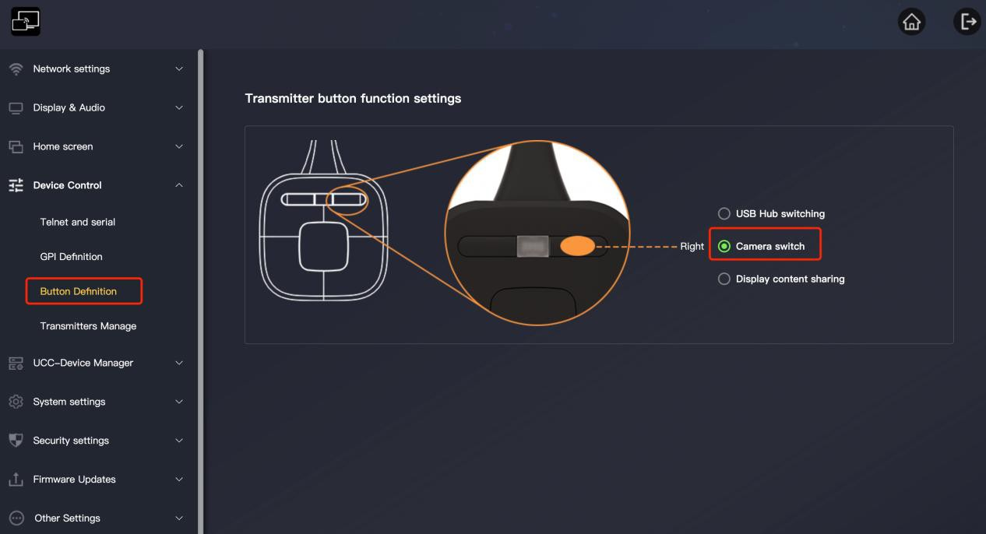
Click the right button on the dongle to switch between the 2 cameras.
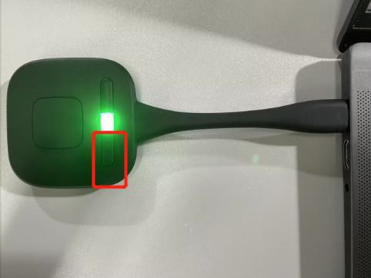

  - Switching the cameras via App

Open the WirelesMedia App in the background, click the icon of camera, then you can get the camera list and select
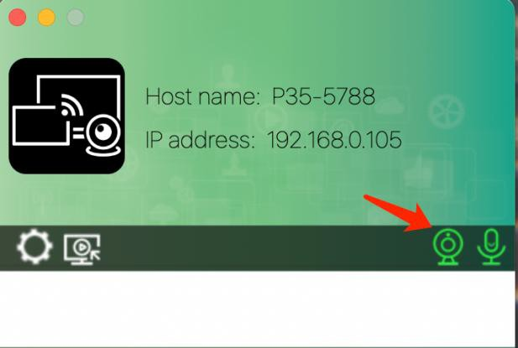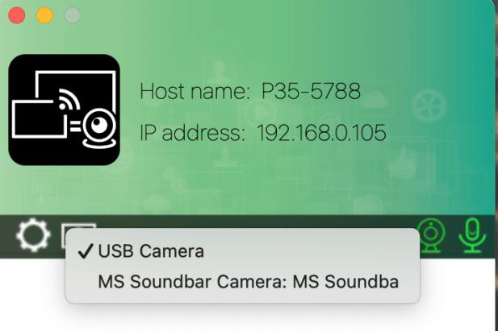

How to collaborate with dual screen in a wireless conferencing?

  - In 1+4 or 4+1 dual display mode, people can utilize one screen for the video conferencing, and the other screen for content sharing, application like below:
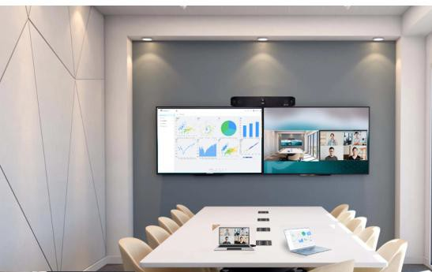

Note: to ensure the experience of this collaboration, the total cast sources in 2 screens should not exceed 2.
  - The shared content on the local screen, including annotation and whiteboarding can be also shared to remote participants by PC that host the wireless conferencing, the process are:
    - Open the WirelessMedia App in the background, click the button below

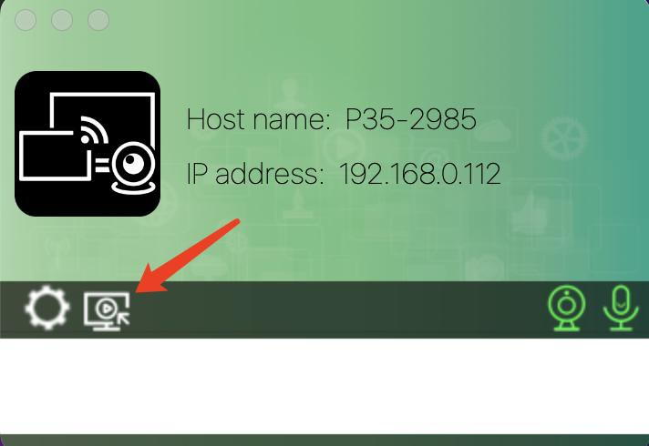

Note: when the quantity of cast sources over 2, this function will not work.

Alternatively, you can define the right button of dongle as “display content sharing’ in the web.

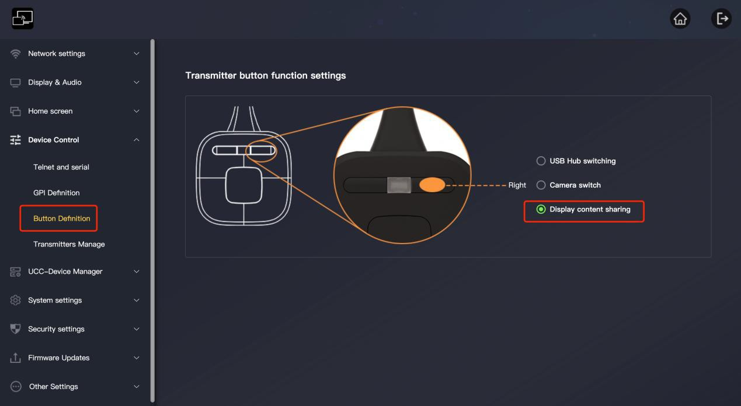
Then you can just press the right button to activate this function, no need to open the App

    - Then you will get a window that captured the content on the screen
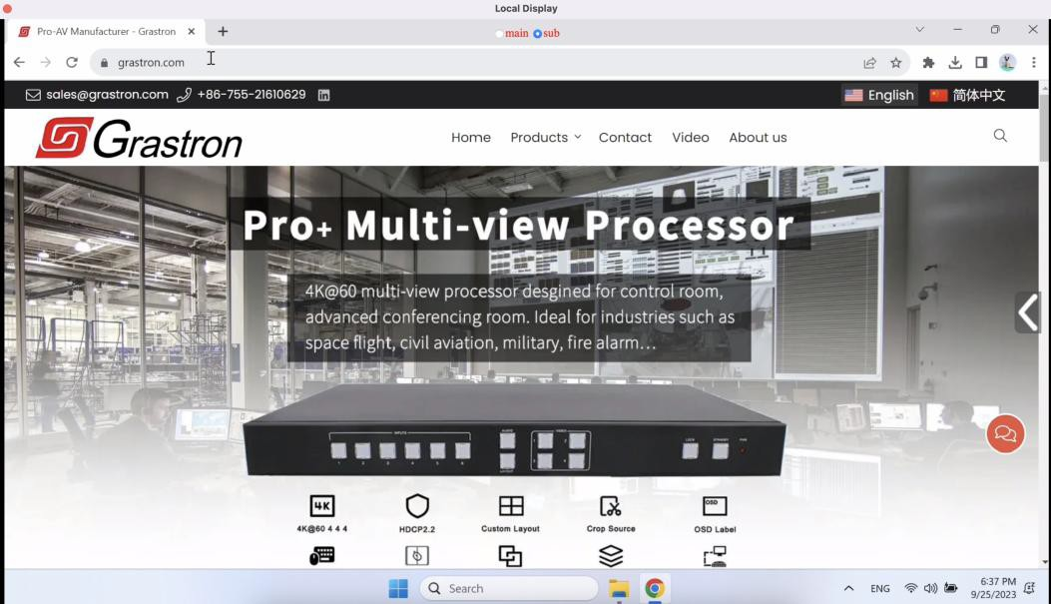
    - Back to the VC app like Teams, click the “share” button and click the “Window”

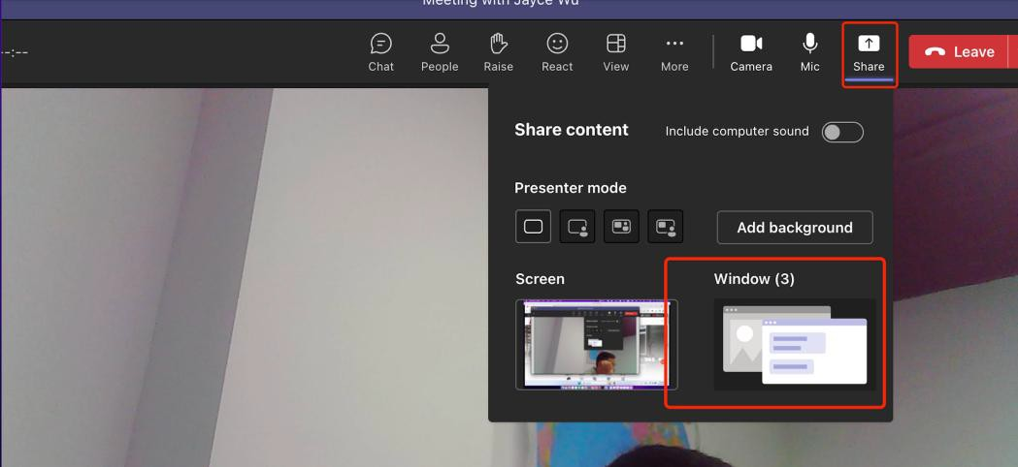
    - Choose the “Local Display”, then the remote participants can see the share content on your local screen.
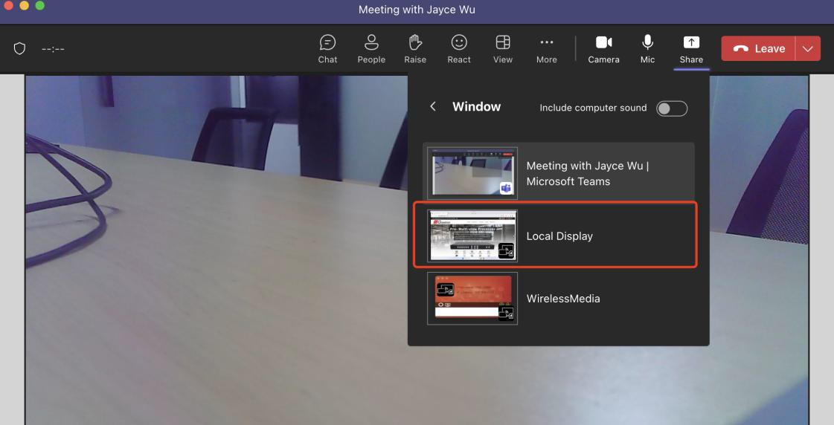

- How to start a video conferencing from room PC？

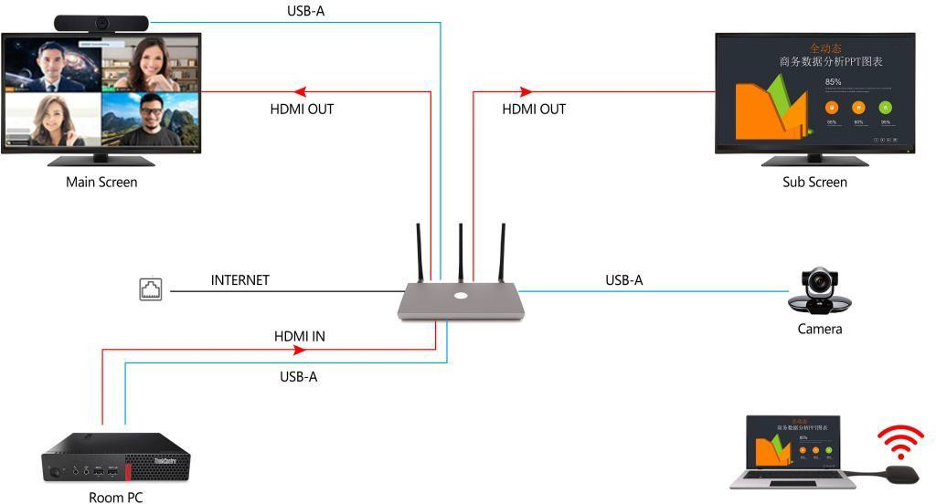

  - Connect the room PC with WU-20 by HDMI and USB cable.
  - make sure the USB hub is switched to the USB-B source (by default it’s on the USB-B)

  - Launch VC app such as teams from desktop
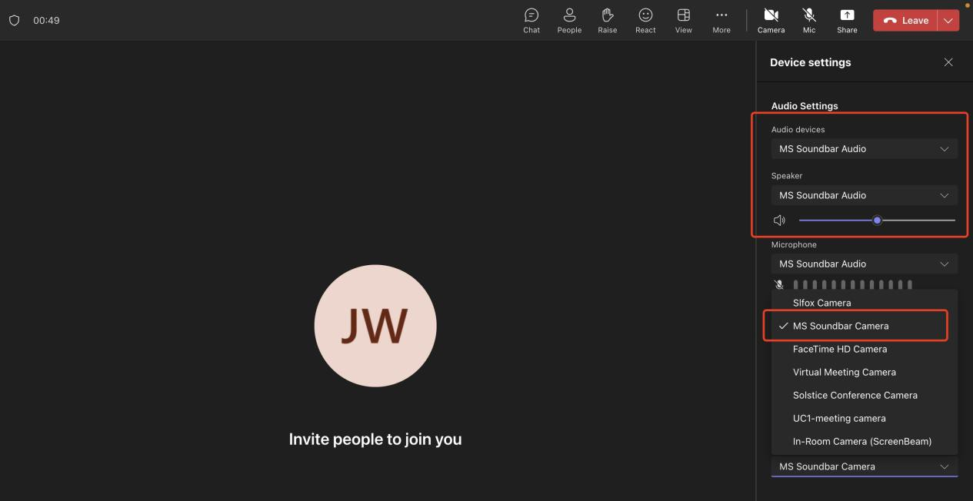
Select Settings>Video>Camera>select the corresponding name of camera Settings>Audio > Speaker and Microphone, select the corresponding name of audio

- How to switch USB devices between room PC and wireless conferencing？
1st of all, we provide an automatic mode to simplify the user experience, the USB hub is on the USB-B source by default, people can get indication from the icons in the home screen, when people selects the virtual meeting camera/audio in the VC app, it will automatically switched to the wireless host PC.When the meeting is ended and people disconnect the virtual camera/mic, the USB hub will be switched back to USB-B source again.
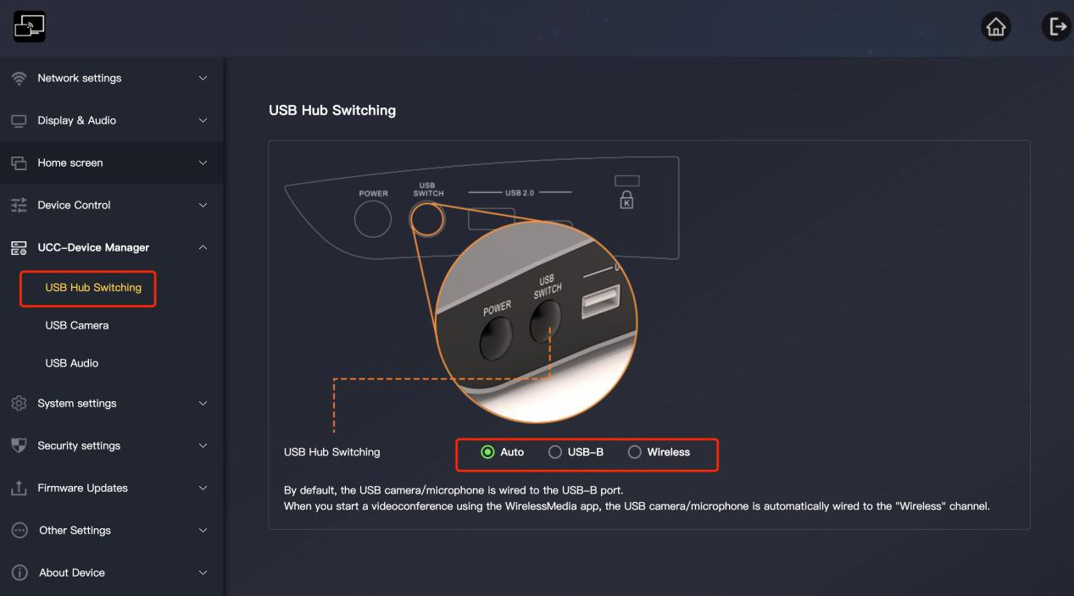

When the USB hub is on the USB-B source, the icon of cam and mic are below:

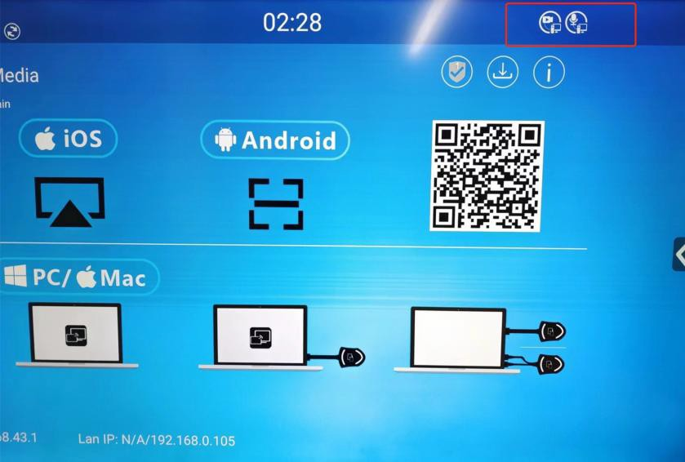

When the USB hub is on the wireless source, the icon of cam and mic are below:
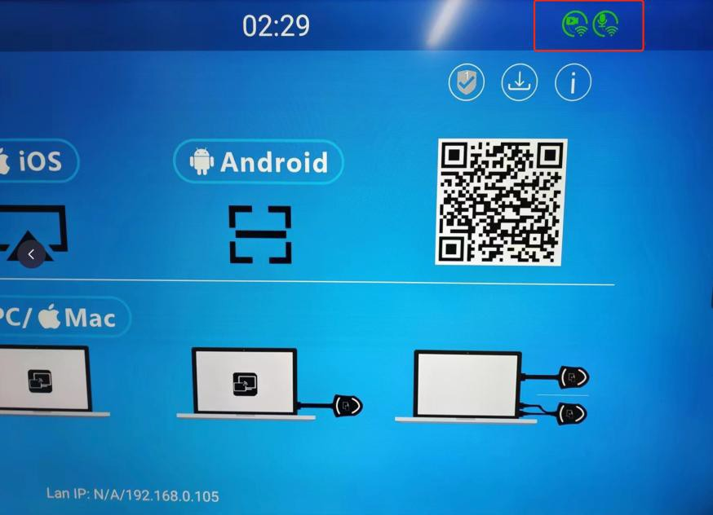

  - Switch the USB hub manually in the web
Click the UCC Device Manager> USB Hub Switch> select the source “USB-B” or “Wireless”

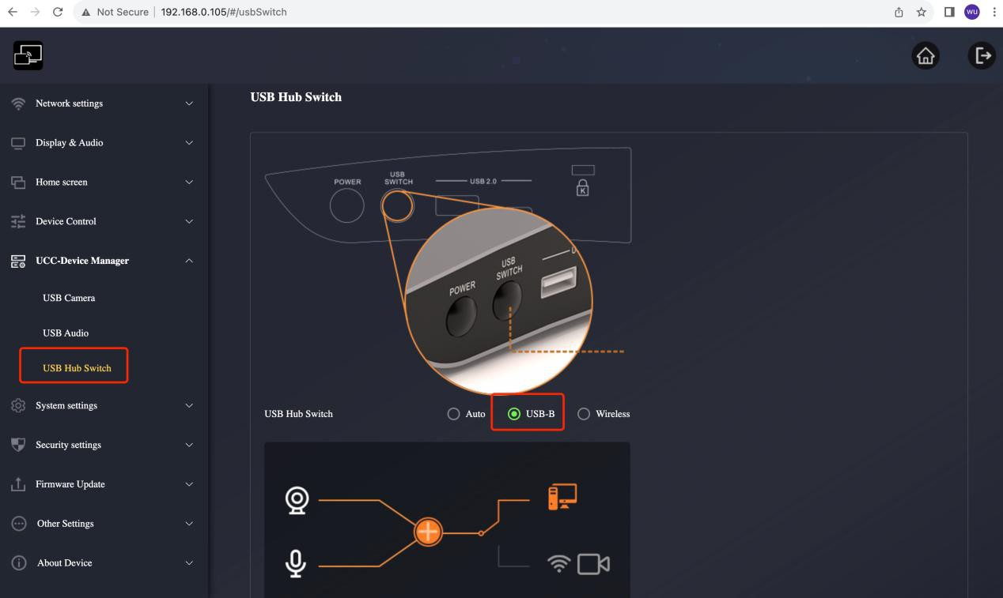

  - Switch the USB hub by dongle.

If you have defined the right button as USB switch, you can press the right button to switch

the USB hub between USB-B and Wireless.
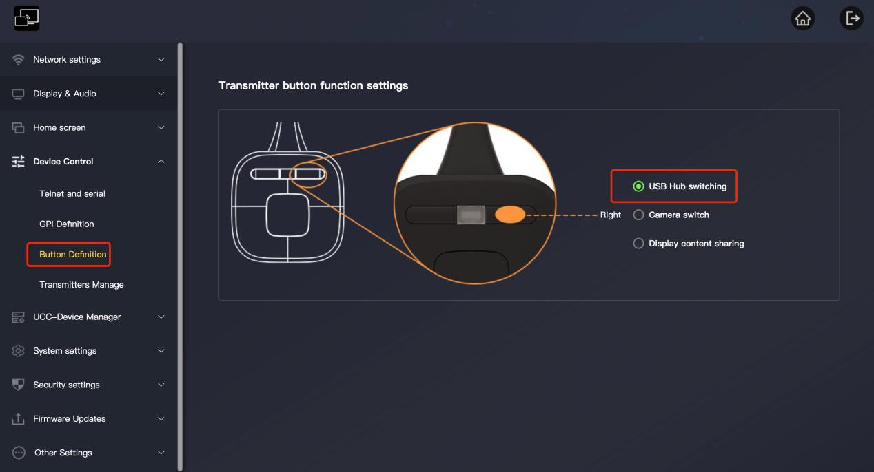

  - Switch the USB hub by App
You can also switch the USB hub in the App, ckick the setting icon, and you will see the USB select option
