AVP-140V2
DONG-HDMI300 / DONG-USB-C300
Wireless Presentation System with HDMI In
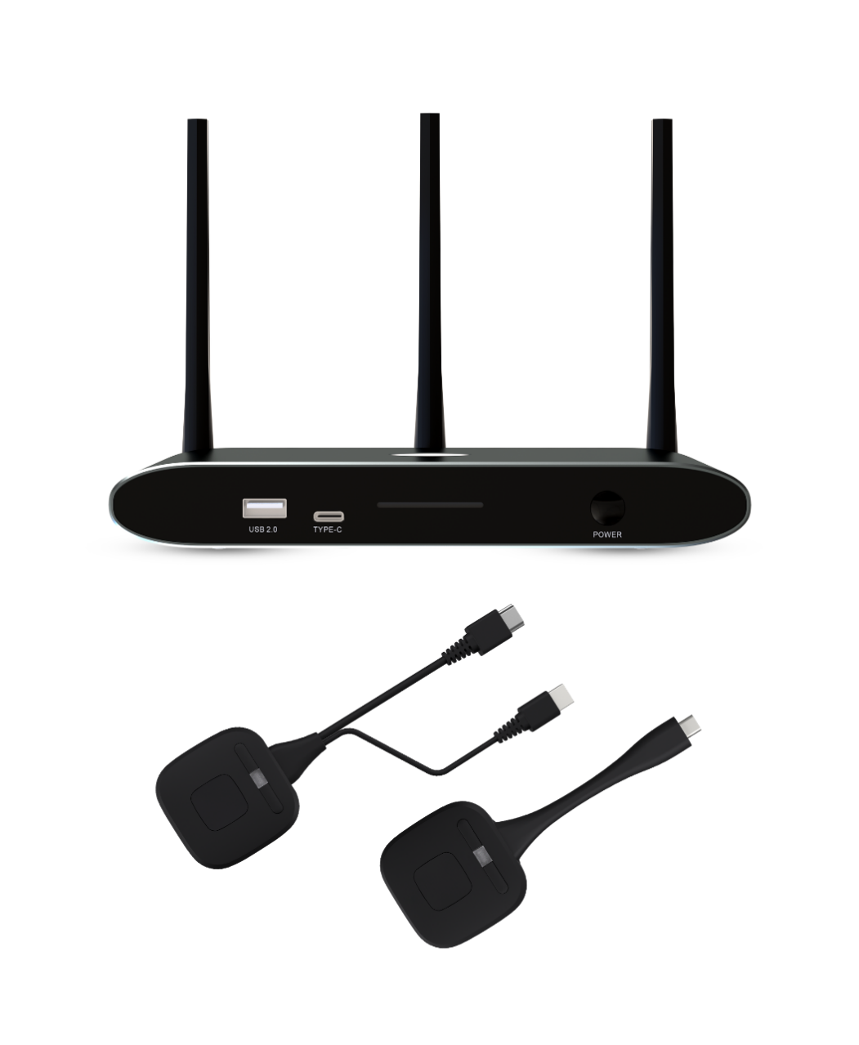

USER MANUAL

Table of Contents
1. PRECAUTIONS 5
1.1. Important Remark 5
1.2. Important Safety Instructions 6
1.3. Cleaning 6
2. Packing Contents 7
3. Description and Features 7
3.1 Main Features 7
3.2 Optional Accessories 8
4. Install & Connect 8
4.1 Wall Mount Install 8
4.2 Front Panel 9
4.3. Rear Panel 10
4.3.1. Restoring factory settings using the rear panel button 10
4.4 Wireless Dongle 11
4.4.1 DONG-HDMI300 11
4.4.2 DONG-USBC300 12
4.4.3 LED Indicator Light 12
4.5 Application Connection Diagram 14
4.6 Power Connection 14
4.7 Video Connection 15
4.8 Audio Connection 16
4.9 LAN Connection 17
4.10 USB Control Devices Connection 18
5. Start-up and Operation 19
5.1 Main Screen 19
5.2 Wired Presentation Mode 21
5.3 Wireless Presentation Mode 21
5.3.1 Screen Sharing using Dongle 21
5.3.2 Screen Sharing using WirelessMedia APP 22
5.3.3 Screen Sharing using Airplay 32
5.3.4 Screen Sharing using Miracast 33
5.3.5 Screen Sharing using Android apk 35
5.3.6 Screen Sharing using Chromecast 36
5.5 Home screen preview windows 38
5.6 Whiteboard and Annotation 39
5.6.1 Whiteboard 39
5.6.2. Annotations 41
6. WebGUI Setting Managemant & Configuration 42
6.1. Network Settings 44
6.1.1. Network Wizard 44
6.1.2. Wireless Network Configuration 53
6.1.3. Wired Network Configuration (Allows configuration of wired LAN 1
and LAN 2 settings) 55
6.1.4. Advanced Settings 56
6.2. Display and Sound 58
6.2.1. HDMI 58
6.2.2. Sound 60
6.2.3. Layout Setting 61
6.2.4. Native Protocol Support 62
6.3. Wallpaper 63
6.3.1. Custom wallpaper 63
6.3.2. Digital Signage 63
6.3.3. Additional Settings 64
6.4. Device Control 66
6.4.1. Remote Login (Telnet) and Serial Port 66
6.4.2. Dongle Management 68
6.4.3. Near-Field Discovery Settings 69
6.5. System Settings 70
6.5.1. Date & Time 70
6.5.2. Language 71
6.5.3. Configuration Profiles 72
6.5.4. Auto-Standby 73
6.5.5. Restart 73
6.5.6. Factory Reset 74
6.6. Security Settings 75
6.6.1. Security Level 75
6.6.2. Login Password 76
6.7. Firmware Update 76
6.7.1. Firmware Update 76
6.7.2. Auto-Upgrade 77
6.8. Other Settings 77
6.8.1. Auto-Create Launcher 77
6.8.2. Clear Records After Meeting 78
6.8.3. Developer Tools 79
6.9. About the Device 79
7. Firmware Update 80
7.1. Upgrading AVP-140V2 Firmware 80
7.2. Upgrading DONG-HDMI300 / DONG-USBC300 Firmware 81
8. Troubleshooting 82
9. Technical Data 87
9.1. Specification 87
9.2. Mechanical Drawings 88

PRECAUTIONS

Important Remark
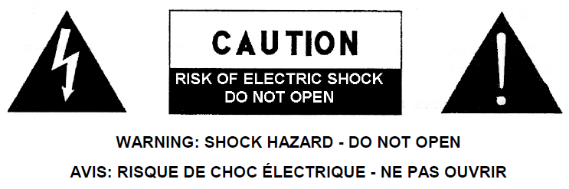

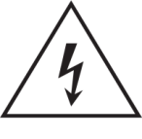
The lightning flash with arrowhead symbol, within an equilateral triangle, is intended to alert the user to the presence of uninsulated “dangerous voltage” within the product’s enclosure that may be of sufficient magnitude to constitute a risk of electric shock to persons.
The exclamation point within an equilateral triangle is intended to alert the user to the presence of important operating and maintenance (servicing) instructions in the literature accompanying the appliance.

WARNING (If applicable): The terminals marked with symbol of “ ” may be of sufficient magnitude to constitute a risk of electric shock. The external wiring connected to the terminals requires installation by an instructed person or the use of ready-made leads or cords.
WARNING: To prevent fire or shock hazard, do not expose this equipment to rain or moisture.
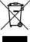
WARNING: A device with Class I construction shall be connected to a mains socket- outlet with a protective earthing connection.
WARNING: This product must not be discarded, under any circumstance, as unsorted urban waste. Take to the nearest electrical and electronic waste treatment centre.


This equipment has been tested and found to comply with the limits for a Class A digital device, pursuant to part 15 of the FCC Rules. These limits are designed to provide reasonable protection against harmful interference when the equipment is operated in a commercial environment. This equipment generates, uses, and can radiate radio frequency energy and, if not installed and used in accordance with the instruction manual, may cause harmful interference to radio communications. Operation of this equipment in a residential area is likely to cause harmful interference in which case the user will be required to correct the interference at his own expense.

  - Important Safety Instructions

- Read these instructions.
- Keep these instructions.
- Heed all warnings.
- Follow all instructions.
- Do not use this device near water.
- Clean only with dry cloth.
- Do not block any ventilation openings. Install in accordance with the manufacturer’s instructions.
- Do not install near any heat sources such as radiators, heat registers, stoves, or other device (including amplifiers) that produce heat.
- Do not defeat the safety purpose of the polarized or grounding type plug. A polarized plug has two blades with one wider than the other. A grounding type plug has two blades and a third grounding prong. The wide blade or the third prong are provided for your safety. If the provided plug does not fit into your outlet, consult an electrician for replacement of the obsolete outlet.
- Protect the power cord from being walked on or pinched particularly at the plugs, convenience receptacles, and at the point where they exit from the device.
- Only use attachments/accessories specified by the manufacturer.
- Unplug the device during lightening sorts or when unused for long periods of time.
- Refer all servicing to qualified personnel. Servicing is required when the device has been damaged in any way, such as power supply cord or plug is damaged, liquid has been spilled or objects have fallen into the device, the device has been exposed to rain or moisture, does not operate normally, or has been dropped.
- Disconnecting from mains: When switching off the POWER switch, all the functions and light indicators of the unit will be stopped, but fully disconnecting the device from mains is done by unplugging the power cable from the mains input socket. For this reason, it always shall remain easily accessible.
- Equipment is connected to a socket-outlet with earthing connection by means of a power cord.
- The marking information is located at the bottom of the unit.
- The device shall not be exposed to dripping or splashing and that no objects filled with liquids, such as vases, shall be placed on device.

Cleaning
Clean the unit with a soft, dry clean cloth or slightly wet with water and neutral liquid soap only, then dry it with a clean cloth. Be careful that water never gets into the unit through any hole. Never use alcohol, benzine, solvents or abrasive substances to clean this unit.

Grastron Technology Co.,Ltd. accepts no liability for any damage that may be caused to people, animal, or objects due to failure to comply with the warnings above.

Thank you for choosing our device AVP-140V2/DONG-HDMI300 /DONG-USBC300！
We appreciate your trust.

It is VERY IMPORTANT to carefully read this manual and to fully understand its contents before any connection in order to maximize your use and get the best performance from this equipment.
To ensure optimal operation of this device, we strongly recommend that its maintenance be carried out by our authorised Technical Services.

- Packing Contents
- AVP-140V2
- Antenna(3units).Not pre-mounted to avoid damages.
- Power Adaptor
- RS232 connector

Description and Features
The AVP-140V2 is a wireless presentation switcher with one HDMI input and one HDMI output, supporting up to 4K60Hz resolution. It supports sharing PC content to displays via dongle, Windows, macOS, and native protocols such as Airplay, Miracast, and Chromecast. Four devices can be displayed simultaneously in a multi-view layout. All features can be configured and managed through a powerful WebGUI management console.

3.1 Main Features
- One HDMI output, supporting up to 4K@60Hz
- One HDMI input, supporting up to 4K@30Hz
- Supports EDID management
- Supports ultrasonic and Bluetooth near-field discovery technology
- Two Gigabit Ethernet ports, one of which supports Power over Ethernet (802.11at compliant, supporting up to 15W)
- 3.5mm headphone unbalanced stereo analog audio output
- One RS232 port, supporting both receiving commands to control the device and sending commands to control other devices
- Wireless input up to 4K@30Hz video resolution
- Supports native wireless mirroring protocols such as AirPlay, Chromecast, and Miracast for seamless presentations
- Supports screen sharing function with the included Dongle (including the latest 4K dongle and previous 1080p dongle)
- A continuously updated WirelessMedia PC client (currently supported up to Windows 11 and macOS 15) supports screen mirroring function and wireless transmission of camera video data to a computer
- Powerful WebGUI backend management
- Supports Telnet control of the device
- An additional security layer for encrypted wireless transmission
- Supports up to 4 split-screen displays and up to 16 participants to be previewed
- Supports custom background images for the main screen
- Supports wireless touch for the interactive screen, as well as whiteboard and real-time annotation tools
- Local 12V DC power supply

3.2 Optional Accessories
Wireless Dongle：DONG-HDMI300 and DONG-USBC300, used for plug & play wireless mirroring from personal PC or mac desktop to the main screen.
- DONG-HDMI300 is a 4K HDMI wireless Dongle that allows participants to easily share content from a laptop or HDMI device to the AVP-140V2 base unit. Power is supplied by an auxiliary USB Type A connector. It is designed as a cross platform and plug and play device with no additional driver installation needed. This technology allows you to start a transmission and begin sharing content by just connecting the wireless Dongle into the source and pushing the surface. An LED indicator allows the user to know the status of the wireless Dongle at any time.
- DONG-USBC300 is a 4K USB-C wireless Dongle that allows participants to easily share content from a laptop or USB-C video device to the AVP-140V2 base unit.Power is supplied directly through the same connector. It is designed as a cross platform and plug and play device with no additional driver installation needed. This technology allows you to start a transmission and begin sharing content by just connecting the wireless Dongle into the source and pushing the surface. An LED indicator allows the user to know the status of the wireless Dongle at any time.

Install & Connect

Wall Mount Install
The AVP-140V2 can be installed on the wall or flat surface. At the bottom of AVP-140V2, there are two mounting holes that can be fixed to a surface using flat screws.
Mounting screws are not included in the AVP-140V2 box. The type of screws depends on the type of wall (stone, wood, plasterboard, ...) you are mounting the Base Unit AVP-140V2 to. Make sure the head of the screw is not larger than the hole in the bottom of base unit AVP-140V2.
For optimal performance, install the AVP-140V2 close to the display and avoid obstacles between the AVP-140V2 and the Dongles.

*Antenna Placement
*The antennas should be oriented vertically, so perpendicular to the ceiling and parallel to the walls.
*The antennas should be installed far enough (at least 50cm/1.6ft) from metallic surfaces to avoid unwanted reflections and far enough (at least 1m/3.3ft) from other radio equipment that operates in the same frequency range, e.g. other WiFi access points, cordless telephone,microwave ovens, etc. It is also best to install antennas at least 15 cm (6 inches) from concrete walls.
*The most favourable situation is a direct line of sight between antennas and buttons. Any obstruction will cause the signal to follow a longer propagation path, which can result in performance degradation.
*Due to the particular radio pattern of the dipole antennas, the antennas should not be placed just above potential positions of AVP-140V2 users. As a result, the advised position for the antennas is at the side of the meeting room.

4.2 Front Panel
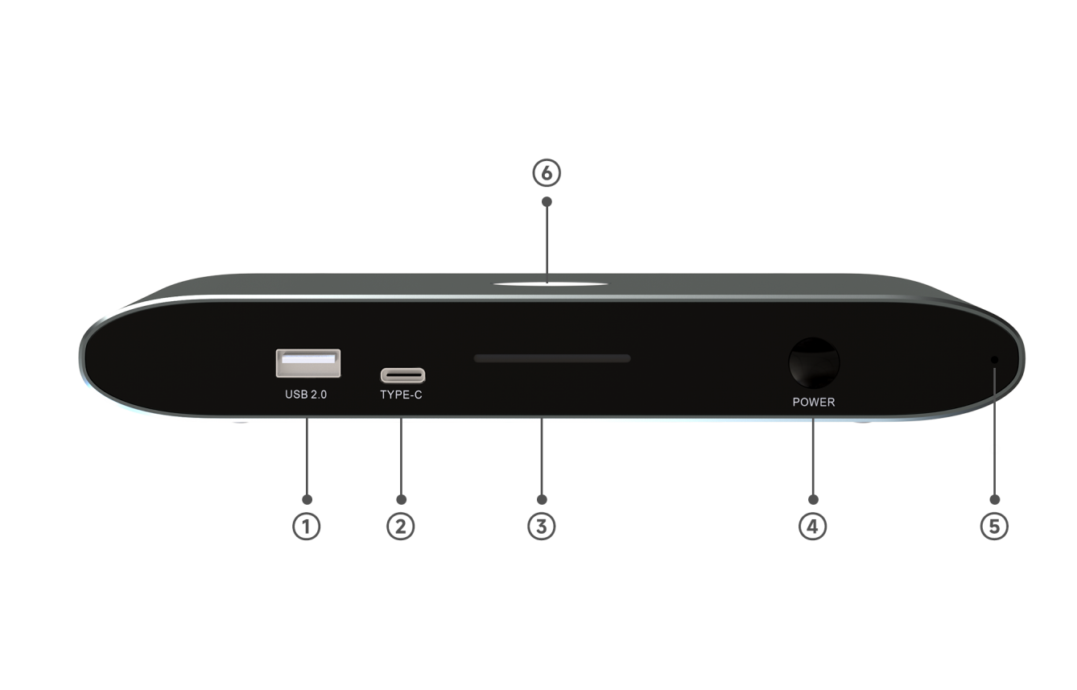
- USB 2.0 port: For pairing the DONG-HDMI300 with the AVP-140V2, and can also connect a USB flash drive or mouse
- Type-C port: For pairing the DONG-USBC300 with the AVP-140V2
- Indicator light 1
- Power button: Turns the device on and off
- Ultrasonic speaker: Sends ultrasonic signals
- Indicator light 2

Rear Panel
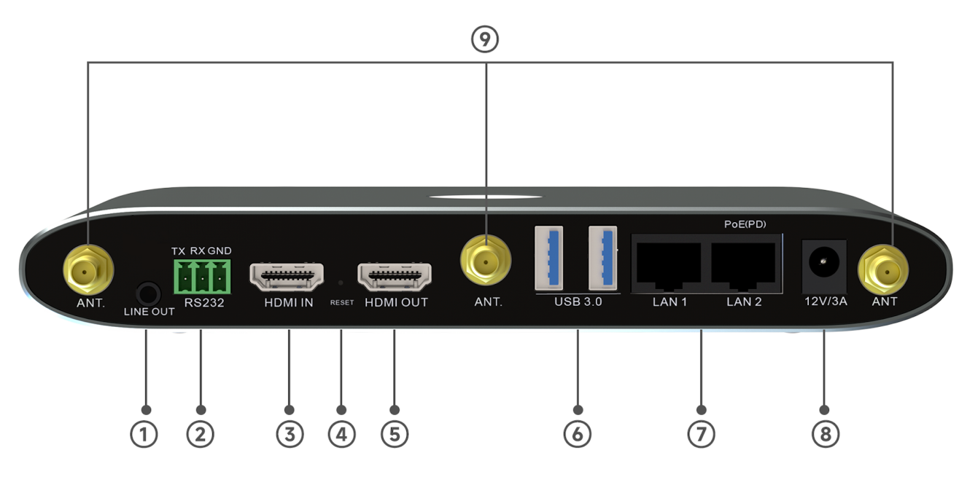

- LINE OUT: 3.5mm headphone unbalanced stereo analog audio output
- RS-232:Simple RS-232 interface for receiving and sending serial commands to control this unit or other slave devices
- HDMI IN：HDMI video input, supporting up to 4K@30Hz
- RESET：Reset button to factory default settings
- HDMI OUT: HDMI output, supporting up to 4K@60Hz
- Two USB 3.0 ports: connect a mouse, touchscreen, etc.
- LAN Ethernet Ports, LAN 2 support PoE
- DC Power Jack: Local 12V DC power supply
- Antenna ANT: Connect the three provided antennas to use Miracast and built-in WiFi

    - Restoring factory settings using the rear panel button

By using this function, all previous settings will be lost and you will need to set them up again.
When the AVP-140V2 is powered on and the home screen is displayed, press the reset button on the rear panel of the AVP-140V2. Use a pointed object (such as an unbent paper clip) to press this button for at least 2 seconds until the "Factory Reset" page is displayed, as shown below:
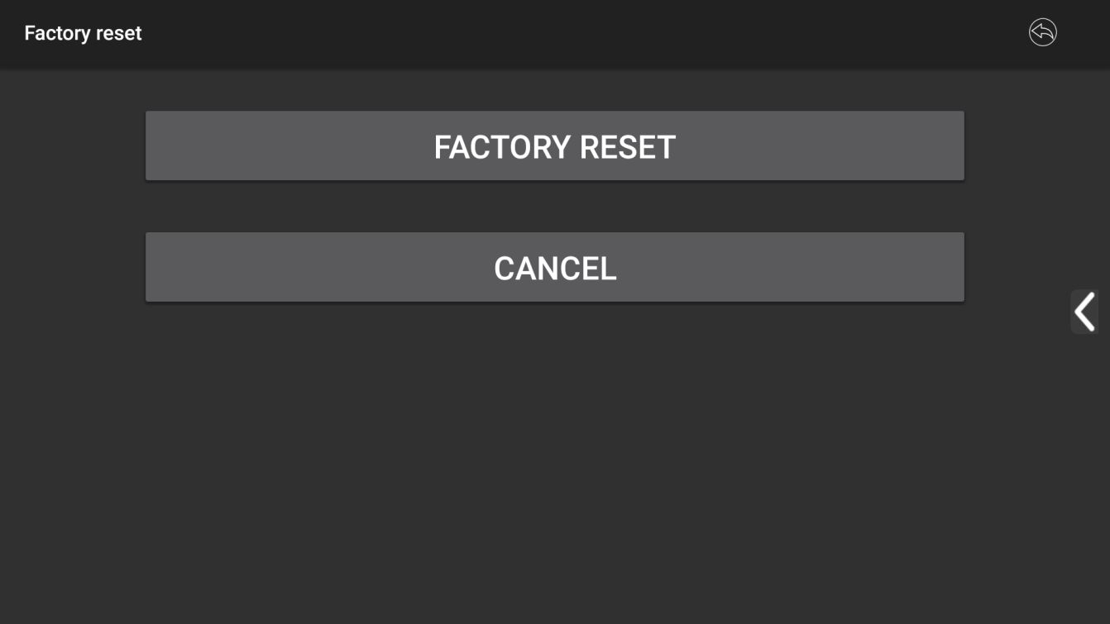

AVP-140V2 will reboot to default configuration after 3 seconds.
If the AVP-140V2 HDMI output is not connected to a display and no image is available, press and hold the reset button until the red LED on the top surface of the AVP-140V2 illuminates to perform the reset process.

4.4 Wireless Dongle

4.4.1 DONG-HDMI300
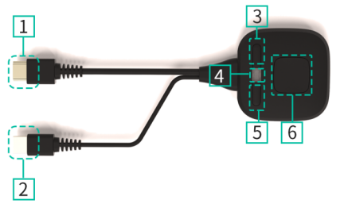
- HDMI Port：Connects to a PC/laptop to share the screen.
- USB Connector: Provides power to the transmitter or connects to the AVP-140V2 for pairing or upgrading.
- Sub-Button 1 - Left Button: Freezes the projected screen. Pressing this button while projecting freezes the screen.
- LED Indicator: Indicates the button status. For more information, see the LED Indicator section.
- Sub-Button 2 - Right Button: Displays device information(status bar)while projecting.
- Main Button: Pressing this button while the indicator light is solid green will start displaying the contents of the PC/laptop screen on the main screen. Pressing the button again during a meeting will toggle screen sharing.

4.4.2 DONG-USBC300
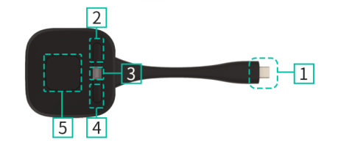
1. Type-C (DP) Connector: Use the button on the Type-C (DP) connector to plug in a PC/laptop to share your screen.
2. Sub-Button 1 - Left Button: Freezes the projected screen. Pressing this button while projecting freezes the screen.
3. LED Indicator: Indicates the button's status. For more information, see the LED Indicator section.
4. Sub-Button 2 - Right Button: Displays device information (status bar) while projecting.
5. Main Button: Pressing this button while the indicator light is solid green will start displaying the contents of the PC/laptop screen on the main screen. Pressing the button again during a meeting will toggle screen sharing.

DONG-USBC300 is a full-featured Type-C interface that complies with the DP Alt mod standard and supports audio and video transmission.

4.4.3 LED Indicator Light
 | 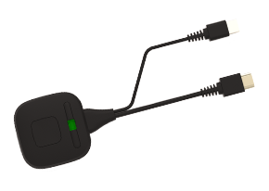  DONG-HDMI300-4K | 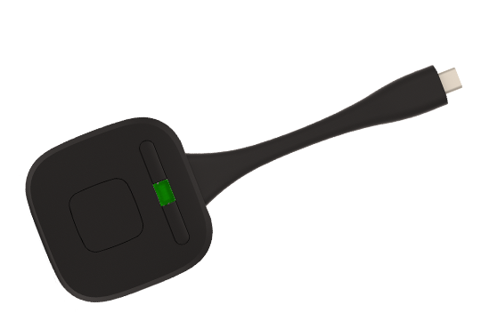  DONG-USBC300-4K
 | 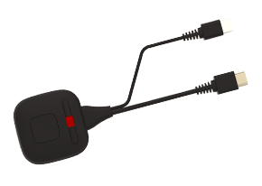  DONG-HDMI300-4K | 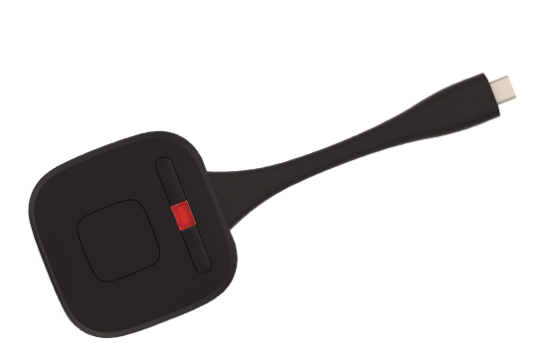  DONG-USBC300-4K

- Connecting the DONG-HDMI300 / DONG-USBC300 to the AVP-140V2:
First, connect the DONG-HDMI300 / DONG-USBC300 to the AVP-140V2 receiver:
  - When the LED indicator flashes green: The DONG-HDMI300 / DONG-USBC300 is pairing with the AVP-140V2 receiver or undergoing a firmware upgrade.
  - When the LED indicator is solid red: Pairing is complete. The DONG-HDMI300 / DONG-USBC300 can be unplugged and is ready for use.

- Connecting the DONG-HDMI300/DONG-USBC300 to a source device:：
First, you need to connect the DONG-HDMI300 / DONG-USBC300 to a source device. For example, to a PC:
  - When the LED indicator is flashing green: The DONG-HDMI300/DONG-USBC300 is plugged into the laptop and initialized.
  - When the LED indicator is solid green: The PC desktop is ready to be mirrored on the main screen connected to the AVP-140V2's HDMI output.
  - When the LED indicator is static red: The PC desktop is mirrored on the screen.

4.5 Application Connection Diagram
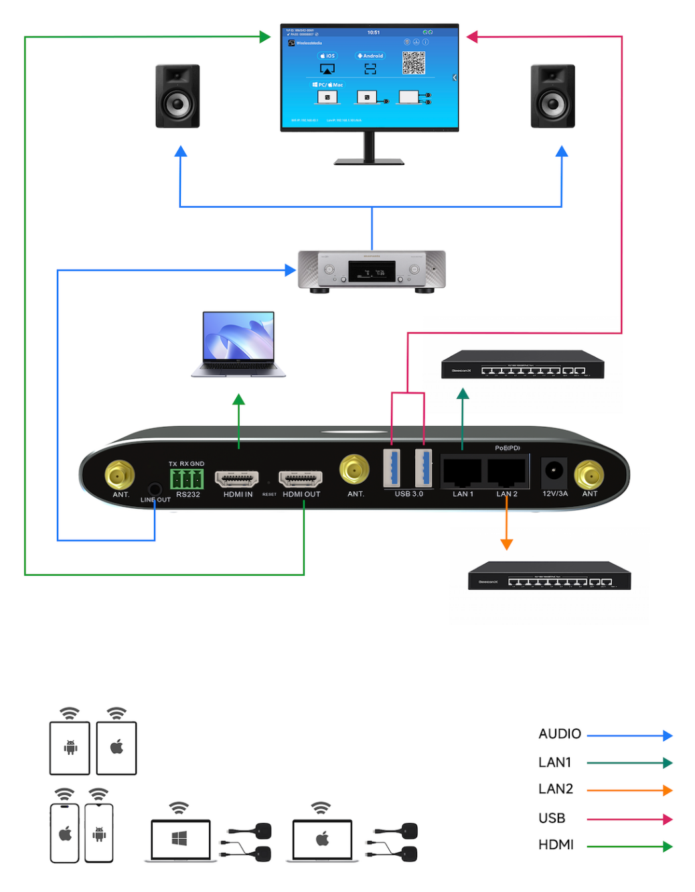

4.6 Power Connection
- Local power supply
- Plug the power connector of the power adapter into the power input connector of the Base Unit AVP-140V2, which supports 12V/3A.
- Select the appropriate power plug (US, UK, EU or AU) and install it on the power adapter.
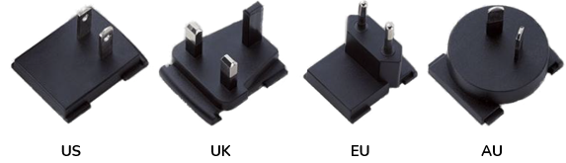

Connect the power cord plug to a wall outlet.
After the AVP-140V2 is powered on, it is recommended to use the POWER button on the front of the AVP-140V2 to turn it on or off.
- POE
If your LAN Ethernet switch supports PoE (Power over Ethernet), you can use the LAN 2 port to power the Base unit AVP-140V2 instead of using an external power adapter. (The LAN2 port of this unit supports PoE.)

4.7 Video Connection
Connect the AVP-140V2's HDMI output to a 4K or Full HD monitor via an HDMI cable.
After powering on, the system will display the home page, as shown below
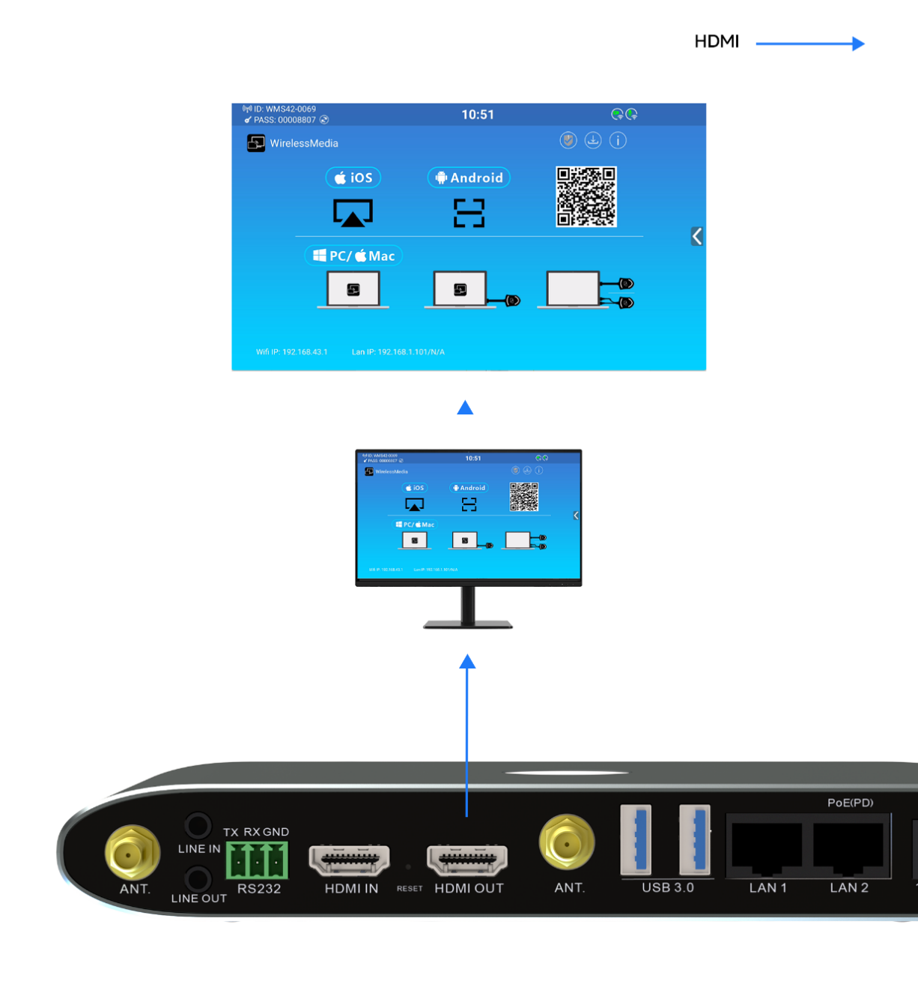

4.8 Audio Connection
Connect an audio cable with a mini-jack 3.5mm connector to the AVP-140V2's audio line. Connect the other end to the conference room's sound system.
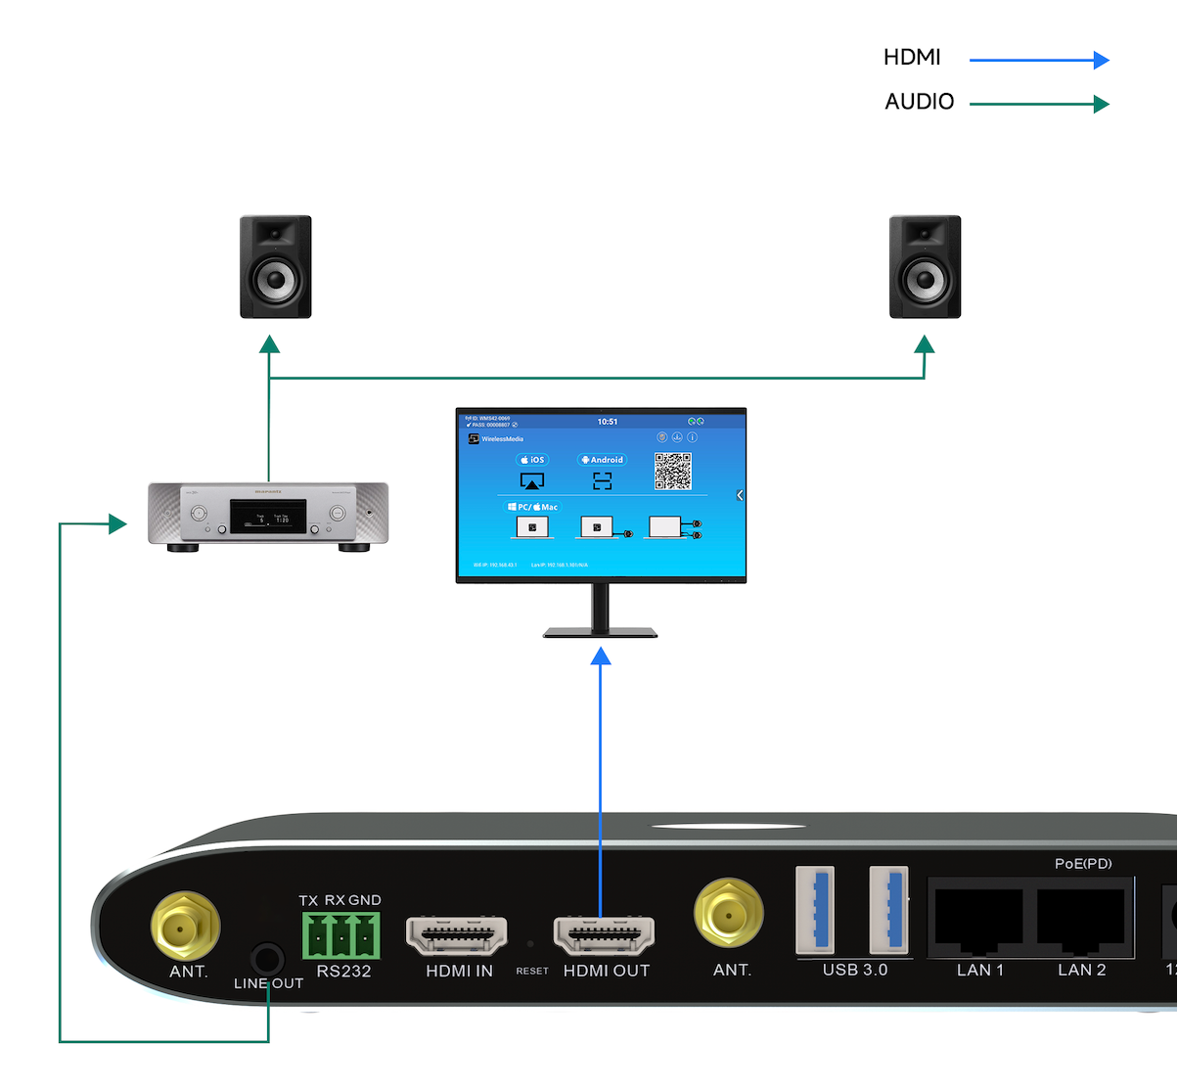
When the audio output of the source device is selected, the DONG-HDMI300 and DONG-USBC300 can transmit audio to the AVP-140V2 receiver.

4.9 LAN Connection
Connect an Ethernet cable with an RJ-45 connector to the LAN 1 or LAN 2 port on the AVP-140V2 Base Unit. Connect the other end to your router. DHCP is enabled by default on the AVP-140V2 console.
- If there is a DHCP server on the network, an IP address will be automatically assigned.
- If there is no DHCP server on the network, the AVP-140V2 will require manual configuration of a static IP address. For more information, refer to the "Network Settings" chapter.
If the LAN Ethernet switch supports PoE (Power over Ethernet), the AVP-140V2's LAN 2 port allows you to power the switch instead of using the included external power adapter.
Wireless Direct mode is enabled by default. In this network mode, the AVP-140V2 generates its own wireless SSID with an IP address of 192.168.43.1. For more information on how to properly configure the network settings for your application, refer to the "Wireless Networking" chapter.
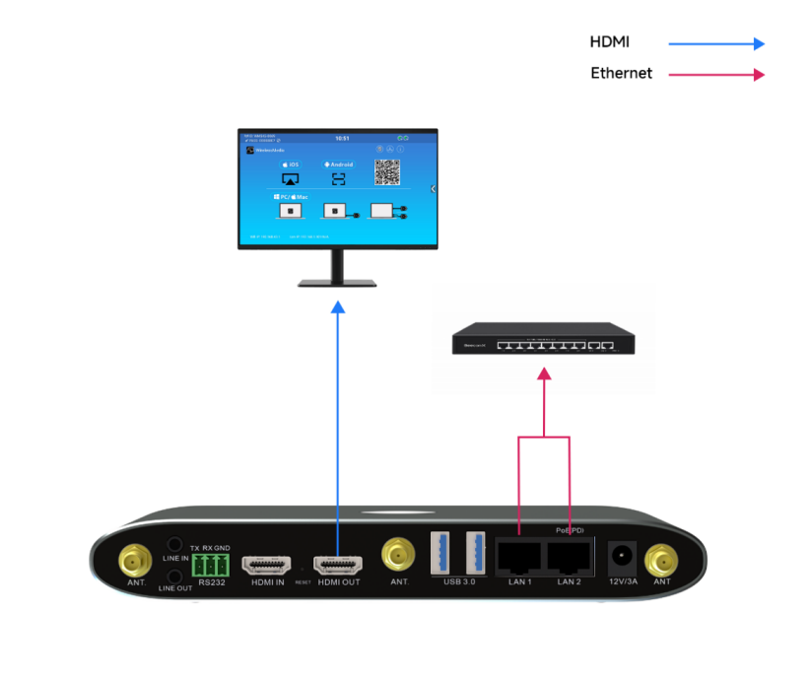
LAN connection can be used for：
- Network integration of the AVP-140V2 in guest or corporate networks.
- Telnet control of the AVP-140V2.
- Maintenance purposes
- Over-the-air (OTA) updates of the AVP-140V2 firmware.

4.10 USB Control Devices Connection
If the user connects an USB Mouse or Touchscreen, the following features will be available:

- Moderator tab to manage the active users sharing content with the AVP-140V2.
- Whiteboard or Annotation during a presentation.
- USB-HID function for laptop control and click function of a touchscreen:
  - USB mouse :
    - Single click to select.
    - Right-click to back to the Home Page.

  - Touch screen:
    - Click to select.
    - Long press to open the contextual menus, as double-click or click the right button of a USB mouse.

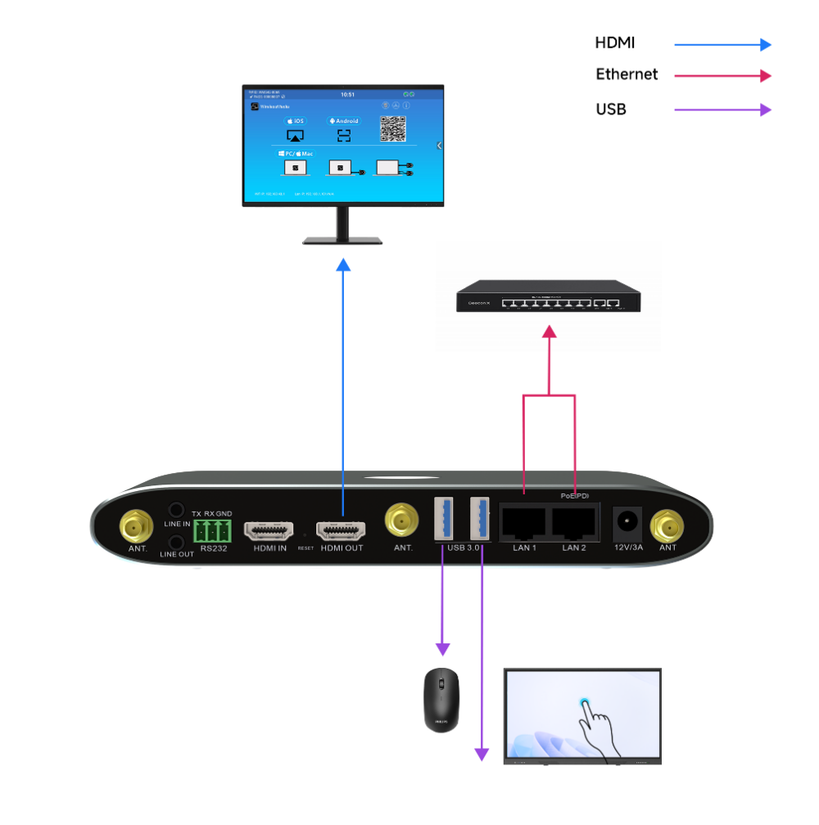

Start-up and Operation

5.1 Main Screen
When the user boots up the AVP-140V2 receiver normally and connects it to an HDMI display, the following main screen will be displayed:
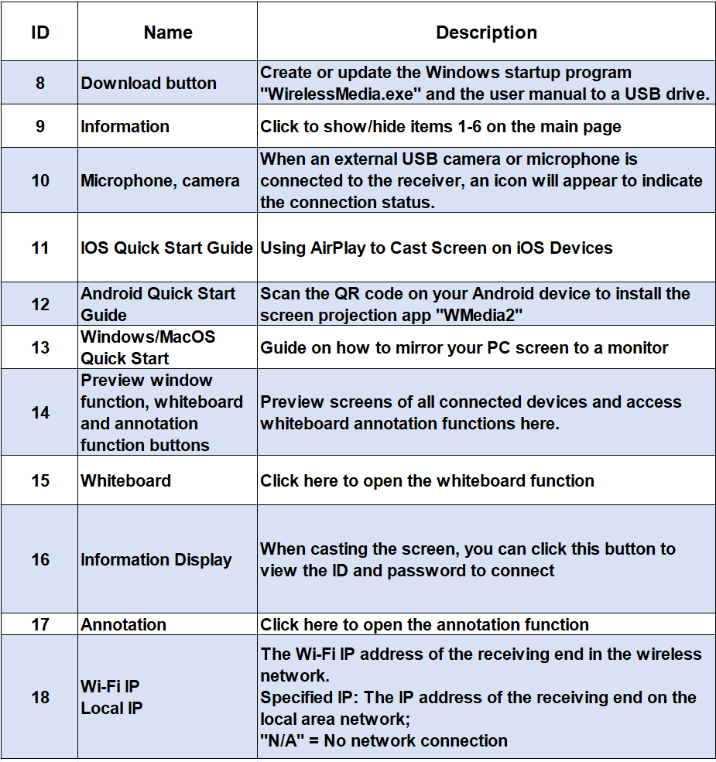
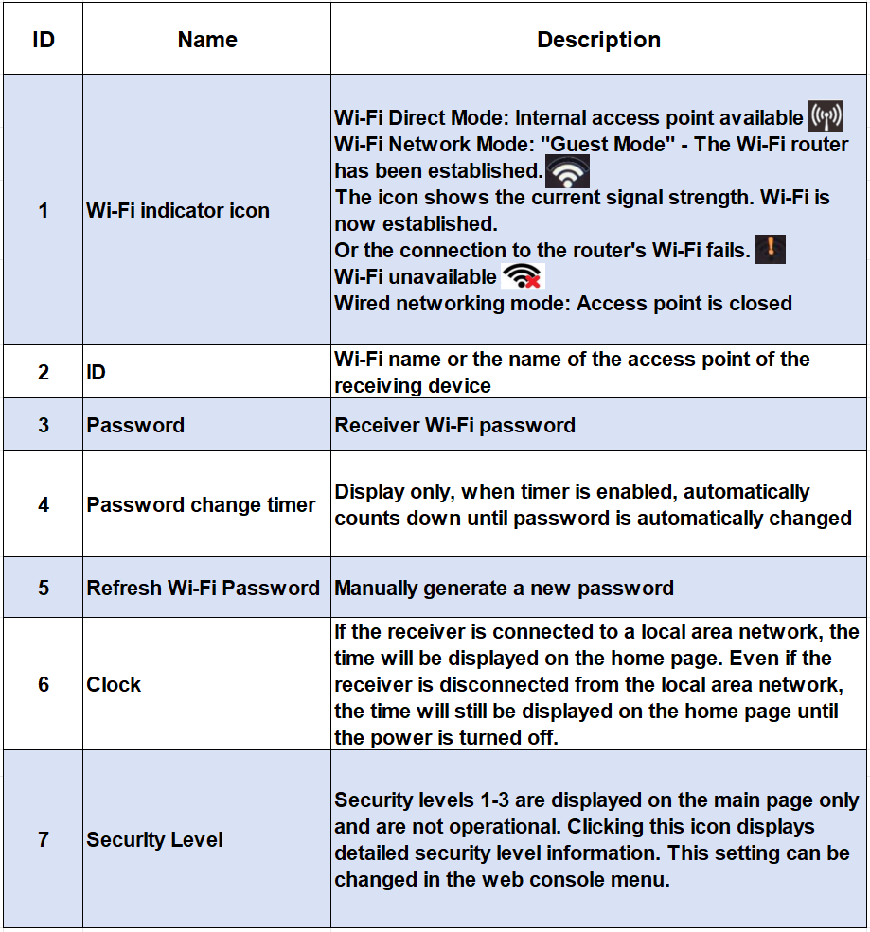
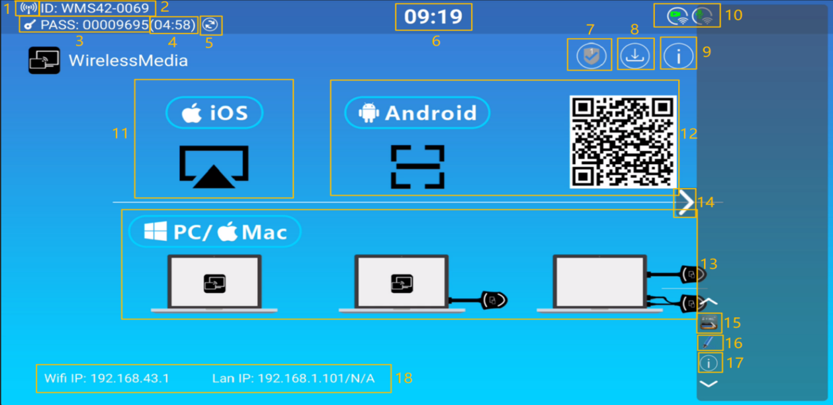

Pairing the Dongle with the AVP-140V2
Connecting the DONG-HDMI300 (HDMI Wireless Dongle) to the front panel's USB Type-A port or the DONG-USBC300 to the USB Type-C port will automatically initiate the pairing process.
The Dongle can only be paired with one receiver and will always reconnect to the last paired receiver(base unit).

After plugging in the transmitter, a message will be displayed indicating that the wireless transmitter is connecting, as shown below:
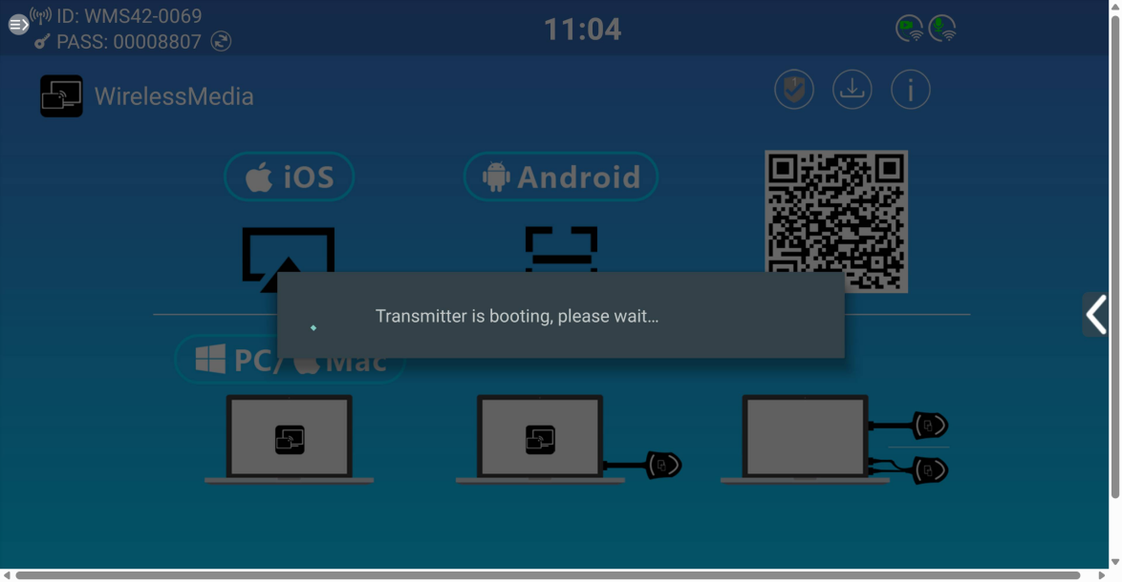
After pairing is completed, the message sheet displays "Pairing successful! " on the home page. You can then unplug the Dongle and use it to screen share content.
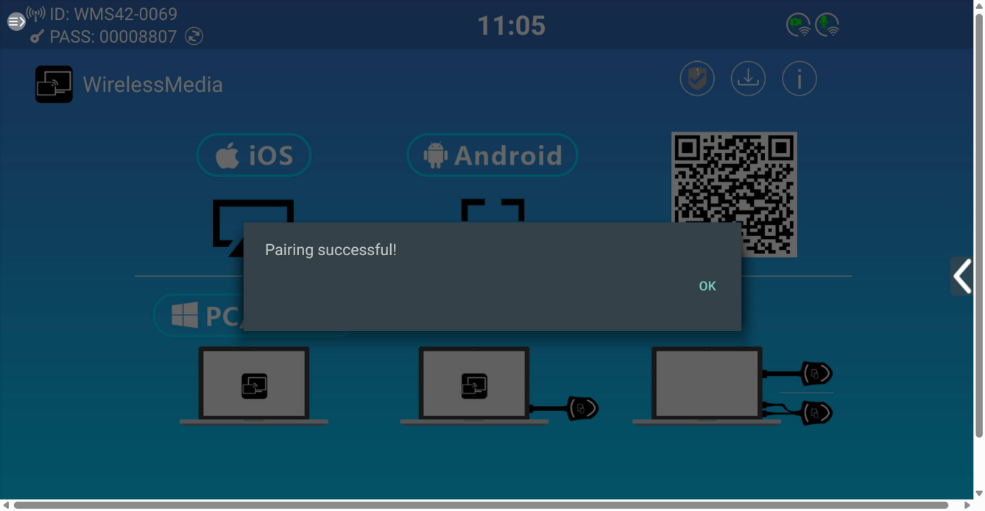
If the error message "Configuration Failed" is displayed, check that the USB/type-C connection is stable and try again.
After changing the SSID/WiFi channel or reconfiguring the network, all dongles must be re-paired. Dongles that need to be assigned to another AVP-140V2 receiver must be re-paired.

5.2 Wired Presentation Mode
AVP-140V2 supports HDMI IN wired screen sharing. Use an HDMI cable, plug one end into the HDMI IN port of the device, and the other end directly into the computer to directly share the screen. Set up as shown below:

5.3 Wireless Presentation Mode
The AVP-140V2 can be used to wirelessly share the screen of AV sources. The AVP-140V2 can simultaneously mirror up to four sources onto the display, supporting PCs/laptops and mobile devices.

5.3.1 Screen Sharing using Dongle
- Pair the DONG-HDMI300 or DONG-USBC300 with the AVP-140V2 receiver. See Pairing the Dongle with the AVP-140V2.
- Plug the DONG-HDMI300 into the USB-A and HDMI ports of the device whose content you want to share, or the DONG-USBC300 into the USB-C port.
- When ready, the LED indicator will turn solid green. Pressing the middle button will start wireless presentation, and the LED indicator will turn solid red.
- Pressing the middle button again will stop wireless presentation, and the LED indicator will return to solid green.
DONG-HDMI300-4K DONG-USBC300-4K
- When the LED is solid red, the content will be mirrored to the home screen connected to the AVP-140V2 receiver.
DONG-HDMI300-4K DONG-USBC300-4K
For more information on the LED status, see section LED indicator light.

5.3.2 Screen Sharing using WirelessMedia APP

5.3.2.1 Download the WirelessMedia desktop app
The WirelessMedia application is a launcher that allows users to run the WirelessMedia application from any source device hosting it (Mac, PC). Simply copy the launcher to the internal storage and the user can run the WirelessMedia application.
To set up WirelessMedia, there are two ways to obtain the WirelessMedia desktop application:
- Download from the website You can download the app from the website by connecting your device (laptop/Android) to the same network as the AVP-140V2 controller.
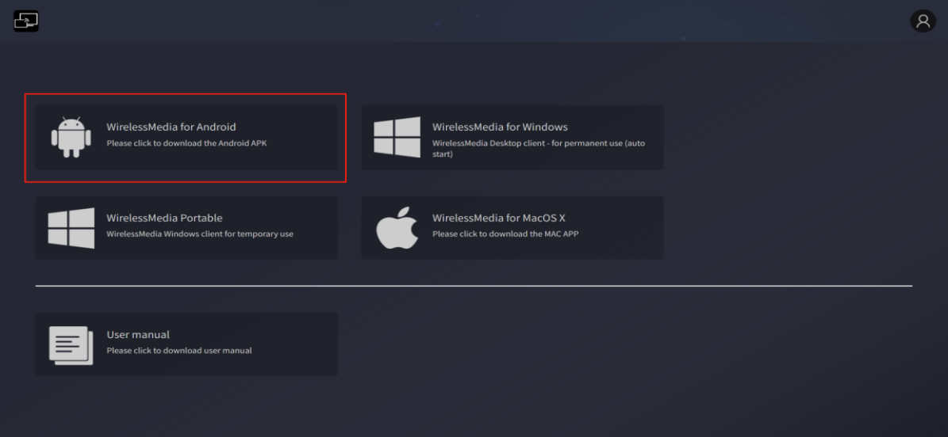
- Automatically create a startup program
Connect a USB drive and click the download icon on the main page to download the application to the root directory of the USB drive. Then copy the application to your computer.
When a user connects a laptop to the AVP-140V2 via WiFi for the first time, when the application detects that the device is connected to a camera, microphone, and speakers, it will pop up a message bar to instruct to install a virtual driver to activate the USB over WiFi function so that a video conference can be started through the AVP-140V2.
The virtual driver is only used for video conferencing and can be mirrored without installation. If the AVP-140V2 is not connected to a camera, microphone, or speakers, it will not prompt for driver installation and can still mirror the desktop.

5.3.2.2 Manually connect the WirelessMedia desktop application
Copy the WirelessMedia app to your laptop's local storage to start using it.
If near-field device discovery is disabled, you'll need to manually connect: (See the near-field discovery settings on the web page for details.)
- Start the WirelessMedia app on the source device. Available AVP-140V2 switches will indicate whether the source device and switch are on the same network.
Connect your laptop to the WiFi network (Guest, Staff) displayed on the home screen, or connect to the LAN on your network using an Ethernet cable.
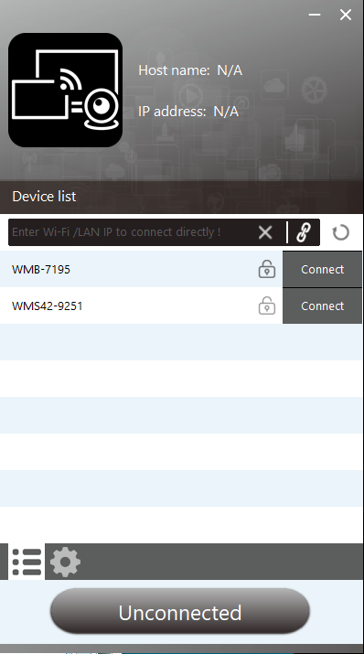

- Double-click the WirelessMedia application. A list of all available AVP-140V2 base units on the same network will be displayed. Select the device you want to connect to. The connection is password-protected (lock icon).

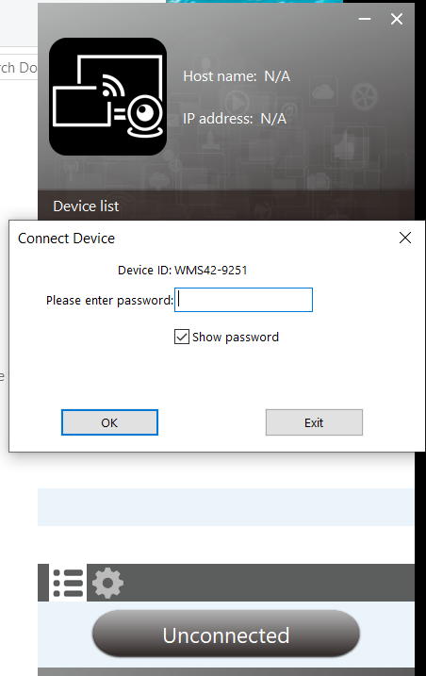
- Enter the AVP-140V2 password and click "Connect" to start sharing the system.
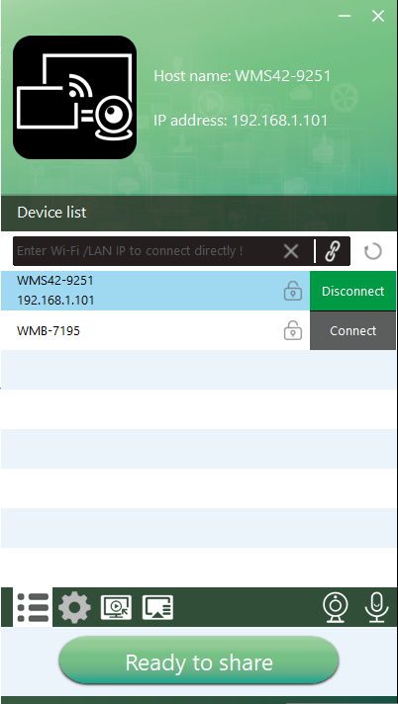
If the AVP-140V2 receiver is not displayed, you can also connect manually by entering the name (SSID) or IP address (click the icon).

5.3.2.3 Automatic connection method: Introduction to near-field discovery
- The AVP-140V2 supports near-field discovery. Near-field discovery is a smart device detection technology that automatically identifies nearby devices (such as the AVP-140V2) using wireless signals (such as Bluetooth Low Energy (BLE) and ultrasound). This allows:
Quick Device Discovery: Automatically finds nearby ultrasound-enabled devices and prioritizes them.
Secure Authentication: No need to manually enter a device connection password.
Automatic Connection and Screen Mirroring: Fully automated operation, connection, and screen mirroring.
- The value of this technology:
Efficiency improvement:Reduces the time spent on manual password entry, shortening the operation process by over 70%.
Lowered entry barriers: Especially suitable for visitors who are unfamiliar with devices.

5.3.2.4 Automatically connect to the WirelessMedia desktop application
Automatic connection is possible when near-field device discovery is turned on: (See the web page for details on near-field discovery settings.)
- Start the WirelessMedia application on the source device. The available AVP-140V2 switcher will show whether the source device and the switcher are on the same network.
2.Connect your laptop to the WiFi network shown on the home screen (Guest, Staff), or to the LAN on your network using a network cable.
3. Double-click the WirelessMedia app to display a list of all available AVP-140V2 base units in the same network. If a device in the searched device list supports near-field discovery, the app will prompt you to turn on near-field discovery.
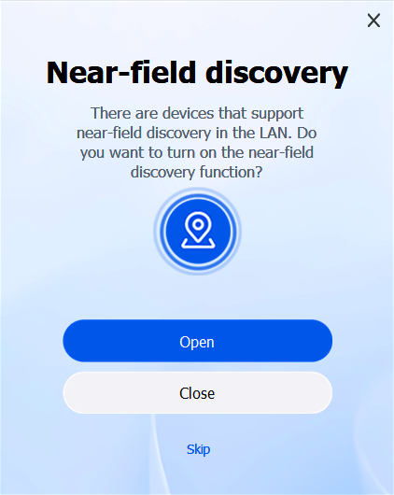

After choosing to turn it on, the app will display the near-field discovery functions "Auto-join" and "Near-field discovery" in the system settings and check them by default.

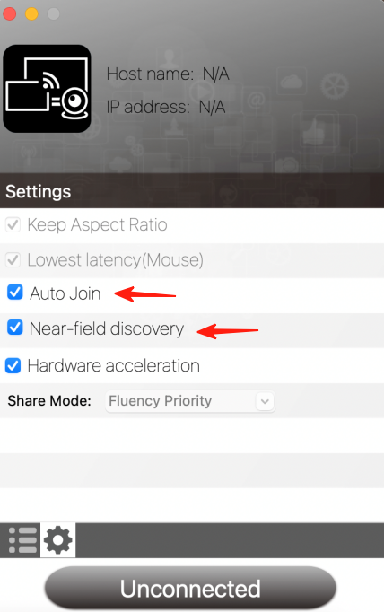

After choosing to turn off, the app will display the near-field discovery function "Auto-join" and "Near-field discovery" in the system settings, and "Auto-join" will be checked by default.
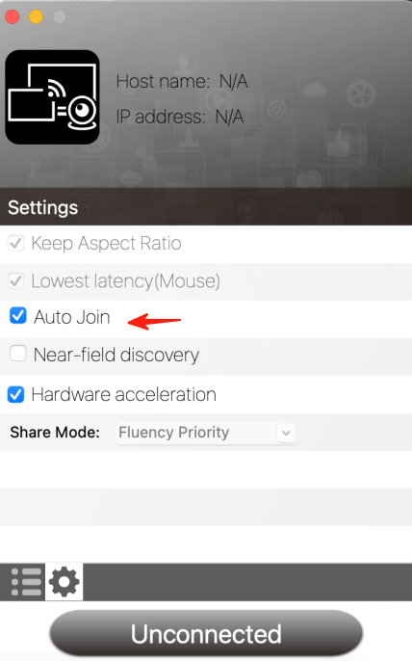
Click Skip to ignore it, and the near-field discovery switch will not be displayed in the system settings.
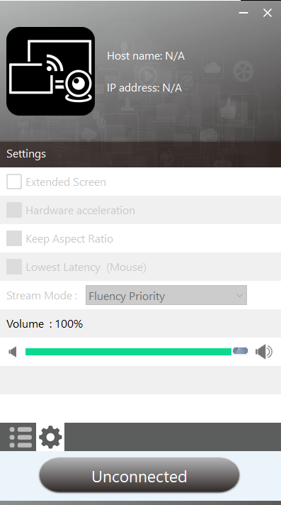
This section explains how to use automatic connection, using the example of selecting "Open" when launching the WirelessMedia app for the first time.
When both Auto-Join and Nearby Device Discovery are enabled, the app will display a pop-up asking you to share your screen when it detects an ultrasonic device. Clicking "Yes" will automatically connect and start casting.

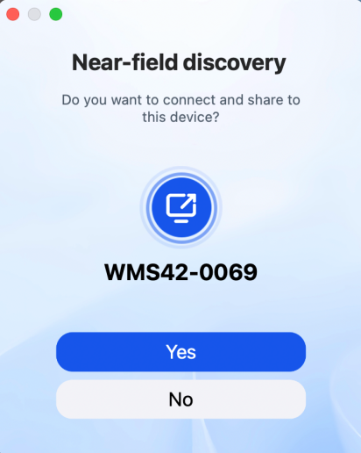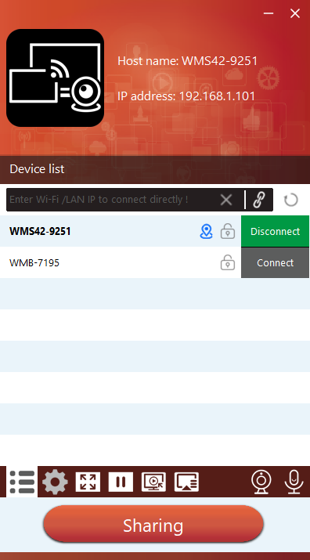

If you click "No", you need to manually click "Connect" to successfully connect without entering a password, and the system can be shared.

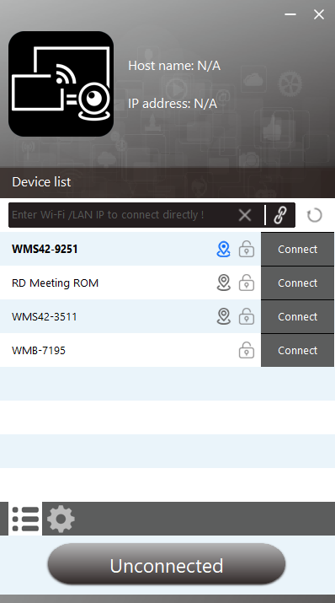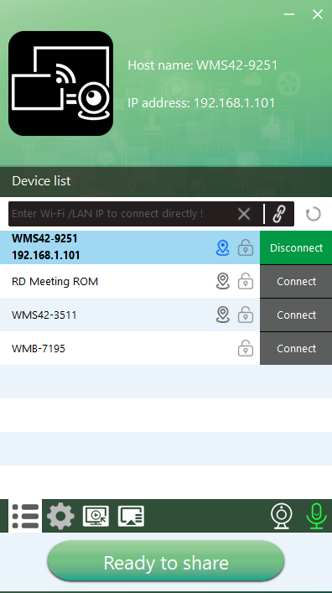

The WirelessMedia application layout will turn green. Clicking "Shareable" will start sharing content with the primary display connected to the AVP-140V2's HDMI output. When the window color is static red, the desktop is mirrored to the primary screen.
Clicking "Sharing" will stop sharing content. The window will turn to a static green color again.
Note: Connecting to an ultrasonic device does not require a password. When the icon is blue, click Connect in the device list to automatically connect. This feature is only supported on devices that can detect ultrasonic signals. If a device can only detect Bluetooth signals, the nearby device icon will not turn blue. Bluetooth signals are currently used primarily for searching for devices across VLANs. After enabling near-field discovery, the app will no longer automatically detect Bluetooth status upon opening (no prompt to turn on Bluetooth will appear the first time the app is run).

·WirelessMedia Settings
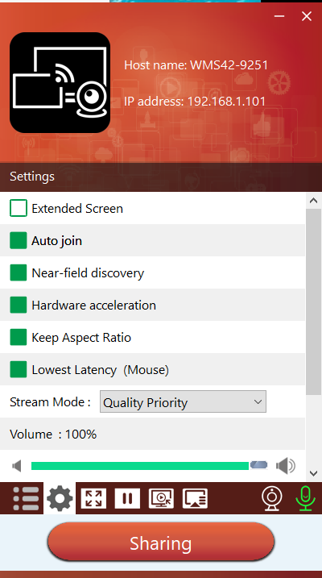

System Setting:
1.Options
·Get Extended Screen:
Transmit the extended desktop of the active source.
Main Screen（1）Displayed on the laptop, and the virtual extended screen（2） Displayed on the main screen. If the PC is already connected to an extended screen, the extended screen（3）Will always be displayed on the main screen.
When using the "Extended Screen" function for the first time, click "Extended Screen" and a message will pop up indicating that the "Extended Display" driver has been installed. Click "Yes" to continue. After the installation, the extended screen function will be available.
If the Extend Screen feature is selected, Windows automatically switches to Extend Mode. If you stop streaming using WirelessMedia (Pause), Windows remains in Extend Mode until you press Windows Key + P on your laptop to select PC Screen Only mode.
In macOS, extending the desktop (Use Separate Display) via AirPlay only works when "Show on WirelessMedia App" is enabled.
Automatically join:
After launching the WirelessMedia app, a prompt will pop up asking, "Do you want to connect and share your desktop to this device?" Click Yes to automatically connect and cast your screen.
·Near-field discovery: Easier to find nearby projection devices, primarily used for searching for devices across VLANs.
·Hardware Acceleration:
Use hardware acceleration to improve image quality and reduce latency, delivering enhanced screen projection.
·Keep aspect ratio:
This parameter will use the original aspect ratio of the main screen.
·Ultra-Low Latency Mouse:
This setting applies uniquely to each WirelessMedia host device. The mouse pointer's shape matches the shape in the application being used. This parameter significantly improves mouse responsiveness (approximately less than 20 milliseconds).
·Screen Mirroring Mode:
This parameter adjusts performance to suit the desired application:
o Smoothness first: image transmission delay is short, image resolution will be lower, suitable for PPT presentation mode.
o Image quality priority (default): The image resolution is relatively high, but when the image content is complex, the transmission delay will be relatively large. It is suitable for watching videos.
·Volume:
This parameter adjusts the playback volume of the main screen when using Presentation Mode (not available in macOS).

- Full Screen:
Click the full screen icon on the PC UI, or long-press the wireless transmitter to fully display the content. Another short press returns the screen to quad-view mode.


- Freeze:
Click the freeze icon on the PC UI or press the left button on the dongle to freeze the projected content. Click again to unfreeze.

- Replay

Clicking the replay icon on the PC UI will open the replay window, where you can see the contents of the screen.

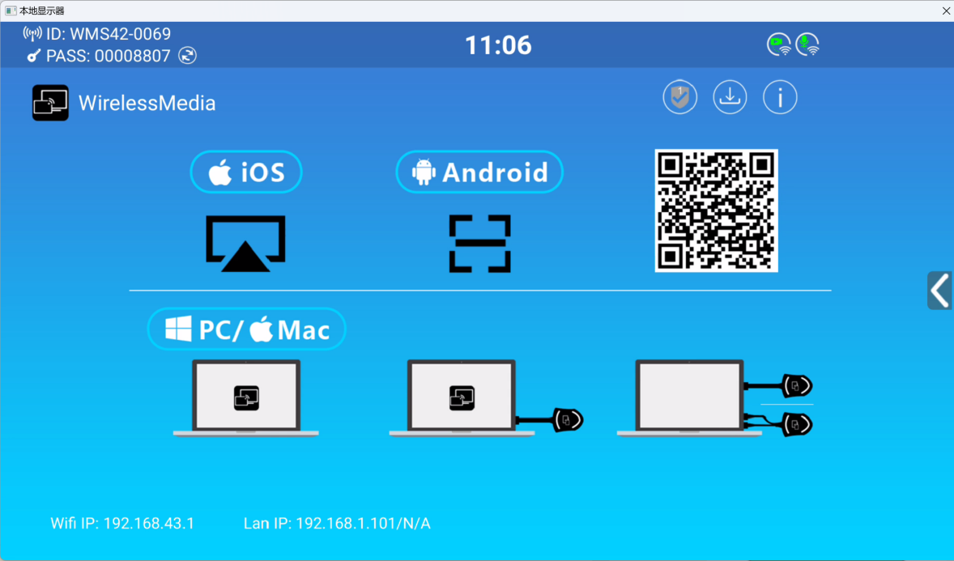


- Cast Window
Click the Cast Window icon on the PC UI to select the desktop or window to display the casted screen.
- Use the camera and microphone icons on the PC software to switch the camera and microphone to use.
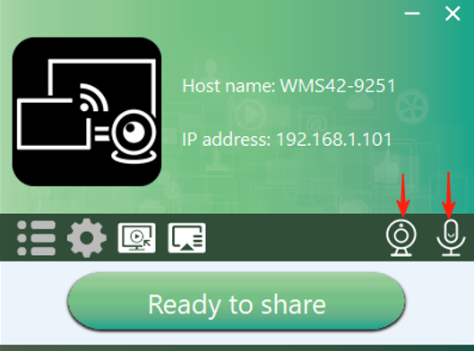

5.3.3 Screen Sharing using Airplay
On iOS and macOS devices, users can wirelessly transmit screen content or sound to the AVP-140V2 receiver via the Airplay protocol.
1. Connect your iOS or macOS device to the same WiFi network as the AVP-140V2.
2. Display the Control Center. Click the Airplay icon on your iOS and macOS devices and select the target AVP-140V2 to start sharing content with the AVP-140V2.
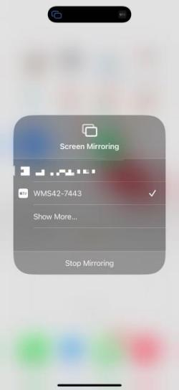

5.3.4 Screen Sharing using Miracast
Android Device
- Wi-Fi must be enabled.
- Go to Connections & Sharing in your phone's settings and tap "Mirror Phone Screen."
- Search for devices, select the AVP-140V2 SSID, and tap Connect.
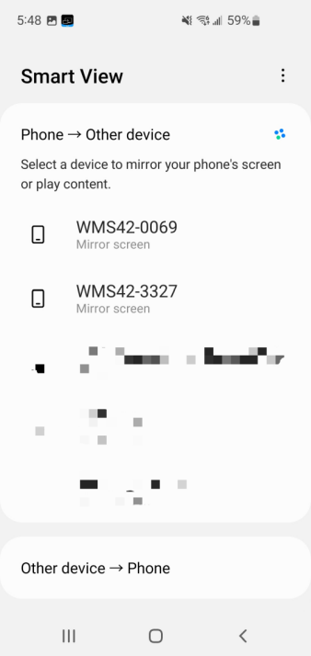
In Security Level 1 mode, you can connect without entering a password.
In Security Level 2, you must enter the password on the AVP-140V2 home screen to connect and start casting.
In Security Level 3, Miracast is disabled.
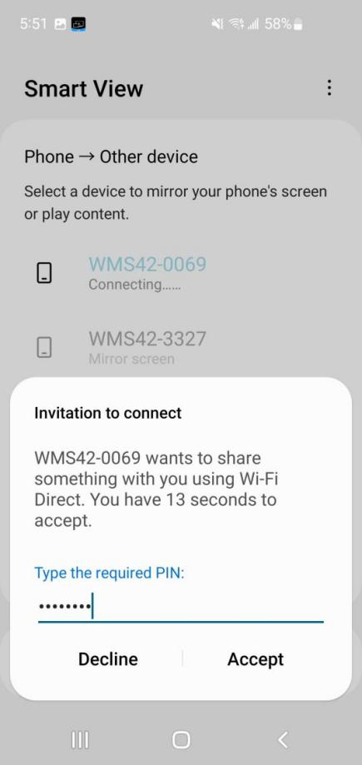
4. After entering your password, your phone's content will appear on the display.
5. Click the "End Screen Mirroring" icon to stop mirroring.

- PC

- Wifi must be enabled.
- Press + K and then click "Connect to a wireless display" in the pop-up window.
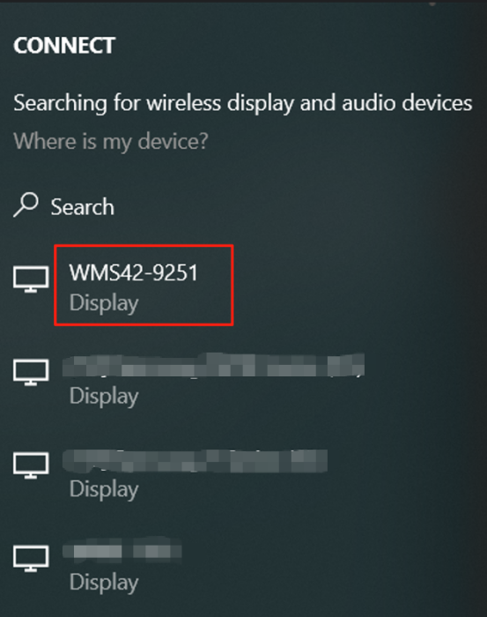
In Security Level 1 mode, you can connect without entering a password.
In Security Level 2, you'll need to enter a password on the AVP-140V2 home screen to connect and mirror. After entering the password, your mobile content will appear on the display.
In Security Level 3, Miracast is disabled.

5.3.5 Screen Sharing using Android apk
- Android Device
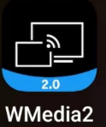

- Download the WirelessMedia app (see the WebGUI Setup Management and Configuration chapter).

- Connect your Android device to one of the displayed WiFi networks.
- Open the WirelessMedia app on your Android device and pull down to refresh the device list.
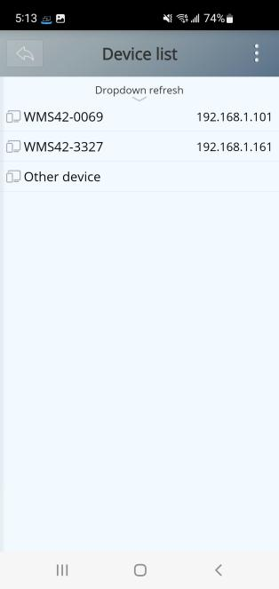
- Select the AVP-140V2 you want to connect to and enter the password to start screen sharing.
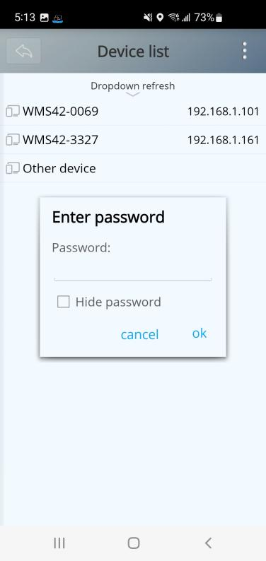
- Click the Share Screen button again to stop mirroring.

5.3.6 Screen Sharing using Chromecast
1. Connect your PC and AVP-140V2 to the same network.
2. Open the Chrome browser.

3. Click "Cast" to connect to the Chromecast function.

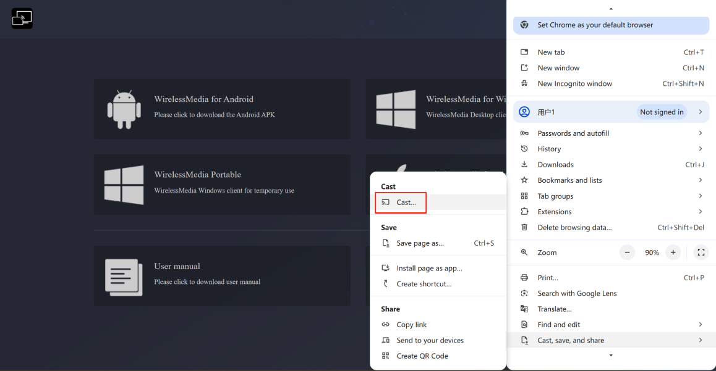
4.Click the AVP-140V2 SSID to start sharing content
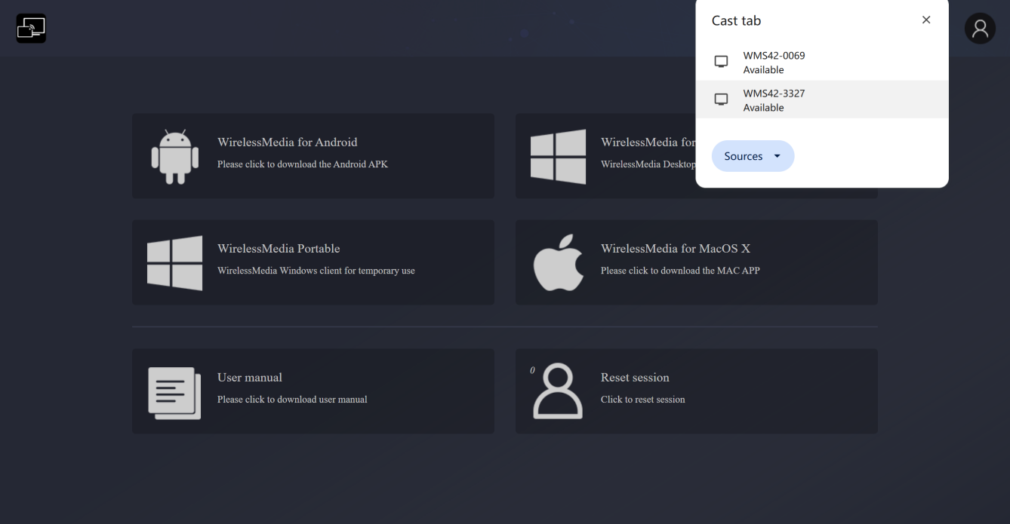
5. Click the AVP-140V2 SSID again to stop sharing content.

5.5 Home screen preview windows
The AVP-140V2 includes a moderator preview window that allows users to choose which online devices appear on the home screen, turn wireless casting on and off on any device, or control volume playback.
In order to show, hide or manage the moderator tab, a USB HID compliant device (touch screen, mouse, ...) connected to the AVP-140V2 receiver is required.
A window previewing all connected Dongles, WirelessMedia application users and Airplay/Miracast/Chromecast screen sharing devices will appear on the tab. Various window prefix layouts can be selected in the Moderator section of the WEB settings, see the Moderator Layout chapter.
Allowing 4 users to be on screen simultaneously, an additional 14 users can connect to the AVP-140V2 receiver while it is on standby.

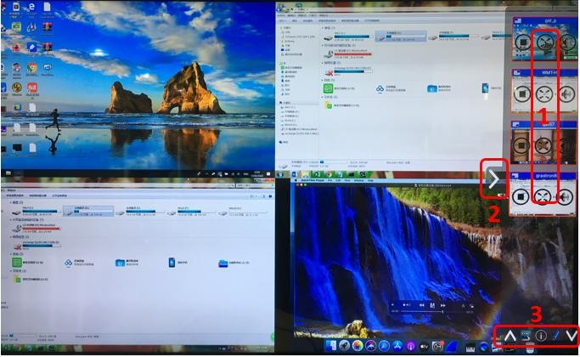
- Preview control buttons:
 | 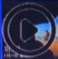 | Click to start screen casting
 | 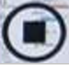 | Click this to stop screen casting
 |  | Click to make this device full screen
 |  | Click to mute the screencaster's volume
 | Arrow showing preview tab
 | Whiteboard and annotation. See below for details

5.6 Whiteboard and Annotation
Whiteboard and annotation requires a USB HID-compliant device, such as an interactive whiteboard, touchscreen, or mouse. There are two different modes:

5.6.1 Whiteboard
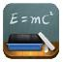
Opens a whiteboard that allows users to write notes and draw content. It allows different graphics, colors and backgrounds. To launch the whiteboard, click the whiteboard icon
under the sidebar menu
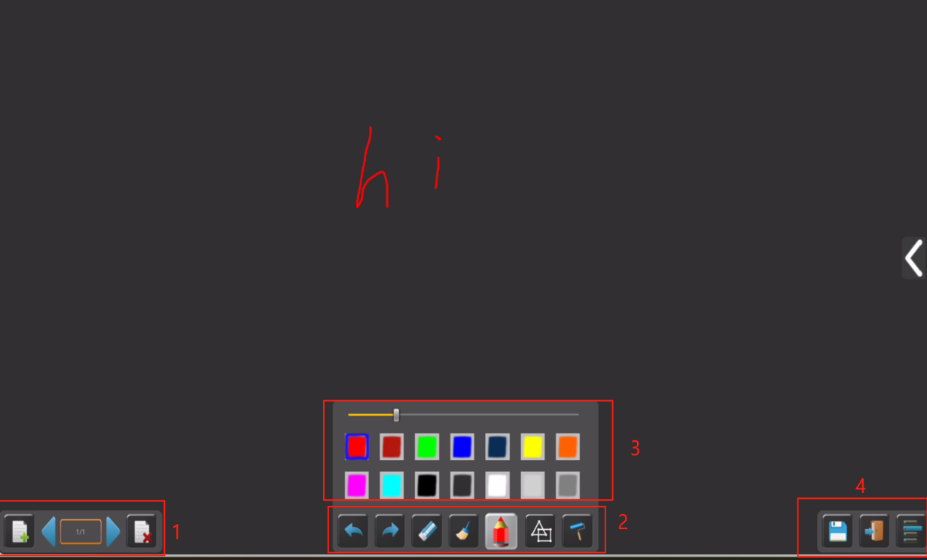
Use the toolbar to select one of the following functions:
ID | Icon | Function
Toolbar 1 | 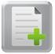 | Add a blank page
Toolbar 1 |  | Delete current page
Toolbar 1 |  | Display the previous or next page
Toolbar 2 |  | Undo: Change one step back
Toolbar 2 |  | Rework: A step forward in change
Toolbar 2 | 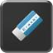 | Erasing part of a drawing or annotation
Toolbar 2 | 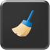 | Clear the entire drawing/text on the screen
Toolbar 2 | 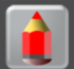 | Pens allow writing/drawing in different colors
Toolbar 2 | 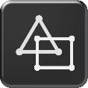 | Drawing basic geometric shapes
Toolbar 2 | 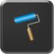 | Select the color of the artboard and the drawing will be kept
Toolbar 3 | 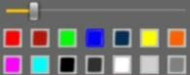 | A pop-up window will appear when "Pen" or "Draw Shape" or "Select Artboard Color" is selected to change the pen size, shape or color.
Toolbar 4 | 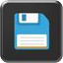 | Save the current screenshot to local storage (PNG+WMN).
Toolbar 4 | 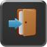 | Close the whiteboard and return to the main page.
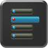  File Options | 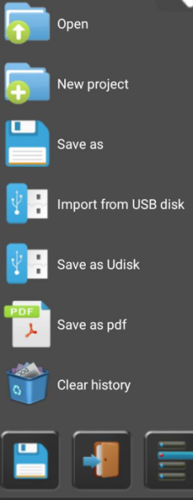 | - Open WMN files from local storage and continue/edit old projects  - Create new projects  - Save as WMN files to local storage and delete them after power failure  - Import projects (WMN) from a USB drive  - All pages are saved as PDF files to local storage  - Delete history - delete all whiteboard and annotation files on local storage

Annotations
Users are allowed to draw or write annotations on the content displayed by active sharing devices. It supports various graphics, colors, and backgrounds. To activate the annotation mode, click the annotation icon 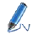in the sidebar menu.
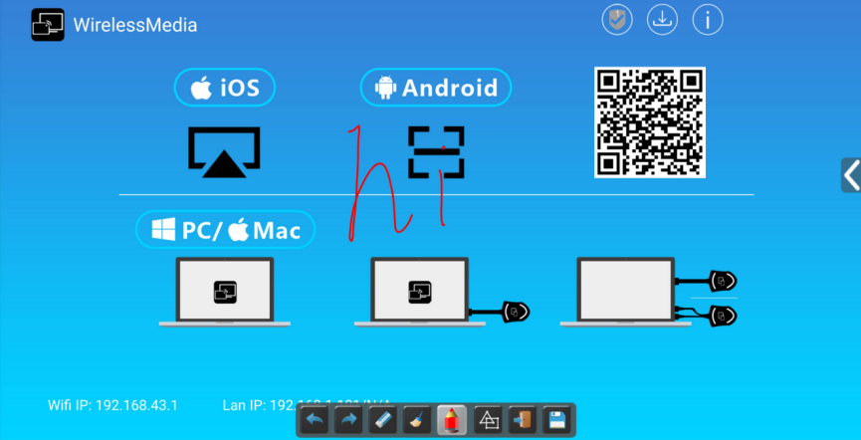

Use the toolbar to select one of the following functions:
ID | Icon | Function
Toolbar 1 |  | Undo: Revert the last change
Toolbar 1 |  | Redo: Reapply the last undone change
Toolbar 1 |  | Erase part of the drawing or annotation
Toolbar 1 |  | Clear all drawings/text on the screen
Toolbar 1 |  | Pen: Allows writing/drawing with different colors
Toolbar 1 |  | Draw basic geometric shapes
Toolbar 1 |  | Close the annotation function and return to the main page. Save the current document (WMN) to a local file.
Toolbar 1 |  | Save the current screenshot to local storage (PNG).

- Download drawings to connected users
When the whiteboard or annotation screen is saved to AVP-140V2 internal storage, users can download the saved file by scanning the QR code or entering the provided IP address in a browser.
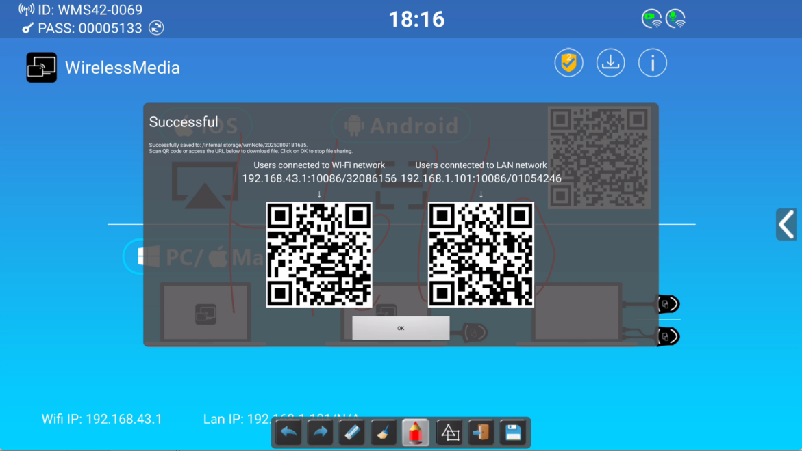
Data can be copied to the USB flash drive. After connecting to AVP-140V2, it can be imported into the whiteboard section via "Import from USB flash drive".

- WebGUI Setting Managemant & Configuration

To access AVP-140V2 WEB settings, enter the receiver’s IP address in an internet browser.
The first displayed page allows users to download the WirelessMedia application for all platforms.
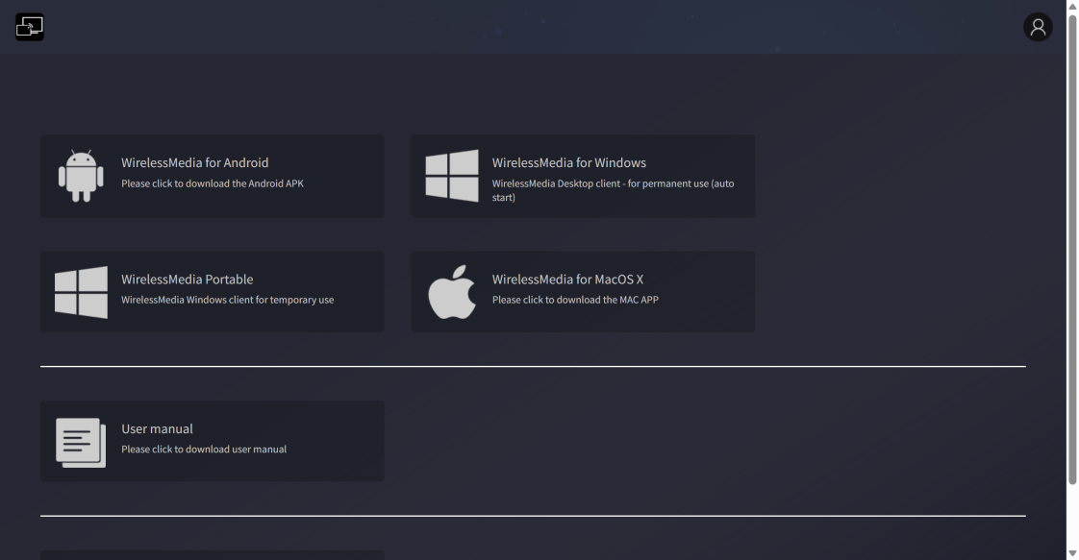
If AVP-140V2 is in "Wireless Direct Mode", first connect to the AVP-140V2 Lite SSID and enter the current password on the main screen. The IP address is 192.168.43.1. For detailed network configuration instructions, refer to the "Network Settings" chapter.

Click the icon in the upper right corner
The login page will appear, with the default password: admin
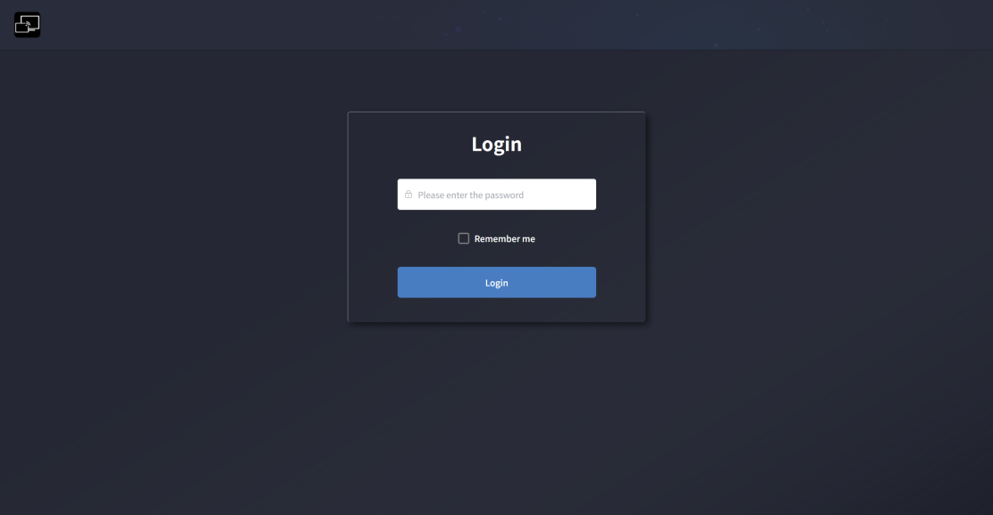

Entering login credentials grants access to the main WEB settings page.

Network Settings
To fully utilize AVP-140V2 features, configuring and integrating the receiver’s network settings according to application requirements is crucial. AVP-140V2 includes two independent wired LANs and one WiFi network card.
The following sections are accessible in the "Network Settings" page:

Network Wizard
This section guides users through setting up AVP-140V2’s dual-network operating mode.
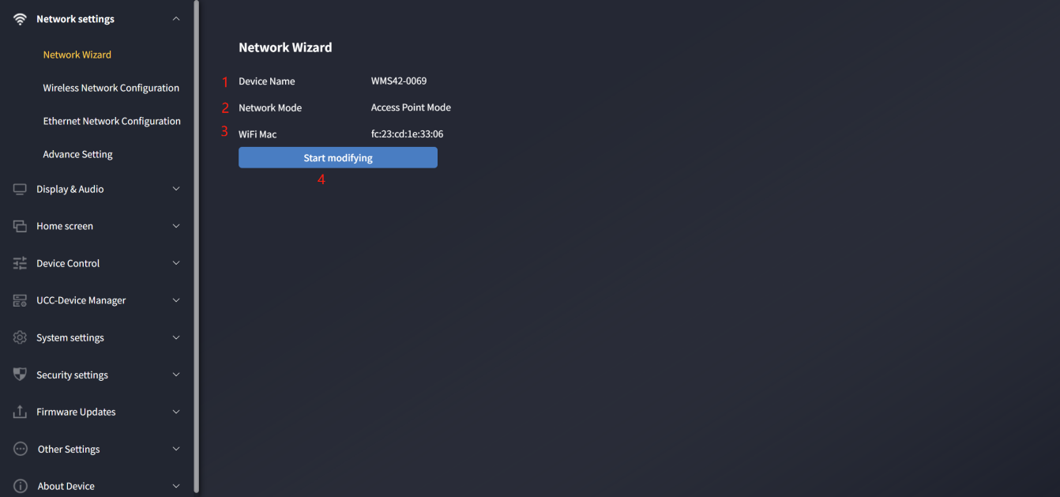
- Device Name: Indicates the current name assigned to AVP-140V2.
- Network Mode: Shows the currently configured network operating mode.
- WiFi Mac: Displays the MAC address assigned to AVP-140V2’s network card.
- Start Modification: Click to enter the network setup wizard, where you can change the network mode and properly configure AVP-140V2 into existing network infrastructure.
Any change to the network mode requires the dongle to re-pair with the AVP-140V2 receiver.

Network Mode Configuration
- Device Name: When the base unit is configured in Wireless Direct Mode, this name serves as the WiFi SSID; in Bridge Mode, it functions as the base unit name. Note that changing the device name may require re-pairing the dongle. Do not use special symbols such as: ;!@#$%^&*()
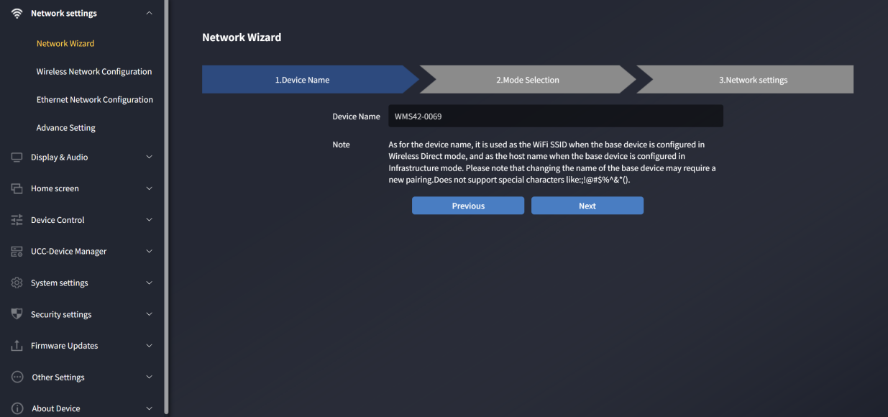

- Mode Selection: Choose the desired network mode and click "Next".
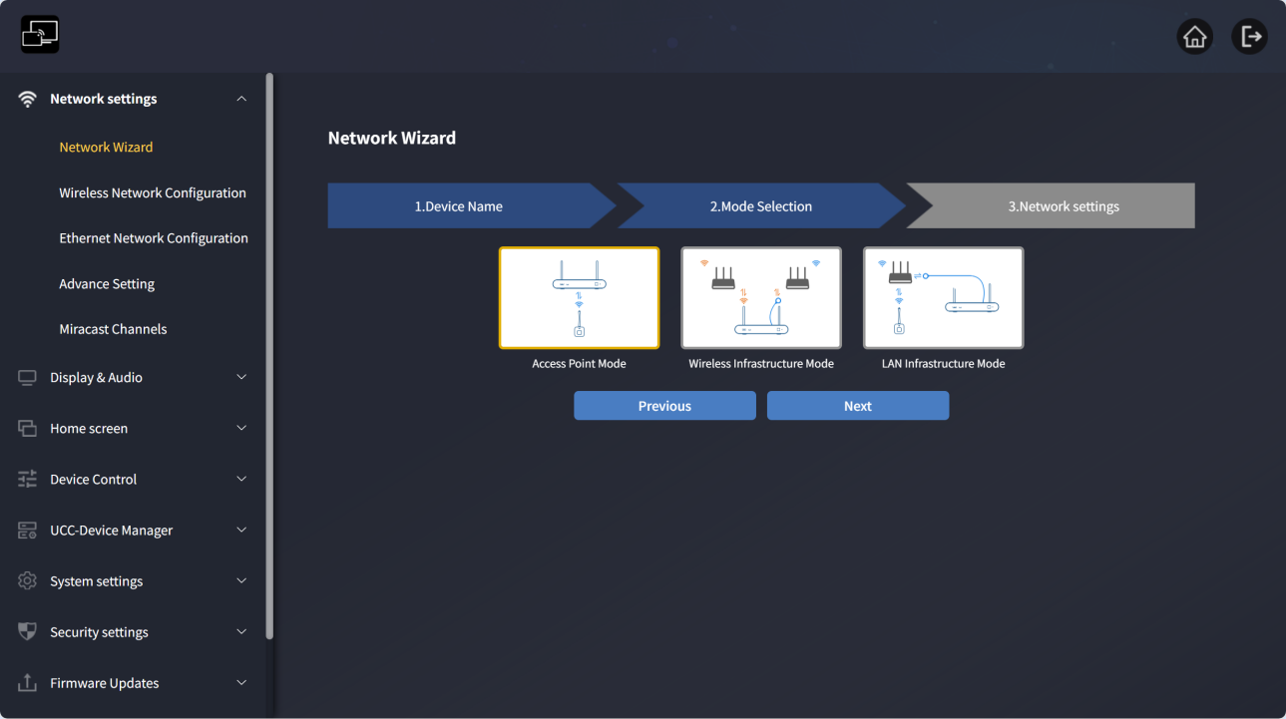

- Direct Mode
AVP-140V2 starts with the default independent "Wireless Direct Mode" after factory reset or first use. The receiver creates its own wireless access point, and all devices must connect to it to share content with the receiver. This option is ideal for temporary operations, small installations, rooms without network access, or networks where guest access is restricted due to strict security policies, being completely isolated from the corporate network.
In this mode, AVP-140V2 operates without additional wireless network configuration. Simply pair the dongle with the AVP-140V2 receiver, connect a computer to AVP-140V2’s internal hotspot and open the WirelessMedia app, or use native wireless protocols like Airplay, Miracast, or Chromecast.
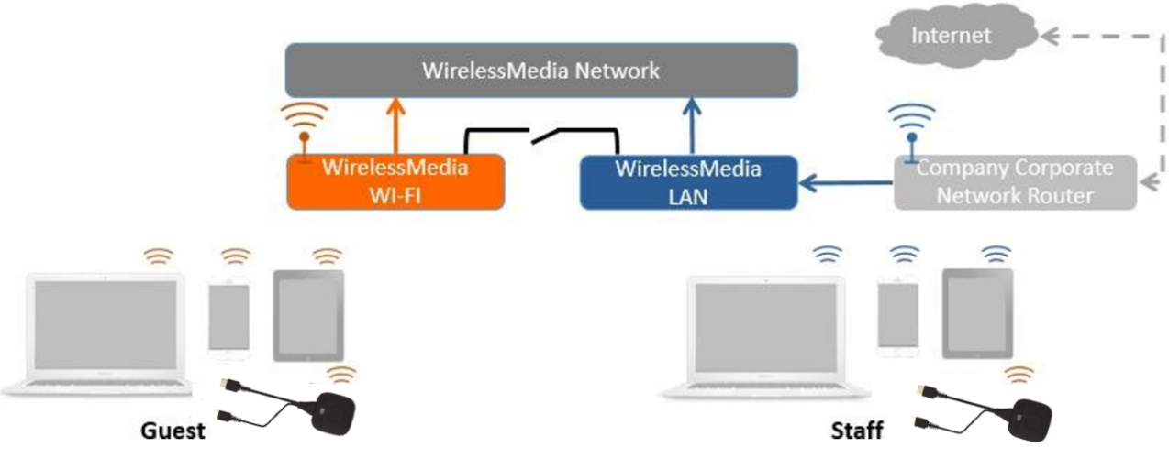

- Click "Next" to set up the WiFi access point.
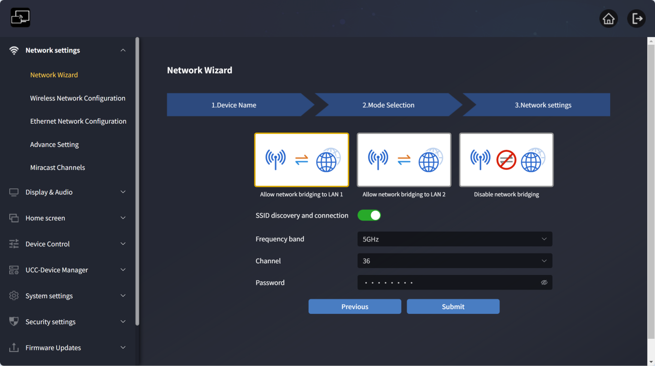

- Three ways to connect to the internet via AVP-140V2 in "Wireless Direct Mode":
a) Internet access via LAN 1 port: The hotspot can communicate with Ethernet port 1, allowing internet access through LAN1 when connected to the hotspot.
b) Internet access via LAN 2 port: The hotspot can communicate with Ethernet port 2, allowing internet access through LAN2 when connected to the hotspot.
c) Disable internet access: No internet access when connected to the hotspot (for security).
- Allow base unit SSID to be discovered and connected: Select "Yes" to make the AVP-140V2 SSID searchable; select "No" to hide it.
- Frequency Band: Click to select 2.4 GHz or 5 GHz WiFi. Default is 5 GHz.
- Channel: Click to select the WiFi channel. Default is 5 GHz, channel 36. Changing the WiFi channel does not require re-pairing the dongle.
o 2.4 GHz band: Channels 1, 2, 3, 4, 5, 6, 7, 8, 9, 10, 11
o 5 GHz band: Default is 5 GHz, channel 36
- Region-specific supported channels:
Europe: Only 36, 40, 44, 48
USA and China: 36, 40, 44, 48, 149, 153, 157, 161
Channel 36 is globally supported, so it is set as the default.
- Password: Click the input field to enter an 8-character password.
- Click "Submit Settings" to complete configuration. Then re-pair the wireless dongle
with AVP-140V2.
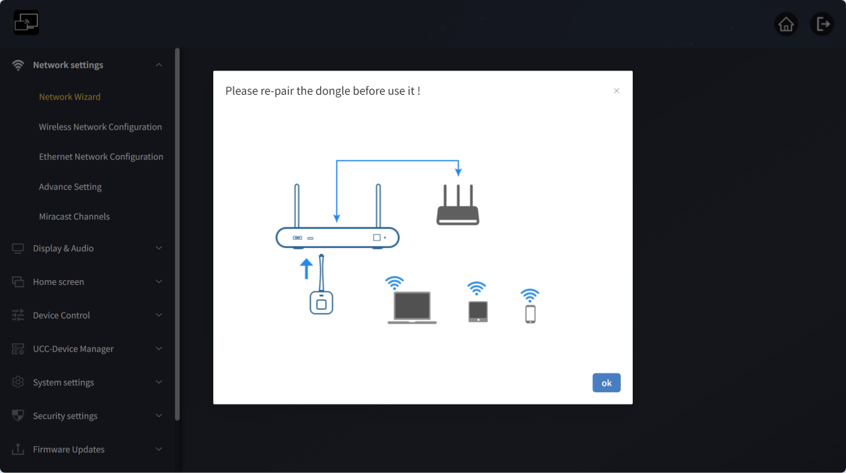

- Wireless Bridge Mode
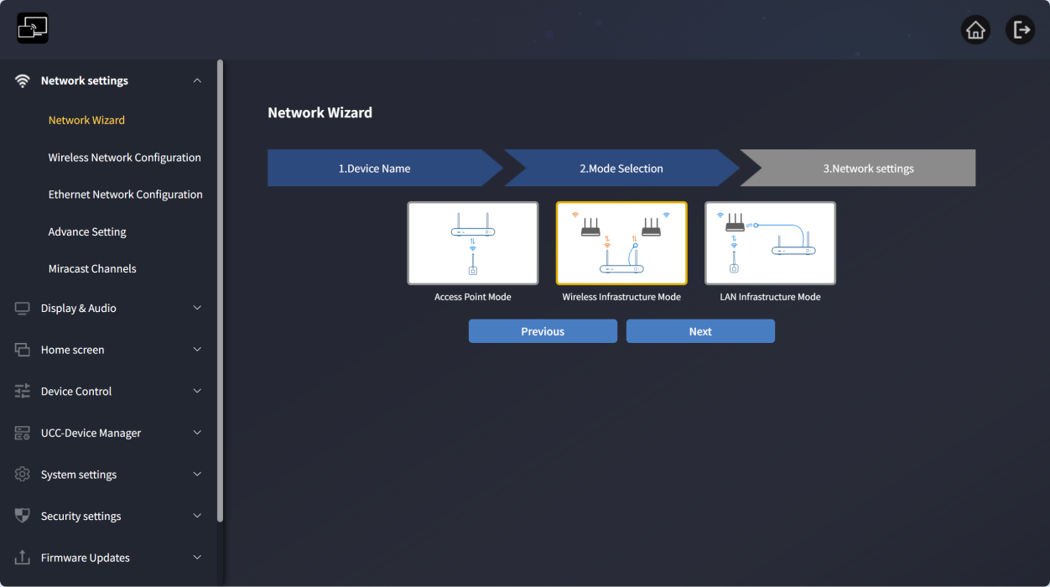

AVP-140V2 can connect to both wired and wireless networks simultaneously. The receiver is securely "connected to the corporate network" via LAN. Guest users connect to the Wi-Fi "guest network", while employees access the corporate network access point without switching Wi-Fi. A wireless "guest" network is provided for external visitors, and a wired "employee" network for staff. Guest users cannot access any resources on the corporate internal network.
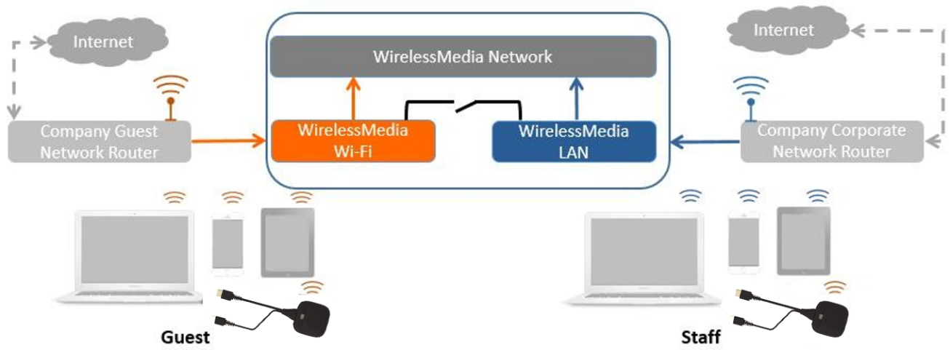

AVP-140V2’s wireless network connects to the guest’s Wi-Fi network (guest mode), with the indicator icon.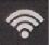

PC users can use the WirelessMedia PC program (Windows or MacOS) with or without a dongle.

Android users can share content by installing the APK, and iOS users can use AirPlay (Apple only).

Click "Next" to configure this network mode:
- Dongle and base unit connected via wireless network
Select a wireless network separate from the corporate network for guests.
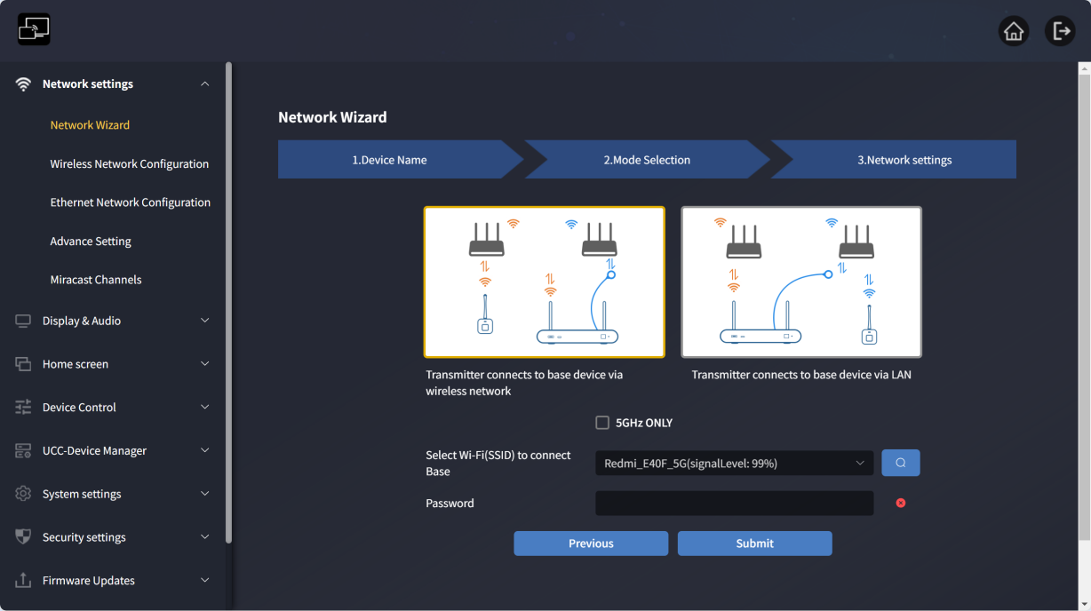
Only 5G channels: Check to search only 5G networks, uncheck to search all.
- Select a router for the base unit to connect: Choose a guest network to access the receiver.
- Password: Enter the connection password.

Click "Submit Settings" to complete configuration. Then re-pair the wireless dongle with AVP-140V2.
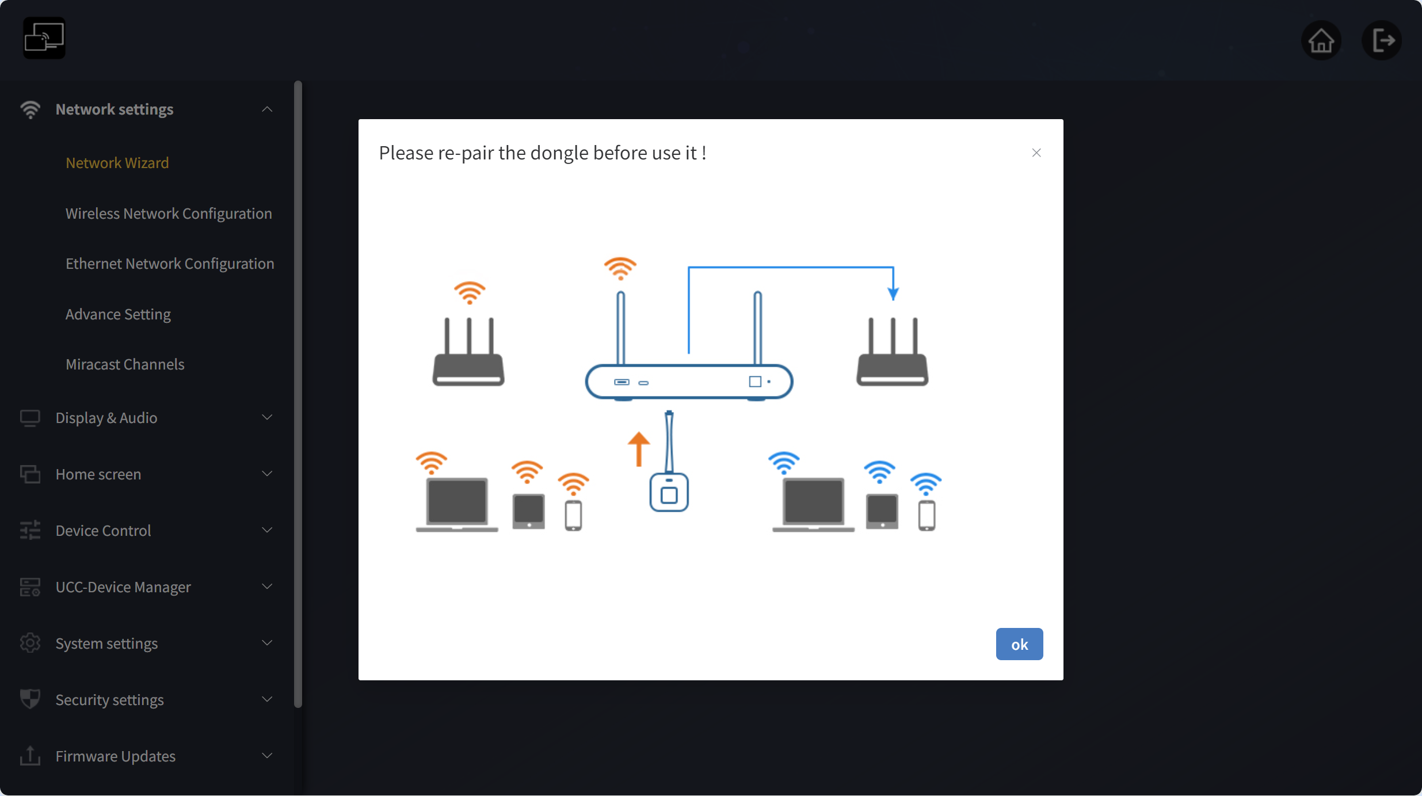

  - Dongle and base unit connected via wired network:
Select a wireless network for guests and a wired network for company employees.
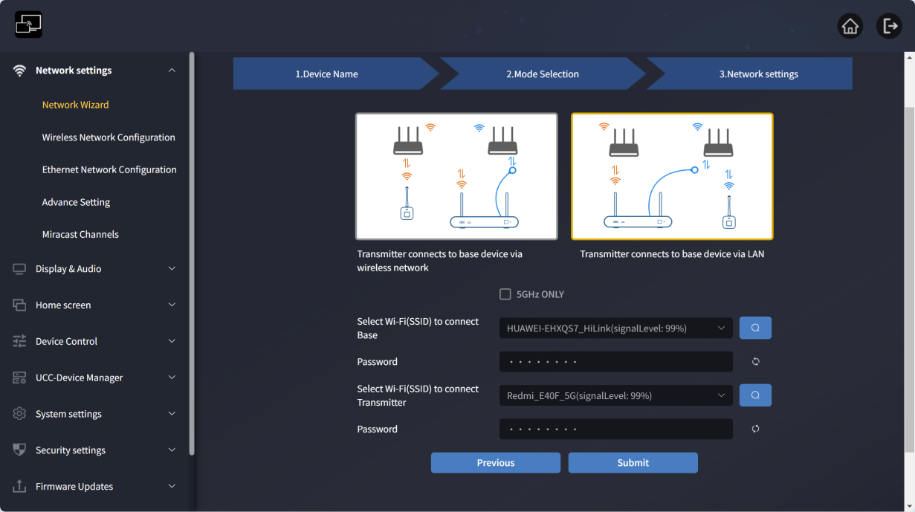
Only 5G channels: Check to search only 5G network, uncheck to search all.
- Select a router for the base unit to connect: Choose a guest wireless network to connect to the AVP-140V2 receiver.
- Password: Enter the connection password.
- Select a router for the dongle to connect: Choose the corporate wired network connected to AVP-140V2, and pair the dongle with the receiver (Note: The selected network must match the wired network connected to the LAN port; otherwise, the paired dongle will not work).
- Password: Enter the LAN password.

Note: Typically in this mode, the dongle is paired to a dedicated employee network within the corporate network for enhanced security.

  - Click "Submit Settings" to complete configuration. Then re-pair the wireless dongle with AVP-140V2.
- Wired Bridge Mode
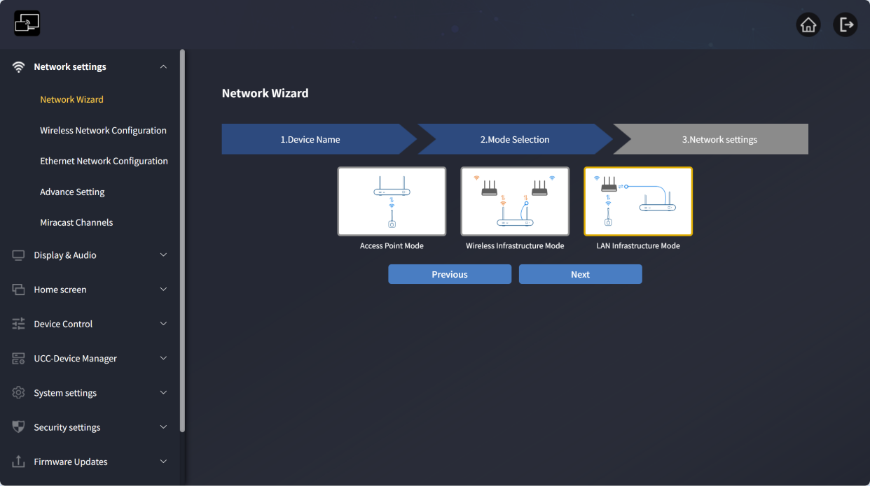
In this configuration, AVP-140V2’s built-in WiFi access point is disabled.

Dongle and mobile devices can connect to the corporate network. The AVP-140V2 receiver connects to the company’s wired network via an Ethernet cable.
This mode is mainly used when the guest network is disabled, and only the employee network is in use.
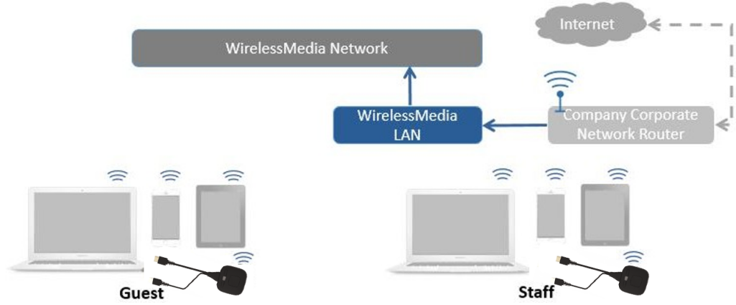
- Click "Next", select the LAN network for company employees, and re-pair the wireless dongle to this network.
Select a router for the base unit to connect: Choose the wired network used by employees (matching the wired network connected to the LAN port).
Password: Enter the connection password.
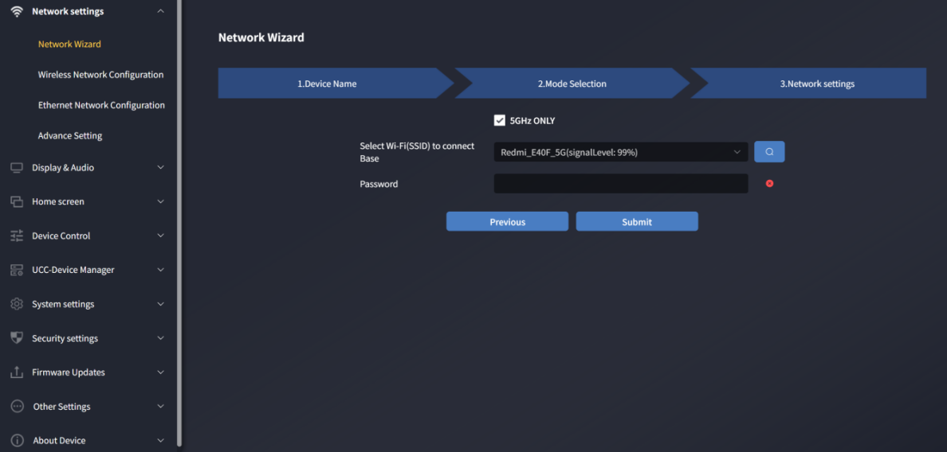

- After successful submission, re-pair the wireless dongle with AVP-140V2.

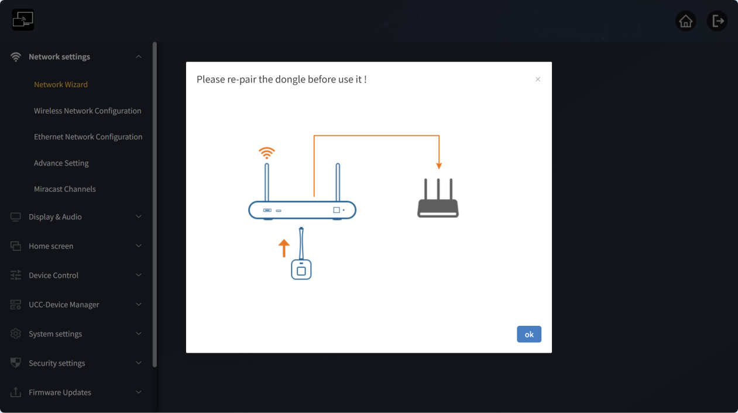

Wireless Network Configuration
For detailed configuration of the three modes on this page, refer to the "Network Wizard" section above.
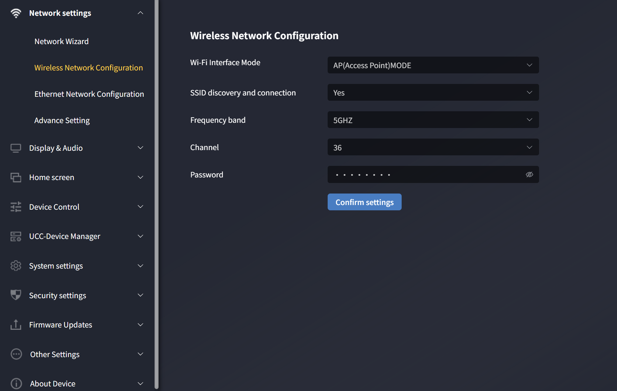
Wireless operating modes: Hotspot Mode, Station Mode, Off.
You can directly set the network mode here as: Wireless Direct, Wireless Networking, or Wired Networking.
The network mode set in the Network Wizard page will sync to this page, and vice versa.

Hotspot Mode
This page displays Hotspot Mode when the network mode is set to Wireless Direct.
In Hotspot Mode, you can directly configure settings for Wireless Direct Mode.

Station Mode
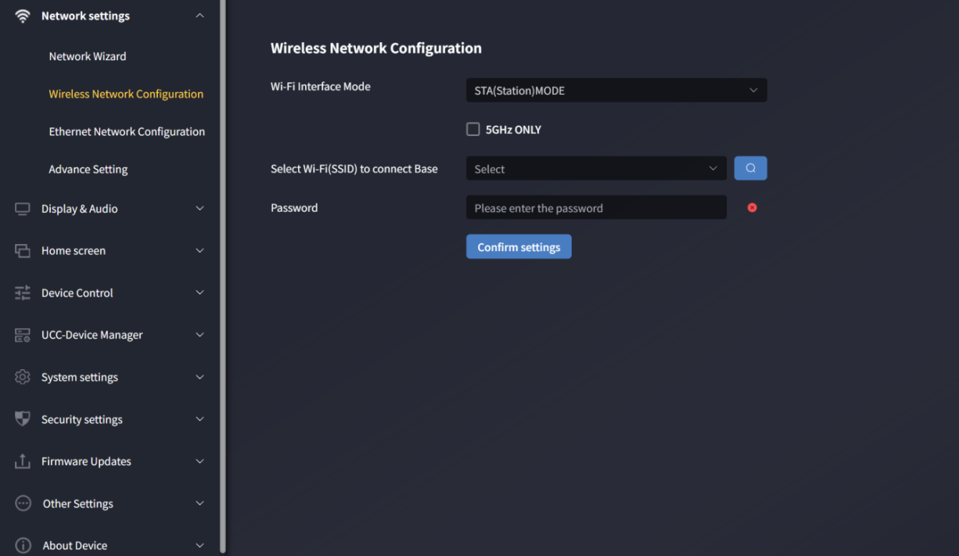
This page displays Station Mode when the network mode is set to Wireless Bridge.
You can directly configure the network connected in Wireless Bridge Mode here.

Off
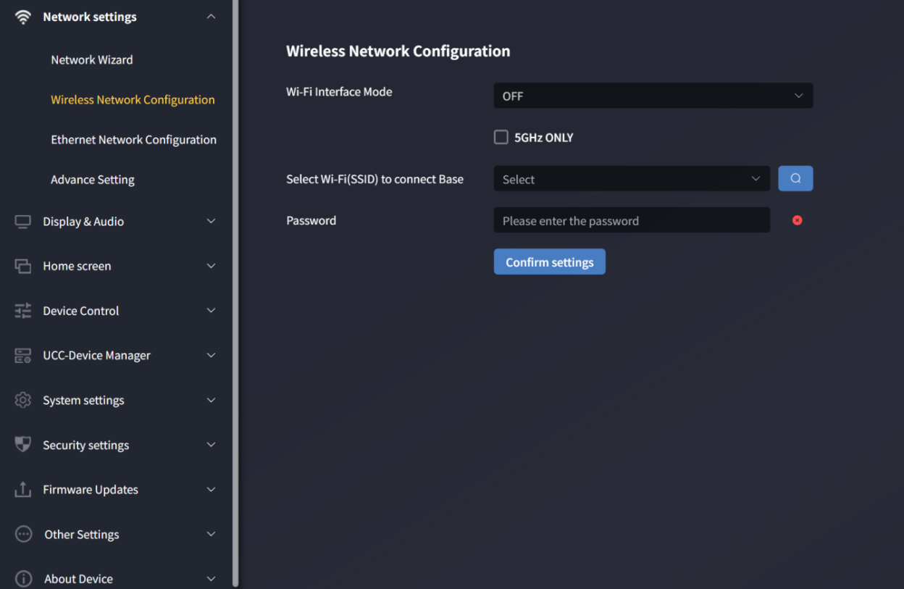
This page displays "Off" When the network mode is set to Wired Bridge.
You can directly configure the wired network connected in Wired Bridge Mode here.

Wired Network Configuration (Allows configuration of wired LAN 1 and LAN 2 settings)
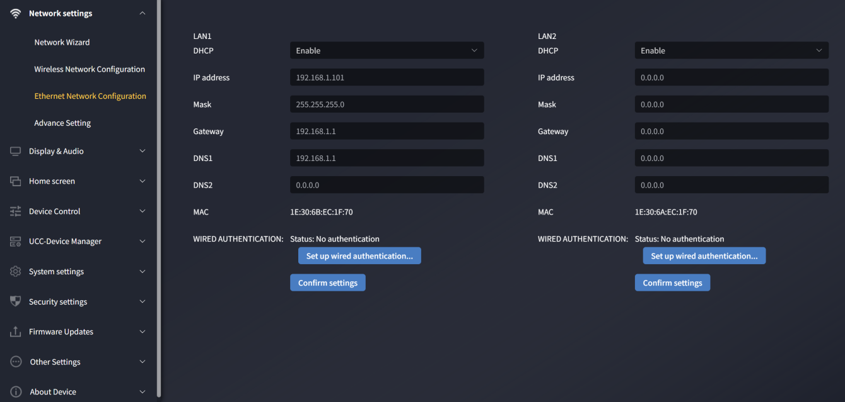
- DHCP: If a DHCP server exists on the network, this enables automatic IP address assignment. To configure a static IP, disable this first.
- Subnet Mask: Allows entry of the required network mask.
- Gateway: Allows entry of the required IP gateway.
- DNS1-2: Allows entry of required DNS servers.
- Wired Authentication Status: Configures wired authentication (None, EAP-TLS, EAP-TTLS, PEAP).

Advanced Settings

Internet Access Settings
In Wireless Direct Mode, you can directly change AVP-140V2’s internet connection methods here:
- Allow base unit internet access via LAN 1 port
- Allow base unit internet access via LAN 2 port
- Disable internet access
For detailed configuration and functions, refer to the Wireless Direct Mode settings in the "Network Wizard" section.
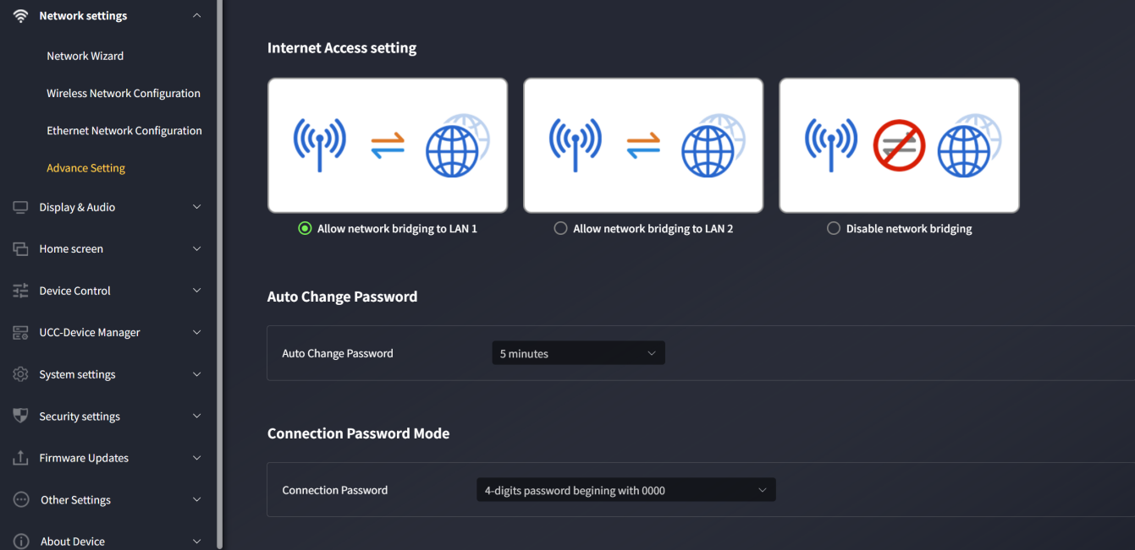

Auto-change Password
The password for all meeting participants remains unchanged while at least one wireless dongle or mobile device is connected to the AVP-140V2 receiver. A configurable timeout starts after the user disconnects. If the password is changed, users do not need to re-pair the dongle.
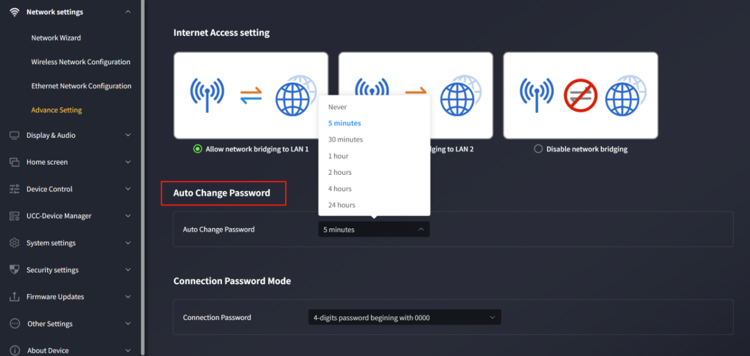
- Configure to automatically change the WiFi password to a random number at regular intervals.
- Click to set the configuration:
Never: Never change the WiFi password (even after power-off).
- 5 minutes: Change the WiFi password every 5 minutes.
- 30 minutes: Change the WiFi password every 30 minutes.
- 1 hour: Change the WiFi password every 1 hour.
- 2 hours: Change the WiFi password every 2 hours.
- 4 hours: Change the WiFi password every 4 hours.
- 24 hours: Change the WiFi password every 24 hours.

Connection Password Mode
Two password formats can be displayed on the main screen:
- 4-digit password, starting with 0000
- 8-digit password
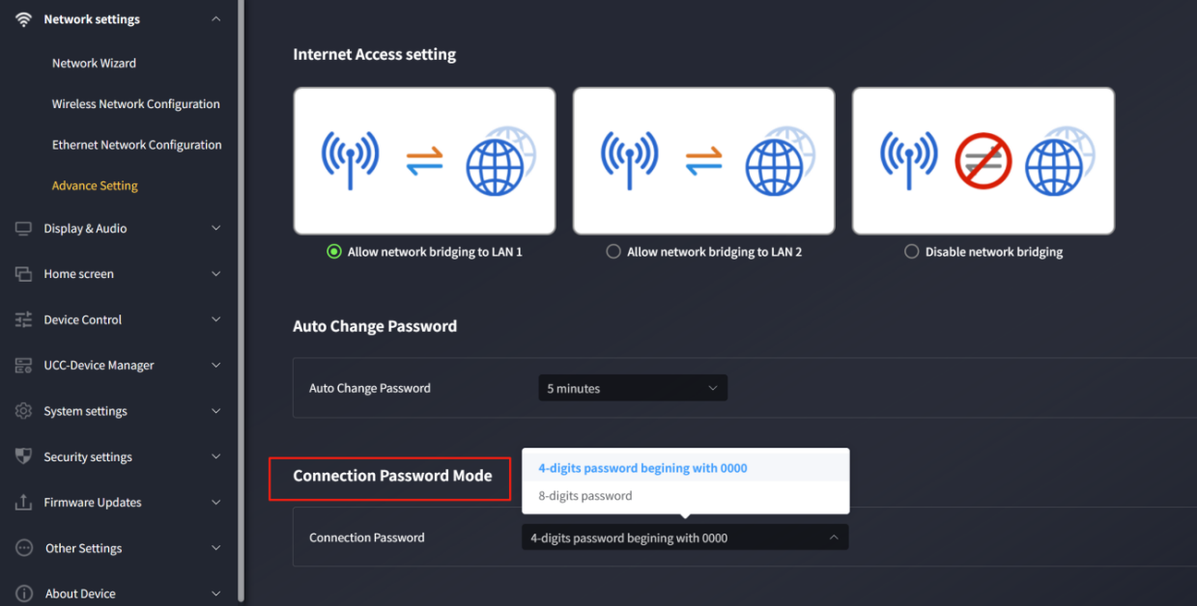

Display and Sound

HDMI

HDMI Resolution Setting
- Select the HDMI output resolution of the receiver.
- Auto
- 3840x2160@30
- 4096x2160@60
- 4096x2160@50
- 4096x2160@30
- 4096x2160@25
- 4096x2160@24
- 3840x2160@60
- 3840x2160@50
- 3840x2160@30
- 1920x1080@60
- 1920x1080@50
- 1920x1080@30
- 1280x720@60
- 1280x720@50

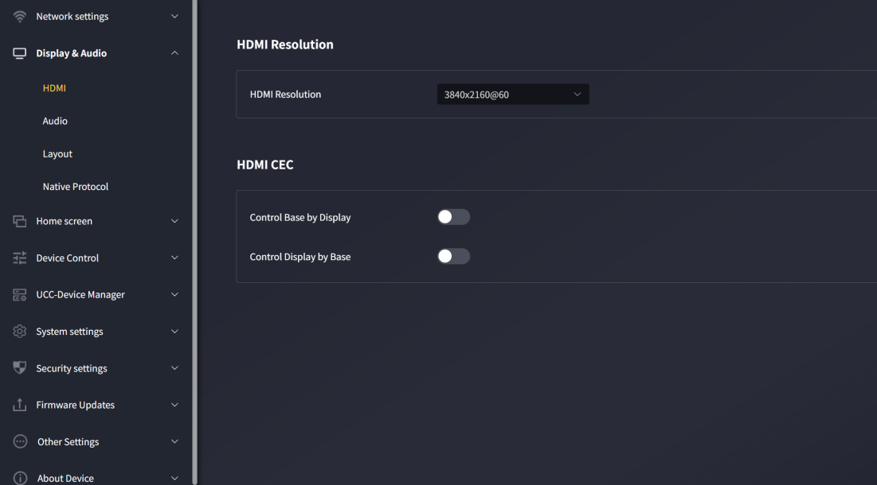

If the display only supports Full HD, 4K resolutions will not appear in the list.

HDMI CEC
If the connected display supports CEC, AVP-140V2 supports CEC functionality.
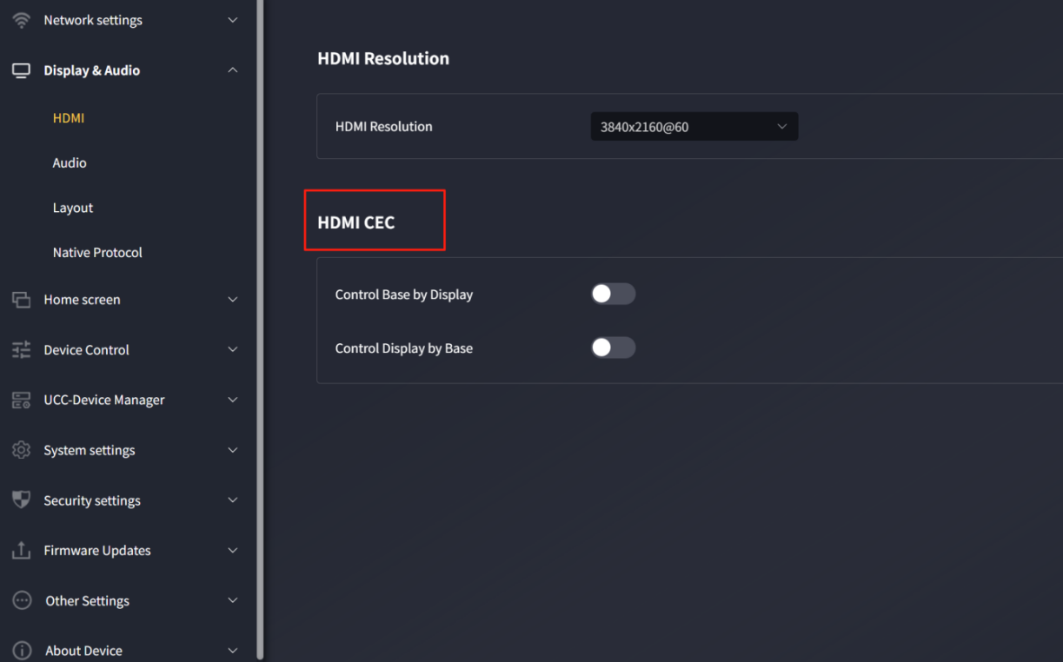
- Allow display to control the base unit
With this option, you can choose whether the connected AVP-140V2 base unit automatically enters standby mode immediately after the display is turned off.
o On: Once the display is turned off, the AVP-140V2 base unit also turns off automatically.
o Off (default): The display is turned off, but AVP-140V2 does not turn off automatically.
- Allow base unit to control the display
With this option, you can choose whether the connected display automatically enters standby mode immediately after the AVP-140V2 base unit is turned off.
o On: Once AVP-140V2 is turned off, the connected display also turns off automatically.
o Off (default): When AVP-140V2 is turned off, the display does not turn off automatically.

Sound
Allows users to select the audio output source.
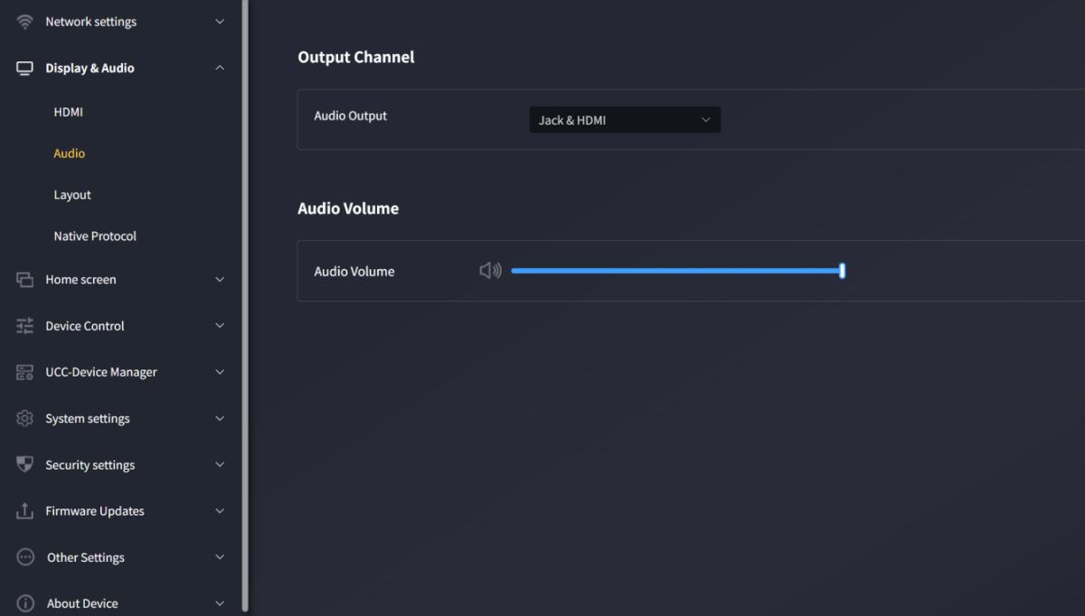
- Audio Output:
- Jack: Outputs only 3.5mm mini-jack audio.
- HDMI: Outputs only HDMI audio.
- Jack&HDMI (default): Outputs both jack and HDMI audio.

- Sound Volume: Adjustable from 0~100, default is 100.

Layout Setting
Allows various fixed window layout presets to display participants on the main screen. A maximum of 4 screens can be displayed simultaneously.
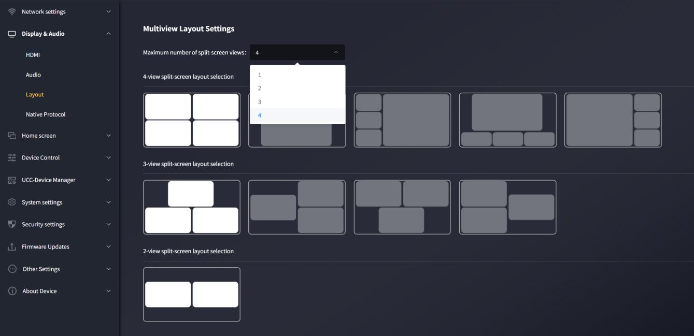
Maximum number of allowed screens: 1, 2, 3, 4
You can manually select the number of allowed casting screens. For example, selecting 4 allows up to 4 screens with a 4-split layout; selecting 3 allows up to 3 screens, and so on for 1 or 2.
Example: Selecting a maximum of 1 screen:
You can check "Automatically switch to HDMI source if HDMI source is active".
Checked: When the HDMI source is active and no casting source is available, it automatically switches to the HDMI source.
Unchecked: Returns to the homepage when no casting source is available.
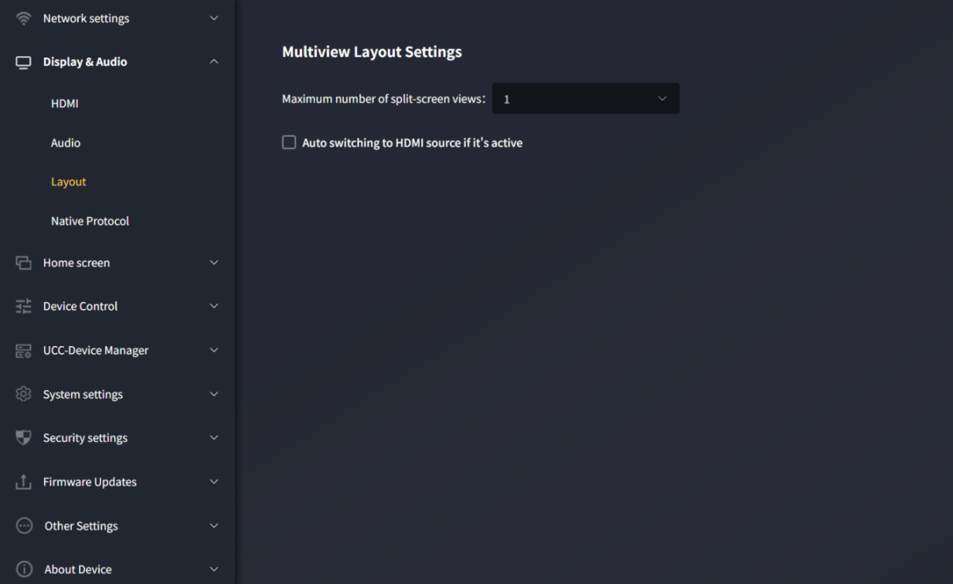

Native Protocol Support
Enabling/disabling third-party protocol casting adjusts the security level to custom.
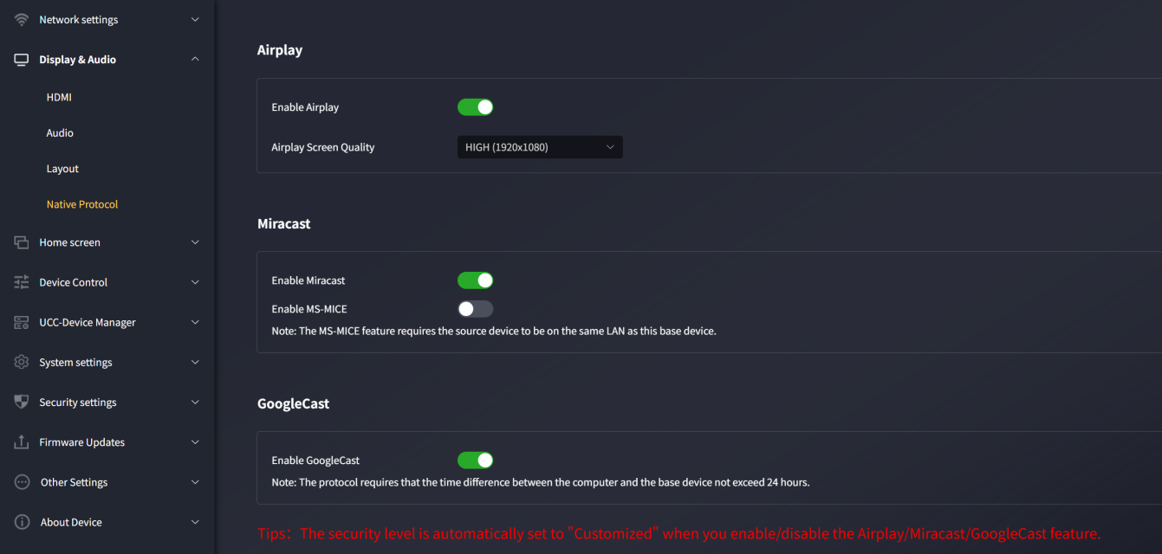

Airplay
Enable the Airplay switch to allow Airplay casting from Macbook, iPhone, and iPad. If the switch is turned off, AirPlay projection cannot be performed.
Airplay switch: Enabled by default
Airplay casting resolution:
High (1920*1080)
Medium (1600*900)
Low (1280*720)
4k (3840*2160)
Note: Higher resolution means better clarity but also greater latency.

Miracast
Miracast switch: Enabled by default
Miracast uses the P2P protocol by default, supporting a maximum resolution of 1080p. In this mode, the computer and receiver do not need to be on the same network. Simply press Windows+K to activate Miracast, find the AVP-140V2 device in the search results, and click to connect to start casting.
Miracast MICE protocol switch: Disabled by default
MS-MICE is an extension of the P2P protocol. Activating this protocol requires the PC and AVP-140V2 to be on the same LAN. Device search still uses P2P, but video streaming uses the LAN. Operation is identical to when MS-MICE is disabled.
Note: MS-MICE requires the source device and this device to be on the same LAN.

Google Cast
Google Cast switch: Enabled by default
Note: This protocol requires the time difference between the computer and host to be within 24 hours.

Wallpaper

Custom wallpaper
Allows customization of the main screen background. Click "+" to add a local image as the background.
Note: Currently supported image formats are: JPG/BMP/PNG. The maximum resolution is 3840*2160, and the file size must be within 4MB.
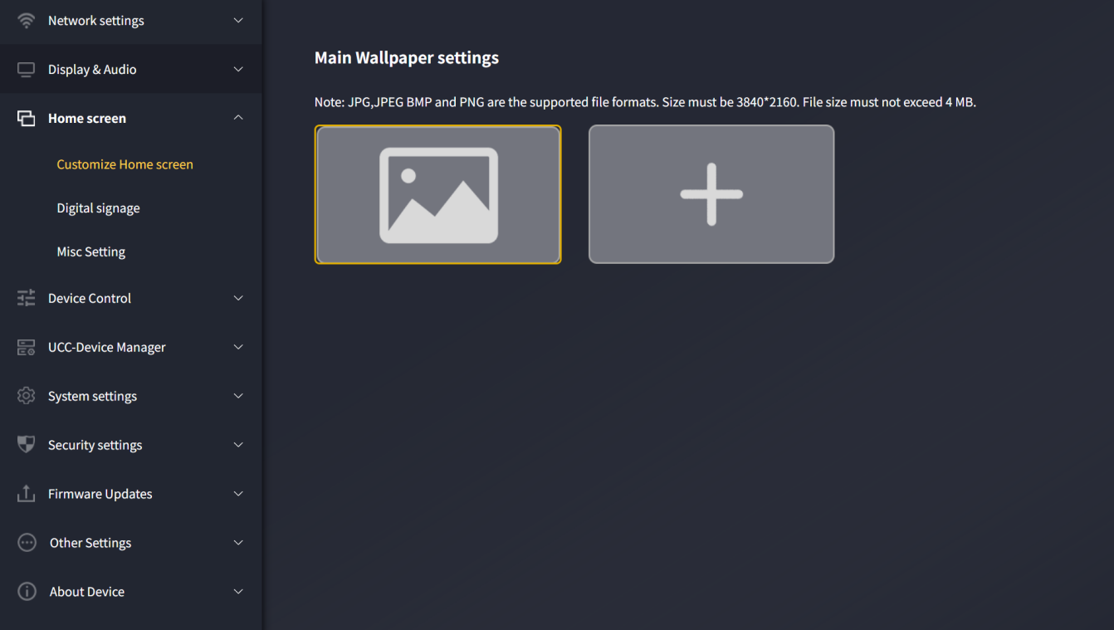

Digital Signage
This function displays desired web content when the device is in sleep mode.
Note: The digital signage function activates when preparing for "auto-standby".
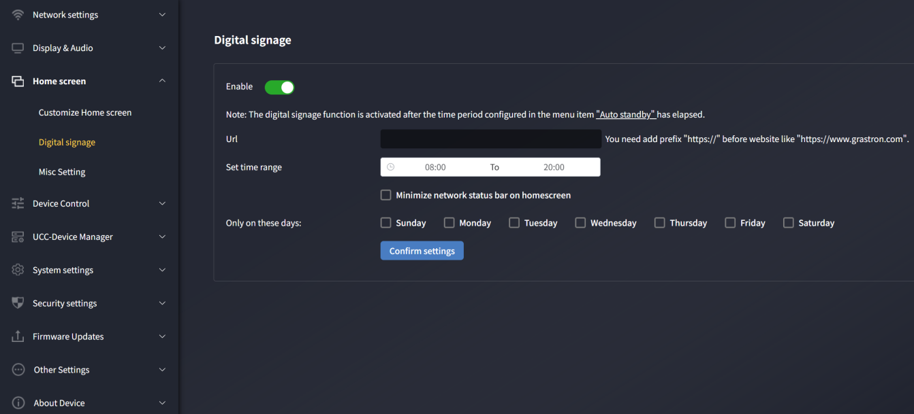
Switch: Disabled by default.
URL: Enter the desired URL.
Set time range: Define the period during which the display shows content from the set URL while in sleep mode.
Activate only on these days: Customize the days (Monday to Sunday) for display.
You can click "Auto-standby" in the prompt on this page to jump to the auto-sleep settings.
If the current time is within the set period, pressing the power button on AVP-140V2 enters the digital signage page; pressing it again exits to the main page.

Additional Settings
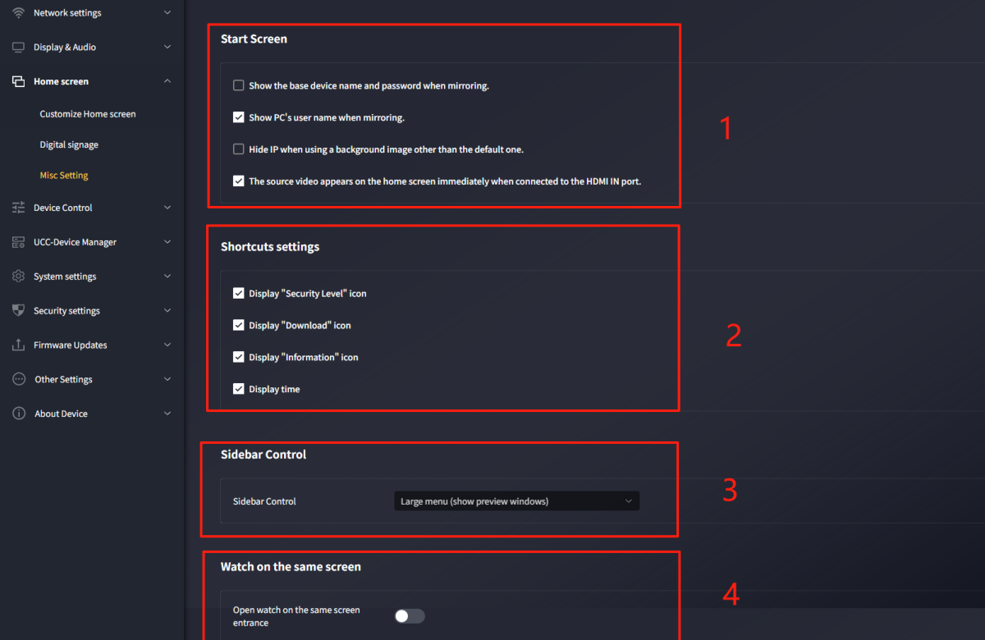

- Startup Screen:
- Show device name and password while sharing the screen: When checked, AVP-140V2’s device ID and password remain visible during casting.
- Show computer username during casting: When checked, the PC username appears during casting.
- Hide IP when using non-default background: When checked, the IP address is hidden during casting.
- Auto-cast when HDMI source is inserted: When checked, inserting an HDMI source into AVP-140V2’s HDMI IN port triggers automatic casting.

- Shortcut Settings:
- Show "Security Level" icon: When checked, the security level icon appears on the main screen; otherwise, it is hidden.
- Show "Download" icon: When checked, the download icon appears on the main screen; otherwise, it is hidden.
- Show "Info" icon: When checked, the info icon appears on the main screen; otherwise, it is hidden.
- Show "Time": When checked, time information appears on the main screen; otherwise, it is hidden.
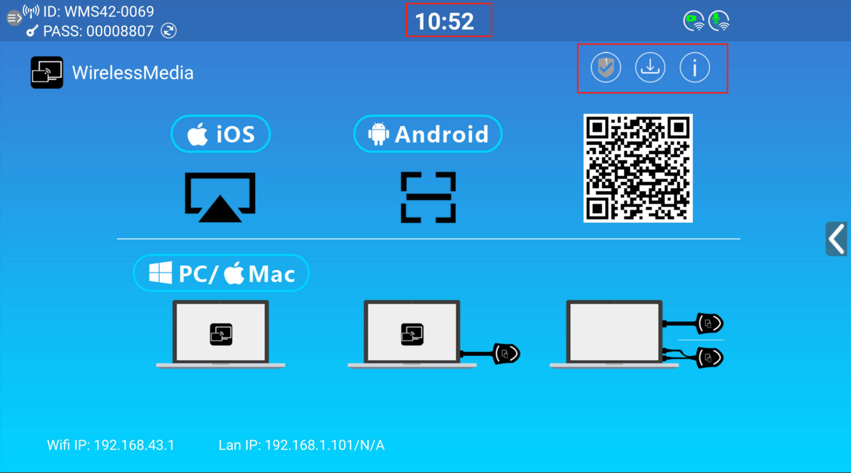
- Sidebar Control:
- Fully hide sidebar (including arrow): The main screen shows no sidebar.
- Small menu (no preview window): The sidebar displays as a small menu (including whiteboard, annotation, and info icons).
- Large menu (with preview window): The sidebar displays as a large menu, showing a casting preview window.

- Screen Sharing View:
- Enable screen sharing entry: Disabled by default.
- When enabled, a "Screen Sharing" option appears on the web page, which captures on-screen content into a window for remote sharing.
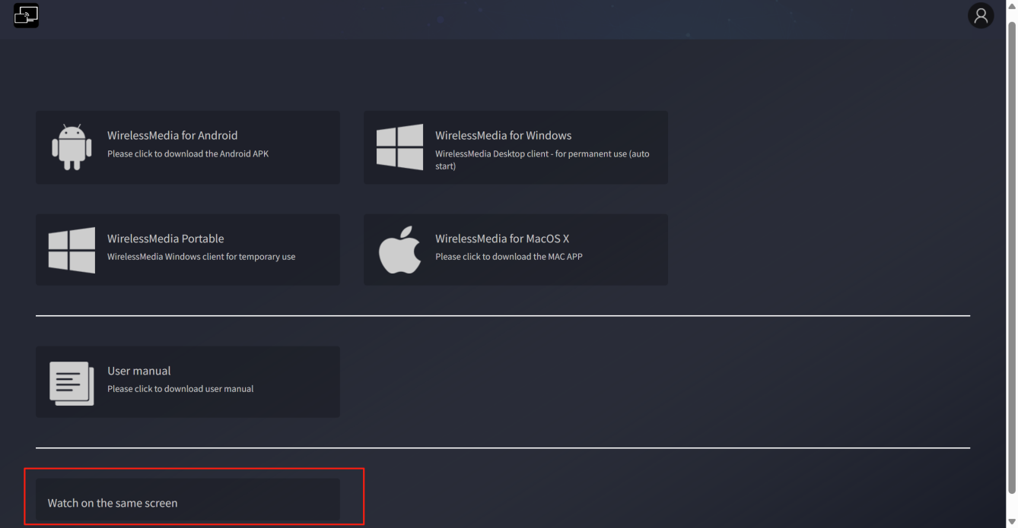

Device Control

Remote Login (Telnet) and Serial Port
This allows configuration of Telnet and RS-232 commands to control AVP-140V2.
Contact the supplier for the command list. Additionally, RS232 supports simple commands (e.g., power on/off, cascaded device control) for basic central control.
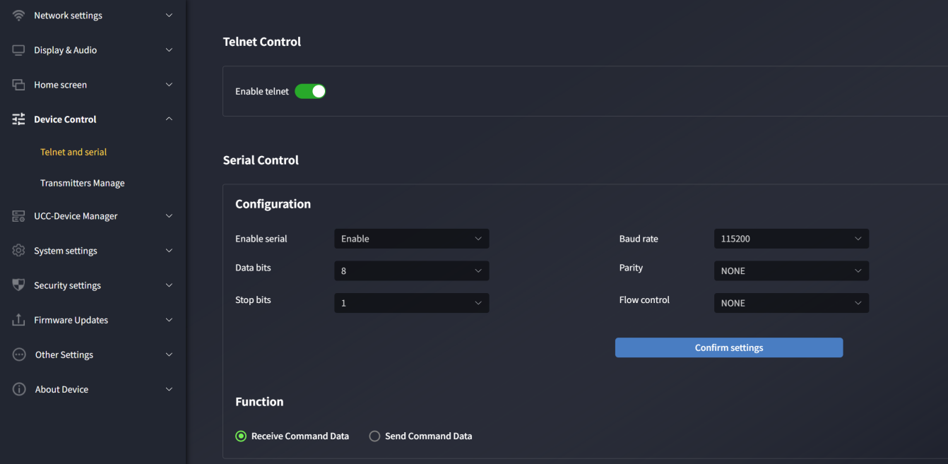

Remote Login (Telnet) Control
Allow remote login (Telnet): Enabled by default. This switch must be on for Telnet commands to control the device.
Disabling the switch blocks Telnet control of AVP-140V2.
- For Telnet communication via TCP commands, enter the current AVP-140V2 base unit’s IP address and port: 23.
- For multi-word commands, separate words with spaces.
- Commands are case-insensitive.

Serial Port Settings
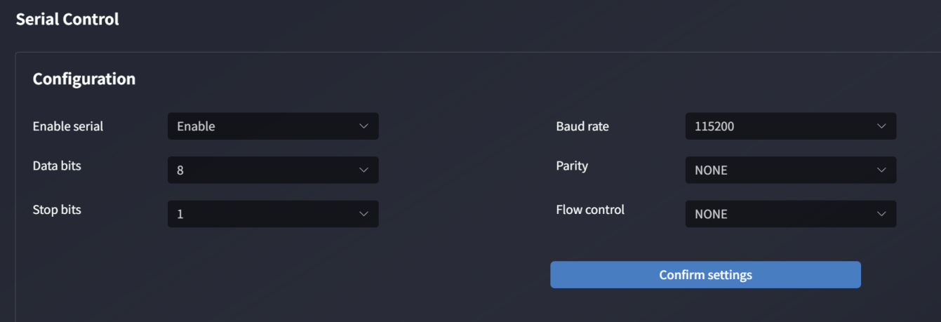
Serial port function: Enabled by default. Disabling it blocks RS-232 control of AVP-140V2.
Configure baud rate, data bits, parity, stop bits, and flow control as needed. For RS-232 communication, enter your chosen parameters on the serial port settings screen.

Serial port mode
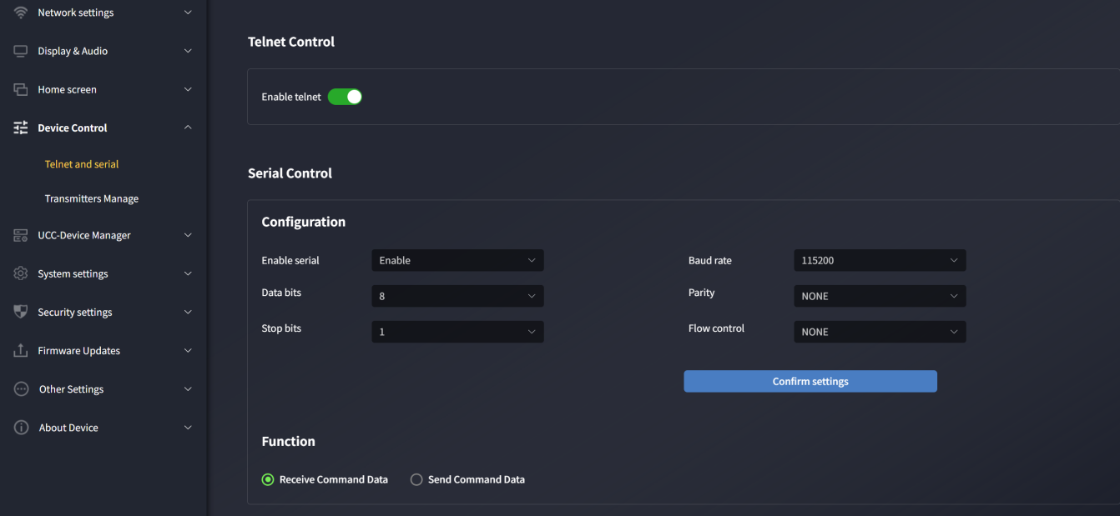
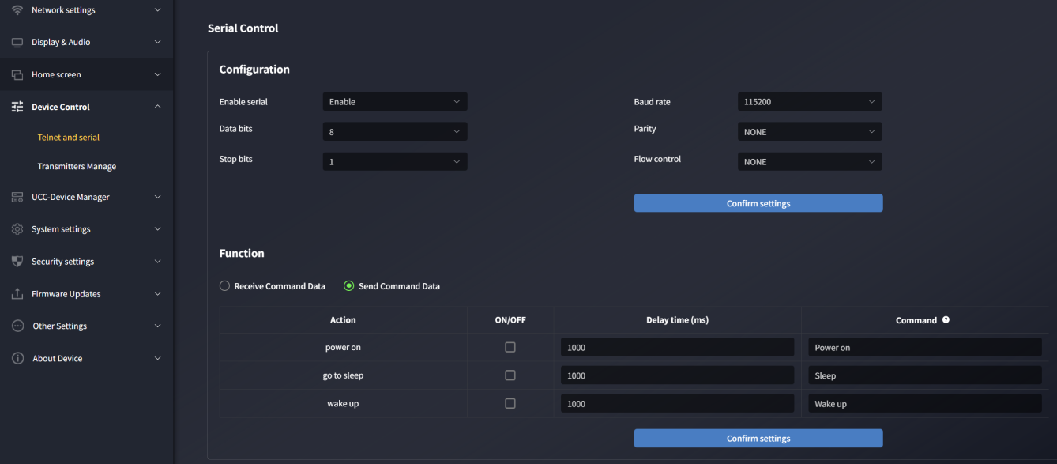

Dongle Management
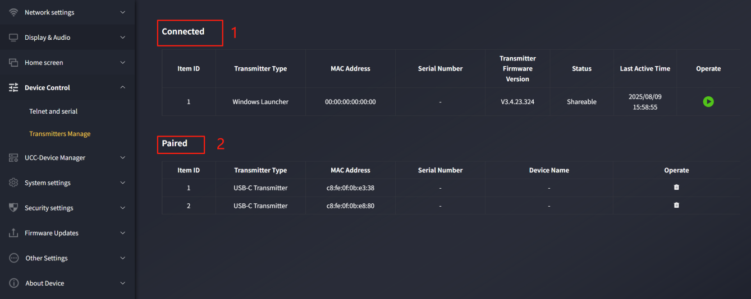
- Currently connected dongle: Displays devices connected to AVP-140V2, including details like serial number, firmware version, status, last operation time, and controls (cast/stop casting).
- Paired dongle: Displays devices successfully paired with AVP-140V2, including details like MAC address, serial number, device name, and controls (delete connected devices).

Near-Field Discovery Settings
Near-field device discovery: Enabled by default.
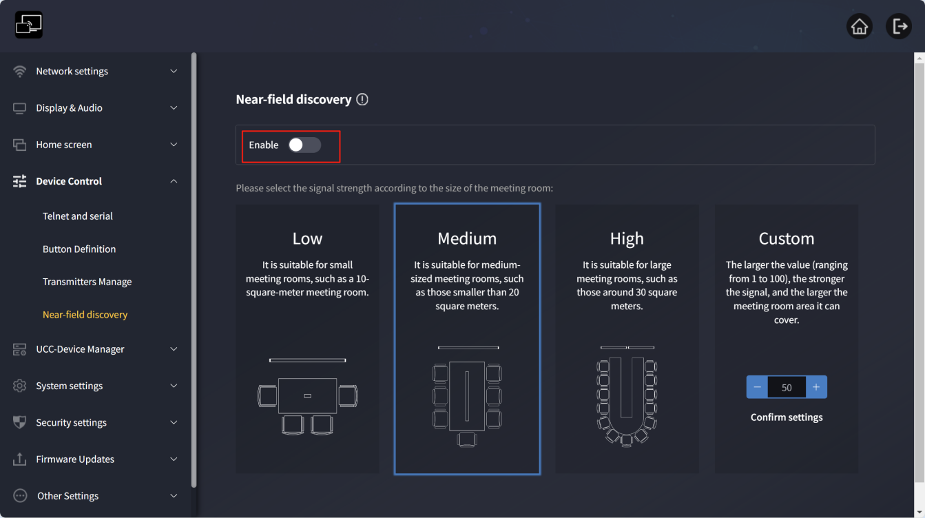
When enabled, nearby base units are discovered via Bluetooth and ultrasound for one-click casting and meetings.
The web page offers 4 signal strength options: Low, Medium, High, Custom.
Different values correspond to different ranges:
- Low: Suitable for small meeting rooms (e.g., 10 m²).
- Medium: Suitable for medium meeting rooms (e.g., 20 m²).
- High: Suitable for large meeting rooms (e.g., 30 m²).
Custom: Adjust values (1-100) as needed; higher values mean stronger signals and larger coverage.

Note: If meeting room interference is severe, try a higher power level.

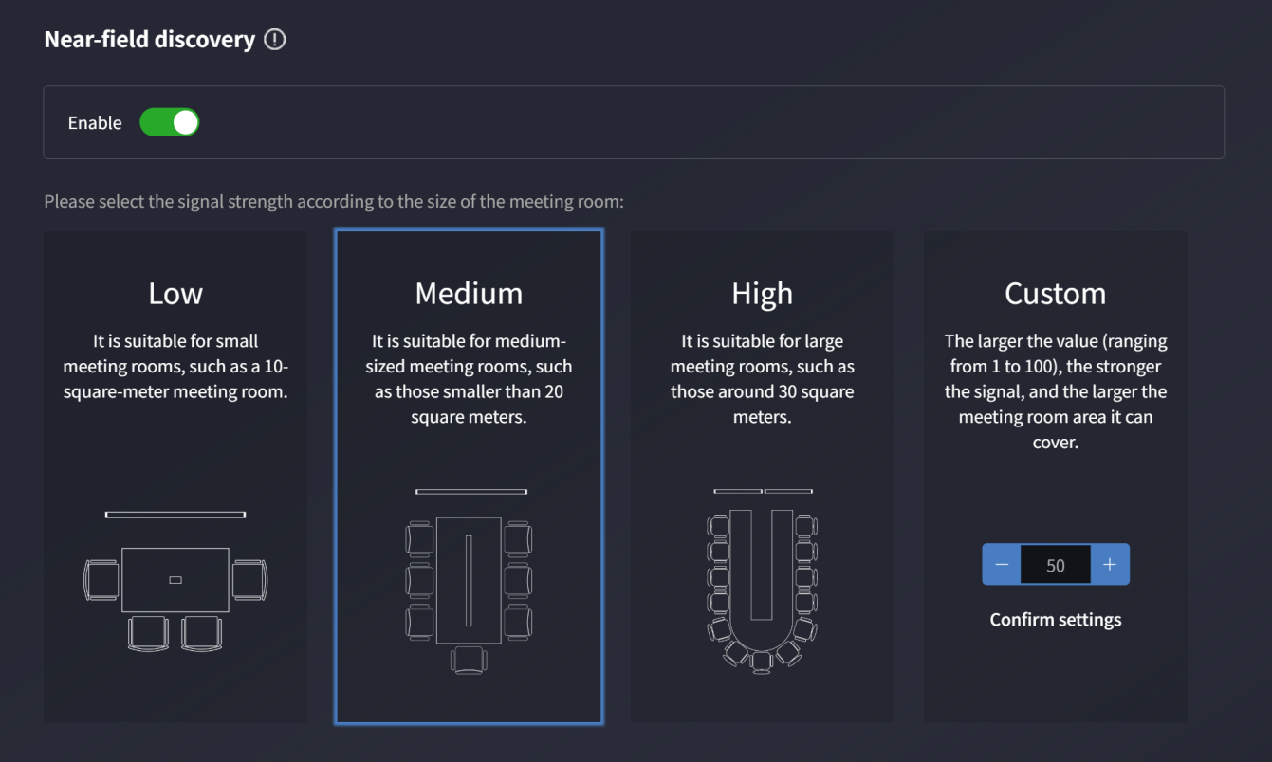

System Settings

Date & Time
      - Date & Time
Use 24-hour format: When checked, time displays in 24-hour format; otherwise, 12-hour format is used.
Time server address: 2.android.pool.ntp.org
Set date & time:
- Use network time: Check to sync time with the NTP server.
- Off: Disable network time to set date and time manually.
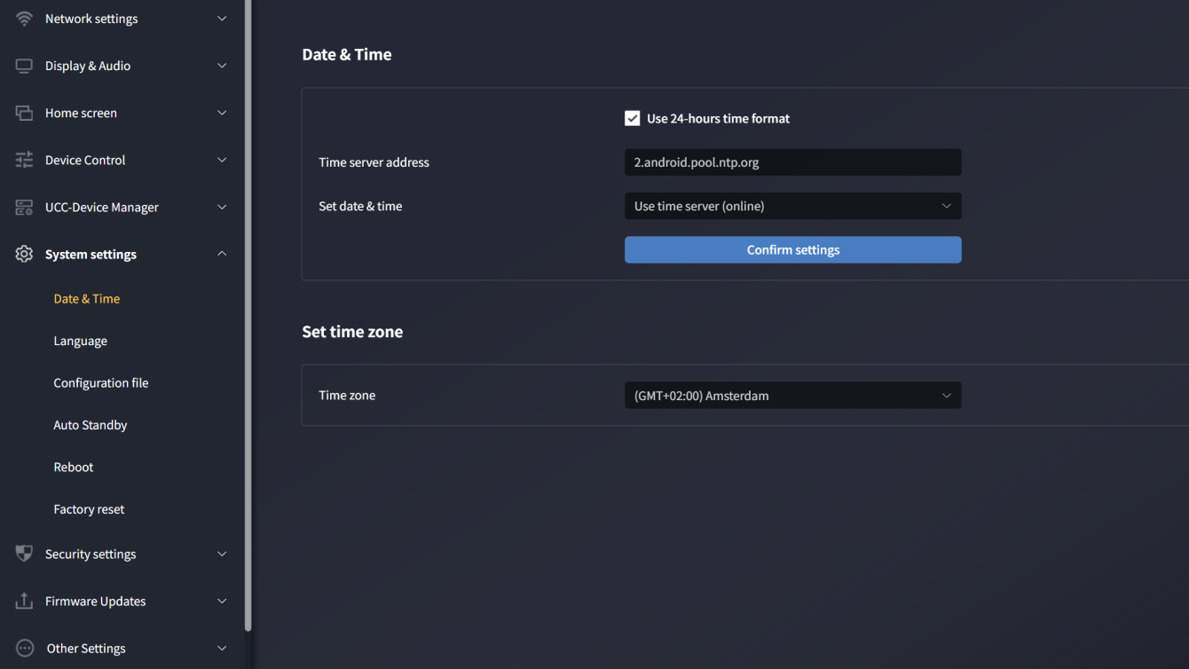
      - Time Zone: Click the "Time Zone" tab to select the appropriate time zone.
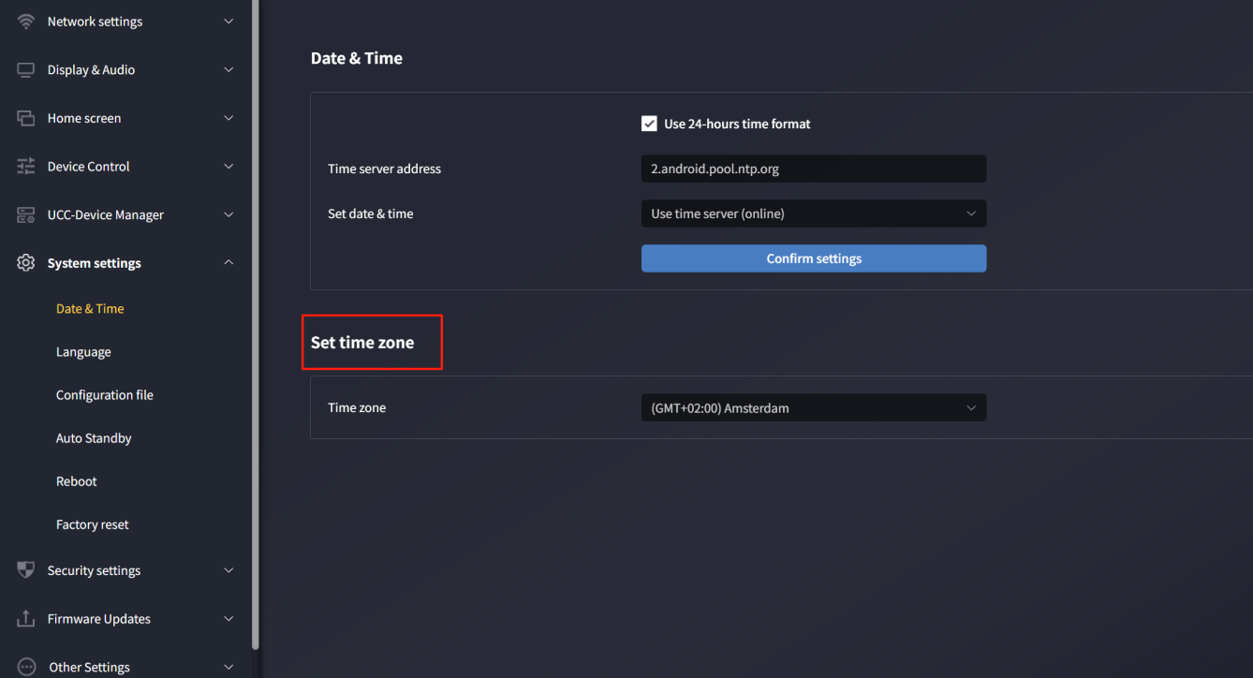

Language
Allows selection of display languages for the main screen and web page. Default main screen language is Chinese; default web language is Chinese.
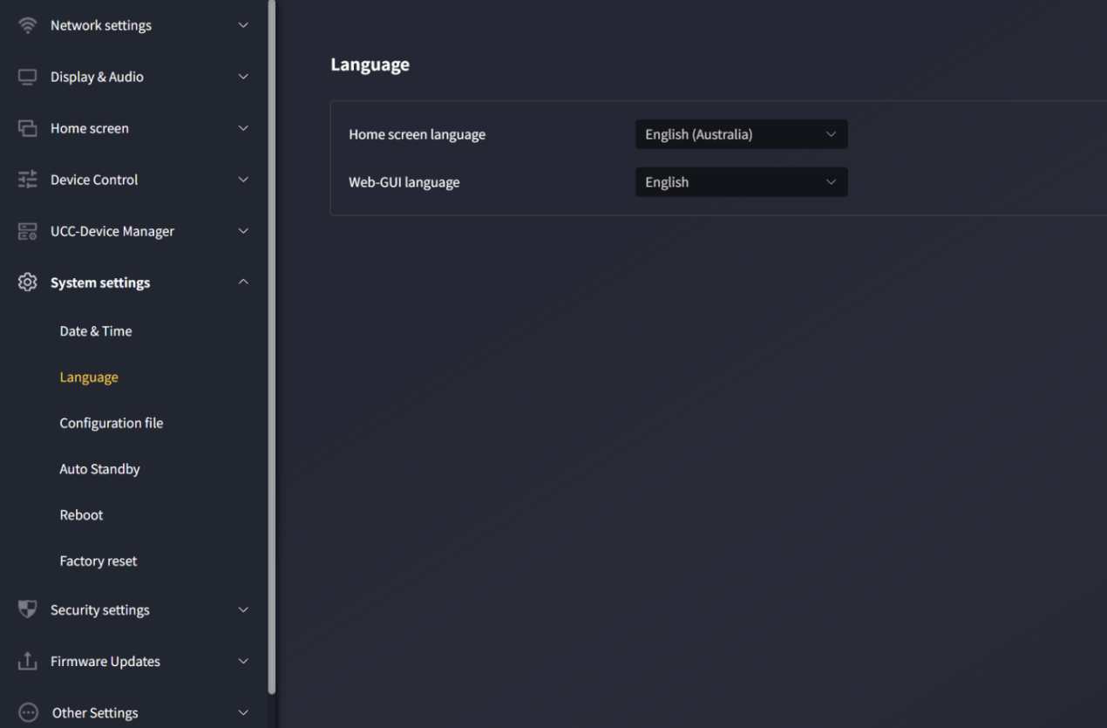

Configuration Profiles
A downloadable preset that saves all settings for deployment to other devices.
- Upload configuration: Upload a configuration file (filename must be "config.dat").
- Download configuration: Save the current device configuration to your computer.
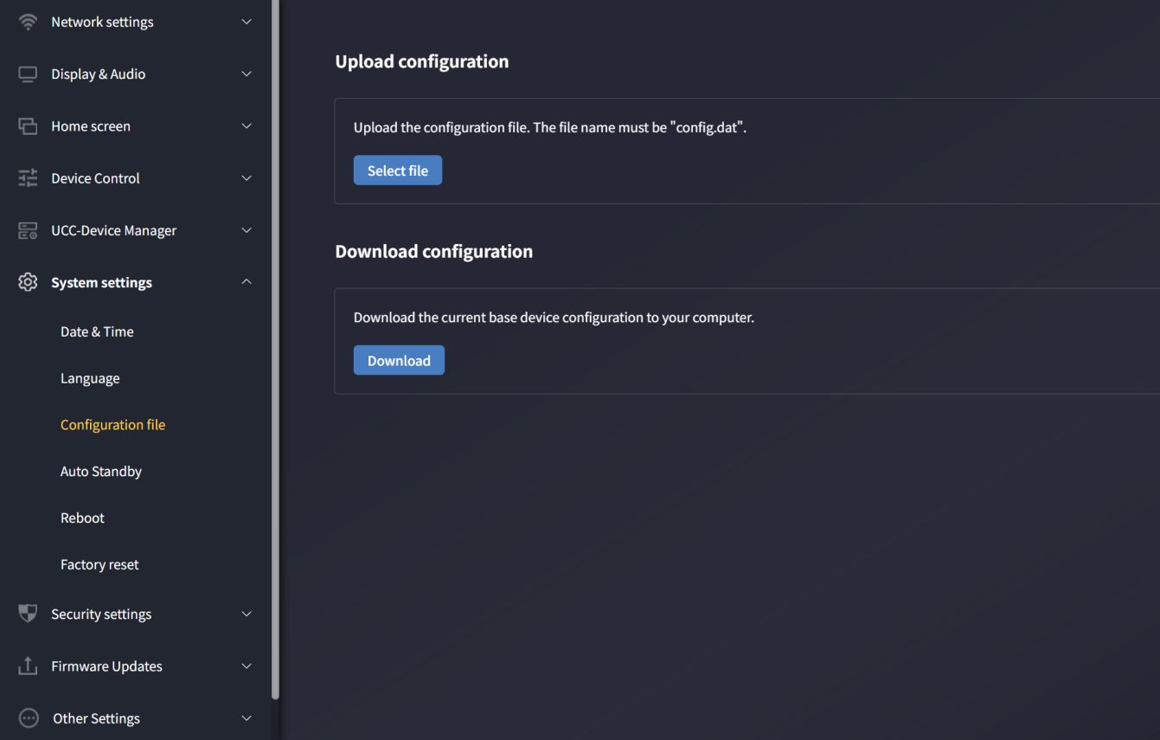

Auto-Standby
If auto-standby is activated, AVP-140V2 switches to power-saving mode after a configurable period of inactivity (no wireless transmitter, disconnected mobile device WiFi, or no system operations). The maximum period is 30 minutes. In standby, the green LED on AVP-140V2’s top flashes, and HDMI output is disabled.
• The device wakes when DONG-HDMI300/DONG-USBC300 is inserted/connected or a mobile device connects.
• Moving the mouse in AVP-140V2 USB input also wakes the device.

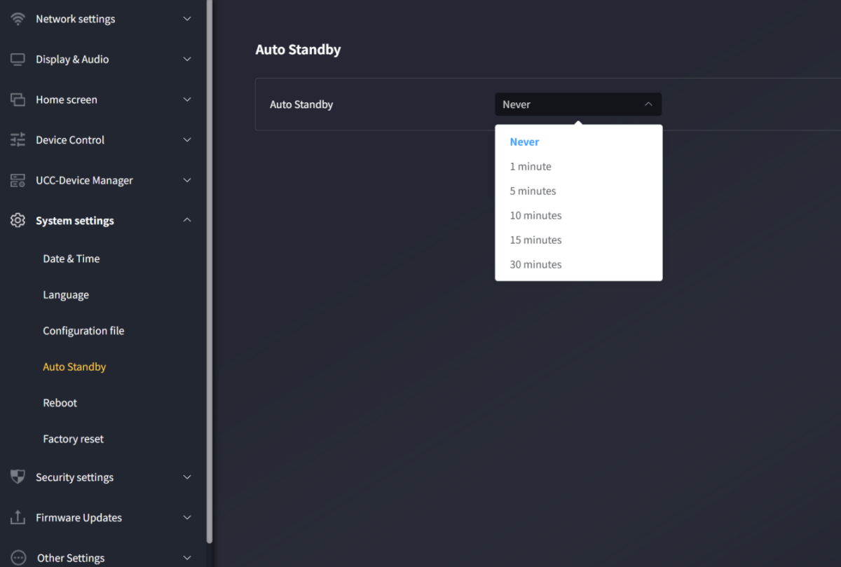

Restart
Allows scheduled restart and weekly restart routines.
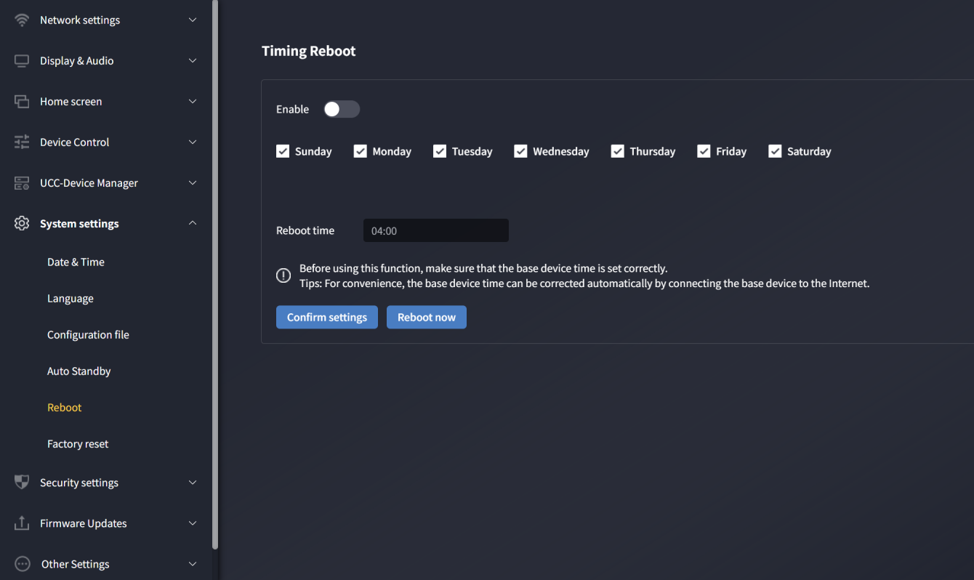
Enable scheduled restart:
- Set the restart time for AVP-140V2 and select days (Monday to Sunday).
- Manually set the restart time.
- After confirmation, AVP-140V2 restarts at the set time. The "Restart Now" button triggers an immediate restart regardless of scheduled settings.
Ensure the base unit time is correct before using this function. Tip: Connect the base unit to the internet for automatic time correction.

Factory Reset
Allows restoration of default device settings.
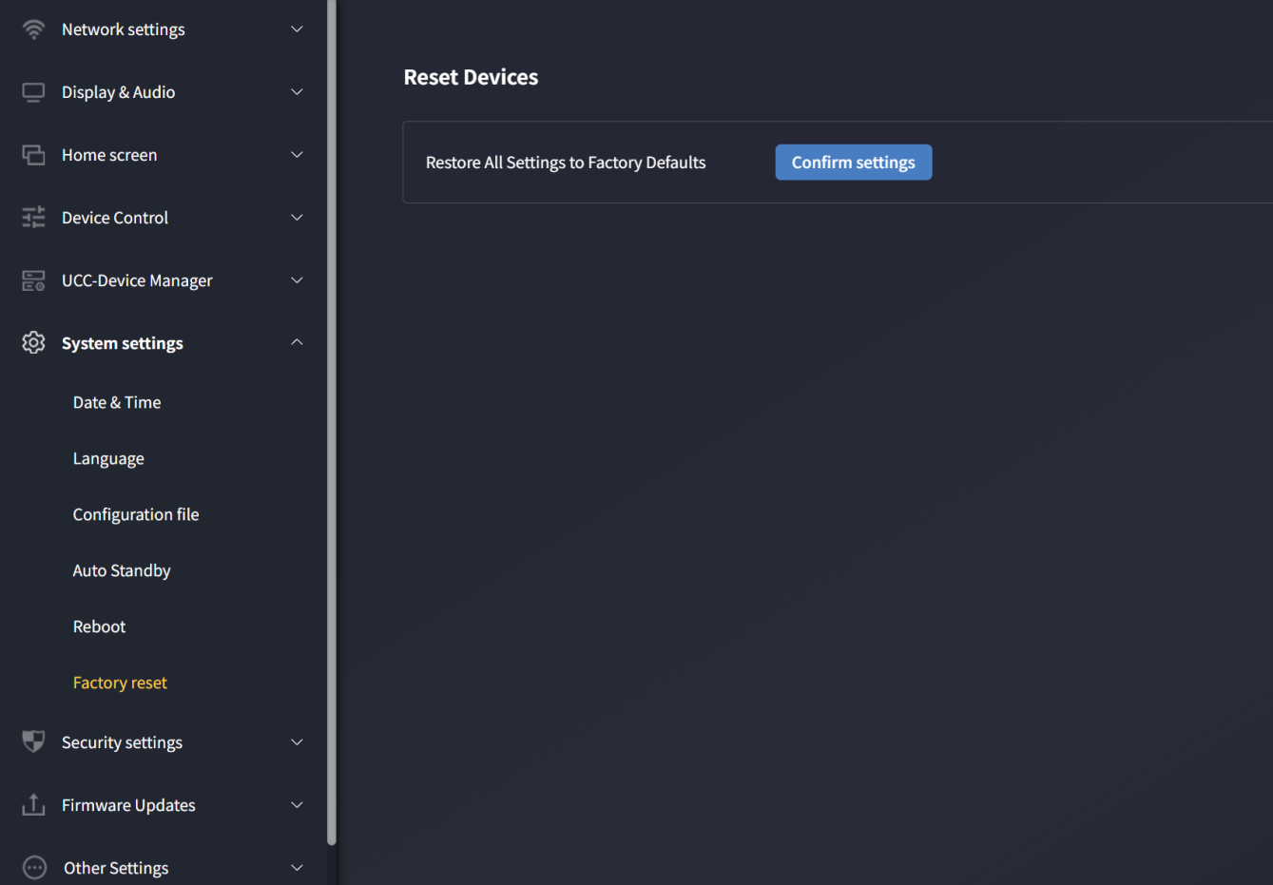

Security Settings

Security Level
Three security levels are available to meet different needs.
Click corresponding menu items to adjust settings. Default level is 1.
- Level 1: Normal security, suitable for daily use in classrooms, regular meeting rooms, etc.
- Level 2: Higher security, includes strong audio/video encryption for companies, organizations, and government agencies. Additional features: password-restricted AirPlay.
- Level 3: Strict security for corporations, authorities, and banks. Includes all Level 2 measures, plus blocked mobile apps and web GUI access. Firmware downgrades are disabled.
- Custom: Manually select security options.

The security level displays on the main screen. Click the icon 

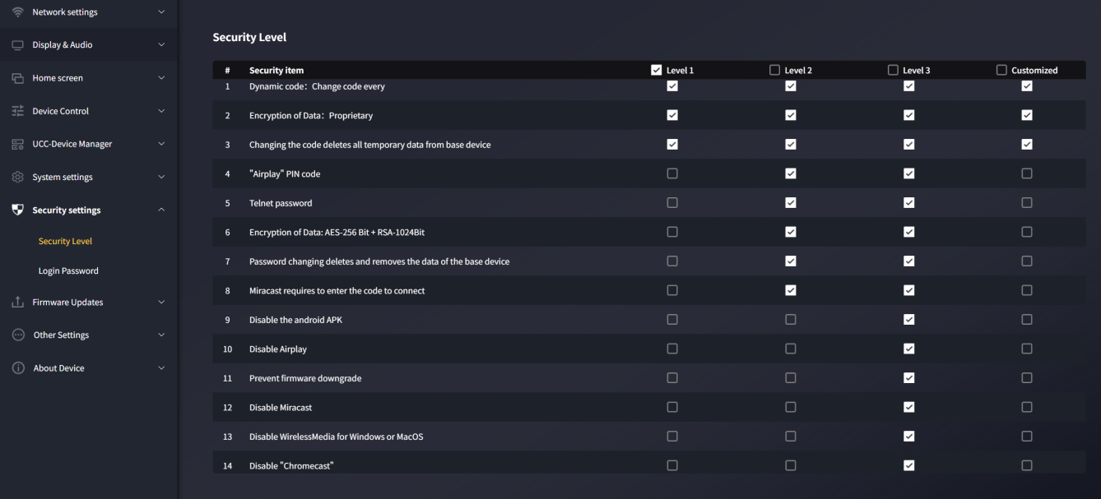

Login Password
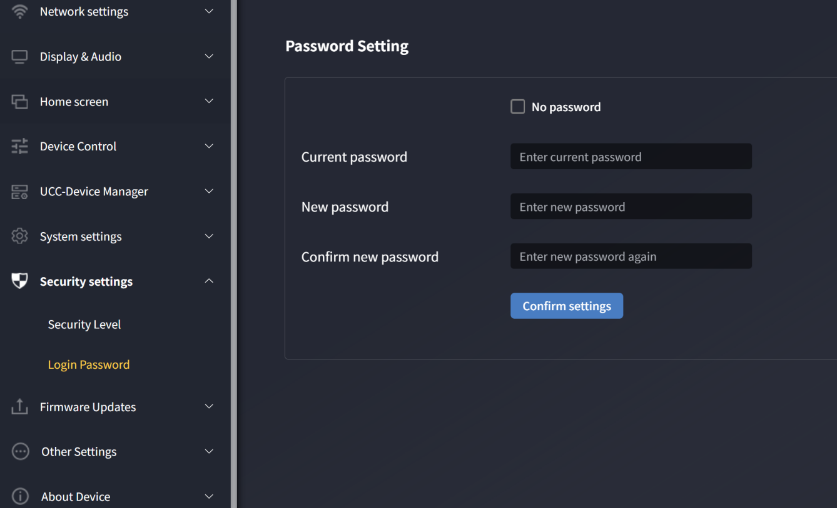
Allows changing the password for web GUI access. Default password is "admin".
- No password: When checked, web login requires no password.
- Current password: Enter the current login password.
- New password: Enter the new password.
- Confirm new password: Re-enter the new password.

Firmware Update

Firmware Update
Users can upload a local update file to upgrade AVP-140V2 (file format: *.img).
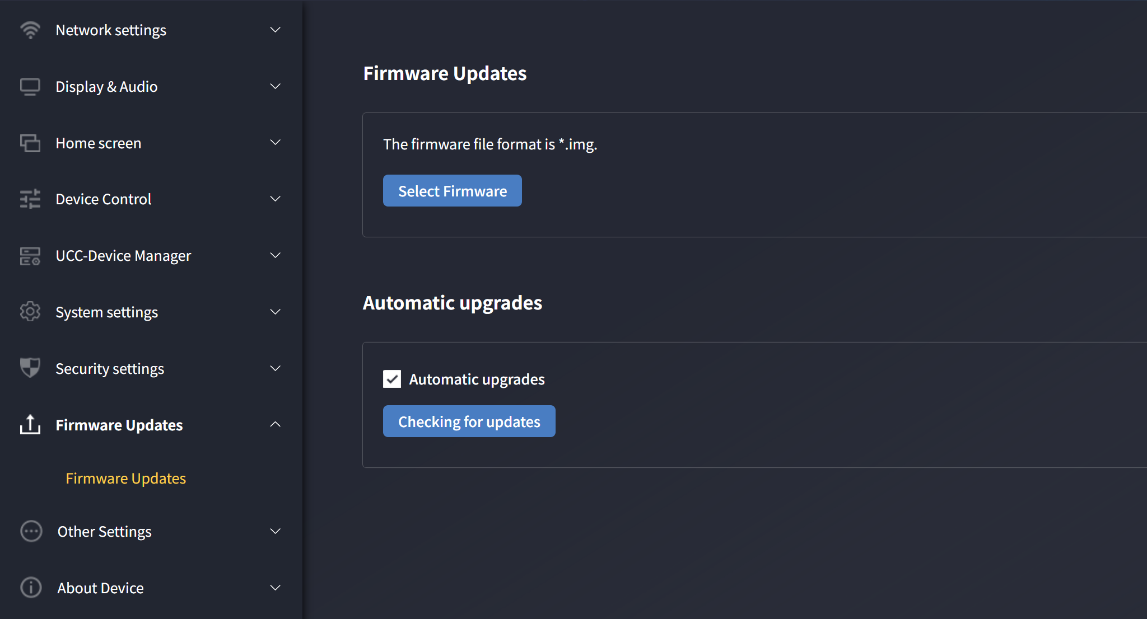

Auto-Upgrade
Check to enable automatic detection and update during early morning hours; uncheck to manually check for updates.

Other Settings

Auto-Create Launcher
After this function is enabled, inserting USB flash drive into any USB port of the base unit will trigger the automatic download of the Launcher software to the USB flash drive.

On: When USB drive is connected, Windows/Mac WirelessMedia apps, user manuals, and Android APK are copied automatically.
Off: No automatic copying. Manual download via the main screen button is required.
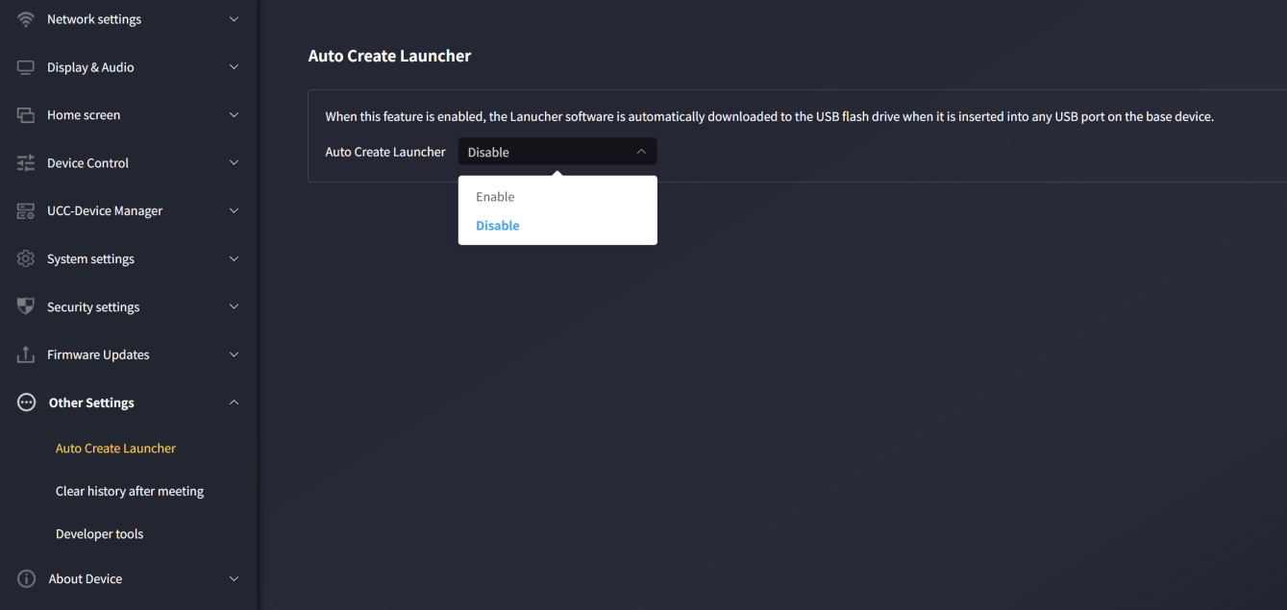

Clear Records After Meeting
Mobile device images, videos, and music are stored in the base unit memory. You can choose to clear this memory when the wireless transmitter is removed from a laptop/PC after a meeting.
- Let user decide: A warning prompts the user to clear history when all devices disconnect.
- Never clear: History remains when all devices disconnect.
- Always clear: History clears automatically without a warning when all devices disconnect.
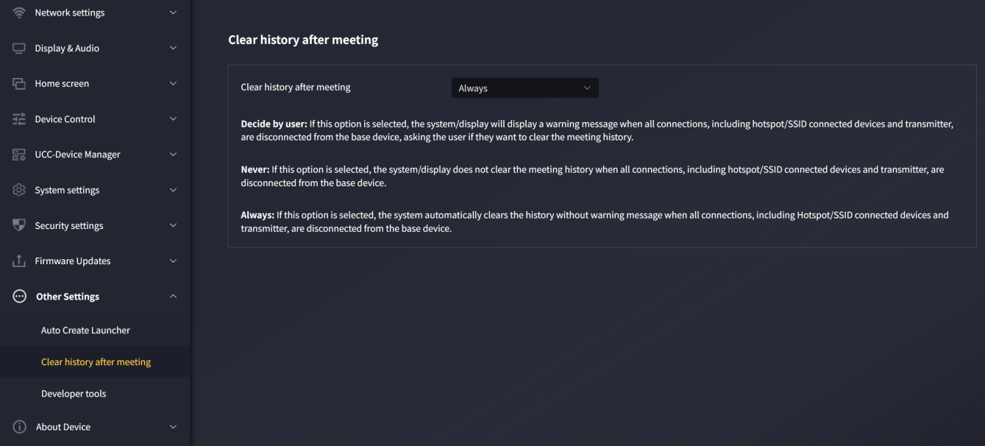

Developer Tools
Used to capture logs for troubleshooting.
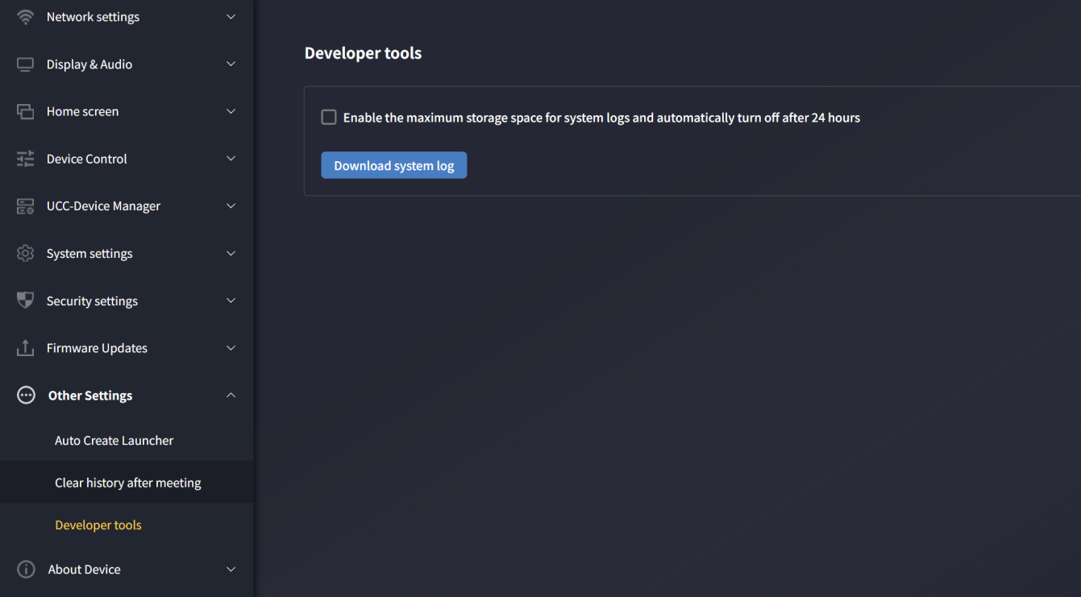
Log capture method:
- After an issue occurs, access this page and click "Download System Logs" to start downloading.
- Open the log file on your computer after download. Provide the log to technical support for assistance.

About the Device
Includes device model, firmware version, web server version, and serial number.
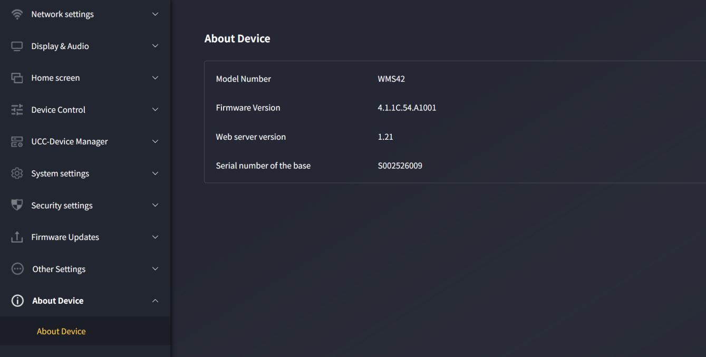

Firmware Update
Three components may require firmware updates:
- Base Unit
  - AVP-140V2
- Dongle
  - DONG-HDMI300
  - DONG-USBC300
All software is stored in the AVP-140V2 base unit and transmitted to other components. After updating AVP-140V2, check if other components need updates.

Upgrading AVP-140V2 Firmware
- External USB Storage Drive:
- Copy the update file "update.img" to the root directory of a USB drive.
- Connect the USB drive to the port next to AVP-140V2’s USB 2.0 port.
- AVP-140V2 automatically detects "update.img" and starts the "Full Update" process. Remove the USB drive within 10 seconds to stop the update.
Do not disconnect power during the upgrade; this may corrupt the firmware.
- The upgrade progress is displayed. AVP-140V2 restarts automatically after completio
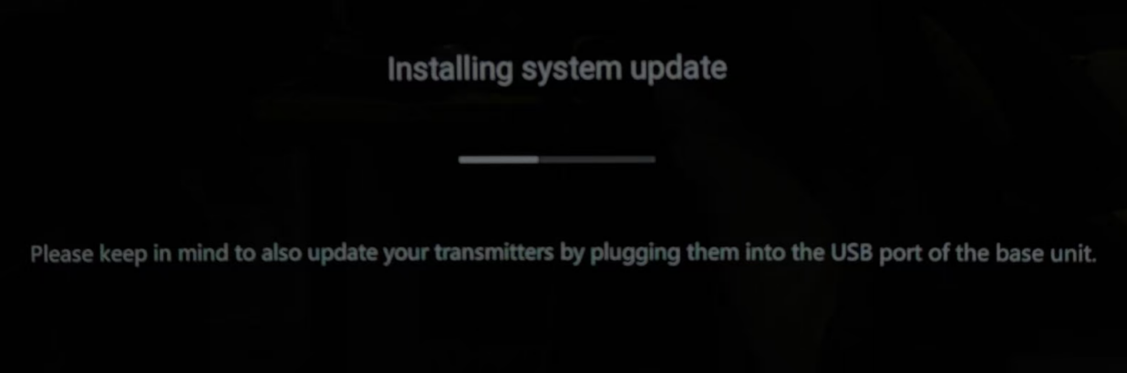
If the progress bar stalls at 1%, try a different USB drive (the current drive may be faulty).

- Disconnect the USB drive after the device boots to the main screen.
- Perform a factory reset after firmware update.

- Web Setting:
- Navigate to "Firmware Update" in "Web Settings".
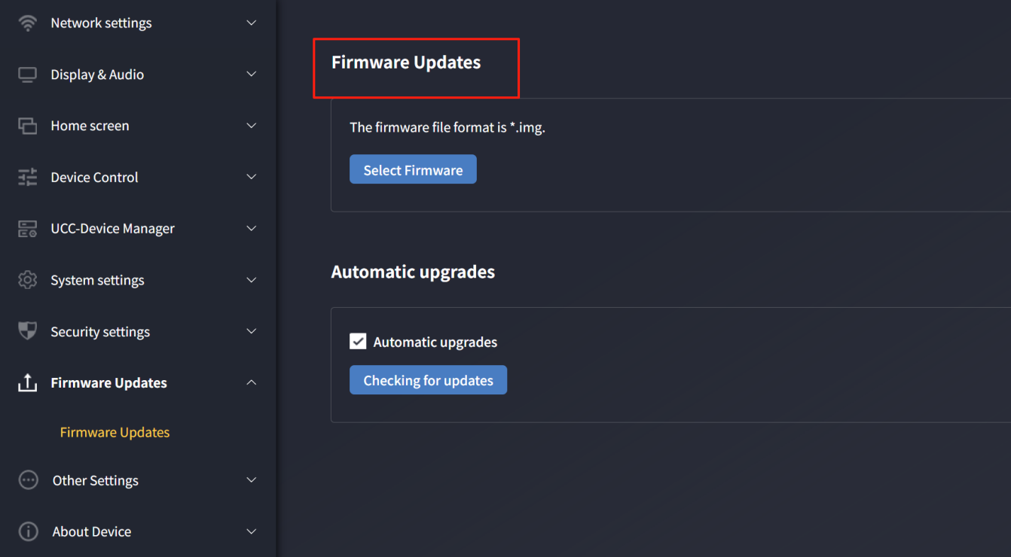
- Select the "update.img" file.
- The upgrade progress is displayed. AVP-140V2 restarts automatically after completion.
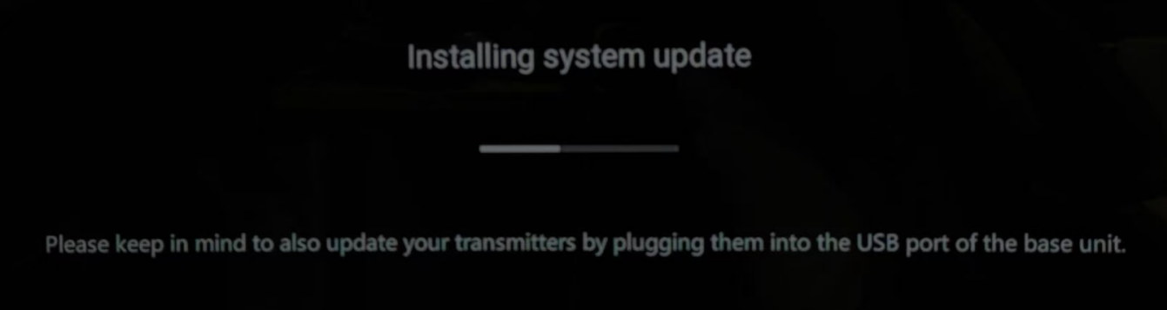
- Confirm the device boots to the main screen.
- Perform a factory reset after firmware update.

Upgrading DONG-HDMI300 / DONG-USBC300 Firmware
- Insert DONG-HDMI300/DONG-USBC300 into the corresponding front USB port of AVP-140V2. A message automatically indicates if the transmitter’s firmware is outdated and needs upgrading.
- The upgrade progress starts automatically via the progress bar.
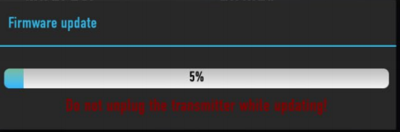

- Pairing with the AVP-140V2 base unit completes automatically afterward.
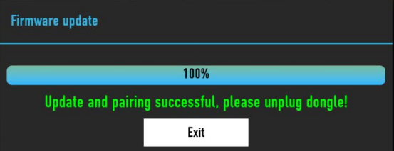

- Once the upgrade finishes, remove the wireless transmitter (DONG-HDMI300 / DONG-USBC300) for use.

Troubleshooting
Below are common issues, causes, and solutions for AVP-140V2.
Issue | Cause | Solution
Android devices cannot find AVP-140V2 via the Android app.  iOS devices cannot find AVP-140V2 via the AirPlay. | AVP-140V2 WiFi password changed while the Android/iOS device was connected. | Reconnect the Android/iOS device using the password displayed on the main screen.
Unstable wireless connection between the Dongle and AVP-140V2. | WiFi issues:  - Interference in the wireless channel.  - Channel overload.  - AVP-140V2 does not auto-switch channels when the RF environment changes. | - Use a WiFi scanner to find free frequencies/channels and configure them in settings.  - Regularly check the RF environment if WiFi networks change frequently.
 | Low signal strength:  - Metal cabinets, walls, and building components may cause reflection, thereby reducing the wireless signal.  - Obstacles between the dongler and AVP-140V2 will lead to a decrease in wireless strength and quality. | - Position the AVP-140V2 close to the main screen.  - Adjust the direction of the antenna on the rear panel of the AVP-140V2 to face the transmitter.  - Clear or restrict all obstacles between the transmitter and AVP-140V2 as much as possible.  - Avoid placing the Base unit inside (metal) cabinets, suspended ceilings, under tables, or in adjacent rooms.
WirelessMedia fails to run when the dongle is inserted into a laptop. | If using the AVP-140V2 on a laptop or a visitor's device for the first time, you must first copy the starter program "WirelessMedia" to your laptop/PC. Run this starter program. The Starter App can be operated without administrator privileges. | There are two ways to load the starter program WirelessMedia; please refer to the "System Settings" chapter. The optimal method is as follows: Download the application via the Base-unit's LAN or WiFi. Once the Launcher program is pre-installed, WirelessMedia can be used immediately thereafter.
 | Poor USB port connection on the laptop. | - Reconnect to the USB port.  - Try a different USB port.  - Restart the laptop.
 | - Corporate policies block certain USB devices.  - The USB port settings on the laptop may restrict the use of high-power USB devices when operating on battery power. | Adjust USB port policies on the laptop if possible.
Poor video performance (blurriness, audio/video loss, stuttering). | - Suboptimal media player.  - Video quality depends on PC/laptop processing power, CPU load from other apps.  - A laptop in battery mode can switch to reduced power consumption to save energy. The transmission of high-definition videos requires a certain amount of CPU capability to ensure optimal transmission quality. | - Use another media player (e.g., VLC) or browser.  - Update video player software.  - Reduce CPU usage of other apps.  - Lower laptop screen resolution.  - Update graphics drivers.  - Disable low-power mode on the laptop.
No video on the screen. | Content uses HDCP. | AVP-140V2 inputs do not support HDCP sources. Connect the source to AVP-140V2 local HDMI input if possible.
No video on the screen. | HDMI cable is loose. | Connect the HDMI cable to the display and Base Unit.
No video on the screen. | Display is off. | Turn on the display.
No video on the screen. | When the AVP-140V2 receiver is in standby mode, the "Power-LED" of the AVP-140V2 flashes, which may be due to a lack of power supply. | - Power cycle the device.  - Insert the dongle into the laptop.
When using Windows 7, the following message regarding the Windows Aero color scheme may appear: "Windows has detected that your computer is performing slowly. This might be because there are insufficient resources to run the Windows Aero color scheme. To improve..." | Lost connection to AVP-140V2. | Safely ignore the message and select "Keep current color scheme".
The content will disappear from the display, and the LED on the dongle button will be flashing. | Lost connection to AVP-140V2. | - AVP-140V2 attempts to restore the connection. If failed, the button’s LED flashes red.  - Remove the dongle from the laptop and try a new one.
No display output. | Display is off. | Turn on the display.
No display output. | Display cable is loose. | Connect the cable to the display and AVP-140V2.
No display output. | AVP-140V2 is in standby mode. | Press the standby button on AVP-140V2 or power cycle the device.
No LAN connection to AVP-140V2. | Incorrect IP address. | - IP address is outside the LAN range.  - DHCP is disabled.
No WiFi connection between mobile devices and AVP-140V2. | Incorrect WiFi frequency. | Ensure the mobile device uses the correct 2.4GHz or 5GHz band.
No WiFi connection between mobile devices and AVP-140V2. | Wrong SSID or password. | Enter the correct SSID and password.
No audio when transferring local files to AVP-140V2. | Unsupported audio formats (e.g., Dolby MS11, DDCO, DTSLBR, DTS, SRS-THEATERSOUND, DTS_StudioSound3D, DTS_HD). | Reformat to supported formats (e.g., DD, DD+, HE-AAC, DTS, DMP, WMA, DRA, COOK) if possible.
No sound on MacBook. | Issues with the Soundflower application, which is integrated in the driver WirelessMedia application. | - Admin password is required.  - Go to macOS System Preferences > Security & Privacy. Allow "Soundflower" by clicking "Allow" next to "Matt Ingalls".  - Relaunch WirelessMedia to auto-install Soundflower.
No AirPlay sound. | Mobile device volume is too low. | Increase the Mobile device volume.
No sound on the main screen when mirroring via "WirelessMedia for Android". | Android limits audio capture, so mirrored videos have no sound. | Use Dongle or Apple AirPlay for audio if needed.
Cannot update AVP-140V2 firmware. | USB drive is formatted as NTFS. | Reformat the USB drive to FAT.
Cannot use AirPlay on MacBook/iPhone/iPad. | OS requirements: Mac OS 10.9+, iOS 8.0+ (WirelessMedia app). | - Connect the iOS device to AVP-140V2’s WiFi and enable AirPlay in Control Center.  - Update the iOS device to a newer OS.
Poor AirPlay video quality. | AirPlay has two modes:  a) Mirroring: 1:1 screen copy. b) Streaming: Video (internet, YouTube), no iOS device display. → Stuttering video. | Lower YouTube quality (e.g., from "Auto" to 720p).
Cannot use with Android devices | OS requirement: Android 2.3 or higher (WirelessMedia app) | Update to a higher version of the operating system

Technical Data

Specification
Specification
HDMI output | 1x HDMI 19-pin female connector
HDMI Output Resolution | 3840x2160@60Hz,3840x2160@30Hz, 1920x1080@60Hz, 1280x720@60Hz
HDMI Format Compliance | HDMI1.4/HDMI2.0
Video Capacity: | 1080P @ ≤60Hz for Airplay, Miracast, Chromecast
Video Capacity: | 4K @ ≤30Hz "WirelessMedia" app
Video Capacity: | 4K @ ≤30Hz for HDMI show-me button
Video Capacity: | 4K @ ≤30Hz for USB-C show-me button
Video Capacity: | 4K @ ≤30Hz for HDMI input
HDCP | HDCP1.4/HDCP2.2
HDMI Input | 1x HDMI 19-pin female connector
HDMI Input Format Compliance | HDCP1.4
HDMI Intput Resolution | 3840x2160@30Hz,31920x1080@60Hz, 1280x720@60Hz
Analog Audio Output | 1x 3.5mm PC audio female jack
Analog Audio Input | 1x 3.5mm PC audio female jack
LAN port | RJ45 x2：1000Mbps x2
USB interface | USB3.0：Type A x2; USB2.0: Type A x1, Type C x1
Audio Input | AirPlay, Miracast, Chromecast, Windows/MAC App, WMH, WMC, USB(MIC)
Audio output | Jack, HDMI, Jack + HDMI, USB(Speaker)
Control connectors | 3.5mm Phoenix terminal/ RS232 interface
Number of window simultaneous on screen | ≤ 4+12（4 main windows+12 thumbnail windows）
Number of simultaneous connections | ≤ 16
Video Playback Frame Rate | 20-60 FPS
Latency | ＜100ms，Min 20ms
WIFI Data rate | Up to 1200Mbps
Wireless transmission protocol | WIFI IEEE 802.11 a/b/g/n/ac/ax，Bluetooth：5.2
Found nearby devices | support
Frequency band | 2.4 GHz & 5 GHz
WIFI Antenna | MIMO 2x2, MIMO 1x1

Mechanical Drawings
AVP-140V2
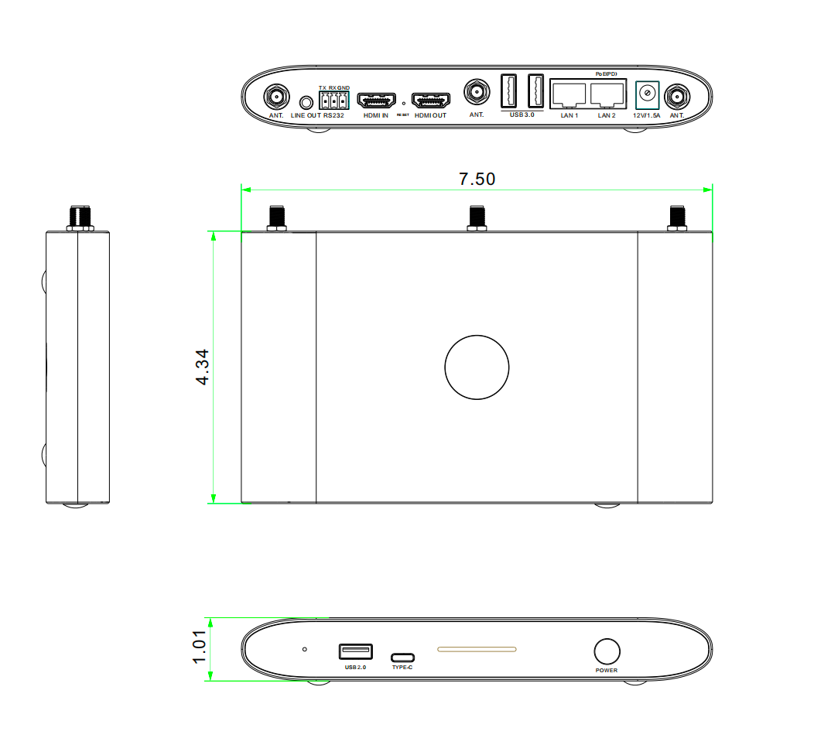

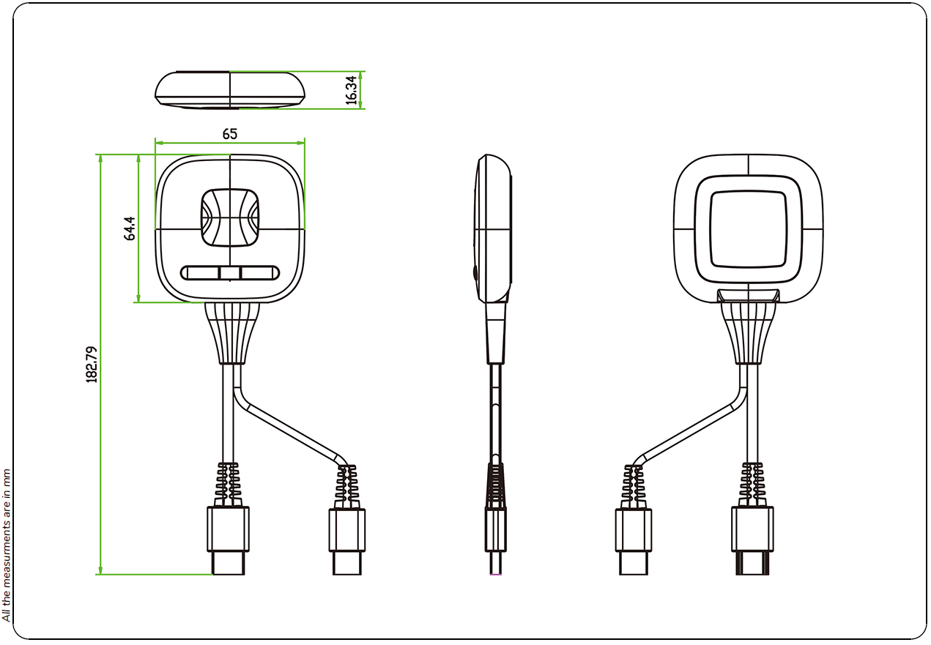
DONG-HDMI300
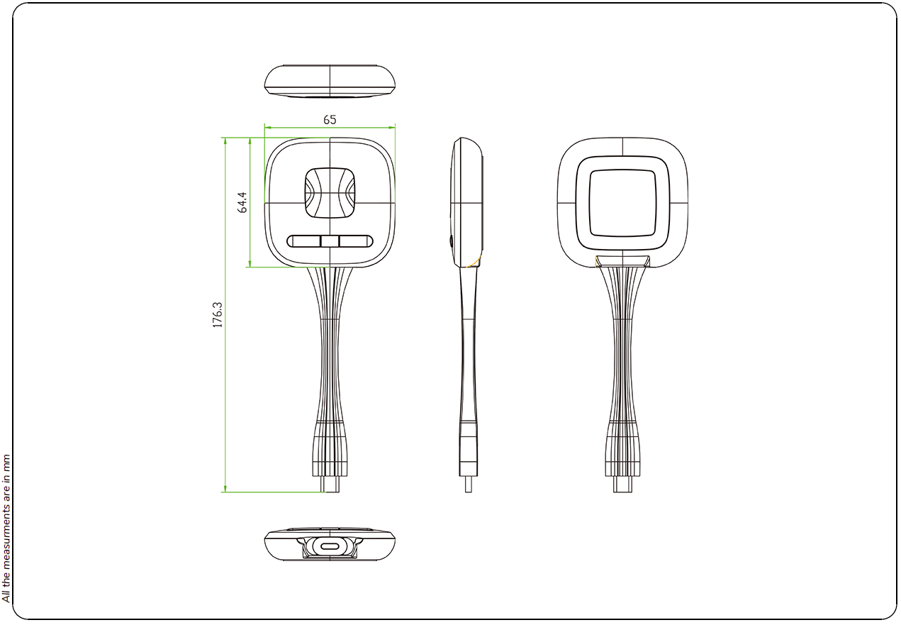
DONG-USBC300

