ALT-STREAM

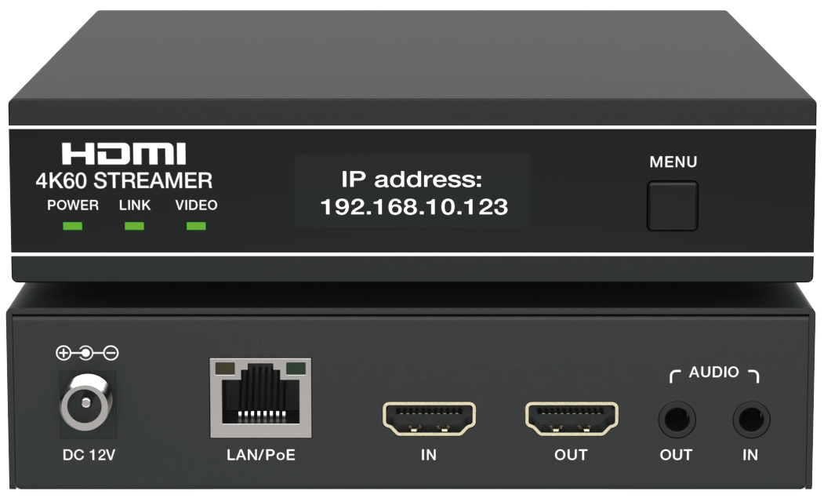


VER 1.0

Thank you for purchasing this product
For optimum performance and safety, please read these instructions carefully before connecting, operating or adjusting this product. Please keep this manual for future reference.
Surge protection device recommended
This product contains sensitive electrical components that may be damaged by electrical spikes, surges, electric shock, lighting strikes, etc. Use of surge protection systems is highly recommended in order to protect and extend the life of your equipment.

Table of Contents
- Introduction. 1
- Features. 1
- Package Contents. 2
- Specifications. 2
- Operation Controls and Functions. 4
  - Front Panel. 4
  - Rear Panel. 5
- Rack Mounting Instruction. 6
  - 6U V2 Rack Mounting. 6
  - 1U V2 Rack Mounting. 7
- Stream Service Introduction. 8
  - Platform Building. 8
  - Web GUI Operation. 9
    - Status. 10
    - Encoder 11
    - Network 15
    - System 16
    - Device List 18
    - Admin 19
  - RTSP/TS Stream Operation. 19
  - RTMP/RTMPS Push Stream (Youtube) Operation 23
  - Audio Only Stream Operation. 25
- Application Example. 28

Introduction
This AV Streamer based on H.265/H.264 compression technology distributes 4K60Hz HDMI signals over a 100M/1G Network. It offers 4K@60Hz H264/ H265 + 1080P@30 H264 + 1280*720@5 JPEG three streams, and supports bitrate configurable, compression video and resolution up to 3840x2160@ 60Hz 4:4:4.
The product also supports analogue audio embedding and extracting, and HDMI loopout as well. Built-in Web GUI makes the product easy to use, API commands for 3rd party control system to manage and control the device(s).

Features
☆ 4K@60 H.264/265 HEVC Ultra HD Encoder
☆ Video resolution up to 4K@60Hz 4:4:4, 18Gbps video bandwidth, as specified in HDMI 2.0b
☆ Supports three streams: 4K@60Hz H264/H265 + 1080P@30 H264 + 1280*720@5 JPEG
☆ Supports RTSP/UDP, RTSP/TCP, RTP/UDP, TS/UDP, RTMP/RTMPS
stream standards
☆ Main stream output: 4K60Hz
☆ Second stream output: 1080P30Hz
☆ Supports unicast and multicast
☆ Supports audio only stream and audio delay settings
☆ Audio format supports LPCM 2CH (48KHz)
☆ Supports stream control (play/pause/stop )
☆ Supports bitrate/resolution/frame rate/EDID configurations
☆ Supports API controls for 3rd party control system via TELNET/SSH login or TCP socket connection
☆ Supports Device Discovery “SHOW ME” function
☆ Supports Controls/Managements in HTTP/HTTPS Web GUI
☆ Supports 802.1X protocol
☆ Supports image preview, point-to-point signal extension, signal distribution
☆ Supports HDMI loop output
☆ Supports analog audio embedding and extracting
☆ 100M/1G Ethernet port, supporting PoE function (802.3af PD device)
☆ Compatible with 1U/6U V2 rack installation
☆ OLED screen display

Package Contents
① 1 x AV Streamer
② 1 x 12V/1A Locking Power Adapter
③ 2 x Mounting Ears
④ 4 x Machine Screws (KM3*6)
⑤ 1 x User Manual

Specifications

Technical
HDMI Compliance | HDMI 2.0b
Video Bandwidth | 18Gbps
Network Video Bandwidth | 1G
Audio Latency | < 60ms
Input Video Resolution | Up to 4K@60Hz 4:4:4
Output Video Resolution | Push stream resolution: Same as input, 3840x2160, 1920x1080, 1280x720, 640x480  Push stream frame rate: 5~60Hz
Color Space | HDMI input: RGB, YCbCr 4:4:4 / 4:2:2 / 4:2:0  Push stream encoding: 4:2:0
Color Depth | HDMI input: 8/10/12bit  Push stream output: 8bit
HDR | Not supported
Audio Formats | LPCM 2CH 48kHz
L/R OUT  Audio Parameters | Output Impedance: 330 Ohms  Line Input / Output Level (Maximum): 2Vrms Frequency Response: (+0.5dB, -1dB) 20Hz to 20kHz Audio S/N Ratio: >90dB@2Vrms, 1kHzA-weighted Audio THD+N: <0.05%@2Vrms, 1KHz
Transmission Distance | 16ft/5m (HDMI)  328ft/100m (CAT6/6A/7)

ESD Protection | IEC 61000-4-2:  ± 15kV (Air-gap discharge) & ± 8kV (Contact discharge)
Connection
Input ports | 1 x IN [HDMI Type A, 19-pin female] 1 x AUDIO IN [3.5mm audio jack]
Output ports | 1 x OUT [HDMI Type A, 19-pin female] 1 x AUDIO OUT [3.5mm audio jack]
Network port | 1 x LAN/PoE [RJ45 jack, support PoE 802.3af power supply]
Mechanical
Housing | Aluminum+Iron
Color | Black
Dimensions | 130mm [W] x 160mm [D] x 30mm [H]
Weight | 659g
Power Supply | Input: AC100 - 240V 50/60Hz,  Output: DC 12V/1A  (US/EU standards, CE/FCC/UL certified)
Power Consumption | 7.2W
Operating  Temperature | 32 ~ 104°F / 0 ~ 40°C
Storage Temperature | -4 ~ 140°F / -20 ~ 60°C
Relative Humidity | 20 ~ 90% RH (no-condensing)

Operation Controls and Functions

Front Panel

MENU
POWER LINK VIDEO
1 2 3
4
5

No. | Name | Function Description
1 | POWER LED  (Green) | The POWER LED is steady on when the unit is powered on, and off when the unit is powered off.
2 | LINK LED  (Green) | 1G network connection indicator light.  - Light on: There is network connection.  - Light off: There is no network connection.  - Light flashing at 1Hz: The push stream is in progress.
3 | VIDEO LED  (Green) | Video stream status indicator light.  - Light on: There is locked signal transmission.  - Light off: There is no signal transmission.  - Light flashing at 2Hz: There is unlocked signal transmission.
4 | OLED display screen | The OLED screen displays the device name and IP address (homepage) after the unit is powered on and working normally, scrolls from right to left after 10 seconds, and goes out after 60 seconds.  Notes:  - When the OLED screen is turned off, press the MENU button to turn on it.  - When the OLED screen lights up or scrolls, pressing the MENU button can flip pages to display different page contents.  - When the OLED screen goes from off to on, it will display the first page.
5 | MENU button | - Short press the MENU button to turn on the OLED screen or select different page contents.  - Hold down the MENU button for 10 seconds to restore the unit to factory default settings.
Note: When the SHOW ME function is turned on, both the LINK and VIDEO LED will flash at 5Hz.

Rear Panel

AUDIO
DC 12V
IN
OUT
OUT
IN
1
2
3
4
5
6

No. | Name | Function Description
1 | DC 12V | The device can be powered via two methods:  - Local DC 12V/1A power supply (with a high priority)  - PoE from Network Switch. Device acts as PD mode.
2 | LAN/PoE port | 1G network port, supporting PoE 802.3af power supply. Connect to the network port of the corresponding application, such as 1G Ethernet or Stream transmission.
3 | IN port | HDMI signal input port, connected to the HDMI source device such as DVD or TV box with HDMI cable.
4 | OUT port | HDMI signal loop output port, connected to the HDMI display device such as TV or Monitor with HDMI cable.
5 | AUDIO OUT port | Analog audio output port, used for outputting the audio extracted from the HDMI IN port.
6 | AUDIO IN port | Analog audio input port, used for audio embedding. The main chip encoding and push stream use the embedded audio from the AUDIO IN port, while the HDMI loop output maintains the source audio from HDMI IN.

Rack Mounting Instruction

6U V2 Rack Mounting
This product can be mounted in a standard 6U V2 rack (Please contact your supplier for 6U V2 rack sale). The mounting steps are as follows:
Step 1: Use included screws to fix two mounting ears on the machine, as shown in the figure below:




Step 2: Insert the machines with mounting ears into a 6U V2 rack (up to 6 units can be installed vertically), as shown in the figure below:
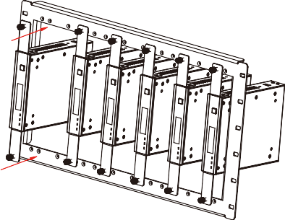

Step 3: Use screws to fix mounting ears on the rack to complete the mounting, as shown in the figure below:

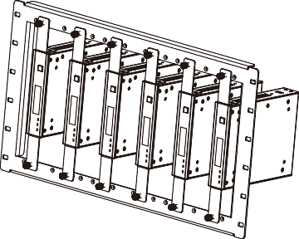

1U V2 Rack Mounting
This product also can be mounted in a standard 1U V2 rack (up to 2 units can be installed horizontally). The mounting steps are as follows:
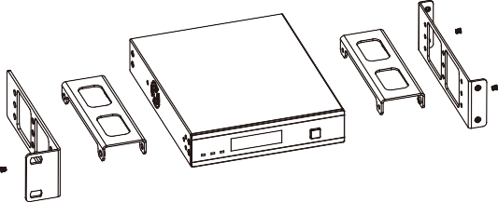
Step 1: Use included screws to fix two 1U V2 rack panels on the machine, then fix the rack panels to the 1U V2 brackets, as shown in the figure below:
Step 2: Fix two rack panels and two brackets on another machine in the same way, then fasten screws between two 1U V2 brackets, so that two machines are mounted in a 1U V2 rack, as shown in the figure below:
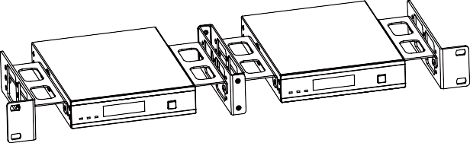

Stream Service Introduction

Platform Building
This AV Streamer can provide RTSP/RTMP/RTMPS stream service through the network. Please follow the steps below to build the platform.
Step 1: Connect the AV Streamer with signal source devices, TV, audio input and output devices. Then connect the AV Streamer, PC, Router and TV App to the same 1G Network Switch, as shown in the figure below.

1G Network Switch

Speakers

Ampliﬁer
HDMI CAT AUDIO

RTMP / RTMPS

RTSP

RTSP

RTSP / RTMP
/ RTMPS
AV Streamer

Router

PC VLC

TV App
Microphone

RTMP /RTMPS

Social Media Server Router Pad Phone PC TV
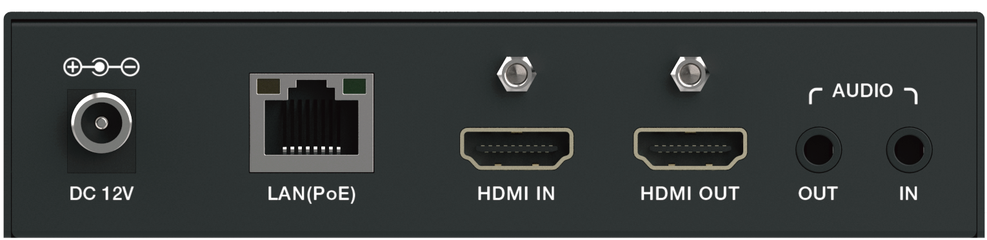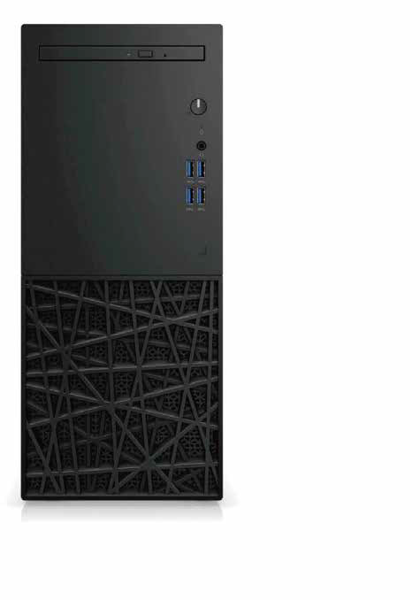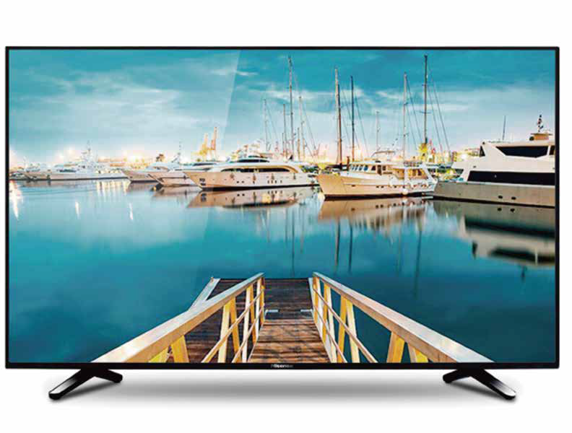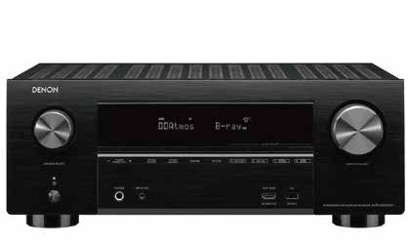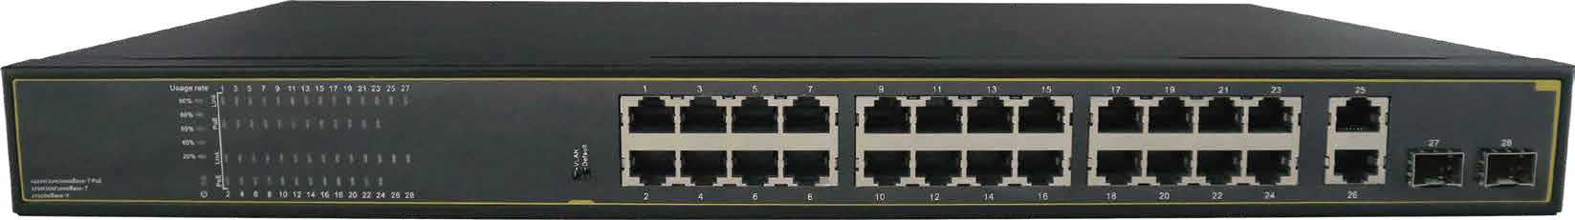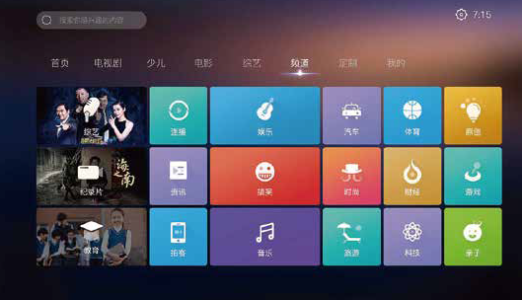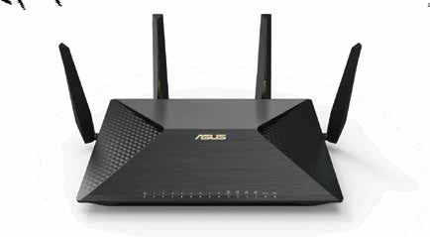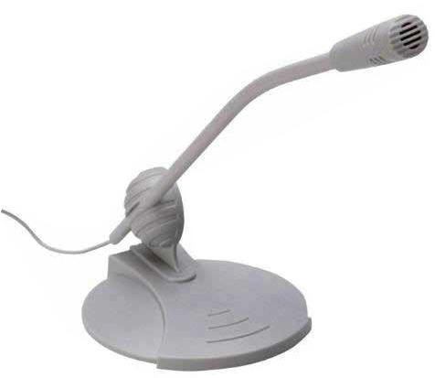Step 2: Power on the AV Streamer, then use the MENU button on the front panel to switch the OLED screen to the IP address page, and the current IP address of the AV Streamer is 192.168.10.80, as shown in the figure below.
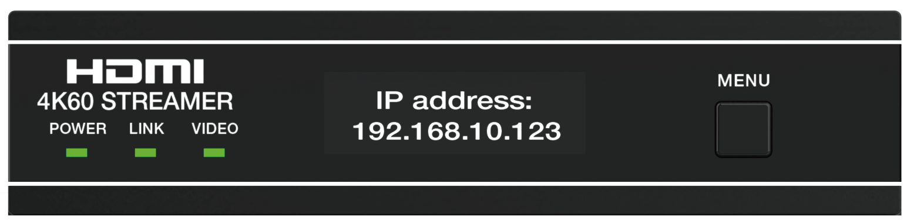
80
Note: The default IP address of the AV Streamer is 169.254.1.11.
Step 3: Set the PC’s IP address to be in the same network segment with the IP address of the AV Streamer.

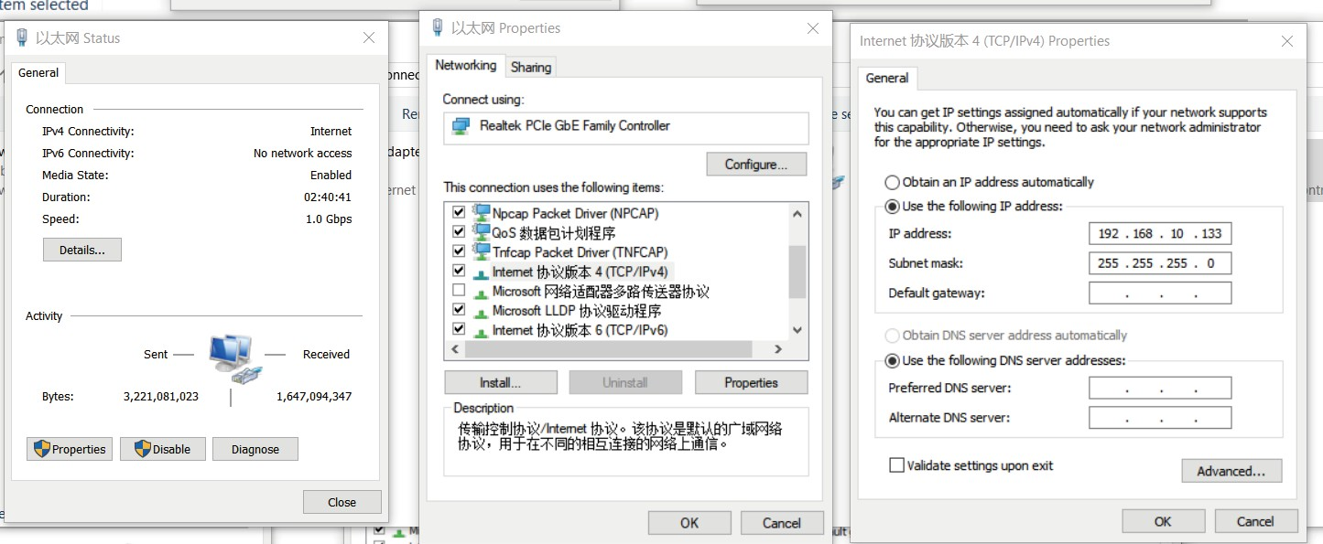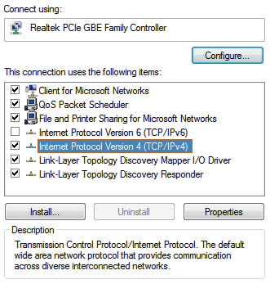
Ethernet Properties
Ethernet Status
Internet Protocol Version 4 (TCP/IPv4) Properties
100
Step 4: Open the Google Chrome PC browser, enter the current IP address (192.168.10.80) of the AV Streamer in the address bar, and tap the Enter button to access the Web GUI.

Web GUI Operation
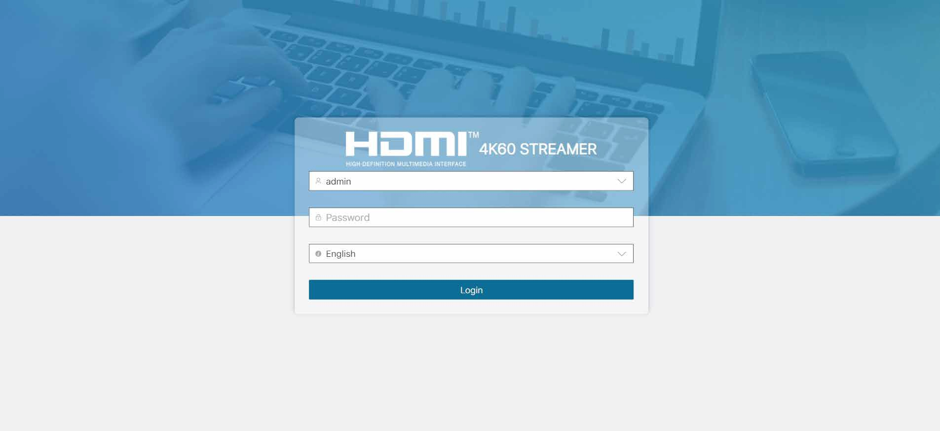
Before enter the built-in Web GUI of the AV Streamer, there will be a login page, as shown in the figure below.
The username and password can only be admin or user. The default password for admin is admin, while the default password for user is 123456. Input the username and password, and select the desired language, then click “Login” to access the Web GUI.

Status
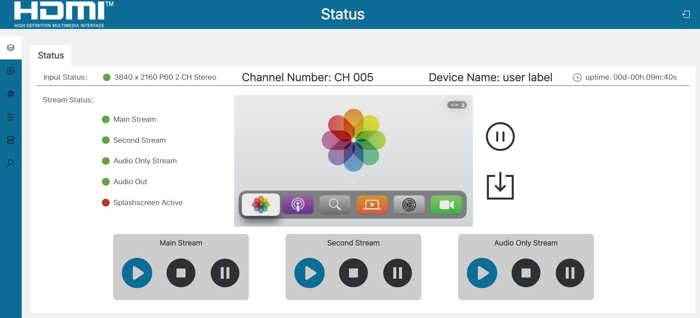
⑧
①
②
③
④
B
A
⑤
⑦
C
⑥
① Input Status: The status and information of the input signal. The green dot indicates that there is signal input, the format of the input audio and video is 1080P60 dual-channel stereo. If the dot is red and shows “No Signal”, it means there is no signal input.
② Channel Number: The channel number of the device, as shown in the
above figure, the channel number of the device is 005.
③ Device Name: The name of the device.
④ uptime: It displays the running time of the device.
⑤ Stream Status: The status of output streams.
Main Stream: Main stream status, the red dot indicates that the stream is
in STOP status, the orange dot indicates that the stream is in PAUSE status, and the green dot indicates that the stream is in ACTIVE status.
Second Stream: Second stream status, the red dot indicates the stream is in STOP status, the orange dot indicates the stream is in PAUSE status, and the green dot indicates the stream is in ACTIVE status.
Audio Only Stream: Audio stream status, the red dot indicates that the stream is in STOP status, the orange dot indicates that the stream is in PAUSE status, and the green dot indicates that the stream is in ACTIVE status.
Audio Out: This item indicates whether there is audio output. The red
dot indicates that there is no audio output, while the green dot indicates that there is audio output.

Splashscreen Active: This item indicates whether the main stream Splash- screen is displayed or not. The green dot indicates that Splashscreen is displayed, the red dot indicates that the Splashscreen is not displayed.
⑥ Stream control buttons (please refer to point ⑤ for status display)
Main Stream: Main stream control buttons, press the ACTIVE button to enable the main stream; press the PAUSE button to pause the main stream; press
the STOP button to stop the main stream.
Second Stream: Second stream control buttons, press the ACTIVE button to enable the second stream; press the PAUSE button to pause the second stream; press the STOP button to stop the second stream.
Audio Only Stream: Audio only stream control buttons, press the ACTIVE button to enable the audio only stream; press the PAUSE button to pause the audio only stream; press the STOP button to stop the audio only stream.
⑦ Image Capture:
A: This area displays the captured picture.
B: After clicking the Freeze button, the picture will be refreshed at a frequency of 5Hz.
C: After clicking the Download Picture button, the captured picture will be downloaded to the computer.
⑧ Logout button. Click this button to log out of the Web GUI.

Encoder
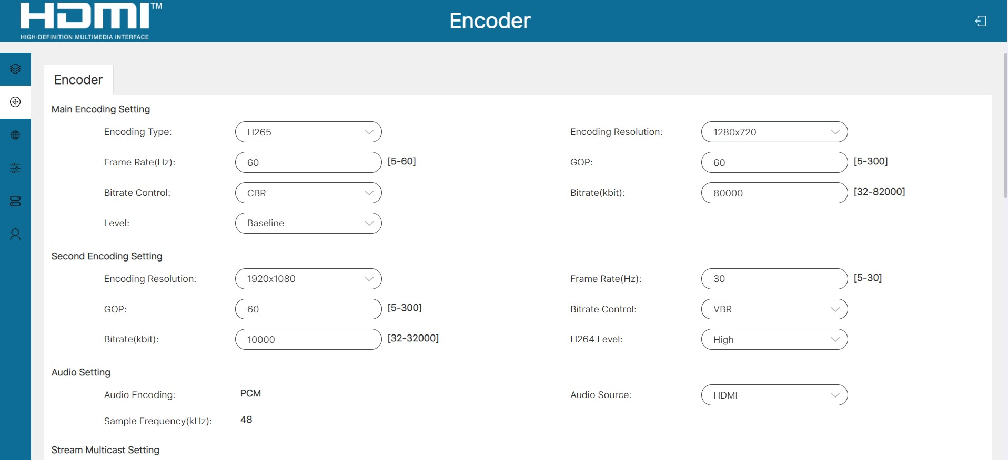

① Main Encoding Setting
Encoding Type: The encoding type, including H264 and H265. It is unique to the main stream.
Encoding Resolution: The encoding resolution, including Same as input, 3840x2160, 1920x1080, 1280x720, 640x480. Among them, Same as input and 3840x2160 are unique to the main stream. Same as input means the encoding resolution is the same as the input resolution.
Frame Rate(Hz): The encoding frame rate.
GOP: The picture group, that is, the interval between two I-frames.
Bitrate Control: The bitrate control type, including VBR (Variable Bit Rate) and CBR (Constant Bit Rate).
Bitrate(kbit): The bitrate value.
Level: The main stream supports Baseline only.
② Second Encoding Setting
Encoding Resolution: The encoding resolution, including 1920x1080, 1280x720, 640x480.
Frame Rate(Hz): The encoding frame rate.
GOP: The picture group, that is, the interval between two I-frames.
Bitrate Control: The bitrate control type, including VBR (Variable Bit Rate) and CBR (Constant Bit Rate).
Bitrate(kbit): The bitrate value.
H264 Level: The second stream supports three levels: Baseline, Main and High.
③ Audio Setting
Audio Encoding: The audio encoding type (read-only status).
Sample Frequency(kHz): The audio sample frequency (read-only status). Audio Source: You can choose whether to use HDMI or Analog as the streaming video source.
④ Stream Multicast Setting
Channel Number: The broadcast channel number of the stream. The round dot indicates the channel is available/disable. The green dot indicates that the channel is available, while the red dot indicates that the channel is disable
for there may be other devices with the same channel number as this device.
Multicast IP addresses:
The multicast addresses are automatically assigned by the device according to the channel number. (read-only status)

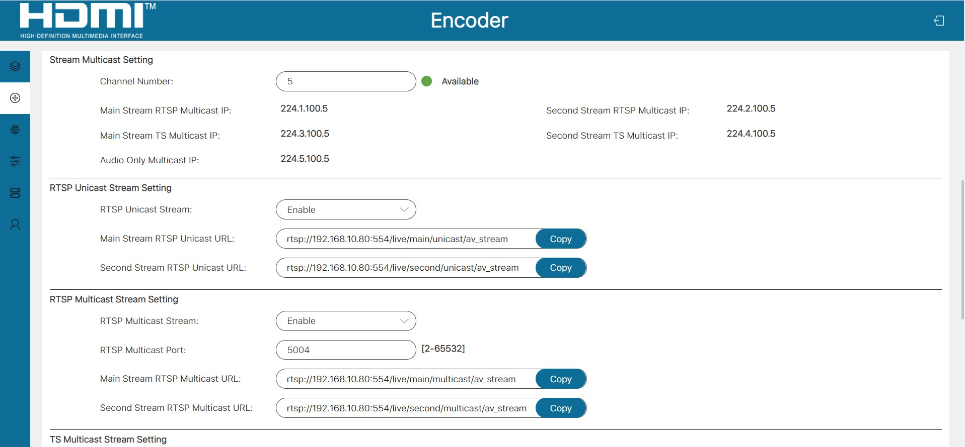
⑤ RTSP Unicast Stream Setting
RTSP Unicast Stream: Click the drop-down menu items to enable/disable the RTSP unicast stream.
Main Stream RTSP Unicast URL: The main stream RTSP unicast address. After the RTSP unicast stream is enabled, you can click “Copy” to copy the main stream RTSP unicast URL, then paste it into the media player for playback.
Second Stream RTSP Unicast URL: The second stream RTSP unicast address. After the RTSP unicast stream is enabled, you can click “Copy” to copy the second stream RTSP unicast URL, then paste it into the media player for playback.
⑥ RTSP Multicast Stream Setting
RTSP Multicast Stream: Click the drop-down menu items to enable/disable the RTSP multicast stream.
RTSP Multicast Port: The RTSP multicast stream port number. After setting, it takes effect for both the main stream and the second stream.
Main Stream RTSP Multicast URL: The main stream RTSP multicast address. After the RTSP multicast stream is enabled, you can click “Copy” to copy the main stream RTSP multicast URL, then paste it into the media player for playback.
Second Stream RTSP Multicast URL: The second stream RTSP multicast address. After the RTSP multicast stream is enabled, you can click “Copy” to copy the second stream RTSP multicast URL, then paste it into the media player for playback.

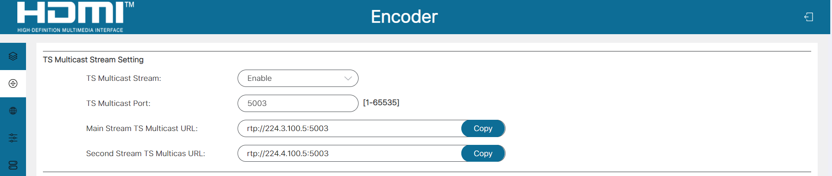
⑦ TS Multicast Stream Setting
TS Multicast Stream: Click the drop-down menu items to enable/disable the TS multicast stream.
TS Multicast Port: The TS multicast stream port number. After setting, it takes effect for both the main stream and the second stream.
Main Stream TS Multicast URL: The main stream TS multicast address. After the TS multicast stream is enabled, you can click “Copy” to copy the main stream TS multicast URL, then paste it into the media player for playback.
Second Stream TS Multicast URL: The second stream TS multicast address. After the TS multicast stream is enabled, you can click “Copy” to copy the second stream TS multicast URL, then paste it into the media player for playback.
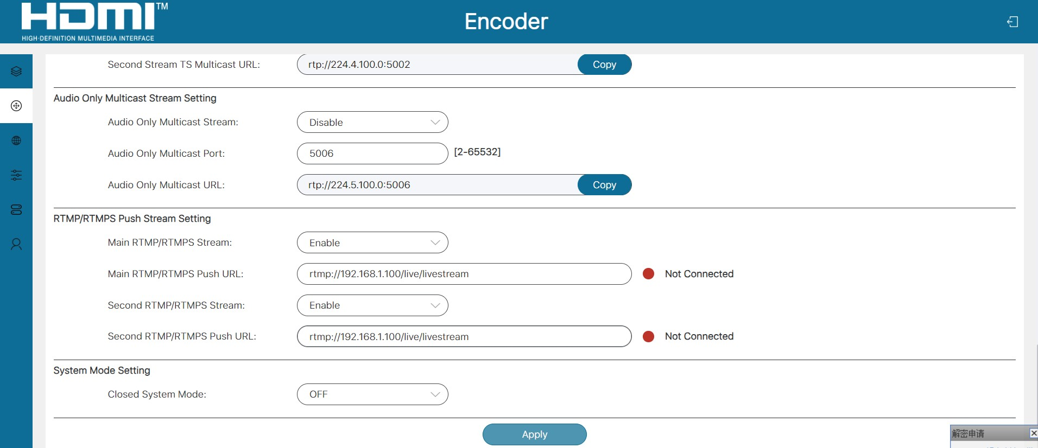
⑧ Audio Only Multicast Stream Setting
Audio Only Multicast Stream: Click the drop-down menu items to enable/ disable the audio only multicast stream.
Audio Only Multicast Port: The audio only multicast stream port number.

Audio Only Multicast URL: The audio only multicast address. After the audio only multicast stream is enabled, you can play audio only multicast stream
on computer through the corresponding software such as VLC media player.
⑨ RTMP/RTMPS Push Stream Setting
Main RTMP/RTMPS Stream: Click the drop-down menu items to enable/ disable the main RTMP/RTMPS stream.
Main RTMP/RTMPS Push URL: The website of the main RTMP/RTMPS push stream. The push stream will start only when “Enable” is selected. If there is no push stream or the push stream fails, the status light shows as a red dot, and the push stream shows as a green dot if the push stream is normal.
Second RTMP/RTMPS Stream: Click the drop-down menu items to enable/ disable the Second RTMP/RTMPS stream.
Second RTMP/RTMPS Push URL: The website of the second RTMP/ RTMPS push stream. The push stream will start only when “Enable” is selected. If there is no push stream or the push stream fails, the status light shows as a red dot, and the normal push stream shows as a green dot if the push stream is normal.
After setting the encoding attribute, stream, channel and audio, please click “Apply” to take effect.

Network
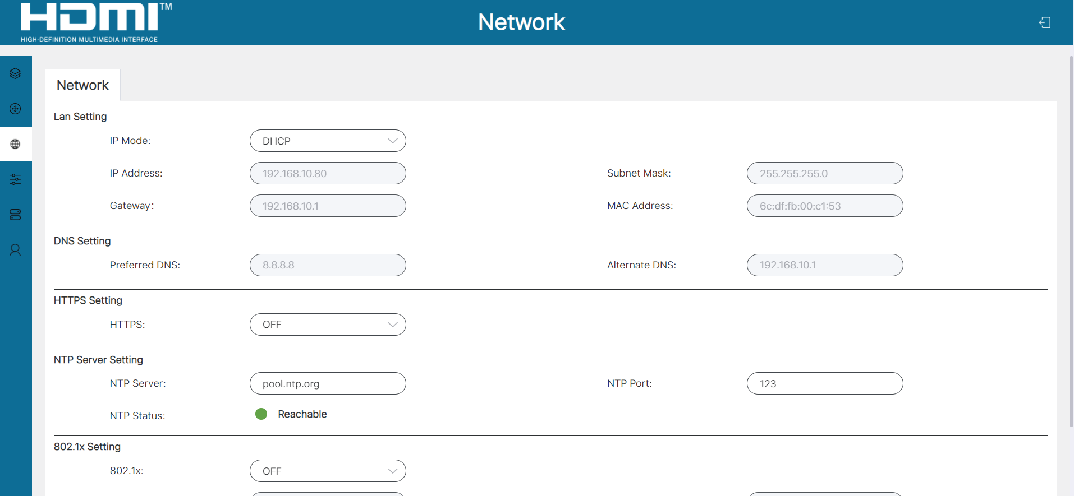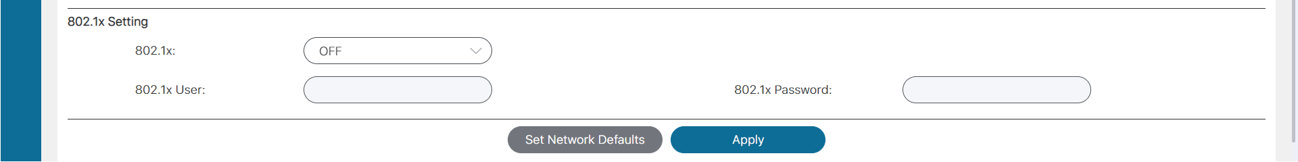

① LAN Setting
Select to set the IP Mode (DHCP/Static). When Static is selected, you can manually set the IP address, Subnet Mask and Gateway, then click “Apply” to take effect. When DHCP is selected, the IP attributes will be assigned by the router or other DHCP server automatically.
② DNS Setting
It displays the preferred DNS and alternate NDS (read-only status).
③ HTTPS Setting
The system uses HTTP to login by default. When the switch is turned to ON, the HTTPS function is enabled. The system will reboot after switching between HTTP and HTTPS.
④ NTP Server Setting
NTP Server: The address of the NTP server.
NTP Port: The access port of the NTP server.
NTP Status: The access status of the NTP Server. The green dot indicates normal access to the NTP server, the red dot indicates failure to access the NTP server.
⑤ 802.1x Setting
802.1x: Click the drop-down menu to select ON/OFF to enable/disable the 802.1x function.
802.1x User: The login username.
802.1x Password: The login password.
Set Network Defaults: Click this button to restore the network settings to the default state.
Apply: Click this button to save the configured properties, otherwise the configured properties will not take effect.

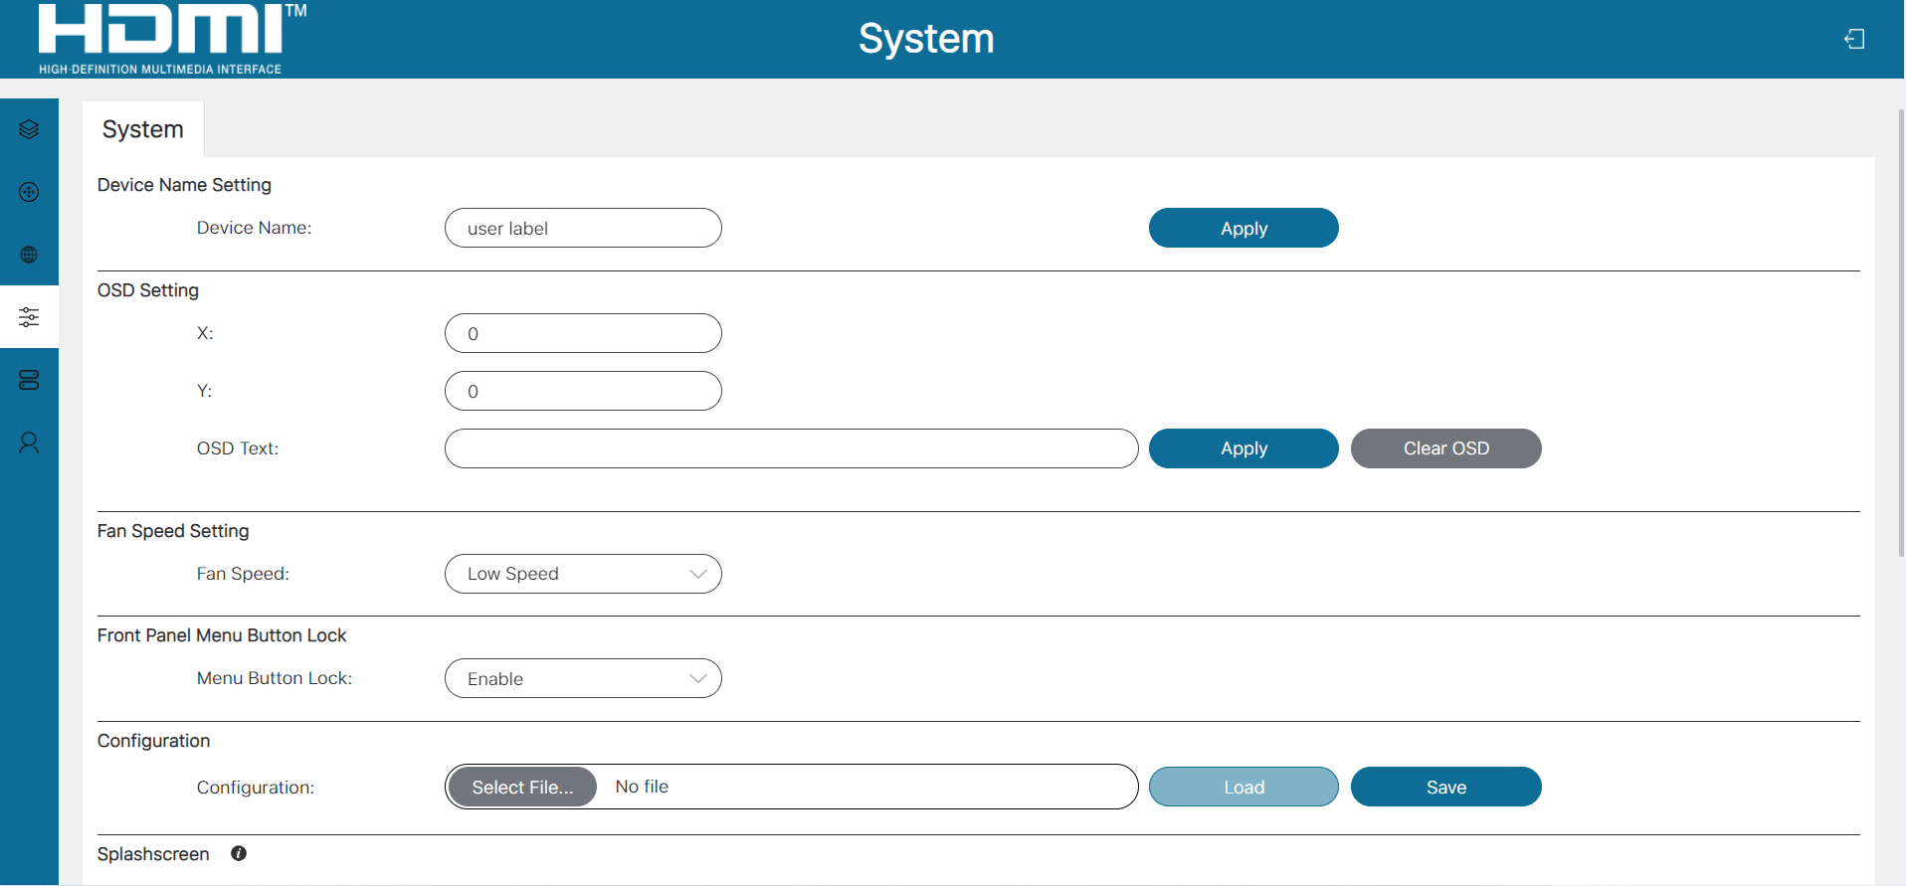
System

① Device Name Setting: The device name can be modified. Input the new name, then click “Apply” to take effect.
② OSD Setting
X: The horizontal coordinate of the OSD display, originating from the top left of the screen, from left to right.
Y: The vertical coordinate of the OSD display, originating from the top left of the screen, from top to bottom.
OSD Text: Input the contents of the OSD display in the input box, then click “Apply” to display the OSD. Clicking “Clear OSD” will clear the OSD display.
③ Fan Speed Setting
Fan Speed: Click the drop-down menu to select the fan speed (Silent/Low Speed/Standard Speed/High Speed).
④ Front Panel Menu Button Lock
Menu Button Lock: Click the drop-down menu to select “Enable/Disable” to enable/disable the MENU button on the front panel.
⑤ Configuration
Download configuration: Click the “Save” button to export the current device configuration file to the computer.
Upload configuration: Click “Select File” to select the configuration file to be imported, then click “Load” to upload the file.
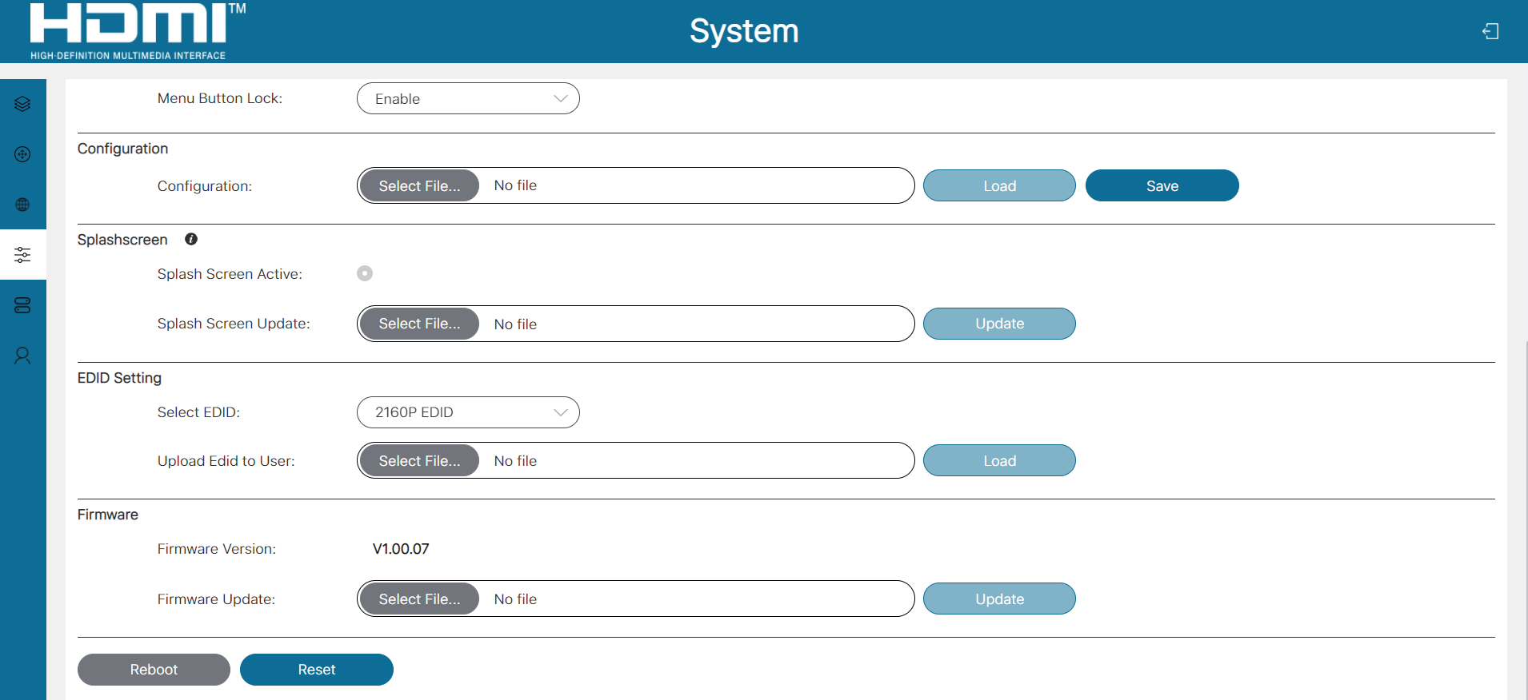

⑥ Splashscreen
Splash Screen Active: The dot indicates the image upload status. The gray dot indicates that the image displayed by Splashsreen has not been uploaded, the green dot indicates that the image displayed by Splashsreen has been uploaded.
Splash Screen Update: Click “Select File” to select the picture file to be uploaded, then click “Update” to upload the picture.
⑦ EDID Setting
Select EDID: Click the drop-down menu to select the desired EDID.
Upload EDID to User: Click “Select File” to select the EDID file (a binary file containing 256 bytes of EDID data), then click “Load” to start upload.
Note: For user-defined EDID uploading, you should firstly click “Select File” to import the EDID file, then select “User EDID”.
⑧ Firmware
Firmware Version: The version of the current firmware.
Firmware Update: Click “Select File” to select the firmware file to be updated, then click “Update” to start update.
Reboot: Click “Reboot” to reboot the device.
Reset: Click “Reset” to restore the device to factory settings.

Device List
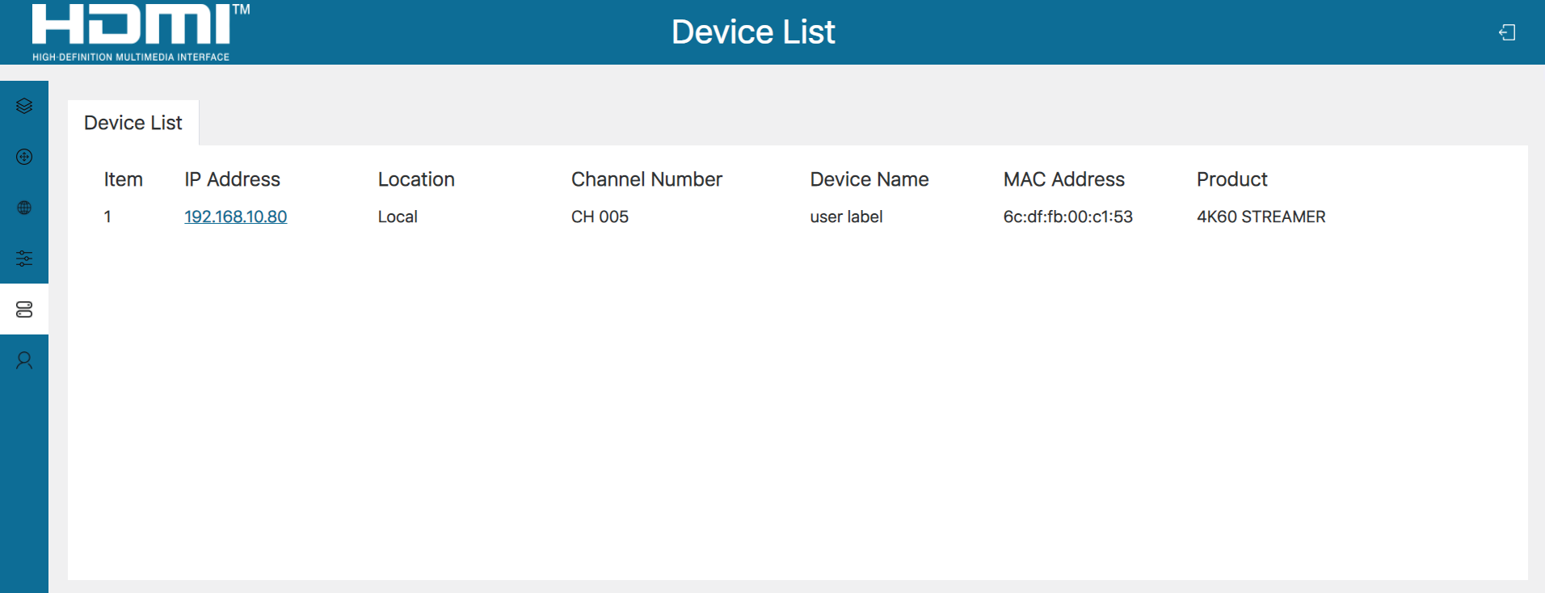
This page displays information about all devices that can be searched for on the network.
IP Address: The IP address of the device.
Location: This item indicates whether the device is local or not.

Channel Number: The device channel number. If the channel number is in conflict between two devices, both of them will be displayed in red.
Device Name: The name of the device.
MAC Address: The MAC address of the device.
Product: The model of the product.

Admin
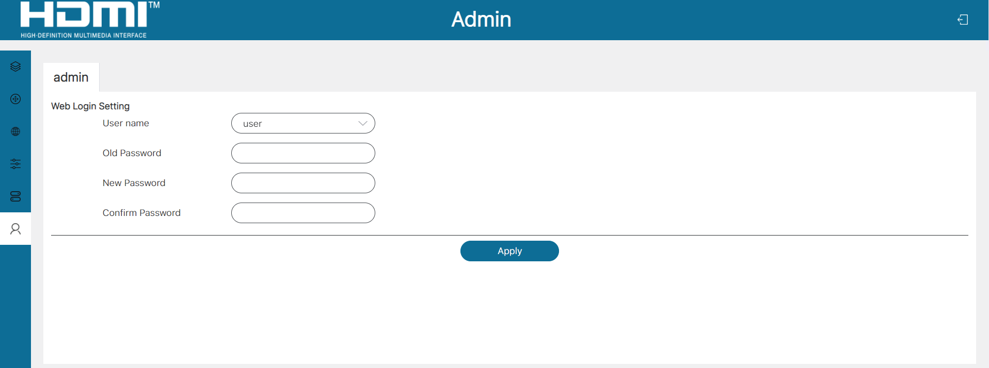
You can modify the Web login password for admin/user. After inputting the old password, new password and confirm password, click “Apply” to take effect.

RTSP/TS Stream Operation
This AV Streamer supports playing RTSP/TS stream on computer through the corresponding software such as VLC media player, simultaneously you can access the build-in Web GUI to configure the stream.
The operation steps show as below.
Step 1: Enable the RTSP/TS stream on the Encoder page of the Web GUI, as shown in the figure below.

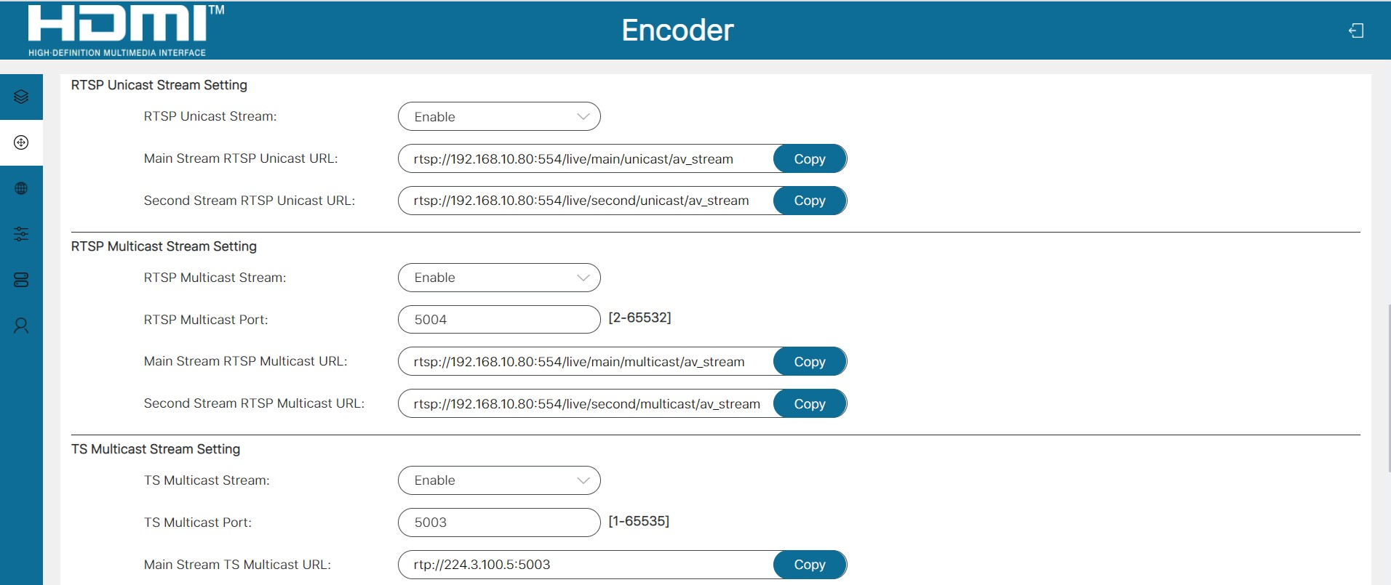
Step 2: Click the “Copy” button behind the RTSP/TS stream to be played to copy the stream URL.
Step 3: Install the VLC media player software (https://www.videolan.org/) on PC.

Step 4: After successful installation, open the VLC media player on PC. Please see the icon below.

Step 5: Click “Media > Open Network Stream”.
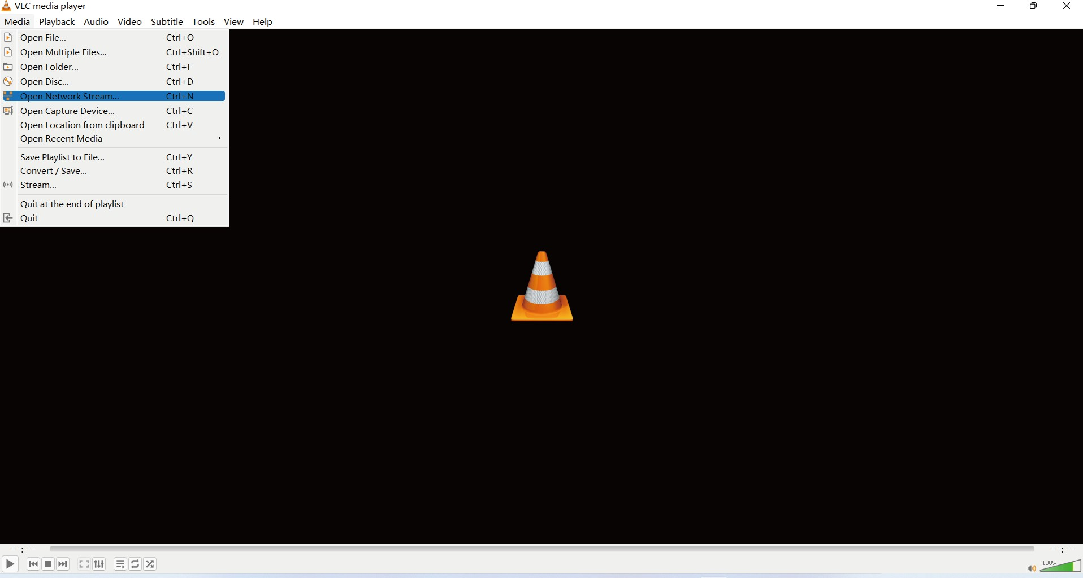

After clicking the “Open Network Stream” option, the Open Media window will pop up. Paste the RTSP/TS stream URL into the URL input box, then click the “Play” button to start playing stream.
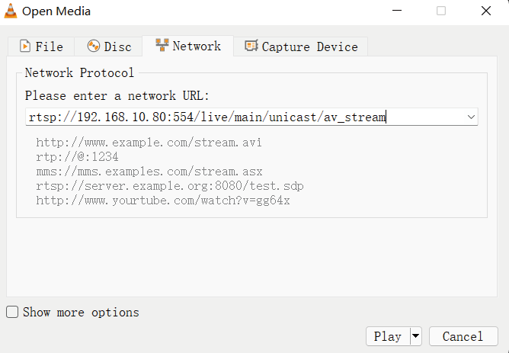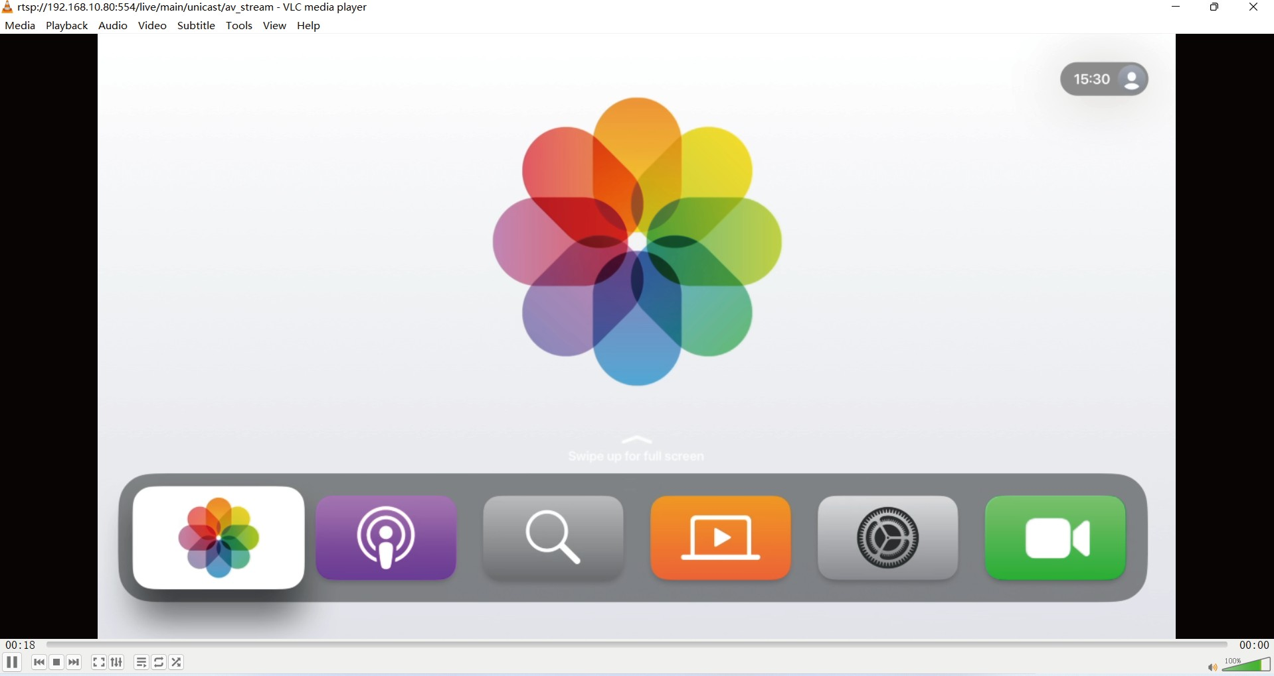

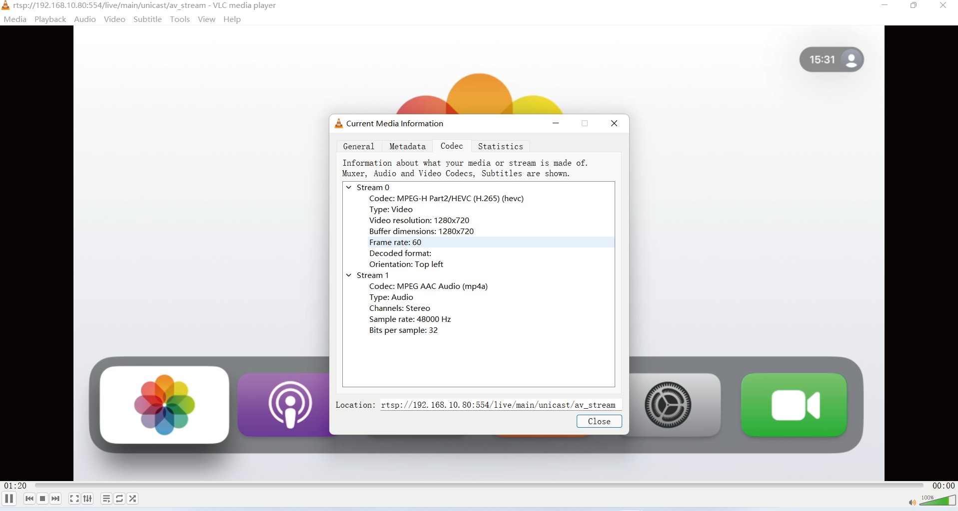
On VLC media player, you can view the TS/RTSP stream settings that are configured on the “Encoder Page” (for details, please refer to “7.2 Web GUI Operation). Choose “Tools > Codec Information” to display the stream information in the pop-up window as shown below.
Choose “Tools>Codec Information>Statistics” to check the current bitrate. Please see the following picture.
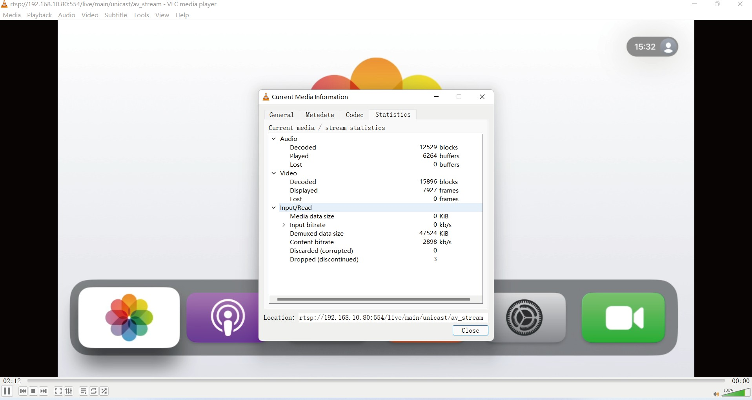
Note: The bitrate is floating up and down when you check it. This is a normal phenomenon.

RTMP/RTMPS Push Stream (Youtube) Operation
This AV Streamer supports RTMP/RTMPS push stream on computer through the corresponding website such as Youtube, simultaneously you can access the build-in Web GUI to configure the push stream.
The operation steps show as below.
Step 1: Login to https://www.youtube.com/ and click on the create icon to start uploading.
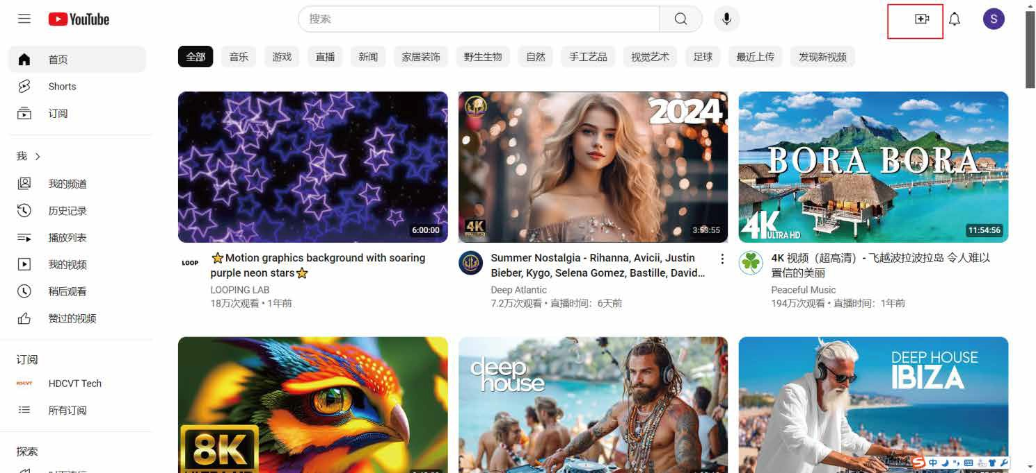
Step 2: Obtain the URL of the RTMP/RTMPS push stream.
RTMP is used by default, according to the following information, the RTMP push stream URL is
rtmp://a.rtmp.youtube.com/live2/589x-m3g8-cw98-hrcp-a34k

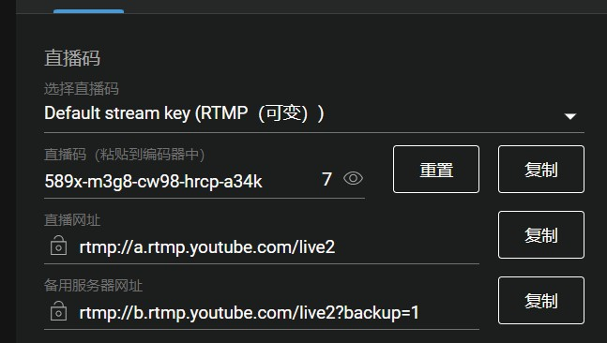Live stream key
Select the live stream key
(RTMP (variable) ) Live stream key (pasted into editor)

Live stream URL

Backup Server URL

Reset Copy Copy
Copy

Click the icon to obtain the URL of the RTMPS push stream, according to the following information, the RTMPS push stream URL is rtmps://a.rtmps.youtube.com/live2/589x-m3g8-cw98-hrcp-a34k
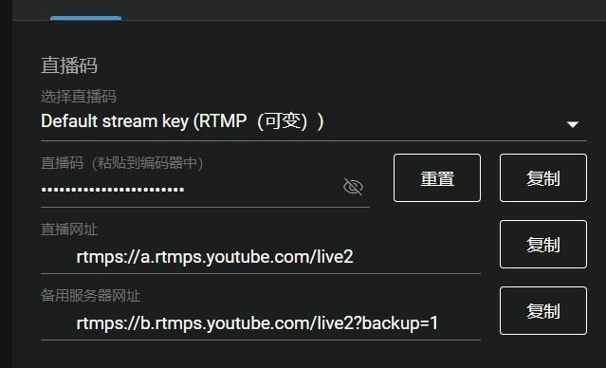
Live stream key
Select the live stream key
(RTMP (variable) )

Live stream key (pasted into editor)
Reset
Copy
Live stream URL
Copy
Backup Server URL
Copy

Step 3: Start the push stream.
Fill in the Main RTMP/RTMPS PUSH URL with the push stream URL and enable it by selecting “Enable” from the drop-down menu.
rtmps://a.rtmps.youtube.com/live2/589x-m3g8-cw98-hrcp-a34k

Manually refresh the page and wait for the red dot to turn into a green dot, indicating that the push stream is successful.

Audio Only Stream Operation
This AV Streamer supports playing audio only multicast stream on computer through the corresponding software such as VLC media player, and you can simultaneously access the build-in Web GUI to configure the stream.
The operation steps show as below.
Step 1: Enable the Audio Only Multicast Stream on the Encoder page of the Web GUI, as shown in the figure below.
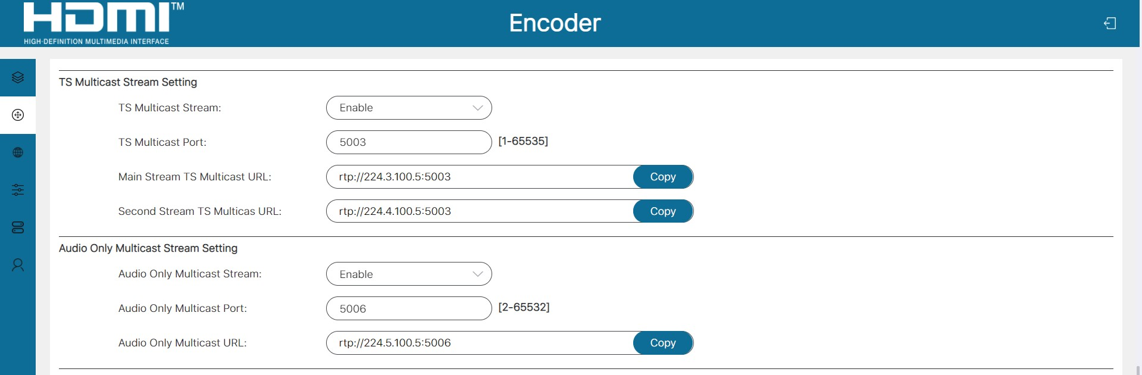
Step 2: Open a serial command tool on PC, as shown in the figure below, input the Module IP (192.168.10.80) of the device, and the Port (8000), then click “Connect” to connect with the device.
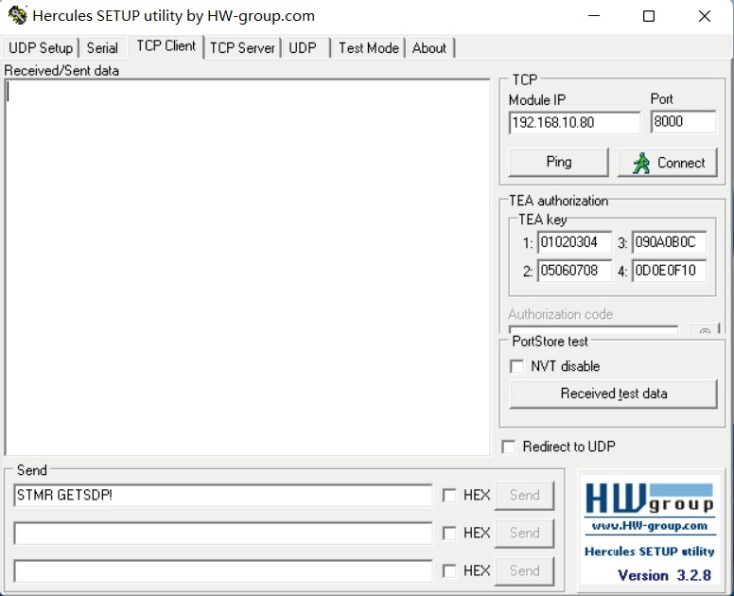

Step 3: Input the command “STMR GETSDP!” and click “Send”, then you will get the feedback, as shown in the figure below.
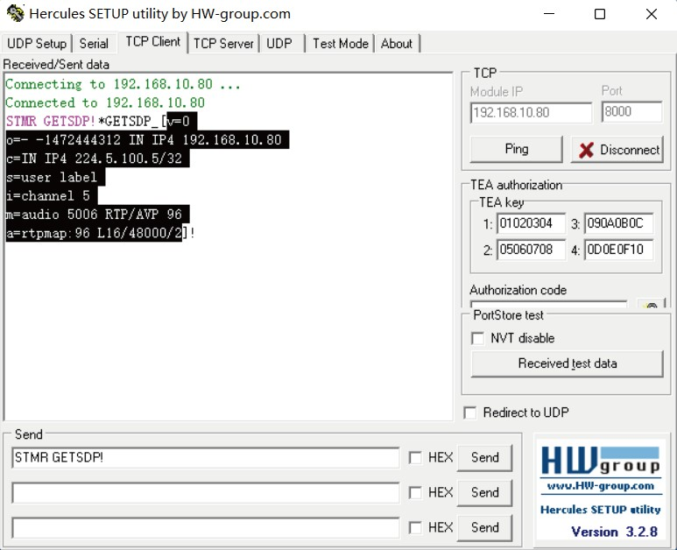
Step 4: Copy the obtained configuration file (selected part in the figure above), then paste it in the new-created notepad (or directly overwrite the content of the provided RTP_AUDIO-STREAM-PCM.sdp file). Finally, save the file with the name of “RTP_AUDIO-STREAM-PCM.sdp”, as shown below.
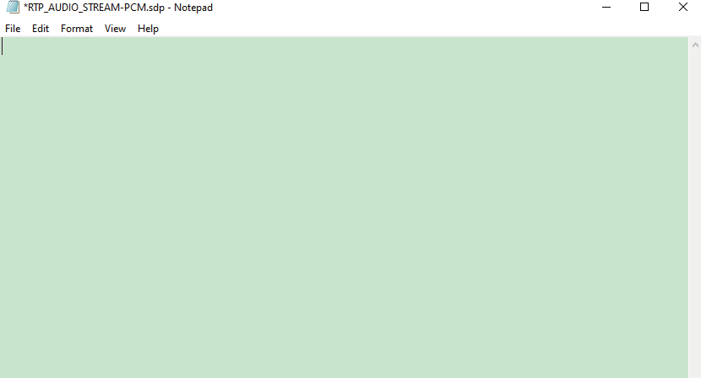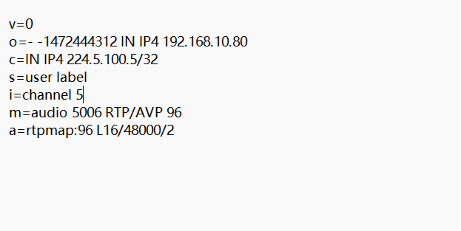

Step 5: Open the VLC media player on PC, click “Media > Open File” to import the sdp file, then the audio only multicast stream will start to play.
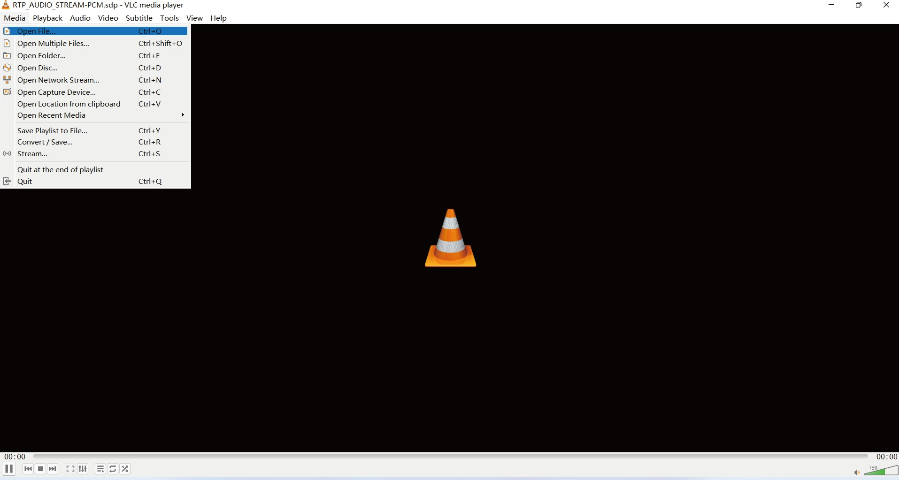
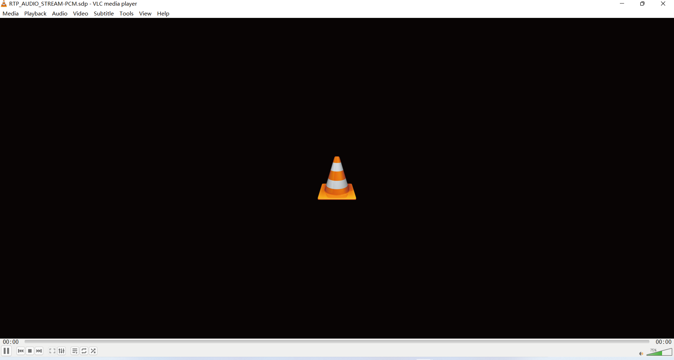

Application Example

1G Network Switch

Speakers

Ampliﬁer

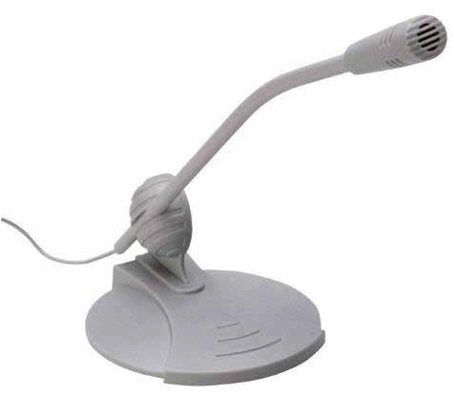HDMI CAT AUDIO

RTMP / RTMPS

RTSP

RTSP

RTSP / RTMP
/ RTMPS
AV Streamer

Router

PC VLC

TV App
Microphone

RTMP /RTMPS

Social Media Server Router Pad Phone PC TV


The terms HDMI and HDMI High-Definition Multimedia interface, and the HDMI Logo are trademarks or registered trademarks of HDMI Licensing LLC in the United States and other countries.

