ALT-SHARE
Quick Start Guide v1.1

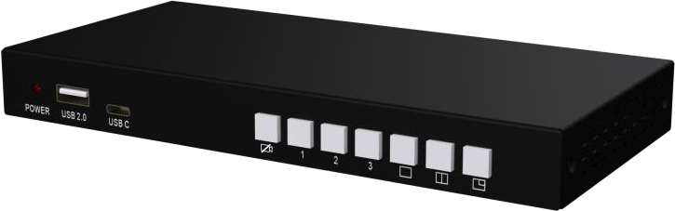

front panel:

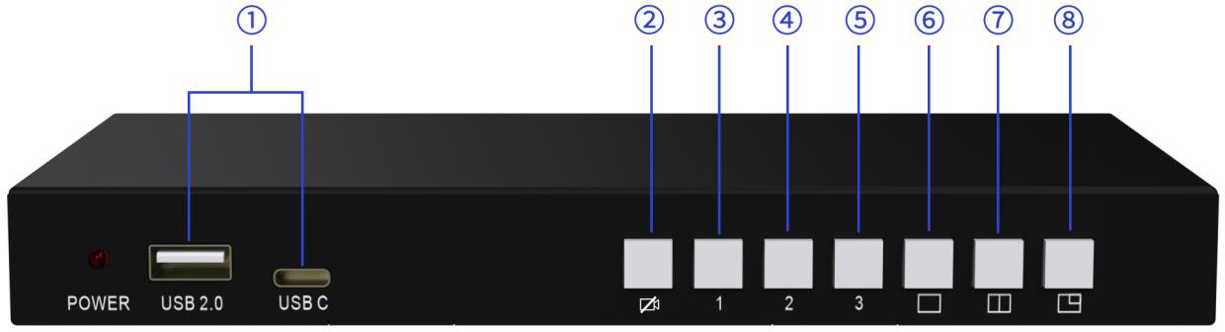

rear panel:

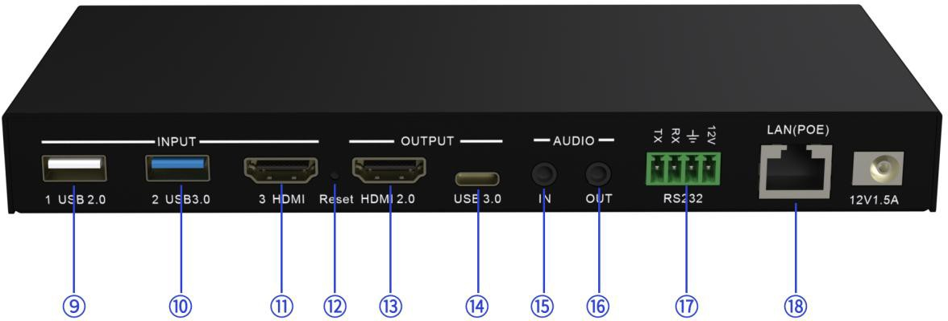

Reserved for future use Mute button
1
2
Switch the source from USB 2.0 Switch the source from USB 3.0 Switch the source from HDMI Single view layout
3
4
5
6
Side by side layout Big & small layout 1x USB 2.0 camera 1x USB 3.0 camera
7
8
9
10
1x HDMI camera or video source Reset
11
12
1x HDMI 2.0 output for screen
13
1x USB-C output for PC 1x line in
14
15
1x line out
16
1x RS232 for control
17
1x 1000M LAN for control and PoE
18

System Diagram:

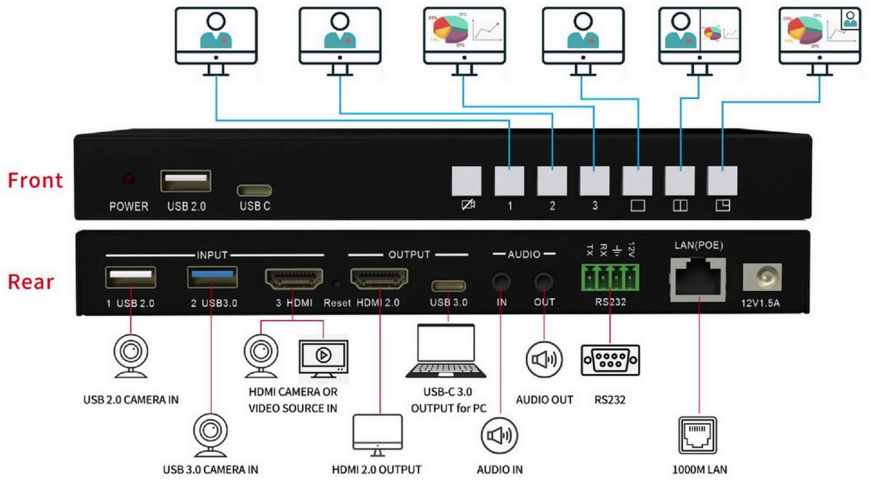

Specifications:
-Supports 3 camera sources connection, 1x USB 3.0, 1x USB 2.0, 1x HDMI 1.4
-HDMI input can be any HDMI source like laptop, document camera
-Seamless switching between 3 input sources
-Mix videos from 3 input sources
-Mixed layout can be defined in the web like picture in picture, side by side, big and small.
-1x HDMI 2.0 output for local monitor, 1x USB-C (UVC/UAC) output for PC
-Enable mute video/audio to video conferencing or live broadcasting
-Support overlay company logo or text on the output video (future firmware)
-Audio I/O and mixer through the web
-Controllable by LAN & RS-232
-PoE supported, saving additional PSU
-Cost-effective, reliable and simple to install (no driver required)
-Compact and slim housing design with only 18mm height

Front user button:

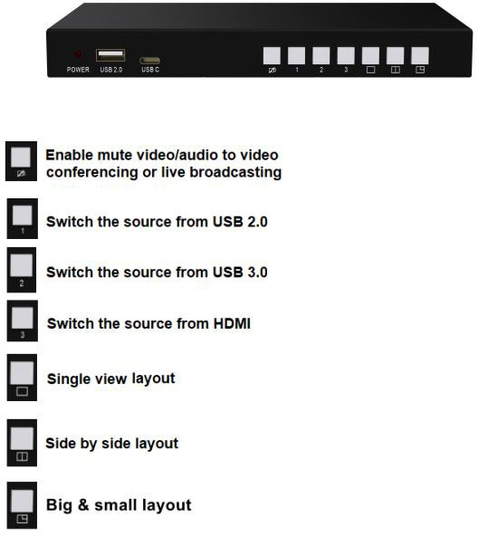

Quick to Start

Power on & Video Switching.

  - Run video conferencing software, such as Zoom, Microsoft Teams, etc.
Note: the HDMI output will show the default homepage without camera activated, it will sync the video image once camera source is selected during video conferencing.
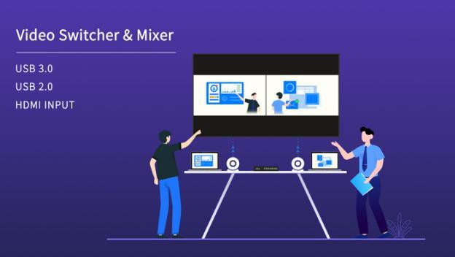

  - Select [VM10 Camera], will output the video source from USB 2.0 by default
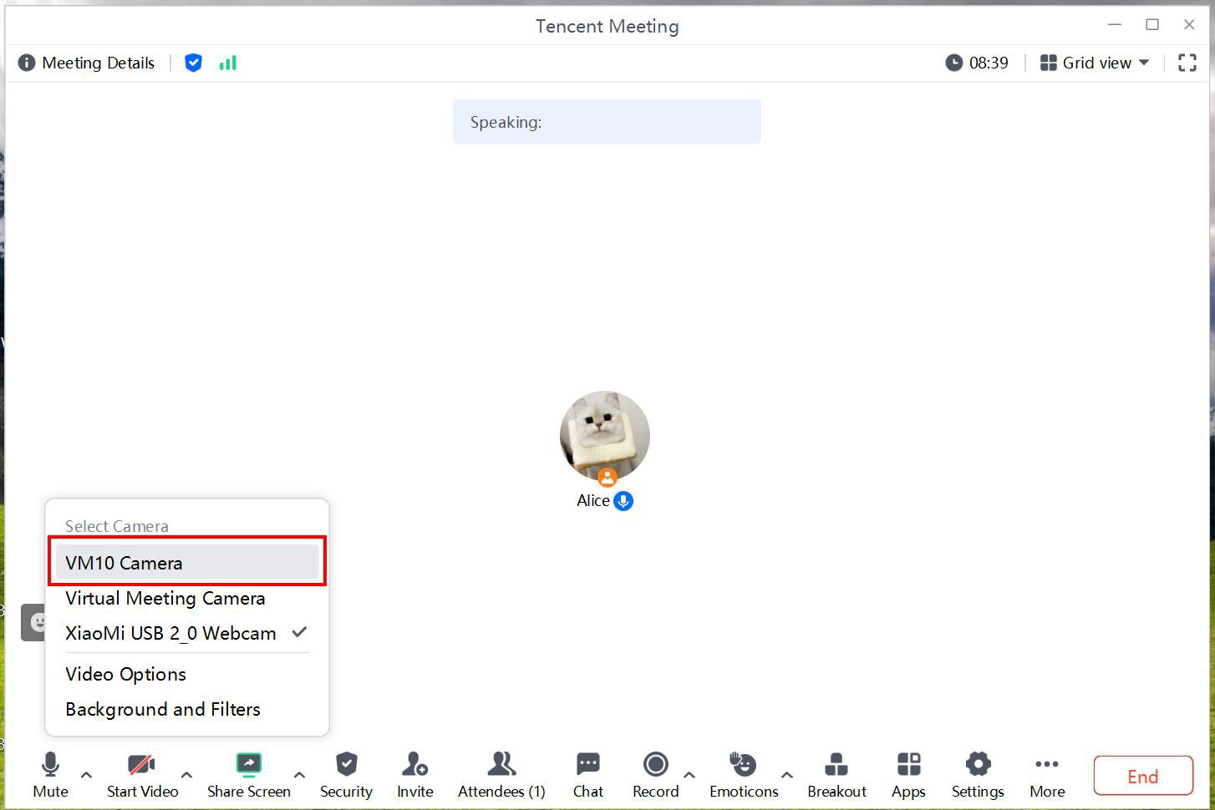

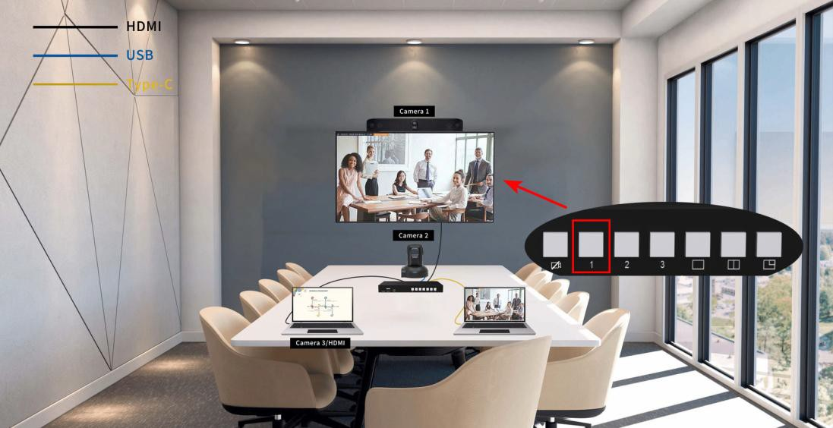

  - Click the [button 2], switch the source from USB 3.0
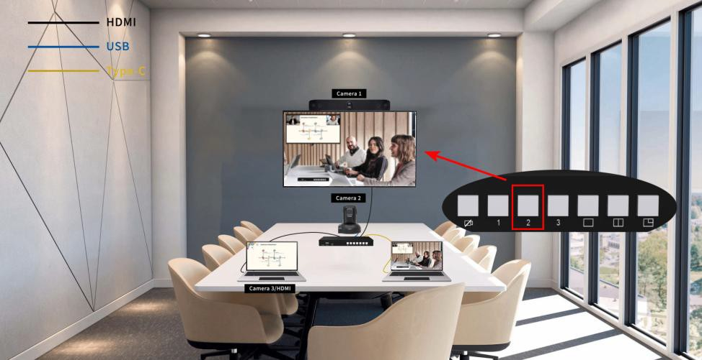

  - Click the [button 3], switch the source from HDMI
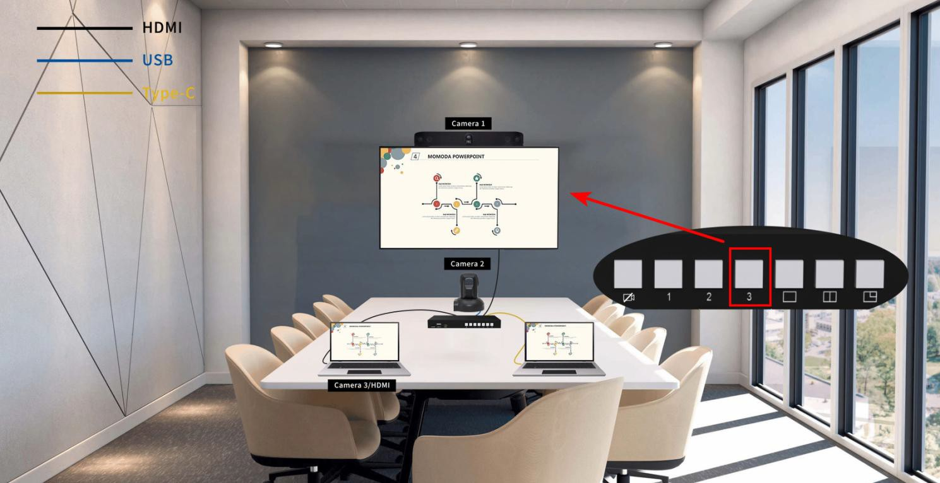

Mixed layout

  - Single view layout
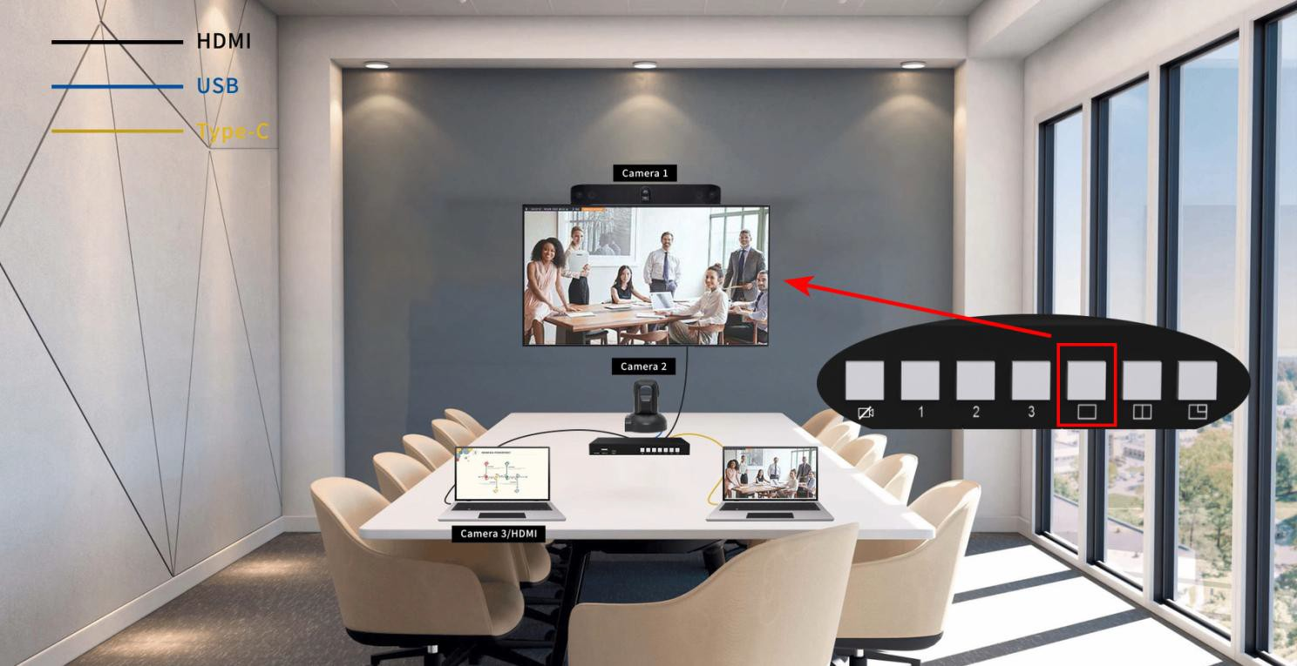

  - Side by side layout.

-firstly click this button to enter this layout, then click any 2 buttons of 3 video sources to make them mixed
-double click the button to swap the position of two sources
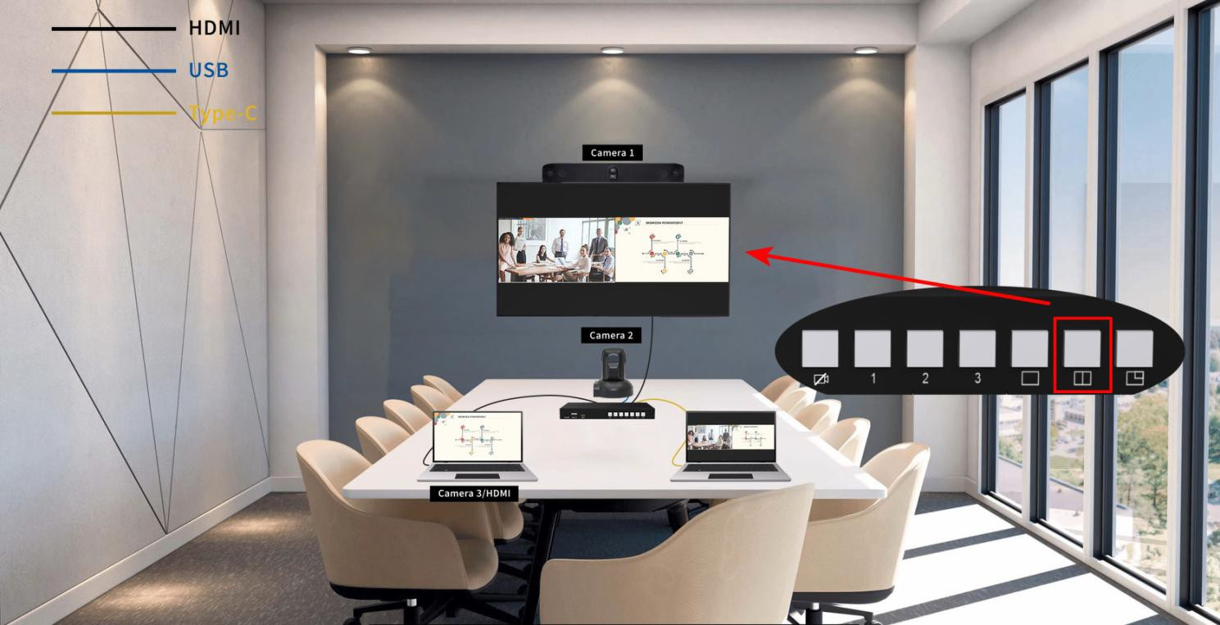

  - Big & small layout, double click the button to swap the position of two sources

-firstly click this button to enter this layout, then click any 2 buttons of 3 video sources to make them mixed
-double click the button to swap the position of two sources
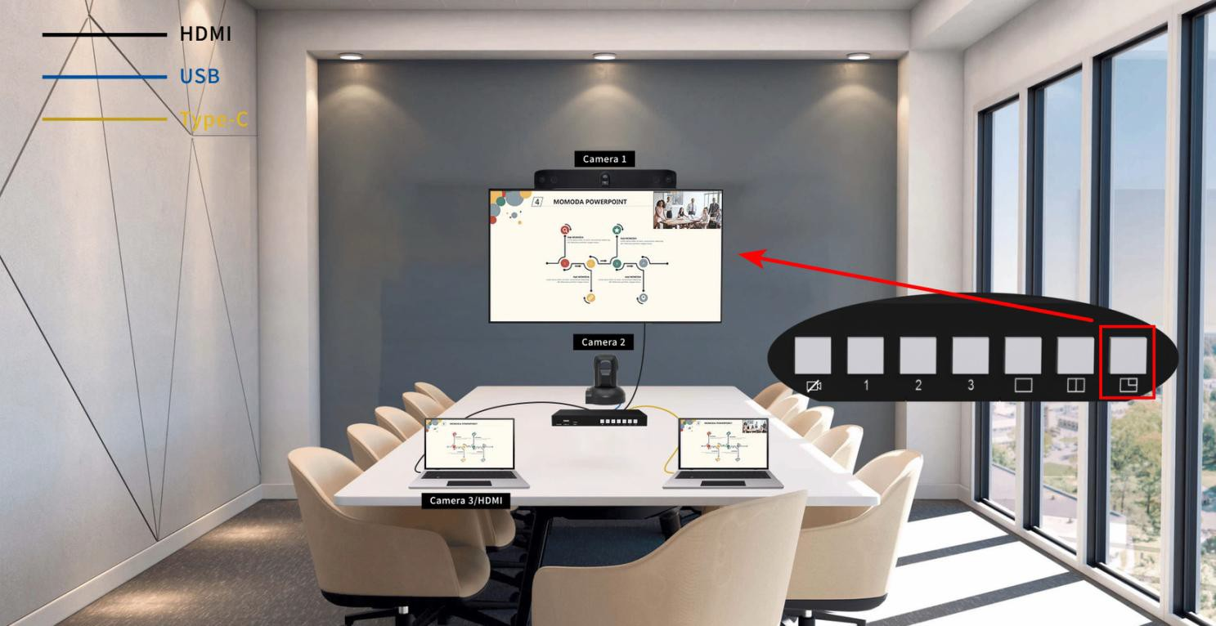

  - Enable mute video/audio to video conferencing or live broadcasting
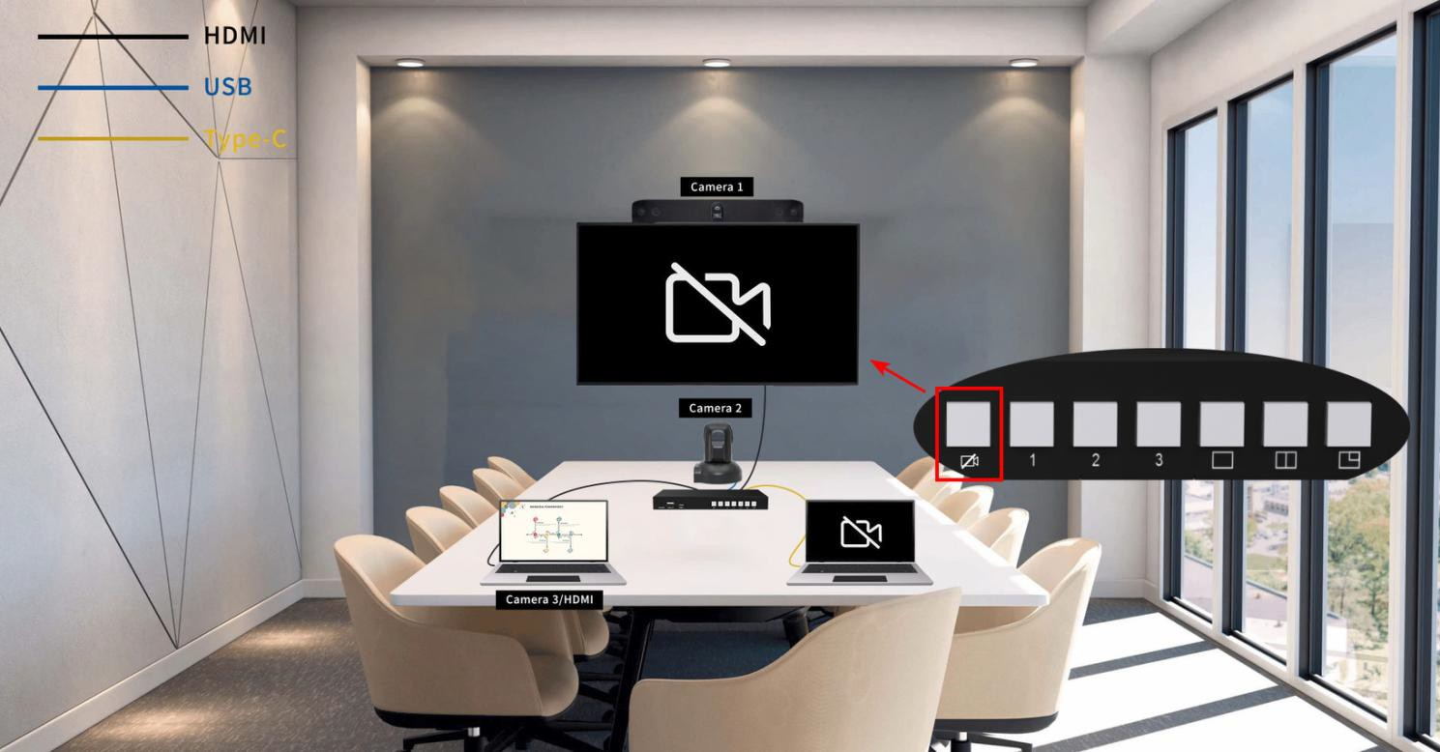

Audio I/O and setting through the web
  - use the LAN IP address indicated in the home page to enter the Web UI.（Password is admin）
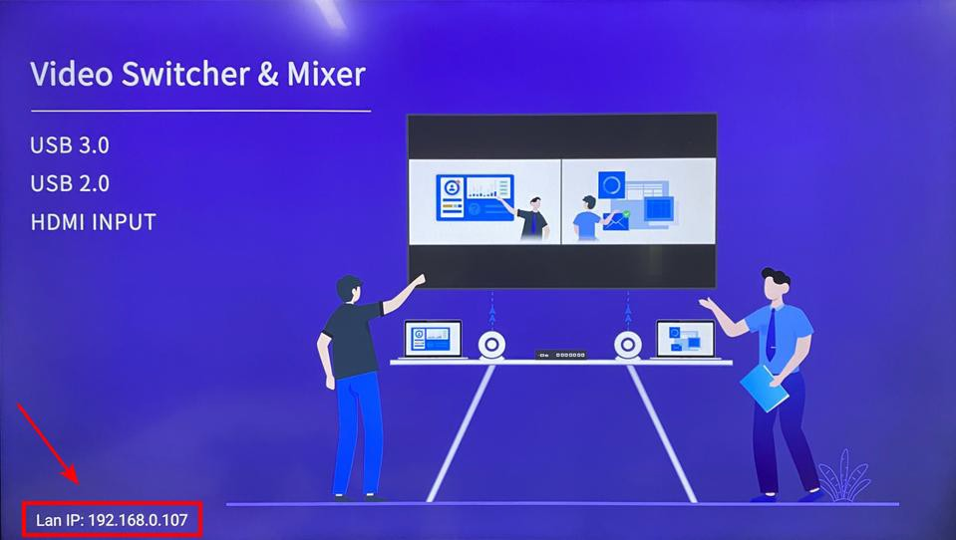

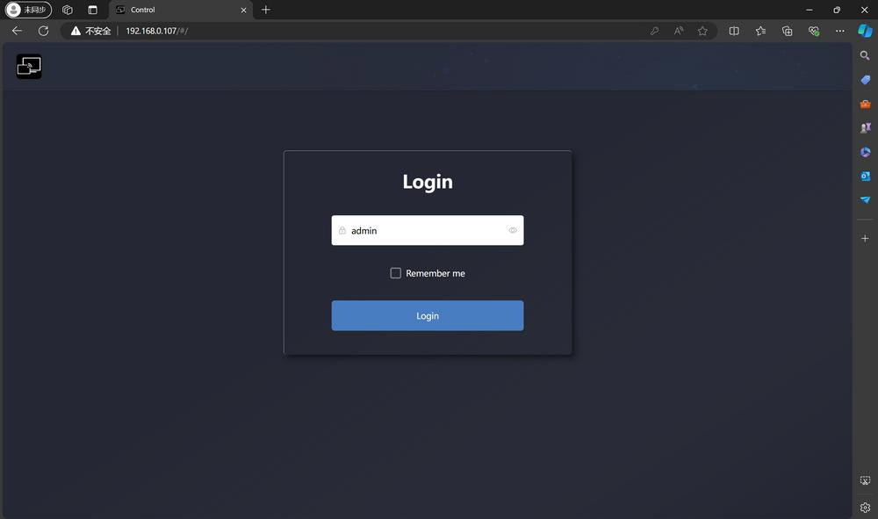

  - Click the [Audio Setting]
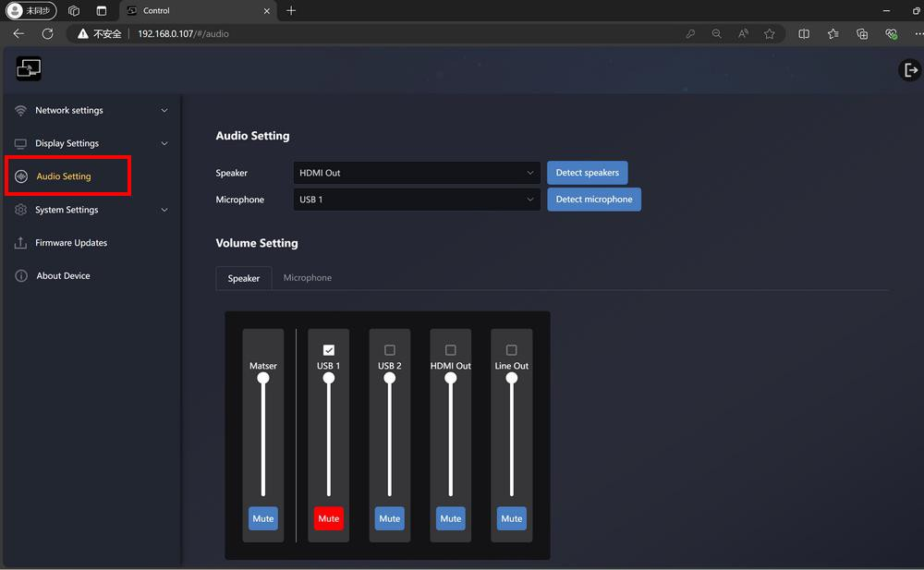

  - Select the audio from corresponding sources as UAC signal, supporting volume control and mute for each source.
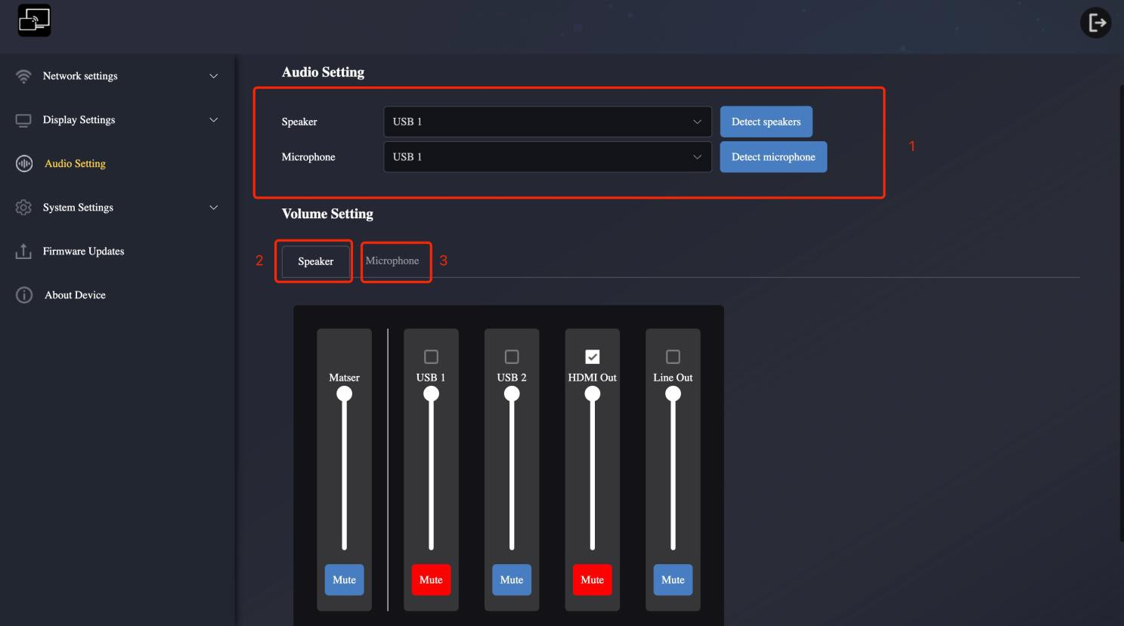

-part 1 is for testing speaker and microphone from connected sources
-part 2 is for selecting source for speaker out
-part 3 is for selecting sources for mic in, can be mixed with difference sources.

  - The [Success] prompt box will pop up on the right when the setting is completed.
