ALT-IPT4KSDV

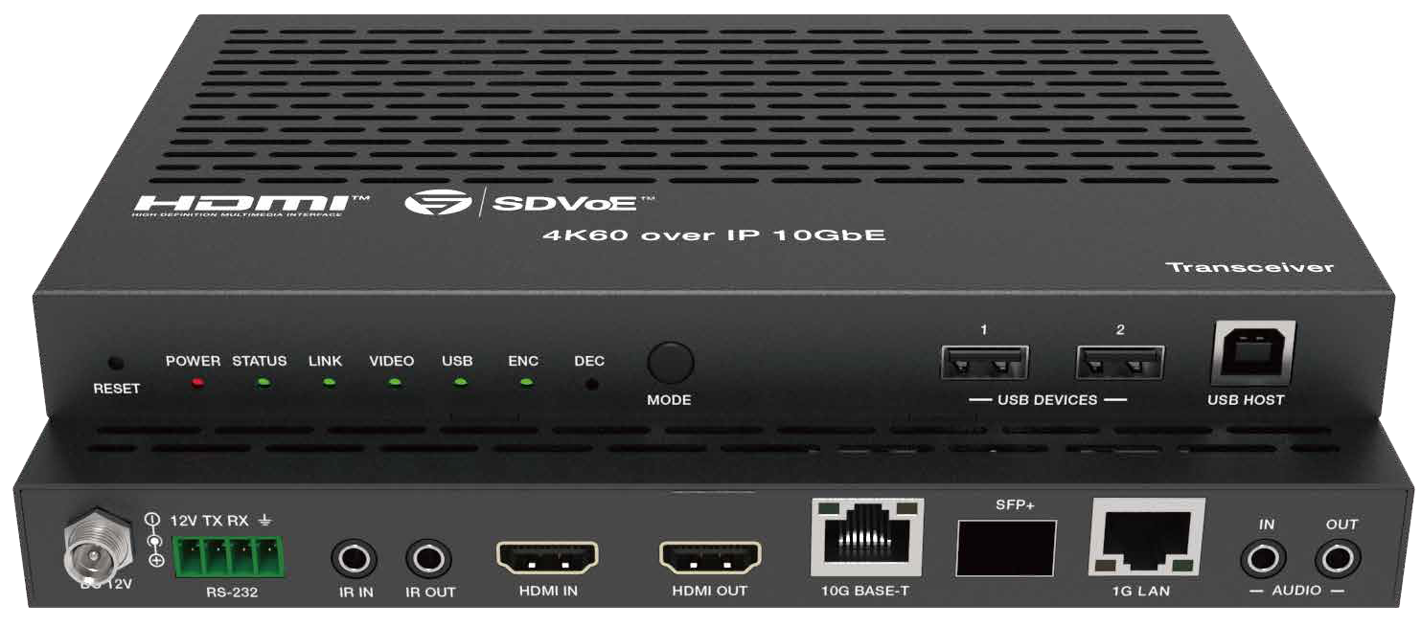


VER 1.1

Thank you for purchasing this product
For optimum performance and safety, please read these instructions carefully before connecting, operating or adjusting this product. Please keep this manual for future reference.

Surge protection device recommended
This product contains sensitive electrical components that may be damaged by electrical spikes, surges, electric shock, lighting strikes, etc. Use of surge protection systems is highly recommended in order to protect and extend the life of your equipment.

Table of Contents
- Introduction. 1
- Features. 1
- Package Contents. 2
- Specifications. 2
- Operation Controls and Functions. 4
  - Front Panel. 4
  - Rear Panel. 5
  - IR Pin Definition. 6
- Rack Mounting Instruction. 6
  - 6U Rack Mounting. 6
  - 1U Rack Mounting. 8
- Preview Stream Introduction. 9
  - Connecting Web for Control. 9
  - VLC Media Player Instruction 14
- Switch Model 17
- SDVoE System Control. 18
- Application Example. 18

Introduction
This transceiver is an SDVoE-Compliant, All-In-One AV over IP solution that provides highest-quality, uncompressed 4K and zero-frame latency audio/ video extension over a standard 10G Copper or Fiber Network Switch with instant switching, Video Wall and MultiView functions. It can transfer advanced HDMI content such as HDR (high dynamic range), full color-depth and multi- channel HD Bitstream audio. Flexible transceiver design (one box can be set to encoder or decoder) is much convenient in a real installation site and inventory control. Its built-in Secondary Stream supports a high quality, bandwidth configurable H.264/H.265 compression video stream for portable device preview purpose. Multiple control and data signals can be transmitted along with audio and video signals simultaneously, including bi-directional IR, RS-232, USB KVM, CEC and 1G Ethernet.

Features
☆ HDMI 2.0b and HDCP 2.2 compliant
☆ Support video resolution up to 4K@60Hz 4:4:4, 18Gbps video bandwidth
☆ Flexible transceiver design (Encoder, Decoder, Copper and Fiber ports within a single box)
☆ Encoder or Decoder mode can be set via Button or API
☆ Automatic detection of Fiber and Copper ports (priority can be set)
☆ Encoder supports HDMI Loop out
☆ Support HDR10, Dolby Vision, HLG, 3D as well
☆ Support full HDMI audio formats, up to Dolby TrueHD, Dolby Atmos and DTS-HD, DTS:X
☆ Support Zero-Frame latency operating mode
☆ Support signal extension, seamless switching, Matrix, Video Wall up to 9x9 and MultiView up to 25 windows
☆ Flexible audio routes control including bidirectional analog audio transmissions between Encoder and Decoder
☆ Built-in H.264/H.265 Secondary Stream (SS) for preview
☆ Support Secondary Stream VLAN tagging and parameters configuration
☆ Support bi-directional IR and RS-232 control signal pass-through
☆ Support USB2.0 (KVM), CEC routing control
☆ Support IR, RS-232, TCP/IP, Web GUI control
☆ Standard POE supported (802.3at PD device)
☆ 10G managed network switch

Package Contents
① 1 x SDVoE Transceiver
② 1 x 12V IR Receiver cable (1.5 meters)
③ 1 x IR Blaster cable (1.5 meters)
④ 1 x 4pin-3.81mm phoenix connector
⑤ 1 x 12V/2.5A Locking power adapter
⑥ 2 x Mounting ears
⑦ 4 x Machine screws (KM3*6)
⑧ 1 x User Manual
MAC Address Label (stuck on the back of the product): MAC 1: SDVoE MAC address
MAC 2: USB2.0 MAC address
MAC 3: Secondary Stream (SS) Module MAC address

Specifications

Technical
HDMI Compliance | HDMI 2.0b
HDCP Compliance | HDCP 2.2
Video Bandwidth | 18Gbps
Input Format | 10GBaseT
Network Video Bandwidth | 10G
Video Resolution | Up to 4K@60Hz 4:4:4
Color Space | RGB, YCbCr 4:4:4 / 4:2:2 / 4:2:0
Color Depth | Full Color-Depth
HDR | HDR, HDR 10, HDR10+, Dolby Vision, HLG
HDMI Audio Formats | LPCM, Dolby Digital/Plus/EX, Dolby True HD, Dolby Atmos, DTS, DTS-EX,DTS-96/24, DTS High Res, DTS-HD Master Audio, DSD, DTS:X
Analog Audio Formats | Left and Right stereo analog audio
Transmission Distance | 100m (CAT6A/7) / 70m (CAT6)

ESD Protection | Human body model — ±8kV (Air-gap discharge) &  ±4kV (Contact discharge)
Connection
Input ports | 1 x HDMI IN [Type A, 19-pin female]  1 x USB 2.0 HOST [Type B, 4-pin female] 1x IR IN [3.5mm Jack]  1x AUDIO IN [3.5mm Jack]  1 x RS-232 [4-pin phoenix connector]
Output ports | 1 x HDMI OUT [Type A, 19-pin female] 1x AUDIO OUT [3.5mm Jack]  1 x IR OUT [3.5mm Jack]  2 x USB 2.0 DEVICE [Type-A, 4pin female]
Network ports | 1 x 10G BASE-T [RJ45 jack]  1 x 10G SFP+ [Fiber slot] 1 x 1G LAN [RJ45 jack]
Mechanical
Housing | Metal Enclosure
Color | Black
Dimensions | 204mm [W] x 134mm [D] x 21.5mm [H]
Weight | 693g
Power Supply | Input: AC100 - 240V 50/60Hz,  Output: DC 12V/2.5A  (US/EU standards, CE/FCC/UL certified)
Power Consumption | ≈13.5W
Operating  Temperature | 32 - 104°F / 0 - 40°C
Storage Temperature | -4 - 140°F / -20 - 60°C
Relative Humidity | 20 - 90% RH (no-condensing)
Resolution / Cable Length | 4K60 -  Feet / Meters | 4K30 -  Feet / Meters | 1080P60 -  Feet / Meters
HDMI IN / OUT | 16ft / 5M | 32ft / 10M | 50ft / 15M
The use of “Premium High Speed HDMI” cable is highly recommended.

Operation Controls and Functions

Front Panel
POWER STATUS LINK VIDEO USB ENC DEC
RESET
MODE
USB DEVICES
USB HOST
1 2 3 4 5 6 7 8 9
10
11

No. | Name | Function Description
1 | RESET button | Restore default settings button. Press and hold this button for 5 seconds in the power-on state to restore the default settings.
2 | POWER LED  (Red) | When the product is powered on, the red power LED will be on.
3 | STATUS LED  (Green) | System status indicator.  - Light on: The system is running normally.  - Light flashing/light off: Program firmware lacking or hardware error.
4 | LINK LED  (Green) | 10G network connection indicator.  - Light on: 10G network port is connected with device.  - Light off: 10G network port is not connected with device.
5 | VIDEO LED  (Green) | Video signal detection indicator.  - ENC mode: Indicator lighting on means video input is detected.  - DEC mode: Indicator lighting on means that HDMI OUT has video signal output.
6 | USB LED  (Green) | USB connection indicator.  - Light flashing: The product is connected with USB devices, and there is data transmission.  - Light off: The product is not connected with USB devices.
7 | ENC LED  (Green) | When the device is in ENC mode, the ENC LED is always on.
8 | DEC LED  (Green) | When the device is in DEC mode, the DEC LED is always on.
9 | MODE button | Mode switch button. Press and hold the button for 5 seconds to switch ENC or DEC mode.
10 | USB DEVICES  port | USB device ports. Connect to mouse, keyboard or U Disk when the product is in DEC mode.
11 | USB HOST  port | USB HOST input port. Connect to PC when the product is in ENC mode.

Description of ENC/DEC LED: (1) When the device is powered on, the ENC/DEC LED flashes for about 15 seconds, and then keeps on, indicating the current ENC/DEC mode. Press and hold the MODE button for 5 seconds to switch to another mode. The corres- ponding ENC/DEC LED flashes for about 30 seconds and then stays on, indicating that the mode is switched successfully.
IR OUT port
(2) The user can also turn on the SHOW ME mode of the device by the Controller box. At this time, the ENC/DEC LED flashes to indicate the current corresponding ENC/DEC device, so that the user can easily find the device.

Rear Panel

SFP+
12V TX RX
IN OUT
DC 12V
RS-232
IR IN IR OUT
HDMI IN
HDMI OUT
10G BASE-T
AUDIO
1
2
3 4
5
6
7
8
9
10 11

No. | Name | Function Description
1 | DC 12V | DC 12V/2.5A power input port.
2 | RS-232 | Connect to PC or control system with a 4-pin phoenix connector cable for RS-232 signal pass-through.  ‘12V’ means that the product can supply power to the outside.
3 | IR IN port | IR signal input port.
4 | IR OUT port | IR signal output port.
5 | HDMI IN port | HDMI signal input port (ENC). Connect to HDMI source device such as DVD or Set-top box with HDMI cable.
6 | HDMI OUT port | HDMI signal output port.  - ENC mode: Used to loop out HDMI IN signal.  - DEC mode: Used to output remote Encoder video stream signal.
7 | 10G BASE-T port | 10G network cable port. Connect to 10G Switch for video transmission.
8 | SFP+ port | 10G network optical fiber port. Connect to 10G Switch for video transmission.
9 | 1G LAN port | 1G network port. Connect to the network port of the corresponding application, such as 1G Ethernet or Secondary Stream transmission.

10 | AUDIO IN | Analog audio input port. Used for stereo analog audio transmission, Secondary Stream audio embedding, HDMI audio embedding.
11 | AUDIO OUT | Analog audio output port. Used to output HDMI extracted stereo audio or output remote stereo analog audio signal.

IR Pin Definition

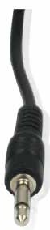
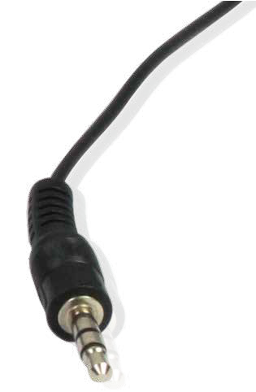
IR BLASTER IR RECEIVER

+
IR BLASTER
-

IR RECEIVER
Power 12V

Rack Mounting Instruction

6U Rack Mounting
This transceiver can be mounted in a standard 6U rack (Please contact your supplier for 6U rack sale). The mounting steps are as follows:
Step 1: Use included screws to fix two mounting ears on the transceiver, as shown in the figure below:


Step 2: Insert the transceiver with mounting ears into a 6U rack (up to 10 units can be installed vertically), as shown in the figure below:
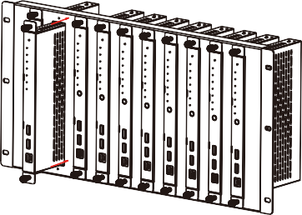

Step 3: Use screws to fix mounting ears on the rack to complete the mounting, as shown in the figure below:
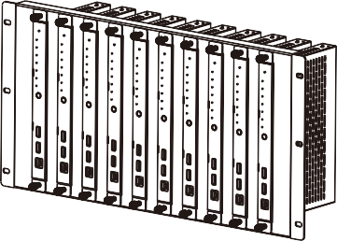

1U Rack Mounting
This transceiver also can be mounted in a standard 1U rack (up to 4 units can be installed horizontally). The mounting steps are as follows:
Step 1: Stack two transceivers on top of each other, then use included screws to fix two 1U rack panels on the transceivers, as shown in the figure below:
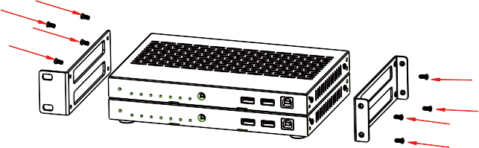

Step 2: Fix two 1U rack panels on another two stacked transceivers in the same way, then use screws to fix two 1U rack panels together, as shown in the figure below:
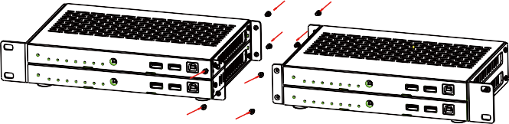

Step 3: Fasten screws between two 1U rack panels, so that four transceivers are mounted in a 1U rack, as shown in the figure below:
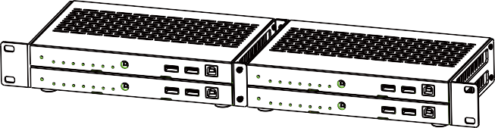

Preview Stream Introduction

Connecting Web for Control
This transceiver supports playing Secondary Stream on computer through the corresponding software such as VLC media player, simultaneously you can access the build-in Web GUI to configure the Secondary Stream.
The operation method shows as below.
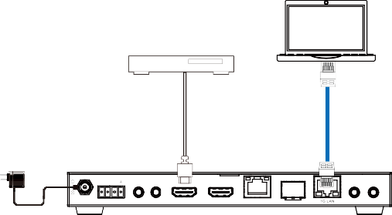Step 1: Connect the transceiver (in Encoder mode) with a PC, HDMI source device and power supply. The connection diagram is shown as below.
DVD or Blu-ray Player
PC
LAN
Power Adapter
SFP+
12V TX RX
IN OUT
DC 12V RS-232 IR IN IR OUT HDMI IN HDMI OUT 10G BASE-T
AUDIO

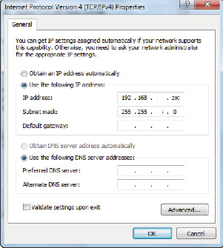
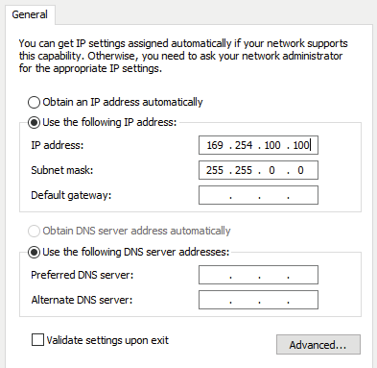
Step 2: Set the PC’s IP address to be 169.254.100.100, and the Subnet mask to be 255.255.0.0.
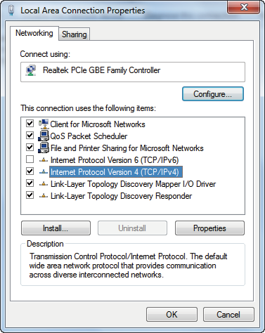
169 168 110 30
0

Step 3: Install a bonjour protocol checking tool (such as zeroconfService Browser) on PC to find the IP address of the Encoder.
Take zeroconfServiceBrowser as an example. After opening the software, you can select “Workgroup Manager” in Services of Browser, select
the Host name in Service-Instances, and find the IP address in the Address item in of Instance-Info.
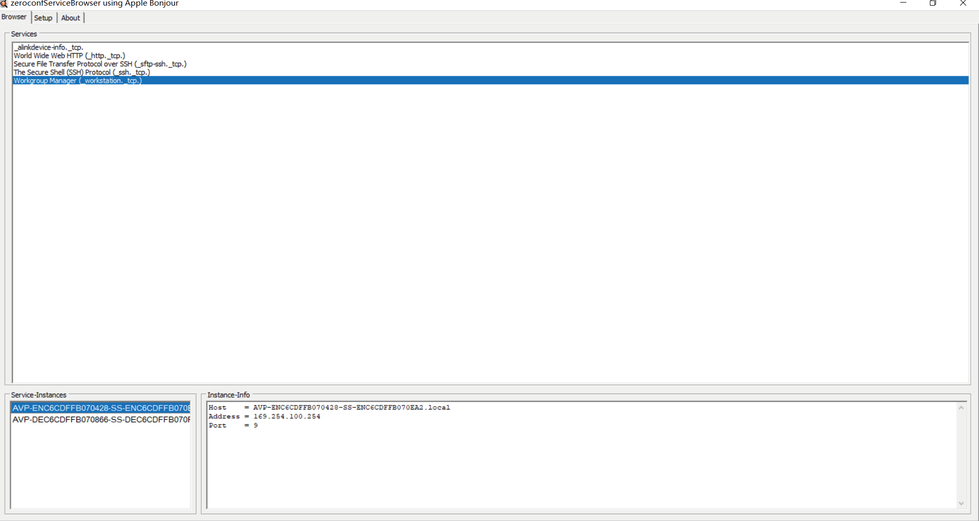
Notes:
- The window in the lower left corner displays the Host names of all SS devices in the current network.
- The window in the lower right corner displays the Host name, IP address and Port number of the selected SS device.
- The Host name of Encoder starts with AVP-ENC; the Host name of Decoder starts with AVP-DEC.

Step 4: Set the PC’s IP address to the same network segment with IP address of the Encoder Secondary Stream (SS). (If these two IP addresses are in the same network segment, you can skip this step.)

Step 5: Input the IP address of the Encoder Secondary Stream (SS) found through the bonjour protocol checking tool into the web browser on PC. The following login interface will appear.
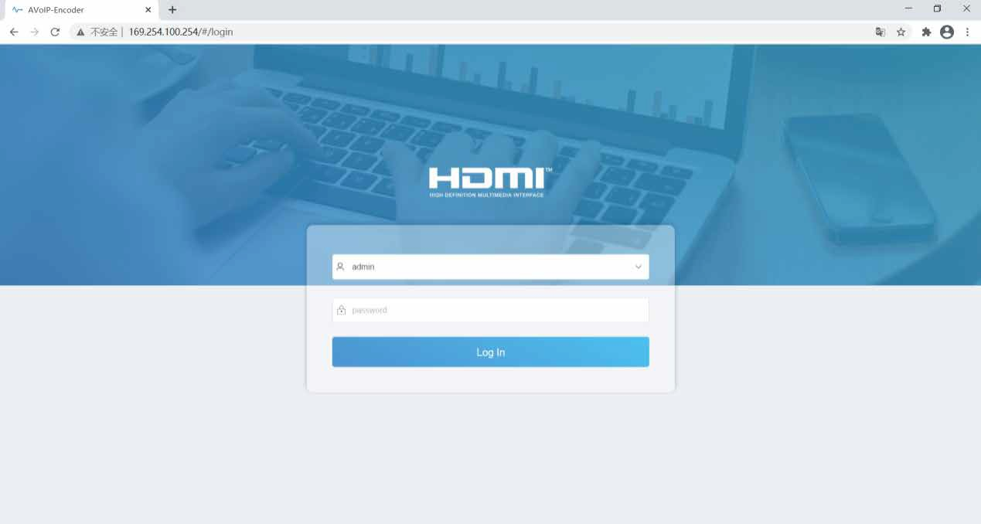

Please select the fixed user name “admin”, and Input the default password “admin”. Then click “Log In” to enter the Status page.

  - Status Page
The Status page provides basic information about the installed firmware version and the network settings.
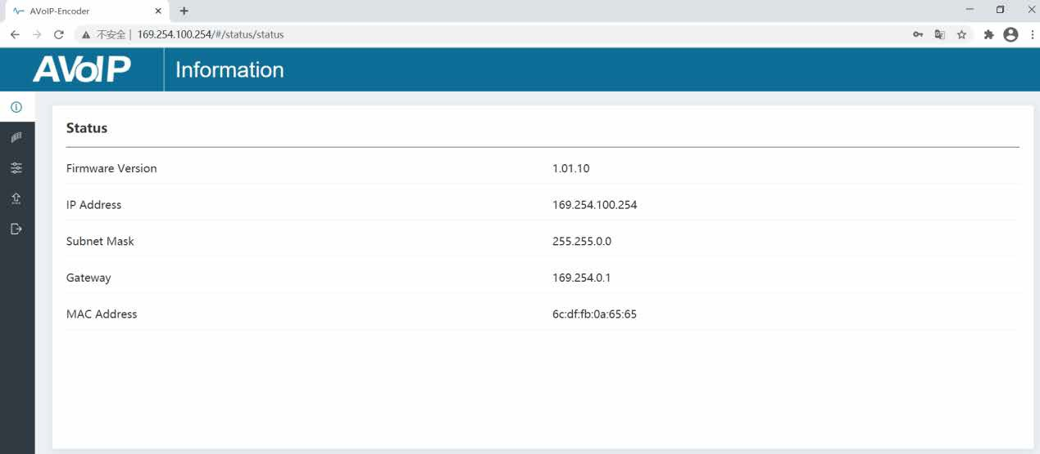

  - Video Page
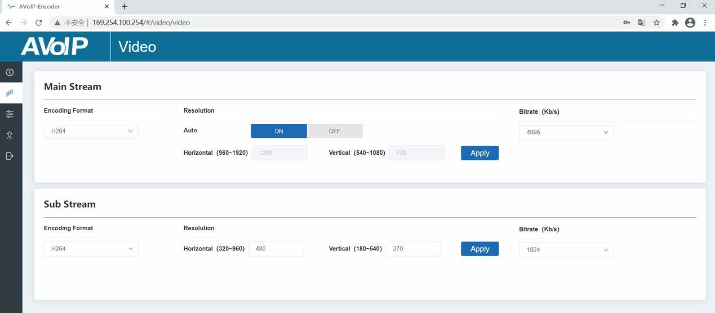
On the Video page, you can set the Main Stream and Sub Stream separately. Encoding Format can be set to H.265/H.264 according to the decoding protocol used in the 3rd party software which decodes the Secondary Stream. Pull the drop-down box to select it to take effect.
The Resolution of the Main Stream includes Auto, Horizontal and Vertical. If Auto is set to ON, the resolution will follow the input resolution. At this time, Horizontal and Vertical display the current input resolution and are grayed out

and cannot be set. If Auto is set to OFF, then Horizontal and Vertical can be set to the resolution of the Main Stream encoding. The horizontal range is 960~1920, the vertical range is 540~1080, and it needs to be an even number. Click the “Apply” button to take effect.
The Resolution of the Sub Stream includes Horizontal and Vertical. Horizontal and Vertical can be set to the resolution of the Sub Stream encoding. The horizontal range is 320~960, the vertical range is 180~540, and it needs to be an even number. Click the “Apply” button to take effect.
Bitrate is used to set the bit rate of the encoding.

  - Setting Page
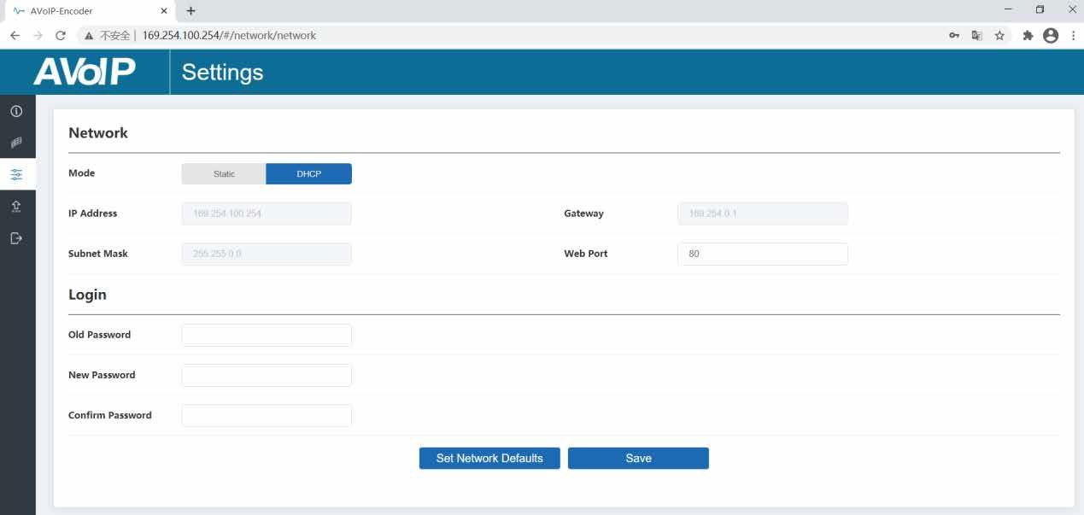
The Setting page includes two parts: Network and Login.
Network can be set to Static or DHCP. When set to Static, you can enter IP address, gateway and subnet mask; When set to DHCP, the IP address, gateway and subnet mask are grayed out and cannot be edited. A DHCP server (e.g. network router) which automatically assigns IP related settings should be installed in the system. Web Port is the port of the Web page. After setting, click “Save” to take effect. After setting the IP address, the page will automatically
switch to the set IP address. Click “Set Network Defaults”, it will be restored to the default DHCP state.

The Web login password can be changed on the “Login” part. Enter the old password in “Old Password”, enter the new password in “New Password”, enter the new password again in “Confirm Password”, and click the “Save” button to take effect.

  - Update Page
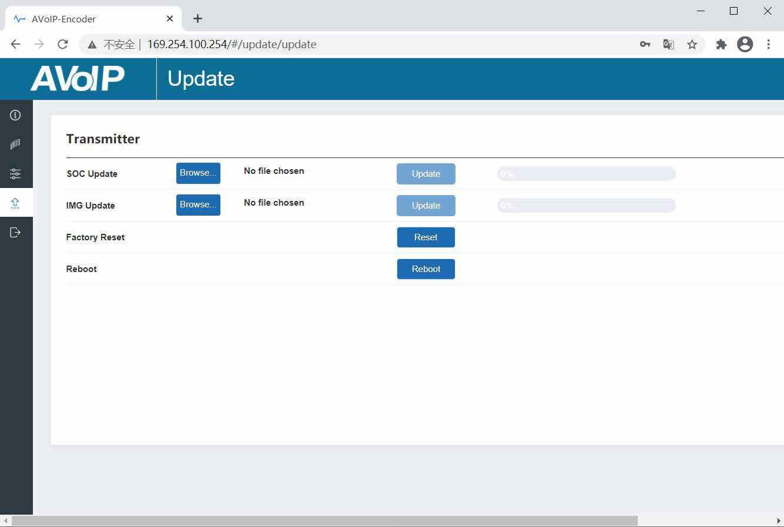
The SOC Update column is used to upgrade firmware. Click the “Browse” button to select the firmware, and then click “Update”. When the progress bar reaches 100%, the upgrade completes and the machine restarts automatically.
The IMG Update column is used to upload the no-signal picture, click the “Browse” button to select the picture in jpg format (the resolution of the picture should be less than or equal to 1920x1080, and the width should be a multiple of 8, the height should be a multiple of 2, and the size of the picture should
be less than 512kB), and then click “Update”. When the progress bar reaches 100%, the upload completes, and the machine takes effect without rebooting.

VLC Media Player Instruction
After the Web GUI is successfully connected, open the VLC media player on PC. Please see the following icon.


Click “Media > Open Network Stream”
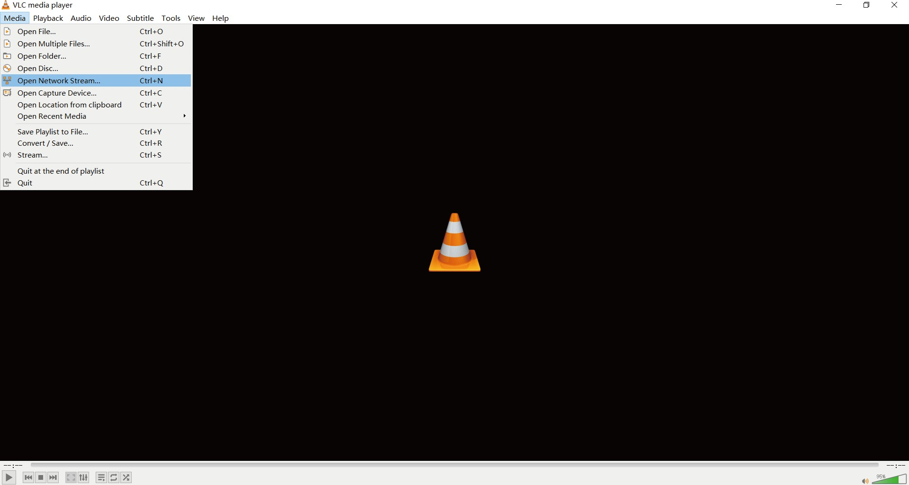

After clicking the “Open Network Stream” option, the following page will appear.
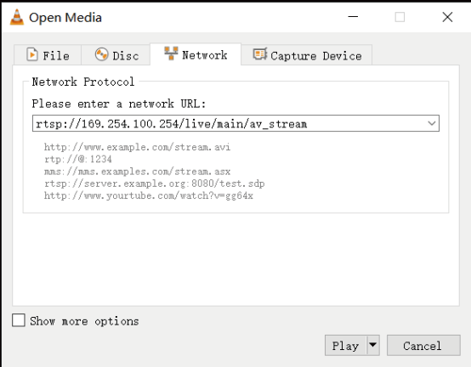

Enter a MainStream or SubStream network URL, then click “Play” button.

Stream | Network URL
MainStream | rtsp://169.254.100.254/live/main/av_stream
SubStream | rtsp://169.254.100.254/live/sub/av_stream.
Note: The default IP address of Secondary Stream is 169.254.100.254. When the IP address of the Encoder Secondary Stream (SS) found through the bonjour protocol checking tool is different from default IP address, please use it instead of the default IP address.
On the VLC media player, you can check Secondary Main Stream or Sub Stream settings that are configured on the “Video Page” (Please refer to “7.1 Connecting Web for Control” for details). Choose “Tools>Codec information”, a pop-up window will display and show you Stream information, as shown in the figure below.
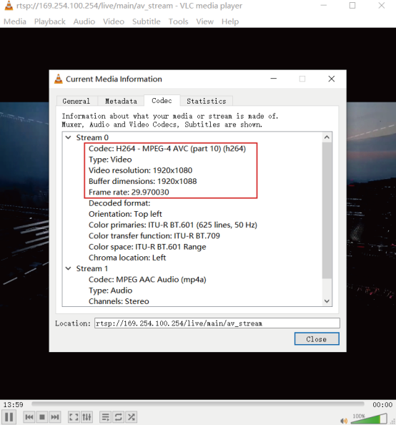

Choose “Tools>Codec information>Statistics” to check current Bitrate. Please see the following picture.

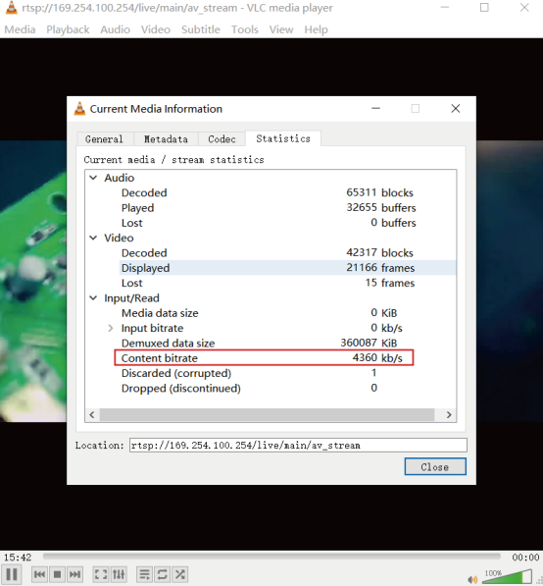
Note: The Bitrate is floating up and down when you check it. This is a normal phenomenon.

Switch Model
A network Switch used to set up the system should support below features:
- Type of layer 3/managed network Switch.
- 10 Gigabit bandwidth.
- IGMP version 2 supported.
- IGMP version 2 snooping enabled.
- Filter/Drop unregistered multicast traffic.
- Disable unregistered multicast flooding.
- Enable fast leave support.
The following Switch models are highly recommended.
Manufacturer | Model Number
Netgear | ProSAFE PLUS XS708E
Netgear | ProSAFE M4300 Intelligent Edge Series
Netgear | ProSAFE Smart XS712T
Netgear | M7300-24XF XSM7224S
Arista Networks | 7050X Series

SDVoE System Control
This transceiver can be controlled by Controller Box or third-party controller. For details of SDVoE system control, please refer to SDVoE Controller Box user manual.

Application Example

MultiView

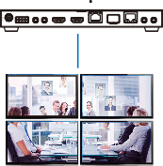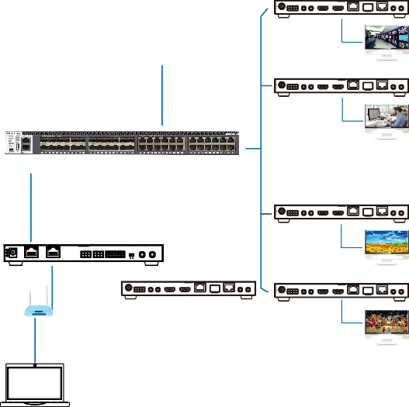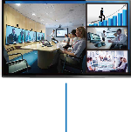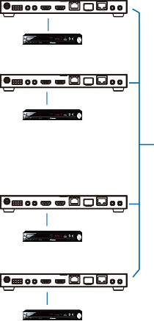Transceiver (ENC Mode) Transceiver (DEC Mode)

12V TX RX

SFP+

IN OUT

12V TX RX

SFP+

IN OUT

DC 12V RS-232 IR IN IR OUT HDMI IN HDMI OUT 10G BASE-T

AUDIO

DC 12V RS-232 IR IN IR OUT HDMI IN HDMI OUT 10G BASE-T

AUDIO

DVD

12V TX RX

DC 12V RS-232 IR IN IR OUT HDMI IN HDMI OUT 10G BASE-T

SFP+

IN OUT

AUDIO TV

Transceiver (ENC Mode)
Transceiver (DEC Mode)

Transceiver (DEC Mode)

12V TX RX

SFP+

IN OUT

12V TX RX

SFP+

IN OUT

DC 12V RS-232 IR IN IR OUT HDMI IN HDMI OUT 10G BASE-T

AUDIO

DC 12V RS-232 IR IN IR OUT HDMI IN HDMI OUT 10G BASE-T

AUDIO

DVD
TV

10G Ethernet Switch

Transceiver (ENC Mode) Transceiver (DEC Mode)

12V TX RX

SFP+

IN OUT

12V TX RX

SFP+

IN OUT

DC 12V RS-232 IR IN IR OUT HDMI IN HDMI OUT 10G BASE-T

DVD

AUDIO

Controller Box
IR IN IR OUT

VOUT

IO4 IO3 IO2 IO1
IO LEVEL

DC 12V RS-232 IR IN IR OUT HDMI IN HDMI OUT 10G BASE-T

AUDIO

Transceiver (ENC Mode)

DC 12V

1 RS-232 2

5V 12V

12V TX RX

SFP+

IN OUT
TV
Transceiver (DEC Mode)
SFP+

12V TX RX

SFP+

IN OUT

DC 12V RS-232 IR IN IR OUT HDMI IN HDMI OUT 10G BASE-T

AUDIO

DC 12V
12V TX RX

RS-232 IR IN IR OUT

HDMI IN HDMI OUT 10G BASE-T
IN OUT

AUDIO

DC 12V RS-232 IR IN IR OUT HDMI IN HDMI OUT 10G BASE-T

DVD

AUDIO
Router TP-I LNK

12V TX RX

DC 12V RS-232 IR IN IR OUT HDMI IN HDMI OUT 10G BASE-T

SFP+

IN OUT
TV

AUDIO

4×Transceiver (DEC Mode)
PC

Video Wall

Notes:
- For the default IP mode of Control LAN port of the Controller Box is DHCP, the PC also needs to be set to “Obtain an IP address automatically” mode, and a DHCP server (e.g. network router) is required in the system.
- If there is no DHCP server in the system, 192.168.0.225 will be used as the IP address of Control LAN port. You need to set the IP address of the PC to be in the same network segment. For example, set PC’s IP address as 192.168.0.88.
- You can access the Web GUI by inputting Control LAN port IP address (192.168.0.225) or URL "http://controller.local" on your computer's browser.
- No need to care about settings of Video LAN port of the Controller Box, they are managed by Controller automatically (Default).
- When the Network Switch does not support POE, the Encoder, Decoder and Controller Box should be powered by DC power adapter.


The terms HDMI and HDMI High-Definition Multimedia interface, and the HDMI Logo are trademarks or registered trademarks of HDMI Licensing LLC in the United States and other countries.

