ALT-IPE460USBC

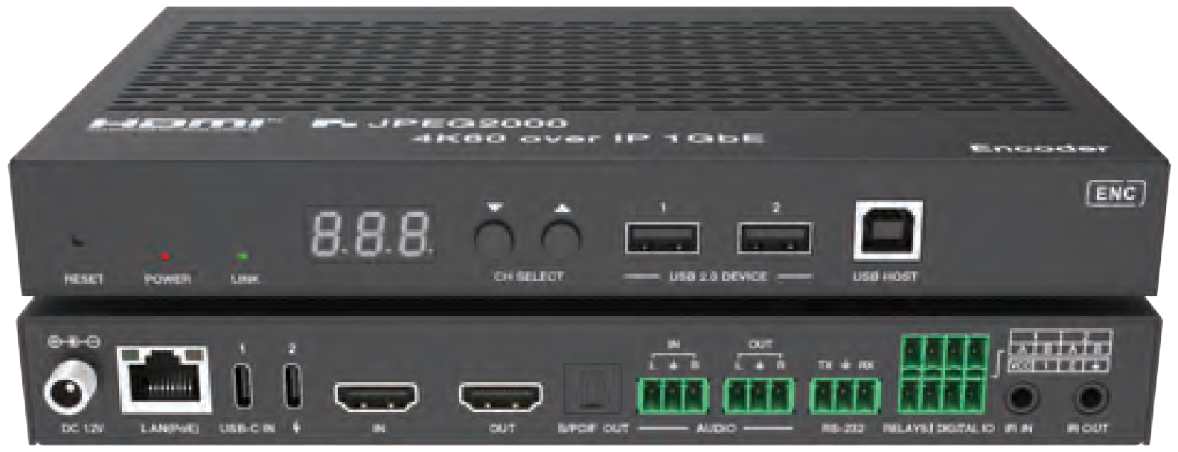


VER 1.0

Thank you for purchasing this product

For optimum performance and safety, please read these instructions carefully before connecting, operating or adjusting this product. Please keep this manual for future reference.

Surge protection device recommended

This product contains sensitive electrical components that may be damaged by electrical spikes, surges, electric shock, lighting strikes, etc. Use of surge protection systems is highly recommended in order to protect and extend the life of your equipment.

Table of Contents
- Introduction. 1
- Features. 1
- Package Contents. 2
- Specifications. 3
- Operation Controls and Functions. 6
  - Encoder Panel. 6
  - Decoder Panel. 11
- Signal Switching Mode. 17
- IR Pin Definition. 19
- Rack Mounting Instruction. 19
  - 6U V2 Rack Mounting. 19
  - 1U V2 Rack Mounting. 21
- Web GUI Operation Guide. 22
  - Preparation before Entering the System. 22
  - Functions and Operation. 23
- MJPEG Substream Operation Introduction. 32
  - MJPEG Substream Preview/Configuration via Web Page. 32
  - VLC Media Player Instruction. 35
- Switch Model 38
- 4K over IP System Control. 39
- Application Example. 39

Introduction

The product is based on JPEG2000 technology. It adopts ASPEED AST1530 for image codec and low delay KVM applications. Encoder features HDMI and USB-C dual inputs, with a video resolution of up to 4K60 4:4:4. It supports audio embedding and de-embedding function, ARC/eARC/S/PDIF/analog audio return function, as well as USB 2.0/KVM/Camera, 1G Ethernet, bi- directional RS-232, two-way IR and PoE function. Guest mode controls of

RS-232, IR, CEC are supported. Built-in two channel RELAY ports and two channel I/O ports for contact control. Dante AV-A mode is supported if the product is license activated.

The USB-C IN 1 port supports video/audio/USB data transmission and power charging to USB-C source device by USB-C adapter connected to the USB-C IN 2 port.

Built-in MJPEG Substream which supports plenty API commands to achieve flexible configurations is useful for 3rd party control Apps to preview video content.

The system is based on Linux for software development, provides flexible control methods, and can realize intelligent networking based on Gigabit Ethernet Switch.

Features

☆ HDCP 2.2 compliant

☆ Support 18Gbps video bandwidth

☆ Input and output video resolution is up to 4K60 4:4:4, as specified in HDMI 2.0b

☆ Signal transmission distance can be extended up to 328ft / 100m via CAT6/6A/7 cable

☆ With HDMI and USB-C dual inputs, supporting auto switching (switch to the corresponding signal input channel automatically when the signal source is connected and detected)

☆ The USB-C IN 1 port supports video/audio/USB data transmission and power charging to USB-C source device by USB-C adapter (up to PD 100W) connected to the USB-C IN 2 port

☆ Transmit video, analog/digital audio, IR , RS-232, CEC and USB 2.0 signal over Ethernet

☆ ARC/eARC/S/PDIF/analog audio return transmission (Note: The analog audio return transmission is available only in the point to point connection mode)

☆ Optional built-in Dante AV-A

☆ Audio embedding and de-embedding are supported

☆ Channel configuration via front panel buttons and LED screen

☆ Built-in two channel RELAY ports and two channel I/O ports for contact control

☆ Support unicast and multicast functions

☆ Support point-to-point, video matrix and video wall functions (video wall supports up to 9x9)

☆ Intelligent video wall class management

☆ Built-in MJPEG Substream for video real-time preview on portable devices

☆ 1G managed network Switch

☆ Standard PoE (802.3at PD device) or local 12V power supply

☆ Support HDR10, Dolby Vision, HLG bypass

☆ Audio formats: LPCM 2.0/5.1/7.1CH, Dolby Digital/Plus/EX, Dolby True HD, Dolby Atmos, DTS, DTS-96/24, DTS-EX DSD, DTS High Res,

DTS-HD Master, DTS:X

☆ Flexible control via front panel buttons, IR, RS-232, TCP/IP and Web GUI

☆ Smart networking design for easy and flexible installation

Package Contents

① 1x JPEG2000 4K60 AV over IP 1GbE Encoder

② 1x IR Receiver cable (1.5 meters)

③ 1x IR Blaster cable (1.5 meters)

④ 3x 3pin-3.81mm Phoenix Connector (male)

⑤ 2x 4pin-3.81mm Phoenix Connector (male)

⑥ 1x 12V/2.5A Locking Power Supply

⑦ 2x Mounting Ear

⑧ 4x Machine Screw (KM3*4)

⑨ 1x User Manual

Specifications

Technical
HDMI Compliant | HDMI 2.0b
HDCP Compliant | HDCP 2.2
Video Bandwidth | 18Gbps
Video Compression Standard | JPEG2000
Video Network Bandwidth | 1G
USB Bandwidth | USB 2.0 480Mbps
Input Video Resolution | 480i ~ 1080p50/60Hz, 4Kx2K@24/30Hz,  4K2K@50Hz/60Hz 4:4:4
Output Video Resolution | Auto, 3840x2160p60, 3840x2160p50, 4096x2160p60, 4096x 2160p50, 3840x2160p30, 3840x2160p25, 1920x1200p60,  1920x1080p60, 1920x1080p50, 1360x768p60,1280x800p60,  1280x720p60, 1280x720p50, 1024x768p60
Color Depth | 8/10/12-bit
Color Space | RGB, YCbCr 4:4:4 / 4:2:2 / 4:2:0
HDR | Both input and output support HDR
IR Level | Default 12V, optional 5V (set through front panel buttons, API commands, upper computer, or controller)
IR Frequency | Wideband 20K - 60KHz
Transmission Distance | 131ft/100m CAT6/6A/7
HDMI Audio Formats | LPCM 2.0/5.1/7.1CH, Dolby Digital/Plus/EX, Dolby True HD, Dolby Atmos, DTS, DTS-96/24, DTS-EX DSD, DTS High Res, DTS-HD Master, DTS:X
Audio Sample Rate | 32~192kHz
ESD Protection | IEC 61000-4-2:  ±15kV (Air-gap discharge) & ±8kV (Contact discharge)

TX Analog Audio
Input Impedance | 10K ohms
Output Impedance | 33 ohms
Line Input Level (Maximum) | 0dB(1Vrms) @ unbalanced audio
Line Output Level (Maximum) | 0.9Vrms @ unbalanced audio
Frequency Response | (±0.146dB) 20Hz ~ 20kHz
Audio Output Sync Delay | 0 to 50ms
Audio S/N Ratio | 96dB@0dB,1kHz A-weighted
Audio THD+N | 0.014%@0dBV,1kHz
Dante Audio
Dante Audio Channels | Maximum 2x2 (input x output)
Sample Rate | 44.1, 48, 88.2, 96kHz
Audio Format | LPCM only
PCM Sample Format | Signed 32-bit little endian
Connection
Encoder | Input: 1x HDMI IN [HDMI Type A, 19-pin female]  1x L/R AUDIO IN [3-pin 3.81mm Phoenix connector] 1x USB-C Video [USB Type C, 24-pin female]  1x USB-C Charging [USB Type C, 24-pin female] Output: 1x HDMI OUT [HDMI Type A, 19-pin female]  1x L/R AUDIO OUT [3-pin 3.81mm Phoenix connector] 1x S/PDIF OUT [Optical audio connector]  Control: 1x RS-232 [3-pin 3.81mm Phoenix connector] 1x LAN(PoE) [RJ45 jack, supporting PoE]  1x USB 2.0 HOST [USB Type B, 4-pin female] 2x USB 2.0 DEVICE [USB Type-A, 4pin female] 2x RELAYS [3.81mm Phoenix connector]  2x DIGITAL IO [3.81mm Phoenix connector] 1x IR IN [3.5mm audio jack, 5V/12V IR]  1x IR OUT [3.5mm audio jack, 5V/12V IR]

Decoder (optional) | Input: 1x S/PDIF IN [Optical audio connector]  1x L/R AUDIO IN [3-pin 3.81mm Phoenix connector] Output: 1x HDMI OUT [Type A, 19-pin female]  1x L/R AUDIO OUT [3-pin 3.81mm Phoenix connector] Control: 1x RS-232 [3.81mm Phoenix connector]  1x LAN (POE) [RJ45 jack]  1x FIBER [Optical fiber slot]  2x USB 1.1 DEVICE [Type-A, 4-pin female] 2x USB 2.0 DEVICE [Type-A, 4-pin female] 2x RELAYS [3.81mm Phoenix connector] 2x DIGITAL IO [3.81mm Phoenix connector] 1x IR IN [3.5mm audio Jack, 5V/12V IR]  1x IR OUT [3.5mm audio Jack, 5V/12V IR]
Mechanical
Housing | Metal enclosure
Color | Black
Dimensions | Encoder/Decoder: 204mm [W] x 136mm [D] x 25.5mm [H]
Weight | Encoder: 632g Decoder: 626g
Power Supply | Input: AC100 - 240V 50/60Hz,  Output: DC 12V/2.5A (US/EU standards, CE/FCC/UL certified)
Power Consumption | Encoder: 12W (Max.) Decoder: 7.8W (Max.)
Operating  Temperature | 32°F - 104°F / 0°C - 40°C
Storage Temperature | -4°F - 140°F / -20°C - 60°C
Operating Humidity | 20% - 80% (relative humidity, no condensing)
Storage Humidity | 10% - 90% (relative humidity, no condensing)
Resolution / Cable Length | 4K60 -  Feet / Meters | 4K30 -  Feet / Meters | 1080P60 -  Feet / Meters
HDMI IN / OUT | 16ft / 5M | 32ft / 10M | 50ft / 15M
The use of “Premium High Speed HDMI” cable is highly recommended.

Operation Controls and Functions

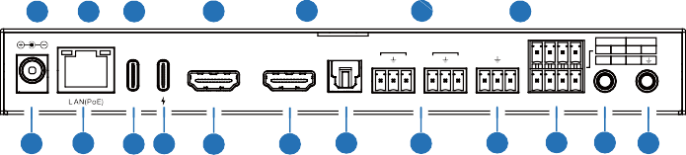Encoder Panel
1
2
3
4
5
6
7
1 2
1 2
IN OUT
L R L R TX RX
VCC 1 2
DC 12V
USB-C IN
IN
OUT S/PDIF OUT AUDIO RS-232 RELAYS DIGITAL IO IR IN IR OUT
19 18 17 16 15
14
13
12
11
10 9 8
B
A
B
A

ENC
1 2

RESET POWER LINK CH SELECT USB 2.0 DEVICE USB HOST

No. | Name | Function Description
1 | RESET | During device operation, press and hold the RESET button for 5 seconds. When the POWER LED and LINK LED flash simultaneously and the LED screen displays 3 dots, it indicates that the device is resetting. Then you can release the RESET button. The device is in unicast mode after the reset.
2 | POWER LED  (Red) | - Light on: The system is powered on (with PoE or DC power  supply).  - Light off: The system is powered off (without PoE or DC power  supply).
3 | LINK LED  (Green) | Connection status LED.  - Light on: Encoder and Decoder are connected through the LAN(PoE) port, and there is video signal transmitted to the Decoder.  - Light flashes: Encoder and Decoder are connected through the LAN(PoE) port, but there is no video signal transmitted to the Decoder.  - Light off: Encoder and Decoder are not connected through the LAN(PoE) port.
4 | LED screen | Shows Encoder ID as default. Displays the corresponding options of configuration functions during setting Encoder configurations.
5 | CH SELECT | UP and DOWN buttons, used to set Encoder ID and other settings.
6 | USB 2.0 DEVICE | Connect to USB 2.0 devices.
7 | USB HOST | USB Host port, connected to a PC.
8 | IR OUT | IR signal output port. The IR level can be set to 5V or 12V (default) through the panel buttons.

No. | Name | Function Description
9 | IR IN | IR signal input port. The IR level can be set to 5V or 12V (default) through the panel buttons.
10 | RELAYS I DIGITAL IO | VCC: Power output (12V or 5V configurable), maximum to 12V @50mA, 5V@ 100mA loading. The default output is 12V. RELAYS: 2 channel low-voltage relay ports, each group is independent and isolated, maximum to 1A 30VDC loading.  Contacts are disconnected by default.  DIGITAL IO: 2 channel GPIO ports, for digital level signal output control or input detection (up to 12V level detection). The output control mode (default mode, low level as default output) or input detection mode is configurable. The DIGITAL IO internal pull-up voltage follows the VCC.  Output control mode:  - The maximum withstand sink current is 50mA when outputting low level.  - When VCC is 5V and high level is output, the maximum current driving capacity is 2mA.  - When VCC is 12V and high level is output, the maximum current driving capacity is 5mA.  Input detection mode:  - When VCC is 5V, DIGITAL IO is pulled up to 5V internally through a 2.2K ohm resistor.  - When VCC is 12V, DIGITAL IO is pulled up to 12V internally through a 2.2K ohm resistor.
11 | RS-232 | RS-232 serial port, supporting RS-232 command pass-through and local serial port control. The default baud rate is 115200.
12 | AUDIO IN/OUT | AUDIO IN: Analog audio input port, the audio can be embedded into the HDMI signal for pass-through over to HDMI output and audio out on Decoder, or be loopout by the AUDIO OUT port on Encoder.
12 | AUDIO IN/OUT | AUDIO OUT : Analog audio output port. It can output the audio extracted from the HDMI IN port (in case of LPCM) . Also it can output the audio transmitted from the AUDIO IN port of the Decoder in unicast mode (point-to-point direct connection).
13 | S/PDIF OUT | S/PDIF signal output port. It can output the ARC or S/PDIF audio returned from the Decoder when both the Encoder and Decoder are correspondingly set to the ARC or S/PDIF audio return mode (Set through the Controller Box or API commands in Multicast mode; Set through the front panel buttons in unicast mode).
14 | HDMI OUT | HDMI local loop output port, connected to an HDMI display device such as TV or monitor.
15 | HDMI IN | HDMI signal input port, connected to an HDMI source device such as Blu-ray Player or Set-top box with an HDMI cable.

No. | Name | Function Description
16 | USB-C IN 1 | USB Type C port, supporting 4K60 audio/video and USB 2.0 signals transmission, and charging the external device (The USB-C IN 2 port must be connected to the power supply).
17 | USB-C IN 2 | USB-C power input port, only supporting USB Type C PD power input up to 100W. Connect this port to the UCB-C power adapter to charge the device connected to the USB-C IN 1 port.
18 | LAN(PoE) | 1G LAN port, supporting PoE function, with Auto IP mode by default, and the default IP address is 169.254. x.x. Connect to the network Switch to form a distributed system.  Yellow LED: Light flash when there is data transmission, and light off when there is no data transmission.  Green LED: Light on when the network is linked normally, and light off when the network is not linked.  Note: When the network Switch delivers PoE power supply, DC 12V adapter doesn't need to apply on the unit.
19 | DC 12V | The device can be powered via two methods:  - Local DC 12V/2.5A power supply (with priority)  - PoE from Network Switch. Device acts as PD mode. When the  Switch supports PoE function, DC power supply is not needed.

Operation description of the LED screen and CH SELECT buttons (For Encoder).
1, ENC ID: After the system is powered on, the Encoder’s LED screen will show the ENC ID (000 by default if not set).
2, IP address: Press and hold the UP button for 5 seconds, the Encoder’s LED screen will show in sequence "IPx", "xxx", "xxx", "xxx", "xxx", which are the IP mode and IP address of Encoder.
3, Configuration mode: Press and hold UP + DOWN buttons at the same time for 5 seconds, then release to enter the configuration mode with “CFN” displaying on the LED screen.
4, Device ID settings: After entering the configuration mode, press the UP/DOWN button to enter the first page with the current ID number (e.g. 001) displaying on the LED screen (000 by default). Press and hold UP + DOWN buttons for 5 seconds, then release to enter the ID settings mode, in which the ID number (e.g. 001) on the LED screen will flash at 1Hz, then press the UP/DOWN button to select the device ID you desired (ID range: 000~762), then press and hold UP + DOWN buttons for 5 seconds to confirm the setting and stop flashing. After setting, the unit will reboot automatically. Note: The device ID can not be modified in Controller Box mode.

5, EDID settings: After entering the configuration mode, press the UP/DOWN button to enter the second page with “E00” (in which “E” refers to EDID, “00” to EDID ID) or “COP” (which indicates copy EDID) displaying on the LED screen (E15 by default). Press and hold UP + DOWN buttons for 5 seconds, then release to enter the EDID settings mode, in which the EDID ID number (e.g. E01) on the LED screen will flash
at 1Hz, then press the UP/DOWN button to select the EDID ID you desired, then press and hold UP + DOWN buttons for 5 seconds to confirm the setting and stop flashing. The corresponding EDID ID is as follows:

EDID ID | EDID Description | EDID ID | EDID Description
E00 | 1080P_Stereo_Audio_2.0_SDR | E12 | 4K2K60_420_Stereo_Audio_2.0_SDR
E01 | 1080P_DolbyDTS_5.1_SDR | E13 | 4K2K60_420_DolbyDTS_5.1_SDR
E02 | 1080P_HD_Audio_7.1_SDR | E14 | 4K2K60_420_HD_Audio_7.1_SDR
E03 | 1080I_Stereo_Audio_2.0_SDR | E15 | 4K2K60_444_Stereo_Audio_2.0_SDR
E04 | 1080I_DolbyDTS_5.1_SDR | E16 | 4K2K60_444_DolbyDTS_5.1_SDR
E05 | 1080I_HD_Audio_7.1_SDR | E17 | 4K2K60_444_HD_Audio_7.1_SDR
E06 | 3D_Stereo_Audio_2.0_SDR | E18 | 4K2K60_444_Stereo_Audio_2.0_HDR_10-bit
E07 | 3D_DolbyDTS_5.1_SDR | E19 | 4K2K60_444_DolbyDTS_5.1_HDR_10-bit
E08 | 3D_HD_Audio_7.1_SDR | E20 | 4K2K60_444_HD_Audio_7.1_HDR_10-bit
E09 | 4K2K30_444_Stereo_Audio_2.0_SDR | E21 | DVI_1280x1024
E10 | 4K2K30_444_DolbyDTS_5.1_SDR | E22 | DVI_1920x1080
E11 | 4K2K30_444_HD_Audio_7.1_SDR | E23 | DVI_1920x1200
Note: In point to point connection mode, before using the EDID copy function, all codecs need to be set to CA1 unicast mode, and after setting, the HDMI cable of the Decoder needs to be re-plugged to report the EDID of TV to the Encoder.
6, IR mode settings: After entering the configuration mode, press the UP/DOWN button to enter the third page with “IR2” (in which “IR” refers to IR, and “2” to 12V) displaying on the LED screen (IR2 by default). Press and hold UP + DOWN buttons for 5 seconds, then release to enter the settings mode, in which the IR mode (IR1 or IR2) on the LED screen will flash at 1Hz, then press the UP/DOWN button to select the IR mode, then press and hold UP + DOWN buttons for 5 seconds to confirm the setting and stop flashing.
The corresponding IR mode options are as follows: IR1: 5V IR wire
IR2: 12V IR wire

7, Audio embedding mode settings: After entering the configuration mode, press the UP/DOWN button to enter the fourth page with “HDI/ANA” displaying on the LED screen (HDI by default). Press and hold UP + DOWN buttons for 5 seconds, then release to enter the settings mode, in which the audio return mode (HDI/ANA) on the LED screen will flash at 1Hz, then press the UP/DOWN button to select the mode, then press and hold UP + DOWN buttons for 5 seconds to confirm the setting and stop flashing.
The corresponding audio embedding mode options are as follows: HDI: HDMI audio embedding
ANA: Analog audio embedding
8, IP mode settings: After entering the configuration mode, press the UP/DOWN button to enter the fifth page with “IP1/IP2/IP3” displaying on the LED screen (IP3 by default). Press and hold UP + DOWN buttons for 5 seconds, then release to enter the settings mode, in which the IP mode (IP1/IP2/IP3) on the LED screen will flash at 1Hz, then press the UP/DOWN button to select the mode, then press and hold UP + DOWN buttons for 5 seconds to confirm the setting and stop flashing. After setting, the unit will reboot automatically.
The corresponding IP mode options are as follows:
IP1: Static IP mode (Default IP address: 169.254.100.254) IP2: DHCP IP mode
IP3: Auto IP mode (Default assigned network segment: 169.254.xxx.xxx)
Note: The IP mode can not be modified in Controller Box mode.
9, Multicast mode settings: After entering the configuration mode, press the UP/DOWN button to enter the sixth page with “CA1/CA2” displaying on the LED screen (CA1 by default). Press and hold UP + DOWN buttons for 5 seconds, then release to enter the settings mode, in which the multicast mode (CA1/CA2) on the LED screen will flash at 1Hz, then press the UP/DOWN button to select the mode, then press and hold UP + DOWN buttons for 5 seconds to confirm the setting and stop flashing. After setting, the unit will reboot automatically.
The corresponding multicast mode options are as follows:
CA1: Unicast mode CA2: Multicast mode
10, Audio return mode settings: After entering the configuration mode, press the UP/ DOWN button to enter the seventh page with “C2C/A2A” displaying on the LED screen (C2C by default). Press and hold UP + DOWN buttons for 5 seconds, then release to enter the settings mode, in which the audio return mode (C2C/A2A) on the LED screen will flash at 1Hz, then press the UP/DOWN button to select the mode, then press and hold UP + DOWN buttons for 5 seconds to confirm the setting and stop flashing. After setting, the unit will reboot automatically.
The corresponding audio return mode options are as follows:
C2C: The eARC/ARC or S/PDIF audio from the Decoder is transmitted back to the HDMI IN or SPDIF OUT port of the Encoder.
A2A: The analog audio embedded in the Decoder is transmitted back to the AUDIO OUT analog audio port of the Encoder.

Note:
    - The audio return mode can not be modified through front panel buttons in Controller Box or Multicast mode.
    - Only when both the Encoder and Decoder are correspondingly set to C2C/A2A audio return mode in unicast mode, the audio return can be realized.
    - The A2A audio return mode is available only in unicast mode.
    - When using ARC, ARC audio amplifier on Encoder HDMI IN port and ARC TV on Decoder HDMI OUT port should be used.
When using eARC, eARC audio amplifier on Encoder HDMI IN port and eARC TV on Decoder HDMI OUT port should be used.
    - After entering various setting modes, you can hold down the DOWN button to exit the current interface quickly, or if you do not perform any operation within 5 seconds, it will automatically return to the previous interface.

Decoder Panel
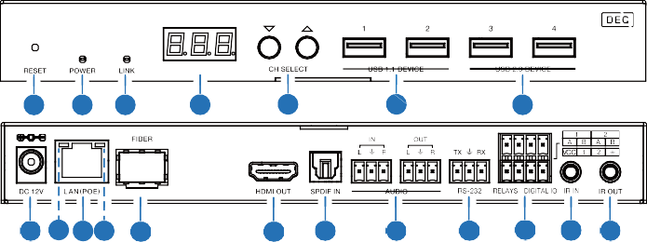
1 2 3
4
5
6
7
19 18 16 17 15
14 13
12
11 10 9 8

No. | Name | Function Description
1 | RESET | During device operation, press and hold the RESET button for 5 seconds. When the POWER LED and LINK LED flash simultaneously and the LED screen displays 3 dots, it indicates that the device is resetting. Then you can release the RESET button. The device is in unicast mode after the reset.
2 | POWER LED  (Red) | - Light on: The system is powered on (with PoE or DC power  supply).  - Light off: The system is powered off (without PoE or DC power  supply).

No. | Name | Function Description
3 | LINK LED  (Green) | Connection status LED.  - Light on: Encoder and Decoder are connected through the LAN(PoE) port, and there is video signal transmitted from the Encoder.  - Light flashes: Encoder and Decoder are connected through the LAN(PoE) port, but there is no video signal transmitted from the Encoder.  - Light off: Encoder and Decoder are not connected through the LAN(PoE) port.
4 | LED screen | Shows the selected Encoder ID as default. Displays the corresponding options of configuration functions during setting Decoder configurations.
5 | CH SELECT | UP and DOWN buttons, used to set Decoder ID and other settings.
6 | USB 1.1 DEVICE | Connect to USB 1.1 devices, such as Keyboard or Mouse.
7 | USB 2.0 DEVICE | Connect to USB 2.0 devices, such as USB flash disk or USB Camera.
8 | IR OUT | IR signal output port. The IR level can be set to 5V or 12V (default) through the panel buttons.
9 | IR IN | IR signal input port. The IR level can be set to 5V or 12V (default) through the panel buttons.
10 | RELAYS I DIGITAL IO | VCC: Power output (12V or 5V configurable), maximum to 12V@50mA, 5V@ 100mA loading. The default output is 12V. RELAYS: 2 channel low-voltage relay ports, each group is independent and isolated, maximum to 1A 30VDC loading. Contacts are disconnected by default.  DIGITAL IO: 2 channel GPIO ports, for digital level signal output control or input detection (up to 12V level detection). The output control mode (default mode, low level as default output) or input detection mode is configurable. The DIGITAL IO internal pull-up voltage follows the VCC.  Output control mode:  - The maximum withstand sink current is 50mA when outputting low level.  - When VCC is 5V and high level is output, the maximum current driving capacity is 2mA.  - When VCC is 12V and high level is output, the maximum current driving capacity is 5mA.  Input detection mode:  - When VCC is 5V, DIGITAL IO is pulled up to 5V internally through a 2.2K ohm resistor.  - When VCC is 12V, DIGITAL IO is pulled up to 12V internally through a 2.2K ohm resistor.

No. | Name | Function Description
11 | RS-232 | RS-232 serial port, supporting RS-232 command pass-through and local serial port control. The default baud rate is 115200.
12 | AUDIO IN/OUT | AUDIO IN: Analog audio input port, the audio can be transmitted to Encoder AUDIO OUT in unicast mode (point-to-point direct connection).
12 | AUDIO IN/OUT | AUDIO OUT: Analog audio output port. It outputs the same audio of that on HDMI OUT in case audio format is LPCM.
13 | SPDIF IN | S/PDIF signal input port.
14 | HDMI OUT | HDMI signal output port, connected to an HDMI display device such as TV or monitor.
15 | FIBER | Connect with optical fiber module, and receive signals from the Encoder with an optical fiber cable directly or through a Switch.
16 | LAN (POE) | 1G LAN port, supporting PoE function, with Auto IP mode by default, and the default IP address is 169.254. x.x. Connect to the network Switch to form a distributed system.  Note: When network switch delivers PoE power supply, DC 12V adapter doesn't need to apply on the unit.
17 | Data Signal Indicator lamp (Yellow) | - Light flashing: There is data transmission.  - Light off: There is no data transmission.
18 | Link Signal Indicator lamp (Green) | - Light on: The network cable is connected normally.  - Light off: The network cable is not connected well.
19 | DC 12V | The device can be powered via two methods:  - Local DC 12V/2.5A power supply  - PoE from Network Switch. Device acts as PD mode.  When the Switch supports PoE function, DC power supply is not needed.

Operation description of the LED screen and CH SELECT buttons (For Decoder).
1, ENC connection: After the system is powered on, the Decoder’s LED screen will show 000 by default if not set. Directly press the UP/DOWN button to select the channel ID of the connected Encoder (ID range: 000~762) to complete connection.
2, IP address: Press and hold the UP button for 5 seconds, the Decoder’s LED screen will show in sequence "IPx", "xxx", "xxx", "xxx", "xxx", which are the IP mode and IP address of Decoder.

3, Configuration mode: Press and hold UP + DOWN buttons at the same time for 5 seconds, then release to enter the configuration mode with “CFN” displaying on the LED screen.
4, Device ID settings: After entering the configuration mode, press the UP/DOWN button to enter the first page with the current ID number (e.g. 001) displaying on the LED screen (000 by default). Press and hold UP + DOWN buttons for 5 seconds, then release to enter the ID settings mode, in which the ID number (e.g. 001) on the LED screen will flash at 1Hz, then press the UP/DOWN button to select the device ID you desired (ID range: 000~762), then press and hold UP + DOWN buttons for 5 seconds to confirm the setting and stop flashing. After setting, the unit will reboot automatically. Note: The device ID can not be modified in Controller Box mode.
5, Output scaling settings: After entering the configuration mode, press the UP/DOWN button to enter the second page with “S00” (in which “S” refers to Scaling, and “00” to resolution ID) displaying on the LED screen (S00 by default). Press and hold UP + DOWN buttons for 5 seconds, then release to enter the settings mode, in which the Sxx on the LED screen will flash at 1Hz, then press the UP/DOWN button to select the resolution ID you desired, then press and hold UP + DOWN buttons for 5 seconds to confirm the setting and stop flashing.

The scaling settings are listed below:

Scaling Sxx | Resolution Description | Scaling Sxx | Resolution Description
S00 | bypass | S07 | 2160P50
S01 | 1080P50 | S08 | 2160P60
S02 | 1080P60 | S09 | 1280x1024
S03 | 720P50 | S10 | 1360x768
S04 | 720P60 | S11 | 1440x900
S05 | 2160P24 | S12 | 1680x1050
S06 | 2160P30 | S13 | 1920x1200

6, IR mode settings: After entering the configuration mode, press the UP/DOWN button to enter the third page with “IR2” (in which “IR” refers to IR and “2” to 12V) displaying on the LED screen (IR2 by default). Press and hold UP + DOWN buttons for 5 seconds, then release to enter the settings mode, in which the IR mode (IR1 or IR2) on the LED screen will flash at 1Hz, then press the UP/DOWN button to select the IR mode, then press and hold UP + DOWN buttons for 5 seconds to confirm the setting and stop flashing.
The corresponding IR mode options are as follows: IR1: 5V IR wire
IR2: 12V IR wire

7, eARC/ARC or S/PDIF audio return settings: After entering the configuration mode, press the UP/DOWN button to enter the fourth page with “ARC/SPD” displaying on the LED screen (ARC by default). Press and hold UP + DOWN buttons for 5 seconds, then release to enter the audio return settings mode, in which the audio return mode (ARC/ SPD) on the LED screen will flash at 1Hz, then press the UP/DOWN button to select the mode, then press and hold UP + DOWN buttons for 5 seconds to confirm the setting and stop flashing.
The corresponding audio return mode options are as follows:
ARC: eARC/ARC audio return (The audio from the HDMI OUT port of Decoder is transmitted back to the HDMI IN port of the Encoder.)
SPD: S/PDIF audio return (The audio from the S/PDIF IN port of Decoder is transmitted back to the S/PDIF OUT port of the Encoder.)

Note:
    - The audio return mode can not be modified through front panel buttons in Controller Box or Multicast mode.
    - Only when both the Encoder and Decoder are set to C2C audio return mode, the eARC/ARC or S/PDIF audio return can be realized.
    - When using ARC, ARC audio amplifier on Encoder HDMI IN port and ARC TV on Decoder HDMI OUT port should be used.
When using eARC, eARC audio amplifier on Encoder HDMI IN port and eARC TV on Decoder HDMI OUT port should be used.
8, IP mode settings: After entering the configuration mode, press the UP/DOWN button to enter the fifth page with “IP1/IP2/IP3” displaying on the LED screen (IP3 by default). Press and hold UP + DOWN buttons for 5 seconds, then release to enter the settings mode, in which the IP mode (IP1/IP2/IP3) on the LED screen will flash at 1Hz, then press the UP/DOWN button to select the mode, then press and hold UP + DOWN buttons for 5 seconds to confirm the setting and stop flashing. After setting, the unit will reboot automatically.
The corresponding IP mode options are as follows:
IP1: Static IP mode (Default IP address: 169.254.100.253) IP2: DHCP IP mode
IP3: Auto IP mode (Default assigned network segment: 169.254.xxx.xxx)
Note: The IP mode can not be modified in Controller Box mode.
9, Fiber/Copper mode settings: After entering the configuration mode, press the UP/ DOWN button to enter the sixth page with “CPP/FIB” displaying on the LED screen (CPP by default). Press and hold UP + DOWN buttons for 5 seconds, then release to enter the settings mode, in which the Copper/Fiber mode (CPP/FIB) on the LED screen will flash at 1Hz, then press the UP/DOWN button to select the mode, then press and hold UP + DOWN buttons for 5 seconds to confirm the setting and stop flashing. After setting, the unit will reboot automatically.

The corresponding Fiber/Copper mode options are as follows: CPP: Copper mode
FIB: Fiber mode
10, Multicast mode settings: After entering the configuration mode, press the UP/ DOWN button to enter the sixth page with “CA1/CA2” displaying on the LED screen (CA1 by default). Press and hold UP + DOWN buttons for 5 seconds, then release to enter the settings mode, in which the Multicast mode (CA1/CA2) on the LED screen will flash at 1Hz, then press the UP/DOWN button to select the mode, then press and hold UP + DOWN buttons for 5 seconds to confirm the setting and stop flashing. After setting, the unit will reboot automatically.
The corresponding multicast mode options are as follows:
CA1: Unicast mode CA2: Multicast mode
11, Audio return mode settings: After entering the configuration mode, press the UP/ DOWN button to enter the seventh page with “C2C/A2A” displaying on the LED screen (C2C by default). Press and hold UP + DOWN buttons for 5 seconds, then release to enter the settings mode, in which the audio return mode (C2C/A2A) on the LED screen will flash at 1Hz, then press the UP/DOWN button to select the mode, then press and hold UP + DOWN buttons for 5 seconds to confirm the setting and stop flashing. After setting, the unit will reboot automatically.
The corresponding audio return mode options are as follows:
C2C: The eARC/ARC or S/PDIF audio from the Decoder is transmitted back to the HDMI IN or S/PDIF OUT port of the Encoder.
A2A: The analog audio embedded in the Decoder is transmitted back to the AUDIO OUT analog audio port of the Encoder.

Note:
- The audio return mode can not be modified through front panel buttons in Controller Box or Multicast mode.
- Only when both the Encoder and Decoder are correspondingly set to C2C/A2A audio return mode in unicast mode, the audio return can be realized.
- The A2A audio return mode is available only in unicast mode.
- When using ARC, ARC audio amplifier on Encoder HDMI IN port and ARC TV on Decoder HDMI OUT port should be used.
When using eARC, eARC audio amplifier on Encoder HDMI IN port and eARC TV on Decoder HDMI OUT port should be used.
- After entering various setting modes, you can hold down the DOWN button to exit the current interface quickly, or if you do not perform any operation within 5 seconds, it will automatically return to the previous interface.

Signal Switching Mode

The HDMI/USB signal input of this product supports auto switching and manual switching modes, which can be set through API commands or the Web GUI configuration of the Controller, as shown in the figures below.
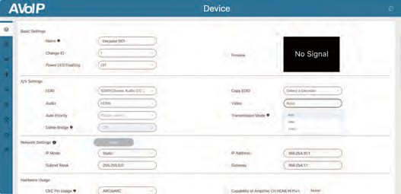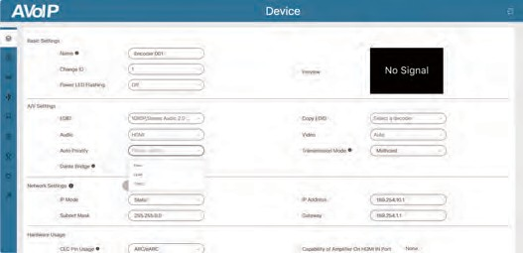

You can select Auto/HDMI/TYPEC for video signal switching (Auto by default). Auto: Automatically switch signal source through signal detection, and the later connected signal source has the priority.

HDMI: Fixed use of HDMI signal source.

TYPEC: Fixed use of USB-C signal source.

Then you can set the auto priority (None/HDMI/TYPEC), None by default. None: USB-C signal source has the priority by default, but it will switch to the HDMI signal source if the HDMI signal source is connected later.

HDMI: HDMI signal source has the priority by default, and it will switch to the USB-C signal source only when the HDMI signal source is disconnected.

TYPEC: USB-C signal source has the priority by default, and it will switch to the HDMI signal source only when the USB-C signal source is disconnected.

The LED screen on the front panel of this product can indicate the signal switching status in auto switching mode.
For HDMI signal input

Active: Detect the HDMI 5V signal → LED screen flashes “HDI” for 3s → There is HDMI signal input → “HDI” remains on for 3s → Normal LED screen display

Connected: Detect the HDMI 5V signal → LED screen flashes “HDI” for 3s

→ There is no HDMI signal input→ Normal LED screen display
Disconnected: No signal detected → Normal LED screen display

For USB-C signal input

Active: Detect the USB-C 5V signal → LED screen flashes “USB” for 3s → There is USB-C signal input → “USB” remains on for 3s → Normal LED screen display

Connected: Detect the USB-C 5V signal → LED screen flashes “USB” for 3s → There is no USB-C signal input→ Normal LED screen display Disconnected: No signal detected → Normal LED screen display

IR Pin Definition
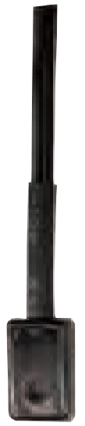
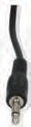
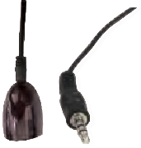

IR BLASTER IR RECEIVER

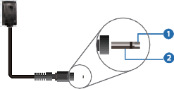+
IR BLASTER
-

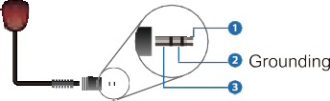
IR RECEIVER
Power 12V

Rack Mounting Instruction

6U V2 Rack Mounting

This product can be mounted in a standard 6U V2 rack (Please contact your supplier for 6U V2 rack sale). The mounting steps are as follows:

Step 1: Use included screws to fix two mounting ears on the product, as shown in the figure below:
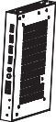

Step 2: Insert the product with mounting ears into a 6U V2 rack (6/8/10 units can be installed vertically), as shown in the figure below:
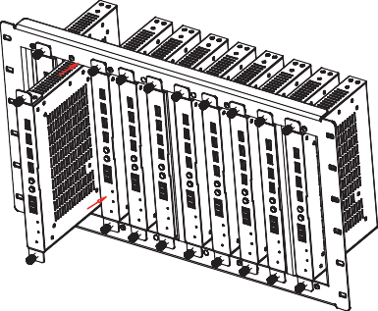

Step 3: Use screws to fix mounting ears on the rack to complete the mounting, as shown in the figure below:
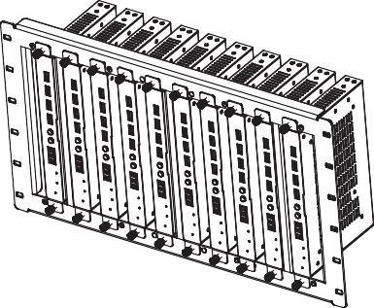

1U V2 Rack Mounting

This product also can be mounted in a standard 1U V2 rack (2 units can be installed horizontally). The mounting steps are as follows:

Step 1: Use included screws to fix two 1U V2 rack brackets on two products respectively, as shown in the figure below:
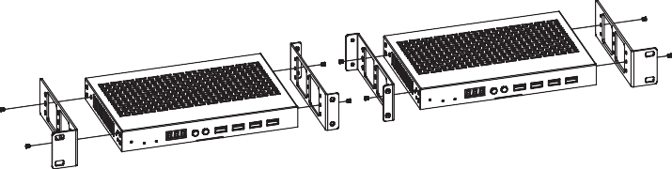

Step 2: Use screws to fix two 1U V2 rack brackets together, as shown in the figure below:
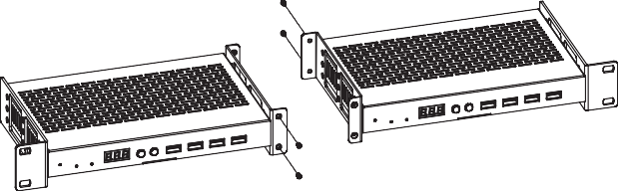

Step 3: Fasten screws between two 1U V2 rack brackets, so that two products are mounted in a 1U V2 rack, as shown in the figure below:
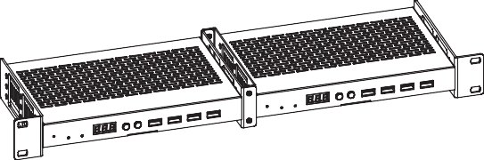

Web GUI Operation Guide

Preparation before Entering the System

The product can be controlled by the built-in Web GUI. The operation steps are as following:

Step 1: Connect the Encoder, Decoder and PC to the same Switch, then connect an HDMI source device, HDMI display device and power supply. The connection diagram is shown as below.
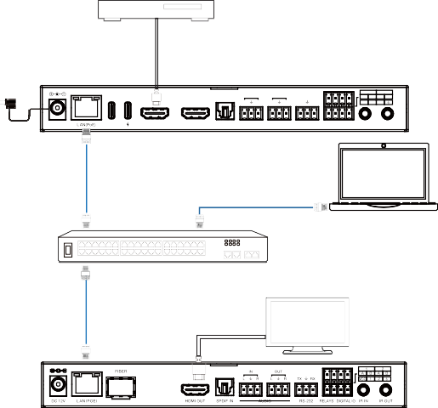Blu-ray Player
Power Adapter
1 2
IN OUT A 1 B A 2 B
L R L R TX RX VCC 1 2
Encoder
DC 12V USB-C IN
IN
OUT S/PDIF OUT AUDIO RS-232 RELAYS DIGITAL IO IR IN IR OUT
LAN
PC
LAN 1G Ethernet Switch
TV or Monitor
Decoder

Step 2: Press and hold the UP button on the front panel of Encoder/Decoder for 5 seconds to check the current IP Address.

Step 3: Set the PC’s IP address to the same network segment with IP address of the Encoder/Decoder found in step 2.

Step 4: Input the IP address of the Encoder/Decoder into the web browser on PC to access the Web GUI of Encoder/Decoder.

Functions and Operation
- System
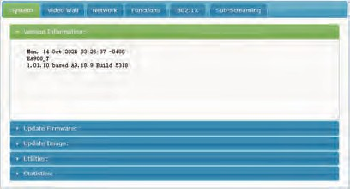
- Version Information: The software version of the device.
- Update Firmware: The firmware update interface.
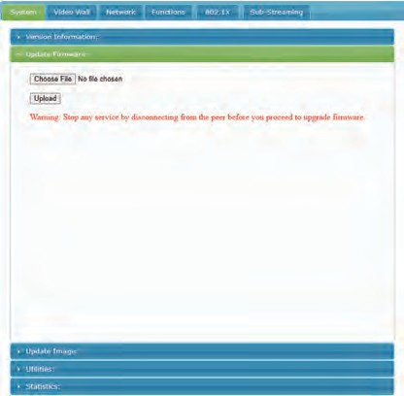

- Update Image: The standby and logo image upload interface.
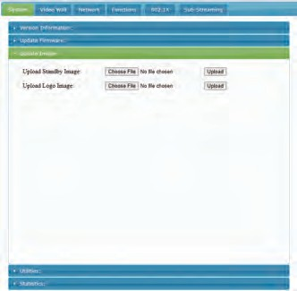

Utilities: This interface allows users to restore to factory default settings, reboot device, set EDID mode, console API command.
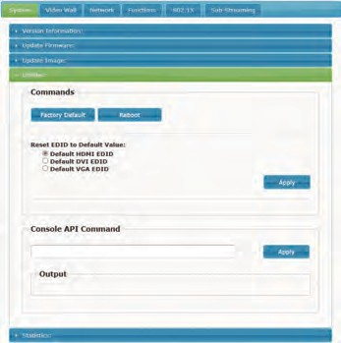

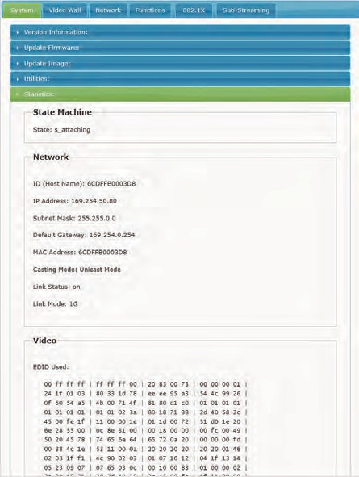
Statistics: The status information of the device. The statistics interface of Encoder is as following:

The statistics interface of Decoder is as following:
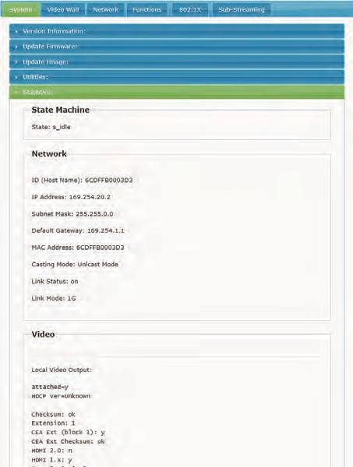

  - Video Wall

Basic Setup: This interface allows users to perform basic settings, such as set the bezel, gap, size and position of the video wall, as well as select the stretch type, rotate and flip.
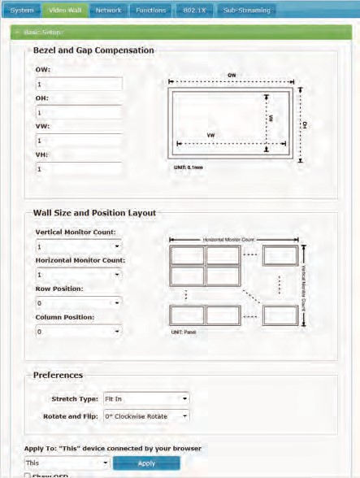

Advanced Setup: This interface allows users to perform advanced settings for the video wall.
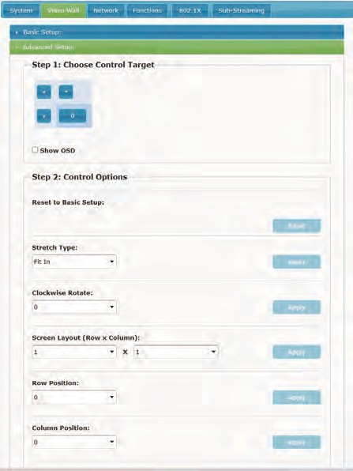

  - Network

This interface allows users to set the IP and select the casting mode (multicast/unicast).

Three IP modes are supported:

Auto IP: The IP address is set automatically. After the device is powered off and restarted, a new IP address is randomly assigned.

DHCP: The IP address of the device is assigned by the router.

Static: Static IP address.
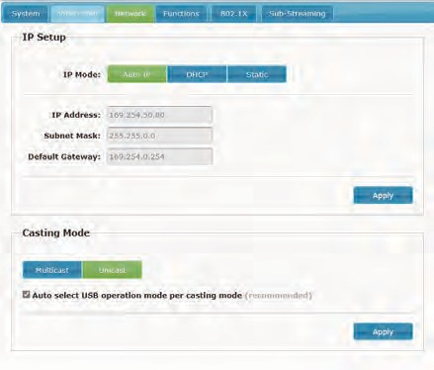

  - Functions

This interface allows users to select the modes of video, USB, serial port and audio.

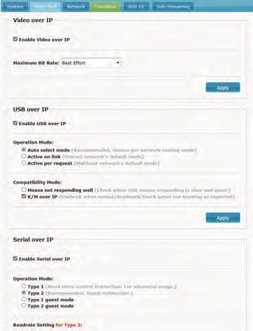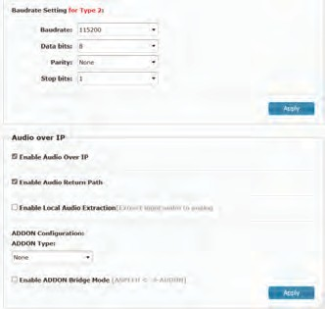

  - 802.1X

This interface allows users to enable 802.1X authentication and validate server certificate.
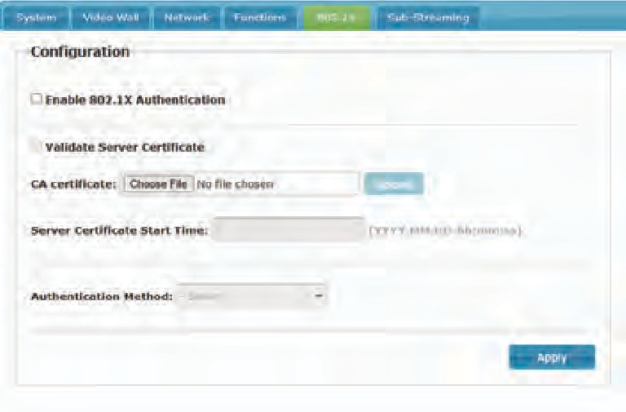
  - Sub-Streaming

This interface allows users to preview the video of the signal source in real time.
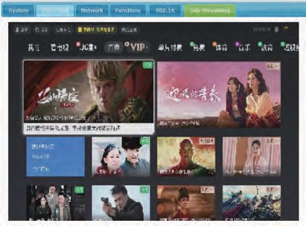

MJPEG Substream Operation Introduction

MJPEG Substream Preview/Configuration via Web Page

The product supports playing MJPEG Substream on computer through the corresponding software such as VLC media player, simultaneously you can access the Web page to configure the MJPEG Substream.

Follow the steps below to preview and configure the MJPEG Substream.

Step 1: Connect the Encoder, Decoder and PC to the same Switch, then connect an HDMI source device, HDMI display device and power supply.

Step 2: Install a bonjour protocol checking tool (such as zeroconfService Browser) on PC to find the IP address of the Encoder/Decoder.

Take zeroconfServiceBrowser as an example. After opening the software, you can select “Workgroup Manager” in Services of Browser, select

the Host name in Service-Instances, and find the IP address in the Address item in of Instance-Info.
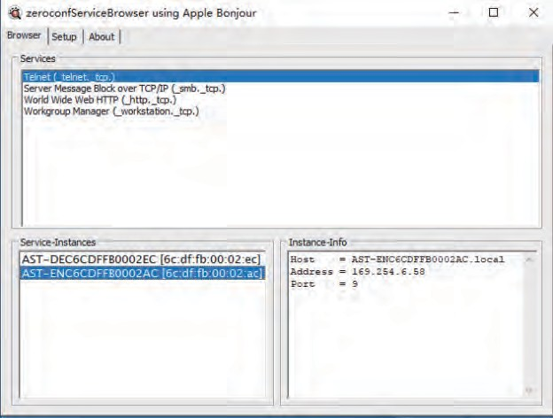

Note:

The window in the lower left corner displays the Host names of all devices in the current network.

The window in the lower right corner displays the Host name, IP address and Port number of the device.

The Host name of Encoder starts with AST-ENC; the Host name of Decoder starts with AST-DEC.

Step 3: Set the PC’s IP address to the same network segment with IP address of the Encoder/Decoder found in step 2.
169 168 101 30

0
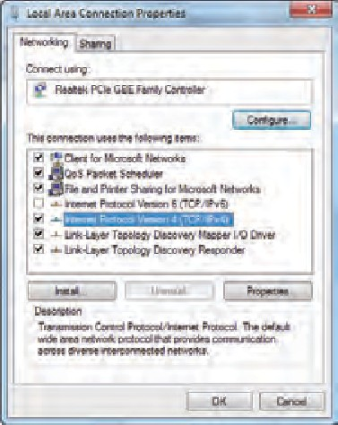
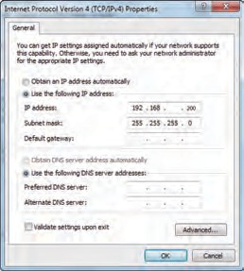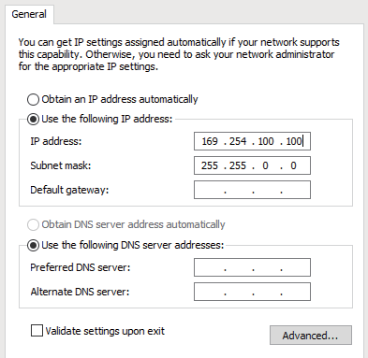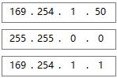

Step 4: According to the IP address of the Encoder/Decoder found through the bonjour protocol checking tool, input “http://IP:PORT/?action=stream” into the web browser on PC. The MJPEG Substream will be displayed with the default resolution, as shown in the figure below.

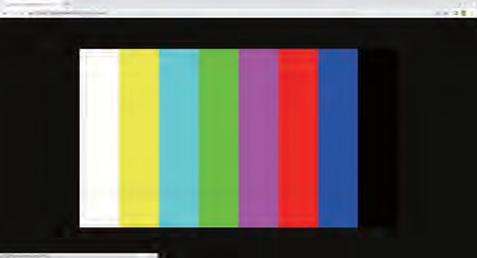

Step 5: Change the resolution of the obtained Encoder/Decoder IP address in the following format. http://IP:PORT/?action=stream&w=x&h=x&fps=x&bw=x&as=x&mq=x

WIDTH: [Optional] image width. In pixels. ‘x’ means no change. Default is 640.

HEIGHT: [Optional] image height. In pixels. ‘x’ means no change. Default is 360.

FRAMERATE: [Optional] frame rate of sub-stream.

Unit: fps (frame per second). ‘x’ means no change. Default is 30.

BW: [Optional] maximum bandwidth of sub-stream traffic.

Unit: Kbps (Kbits per second). ‘x’ means no change. Default is 8000 (8Mbps).

AS: [Optional] aspect ratio configuration. ‘x’ means no change. Default is 0.

0: extend to what “WIDTH” and “HEIGHT” configured

1: [A1 only] keep original aspect ratio and place in the center of output (letterboxing or pillarboxing)

MINQ: [Optional] minimum image quality number. Range: 10, 20, …, 90, 100, higher setting means better image quality. ‘x’ means no change. Default value is 10. Limit driver auto bandwidth control’s minimum quality number.

If quality lower then MINQ value, the driver will drop frame by returning 0 size file.

After changing, input the new Encoder/Decoder IP address into the web browser on PC, the MJPEG Substream will be displayed with the desired resolution, as shown in the figure below.
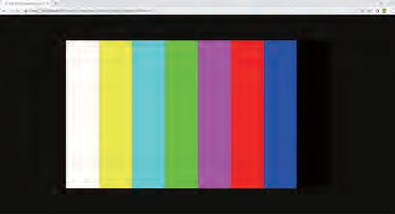

VLC Media Player Instruction

Firstly, perform the step 1~3 as described in Chapter 8.1, then open the VLC media player on PC. Please see the following icon.


Click “Media > Open Network Stream”
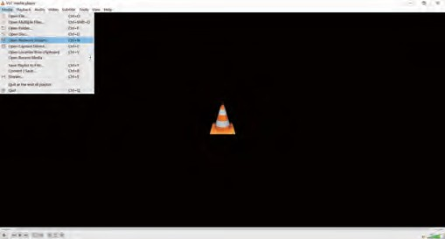

After clicking the “Open Network Stream” option, the following page will appear.
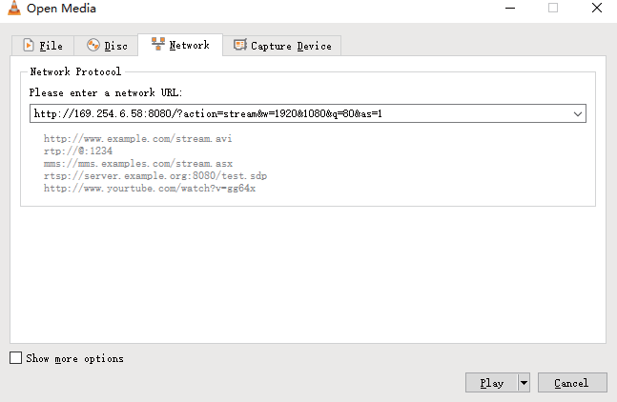

Enter the MJPEG Substream network URL, then click “Play” button.
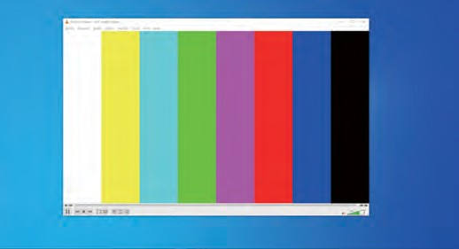

Choose “Tools>Codec information”, a pop-up window will display and show you Stream information, as shown in the figure below.
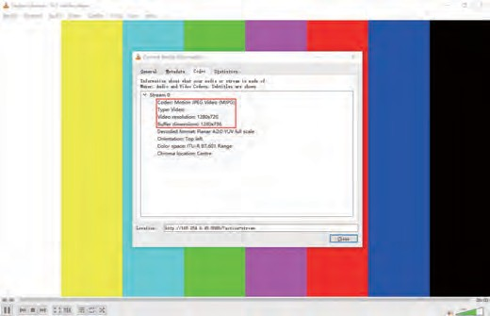

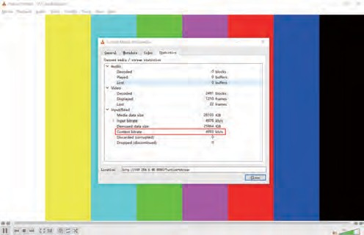
Choose “Tools>Codec information>Statistics” to check current Bitrate. Please see the following picture.

Note: The Bitrate is floating up and down when you check it. This is a normal phenomenon.

Switch Model

A network Switch used to set up the system should support below features:

Type of layer 3/managed network Switch.

Gigabit bandwidth.

8KB jumbo frame capability.

IGMP snooping.

The following Switch models are highly recommended.

Manufacturer | Model Number
CISCO | CISCO SG500
CISCO | CATALYST series
HUAWEI | S5720S-28X-PWR-LI-AC
ZyXEL | GS2210
LUXUL | AMS-4424P

4K over IP System Control

This product can be controlled by Controller Box or third-party controller. For details of 4K over IP system control, please refer to the user manual of “Video over IP Controller”.

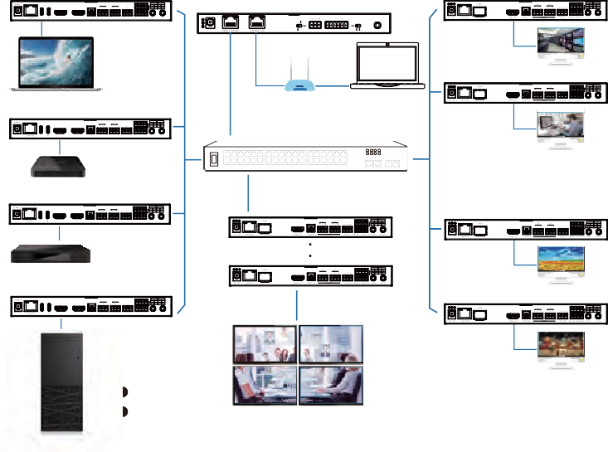Application Example
ENC
DEC
1 2
IN OUT
L R L R TX RX
DC 12V
USB-C IN IN OUT S/PDIF OUT AUDIO RS-232 RELAYS DIGITAL IO IR IN IR OUT
Controller Box

MCU
IR IN
IO LEVEL
NORMAL
5V 12V
DC 12V
Laptop
TV
DEC
TP-I LNK
ENC
1 2
Router (optional) PC
1G Ethernet Switch
IN OUT
1 2
A B A B
L R L R TX RX VCC 1 2
DC 12V
USB-C IN IN OUT S/PDIF OUT AUDIO RS-232 RELAYS DIGITAL IO IR IN IR OUT
TV
TV Box
ENC
1 2
1 2
IN OUT A B A B
L R L R TX RX VCC 1 2
DEC
DC 12V
USB-C IN IN OUT S/PDIF OUT AUDIO RS-232 RELAYS DIGITAL IO IR IN IR OUT
Media Player
1 2
ENC
IN OUT A B A B
L R L R TX RX VCC 1 2
TV
DEC
1 2
4 × DEC
DC 12V
USB-C IN IN OUT S/PDIF OUT AUDIO RS-232 RELAYS DIGITAL IO IR IN IR OUT
Desktop Computer
TV
Video Wall
1 2
A B A B
VCC 1 2

VOUT

IO4 IO3 IO2 IO1


The terms HDMI and HDMI High-Definition Multimedia interface, and the HDMI Logo are trademarks or registered trademarks of HDMI Licensing LLC in the United States and other countries.

Notes:

The Controller has two LAN ports, one is Video LAN and the other one is Control LAN. The purpose of designing Controller with two LAN ports is to isolate audio/video (AV) network from control network. So to make AV

network as an independent network which can not be accessed from control network directly, it's for bringing network security and avoiding AV network traffic flowing into the network in which the controls and managements are for the IP system.

The strongly recommended system setup is connecting Video LAN and Encoders/Decoders in a network Switch, connecting Control LAN and PC in another network Switch. The controls from Control LAN can be achieved by Web GUI/Telnet or SSH login/API commands, all these controls can be bridged by the Controller and applied onto Video LAN. The two LANs are isolated.

For simple usage, you can only connect all Encoders/Decoders and Video LAN and PC RJ-45 port into a single network, and let the Control LAN port not-connected (floating), as Video LAN also supports Web GUI/Telnet or SSH login/API commands controls, this seems “convenient” for general use scenarios, but this is only suggested for system in which there is no network isolation requirement or network traffic non-sensitive.

Only Control LAN connected while Video LAN floating, this is not allowed.

For the default IP mode of Control LAN port of the Controller Box is DHCP, the PC also needs to be set to “Obtain an IP address automatically” mode, and an optional DHCP server (e.g. network router) is recommended in the system.

If there is no DHCP server in the system, 192.168.6.100 will be used as the IP address of Control LAN port. You need to set the IP address of the PC to be in the same network segment. For example, set PC’s IP address as 192.168.6.88.

You can access the Web GUI by inputting URL “http://controller.local” or the Control LAN port IP address 192.168.6.100 (in case of no optional router) on your computer's browser.

No need to care about settings of Video LAN port of the Controller Box, as they are managed by Controller automatically (Default).

When the Network Switch does not support PoE, the Encoder, Decoder and Controller Box should be powered by DC power adapter.

