ALT-IPC4KSDV

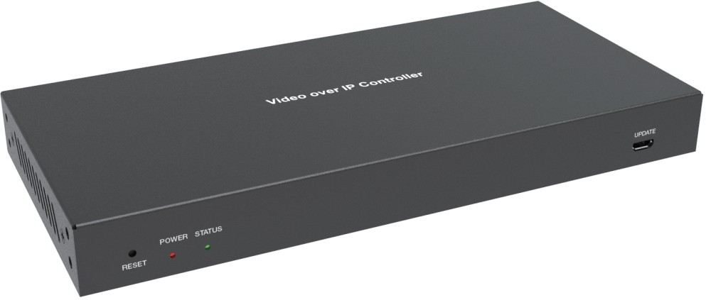


VER 1.0

Thank you for purchasing this product
For optimum performance and safety, please read these instructions carefully before connecting, operating or adjusting this product. Please keep this manual for future reference.

Surge protection device recommended
This product contains sensitive electrical components that may be damaged by electr-ical spikes, surges, electric shock, lighting strikes, etc. Use of surge protection systems is highly recommended in order to protect and extend the life of your equipment.

Table of Contents
- Introduction. 1
- Features. 1
- Package Contents. 1
- Specifications. 2
- Operation Controls and Functions. 2
  - Front Panel. 2
  - Rear Panel. 3
  - IR Pin Definition. 4
- Rack Mounting Instruction. 4
  - 6U Rack Mounting. 4
  - 1U Rack Mounting. 6
- Web GUI User Guide. 7
  - Preparation before Entering the System. 7
  - Functions and Operation. 11
- Application Example. 26

Introduction
This Video over IP Controller is used to control and manage IP products. It supports dual 1G network ports, which can realize dual-network isolation of Control network and Multicast video distribution network. It supports Web GUI/TCP/RS-232/IR/GPIO controls, POE function and IR control signal pass through as well. Since the demand of IP products is daily increased in the current market, the IP Controller will be widely applied in more and more different scenarios.

Features
☆ Easy to create project, control and manage the system
☆ HTTPS, SSH, SFTP security compatible
☆ Built-in Web GUI control interface, supporting Drag & Drop operations
☆ Support image preview
☆ Support video, audio, RS-232, IR, KVM control and management of the distributed system
☆ Dual network ports (VIDEO LAN port supports POE function) to isolate Controls and Multicast networks.
☆ Support LAN/RS-232 port control and third-party central control
☆ Support IR signal receiving (3.5mm audio jack, 12V level)
☆ 4 channel GPIO control ports (5V/12V optional level)
☆ Multiple circuits protection, lightning protection and ESD design
☆ Reliable system design, ensuring 7*24 hours reliable and stable work

Package Contents
① 1 ⅹ Video over IP Controller
② 1 ⅹ 20kHz-60kHz 12V IR Receiver Cable (1.5 meters)
③ 1 ⅹ IR Blaster Cable (1.5 meters)
④ 2 ⅹ 3-pin 3.81mm Phoenix Connector (Male)
⑤ 1 ⅹ 6-pin 3.81mm Phoenix Connector (Male)
⑥ 2 ⅹ Mounting Ears
⑦ 4 ⅹ Machine Screws (KM3*6)
⑧ 1 ⅹ 12V/1A Locking Power Adaptor
⑨ 1 ⅹ User Manual

Specifications

Technical
Network Video Bandwidth | Up to 1G
Transmission Distance | 100m CAT 5E/6/6A/7
Control Ports | 2 x 1G LAN [RJ45 connector] [VIDEO LAN support POE] 1 x IR IN [3.5mm audio jack, 12V level]  1 x IR OUT [3.5mm audio jack]  1 x DIGITAL I/O [6-pin 3.81mm phoenix connector]  2 x RS-232 [3-pin 3.81mm phoenix connector] 1x USB Host [Micro USB, 5-pin female]
Dimensions | 204mm(W)×98.5mm(D)×21.5mm(H)
Housing | Metal Enclosure
Color | Black
Weight | 508g
Power Supply | 12V/1A
Power Consumption | 8.4W
Operating  Temperature | 0°C ~ 40°C / 32°F ~ 104°F
Storage Temperature | -20°C ~ 60°C / -4°F ~ 140°F
Relative Humidity | 20~90% RH (non-condensing)

Operation Controls and Functions

Front Panel
UPDATE
POWER STATUS

RESET

1 2 3
4

No. | Name | Function Description
1 | RESET Button | Press and hold this button (about 10 seconds) until Status LED starts flashing, Controller will be reset automatically.
2 | POWER LED | The red LED will light on when the Controller is powered on.
3 | STATUS LED | The status LED will flash in yellowish-green every 1 second until Controller boots up completely and Control LAN is ready, then it becomes solid.
4 | UPDATE | Firmware update port.  Note: Must keep no connection on this port when Controller works in normal mode.

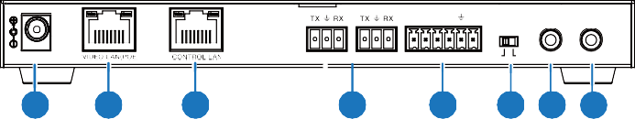Rear Panel
IR IN IR OUT
IO LEVEL
DC 12V
1 RS-232 2
5V 12V
1
2
3
4
5
6 7 8
VOUT
IO4 IO3 IO2 IO1

No. | Name | Function Description
1 | DC 12V | DC 12V/1A power input port.
2 | VIDEO LAN (POE) | 1G Video LAN port, supporting POE function.  Note: When POE is enabled, DC 12V/1A power supply is not required.
3 | CONTROL LAN | The TCP/IP control network port.
4 | 3-pin Phoenix Connectors | Two identical RS-232 serial communication ports.
5 | 6-pin Phoenix Connector | 4 channel I/O level outputs, 1 channel grounding,  1 channel power supply (supports up to 12V/0.5A) to the outside.
6 | IO LEVEL  DIP Switch | Used to control I/O level output and VOUT voltage. Switch to left: 5V I/O level output, VOUT is 5V. Switch to right: 12V I/O level output, VOUT is 12V.
7 | IR IN | 12V IR signal input port.
8 | IR OUT | IR signal output port. (Reserved for future use.)

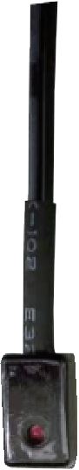
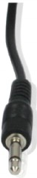
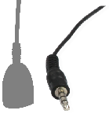
IR Pin Definition
IR BLASTER IR RECEIVER

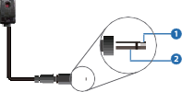+
IR BLASTER
-
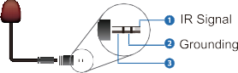
IR RECEIVER
Power 12V

Rack Mounting Instruction

6U Rack Mounting
This Controller can be mounted in a standard 6U rack (Please contact your supplier for 6U rack sale). The mounting steps are as follows:
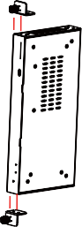
Step 1: Use included screws to fix two mounting ears on the Controller, as shown in the figure below:

Step 2: Insert the Controller with mounting ears into a 6U rack (up to 10 units can be installed vertically), as shown in the figure below:
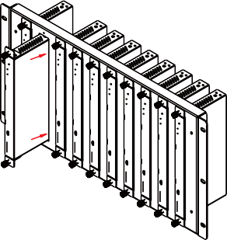
Step 3: Use screws to fix mounting ears on the rack to complete the mounting, as shown in the figure below:
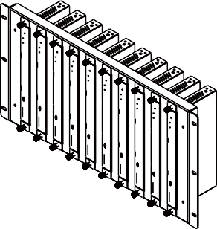

1U Rack Mounting
This Controller also can be mounted in a standard 1U rack (up to 4 units can be installed horizontally). The mounting steps are as follows:
Step 1: Stack two Controllers on top of each other, then use included screws to fix two 1U rack panels on the Controllers, as shown in the figure below:
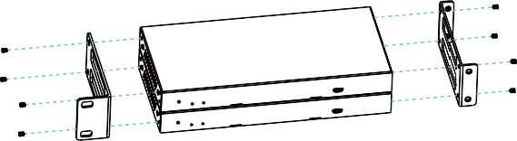

Step 2: Fix two 1U rack panels on another two stacked Controllers in the same way, then use screws to fix two 1U rack panels together, as shown in the figure below:
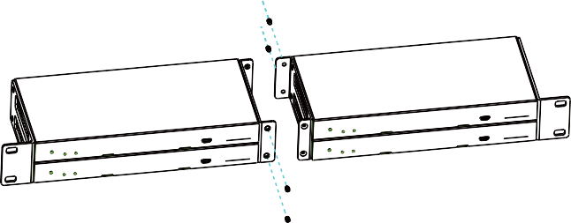
Step 3: Fasten screws between two 1U rack panels, so that four Controllers are mounted in a 1U rack, as shown in the figure below:
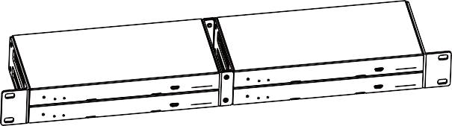

Web GUI User Guide

Preparation before Entering the System
You can use Controller’s Web GUI to control all IP products at the Switch. The operation method is shown as below:
Step 1: Input the Controller’s default IP address (192.168.0.225) or the URL (http://controller.local) into the Web browser address bar on the PC to enter the Web GUI login interface.
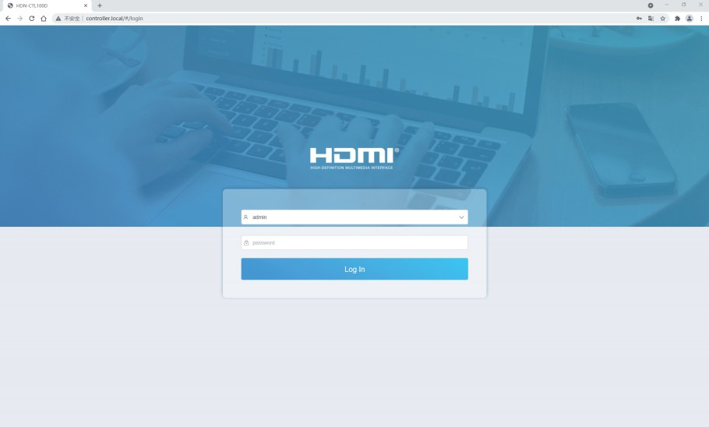

Select the initial username (admin) and input the initial password (1234) on the above login interface. Then, click “Log In” to enter the Web GUI interface. For the first time, you need to setup the project, as shown in the following
figure:
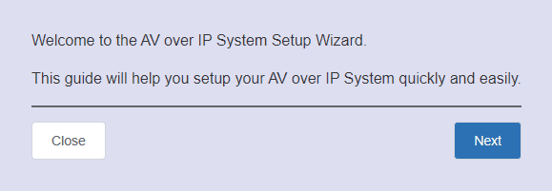

Step 2: Click the “Close” button to load an existing project in web page directly, or click “Next” button to go to the next step.
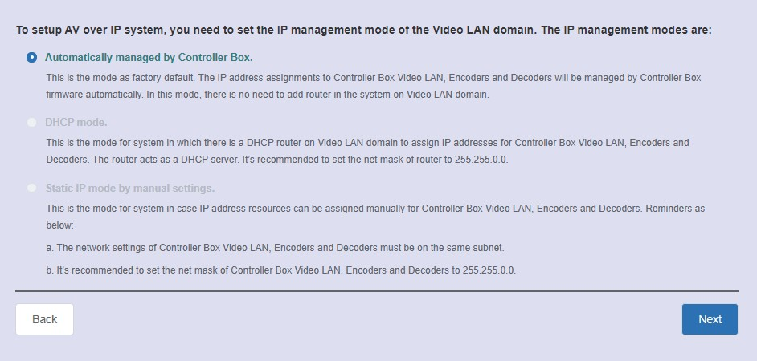

On this interface, you need to set the IP mode of Video LAN.

Mode 1: Automatically managed by Controller Box.
Please connect all the devices according to the following diagram.

Multiview

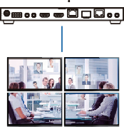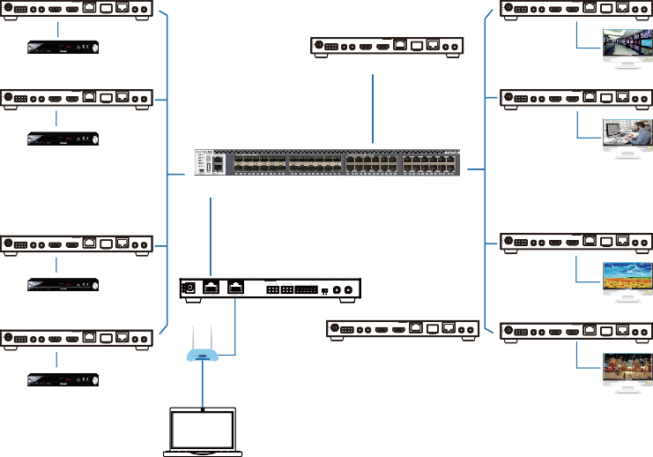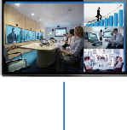Transceiver (ENC Mode) Transceiver (DEC Mode)

12V TX RX

SFP+

IN OUT

12V TX RX

SFP+

IN OUT

DC 12V RS-232 IR IN IR OUT HDMI IN HDMI OUT 10G BASE-T

AUDIO

DC 12V RS-232 IR IN IR OUT HDMI IN HDMI OUT 10G BASE-T

AUDIO

DVD

12V TX RX

DC 12V RS-232 IR IN IR OUT HDMI IN HDMI OUT 10G BASE-T

SFP+

IN OUT

AUDIO TV

Transceiver (ENC Mode)
Transceiver (DEC Mode)

Transceiver (DEC Mode)

12V TX RX

SFP+

IN OUT

12V TX RX

SFP+

IN OUT

DC 12V RS-232 IR IN IR OUT HDMI IN HDMI OUT 10G BASE-T

AUDIO

DC 12V RS-232 IR IN IR OUT HDMI IN HDMI OUT 10G BASE-T

AUDIO

DVD
TV

10G Ethernet Switch

Transceiver (ENC Mode) Transceiver (DEC Mode)

12V TX RX

SFP+

IN OUT

12V TX RX

SFP+

IN OUT

DC 12V RS-232 IR IN IR OUT HDMI IN HDMI OUT 10G BASE-T

DVD

AUDIO

Controller Box
IR IN IR OUT

VOUT

IO4 IO3 IO2 IO1
IO LEVEL

DC 12V RS-232 IR IN IR OUT HDMI IN HDMI OUT 10G BASE-T

AUDIO

Transceiver (ENC Mode)

DC 12V

1 RS-232 2

5V 12V

12V TX RX

SFP+

IN OUT
TV
Transceiver (DEC Mode)
SFP+

12V TX RX

SFP+

IN OUT

DC 12V RS-232 IR IN IR OUT HDMI IN HDMI OUT 10G BASE-T

AUDIO

DC 12V
12V TX RX

RS-232 IR IN IR OUT

HDMI IN HDMI OUT 10G BASE-T
IN OUT

AUDIO

DC 12V RS-232 IR IN IR OUT HDMI IN HDMI OUT 10G BASE-T

AUDIO

DVD

TP-LINK

Router (optional)

12V TX RX

DC 12V RS-232 IR IN IR OUT HDMI IN HDMI OUT 10G BASE-T

SFP+

IN OUT
TV

AUDIO

4×Transceiver (DEC Mode)

PC

Video Wall

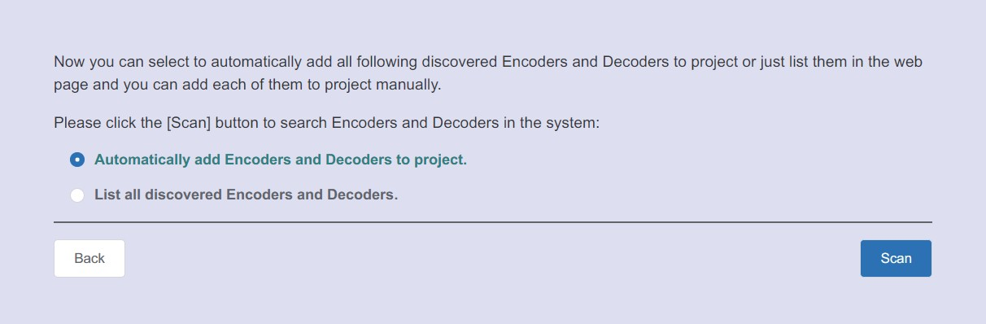
Click the “Next” button and wait for the completion to enter the interface as shown in the figure below.
Select “Automatically add Encoders and Decoders to project”, and click the “Scan” button to enter the Project page. All the connected devices will be listed in the Current Devices list.
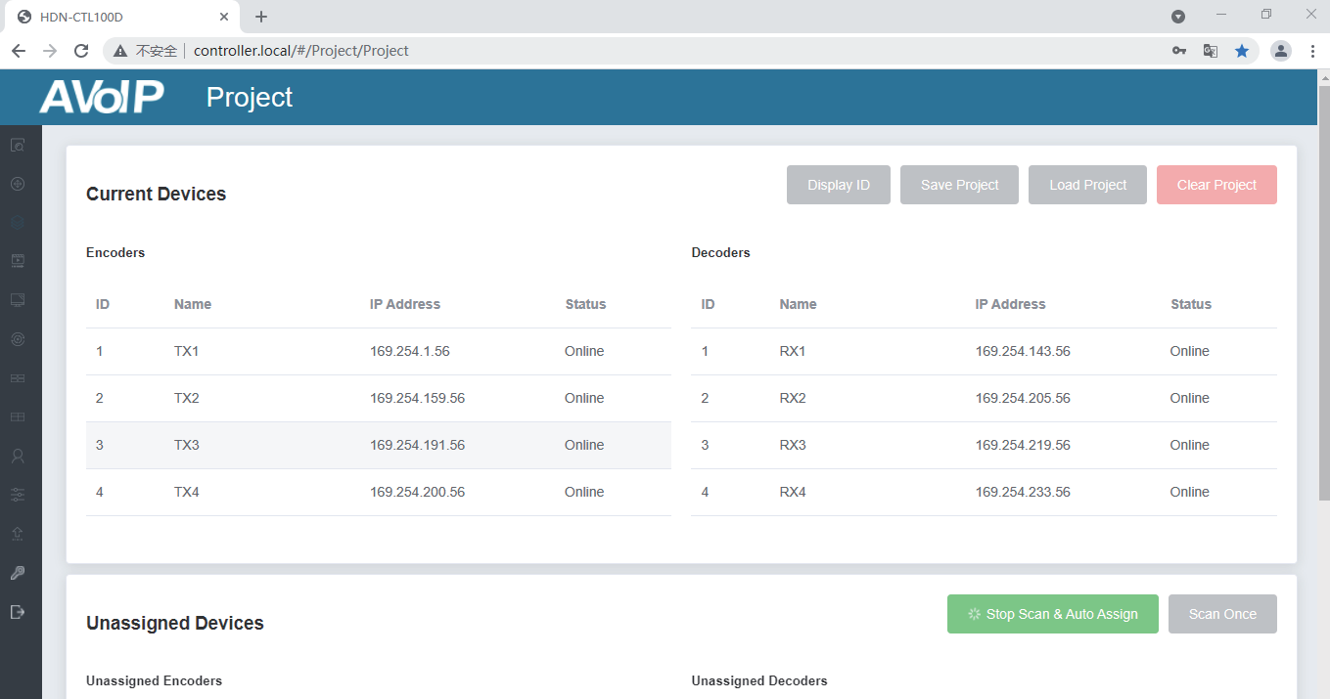
Then click “Stop Scan & Atuo Assign” to stop search.

Note: Currently only Mode 1 is available, Mode 2 and Mode 3 will be ready in short future, the operation steps will be supplemented.

Functions and Operation
    - Preview Page

On this page, you can preview the Encoder/Decoder by clicking the drop- down list on the right side.
    - Matrix Control Page

① Encoders: Display all the current Encoders. The text in the figure is the name of the device.
② Decoders: Display all the current Decoders. The text on the first line is
the name of the Decoder, and the text on the second line refers to the Encoder where the signal resource is from.

Operating Instructions:
- If an Encoder shows “No Signal”, it means that the Encoder cannot be dragged.
- If there is an image on an Encoder, it means that the Encoder can be dragged. As shown in the figure above, if an Encoder is dragged to the place where the red arrow points to, all Decoders will share the same signal resource from this Encoder; if an Encoder is dragged to the place where the blue arrow points to, only the indicated Decoder can receive signals from this Encoder.

  - Project Page

① Current Devices: Devices that have been added to the current project.
② Unassigned Devices: Devices not added to the current project.
Operating Instructions:
- Click “Display ID” to display the ID or PATTERN of the Decoders.
- Click “Save Project” to save the project file (config_file.json), so that you can use the saved project next time without scanning devices again.
- Click “Load Project” to load the existing project directly.
- Click “Clear Project” to clear the current project, then you will need to setup the project again.

- Click “Scan Once” to search devices that do not appear in the current project.
- Click “Start Scan & Auto Assign” to search new devices automatically and add to the current project.

  - Encoders Page

① ID: The ID of the current device. (Note: ID is not duplicated.)
② Name: The name of the current device.
③ MAC Address: The MAC Address of the current device.
④ IP Address: The IP Address of the current device.
⑤ Firmware: The Firmware version No. of the current device.
⑥ Status: The status (online or offline) of the current device.
⑦ EDID: The EDID of the current device.
⑧ L/R Out: The audio selection of the current device.
⑨ CEC Command: The CEC Command of the current device.
Operating Instructions:
- Click “Refresh” to refresh the data of the current Encoders.
- Click the drop-down list of EDID to set the current Encoder’s EDID.
- Click the drop-down list of L/R Out to set the current Encoder’s audio output.
- Click “Command” to set the CEC command for the Encoder.

- Click the icon on the left of ID to check the detail information about the current Encoder, as shown in below:



On this page, you can setup the current Encoder as required.


  - Decoders Page
① ID: The ID of the current device. (Note: ID is not duplicated.)
② Name: The name of the current device.
③ MAC Address: The MAC Address of the current device.
④ IP Address: The IP Address of the current device.
⑤ Firmware: The Firmware version No. of the current device.
⑥ Status: The status (online or offline) of the current device.
⑦ Source: The signal source (Encoder) of the current device.
⑧ Display Mode: The display mode of the current device.
⑨ Scaler Resolution: The resolution of the current device.
⑩ Function: The mode (Matrix/Video Wall/Multiview) of the current device.
CEC Command: The CEC Command of the current device.
11
Operating Instructions:
- Click “Refresh” to refresh the data of the current Decoders.
- Click the drop-down list of Source to select the current Decoder’s signal source.
- Click the drop-down list of Display Mode to select the current Decoder’s display mode.
- Click the drop-down list of Scaler Resolution to select the current Decoder’s resolution.
- Click the drop-down list of Function to select the current Decoder’s mode.

- Click “Command” to set the CEC command for the Decoder.
- Click the icon on the left of ID to check the detail information about the current Decoder, as shown in below:



On this page, you can setup the current Decoder as required.

  - Locked Signal Routing Page

On this page, you can independently route the video and audio signals between Encoder & Decoder devices. You also can set the IR/Serial/USB signals as required. Please click “Locked Routing Help” for details.
  - Video Wall Managment Page

On this page, you can creat and configure video wall as required. Please follow below steps to create a video wall.
Step 1: Click “Create”, a pop-up window will be shown as below:

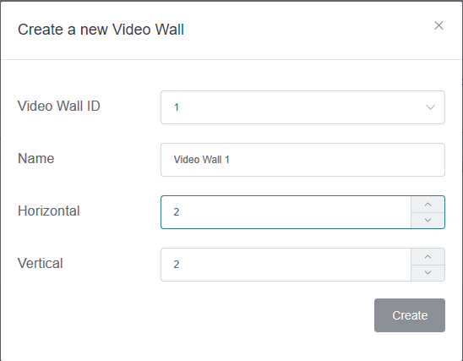

You can set the Video Wall ID, Name, Horizontal and Vertical panel numbers. Then click “Create” to create the Video Wall.
Note: Up to 9 video walls can be created.
Step 2: Select the video wall that you want to configure on the “Video Wall List”, then click “Assign Decoder” to enter the Decoder assignment page. Click each screen to select the corresponding Decoder device, then click “Apply”.

Note: A Decoder can only be assigned to one video wall.

Step 3: Click “Class Configuration” to enter the class configuration page, then click each screen to select the corresponding Class as required (the same class name will form a video wall, you can create a regular or irregular video wall by Class Configuration). Then click “Apply”.

Note: Up to seven configurations can be set up for different application scenarios.
Step 4: After configuration, you can switch to “Video Wall Control” page for video preview, as shown in below.

On this page, you can select different video walls and configurations that you have set up by clicking the drop-down box on the right of “Video Wall Selection
/ Configuration Selection”. Besides, you can directly drag Encoders at the top of the page to the video wall to change signal sources.
If you want to delete a video wall, just select the video wall on the “Video Wall List”, then click “Remove” . A prompt window will pop up and you can delete it after clicking “Yes”.
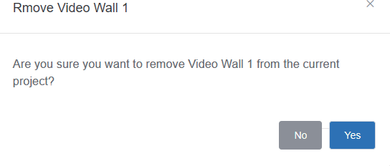
Notes:
- Each Decoder can be set into a part of a video wall array. Each system can contain multiple video walls with different sizes. Each video wall can be assigned to different screens and different layouts that range from 1x2 up to 9x9.
- The controller creates and manages the video wall configurations and provides a simplified control interface and API commands to third party control system.

  - Multiview Managment Page
On this page, you can create and configure multiview as required. Please follow below steps to create a video wall.
Step 1: Click the drop-down list of Decoders to select the Decoder device as shown in the above figure. Then click to select the desired Multiview Layout, which will be displayed in the lower right corner, as shown in the figure below.


Step 2: Drag Encoders from the Encoder List to the Multiview Layout respectively, then click the “Apply” button.

Step 3: After configuration, you can switch to “Multiview Control” page for video preview, as shown in below.

On this page, you can select different Decoders and configurations that you have set up by clicking the drop-down box on the right of “Receiver Selection”
/ “Configuration Selection”.

If you want to delete a multiview, just click the “Reset” button. A prompt window will pop up and you can delete it after clicking “Yes”.

If you want to delete all multiview configurations you set before, just click the “Reset All” button. A prompt window will pop up and you can delete them after clicking “Yes”.


- Users Page
On this page, you can add new user accounts.

- Controller Settings Page

① General Settings: The basic settings of the Controller.
② Control Network: The network port configuration of the Controller connected to the Switch.
③ Video Network:The network port configuration of the Controller
connected to video source devices.
You can update the settings or reset the Controller.

- Firmware Update Page
On this page, you can separately update the firmware of any Encoder/Decoder by clicking the corresponding “Update” button on the right, or update all the firmwares of Encoder/Decoder simultaneously by clicking the corresponding “Update All” button. Also you can update the Second Stream (SS) chip firmware and the NXP firmware.
- Password Update Page
On this page, you can change the password. Note that after changing, it will skip to the Web browser home page or the Web GUI login interface automatically. You need to log in the Web GUI again with the new password.

- Log Out Page
Click “Log Out” on the left, the Web GUI will exit and skip to the login interface automatically.

Application Example

Mode 1: Automatically managed by Controller Box.
Multiview

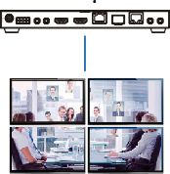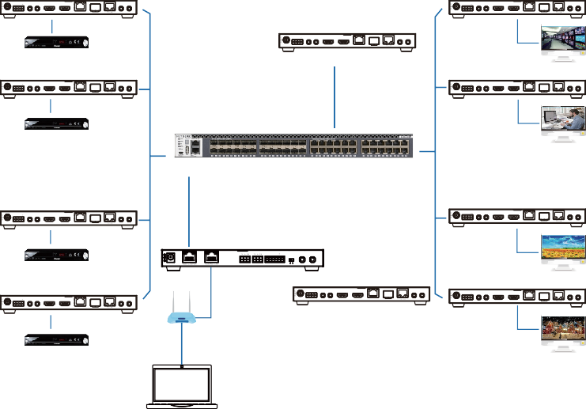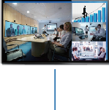Transceiver (ENC Mode) Transceiver (DEC Mode)

12V TX RX

SFP+

IN OUT

12V TX RX

SFP+

IN OUT

DC 12V RS-232 IR IN IR OUT HDMI IN HDMI OUT 10G BASE-T

AUDIO

DC 12V RS-232 IR IN IR OUT HDMI IN HDMI OUT 10G BASE-T

AUDIO

DVD

12V TX RX

DC 12V RS-232 IR IN IR OUT HDMI IN HDMI OUT 10G BASE-T

SFP+

IN OUT

AUDIO TV

Transceiver (ENC Mode)
Transceiver (DEC Mode)

Transceiver (DEC Mode)

12V TX RX

SFP+

IN OUT

12V TX RX

SFP+

IN OUT

DC 12V RS-232 IR IN IR OUT HDMI IN HDMI OUT 10G BASE-T

AUDIO

DC 12V RS-232 IR IN IR OUT HDMI IN HDMI OUT 10G BASE-T

AUDIO

DVD
TV

10G Ethernet Switch

Transceiver (ENC Mode) Transceiver (DEC Mode)

12V TX RX

SFP+

IN OUT

12V TX RX

SFP+

IN OUT

DC 12V RS-232 IR IN IR OUT HDMI IN HDMI OUT 10G BASE-T

DVD

AUDIO

Controller Box
IR IN IR OUT

VOUT

IO4 IO3 IO2 IO1
IO LEVEL

DC 12V RS-232 IR IN IR OUT HDMI IN HDMI OUT 10G BASE-T

AUDIO

Transceiver (ENC Mode)

DC 12V

1 RS-232 2

5V 12V

12V TX RX

SFP+

IN OUT
TV
Transceiver (DEC Mode)
SFP+

12V TX RX

SFP+

IN OUT

DC 12V RS-232 IR IN IR OUT HDMI IN HDMI OUT 10G BASE-T

AUDIO

DC 12V
12V TX RX

RS-232 IR IN IR OUT

HDMI IN HDMI OUT 10G BASE-T
IN OUT

AUDIO

DC 12V RS-232 IR IN IR OUT HDMI IN HDMI OUT 10G BASE-T

AUDIO

DVD

TP-LINK

Router (optional)

12V TX RX

DC 12V RS-232 IR IN IR OUT HDMI IN HDMI OUT 10G BASE-T

SFP+

IN OUT
TV

AUDIO

4×Transceiver (DEC Mode)

PC

Video Wall

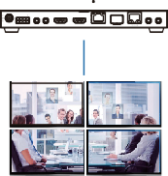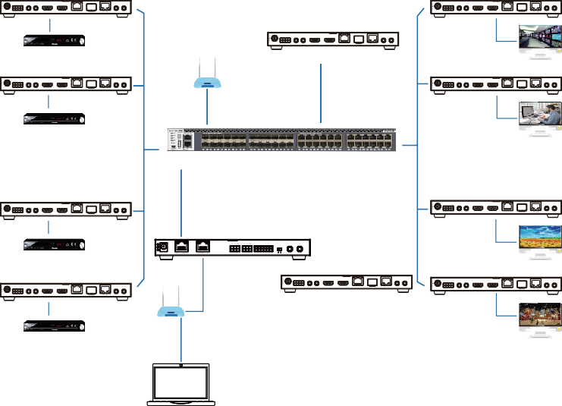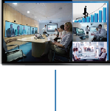Mode 2: DHCP mode.
IR IN IR OUT
IO LEVEL
DC 12V
1 RS-232 2 5V 12V

Transceiver (ENC Mode)

Multiview

Transceiver (DEC Mode)

12V TX RX

SFP+

IN OUT

12V TX RX

SFP+

IN OUT

DC 12V RS-232 IR IN IR OUT HDMI IN HDMI OUT 10G BASE-T

AUDIO

DC 12V RS-232 IR IN IR OUT HDMI IN HDMI OUT 10G BASE-T

AUDIO

DVD

Router

12V TX RX

DC 12V RS-232 IR IN IR OUT HDMI IN HDMI OUT 10G BASE-T

SFP+

IN OUT

AUDIO TV

Transceiver (ENC Mode)
Transceiver (DEC Mode)

Transceiver (DEC Mode)

12V TX RX

SFP+

IN OUT

TP-LINK

12V TX RX

SFP+

IN OUT

DC 12V RS-232 IR IN IR OUT HDMI IN HDMI OUT 10G BASE-T

AUDIO

DC 12V RS-232 IR IN IR OUT HDMI IN HDMI OUT 10G BASE-T

AUDIO

DVD
TV

10G Ethernet Switch

Transceiver (ENC Mode) Transceiver (DEC Mode)

12V TX RX

SFP+

IN OUT

12V TX RX

SFP+

IN OUT

DC 12V RS-232 IR IN IR OUT HDMI IN HDMI OUT 10G BASE-T

DVD

AUDIO

Controller Box

VOUT

IO4 IO3 IO2 IO1

DC 12V RS-232 IR IN IR OUT HDMI IN HDMI OUT 10G BASE-T

TV

AUDIO

Transceiver (ENC Mode)

12V TX RX

SFP+

IN OUT
Transceiver (DEC Mode)
SFP+

12V TX RX

SFP+

IN OUT

DC 12V RS-232 IR IN IR OUT HDMI IN HDMI OUT 10G BASE-T

AUDIO

DC 12V
12V TX RX

RS-232 IR IN IR OUT

HDMI IN HDMI OUT 10G BASE-T
IN OUT

AUDIO

DC 12V RS-232 IR IN IR OUT HDMI IN HDMI OUT 10G BASE-T

AUDIO

DVD

TP-LINK

Router (optional)

12V TX RX

DC 12V RS-232 IR IN IR OUT HDMI IN HDMI OUT 10G BASE-T

SFP+

IN OUT
TV

AUDIO

4×Transceiver (DEC Mode)

PC

Video Wall

Mode 3: Static IP mode by manual settings.

Multiview

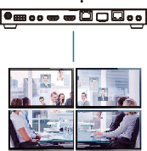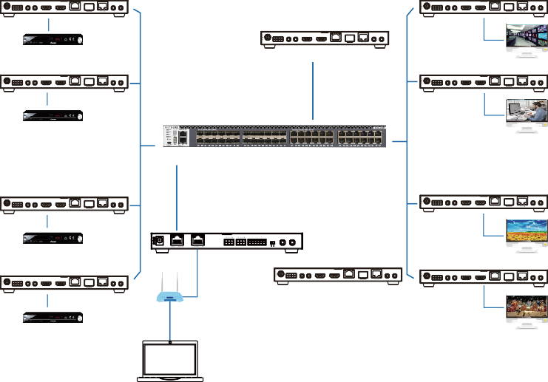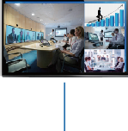Transceiver (ENC Mode) Transceiver (DEC Mode)

12V TX RX

SFP+

IN OUT

12V TX RX

SFP+

IN OUT

DC 12V RS-232 IR IN IR OUT HDMI IN HDMI OUT 10G BASE-T

AUDIO

DC 12V RS-232 IR IN IR OUT HDMI IN HDMI OUT 10G BASE-T

AUDIO

DVD

12V TX RX

DC 12V RS-232 IR IN IR OUT HDMI IN HDMI OUT 10G BASE-T

SFP+

IN OUT

AUDIO TV

Transceiver (ENC Mode)
Transceiver (DEC Mode)

Transceiver (DEC Mode)

12V TX RX

SFP+

IN OUT

12V TX RX

SFP+

IN OUT

DC 12V RS-232 IR IN IR OUT HDMI IN HDMI OUT 10G BASE-T

AUDIO

DC 12V RS-232 IR IN IR OUT HDMI IN HDMI OUT 10G BASE-T

AUDIO

DVD
TV

10G Ethernet Switch

Transceiver (ENC Mode) Transceiver (DEC Mode)

12V TX RX

SFP+

IN OUT

12V TX RX

SFP+

IN OUT

DC 12V RS-232 IR IN IR OUT HDMI IN HDMI OUT 10G BASE-T

DVD

AUDIO

Controller Box
IR IN IR OUT

VOUT

IO4 IO3 IO2 IO1
IO LEVEL

DC 12V RS-232 IR IN IR OUT HDMI IN HDMI OUT 10G BASE-T

AUDIO

Transceiver (ENC Mode)

DC 12V

1 RS-232 2

5V 12V

12V TX RX

SFP+

IN OUT
TV
Transceiver (DEC Mode)
SFP+

12V TX RX

SFP+

IN OUT

DC 12V RS-232 IR IN IR OUT HDMI IN HDMI OUT 10G BASE-T

AUDIO

DC 12V
12V TX RX

RS-232 IR IN IR OUT

HDMI IN HDMI OUT 10G BASE-T
IN OUT

AUDIO

DC 12V RS-232 IR IN IR OUT HDMI IN HDMI OUT 10G BASE-T

AUDIO

DVD

TP-LINK

Router (optional)

12V TX RX

DC 12V RS-232 IR IN IR OUT HDMI IN HDMI OUT 10G BASE-T

SFP+

IN OUT
TV

AUDIO

4×Transceiver (DEC Mode)

PC

Video Wall

Notes:
- Currently only Mode 1 is available, Mode 2 and Mode 3 will be ready in short future.
- For the default IP mode of Control LAN port of the Controller Box is DHCP, the PC also needs to be set to “Obtain an IP address automatically” mode, and an optional DHCP server (e.g. network router) is recommended in the system.
- If there is no DHCP server in the system, 192.168.0.225 will be used as the IP address of Control LAN port. You need to set the IP address of the PC to be in the same network segment. For example, set PC’s IP address as 192.168.0.88.
- You can access the Web GUI by inputting URL "http://controller.local" or the Control LAN port IP address 192.168.0.225 (in case of no optional Router) on your computer's browser.
- No need to care about settings of Video LAN port of the Controller Box in Mode 1 and Mode 2, as they are managed by Controller automatically.
- When the Network Switch does not support PoE, the Encoder, Decoder and Controller Box should be powered by DC power adpater.

