ALT-IPC460DA (V2)

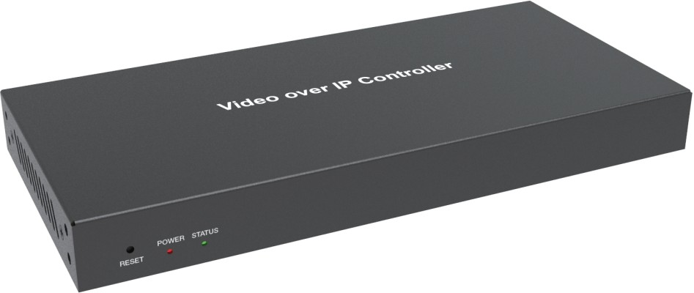


VER 1.0

Thank you for purchasing this product
For optimum performance and safety, please read these instructions carefully before connecting, operating or adjusting this product. Please keep this manual for future reference.

Surge protection device recommended
This product contains sensitive electrical components that may be damaged by electrical spikes, surges, electric shock, lighting strikes, etc. Use of surge protection systems is highly recommended in order to protect and extend the life of your equipment.

Table of Contents
- Introduction. 1
- Features. 1
- Package Contents. 1
- Specifications. 2
- Operation Controls and Functions. 2
  - Front Panel. 2
  - Rear Panel. 3
  - IR Pin Definition. 4
- Rack Mounting Instruction. 4
  - 6U Rack Mounting. 4
  - 1U Rack Mounting. 6
- Web GUI User Guide. 7
  - Preparation before Entering the System. 7
  - Functions and Operation. 15
- Application Example. 27

Introduction
This Video over IP Controller is used to control and manage JPEG2000 IP products. It supports dual 100M network ports, which can realize dual-
network isolation of Control network and Multicast video distribution network. Built-in Web GUI, TCP and RS-232 control are supported. It supports POE function and wide-band 12V IR signal receiving. Since the demand of IP products is daily increased in the current market, the IP Controller will be widely applied in more and more different scenarios.

Features
☆ Easy to create project, control and manage the system
☆ Flexibly support Auto, DHCP and Manual three types of IP configurations
☆ HTTPS, SSH, SFTP security compatible
☆ Built-in Web GUI control interface, supporting Drag & Drop operations
☆ Support image preview
☆ Support video, audio, RS-232, IR, KVM control and management of the distributed system
☆ Dual network ports (VIDEO LAN port supports POE function) to isolate Controls and Multicast networks.
☆ Support LAN/RS-232 port control and third-party central control
☆ Support IR signal receiving (3.5mm audio jack, 12V level)
☆ 4 channel GPIO control ports (5V/12V optional level)
☆ Multiple circuits protection, lightning protection and ESD design
☆ Reliable system design, ensuring 7*24 hours reliable and stable work

Package Contents
① 1 ⅹ Video over IP Controller
② 1 ⅹ 20kHz-60kHz 12V IR Receiver Cable (1.5 meters)
③ 1 ⅹ 3-pin 3.81mm Phoenix Connector (Male)
④ 1 ⅹ 6-pin 3.81mm Phoenix Connector (Male)
⑤ 2 ⅹ Mounting Ears
⑥ 4 ⅹ Machine Screws (KM3*6)
⑦ 1 ⅹ 12V/1A Locking Power Adaptor
⑧ 1 ⅹ User Manual

Specifications

Technical
Network Bandwidth | 100M
Transmission Distance | 100m CAT 5E/6/6A/7
Control Ports | 2 x 100M LAN [RJ45 connector] [VIDEO LAN support POE] 1 x IR IN [3.5mm audio jack, 12V level]  1 x DIGITAL I/O [6-pin 3.81mm phoenix connector] 1 x RS-232 [3-pin 3.81mm phoenix connector]
Dimensions | 204mm(W)×98mm(D)×21mm(H)
Housing | Metal Enclosure
Color | Black
Weight | 509g
Power Supply | 12V/1A
Power Consumption | 4.5W
Operating  Temperature | 0°C ~ 40°C / 32°F ~ 104°F
Storage Temperature | -20°C ~ 60°C / -4°F ~ 140°F
Relative Humidity | 20~90% RH (non-condensing)

Operation Controls and Functions

Front Panel

POWER STATUS

RESET

1 2 3

No. | Name | Function Description
1 | RESET Button | Press and hold this button (about 10 seconds) until Status LED starts flashing, Controller will be reset automatically.
2 | POWER LED | The red LED will light on when the Controller is powered on.
3 | STATUS LED | The status LED will flash in yellowish-green every 1 second until Controller boots up completely and Control LAN is ready, then it becomes solid.

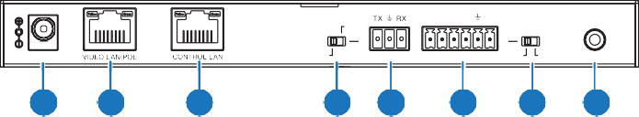Rear Panel
MCU
IR IN
IO LEVEL
DC 12V
NORMAL
5V 12V
1
2
3
4
5
6
7
8
VOUT
IO4 IO3 IO2 IO1

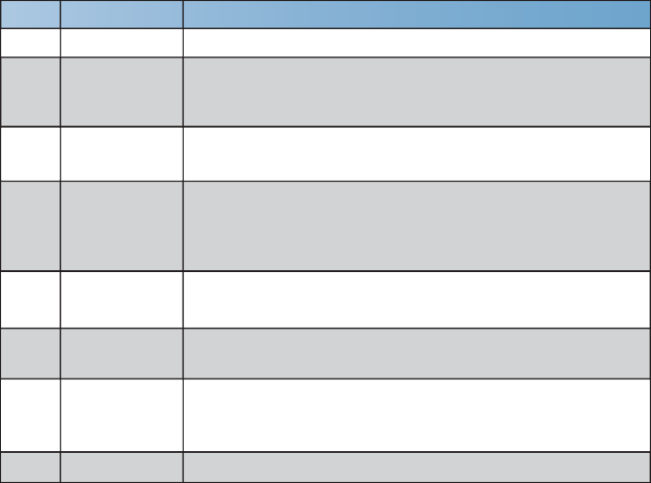
No.
1

2

3

4

Name
DC 12V

VIDEO LAN (POE)

CONTROL LAN

MCU/Normal DIP Switch

Function Description
DC 12V/1A power input port.
100M Video LAN port, supporting POE function.
Note: When POE is enabled, DC 12V/1A power supply is not required.

The TCP/IP control network port.
Normal mode (Default): The RS-232 port is used for serial port commands control.
MCU mode: The RS-232 port is used for MCU software upgrade.

    - 3-pin Phoenix RS-232 serial communication port. Connector
    - 6-pin Phoenix 4 channel I/O level outputs, 1 channel grounding,

Connector

IO LEVEL
    - DIP Switch
    - IR IN
1 channel power supply to the outside.
Used to control I/O level output and VOUT voltage. Switch to left: 5V I/O level output, VOUT is 5V. Switch to right: 12V I/O level output, VOUT is 12V.
12V IR signal input port.

IR Pin Definition

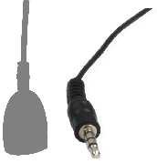
IR RECEIVER

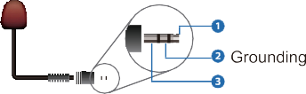
IR RECEIVER
Power 12V

Rack Mounting Instruction

6U Rack Mounting
This Controller can be mounted in a standard 6U rack (Please contact your supplier for 6U rack sale). The mounting steps are as follows:
Step 1: Use included screws to fix two mounting ears on the Controller, as shown in the figure below:
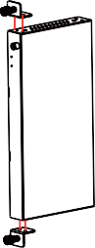

Step 2: Insert the Controller with mounting ears into a 6U rack (up to 10 units can be installed vertically), as shown in the figure below:
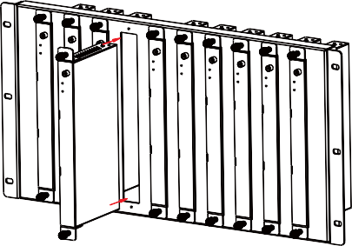

Step 3: Use screws to fix mounting ears on the rack to complete the mounting, as shown in the figure below:
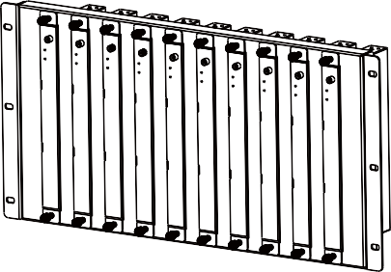

1U Rack Mounting
This Controller also can be mounted in a standard 1U rack (up to 4 units can be installed horizontally). The mounting steps are as follows:
Step 1: Stack two Controllers on top of each other, then use included screws to fix two 1U rack panels on the Controllers, as shown in the figure below:
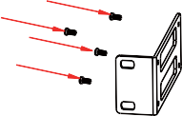
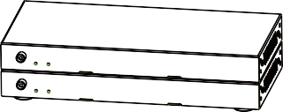
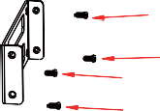

Step 2: Fix two 1U rack panels on another two stacked Controllers in the same way, then use screws to fix two 1U rack panels together, as shown in the figure below:
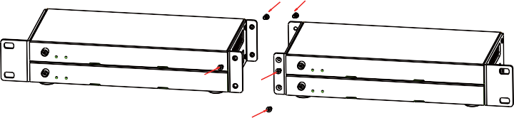

Step 3: Fasten screws between two 1U rack panels, so that four Controllers are mounted in a 1U rack, as shown in the figure below:
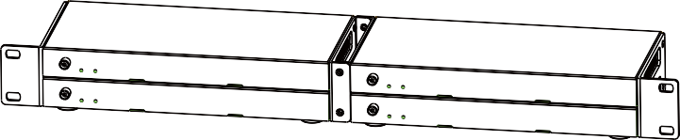

Web GUI User Guide

Preparation before Entering the System
You can use Controller’s Web GUI to control all IP products at the Switch. The operation method is shown as below:
Step 1: Input the Controller’s default IP address (192.168.0.225) or the URL (http://controller.local) into the Web browser address bar on the PC to enter the Web GUI login interface.

Select the initial username (admin) and input the initial password (1234) on the above login interface. Then, click “Log In” to enter the Web GUI interface. For the first time, you need to setup the project, as shown in the following
figure:
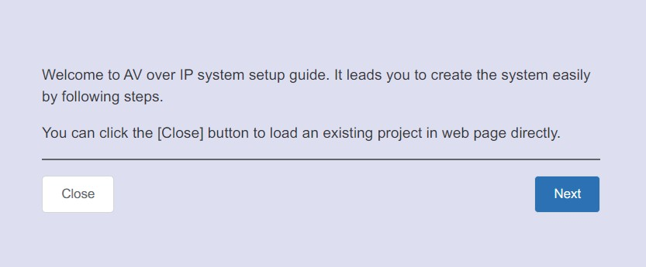

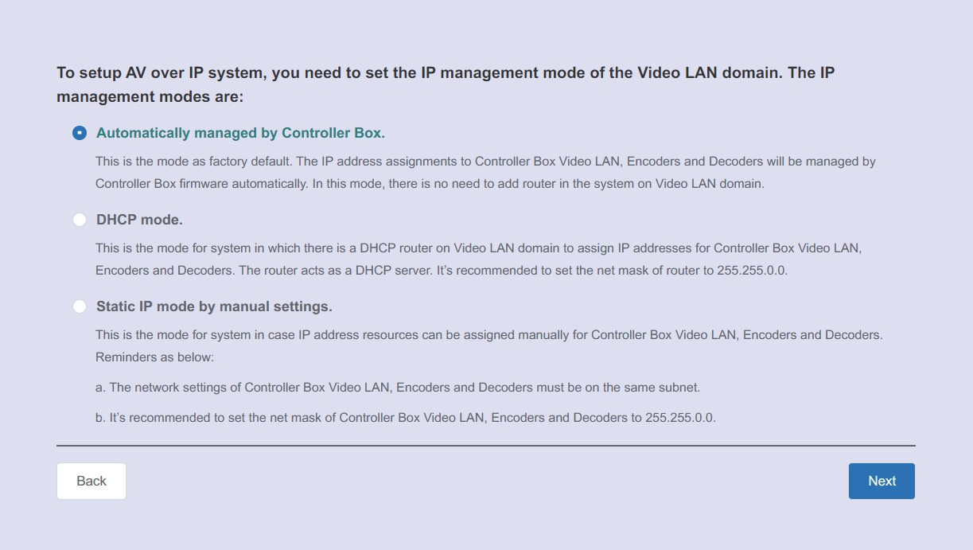
Step 2: Click the “Close” button to load an existing project in web page directly, or click “Next” button to go to the next step.
On this interface, you need to set the IP mode of Video LAN.
Mode 1: Automatically managed by Controller Box.
Please connect all the devices according to the following diagram.
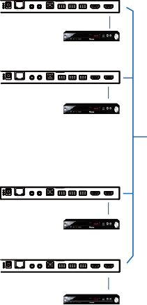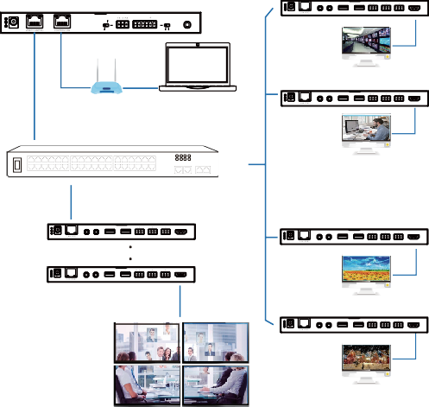ENC
TX RX L R L R

USB HOST RS-232 IN AUDIO OUT HDMI OUT HDMI IN
DVD
ENC
TX RX L R L R

IR IN IR OUT USB HOST RS-232 IN AUDIO OUT HDMI OUT HDMI IN
DVD
ENC
TX RX L R L R

DC 12V USB HOST RS-232 IN AUDIO OUT HDMI OUT HDMI IN
DVD
ENC
TX RX L R L R

IR IN IR OUT USB HOST RS-232 IN AUDIO OUT HDMI OUT HDMI IN
DVD

DC 12V

IR IN IR OUT

DC 12V

IR IN IR OUT

DC 12V
Controller Box

MCU
DEC
1 2 TX RX L R L R
DC 12V IR IN IR OUT USB DEVICE 2.0 RS-232 IN AUDIO OUT HDMI OUT
IR IN
IO LEVEL
NORMAL
5V 12V
DC 12V
TV
DEC
TP-LINK
1 2 TX RX L R L R
Router (optional) PC
1G Ethernet Switch
DC 12V IR IN IR OUT USB DEVICE 2.0 RS-232 IN AUDIO OUT HDMI OUT
TV
DEC
1 2 TX RX L R L R
1 2 TX RX L R L R
DC 12V
IR IN IR OUT USB DEVICE 2.0 RS-232 IN AUDIO OUT HDMI OUT
DC 12V IR IN IR OUT USB DEVICE 2.0 RS-232 IN AUDIO OUT HDMI OUT
1 2 TX RX L R L R

DC 12V IR IN IR OUT USB DEVICE 2.0 RS-232 IN AUDIO OUT HDMI OUT
TV
4 × DEC
DEC
1 2 TX RX L R L R

DC 12V IR IN IR OUT USB DEVICE 2.0 RS-232 IN AUDIO OUT HDMI OUT
TV
Video Wall

VOUT

IO4 IO3 IO2 IO1

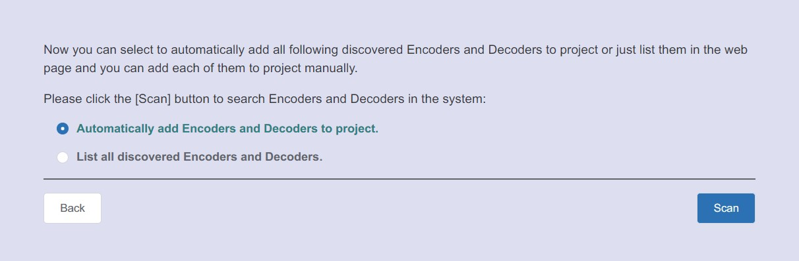
Click the “Next” button and wait for the completion to enter the interface as shown in the figure below.
If you select “Automatically add Encoders and Decoders to project”, and click the “Scan” button to enter the Project page. All the connected devices will be listed in the Current Devices list.
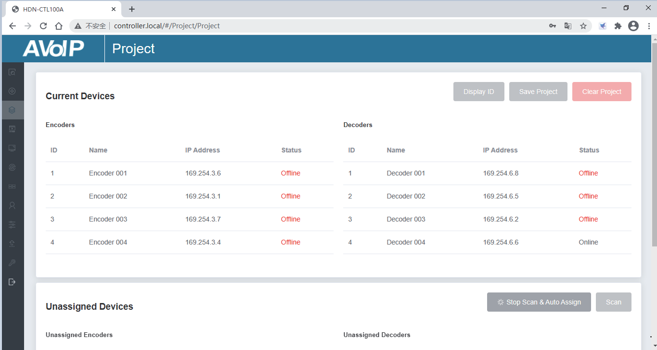

Then click “Stop Scan & Auto Assign” to stop search.

If you select “List all discovered Encoders and Decoders”, and click the “Scan” button to enter the Project page. All the connected devices will be listed in the Unassigned Devices list.

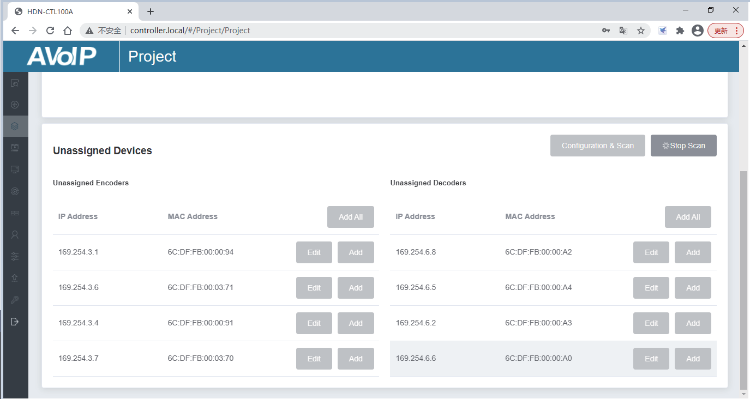
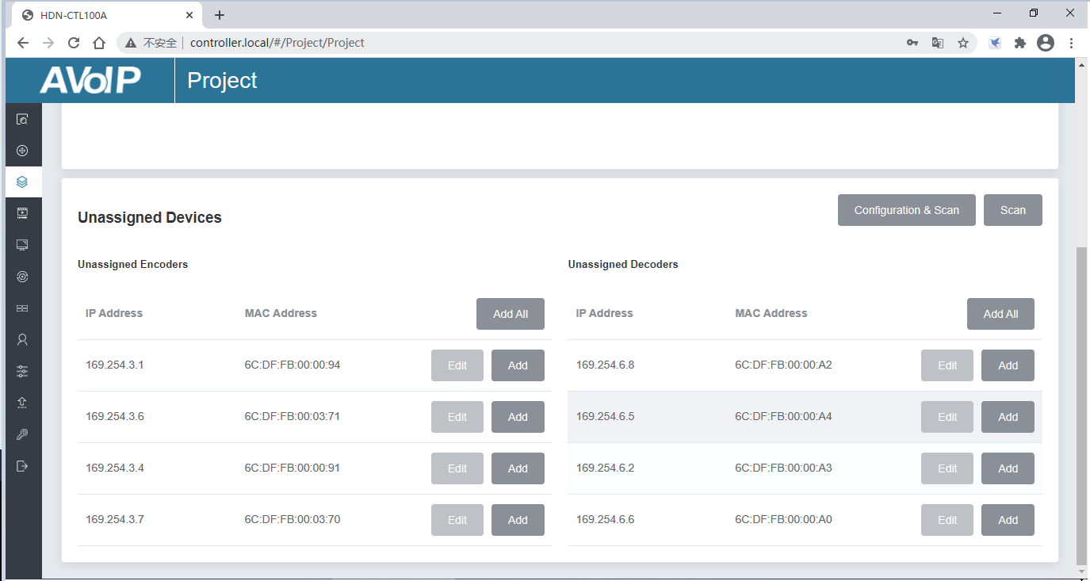
Click “Stop Scan” to stop search. Then the “Add All” buttons and “Add” buttons behind Unassigned Encoders and Unassigned Decoders in the figure below will become operable.
At this time, you can click the “Add” button behind each unregistered Encoder or Decoder to add the device to the project one by one, or click the “Add All” button to add all Encoders or Decoders to the project.
Encoders and Decoders that have been added to the project will appear in the Current Devices list, as shown in the figure below.

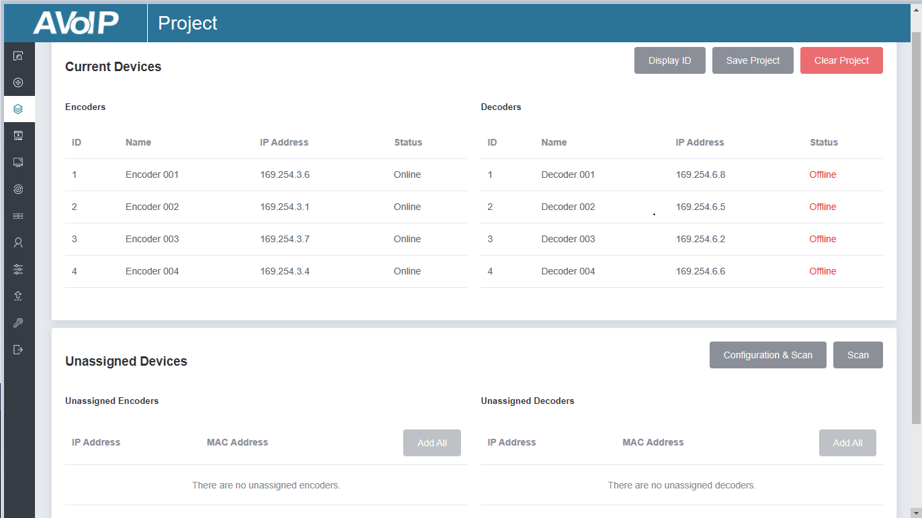
Mode 2: DHCP mode.
Please connect all the devices according to the following diagram.

ENC

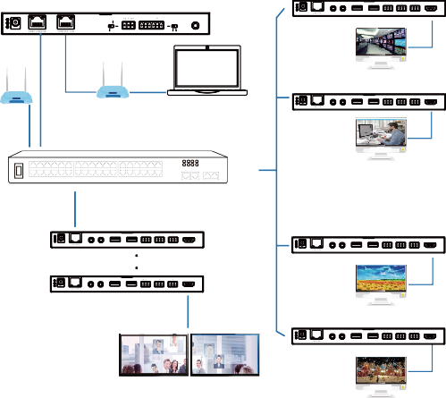
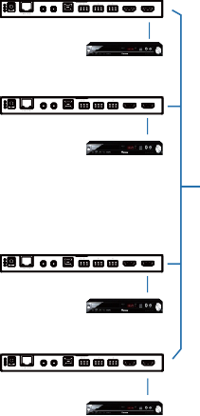Controller Box
TX RX L R L R
DC 12V
IR IN IR OUT USB HOST RS-232 IN AUDIO OUT HDMI OUT HDMI IN
DVD
ENC
TX RX L R L R
DC 12V
IR IN IR OUT USB HOST RS-232 IN AUDIO OUT HDMI OUT HDMI IN
DVD
ENC
TX RX L R L R
DC 12V
IR IN IR OUT USB HOST RS-232 IN AUDIO OUT HDMI OUT HDMI IN
DVD
ENC
TX RX L R L R
DC 12V
IR IN IR OUT USB HOST RS-232 IN AUDIO OUT HDMI OUT HDMI IN
DVD
DEC

1 2 TX RX L R L R

DC 12V IR IN IR OUT USB DEVICE 2.0 RS-232 IN AUDIO OUT HDMI OUT

VOUT

IO4 IO3 IO2 IO1

MCU

IO LEVEL

IR IN

DC 12V

NORMAL

TP-LINK

5V 12V

TV
DEC

TP-LINK

Router
Router (optional) PC 1G Ethernet Switch

DC 12V

1 2 TX RX L R L R

IR IN IR OUT USB DEVICE 2.0 RS-232 IN AUDIO OUT HDMI OUT

TV

1 2 TX RX L R L R

DEC

DC 12V

IR IN IR OUT USB DEVICE 2.0 RS-232 IN AUDIO OUT HDMI OUT

1 2 TX RX L R L R

DC 12V IR IN IR OUT USB DEVICE 2.0 RS-232 IN AUDIO OUT HDMI OUT

DC 12V

1 2 TX RX L R L R

IR IN IR OUT USB DEVICE 2.0 RS-232 IN AUDIO OUT HDMI OUT

4 × DEC

DEC

TV

1 2 TX RX L R L R

DC 12V IR IN IR OUT USB DEVICE 2.0 RS-232 IN AUDIO OUT HDMI OUT

TV

Select “DHCP Mode” on the interface shown below, and click “Next”.
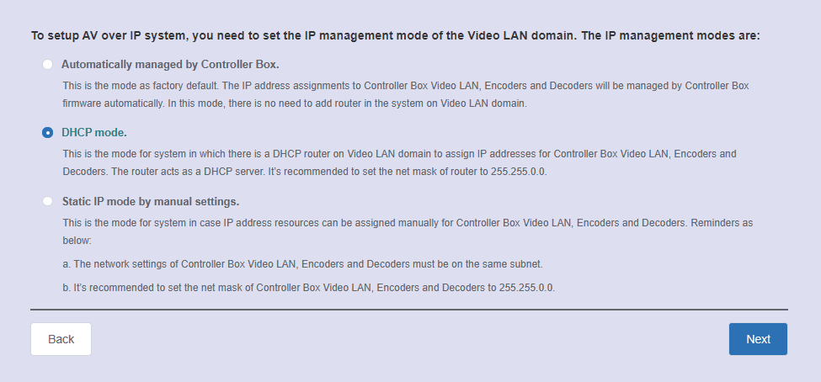
The rest of the steps are the same as the Mode 1 operation.

Mode 3: Static IP mode by manual settings.
Please connect all the devices according to the following diagram.
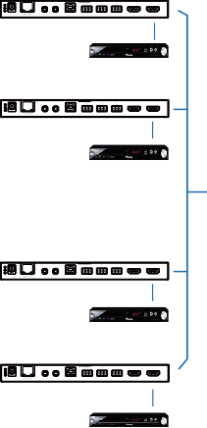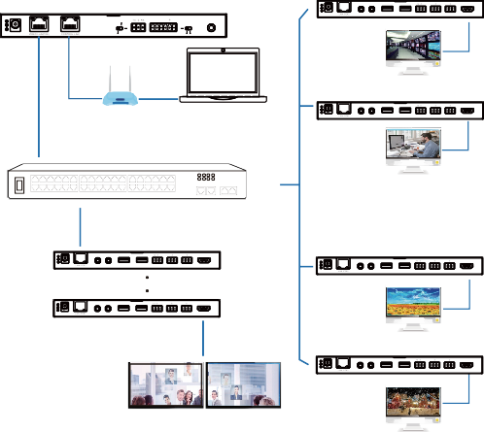ENC
TX RX L R L R
DC 12V
IR IN IR OUT USB HOST RS-232 IN AUDIO OUT HDMI OUT HDMI IN
DVD
ENC
TX RX L R L R
DC 12V
IR IN IR OUT USB HOST RS-232 IN AUDIO OUT HDMI OUT HDMI IN
DVD
ENC
TX RX L R L R
DC 12V
USB HOST RS-232 IN AUDIO OUT HDMI OUT HDMI IN
DVD
ENC
TX RX L R L R
DC 12V
USB HOST RS-232 IN AUDIO OUT HDMI OUT HDMI IN
DVD

IR IN IR OUT

IR IN IR OUT
Controller Box

MCU
DEC
1 2 TX RX L R L R
DC 12V IR IN IR OUT USB DEVICE 2.0 RS-232 IN AUDIO OUT HDMI OUT
IR IN
IO LEVEL
DC 12V
NORMAL
5V 12V
TV
DEC
TP-LINK
1 2 TX RX L R L R
Router (optional) PC
1G Ethernet Switch
DC 12V IR IN IR OUT USB DEVICE 2.0 RS-232 IN AUDIO OUT HDMI OUT
TV
DEC
1 2 TX RX L R L R
1 2 TX RX L R L R
DC 12V IR IN IR OUT USB DEVICE 2.0 RS-232 IN AUDIO OUT HDMI OUT
DC 12V IR IN IR OUT USB DEVICE 2.0 RS-232 IN AUDIO OUT HDMI OUT
1 2 TX RX L R L R

DC 12V IR IN IR OUT USB DEVICE 2.0 RS-232 IN AUDIO OUT HDMI OUT
TV
4 × DEC
DEC
1 2 TX RX L R L R

DC 12V IR IN IR OUT USB DEVICE 2.0 RS-232 IN AUDIO OUT HDMI OUT
TV

VOUT

IO4 IO3 IO2 IO1

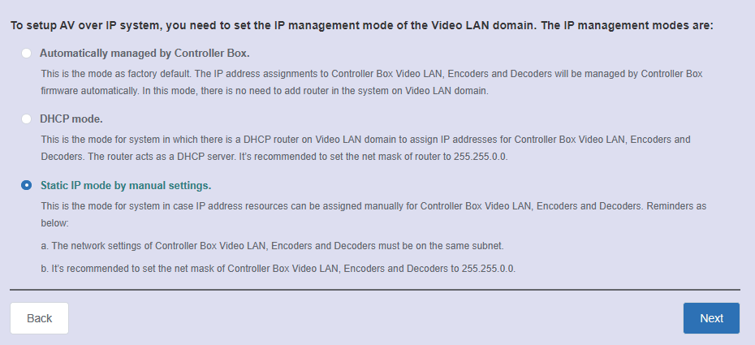
Select “Static IP mode by manual settings” on the interface shown below, and click “Next”.
After entering the interface shown in the figure below, manually set the IP address, subnet mask and gateway of the Video LAN.
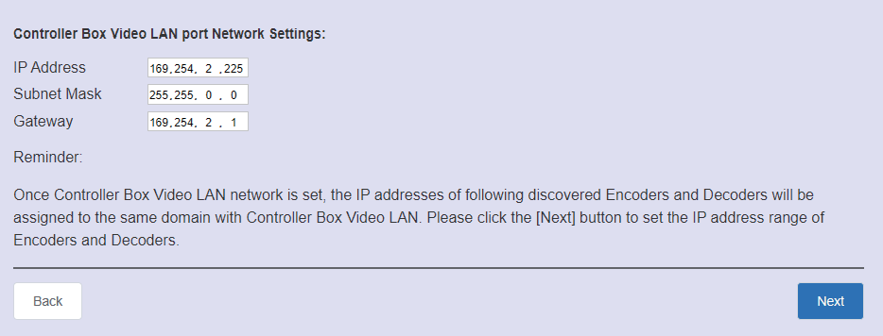
Note:
It’s strongly recommended to use different IP network domain from Control LAN port.

After the progress reaches 100%, enter the interface as shown in the figure below.
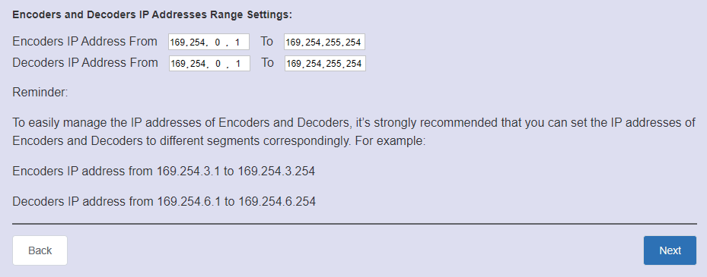

On this interface, you can set the IP address range of Encoders and Decoders.
After the setting is complete, click the “Next” button to enter the interface as shown in the figure below.
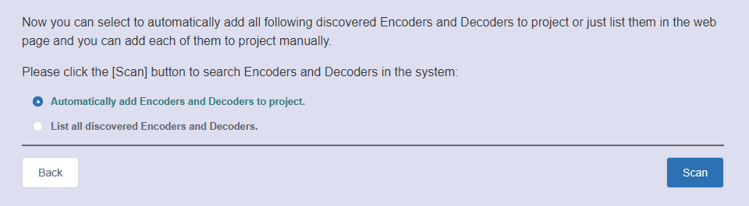
The rest of the steps are the same as the Mode 1 operation.

Functions and Operation
- Preview Page

On this page, you can preview the Encoder/Decoder by clicking the drop- down list on the right side.

- Matrix Control Page
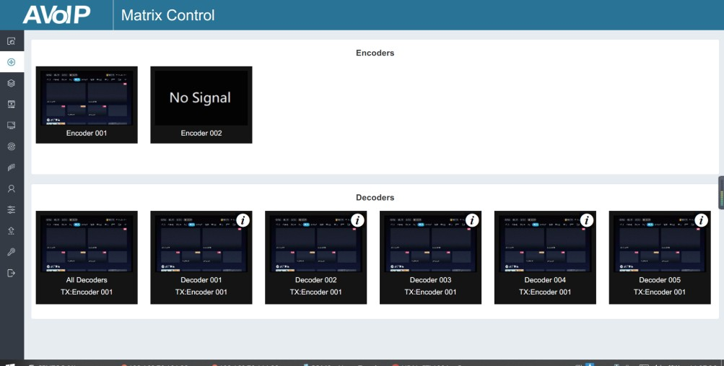
① Encoders: Display all the current Encoders. The text in the figure is the name of the device.
② Decoders: Display all the current Decoders. The text on the first line is
the name of the Decoder, and the text on the second line refers to the Encoder where the signal resource is from.

Operating Instructions:
- If an Encoder shows “No Signal”, it means that the Encoder cannot be dragged.
- If there is an image on an Encoder, it means that the Encoder can be dragged. As shown in the figure above, if an Encoder is dragged to the place where the red arrow points to, all Decoders will share the same signal resource from this Encoder; if an Encoder is dragged to the place where the blue arrow points to, only the indicated Decoder can receive signals from this Encoder.

  - Project Page

① Current Devices: Devices that have been added to the current project.
② Unassigned Devices: Devices not added to the current project.
Operating Instructions:
- Click “Display ID” to display the ID number of the Decoders.
- Click “Save Project” to save the project file (config_file.json), so that you can use the saved project next time without scanning devices again.
- Click “Clear Project” to clear the current project, then you will need to setup devices again.
- Click “Scan” to search devices that do not appear in the current project; Click “Stop Scan”, then it will stop searching.

- Click “Configuration & Scan” to search new devices automatically and add to the current project.

  - Encoders Page

① ID: The ID of the current device. (Note: ID is not duplicated.)
② Name: The name of the current device. (Note: Name is not duplicated.)
③ MAC Address: The MAC Address of the current device.
④ IP Address: The IP Address of the current device.
⑤ Firmware: The Firmware version No. of the current device.
⑥ Status: The status (online or offline) of the current device.
⑦ EDID: The EDID of the current device.
⑧ Audio Selection: The Audio Selection of the current device.
Operating Instructions:
- Click “Refresh” to refresh the data of the current Encoders.
- Click the drop-down list of EDID to set the current Encoder’s EDID.
- Click the drop-down list of Audio Selection to set the current Encoder’s audio output.
- Click the icon on the left of ID to check the detail information about the current Encoder, as shown in below:



On this page, you can setup the current Encoder as required.

  - Decoders Page
① ID: The ID of the current device. (Note: ID is not duplicated.)
② Name: The name of the current device. (Note: Name is not duplicated.)
③ MAC Address: The MAC Address of the current device.
④ IP Address: The IP Address of the current device.
⑤ Firmware: The Firmware version No. of the current device.
⑥ Status: The status (online or offline) of the current device.
⑦ Source: The signal source (Encoder) of the current device.
⑧ Scaler Resolution: The resolution of the current device.
⑨ HDR: The HDR status of the current device.
⑩ Function: The mode of the current device.
Operating Instructions:
- Click “Refresh” to refresh the data of the current Decoders.
- Click the drop-down list of Source to select the current Decoder‘s signal source.
- Click the drop-down list of Scaler Resolution to select the current
Decoder‘s resolution.
- Click the drop-down list of HDR to turn on/off HDR.
- Click the drop-down list of Function to select the current Decoder‘s mode.
- Click the icon on the left of ID to check the detail information about the current Decoder, as shown in below:



On this page, you can setup the current Decoder as required.

  - Locked Signal Routing Page
On this page, you can independently route the different signals between Encoder & Decoder devices. Please click “Locked Routing Help” for details.

  - Video Wall Management Page

On this page, you can create and configure video wall as required. Please follow below steps to create a video wall.
Step 1: Click “Create”, a pop-up window will be shown as below:

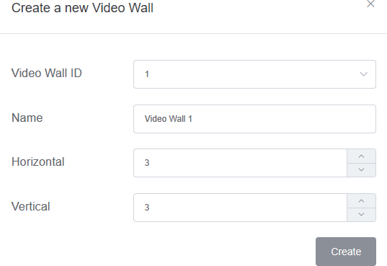

You can set the Video Wall ID, Name, Horizontal and Vertical panel numbers. Then click “Create” to create the Video Wall.
Note: Up to 9 video walls can be created.
Step 2: Select the video wall that you want to configure on the “Video Wall List”, then click “Assign Decoder” to enter the Decoder assignment page. Click each screen to select the corresponding Decoder device, then click “Apply”.
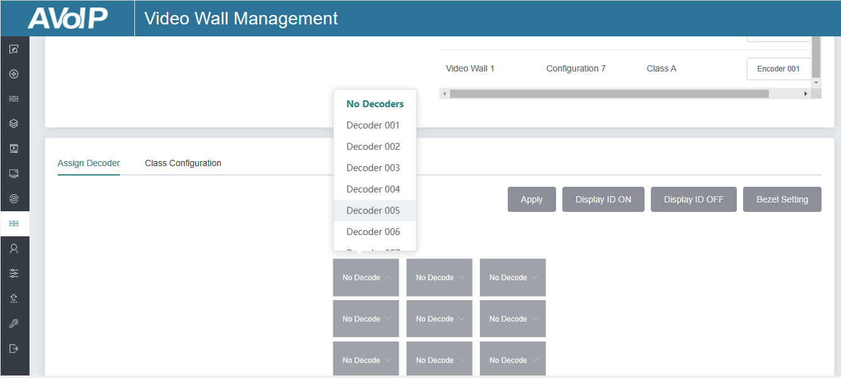
Note: A Decoder can only be assigned to one video wall.

Step 3: Click “Class Configuration” to enter the class configuration page, then click each screen to select the corresponding Class as required (the same class name will form a video wall, you can create a regular or irregular video wall by Class Configuration). Then click “Apply”.
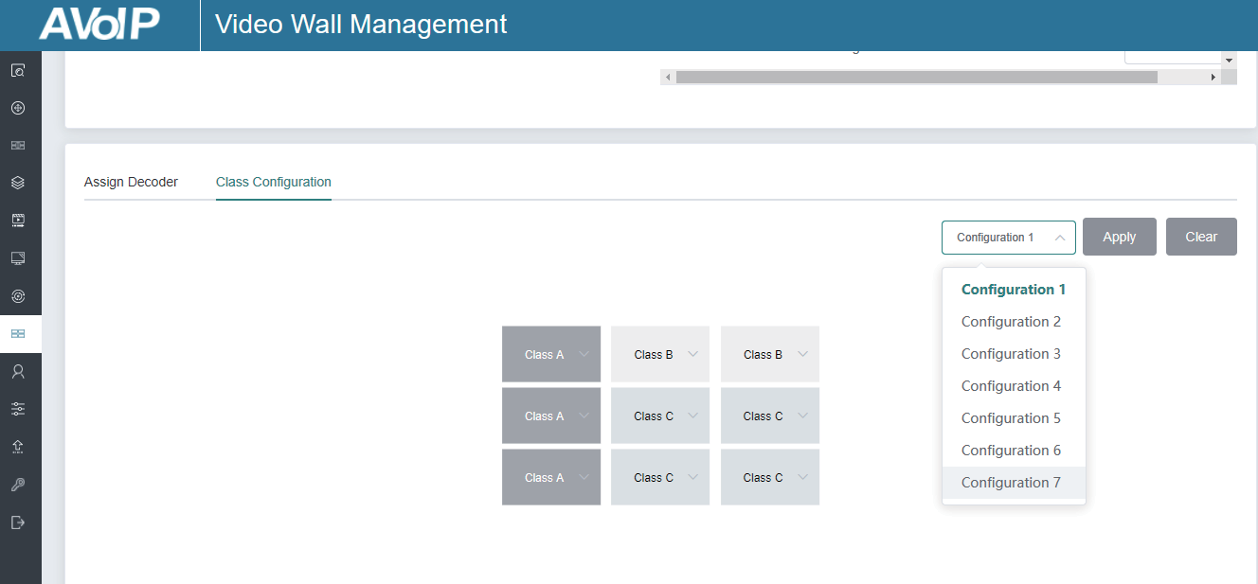
Note: Up to seven configurations can be set up for different application scenarios.
Step 4: After configuration, you can switch to “Video Wall Control” page for video preview, as shown in below.
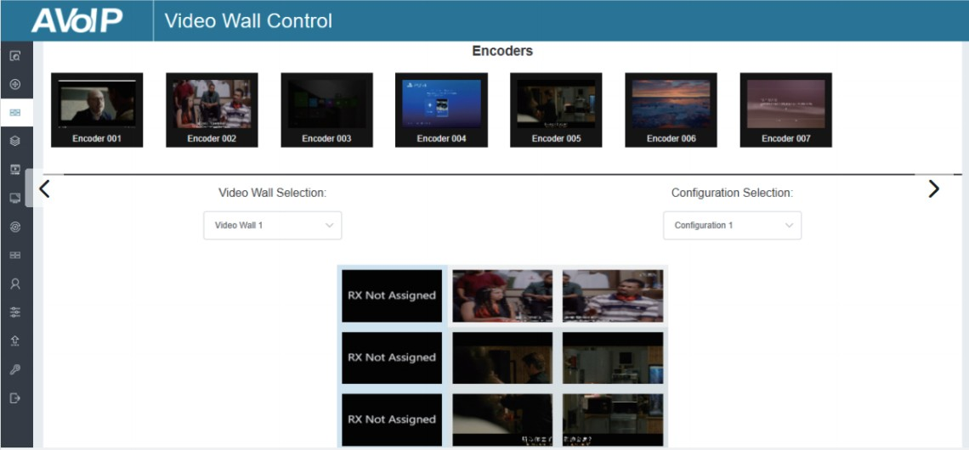

On this page, you can select different video walls and configurations that you have set up by clicking the drop-down box on the right of “Video Wall Selection
/ Configuration Selection”. Besides, you can directly drag Encoders at the top of the page to the video wall to change signal sources.
If you want to delete a video wall, just select the video wall on the “Video Wall List”, then click “Remove” . A prompt window will pop up and you can delete it after clicking “Yes”.

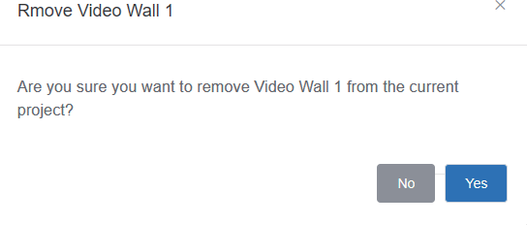
Remove

Notes:
- Each Decoder can be set into a part of a video wall array. Each system can contain multiple video walls with different sizes. Each video wall can be assigned to different screens and different layouts that range from 1x2 up to 9x9.
- The controller creates and manages the video wall configurations and provides a simplified control interface and API commands to third party control system.

  - Users Page

On this page, you can add new user accounts.

  - Controller Settings Page
① General Settings: The basic settings of the Controller.
② Control Network: The network port configuration of the Controller connected to the Switch.
③ Video Network:The network port configuration of the Controller
connected to video source devices.
You can update the settings or reset the Controller.

  - Firmware Update Page
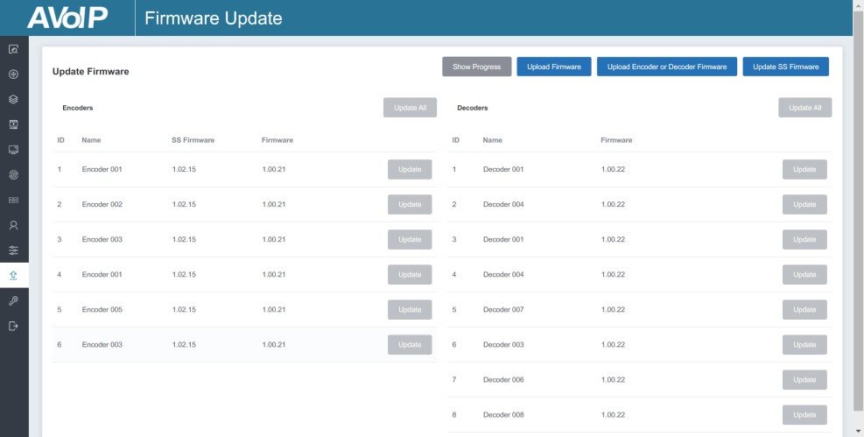
On this page, you can separately update the firmware of any Encoder/Decoder by clicking the corresponding “Update” button on the right, or update all the firmwares of Encoder/Decoder simultaneously by clicking the corresponding “Update All” button. Also you can update the Second Stream chip firmware by clicking the “Update SS Firmware” button.

  - Password Update Page
15/27
On this page, you can change the password. Note that after changing, it will skip to the Web browser home page or the Web GUI login interface automatically. You need to log in the Web GUI again with the new password.

  - Log Out Page
Click “Log Out” on the left, the Web GUI will exit and skip to the login interface automatically.

Application Example

Mode 1: Automatically managed by Controller Box.

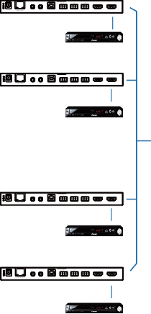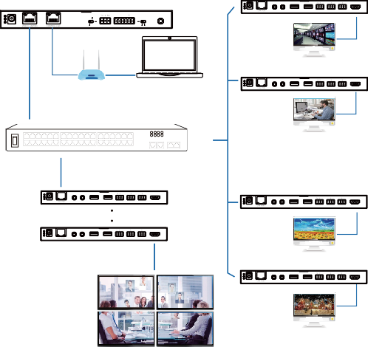ENC
TX RX L R L R
DC 12V
IR IN IR OUT USB HOST RS-232 IN AUDIO OUT HDMI OUT HDMI IN
DVD
ENC
TX RX L R L R
DC 12V
IR IN IR OUT USB HOST RS-232 IN AUDIO OUT HDMI OUT HDMI IN
DVD
ENC
TX RX L R L R
DC 12V
IR IN IR OUT USB HOST RS-232 IN AUDIO OUT HDMI OUT HDMI IN
DVD
ENC
TX RX L R L R
DC 12V
IR IN IR OUT USB HOST RS-232 IN AUDIO OUT HDMI OUT HDMI IN
DVD
Controller Box

MCU
DEC
1 2 TX RX L R L R
DC 12V IR IN IR OUT USB DEVICE 2.0 RS-232 IN AUDIO OUT HDMI OUT
IR IN
IO LEVEL
DC 12V
NORMAL
5V 12V
TV
DEC
TP-LINK
1 2 TX RX L R L R
Router (optional)
1G Ethernet Switch
PC
DC 12V IR IN IR OUT USB DEVICE 2.0 RS-232 IN AUDIO OUT HDMI OUT
TV
DEC
1 2 TX RX L R L R
1 2 TX RX L R L R
DC 12V IR IN IR OUT USB DEVICE 2.0 RS-232 IN AUDIO OUT HDMI OUT
DC 12V IR IN IR OUT USB DEVICE 2.0 RS-232 IN AUDIO OUT HDMI OUT
1 2 TX RX L R L R

DC 12V IR IN IR OUT USB DEVICE 2.0 RS-232 IN AUDIO OUT HDMI OUT
TV
4 × DEC
DEC
1 2 TX RX L R L R

DC 12V IR IN IR OUT USB DEVICE 2.0 RS-232 IN AUDIO OUT HDMI OUT
TV
Video Wall

VOUT

IO4 IO3 IO2 IO1

Mode 2: DHCP mode.

ENC

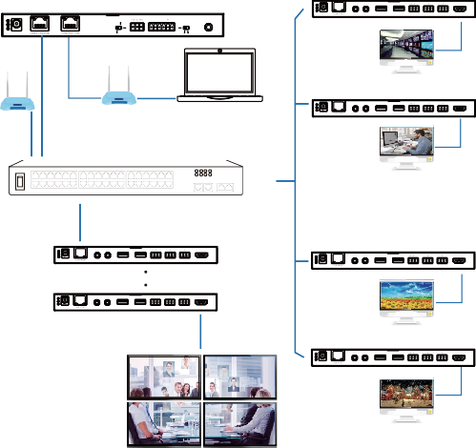Controller Box

DEC

1 2 TX RX L R L R

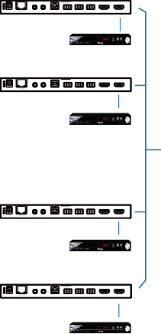DC 12V IR IN IR OUT USB DEVICE 2.0 RS-232 IN AUDIO OUT HDMI OUT
TX RX L R L R
DC 12V
IR IN IR OUT USB HOST RS-232 IN AUDIO OUT HDMI OUT HDMI IN
DVD
ENC
TX RX L R L R
DC 12V
IR IN IR OUT USB HOST RS-232 IN AUDIO OUT HDMI OUT HDMI IN
DVD
ENC
TX RX L R L R
DC 12V
IR IN IR OUT USB HOST RS-232 IN AUDIO OUT HDMI OUT HDMI IN
DVD
ENC
TX RX L R L R
DC 12V
IR IN IR OUT USB HOST RS-232 IN AUDIO OUT HDMI OUT HDMI IN
DVD

VOUT

IO4 IO3 IO2 IO1

MCU

IO LEVEL

IR IN

DC 12V

NORMAL

TP-LINK

5V 12V

TV
DEC

TP-LINK

Router
Router (optional) PC 1G Ethernet Switch

DC 12V

1 2 TX RX L R L R

IR IN IR OUT USB DEVICE 2.0 RS-232 IN AUDIO OUT HDMI OUT

TV

1 2 TX RX L R L R

DEC

DC 12V

IR IN IR OUT USB DEVICE 2.0 RS-232 IN AUDIO OUT HDMI OUT

1 2 TX RX L R L R

DC 12V IR IN IR OUT USB DEVICE 2.0 RS-232 IN AUDIO OUT HDMI OUT

DC 12V

1 2 TX RX L R L R

IR IN IR OUT USB DEVICE 2.0 RS-232 IN AUDIO OUT HDMI OUT

4 × DEC

DEC

TV

1 2 TX RX L R L R

DC 12V IR IN IR OUT USB DEVICE 2.0 RS-232 IN AUDIO OUT HDMI OUT

TV

Video Wall

Mode 3: Static IP mode by manual settings.
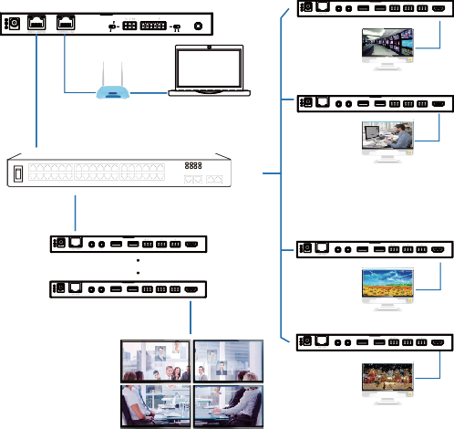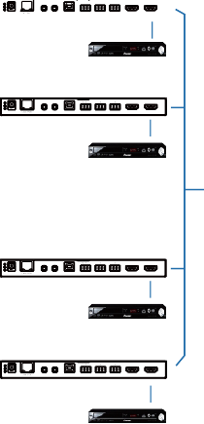ENC
Controller Box
DEC
1 2 TX RX L R L R

DC 12V IR IN IR OUT USB DEVICE 2.0 RS-232 IN AUDIO OUT HDMI OUT
MCU
IR IN
IO LEVEL
NORMAL
5V 12V
DC 12V
TV
DEC
TP-LINK
1 2 TX RX L R L R
Router (optional) PC
1G Ethernet Switch
IR IN IR OUT USB DEVICE 2.0 RS-232 IN AUDIO OUT HDMI OUT
TV
DEC
1 2 TX RX L R L R
1 2 TX RX L R L R
DC 12V IR IN IR OUT USB DEVICE 2.0 RS-232 IN AUDIO OUT HDMI OUT
DC 12V IR IN IR OUT USB DEVICE 2.0 RS-232 IN AUDIO OUT HDMI OUT
1 2 TX RX L R L R
TV
DC 12V IR IN IR OUT USB DEVICE 2.0 RS-232 IN AUDIO OUT HDMI OUT
4 × DEC
DEC
1 2 TX RX L R L R

DC 12V IR IN IR OUT USB DEVICE 2.0 RS-232 IN AUDIO OUT HDMI OUT
TV
Video Wall

DC 12V
DVD
ENC
TX RX L R L R
DC 12V
IR IN IR OUT USB HOST RS-232 IN AUDIO OUT HDMI OUT HDMI IN
DVD
ENC
TX RX L R L R
DC 12V
IR IN IR OUT USB HOST RS-232 IN AUDIO OUT HDMI OUT HDMI IN
DVD
ENC
TX RX L R L R
DC 12V
IR IN IR OUT USB HOST RS-232 IN AUDIO OUT HDMI OUT HDMI IN
DVD

VOUT

IO4 IO3 IO2 IO1

Notes:
- For the default IP mode of Control LAN port of the Controller Box is DHCP, the PC also needs to be set to “Obtain an IP address automatically” mode, and an optional DHCP server (e.g. network router) is recommended in the system.
- If there is no DHCP server in the system, 192.168.0.225 will be used as the IP address of Control LAN port. You need to set the IP address of the PC to be in the same network segment. For example, set PC’s IP address as 192.168.0.88.
- You can access the Web GUI by inputting URL "http://controller.local" or the Control LAN port IP address 192.168.0.225 (in case of no optional Router) on your computer's browser.
- No need to care about settings of Video LAN port of the Controller Box in Mode 1 and 2, as they are managed by Controller automatically (Default).
- When the Network Switch does not support PoE, the Encoder, Decoder and Controller Box should be powered by DC power adapter.

