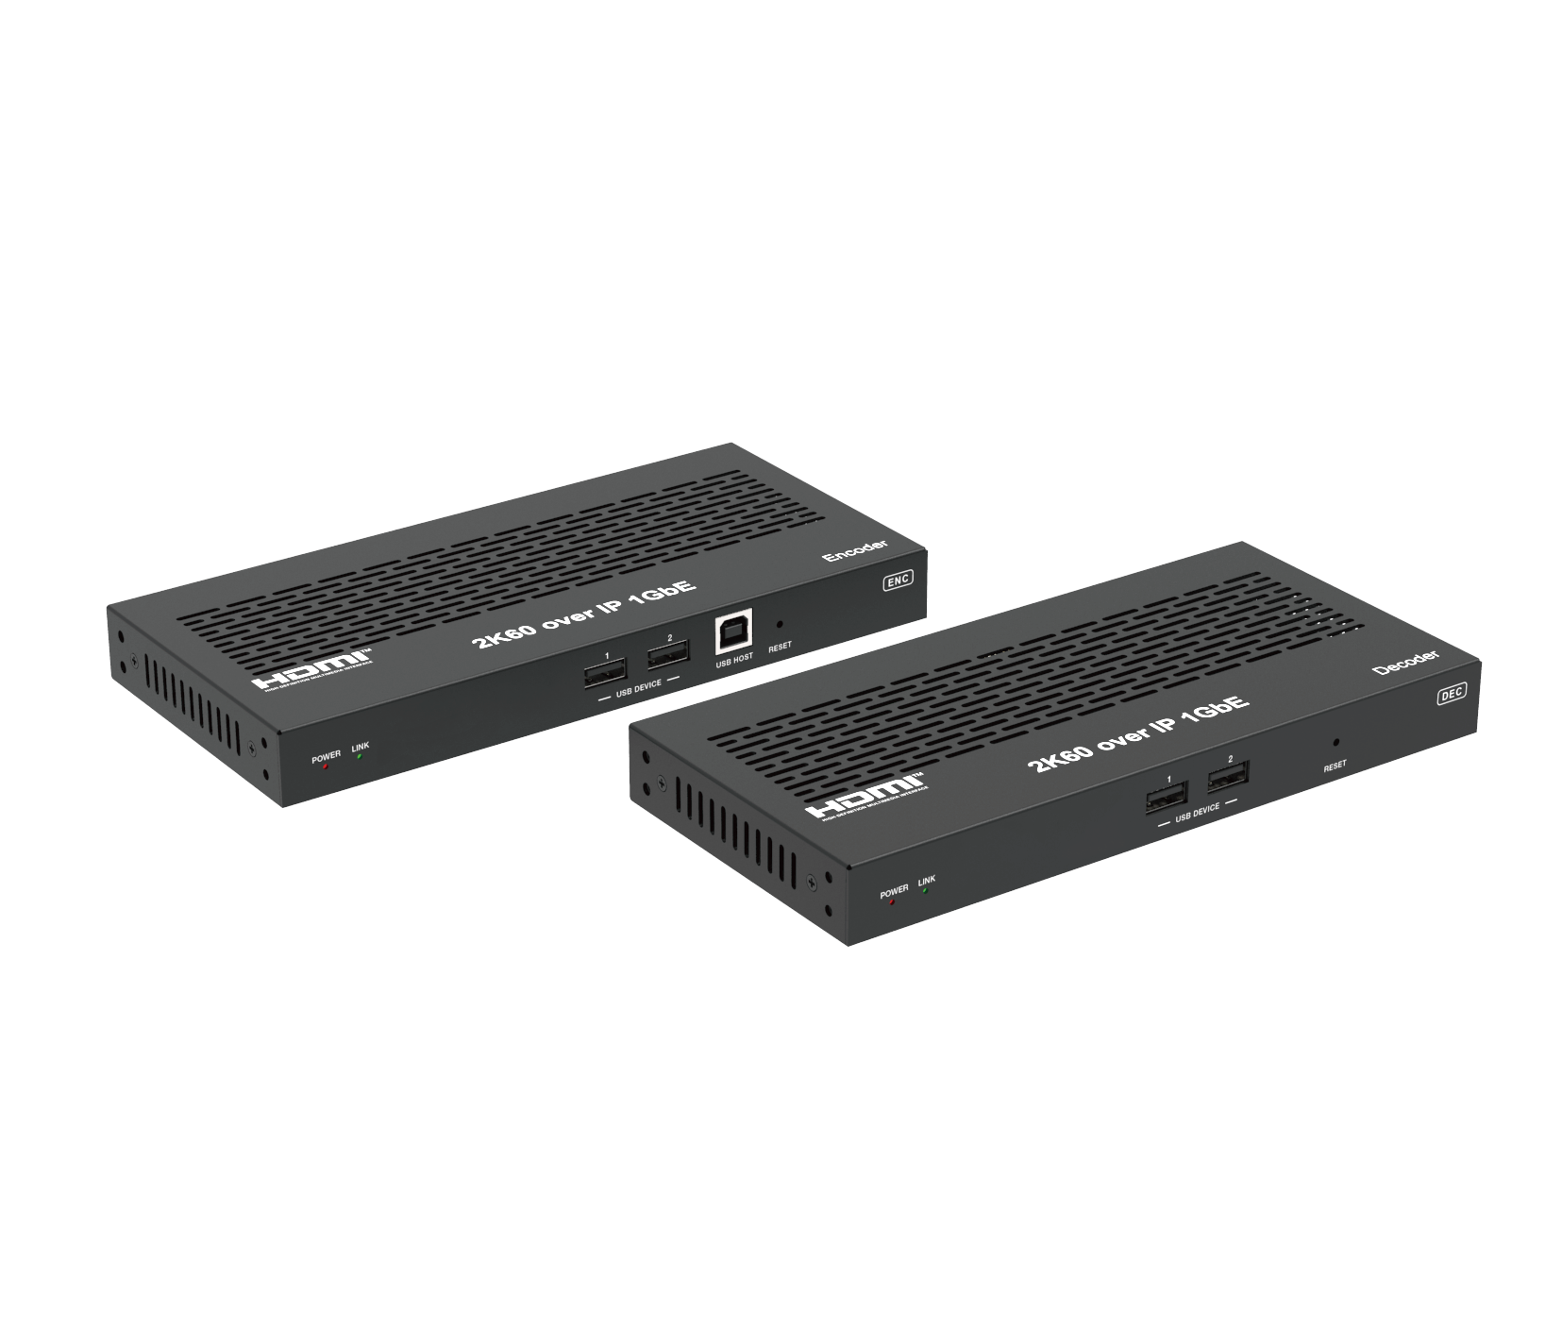
ALT-IPE1080 ALT-IPD1080


VER 1.0

Thank you for purchasing this product
For optimum performance and safety, please read these instructions carefully before connecting, operating or adjusting this product. Please keep this manual for future reference.

Surge protection device recommended
This product contains sensitive electrical components that may be damaged by electrical spikes, surges, electric shock, lighting strikes, etc. Use of surge protection systems is highly recommended in order to protect and extend the life of your equipment.

Table of Contents
- Introduction. 1
- Features. 1
- Package Contents. 2
- Specifications. 2
- Operation Controls and Functions. 4
  - Encoder Panel. 4
  - Decoder Panel. 5
  - IR Pin Definition. 7
- Rack Mounting Instruction. 7
  - 6U Rack Mounting. 7
  - 1U Rack Mounting. 9
- Web GUI User Guide. 10
- Switch Model 17
- Encoder and Decoder Matching Settings. 17
- 2K60 over IP System Control. 19
- Classic Application Example. 19

Introduction
This AV over IP product distributes multiple HD contents to multiple HD display devices over a 100M/1G Network Switch. It offers configurable high quality, low-bandwidth H.265/H.264 configurable compression video and supports resolution up to 1920x1200@60Hz 4:4:4. Signal transmission distance can be extended up to 328ft/100m via CAT5E/6/6A/7 cable. Encoder supports HDMI local loop output. The product supports analog audio embedding and extract
-ing. It also supports USB/KVM function, bidirectional IR/RS-232 control (pass- through & Guest mode) and single-machine control (without a Controller Box, matrix switching can be realized with local IR or RS-232 control).

Features
☆ HDMI 1.3 and HDCP 1.4 compliant
☆ Video resolution up to 1920x1200@60Hz 4:4:4
☆ Support 4.95Gbps video bandwidth
☆ Signal transmission distance can be extended up to 328ft / 100m via CATE/6/6A/7 cable
☆ Support point-to-point signal extension
☆ Support signal distribution, multicast mode, distributed matrix and video wall (up to 9x9) functions over a 1G Network Switch
☆ Intelligent video wall management makes it achievable of novel layout of wall configurations
☆ Support LPCM 2.0CH (32/44.1/48KHz) audio format
☆ Encoder supports HDMI local loop output
☆ Support audio embedding and extracting
☆ Support USB/KVM function (one to one & one to many), and bidirectional IR/RS-232 control (pass-through & Guest mode)
☆ Support main stream and sub stream encoding modes
☆ Stream parameters can be configured via Web GUI or Controller Box
☆ Controlled via IR, RS-232, TCP/IP, Web GUI and Controller Box
☆ Support POE function (802.3af Class 3, PD mode)
☆ Smart networking design for easy and flexible installation

Package Contents
Qty | Item
1 | 2K60 over IP 100M/1GbE Encoder
3 | 3-pin Phoenix Connector (3.81mm, male)
1 | IR Blaster Cable (1.5 meters)
1 | IR Receiver Cable (1.5 meters)
4 | Machine Screw (KM3, 4mm)
2 | Mounting Ear
1 | 12V/1A Locking Power Adapter
1 | User Manual

Qty | Item
1 | 2K60 over IP 100M/1GbE Decoder
2 | 3-pin Phoenix Connector (3.81mm, male)
1 | IR Blaster Cable (1.5 meters)
1 | IR Receiver Cable (1.5 meters)
4 | Machine Screw (KM3, 4mm)
2 | Mounting Ear
1 | 12V/1A Locking Power Adapter
1 | User Manual

or

Specifications

Technical
HDMI Compliance | HDMI 1.3
HDCP Compliance | HDCP 1.4
Video Bandwidth | 4.95Gbps
Video Compression Standard | H.265/H.264
Transmission Distance | 100m (CAT5E/6/6A/7)
IR Level | 12Vp-p
IR Frequency | Wideband 20K - 60 KHz
Video Resolution | Up to 1920x1200@60Hz 4:4:4
Color Space | RGB 4:4:4, YCbCr 4:4:4, YCbCr 4:2:2
Color Depth | Input: 8-bit, 10-bit, 12-bit (1080p@60Hz); Output: 8-bit
Audio Formats | LPCM 2.0CH (32/44.1/48KHz)
ESD Protection | Human body model — ±8kV (Air-gap discharge) &  ±4kV (Contact discharge)

Connection
Encoder | 1x HDMI IN [Type A, 19-pin female] 1x HDMI OUT [Type A, 19-pin female]  1x AUDIO IN [3-pin phoenix connector] 1x AUDIO OUT [3-pin phoenix connector] 1x RS-232 [3-pin phoenix connector]  1x LAN [RJ45 connector, POE]  1x IR IN [3.5mm audio jack, 12V IR] 1x IR OUT [3.5mm audio jack, 12V IR] 1x USB Host [Type B, 4-pin female]  2x USB Devices [Type A, 4-pin female]
Decoder | 1x HDMI OUT [Type A, 19-pin female] 1x LAN [RJ45 connector, POE]  1x AUDIO OUT [3-pin phoenix connector] 1x RS-232 [3-pin phoenix connector]  1x IR IN [3.5mm audio jack, 12V IR] 1x IR OUT [3.5mm audio jack, 12V IR] 2x USB Devices [Type A, 4-pin female]
Mechanical
Housing | Metal enclosure
Color | Black
Dimensions | Encoder / Decoder:  204mm [W] x 95mm [D] x 21.5mm [H]
Weight | Encoder: 470g, Decoder: 467g
Power Supply | Input: AC100 - 240V 50/60Hz,  Output: DC 12V/1A
Power Consumption | Encoder: 3.48W, Decoder: 2.77W
Operating  Temperature | 14 - 113°F / -10 - 45°C
Storage Temperature | -4 - 140°F / -20 - 60°C
Relative Humidity | 20 - 90% RH (no condensing)

Operation Controls and Functions

Encoder Panel
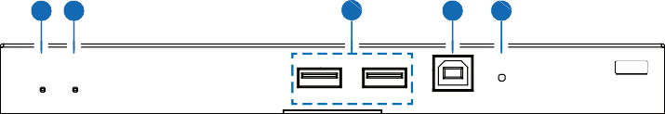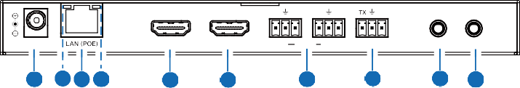
1
2
USB DEVICE
1 2
3
4
5
ENC
POWER LINK
USB HOST RESET
L R L R TX RX
DC 12V
HDMI IN
HDMI OUT
IN AUDIO OUT
RS-232
IR IN IR OUT
15 14 12 13
11
10
9
8
7
6

No. | Name | Function Description
1 | POWER LED  (Red) | The LED flashes at 2Hz during the system startup, and the LED is always on after the startup is complete.
2 | LINK LED  (Green) | Network connection status LED.  - Light on: Network is connected well, and there is compatible signal (the resolution is less than 1920*1200, and the frame rate is less than or equal to 60) access.  - Light flashes at 2Hz: Network is connected well, but there is  not video input.  - Light flashes at 5Hz: Network is connected well, but the accessed signal is incompatible (resolution is greater than 1920*1200, or the frame rate is greater than 60).  - Light off: Network is not connected.
3 | USB DEVICE | Connect to Key or Mouse.
4 | USB HOST | USB-B connector for connecting a PC as KVM function.
5 | RESET | System reset button. Press and hold this button for 3 seconds, the system will restart and restore factory settings.
6 | IR OUT | IR signal output port.
7 | IR IN | 12V IR signal input port.
8 | RS-232 | RS-232 serial port, supporting signal pass-through and local serial port control.

No.
Name
Function Description
AUDIO IN: Analog stereo audio input port. Connect to an audio input source device.

    - IN-AUDIO-OUT AUDIO OUT: Analog stereo audio output port. Connect to an
audio output device.

    - HDMI OUT

    - HDMI IN

    - LAN (POE)
Link Signal
    - Indicator lamp (Green)
Data Signal
    - Indicator lamp (Yellow)

    - DC 12V
HDMI local loop output port, connect to an HDMI display device such as TV or monitor.
HDMI input port, connect to an HDMI source device such as DVD or Set-top box with an HDMI cable.
100M/1G Network port. Connect to a Switch/Router/Hub for data transmission or POE function.
- Illuminating: The network cable is connected normally.
- Dark: The network cable is not connected well.

- Flashing: There is data transmission.
- Dark: There is no data transmission.
The device can be powered via two methods:
- Local DC 12V/1A power supply
- POE from Network Switch. Device acts as PD mode. When the Switch supports POE function, DC power supply is not needed.

Decoder Panel

1
2
USB DEVICE
1 2
3
4
DEC
POWER LINK
RESET
L R TX RX
DC 12V
HDMI OUT
AUDIO OUT RS-232
IR IN IR OUT
13 12 10 11
9
8
7
6
5

No. | Name | Function Description
1 | POWER LED  (Red) | The LED flashes at 2Hz during the system startup, and the LED is always on after the startup is complete.
2 | LINK LED  (Green) | Network connection status LED.  - Light on: Network is connected well, and there is video data.  - Light flashes: Network is connected well, but there is no video  data.  - Light off: Network is not connected.
3 | USB DEVICE | Connect to Key or Mouse.
4 | RESET | System reset button. Press and hold this button for 3 seconds, the system will restart and restore factory settings.
5 | IR OUT | IR signal output port.
6 | IR IN | 12V IR signal input port.
7 | RS-232 | RS-232 serial port, supporting signal pass-through and local serial port control.
8 | AUDIO OUT | Analog stereo audio output port. Connect to an amplifier or loudspeaker through a 3-pin phoenix connector. It follows the audio output of the Encoder.
9 | HDMI OUT | HDMI output port, connect to an HDMI display device such as TV or monitor.
10 | LAN (POE) | 100M/1G Network port. Connect to a Switch/Router/Hub for data transmission or POE function.
11 | Link Signal  Indicator lamp (Green) | - Illuminating: The network cable is connected normally.  - Dark: The network cable is not connected well.
12 | Data Signal Indicator lamp (Yellow) | - Flashing: There is data transmission.  - Dark: There is no data transmission.
13 | DC 12V | The device can be powered via two methods:  - Local DC 12V/1A power supply  - POE from Network Switch. Device acts as PD mode. When the Switch supports POE function, DC power supply is not needed.

IR Pin Definition
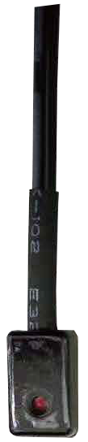
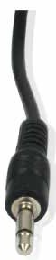
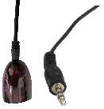
IR Receiver and Blaster pin’s definition as below:
IR BLASTER IR RECEIVER

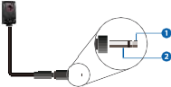+
IR BLASTER
-
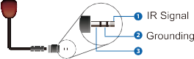
IR RECEIVER
Power 12V

Rack Mounting Instruction

6U Rack Mounting
This product can be mounted in a standard 6U rack (Please contact your supplier for 6U rack sale). The mounting steps are as follows:
Step 1: Use included screws to fix two mounting ears on the product, as shown in the figure below:
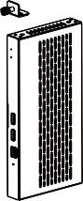

Step 2: Insert the product with mounting ears into a 6U rack (up to 10 units can be installed vertically), as shown in the figure below:
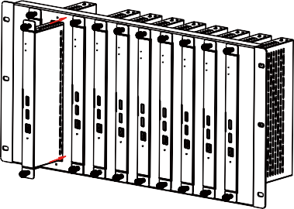

Step 3: Use screws to fix mounting ears on the rack to complete the mounting, as shown in the figure below:
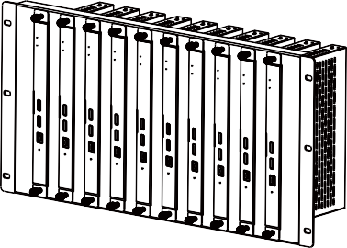

1U Rack Mounting
This product also can be mounted in a standard 1U rack (up to 4 units can be installed horizontally). The mounting steps are as follows:
Step 1: Stack two products on top of each other, then use included screws to fix two 1U rack panels on the products, as shown in the figure below:
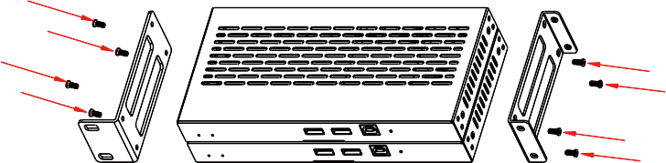
Step 2: Fix two 1U rack panels on another two stacked products in the same way, then use screws to fix two 1U rack panels together, as shown in the figure below:
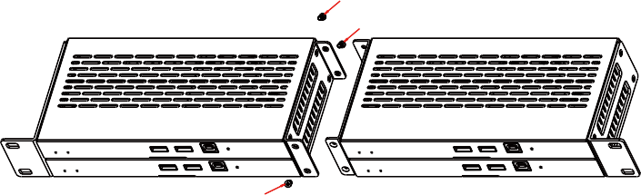

Step 3: Fasten screws between two 1U rack panels, so that four products are mounted in a 1U rack, as shown in the figure below:
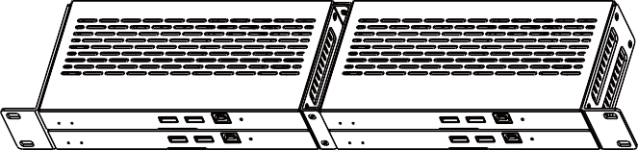

Web GUI User Guide
You can use the built-in Web GUI to configure all IP products through a Switch. The operation method is shown as below.
Step 1: Connect the PC, Encoders and Decoders you need to configure to a Switch. The connection diagram is shown as below.

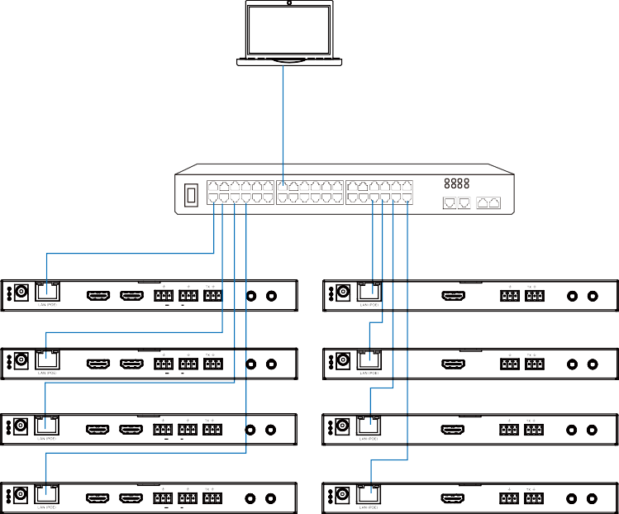
PC

CAT5E/6/6A/7

Switch

Encoder Decoder

L R L R TX RX L R TX RX

DC 12V

HDMI IN

HDMI OUT

IN AUDIO OUT

RS-232

IR IN IR OUT

DC 12V

HDMI OUT

AUDIO OUT RS-232 IR IN IR OUT

L R L R TX RX L R TX RX

DC 12V

HDMI IN

HDMI OUT

IN AUDIO OUT

RS-232

IR IN IR OUT

DC 12V

HDMI OUT

AUDIO OUT RS-232 IR IN IR OUT

L R L R TX RX L R TX RX

DC 12V

HDMI IN

HDMI OUT

IN AUDIO OUT

RS-232

IR IN IR OUT

DC 12V

HDMI OUT

AUDIO OUT RS-232 IR IN IR OUT

L R L R TX RX L R TX RX

DC 12V

HDMI IN

HDMI OUT

IN AUDIO OUT

RS-232 IR IN IR OUT

DC 12V

HDMI OUT

AUDIO OUT RS-232 IR IN IR OUT

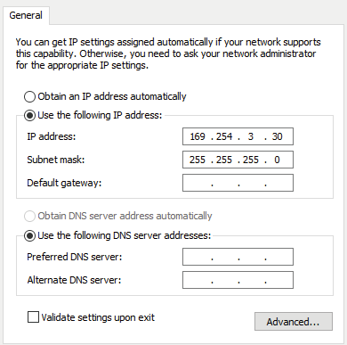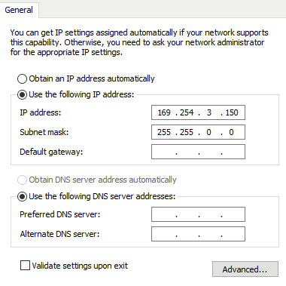Step 2: Set the PC’s IP address to be in the same network segment with the Encoder (default IP address: 169.254.100.254)/Decoder (default IP address: 169.254.100.253), for instance, set the IP address to be 169.254.3.150 and Subnet mask to be 255.255.0.0.
169 168 110 30
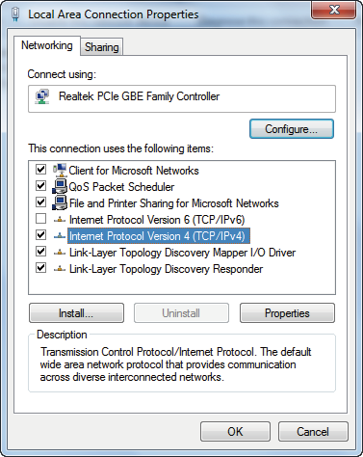
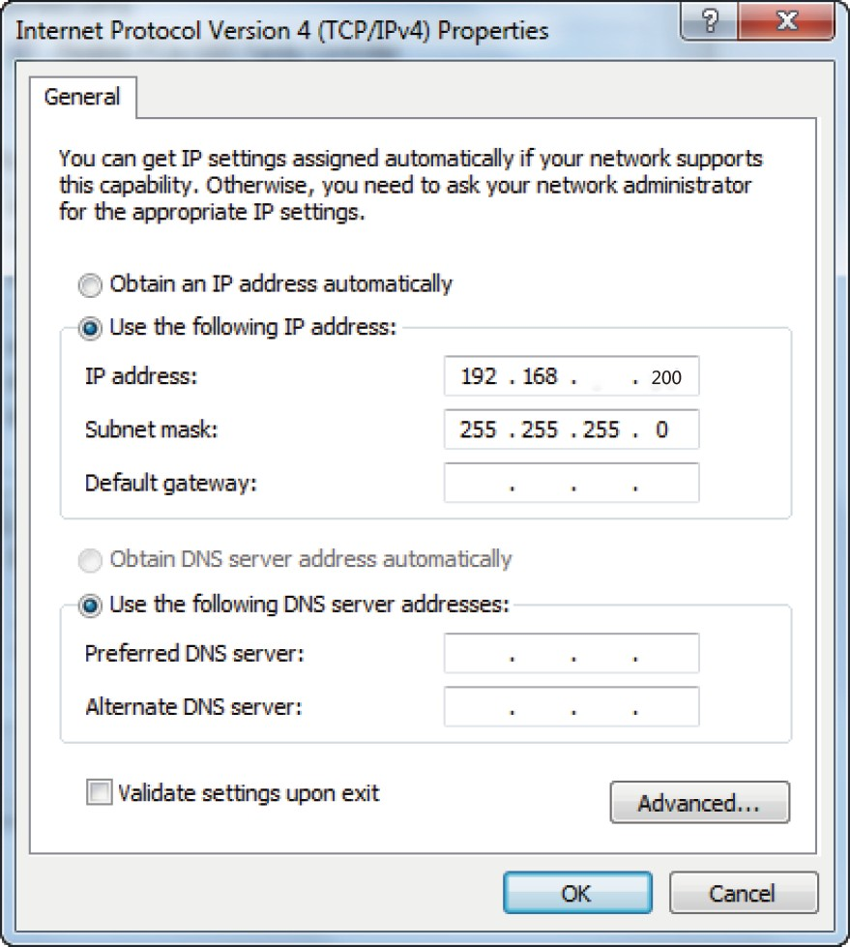
Step 3: Input the IP address of the Encoder/Decoder into the browser on PC to enter the Web GUI login interface.
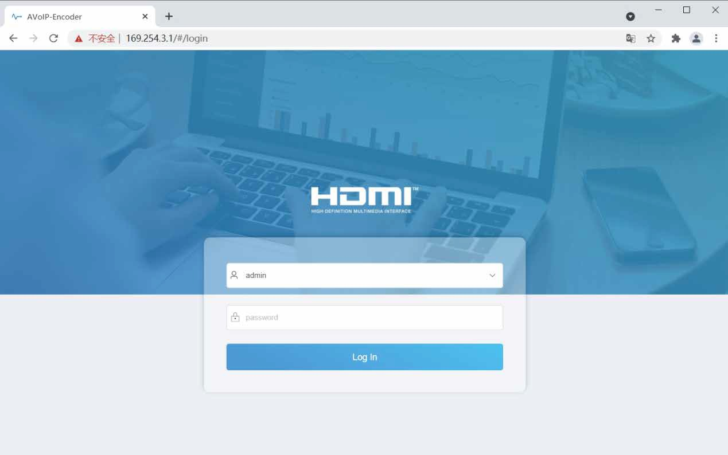
Step 4: Input the default User “admin” and the default Password “admin”, and then click “Log In” to enter the Web GUI interface.

The Web GUI function pages are shown as below:

- Device Information Page
The Status page provides basic information about the Encoder/Decoder, such as Firmware Version, IP Address, Subnet Mask, Gateway and MAC Address.
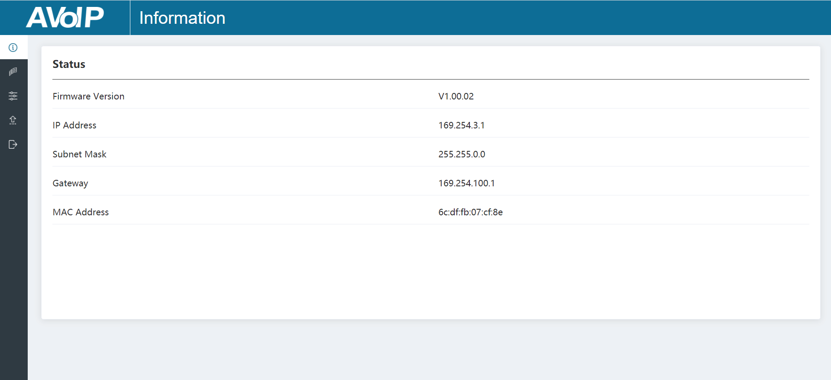

- Video Configuration Page
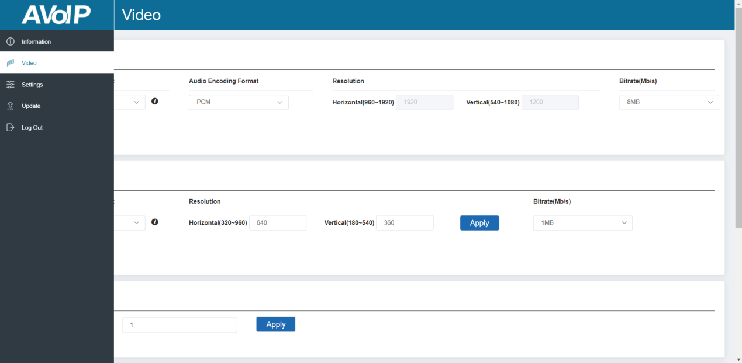
On this page, you can configure the video properties as required.

Encoder Video Configuration
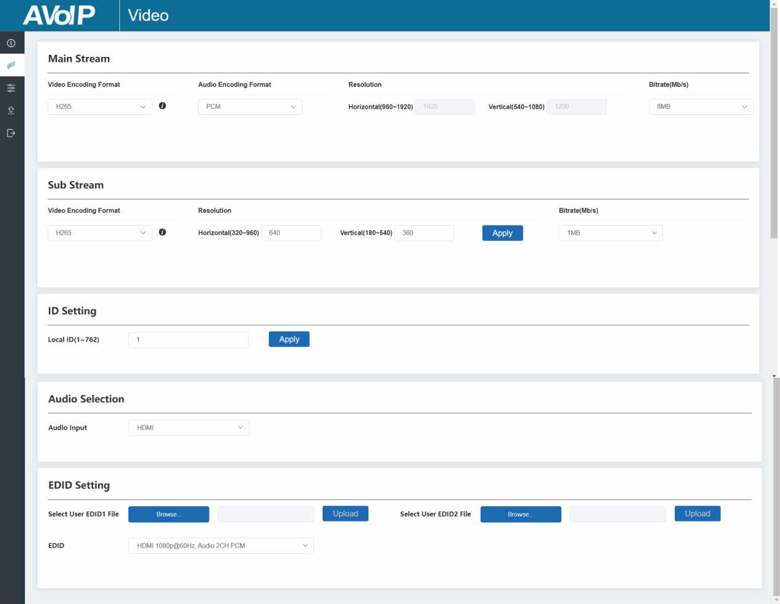
Encoder video configuration page includes Main Stream, Sub Stream, ID Setting, Audio Selection and EDID Setting.
Main Stream: You can configure Video Encoding Format, Audio Encoding Format and Bitrate. Video Encoding Format supports H.264 and H.265 (H.265 by default). Audio Encoding Format supports PCM and AAC (PCM
by default). Encoding Resolution cannot be set, it follows the input resolution. The default Bitrate is 8Mb/s.
Sub Stream: You can configure Video Encoding Format, Resolution and Bitrate. Video Encoding Format supports H.264 and H.265 (H.265 by default). The default Encoding Resolution is 640*360. The default Bitrate is 1Mb/s.
ID Setting: You can configure the ID of the Encoder (ID range: 1~762). After setting the ID and clicking “Apply”, the IP address will change correspondingly, and a prompt will pop up “The IP address will change to 169.254.xxx.xxx.” (Depending on the ID you set). If you click “Confirm”, the browser on PC will redirect to the Web GUI login interface with new IP address.
Audio Selection: You can configure the Audio Input (HDMI/Analog). EDID Setting: You can choose an EDID option from the drop-down list as shown in the below figure.

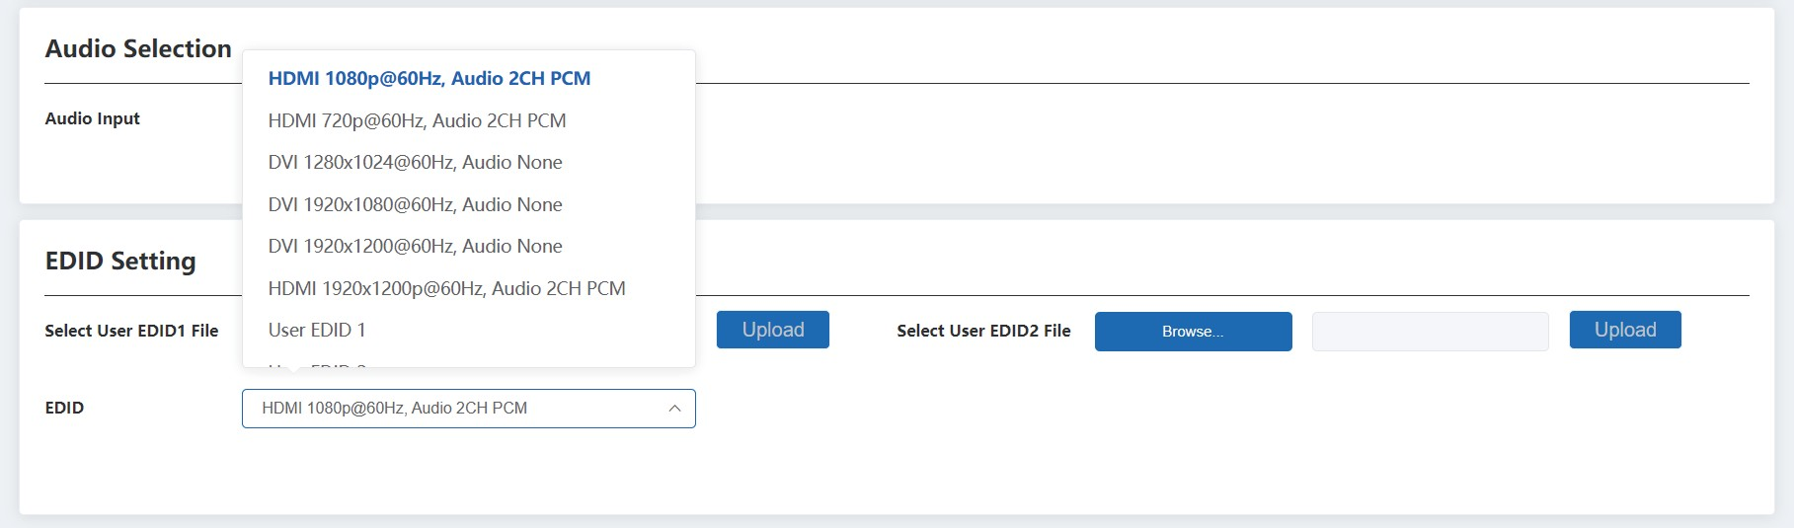
User EDID 1 and User EDID 2 can be uploaded in Select User EDID1 File and Select User EDID2 File, and the content of the uploaded binary file is EDID. (This file can be downloaded from the Download EDID of the Decoder Video page.)

Decoder Video Configuration
Decoder video configuration page includes Transmission Protocol, Scaler Setting, Download EDID, Video Timeout Setting, ID Setting and Picture Setting.
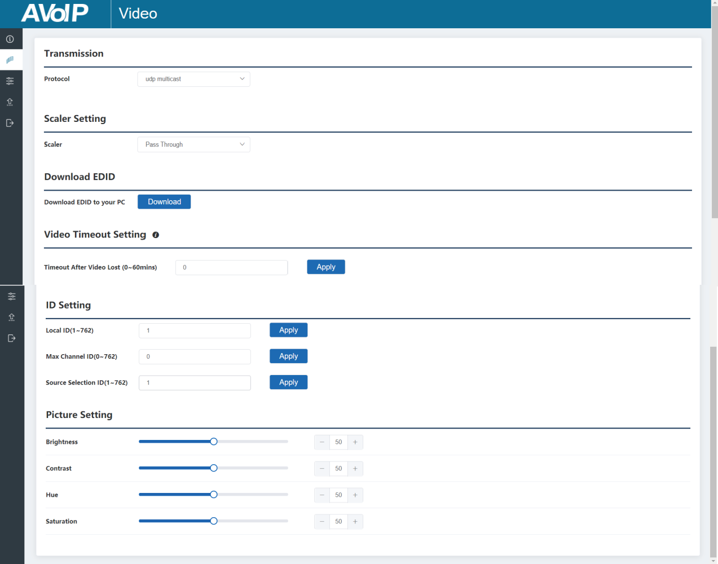

Transmission Protocol: You can select “udp unicast” or “udp multicast” (udp multicast by default).
Scaler Setting: You can set the output resolution (Pass Through by default). Download EDID: You can download the EDID binary file of the display device connected to the Decoder. The EDID file can be used as the User EDID file to be uploaded to the Encoder.
Video Timeout Setting: You can set the timeout to turn off the video output when no input video signal is detected. 0 means never close.
ID Setting:
Local ID: You can configure the ID of the Decoder (ID range: 1~762). After setting the ID and clicking “Apply”, the IP address will change correspondingly, and a prompt will pop up “The IP address will change to 169.254.xxx.xxx.” (Depending on the ID you set). If you click “Confirm”, the browser on PC will redirect to the Web GUI login interface with new IP address.
Max Channel ID: You can set the maximum range of Source Selection ID that can be set. When it is set to 0, there is no limit to the setting range of Source Selection ID.
Source Selection ID: You can select the ID of the Encoder to be the input source.
Picture Setting: You can configure the picture parameters (Brightness, Contrast, Hue and Saturation).

- Settings Page
On this page, you can set Network settings, configure Security Module, modify username and Login Password as required.
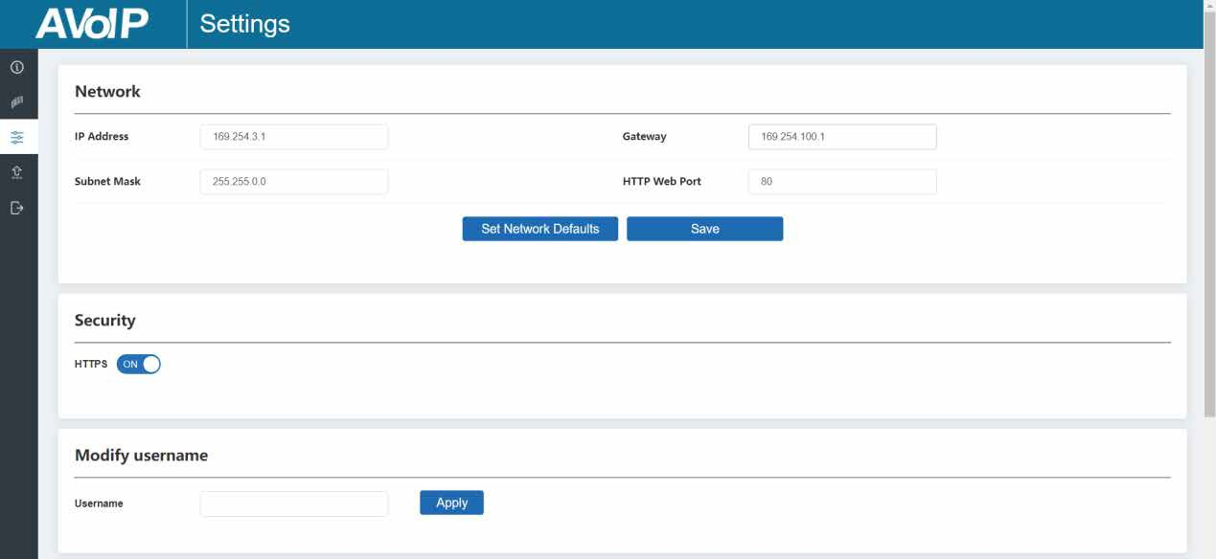

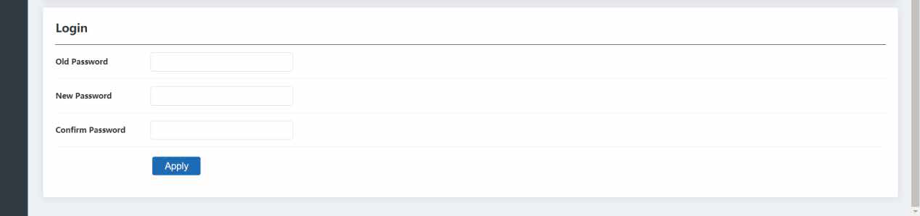
Notes:
- The Network Settings can be set only when the Mode button is set to Static.
- All changes will take effect by clicking “Save” below.
- After any changes to the Network Settings, username or Login Password, it will redirect to the Web browser home page or the Web GUI login interface. You need to log in the Web GUI again with the new settings.

  - Update Page
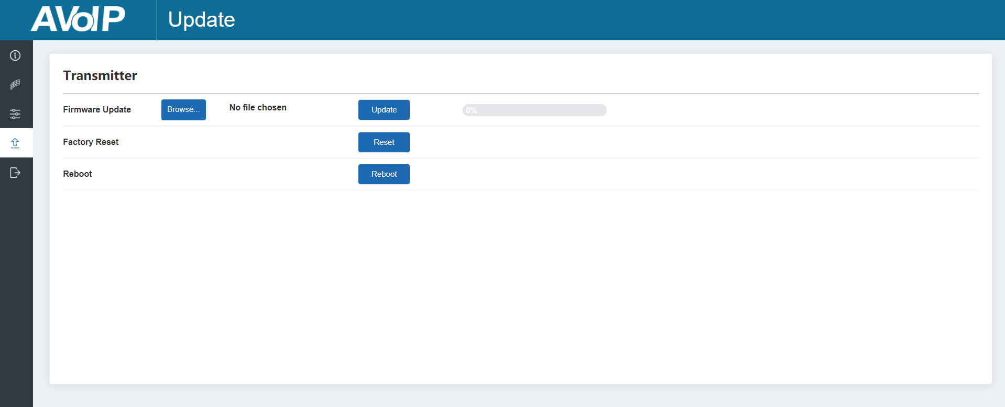
Click “Browse..” to import the upgrade file and click “Update” to start upgrade. There will be a progress bar prompt during the upgrade process. When the progress bar reaches 100%, it indicates the upgrade is successful, and the device will be restarted automatically.
Clicking “Reset” can reset the device to factory default settings. Clicking “Reboot” can reboot the device.

  - Log Out Page
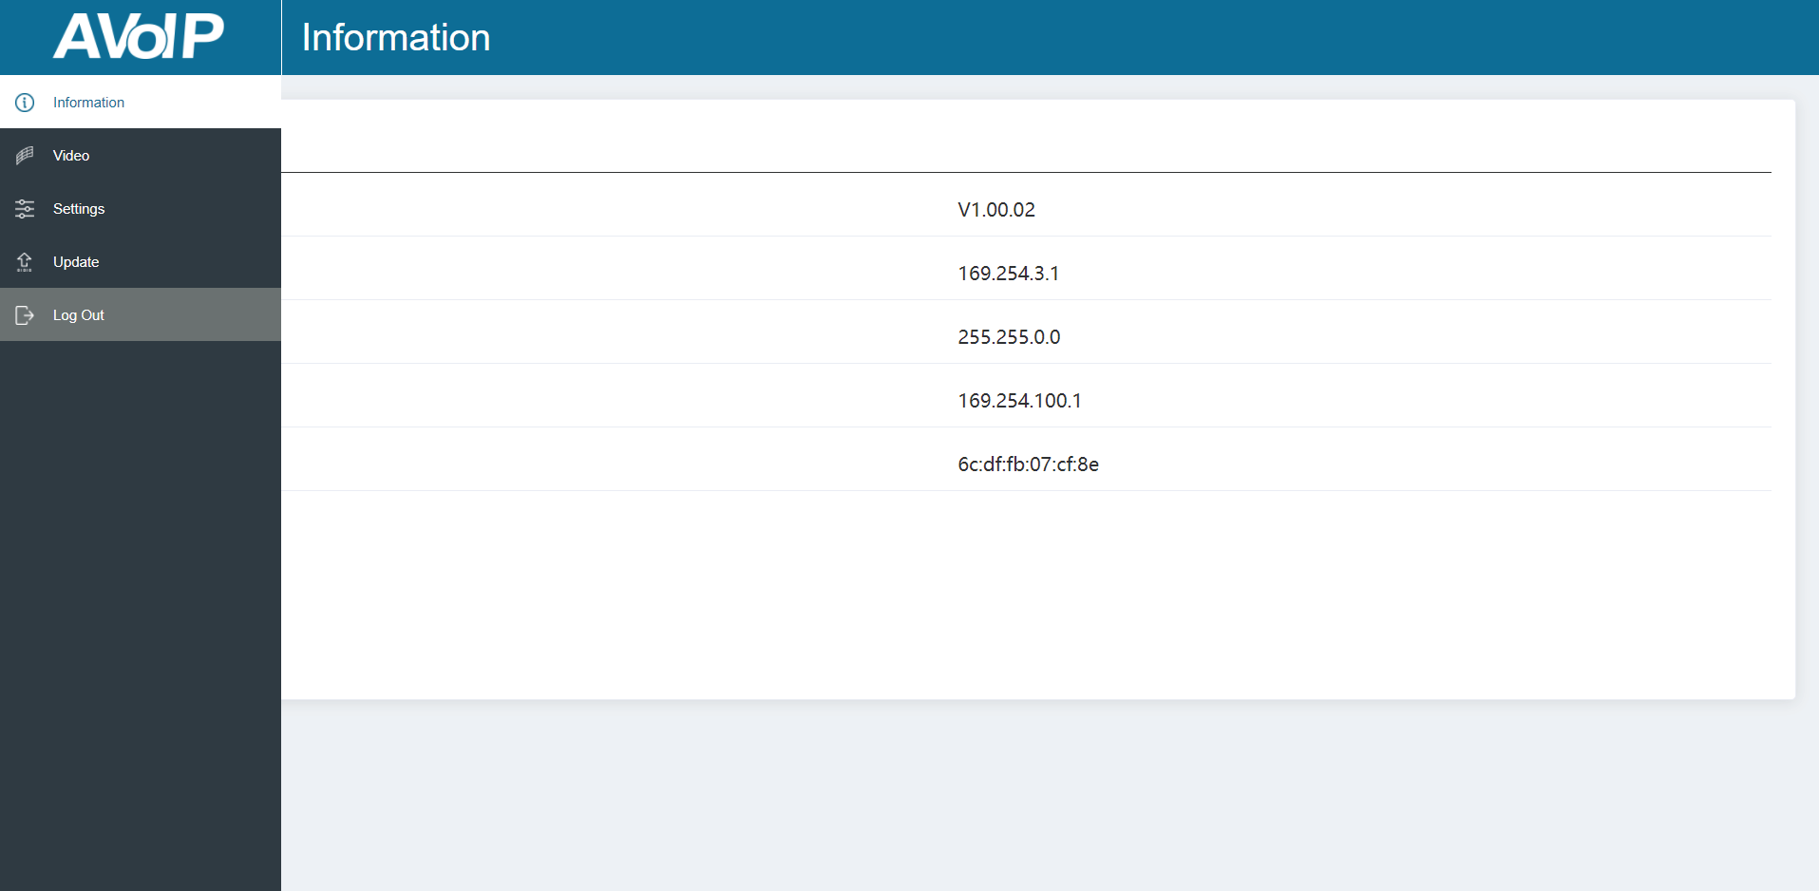

Click “Log Out” on the left, the Web GUI will exit and skip to the login interface automatically.

Switch Model
A network Switch used to set up the system should support below features:
- Type of layer 3/managed network Switch.
- Gigabit bandwidth.
- Support multicast, and need to enable the multicast function.
- Support IGMP snooping, and need to enable the IGMP snooping function.
- Support filter/drop unregistered Multicast traffic, and need to enable the function.
The following Switch models are highly recommended.

Manufacturer | Model Number
HUAWEI | S5720S-28X-PWR-LI-AC
NETGEAR | S3300

Encoder and Decoder Matching Settings
When multiple Encoders and Decoders are used in the system, it is necessary to match them well firstly. Please set the IDs of Encoders and Decoders respectively on the Encoder/Decoder Video Configuration page of Web GUI, then match all Encoders and Decoders via one of following three methods.

Method 1: Use the RS-232 serial port command control.
Connect the RS-232 port of Encoder/Decoder to a PC or control system, as shown in the figure below. Then use a Serial Command tool on PC to send the RS-232 command code: “!OUT xxx FR yyy\r\n”. The function of this command is to connect the Decoder (ID:xxx) to the Encoder (ID:yyy). Match all Encoders and Decoders in the same way.
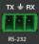
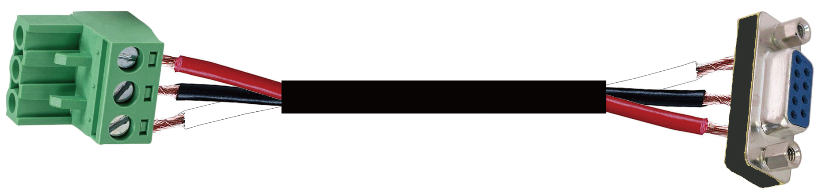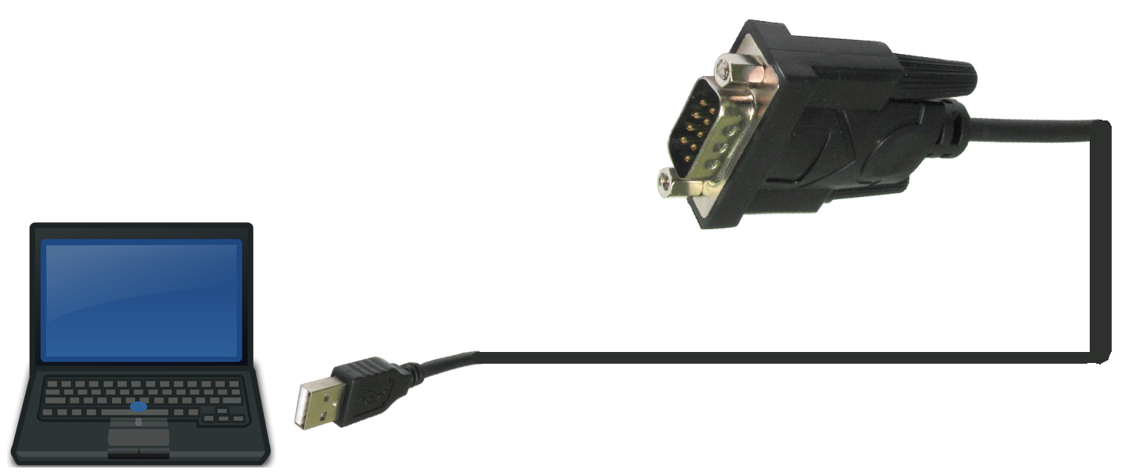
TX
Ground
RX

3-pin Phoenix Connector
RS-232

RS-232 to USB cable
PC

Method 2: Use the Controller Box.
Connect Encoders, Decoders and PC to the same Switch, then login the Web GUI of the Controller Box on the PC to match Encoders and Decoders in the system. For details, please refer to 2K60 over IP Controller Box user manual.
Method 3: Use the IR remote control.
The IR of Decoder supports using IR remote control. The button number on the IR remote control is the ID of Encoder which is to be connected to the current Decoder. You can select Encoder 1~40 to match the current Decoder by directly pressing button 1~40. If you press and hold the button 1 for 5 seconds, Encoder 41~80 can be selected.
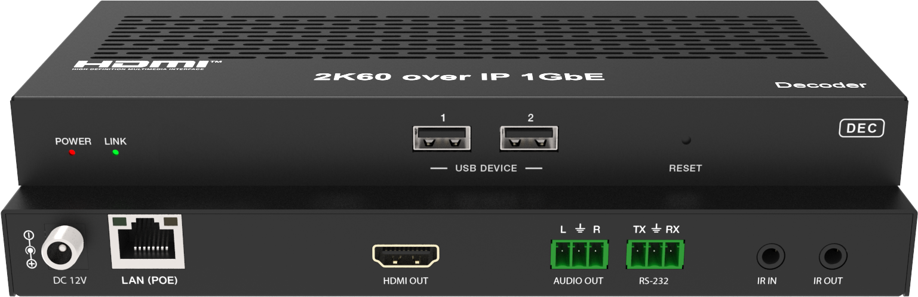

IR remote control

2K60 over IP System Control
This product also can be controlled by Controller Box or third-party controller. For details of 2K60 over IP system control, please refer to 2K60 over IP Controller Box user manual.

Classic Application Example

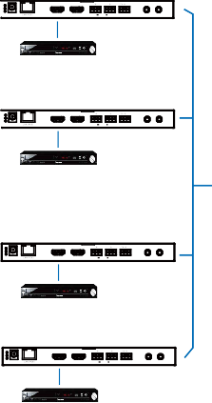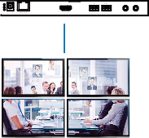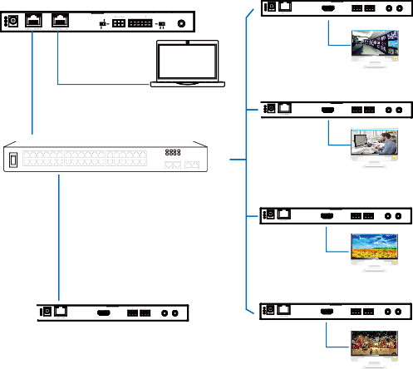ENC
L R L R TX RX

HDMI IN HDMI OUT IN AUDIO OUT RS-232 IR IN IR OUT
DVD
ENC
L R L R TX RX

HDMI IN HDMI OUT IN AUDIO OUT RS-232 IR IN IR OUT
DVD
ENC
L R L R TX RX

HDMI IN HDMI OUT IN AUDIO OUT RS-232 IR IN IR OUT
DVD
ENC
L R L R TX RX
DC 12V
HDMI IN HDMI OUT IN AUDIO OUT RS-232 IR IN IR OUT
DVD

DC 12V

DC 12V

DC 12V
DEC
Controller Box
MCU
L R TX RX
DC 12V
HDMI OUT AUDIO OUT RS-232 IR IN IR OUT
IR IN
IO LEVEL
NORMAL
5V 12V
DC 12V
TV
PC
DEC
L R TX RX

HDMI OUT AUDIO OUT RS-232 IR IN IR OUT
1G Ethernet Switch
TV
DEC
L R TX RX
DC 12V
HDMI OUT AUDIO OUT RS-232 IR IN IR OUT
TV
DEC
L R TX RX
L R TX RX
DC 12V
HDMI OUT AUDIO OUT RS-232 IR IN IR OUT
HDMI OUT AUDIO OUT RS-232 IR IN IR OUT
L R TX RX
TV
HDMI OUT AUDIO OUT RS-232 IR IN IR OUT
4 × DEC

DC 12V

DC 12V

DC 12V

VOUT

IO4 IO3 IO2 IO1

Video Wall

Notes:
- For the default IP mode of Control LAN port of the Controller Box is DHCP, the PC also needs to be set to “Obtain an IP address automatically” mode, and a DHCP server (e.g. network router) is required in the system.
- If there is no DHCP server in the system, 192.168.0.225 will be used as the IP address of Control LAN port. You need to set the IP address of the PC to be in the same network segment. For example, set PC’s IP address as 192.168.0.88.
- You can access the Web GUI by inputting Control LAN port IP address (192.168.0.225) or URL "http://controller.local" on your computer's browser.
- No need to care about settings of Video LAN port of the Controller Box, they are managed by Controller automatically.
- When the Network Switch does not support PoE, the Encoder, Decoder and Controller Box should be powered by DC power adapter.


The terms HDMI and HDMI High-Definition Multimedia interface, and the HDMI Logo are trademarks or registered trademarks of HDMI Licensing LLC in the United States and other countries.

