ALT-DSP88

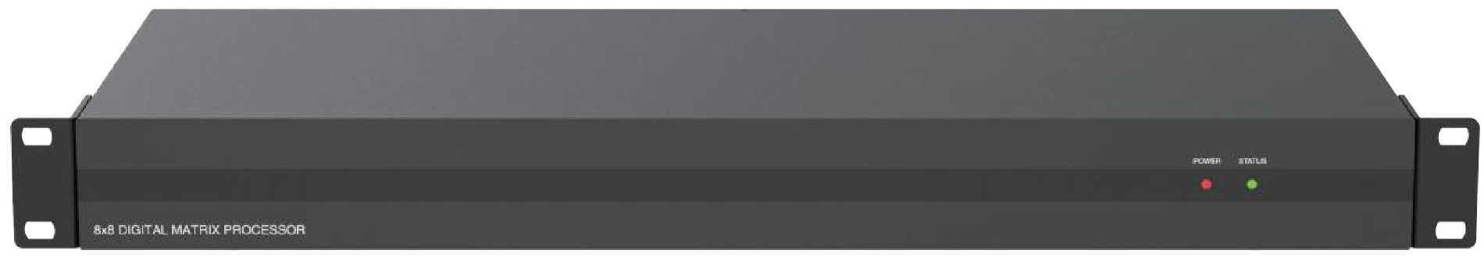
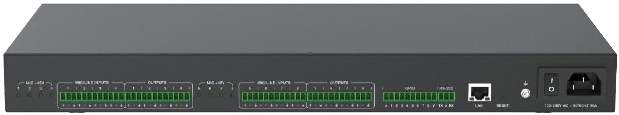



VER 1.0

Thank you for purchasing this product
For optimum performance and safety, please read these instructions carefully before connecting, operating or adjusting this product. Please keep this manual for future reference.

Surge protection device recommended
This product contains sensitive electrical components that may be damaged by electrical spikes, surges, electric shock, lighting strikes, etc. Use of surge protection systems is highly recommended in order to protect and extend the life of your equipment.

Table of Contents
- Introduction. 1
- Features. 1
- Package Contents. 2
- Specifications. 2
- Operation Controls and Functions. 3
  - Front Panel. 3
  - Rear Panel. 3
- Host Computer Control 4
  - Connection 4
  - Volume Meter 5
  - Input Settings 6
  - Expander. 7
  - Equalizer 8
  - Compressor. 9
  - Auto Gain Control 11
  - Auto Mixer 12
  - Adaptive Feedback Cancellation 13
  - Adaptive Echo Cancellation 15
  - Adaptive Noise Suppression. 16
  - Matrix Mixer. 17
  - Output Settings 18
  - Two-way Crossover. 19
  - Delay. 20
  - Limiter. 21
  - Scene Management. 23
  - Serial Settings. 24
  - Control Commands. 24
  - GPIO Setting. 25
  - RESET Setting. 25
- Troubles and Solutions. 26
- Application Example. 26

Introduction
This digital audio processor is typically used for video conference, distant learning, and telemedicine. It features 8-ch MIC/linear inputs, and 8-ch linear outputs. The product can process audio signals with algorithms, such as, full-band Adaptive Echo Cancellation (AEC), Adaptive Noise Suppression (ANS), Automatic Gain Control (AGC), and Auto Mixer, to output a clear, clean and resonant sound with high Signal-to-Noise ratio. Concise but intelligent, the processor is designed to be applied in scenarios without additional software assistance for debugging. It is ready to use after installation, perfect for project implementation and testing. The product can be applied in a diverse range of installations and applications across industries, such as, smart system integration in small-medium sized conference room, instruction recording and distance teaching in education, court trial recording and virtual court trial in judiciary, surgery recording and video consultation in healthcare service, and command center establishment in governmental projects.

Features
☆ Provide 8-ch balanced MIC/linear inputs and 8-ch balanced linear outputs
☆ Support adaptive feedback suppression function
☆ Support the full-band adaptive acoustic echo cancellation technology
☆ Dynamic adaptive noise reduction technology is provided to reduce noise with signal level up to 18dB
☆ Auto Mixer function is provided to set the order of priority when multiple microphones are input at one time
☆ Inclusive of Digital signal processing modules such as Expander, Equalizer, Compressor, Auto Gain Control, Limiter, High Pass Filter, Low Pass Filter and Delay
☆ Capable to switch matrix routings
☆ Support volume control, meter, scene control, etc.
☆ 48V phantom power supply for 8-ch MIC inputs
☆ 48KHz sampling rate, 24-bit for A/D or D/A conversion
☆ Support 8-ch programmable GPIO function
☆ Compatible to run on Win 7 and Win 10, with standard RJ45 interface control
☆ Support RS-232 serial commands control

Package Contents
① 1 x Digital Audio Processor
② 1 x AC 100~240V 50/60Hz Power Cord
③ 1 x 3pin-3.81mm Phoenix Connectors (Male)
④ 1 x 10pin-3.81mm Phoenix Connectors (Male)
⑤ 4 x 12pin-3.81mm Phoenix Connectors (Male)
⑥ 2 x Mounting Ears (Wall Mount)
⑦ 8 x Machine Screws (KM3*4)
⑧ 1 x User Manual

Specifications

Technical
Amplitude-frequency (20Hz~20KHZ@+4dBu) | ±0.2dB
THD+N (1KHZ@+4dBu) | ≤ 0.01%
SNR (linear input) | ≥ 90dB
Dynamic Range | ≥ 100dB
Channel Level Difference | ±0.5dB
Channel Isolation | ≥ 80dB
Max Input Level | 20dBu
Max MIC Gain | 40dB
Input Impedence | 20KΩ
Output Impedence | 300Ω
Sampling Frequency | 48KHZ
A/D and D/A Conversion | 24Bit
Phantom Power | +48 VDC
Connection
Inputs | 8 × Balanced MIC/LINE [3-pin phoenix connector] or 4 × Stereo Audio [3-pin phoenix connector]
Outputs | 8 × Balanced LINE [3-pin phoenix connector] or 4 × Stereo audio [3-pin phoenix connector]
Controls | 1 × LAN [RJ45]  1 × RS-232 [3-pin phoenix connector] 8 × GIPO [10-pin phoenix connector]
Mechanical
Housing | Metal Enclosure
Color | Black
Dimensions | 440mm (W)×250mm (D)×45mm (H)
Weight | 3.3kg
Power Supply | AC 100 - 240V 50/60Hz
Power Consumption | 9W (Max)
Operating Temperature | 0°C ~ 40°C / 32°F ~ 104°F
Storage Temperature | -20°C ~ 60°C / -4°F ~ 140°F
Relative Humidity | 20~90% RH (non-condensing)

Operation Controls and Functions

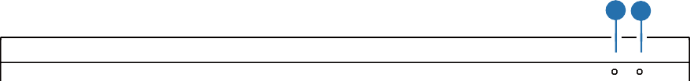Front Panel

8×8 DIGITAL MATRIX PROCESSOR
1 2
POWER STATUS

No. | Name | Function Description
1 | POWER LED | When the device is powered on, the red LED will light on.
2 | STATUS LED | When the device runs in normal, the green STATUS LED will flash.

Rear Panel
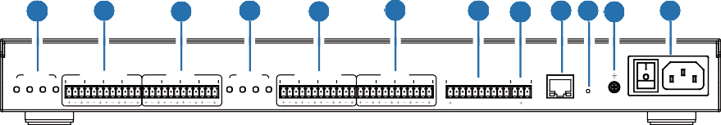
1
2
3
1
2
3
4 5 6 7 8 9
MIC +48V MIC/LINE INPUTS OUTPUTS MIC +48V MIC/LINE INPUTS OUTPUTS
1 2 3 4 1 2 3 4 1 2 5 6 7 8 5 6 7 8 5 6 7 8
GPIO RS-232

1 2 3 4 5 6 7 8 V TX RX LAN RESET 100-240V AC ~ 50/60HZ 10A
4
3

No. | Name 4 | Function Description
1 | MIC +48V | 8 phantom power supply indicators.
2 | MIC/LINE INPUTS | 8-ch balanced MIC/linear inputs, used for connecting audio source devices via phoenix connectors.
3 | OUTPUT | 8-ch balanced linear outputs, used for connecting Amplifier or Speaker via phoenix connectors.
4 | GPIO | 8-ch programmable GPIO interfaces.
5 | RS-232 | Connect to PC or control system for transmitting RS-232 control commands.
6 | LAN | Standard RJ45 interface for network connection.
7 | RESET | Used for reseting the audio processor.
8 | GND | Connect outer housing to the ground.
9 | Power Switch & Power Port | Power switch and AC 100-240V power input port.

Host Computer Control

Connection
The audio processor admits the control of a host computer in windows system (WIN 7 or WIN 10). Take a cable to connect to the LAN port of the processor with the computer for network connection as following steps instructed.
Step 1: Install the “ProAudioProcessor8.exe” application in the host computer and change the computer’s IP address to ensure that IP addresses of the host computer and the processor (Default IP address: 192.168.0.199, Subnet mask: 255.255.255.0) are within the same network segment, as shown in the figure below.
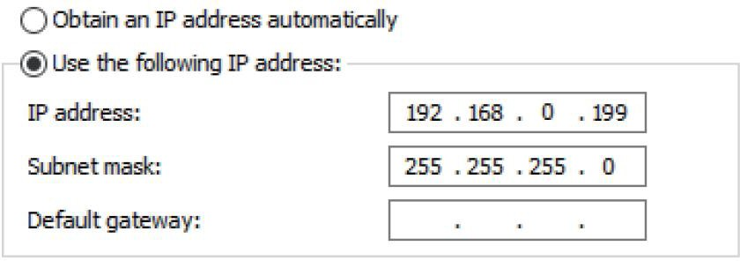
Step 2: Double-click the “ProAudioProcessor8.exe” icon (see the figure below) to run the application in the host computer.

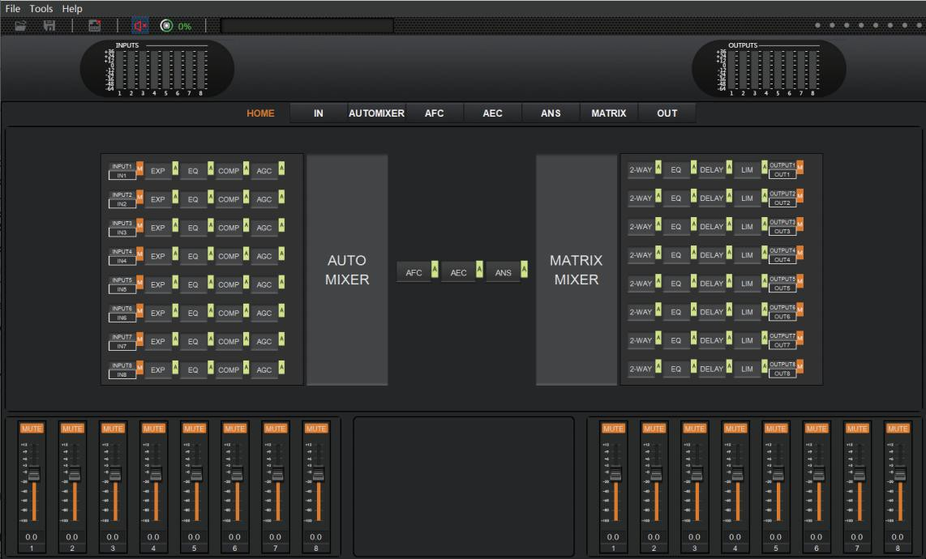
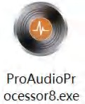
Step 3: When the application is open, the startup page appears and then comes the HOME page, as shown below.
Step 4: Check the Network icon on the tool bar as shown below.


If there is a red X at the top-right corner of this icon as the figure above shown, it means the host computer have not connected with the audio processor yet. In such case, click this icon, then a dialog box with a list of IP addresses of all connected devices will pop out, as the following figure shown.
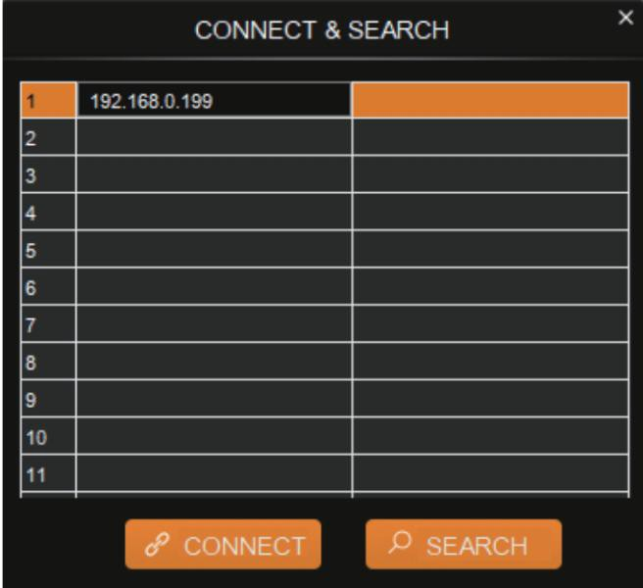
Step 5: Choose the audio processor’s IP address and click CONNECT, then the processor will be connected with the host computer. After connection, the CONNECT & SETUP box (see the figure below) will pop out. You may close it directly if no such operation is needed.
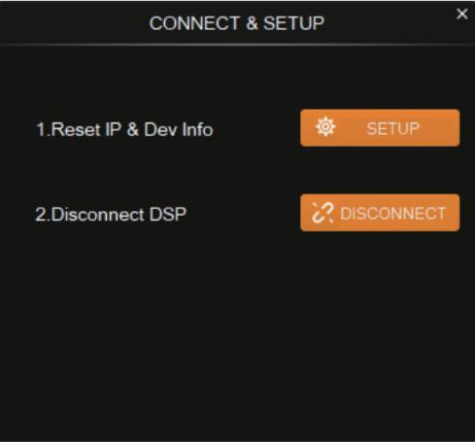


If the audio processor has been connected with the host computer successfully, the Network icon will appear in a way as shown below.

Volume Meter
The volume meter is typically to denote the signal level of the I/O volume.

The meter has 3 colors (Red, Yellow and Green) to denote signal levels for the volume of 8-ch inputs and 8-ch outputs, in which the Red denotes that volume may be too high to be limited and the yellow indicates the volume is within a reasonable range.

Input Settings
As shown below, clicking the INPUT module  on the HOME page or the IN tab on the menu bar, you will enter the INPUT setting page.
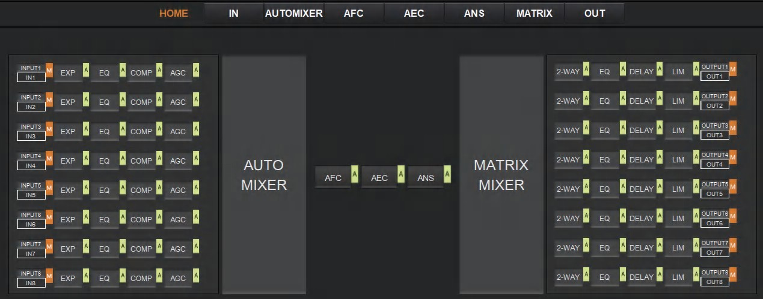
The following figure shows the details of the INPUT setting page.
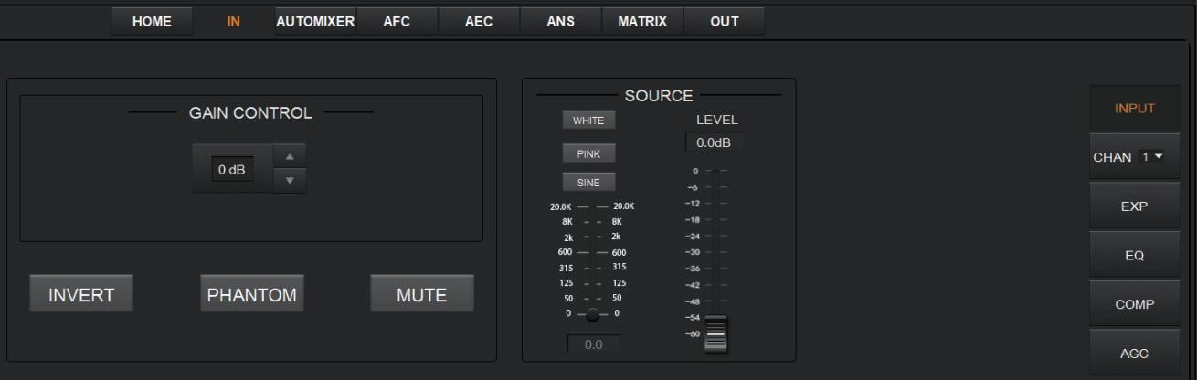
GAIN CONTROL: Indicates the GAIN level of the input signal, which could be adjusted to ensure the gain on the input channel adaptable to the MIC or linear input.
INVERT: When pressed, inverts the polarity of the signal on the input channel.
PHANTON: When pressed, turns on 48V phantom power for the channel.
MUTE: When pressed, mutes the input channel, equivalent to clicking the letter M at the INPUT module  on the HOME page.
WHITE: When pressed, generates white noises for signal testing.
PINK: When pressed, generates pink noises for signal testing.
SINE: When pressed, generates sinusoidal signals for testing, the meter below shows the frequency of the sine wave.
FADER: Controls the signal level of the testing signal.

You can set signal parameters of an input channel by entering its CHAN No. on the right panel of the IN page. Audio process modules, such as, EXPANDER, EQUILIZER, COMPRESSOR and AUTO GAIN CONTROL, are available on the right panel for your setting.

Expander
The Expander, which can effectively extend the dynamic range of the input signal, is used to eliminate noise under the threshold level.
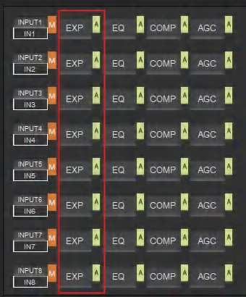
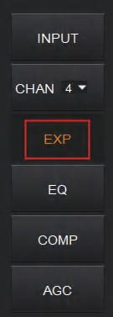
As shown below, clicking the EXP module  on the HOME page or the EXP button on the right panel of the IN page will give you the option to enter the EXP setting page.

or

The following figure shows complete information to configure the expander module.
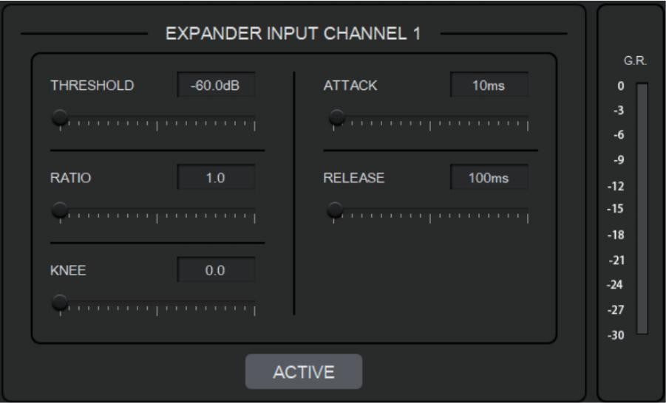

THRESHOLD: The level that the signal below it will be identified as noise and attenuated, with a range of [-60.0, 0.0] dB.
RATIO: The compression ratio for signals below threshold, with a scale of [1.0, 20.0]. If the ratio is 2.0, it means the signal below threshold will be reduced to ½ of the original.
KNEE: The curve setting of the inflection point of the expander, with a scale of [0.0, 20.0]. 0 indicates a hard knee; others indicate a soft knee.
ATTACK: The time required by the expander to begin the Expander process once a signal drops below threshold. Values are squashed between [1, 500] ms.
RELEASE: The time required by the expander to stop the Expander process once a signal is over threshold. Values are squashed between [1, 10000] ms.

G.R. (Gain Reduction) : Indicates the amount of gain attenuation of the input signal (in dB) in the Expander process.
ACTIVE: Activates the EXP process. The function is equivalent to clicking the green letter A at the EXP module on the HOME page.
Clicking the pair of UP-DOWN arrows of the CHAN No. on the right panel of the IN page will give you an option to select an input channel for the Expander configuration.

Equalizer
Each I/O channel has an 8-band parametric equalizer for voice processing, with the frequency, gain and bandwidth of each band adjustable.
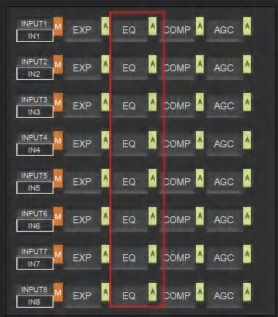
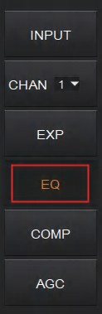
As shown below, clicking the EQ module  on the left panel of the HOME page or the EQ button of the IN page, you will enter the EQ setting page of the input channel.

or

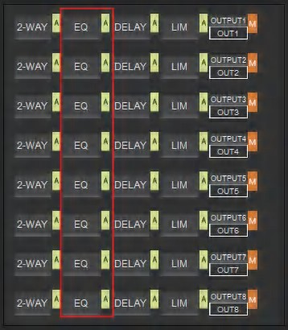
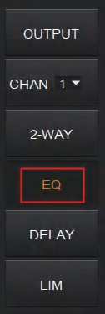
As shown below, click the EQ module on the right panel of the HOME page or the EQ button of the OUT page, you will enter the EQ setting page of the output channel.

or

The figure below shows the setting page of the EQ module.
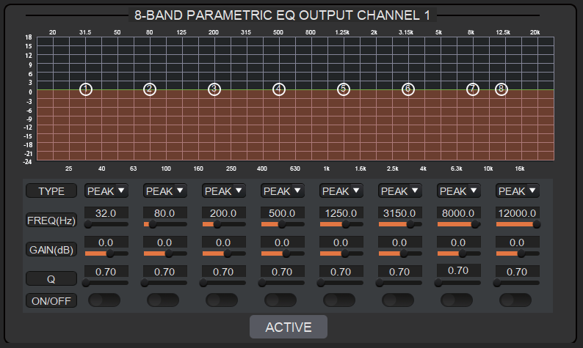

TYPE: Provides 3 types of band/filter, with High Pass, Low Pass and Peak optional.
FREQUENCY : In High/Low Pass Filter, it means the cut-off frequency of the EQ band;
In Peak Filter, it means the center frequency point of the EQ band; with a scale of [20, 20000] Hz.
GAIN: In High/Low Pass Filter, fixed to 0dB; In Peak Filter, squashed between [-24.0, +18.0] dB.
Q FACTOR: value is squashed between [0.02, 50.00].
SWITCH: Each band has a switch. When pressed, the EQ function in this band will be disabled.
ACTIVE: Activates the EQ process. The function is equivalent to clicking the letter A at the EQ module on the HOME page.
A pair of UP-DOWN arrows on the right panel is provided for you to select an input channel for the Equalizer configuration.

Compressor
The Compressor is used to reduce the dynamic range of the signal above a user determined threshold so that output sounds could be more solider.
As shown below, click the COMP module  on the HOME page or the COMP button on the right panel of the IN page, you will enter the Compressor setting page.

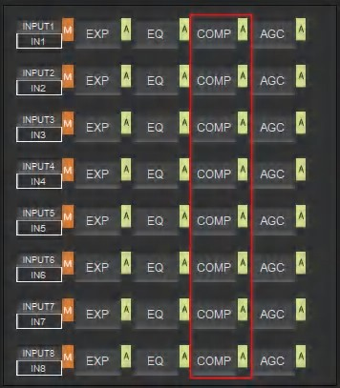
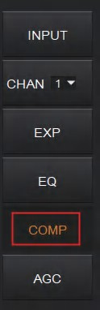
or

The figure as below shows the setting page of the compressor.
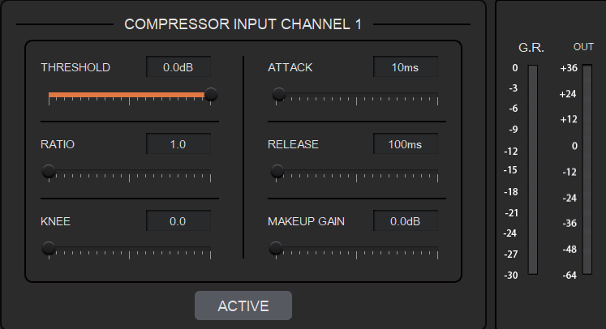

THRESHOLD: The level that the signal above it will be compressed, with a scale of [-60.0, 0.0]dB.
RATIO: The compression ratio for signals with level above threshold, with a scale of [1.0, 20.0]. When the ratio sets to 2.0, it means that the signal with level below threshold will be reduced to ½ of the original.
KNEE: The curve setting of the inflection point of the compressor, with a scale of [0.0, 20.0]. 0 indicates a hard knee; other values for a soft knee.
ATTACK: The time required by the compressor to begin the Compressor process once a signal is over threshold, with a scale of [1, 500] ms.
RELEASE: The time required by the compressor to stop the Compressor process once a signal drops below threshold, with a scale of [1, 10000] ms.
MAKEUP GAIN: Since compressor can reduce the gain level, the Makeup Gain gives you the option to make a compensation for the gain level, with a scale of [-12.0, +18.0] dB.
G.R. (Gain Reduction): Indicates the amount of gain attenuation of the input signal (in dB).
OUT: Meter indicates the output signal level after the Compressor process.
ACTIVE: Activates the COMP process. The function is equivalent to clicking the letter A at the COMP module on the HOME page.

A pair of UP-DOWN arrows on the right panel is also provided for you to select any input channel for the Compressor configuration.

Auto Gain Control
Automatic Gain Control (AGC) intends to control the audio signal within a range so as to extend the distance of pick-up sounds. The AGC process aims to attenuate the signal with excessive high signal level and boost the signal with low signal level up to target level.
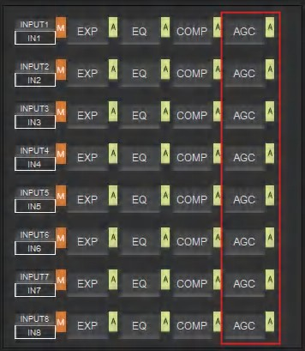
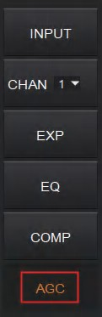
As shown below, by clicking the AGC module  on the HOME page or the AGC button on the right panel of the IN page, you will enter the AGC setting page.

or

The following figure shows the setting page of the AGC module.
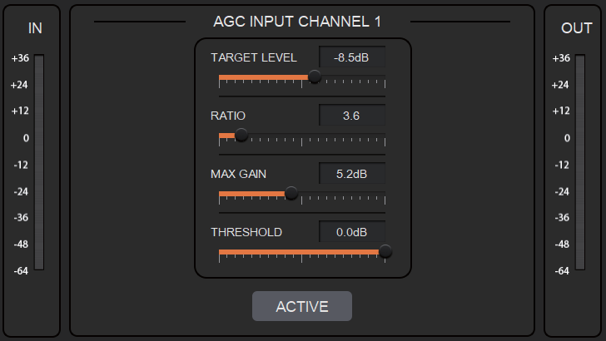

TARGET LEVEL: The desired output signal level, with a scale of [-20.0, 0.0] dB.
RATIO: The compression ratio for signals above target level, with a scale of [1.0, 20.0].
If the value sets to 2.0, it means that signals above target level will be amplified in twice of the original. However, not all signals between the threshold and the target level are linearly amplified by this ratio.

MAX GAIN: It will affect the smooth adjustment of the gain value of the signal between the threshold and the target level, with a scale of [0.0, 12.0] dB.
THRESHOLD: Signals below threshold will remain unchanged while those between threshold and target level will be amplified (at a ratio determined by the TARGET LEVEL, RATIO and MAX GAIN). In order to ensure the work of the AGC process, the Target Level must be set higher than Threshold. The threshold is recommended to set with a range of [-60.0, 0.0]dB.
IN: Meter indicates the detected signal level before the AGC process.
OUT: Meter indicates the output signal level after the AGC process.
ACTIVE: Activates the AGC process. The function is equivalent to clicking the green letter A
at the AGC module on the HOME page.
A pair of up-down arrows on the right panel is available for you to select an input channel for the AGC configuration.

Auto Mixer
The AUTO MIXER is built to set the order of priority for MIC/linear input when 8 MIC/LINE ports are connected at one time.
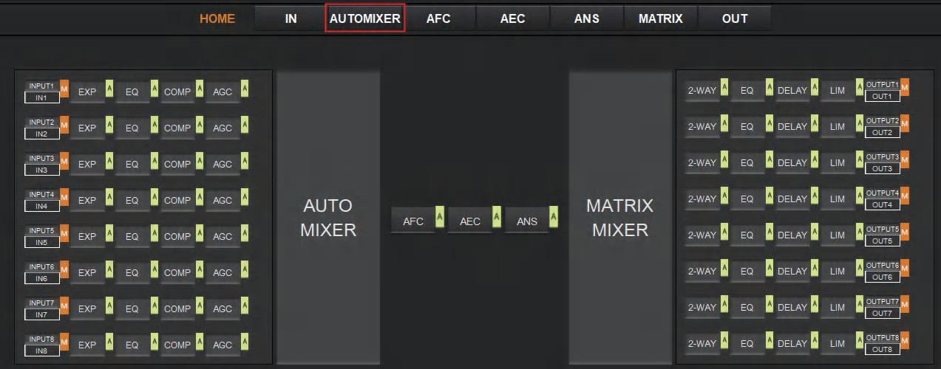
As shown below, by clicking the AUTO MIXER section on the HOME page or the AUTOMIXER tab on the menu bar, you will enter the AUTO MIXER setting page.

The figure as below shows the setting page of the Auto Mixer module.

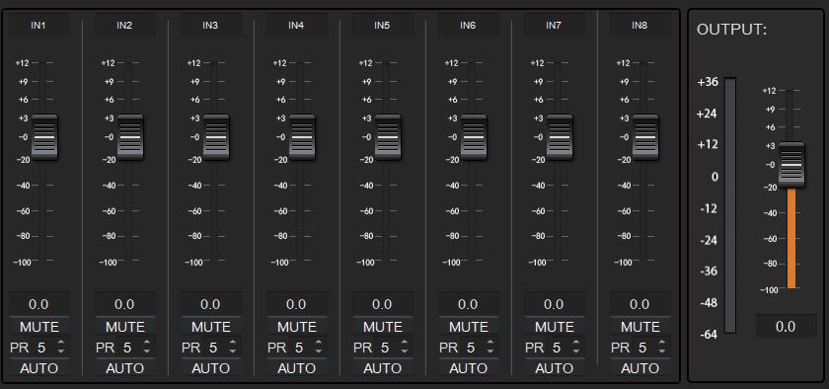

FADER: Each MIC input channel has a fader to adjust its signal level. It controls the mixed volume on the input channel.
MUTE: Each MIC input channel has a MUTE button. Clicking it will enable you to mute the channel.
PR (Priority): Sets the priority of the MIC input, 0 = lowest and 10 = highest priority. Channel of higher-priority will override the one of lower-priority to be prioritized in the auto mixer’s algorithm. If two or more channels are at the same priority, the channel for the main speaker will be prioritized in the AUTO MIXER process.
AUTO: When pressed, the input MIC will be added to the auto mixing system, otherwise, it won’t be auto-mixed.
METER: Indicates the output volume after the AUTO MIXER process.
OUT: Fader to control the output volume after the AUTO MIXER process.

Adaptive Feedback Cancellation
The Adaptive Feedback Cancellation (AFC, also known as the Feed Back Suppression) module can detect and suppress the frequency point of the acoustic feedback in the audio field. The AFC module allows you to detect and suppress the frequency points of the acoustic feedback for 8 bands. Parameters on this module are open to be configured.
As shown below, by clicking the AFC module 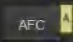 on the HOME page or the AFC tab on the menu bar, you will enter the setting page of the AFC module.

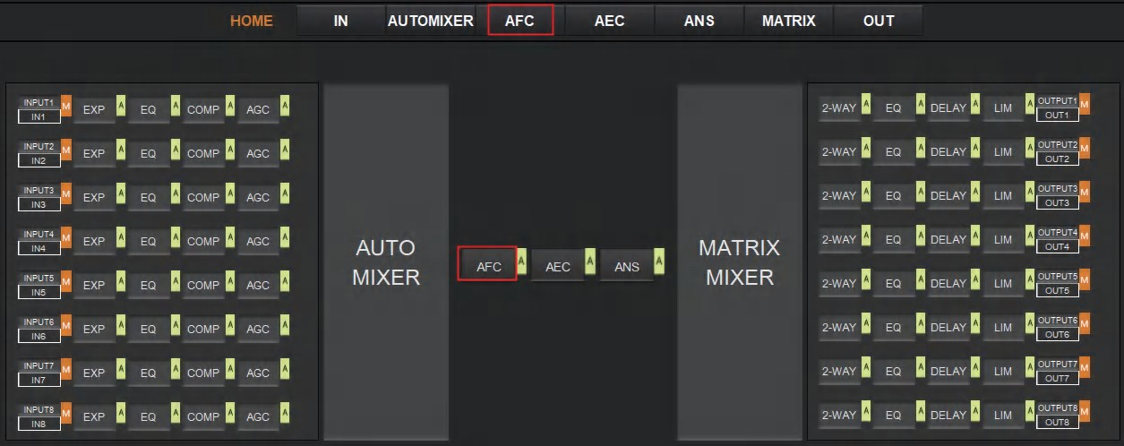

The following figure shows the AFC setting page in detail.
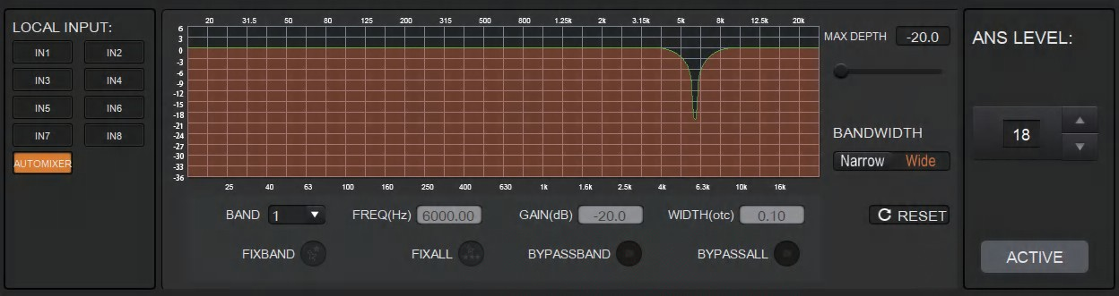

MAX DEPTH: The maximum amount of gain that the module allows to reduce, with a scale of [-20.0, 0.0] dB.
BANDWIDTH: The bandwidth of the filter, with Narrow and Wide optional.
RESET: When pressed, the filter will go back to initial settings and the module will re-detect the frequency point of the acoustic feedback.
FIXBAND: When pressed, fixed values of parameters, such as,Frequency, Gain and Width will be applied to configure the filter in a fixed band. You are allowed to design the filter by setting its parameters.
FIXALL: When pressed, all bands will be processed in a fixed mode or in USER-EDITING mode.
BYPASSBAND: When pressed, the filter of the related band will be disabled. BYPASSALL: When pressed, the AFC module will be disabled, equivalent to pressing the green letter A at the AFC module on the HOME page.
ANS LEVEL: The Adaptive Noise Suppression (ANS) module is provided to suppress noises with signal level up to 18dB. Clicking the ACTIVE button will give you the option to activate this function.

Adaptive Echo Cancellation
The 48kHz full-band Adaptive Echo Cancellation (AEC) algorithm is set to eliminate echoes coming from the far end in a remote video conference.

As shown below, clicking the AEC module  on the HOME page or the AEC tab on the menu bar will allow you to enter the AEC configuration page.
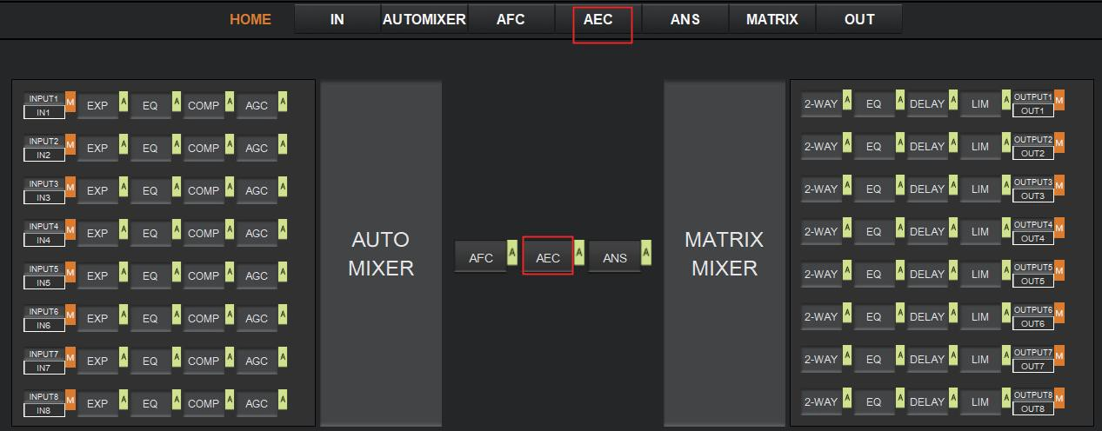
The following figure shows the setting page of the AEC module.
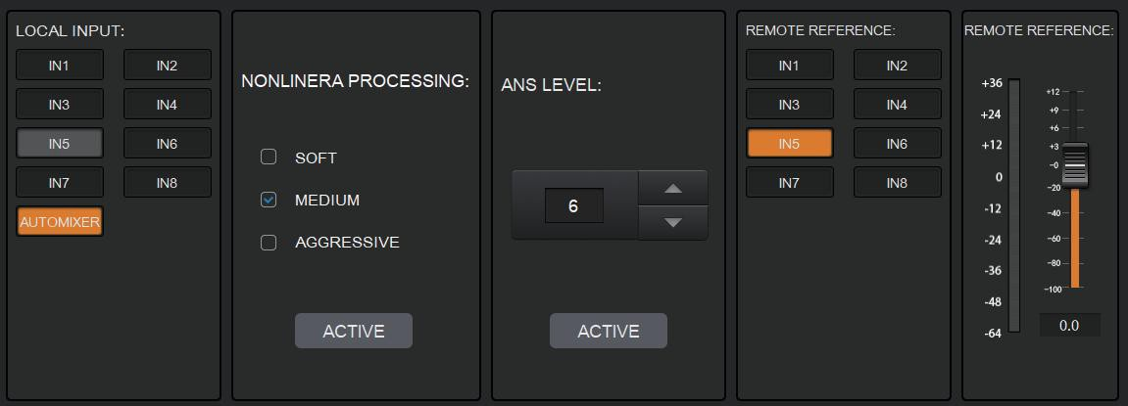

LOCAL INPUT: Shows source signals that are available to have access to the AEC process. AUTOMIXER refers to mixed signals after the AUTOMIXER process.
NONLINEAR PROCESSING: Determines the audio effect for both ends of the video conference, with soft, medium and aggressive optional.
ACTIVE: Activates the AEC process. The function is equivalent to clicking the green letter A at the AEC module on the HOME page.
ANS LEVEL: The Adaptive Noise Suppression (ANS) function is provided to suppress noises with signal level up to 18dB. Pressing the ACTIVE button, the function will be enabled. REMOTE REFERENCE: Indicates signals that are available for the AEC algorithm to learn how to eliminate analogous echoes in practice.

As shown in the figure above, we choose IN5 as reference signals, in such case, we need to connect the IN5 port of the processor to the terminal of the video conference. As the reference signal after the AEC algorithm will be send to the far end by the terminal, we also need to configure selected input channels in the matrix routing. The figure as below gives an example of configuring the matrix routing.

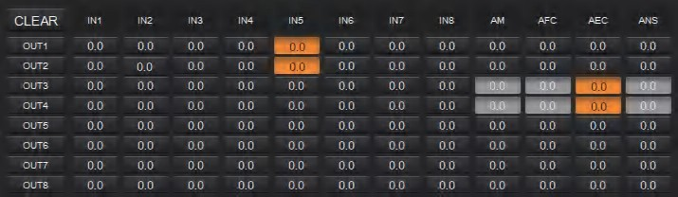

Adaptive Noise Suppression
The 48kHZ full-band Adaptive Noise Suppression (ANS) algorithm can effectively increase the signal to noise (S/N) ratio and suppress noises from the blower or air conditioner.
As shown below, by pressing the ANS module  on the HOME page or the ANS tab on the menu bar, you will enter the ANS configuration page.
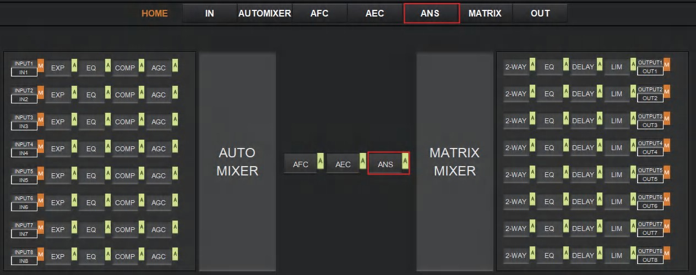

The following figure shows the details of the ANS setting page.

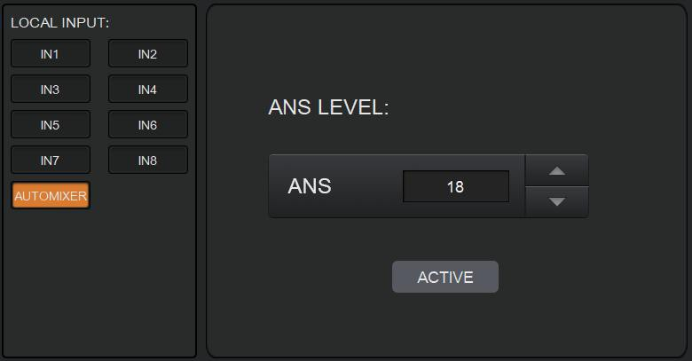

LOCAL INPUT: Shows source signals that are available to have access to the ANS process. AUTOMIXER refers to mixed signals after the AUTOMIXER process.
ANS LEVEL: The ANS module provides 12 noise suppression levels, ranging from 6dB to 18dB.
ACTIVE: Activates the ANS process. The function is equivalent to clicking the green letter A at the ANS module on the HOME page.

Matrix Mixer
The Matrix Mixer allows you to free choose audio route by matrix mode.
As shown below, clicking the MATRIX MIXER section on the HOME page or the MATRIX tab on the menu bar will enable you to enter the MATRIX MIXER configuration page.
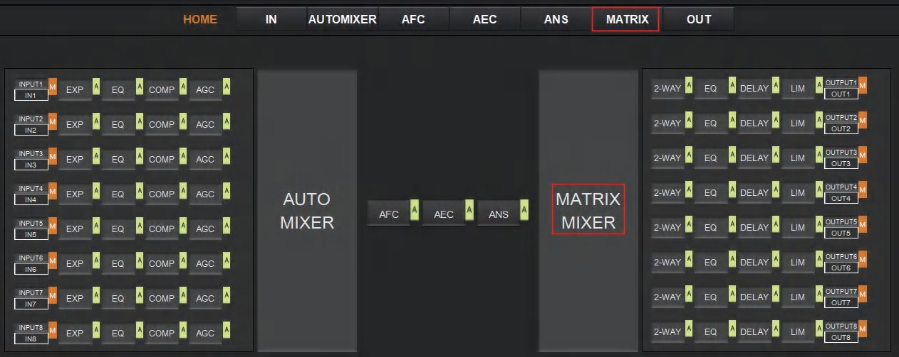
The following figure shows the configuration page in detail.

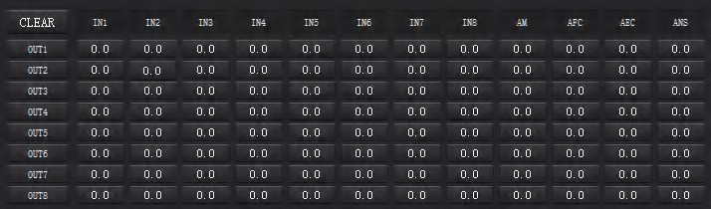

As shown above, the horizontal line stands for output channels and the vertical for input channels (AM, AFC, AEC and ANS exceptable).
AM: Indicates the output signal after the ATUO MIXER process.
AFC: Indicates the output signal after the AFC process. AEC: Indicates the output signal after the AEC process. ANS: Indicates the output signal after the ANS process.
Fader: Each channel has a fader to control the output volume.

Output Settings
As shown below, clicking the OUTPUT module  on the HOME page or the OUT tab on the menu bar will allow you to enter the OUTPUT setting page.
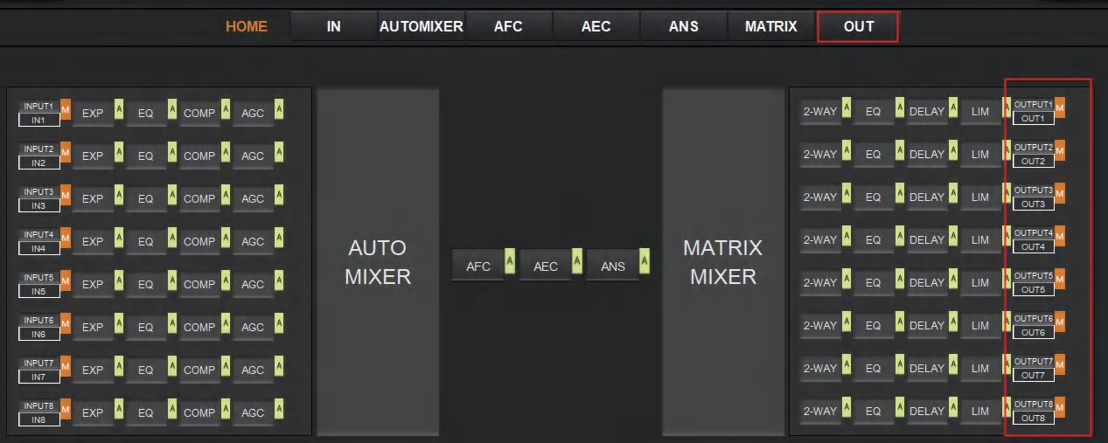

The figure as below shows the details of the setting page.

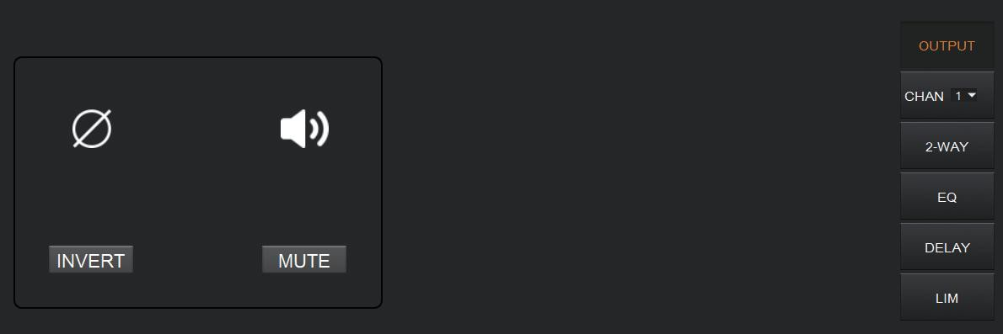

INVERT: When pressed, inverts the polarity of the signal on the channel.
MUTE: When pressed, mutes the output channel. This function is equivalent to press the letter M at the output module on the HOME page.

On the right panel of the OUT page, modules such as 2-way crossover, equalizer, delay and limiter are also available for you to set.
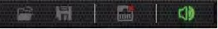

There is a trumpet icon on the tool bar which enables you to mute all analog output channels (excluding Dante channels) at one time (see the figure above). If it is in red, it indicates that all output channels are mute; otherwise, it will be green.

Two-way Crossover
The two-way crossover consists of a High Pass Filter and a Low Pass Filter, which can divide the input signal up into 2 discreet audio bands (Low and High).
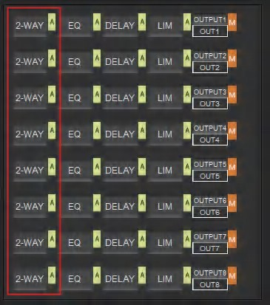
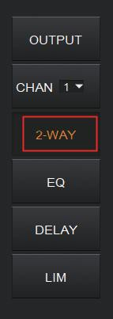
As shown below, pressing the 2-WAY module  on the HOME page or the 2-WAY button on the right panel of the OUT page, you will enter the configuration page.

or

The figure as below shows the setting page.
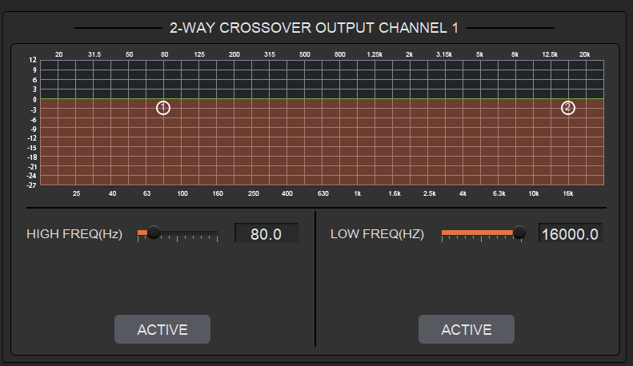
ACTIVE: When pressed, you will activate/inactivate the frequency filter (High Pass or
Low Pass). The activation can be realized by clicking the green letter A at the 2-WAY module on the HOME page. The difference is that clicking the letter A will activate/inactivate the High Pass Filter and the Low Pass Filter at the same time while clicking an ACTIVE button on the setting page will only activate/inactivate the corresponding frequency filter.
FREQUENCY: Indicates the cut-off frequency of the filter.
TYPE: Butterworth filter by default.
SLOPE: 6dB/oct by default.

A pair of UP-DOWN arrows on the right panel is available for you to select an output channel for the Two-way Crossover configuration.

Delay
The Delay module is typically used to delay the output speed of audio signals, which can be applied to meet the purpose of Lip Sync in a video conference.
By clicking the DELAY module on the HOME page or the DLY button on the OUT page, you will enter the configuration page of the Delay module.

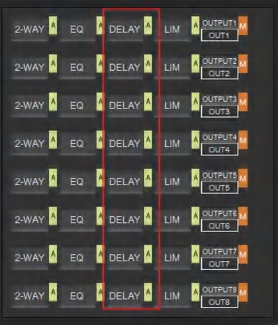
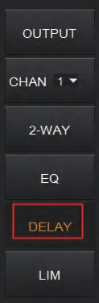
or

The figure as below shows the setting page of this function.
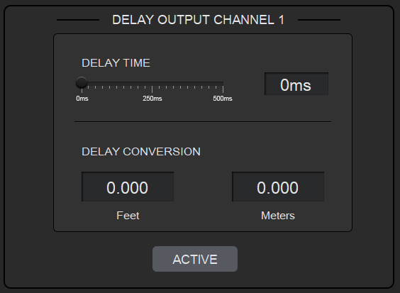

DELAY TIME: Adjusts the delay time of the output audio signal, measured in milliseconds. DELAY CONVERSION: Displays the amount of delay measured in both Feet and Meters. ACTIVE: When pressed, you will activate or inactivate the Delay module. This function can also be realized by clicking the green letter A at the DELAY module on the HOME page.

A pair of UP-DOWN arrows on the right panel is also provided for you to select an output channel for the Delay configuration.

Limiter
A Limiter can reduce the dynamic range of signals by strictly limiting the maximum output level so as to ensure that the connected amplifier won’t be overloaded because of signals with high signal level.

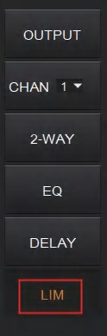
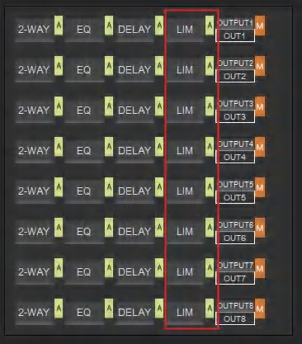
By clicking the LIM module on the HOME page  or the LIMITER button on the OUT page, you will enter the LIMITER configuration page.

or

The figure as below shows the setting page of this module.
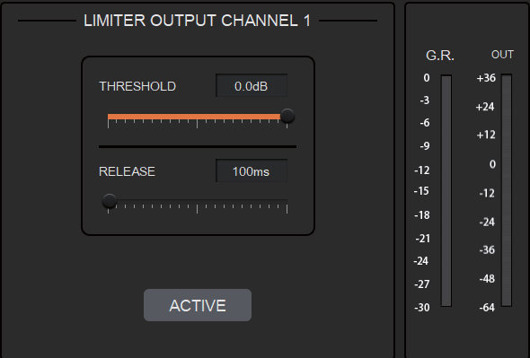

THRESHOLD: Shows that level signals above threshold will be attenuated, with a scale of [-60.0, 0.0] dB.
RELEASE: The time required by the Limiter to stop the LIMITER process once a signal is below threshold, with a scale of [1, 1000] ms.
G.R. (Gain Reduction): Shows the amount of gain attenuation of the input signal, measured in dB.
OUT: Meter indicates output signal level after the LIMITER process.
ACTIVE: When pressed, you will activate/inactivate the function of the Limiter module. The function is equivalent to clicking the green letter A at the LIM module on the HOME page.
You can also click the UP/DOWN arrow on the right panel of the setting page to select an output channel for the LIMITER configuration.

Scene Management
Up to 8 scenes are available to be managed in this audio processor. By clicking “Tools”> “Scene” on the menu bar, you will enter the setting page as shown below.
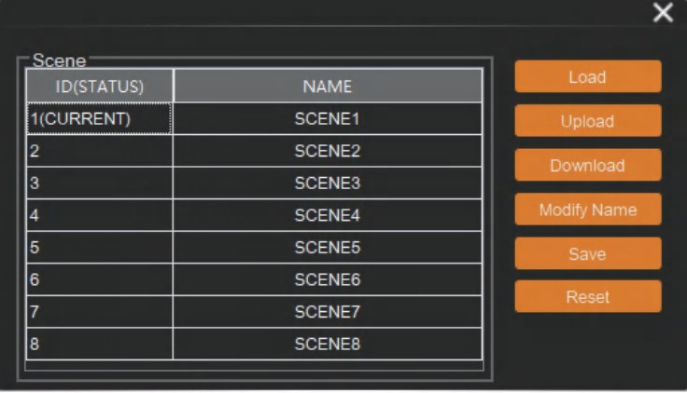
Load: When pressed, the scene saved in this processor will be exported.
Upload: When pressed, the configuration file saved in the host computer will be sent to the processor. The UPLOAD function is equivalent to clicking the OPEN icon on the tool bar as shown below.
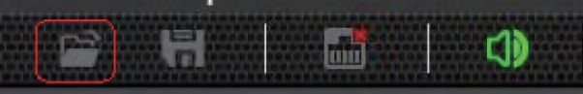

The processor can only read XML configuration files.
Download: When pressed, the present scene will be downloaded to the host computer. The DOWNLOAD function is equivalent to clicking the SAVE icon on the tool bar as shown below.


By default, the file is saved in .xml file format.
Modify Name: When pressed, the scene name displayed on the window will be changed.
Save: When pressed, the scene currently configured will be saved.
Reset: When pressed, the processor will go back to the factory settings.

Serial Settings
You can configure the RS-232 serial parameters by clicking “Tools” > “Serial” on the tool bar to enter its setting page as shown below.
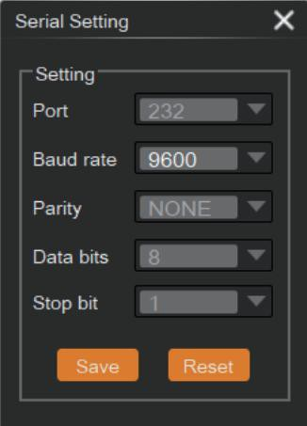

Baud Rate: 9600 by default, open to change.
Reset: Clicking it to restore the system default settings.

Control Commands
The audio processor is controllable via Control Commands. As shown below, by clicking “Tools” > “Command” on the tool bar, you will enter the setting page.
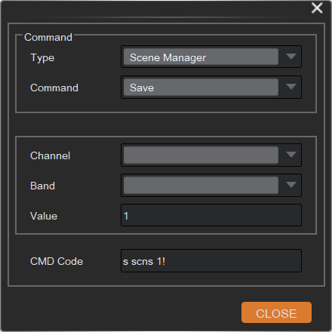

All RS-232 control commands, such as, Scene Management, I/O Control, Modules’ Configuration, and Device Information, can be found in the page. The command code will be listed at the bottom of this page once you have selected the Type, Command, Channel, Band from the drop-down box and entered its value.

GPIO Setting
Up to 8 programmable GPIO function are available to be set in this audio processor. By clicking “Tools”> “GPIO” on the menu bar, you will enter the setting page as shown below.
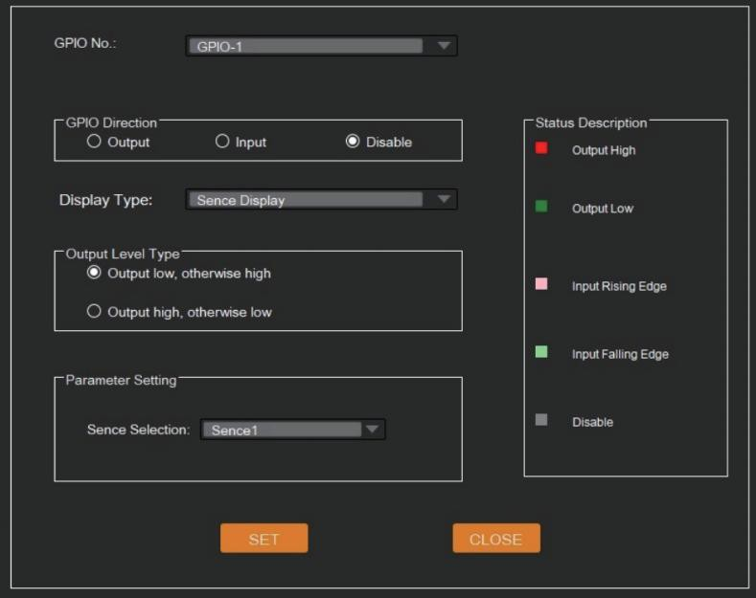

You can set the GPIO function as needed, see details at GPIO Setting page. You can also check GPIO status by GPIO LED at the top-right corner of Host page.

Reset Setting

Press and hold the RESET button on the back panel for 10 seconds until the STATUS LED on the front panel flashes slowly, then release the button, the audio processor will reboot automatically and restore to default settings (including IP address, configuration information etc.).

Troubles and Solutions
If the output audio is abnormal, you may need to check following items at first:
☆ Whether the STATUS LED is normal.
☆ Whether the INPUT/OUTPUT VOLUME is turned down to the lowest level.
☆ Whether cables are in right connection.
☆ Whether the matrix mixer is configured correctly.
☆ Whether the audio modules are applied correctly.

If echo persists when the processor is working, you need to check:
☆ Whether the processor is in normal operation.
☆ Whether the AEC module is activated.
☆ Whether the matrix routing is correctly configured.
☆ Whether the connection of Amplifier or Speaker for outputting reference signals is consistent with the matrix routing.

Application Example

The audio processor supports microphone input, computer, DVD, mixer and other audio source input. It can be used in combination with video conference terminal, recording and broadcasting system, and mixing console. The following figure shows the general connection diagram. Users can connect the devices based on actual requirements.
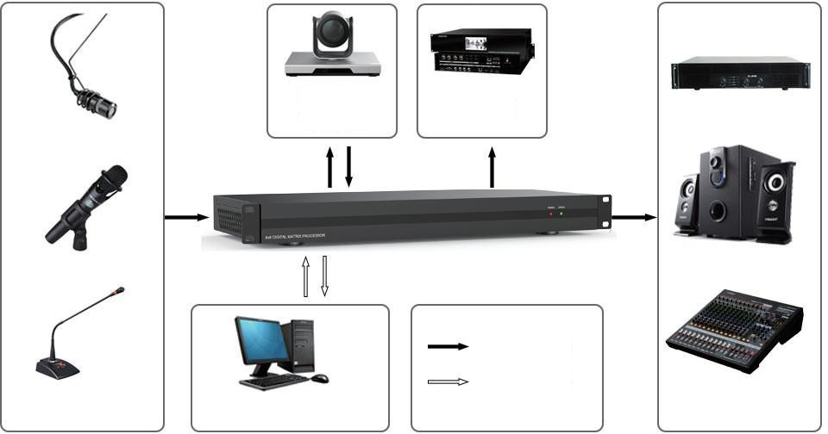
Terminal
Recording System
Audio Source
Analog Audio Signal
Network Control Signal
PC
Amplifier and Loudspeaker

