ALT-D2USBE

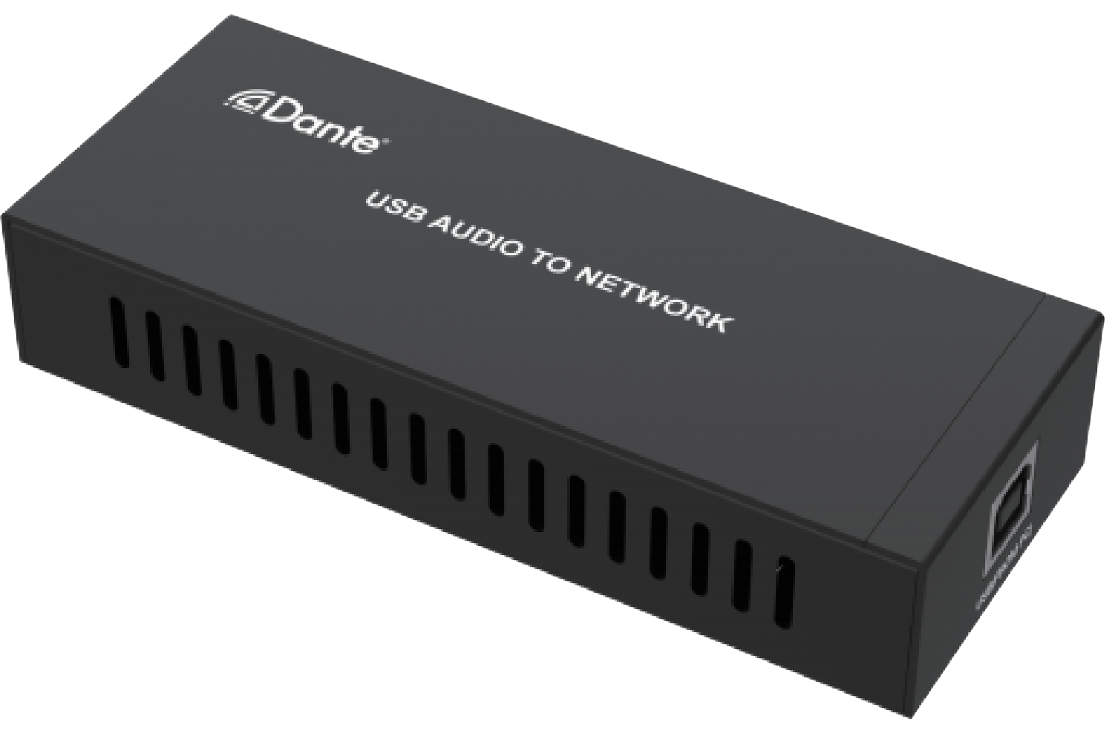


VER 1.0

Thank you for purchasing this product
For optimum performance and safety, please read these instructions carefully before connecting, operating or adjusting this product. Please keep this manual for future reference.

Surge protection device recommended This product contains sensitive electrical components that may be damaged by electrical spikes, surges, electric shock, lighting strikes, etc. Use of surge protection systems is highly recommended in order to protect and extend the life of your equipment.

Table of Contents
- Introduction. 1
- Features. 1
- Package Contents. 1
- Specifications. 2
- Operation Controls and Functions. 3
- Application Example. 4

Introduction
This Dante 2CH USB Audio Encoder/Decoder is a Dante sound card adapter based on the Dante
Ultimo solution. It supports USB audio transmission. Built-in USB sound card chip, it transmits audio signal through network (Dante). It supports USB power supply and POE function. The product is compact and easy to carry, plug and play, suitable for recording studios, art festivals, concerts and other scenes.

Features
☆ Compliant with USB 2.0 Full Speed Operation
☆ Compliant with USB Audio Device Class Specification V1.0
☆ Analog sound card, supporting MIC input and SPK output
☆ Audio sampling rate supports 44.1kHz, 48kHz and 96kHz (24bit)
☆ Dante solution supports AES67 RTP audio transmission
☆ Support USB 5V power supply and POE function (IEEE802.3af Class 0)

Package Contents
① 1× Dante 2CH USB Audio Encoder/Decoder
② 1× USB Cable (6FT USB A to USB B)
③ 1× User Manual

Specifications

Technical
Video Network Bandwidth | 100M
Audio Formats | PCM 2.0 44.1kHz/48kHz/96kHz up to 24bit
Transmission Distance | 100m (CAT6/6A)
Frequency Response | 20Hz to 20kHz
Control Method | Dante Controller
Connection
Input & Output | 1x USB-B  1x DANTE [RJ45 connector, POE]
Mechanical
Housing | Metal Enclosure
Color | Black
Dimensions | 120mm[W] x 47mm[D] x 26mm[H]
Weight | 188g
Power Supply | USB input: 5V-500MA  POE input: IEEE802.3af Class 0
Power Consumption | 1W
Operation Temperature | 32 - 104°F / 0 - 40°C
Storage temperature | -4 - 140°F / -20 - 60°C
Relative Humidity | 20 - 90% RH (no condensation)

Operation Controls and Functions

USB(FROM PC)

1
DANTE(POE)
2

No. | Name | Function Description
1 | USB(FROM PC) | - 2-channel USB digital audio signal port: L/R mixed input and L/R stereo output.  - USB 5V power input port.
2 | DANTE (POE) | Dante digital audio input and output port.  Connect to the Network Switch through RJ45 line, supporting PD power supply.  The green LINK LED is always on after normal connection.  The yellow DATA LED is flashing when there is data transmission.

Application Example
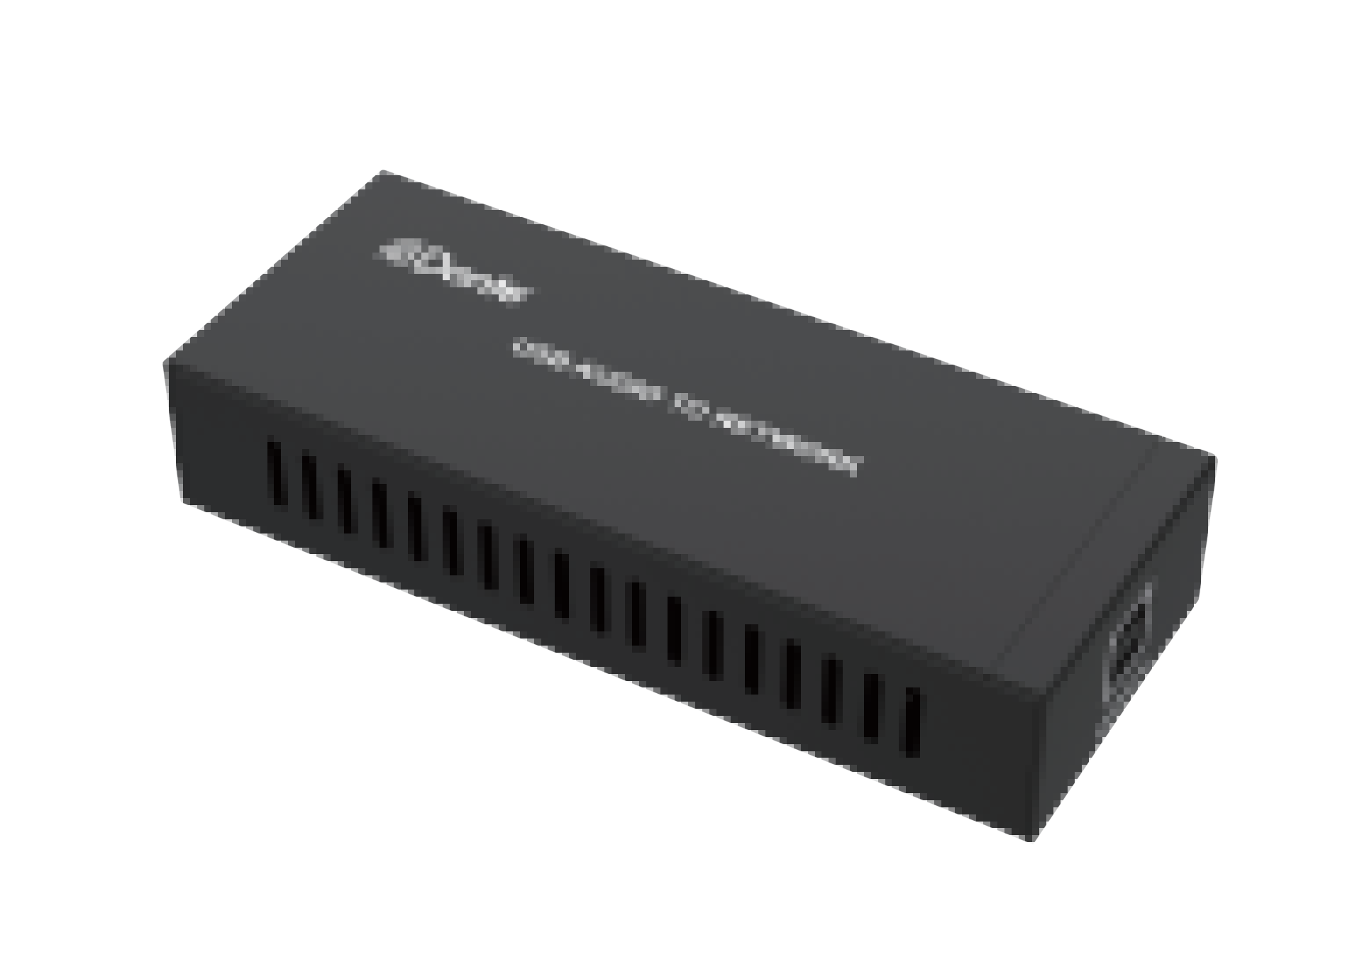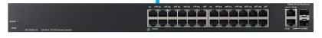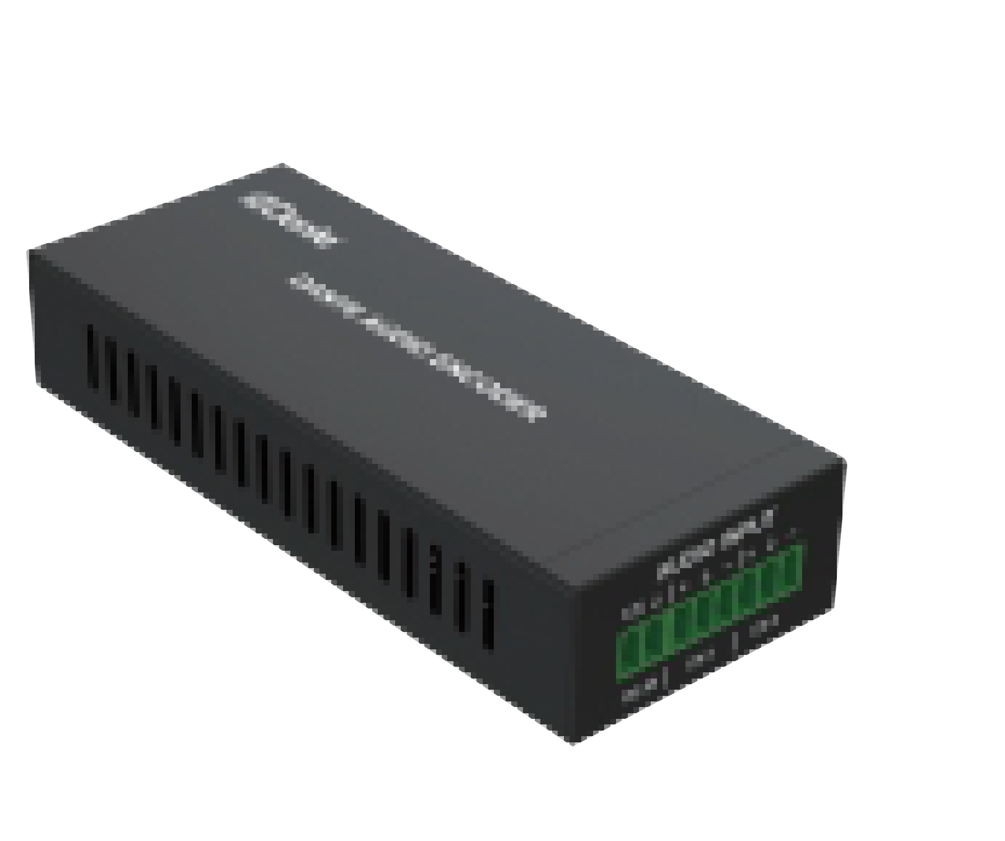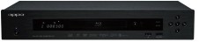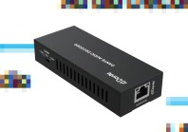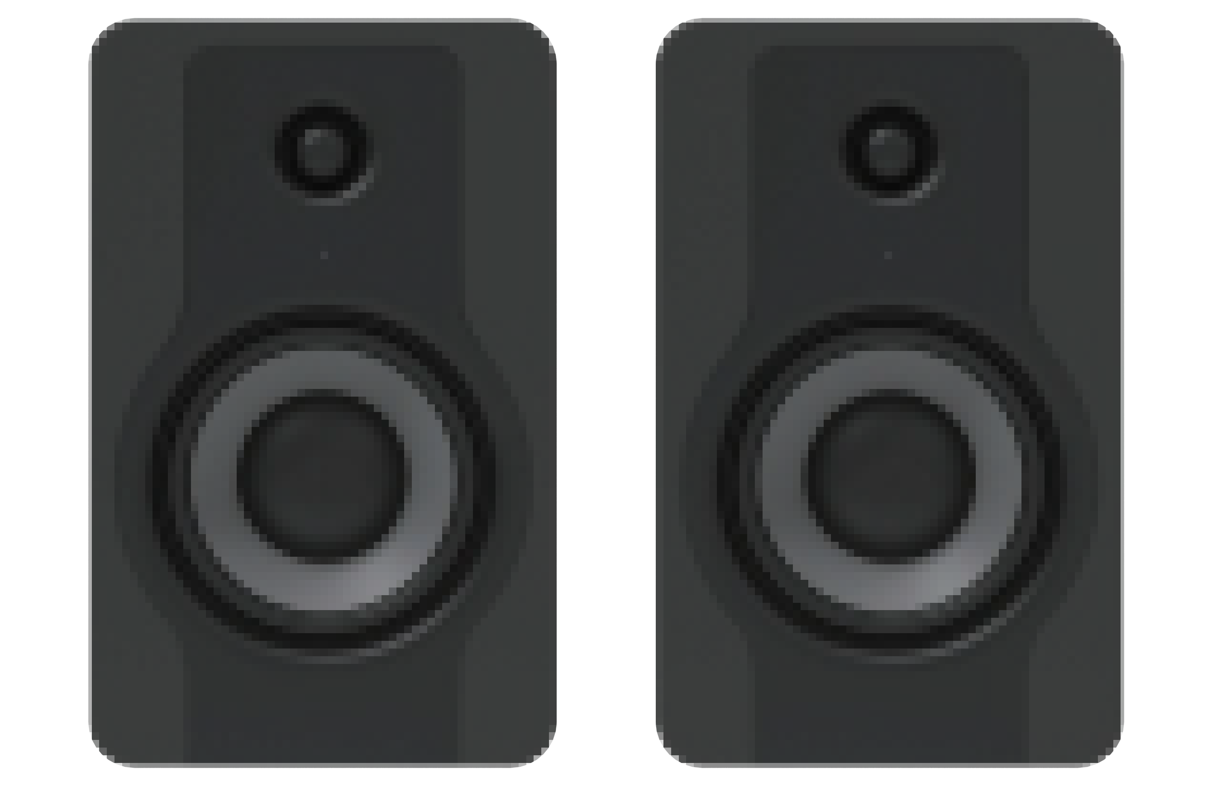USB Audio Encoder/Decoder

Dante Audio

USB Audio

Laptop

100/1000M Network Switch

Dante
Audio Audio Encoder

L/R Audio

DVD

Audio Decoder

Dante A
udio

L/R Audio

Speakers

Trademarks
Dante® is registered trademark of Audinate Pty Ltd. All other trademarks are the property of their respective owners.

