ALT-D2AUD

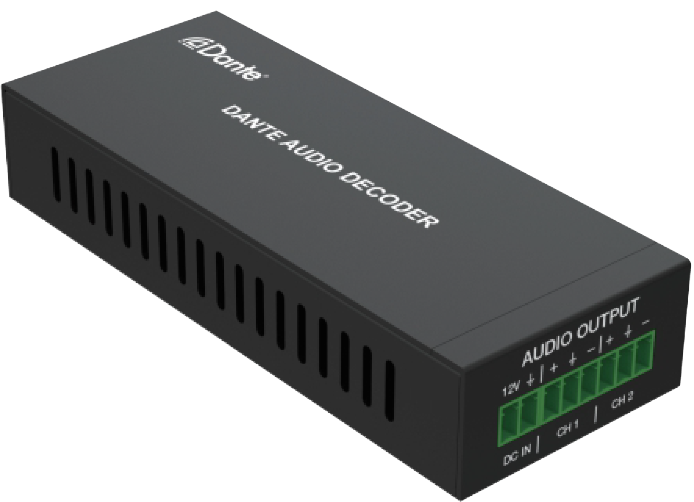


VER 1.0

Thank you for purchasing this product
For optimum performance and safety, please read these instructions carefully before connecting, operating or adjusting this product. Please keep this manual for future reference.

Surge protection device recommended This product contains sensitive electrical components that may be damaged by electrical spikes, surges, electric shock, lighting strikes, etc. Use of surge protection systems is highly recommended in order to protect and extend the life of your equipment.

Table of Contents
- Introduction. 1
- Features. 1
- Package Contents. 1
- Specifications. 2
- Operation Controls and Functions. 3
- Application Example. 4

Introduction
This Dante 2CH Analog Audio Decoder is an audio receiver based on the Dante Ultimo solution. It supports balanced/unbalanced audio output and 3- level gain adjustment. It receives audio signals from the transmitting end through network (Dante), then decodes and outputs the audio as analog audio. It supports POE function.

Features
☆ Analog audio output supports balanced/unbalanced audio output (unbalanced access to "+" and "GND")
☆ Audio sampling rate supports 44.1kHz, 48kHz and 96kHz (24bit)
☆ Dante solution supports AES67 RTP audio transmission
☆ Audio output supports 3-level gain adjustment：
+18dBu, 0dBu (default) and -10dBV
☆ Support DC 12V power supply and POE function (IEEE802.3af Class 0)

Package Contents
① 1× Dante 2CH Analog Audio Decoder
② 1× 6pin-3.81mm Phoenix Connector (male)
③ 1× 2pin-3.81mm Phoenix Connector (male)
④ 1× User Manual

Specifications

Technical
Video Network Bandwidth | 100M
Audio Formats | PCM 2.0 44.1kHz/48kHz/96kHz up to 24bit
Transmission Distance | 100m (CAT6/6A)
Control Method | Dante Controller
Connection
Inputs | 1x DANTE [RJ45 connector, POE] 1x PWR [2-pin phoenix, 3.81mm]
Output | 1x AUD [6-pin phoenix, 3.81mm]
Mechanical
Housing | Metal Enclosure
Color | Black
Dimensions | 120mm[W] x 47mm[D] x 26mm[H]
Weight | 186g
Power Supply | DC input: 12V  POE input: IEEE802.3af Class 0
Power Consumption | 1.32W
Operation Temperature | 32 - 104°F / 0 - 40°C
Storage temperature | -4 - 140°F / -20 - 60°C
Relative Humidity | 20 - 90% RH (no condensation)

Operation Controls and Functions
1
2
3
4

No. | Name | Function Description
1 | DC IN | DC 12V power input port.
2 | AUDIO  OUTPUT (CH1/CH2) | 2 channel analog audio output ports, supporting balanced and  unbalanced audio.
3 | DANTE (POE) | Dante digital audio input port. Connect to the Network Switch through RJ45 line, supporting PD power supply.  The green LINK LED is always on after normal connection.  The yellow DATA LED is flashing when there is data transmission.
4 | GAIN switch | Used for audio output gain adjustment, respectively +18dBu, 0dBu (default), -10dBV.

Application Example

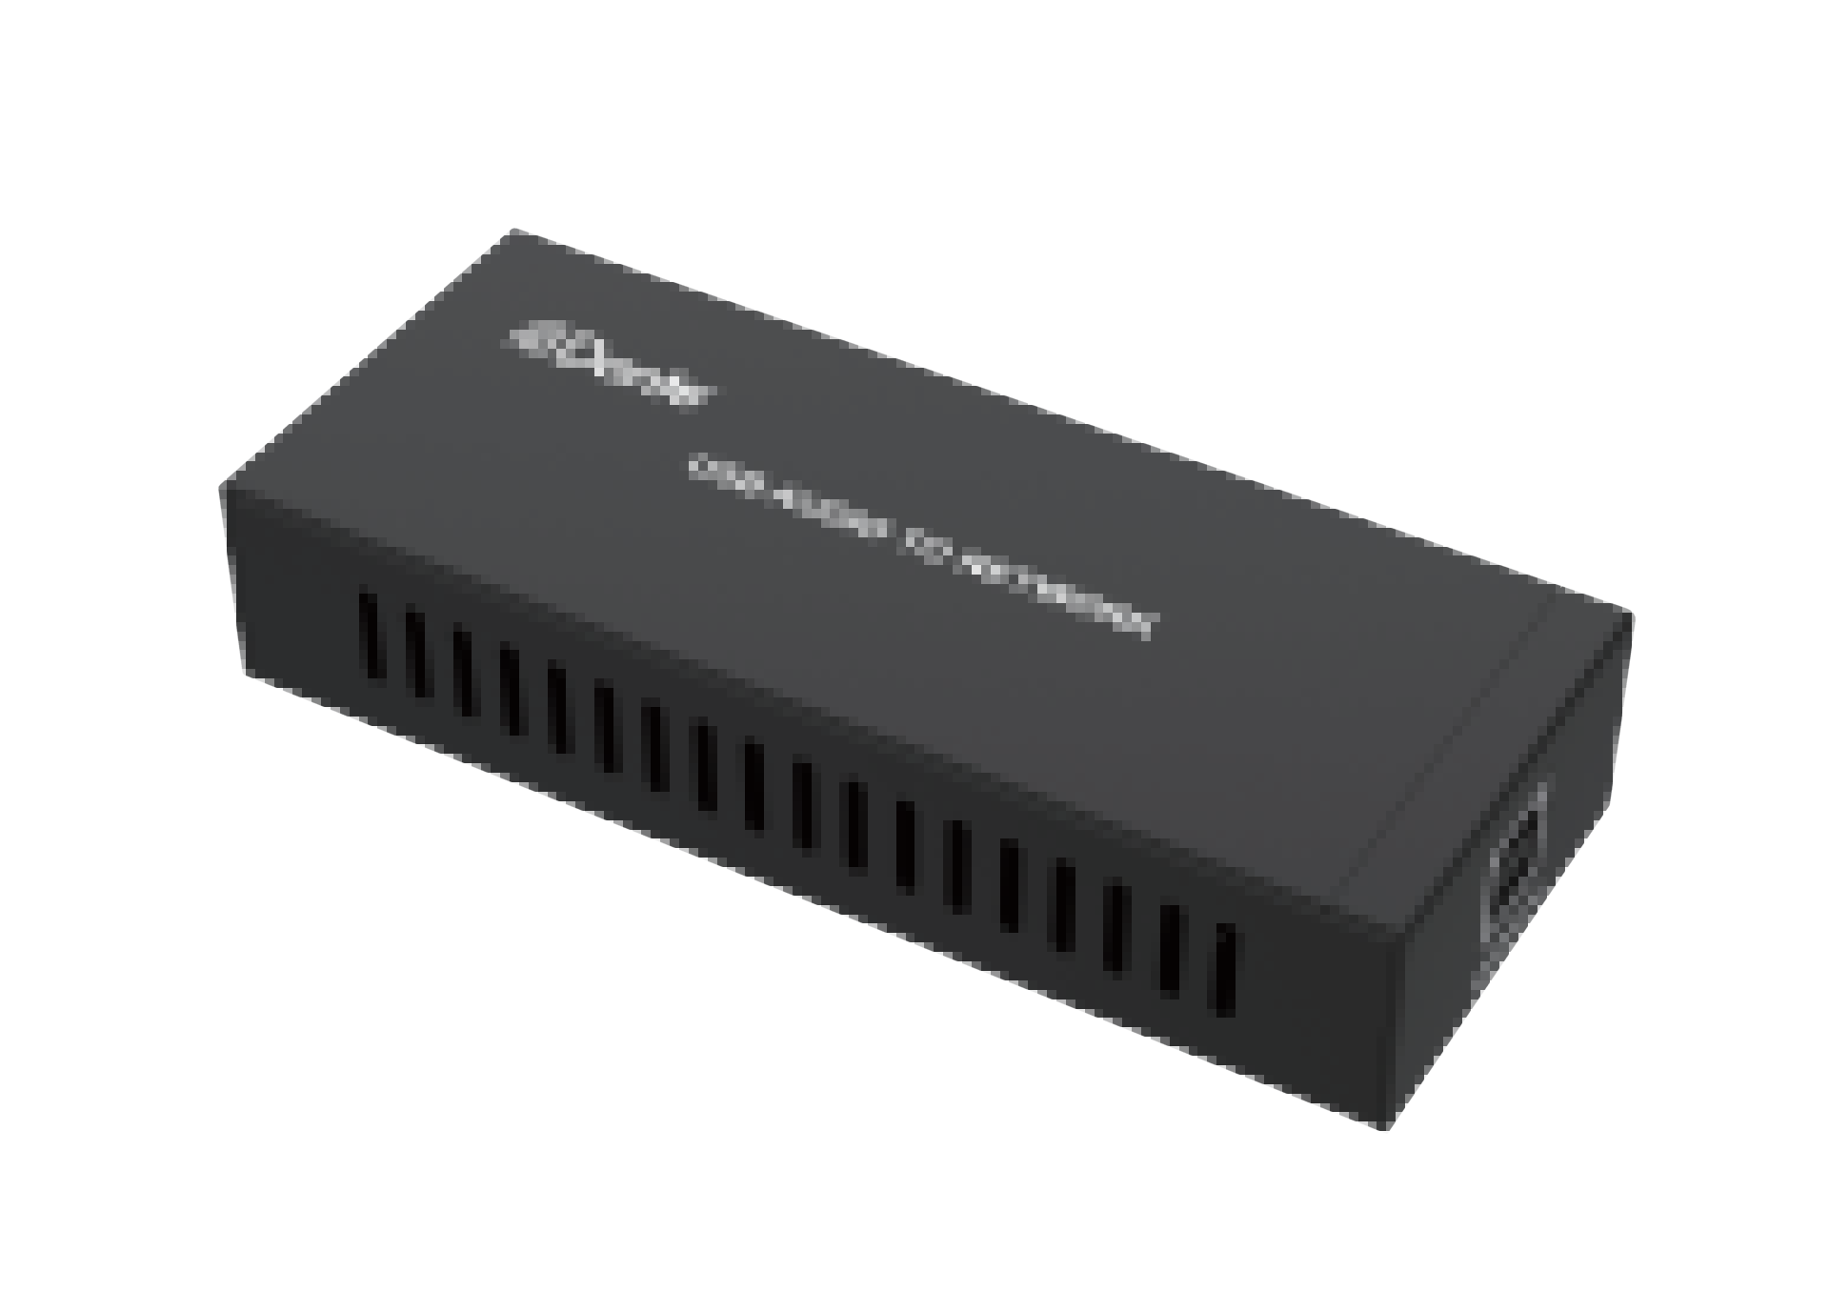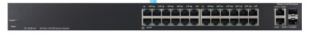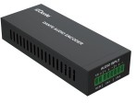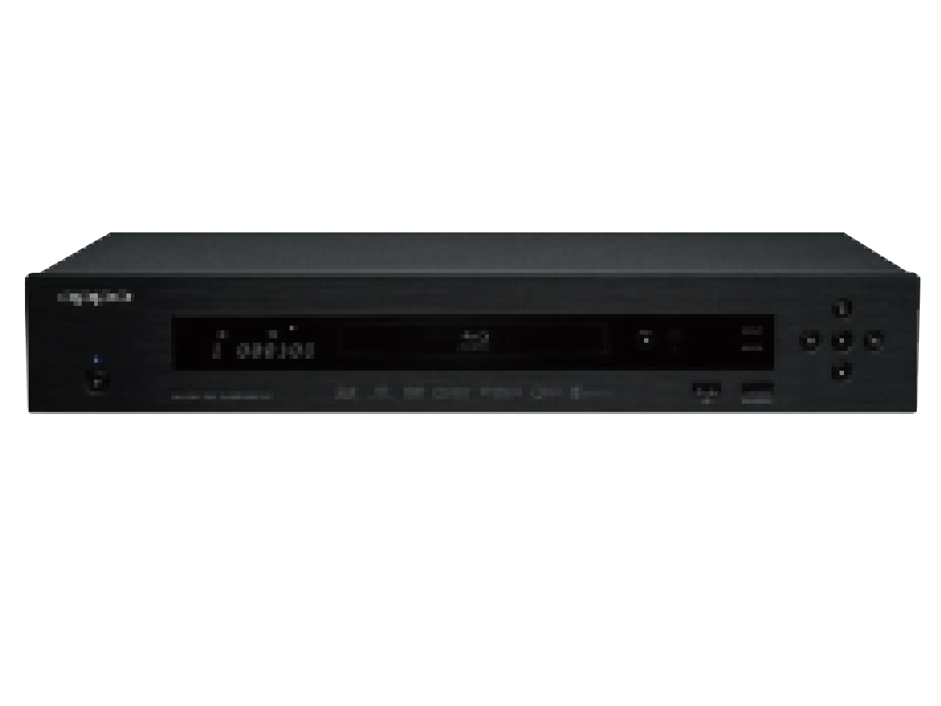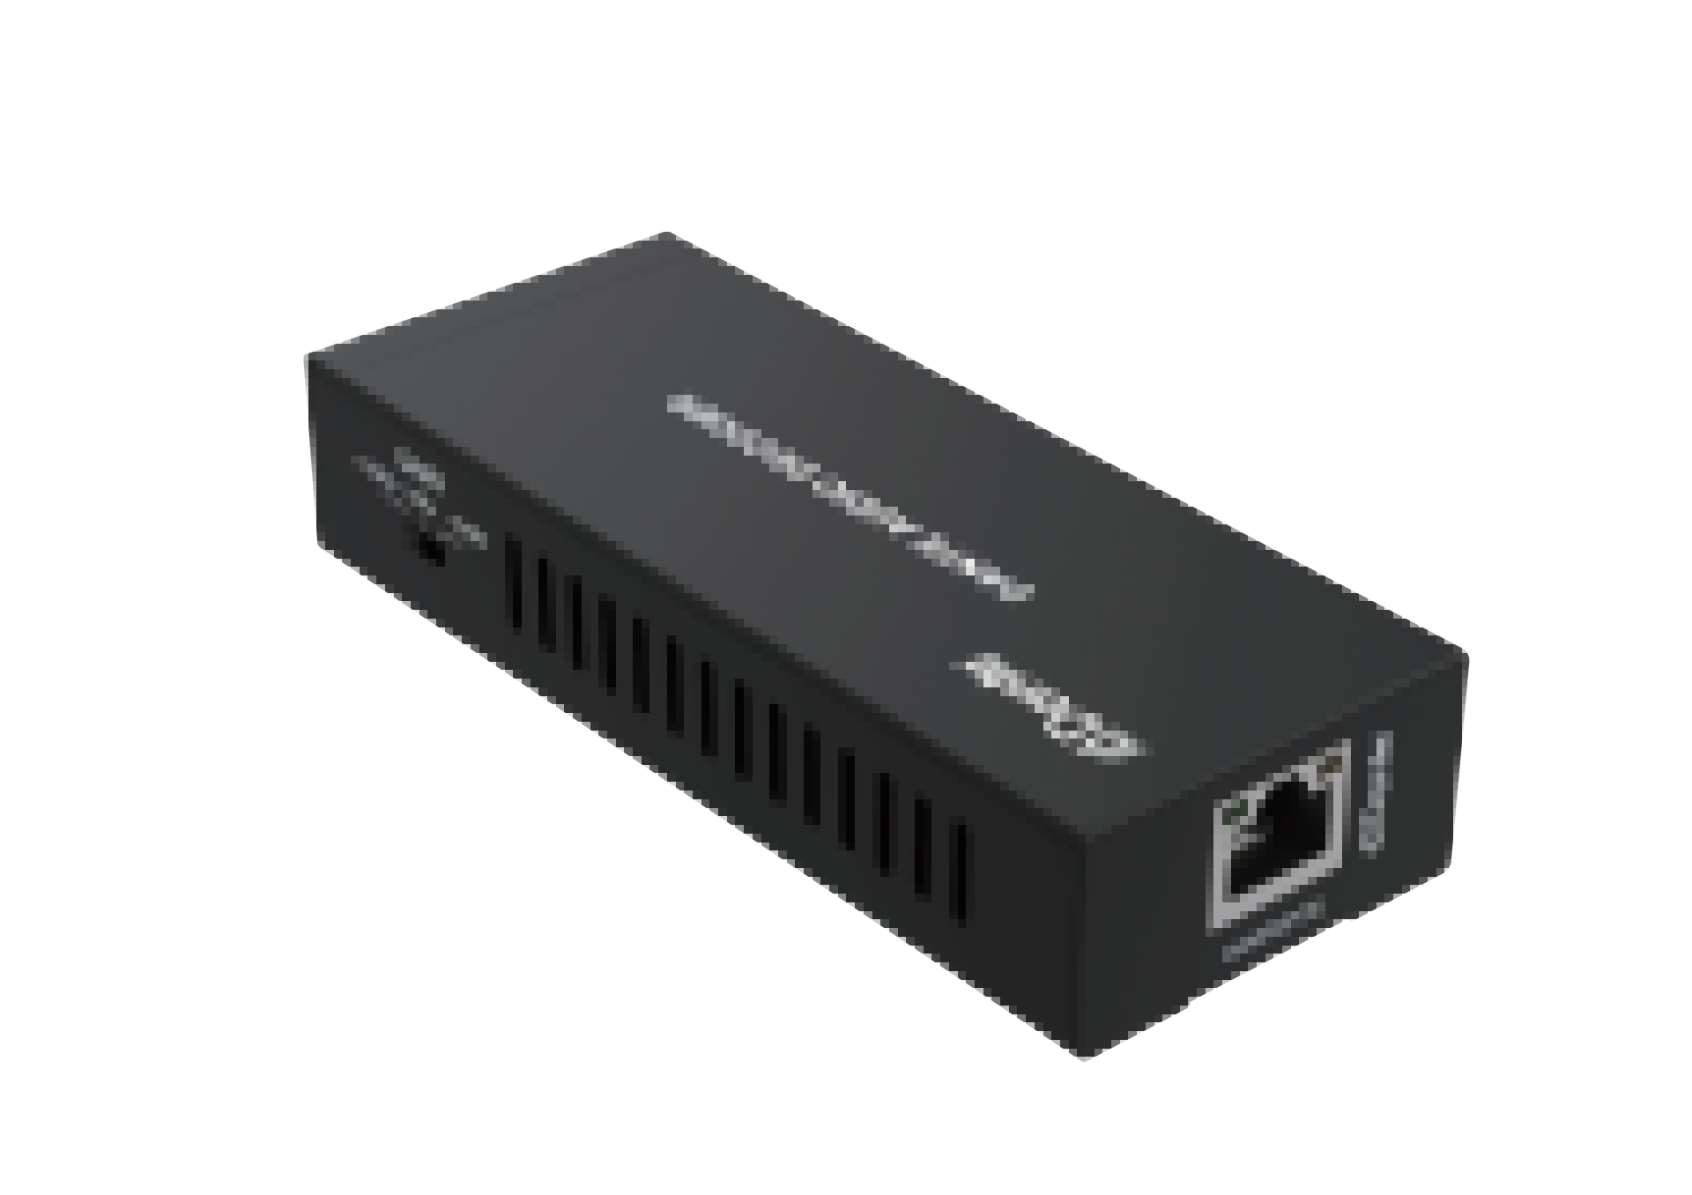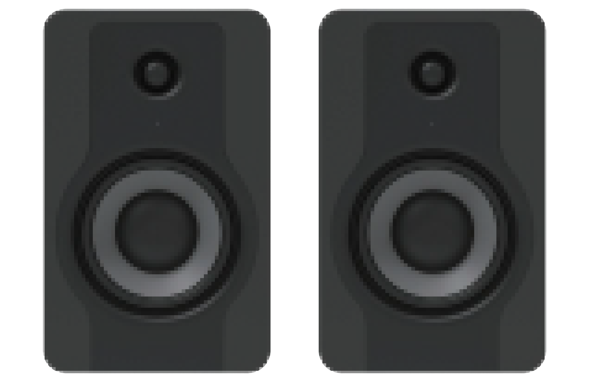USB Audio Encoder/Decoder

Dante Audio

USB Audio

Laptop

100/1000M Network Switch

Dante
Audio Audio Encoder

L/R Audio

DVD

Audio Decoder

Dante Audio

L/R Audio

Speakers

Trademarks
Dante® is registered trademark of Audinate Pty Ltd. All other trademarks are the property of their respective owners.

