ALT-AMP150D

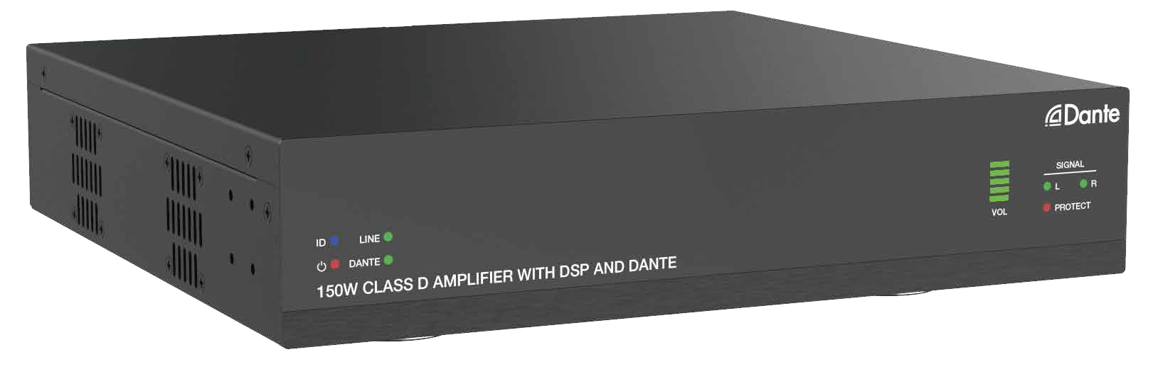



VER 1.0

Thank you for purchasing this product
For optimum performance and safety, please read these instructions carefully before connecting, operating or adjusting this product. Please keep this manual for future reference.

Surge protection device recommended
This product contains sensitive electrical components that may be damaged by electrical spikes, surges, electric shock, lighting strikes, etc. Use of surge protection systems is highly recommended in order to protect and extend the life of your equipment.
Caution
The product requires the use of UTP connectors. Please connect in direct interconnection method and do not cross connect.

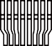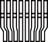White and Orange Orange
White and Green Blue
White and Blue Green
White and Brown Brown

Direct Interconnection Method

Table of Contents
- Introduction. 1
- Features. 1
- Package Contents. 1
- Specifications. 2
- Operation Controls and Functions. 3
  - Front Panel. 3
  - Rear Panel. 4
- Dante Web GUI User Guide 5
- RS-232 Control Command 10
- Connection Diagram. 15

Introduction
This product is designed as a two-channel amplifier using class D amplifier technology. It can be used for powering low impedance (4Ω/8Ω) stereo systems with a maximum power of 2 x 75 Watt, while bridging to a constant voltage (100V and 70V) is possible with a maximum output power of 150 Watt. It features Dante 2CH digital inputs and outputs, and balanced or unbalanced line level analog inputs and outputs.
This amplifier can be controlled via RS-232, LAN and Web GUI. It also features built-in DSP, auto-standby and maximum durability. It is suitable for a vast range of AV installations.

Features
☆ Dante 2CH digital audio, balanced or unbalanced line level analog inputs
☆ Dante 2CH digital audio, balanced or unbalanced line level analog and AMP outputs
☆ Built-in audio DSP processor
☆ Switching between Lo-Z and Hi-Z can be achieved to adapt to various types of speaker
installation.
In Lo-Z output mode, single-channel 150 Watt or two-channel 2 x 75 Watt 4Ω/8Ω can be
selected.
In Hi-Z output mode, single-channel 150 Watt with 70V/100V can be selected.
☆ Independent input gain, output EQ and volume control
☆ 48KHz sampling rate, 24bit independent A/D and D/A converters
☆ 5-12V trigger input
☆ Auto standby
☆ Flexible control via RS-232, LAN and Web GUI
☆ Half rack design/one rack design

Package Contents
① 1 x 150W Class D Amplifier
② 3 x 5pin-3.81mm Phoenix Connector (male)
③ 2 x 4pin-5.08mm Phoenix Connector (male)
④ 6 x Mounting Ear
⑤ 24 x Machine Screw
⑥ 1 x AC (100-240V) Multinational Power Cord (1.5 meters)
⑦ 1 x User Manual

Specifications

Technical
Input | 1x Dante Network audio input  1x LINE balanced stereo 0dBu/10kΩ input
Output | 1x Dante Network audio output  1x Stereo or constant voltage 70V/100V speaker output 1x LINE balanced stereo output
Input Sensitivity | Full power@0.775V (0dBu)
Output Power | DC power supply: 2x 75W@4Ω/8Ω; 1x 150W@8Ω; 1x 150W@70V/100V
Maximum Voltage Gain | 27 - 30dB SE/39 - 42dB BTL
Amplifier Type | Class D
Frequency Response | 20Hz - 20kHz @ ±3dB
Signal to Noise Ratio | 87dB, 20Hz - 10kHz
THD+N | THD+N (1KHz@1W) 0.04%
Control | RS-232, Web GUI
Audio Format | LINE IN [Analog audio, Balanced 2CH, Max input level 2VRMS]  LINE OUT [Analog audio, Balanced 2CH, Max output level 2VRMS]  DANTE [Digital audio 2x2 in/out, PCM 2CH 44.1K-96KHz 16/24Bit]  AMP OUT [Analog audio, Balanced 2CH, Max output level 24.5VRMS]  70V/100V AMP OUT [Analog audio, Unbalanced 1CH, Max output level 70V/100VRMS]
ESD Protection | Human-body Model:  ±8kV (Air-gap discharge) , ±4kV (Contact discharge)
Connection
Input: | 1x LINE IN [5pin-3.81mm Phoenix Connector] 1x DANTE [RJ45 connector]
Output: | 1x LINE OUT [5pin-3.81mm Phoenix Connector]  1x 4/8Ω AMP OUT [MSTB 2.5-GF-5.08, 4-pin locking  phoenix, 5.08mm]  1x 70V/100V AMP OUT [MSTB 2.5-GF-5.08, 4-pin locking  phoenix, 5.08mm]
Control: | 1x RS-232/TRG [5pin-3.81mm phoenix connector] [TRG: 5-12V trigger input to turn on/off the amplifier]  1x LAN [RJ45 connector]

Mechanical
Housing | Front panel: Aluminum; Rear case: Metal Enclosure
Color | Black
Dimensions | 240mm [W]×210mm [D]×44mm [H]
Weight | 1.88Kg
Power Supply | DC Input: AC100 - 240V 50/60Hz
Power Consumption | 240W (Max)
Operating Temperature | 0°C ~ 40°C / 32°F ~ 104°F
Storage Temperature | -20°C ~ 60°C / -4°F ~ 140°F
Relative Humidity | 20%~90% RH (non-condensing)

Operation Controls and Functions

Front Panel
2 3
4
5
SIGNAL
L
R
1
VOL
PROTECT
6
150W CLASS D AMPLIFIER WITH DSP AND DANTE

No. | Name | Function Description
1 | Power LED | When the product is powered on, the red power LED is on.
2 | ID (show me) LED | This LED indicates the presence of the product. It can be controlled through Web GUI or API command. For example, when selecting the “On” option for “DANTE Identification” on the System page  of the Web GUI, the ID (show me) LED on the front panel will flash,  so that you can find the corresponding machine in the system.
3 | LINE/DANTE LED | Input signal source indicators. When the DANTE or LINE IN port is selected as the signal input channel, the corresponding green LINE/DANTE LED is on.  Note: The DANTE port is the signal input channel by default.
4 | VOL LED | The main audio volume of the system is displayed in five green segments, with each segment corresponding to 20% of the volume. 50% of the main audio volume is displayed by default after system initialization.  Note: The audio volume can be controlled through Web GUI or API  command.
5 | SIGNAL L/R LEDs | Left and right channel signal indicators of the stereo audio. When there is stereo audio signal, the LEDs will be on.
6 | PROTECT LED | When the machine is protected by overtemperature, overcurrent or overvoltage, the PROTECT LED is on.

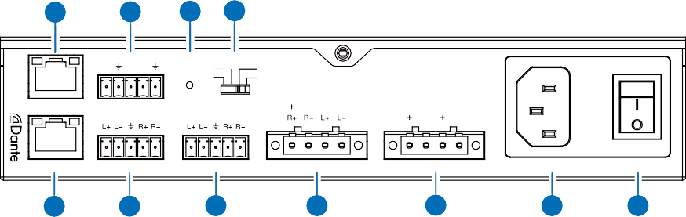Rear Panel
1
2
3 4
TX RX T
80 70V
40 100V
LAN
RS-232 TRG
RESET SPEAKER
BRIDGED
70V 100V
DANTE
LINE IN
LINE OUT
4 / 8 Ω OUT
CLASS 2 WIRING
70 / 100V OUT CLASS 2 WIRING
100-240V AC 50/60HZ
5
6
7
8
9
10
11

No. | Name | Function Description
1 | LAN port | Connect to a PC for Web access. The default IP address is 192.168.0.200.
2 | RS-232/TRG  port | RS-232: Serial control port, used for RS-232 signal pass-through or controlling this product via RS-232 commands.
2 | RS-232/TRG  port | TRG: T trigger signal input port, effective at high level. When this port is connected to a 5V/12V trigger voltage, the amplifier will be mute. After trigger is disconnected, the amplifier can output audio normally.
3 | RESET button | Press and hold this button for 5 seconds to restore to factory default settings.
4 | SPEAKER  switch | Speaker high-low resistance switch, used to switch among Lo-Z (4Ω/8Ω), Hi-70V and Hi-100V.
5 | DANTE port | Dante audio input and output port, using dynamic IP by default.
6 | LINE IN port | Balanced stereo audio input port, with a Max input level of 2Vrms.
7 | LINE OUT port | Balanced stereo audio output port, with a Max output level of 2Vrms.
8 | 4/8Ω OUT port | 4/8Ω speaker output port. When this port is connected to a 4/8Ω speaker and the SPEAKER switch is dialed to 4/8Ω, the audio will be output from this port normally.
9 | 70/100V OUT  port | 70/100V speaker output port. When this port is connected to a 70/ 100V speaker and the SPEAKER switch is dialed to 70/100V, the audio will be output from this port normally.
10 | Power port | 100-240V AC 50/60Hz power input port.
11 | Power switch | Press the power switch to turn on/off the power supply.

Dante Web GUI User Guide
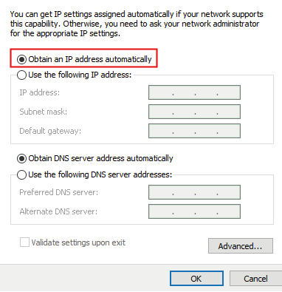
There is a built-in Dante Web GUI for the amplifier. The operation method is shown as below: Step 1: Connect the amplifier and PC to the same Ethernet Switch with two Network cables. Step 2: Set the Network connection setting of PC to be “Obtain an IP address Automatically”.
169 168 110 30
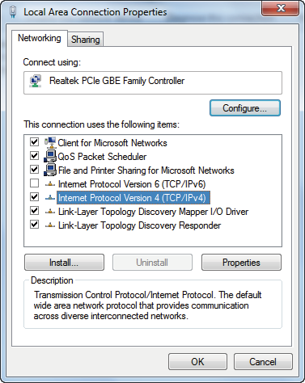
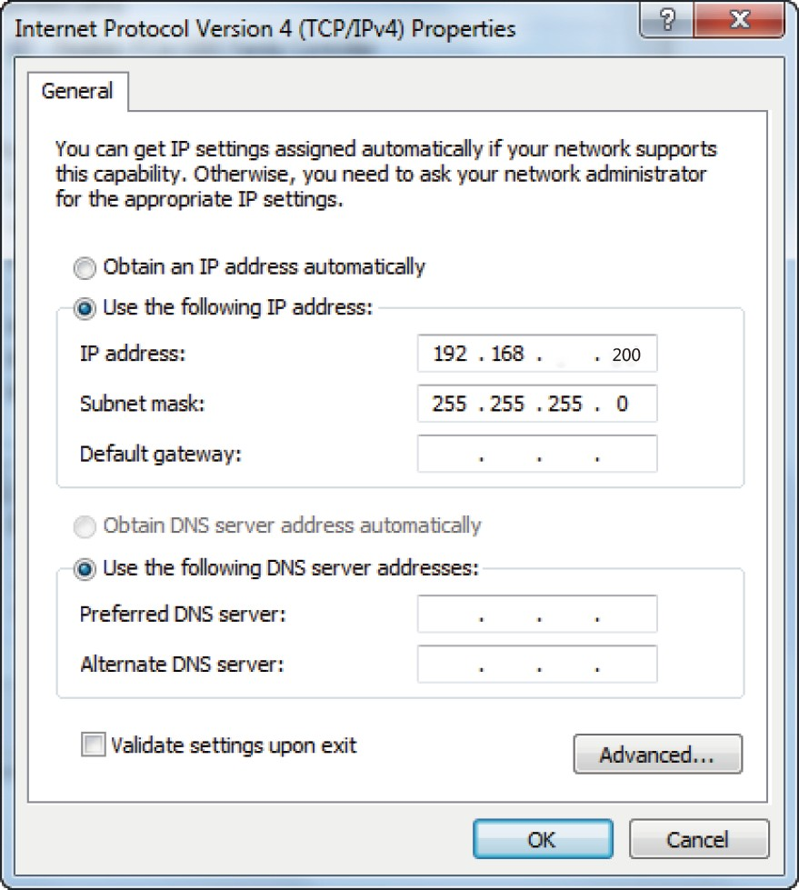
Step 3: Open the Dante Controller software on the PC, and find the Dante device on the
Routing page, as shown in the figure below.
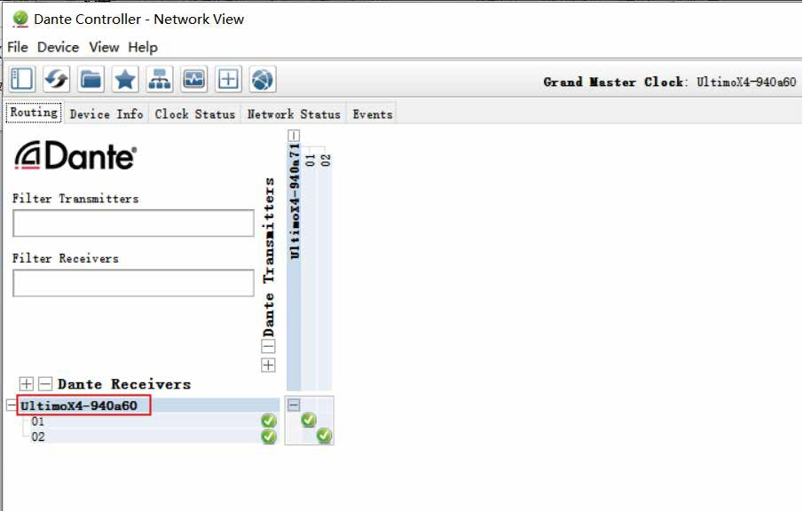

Step 4: Click the Device Info tab to check the IP address of the Dante device.
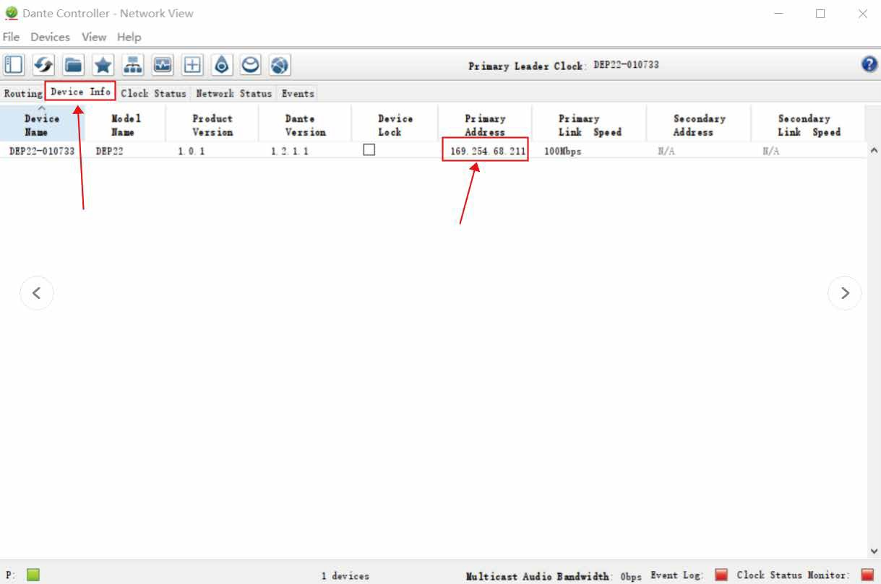
Step 5: Input the IP address of Dante device into your browser on the PC to enter the login interface of the Dante Web GUI.
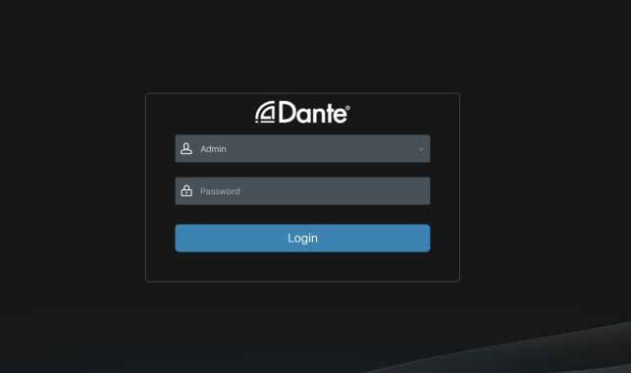

The default usernames and passwords are as below:

Username | User | Admin
Password | 1234 | 1234

Step 6: Select the default username “Admin” and input the password “1234”, then click the “Login” button to enter the Information page of Dante Web GUI.

Information Page
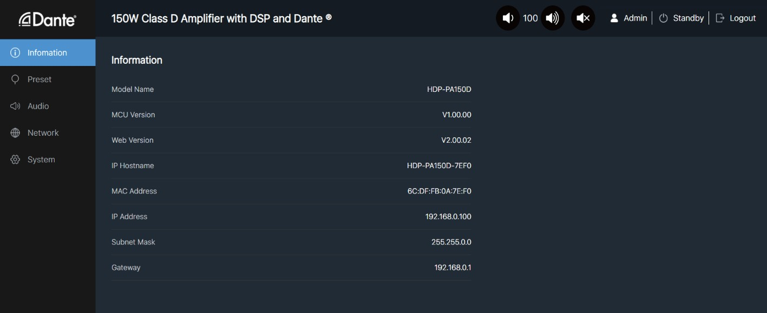
The Information page provides basic information about the model name, software version and IP information.

Preset Page
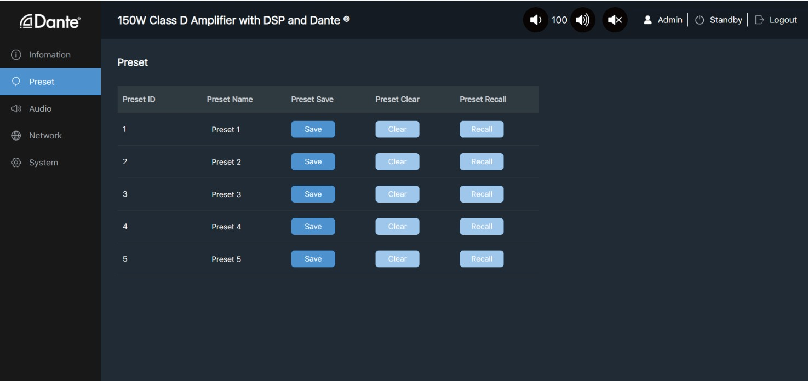

You can set up to 5 preset scenes on the Preset page.
① Preset Name: You can name the preset scene. (Chinese name is not supported.)
② Preset Save: Click the Save button to save the scene.
③ Preset Clear: Click the Clear button to clear the saved scene.
④ Preset Recall: Click the Recall button to recall the saved scene.

Audio Page
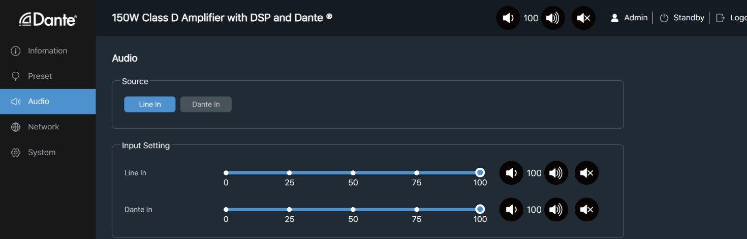

Source Select
① Line In: Click “Line In” to select the LINE IN port as the signal input channel for audio
output.
② Dante In: Click “Dante In” to select the DANTE port as the signal input channel for audio
output.
Input Setting: You can respectively set the output volume or mute/unmute the audio for Line In\Dante In.
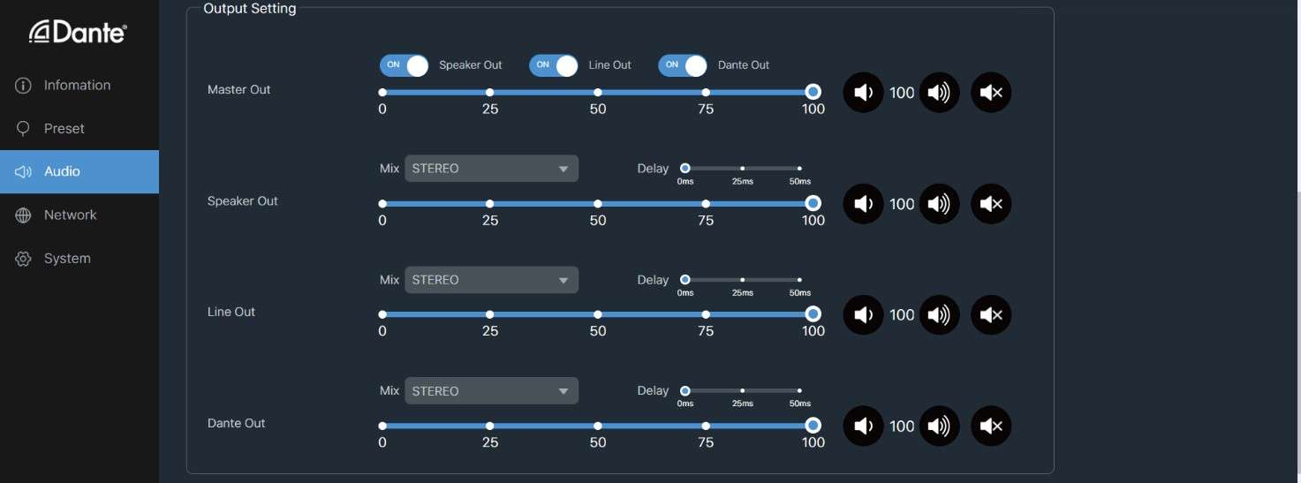

Output Setting
① Master Out: You can respectively set the output volume or mute/unmute the audio for Speaker Out\Line Out\Dante Out, or set them together when turning on three options synchronously.
② Speaker Out\Line Out\Dante Out: Click the drop-down list of Mix to select the audio
output channel for Speaker Out\Line Out\Dante Out. You can set the delay, increase/ decrease the audio or mute/unmute the audio.
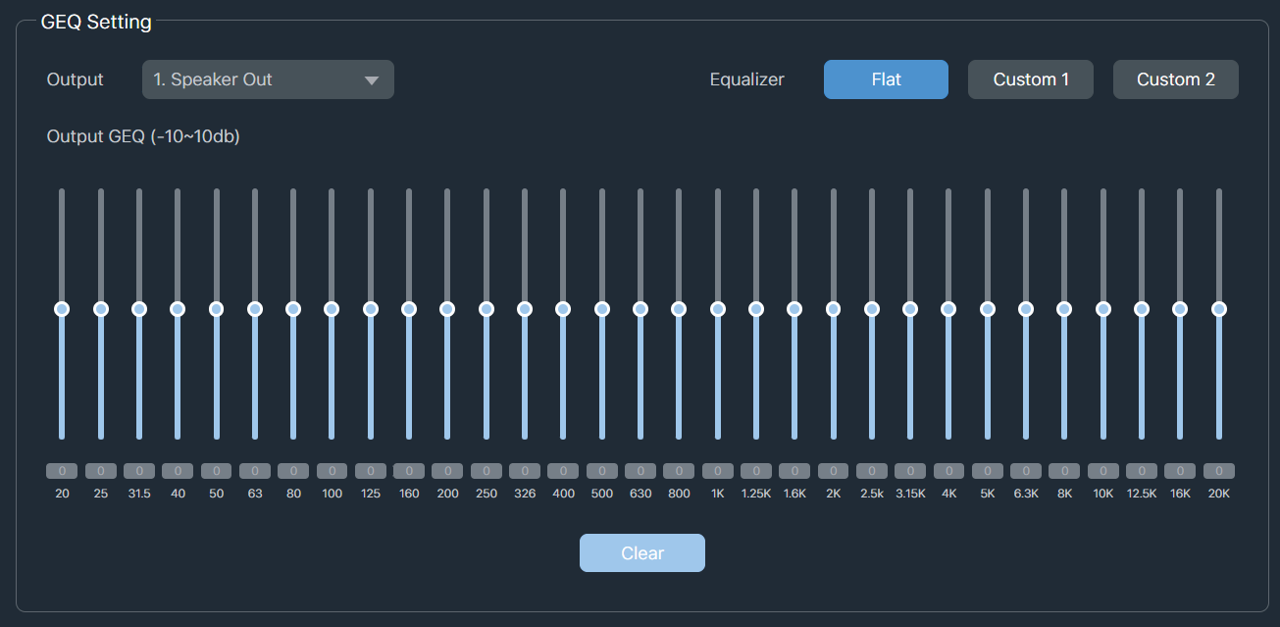

GEQ Setting
① Output: Click the drop-down list to select the output channel.
② Equalizer: Click the buttons to set the equalizer.
Flat: Set all EG to 0db. Custom1: Set EQ for custom 1. Custom2: Set EQ for custom 2.

Network Page
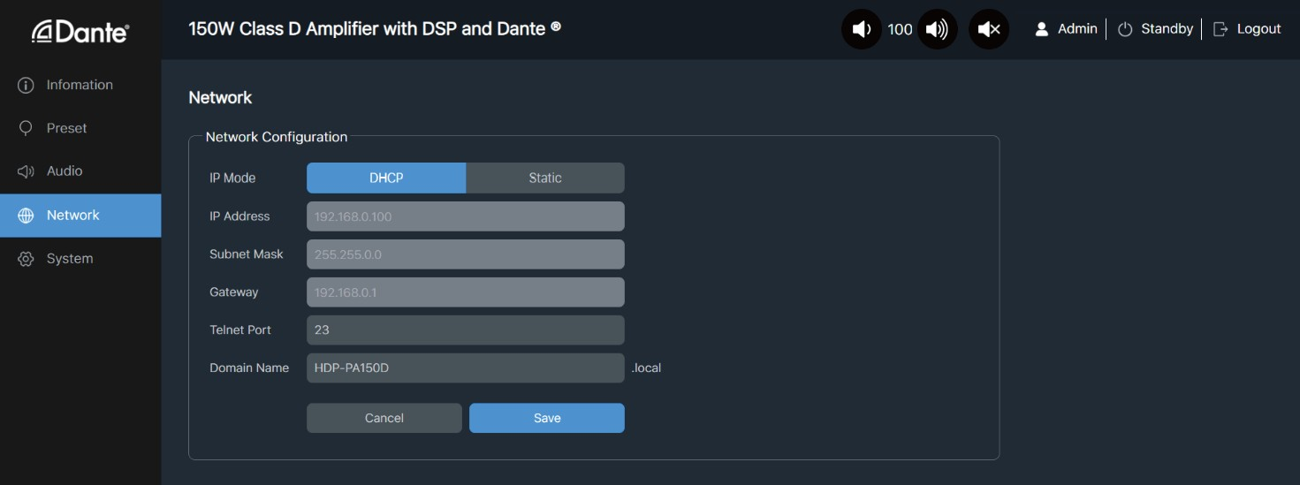

Network Configuration: You can set the IP Mode (DHCP/Static), IP Address, Subnet Mask, Gateway, Telnet Port and Domain Name.
Note: The Domain Name “HDP-PA150D.local” can be used to login the Web GUI.
After setting up, click “Save” to take effect, or you can click “Cancel” to cancel the setting.

System Page
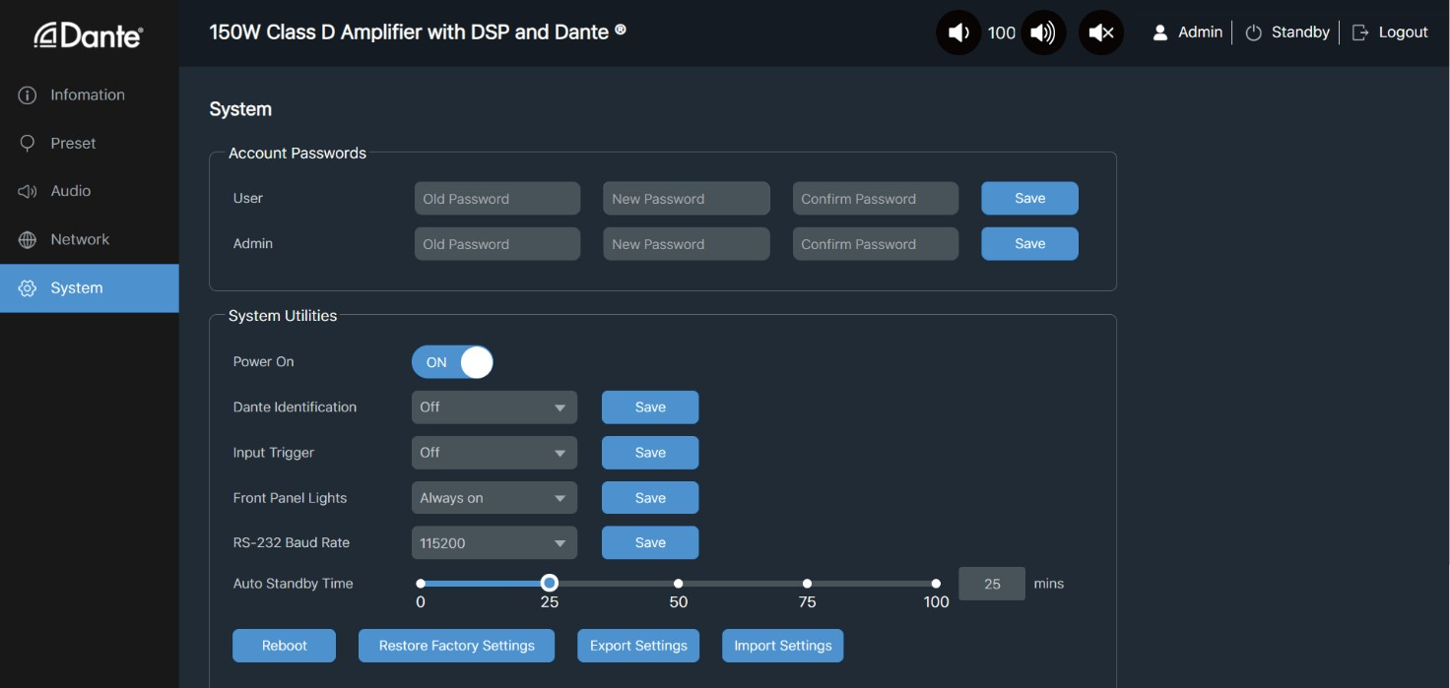

Account Passwords: You can modify the login password for User and Admin. After setting up, click “Save” to take effect.

System Utilities
① Power On: Click “ON/OFF” to power on/off the amplifier.
② Dante Identification: Click the drop-down list to set the display status of the ID LED on
the front panel of the amplifier.
③ Input Trigger: Click the drop-down list to set the input trigger mode.
④ Front Panel Lights: Click the drop-down list to set the display status of the VOL LED on
the front panel of the amplifier.
⑤ RS-232 Baud Rate: Click the drop-down list to set the RS-232 baud rate. After setting up, click “Save” to take effect.
⑥ Auto Standby Time: Drag the slider to set the auto standby time.
⑦ Reboot: Click “Reboot” to reboot the amplifier.
⑧ Restore Factory Settings: Click this button to restore the amplifier to factory settings.
⑨ Export Settings: Click this button to export configuration files.
⑩ Import Settings: Click this button to import configuration files.

RS-232 Control Command
The product also supports RS-232 command control. Connect the RS-232 port of the product to a PC with a 3-pin phoenix connector cable and an RS-232 to USB cable. The connection method is as follows.

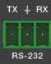
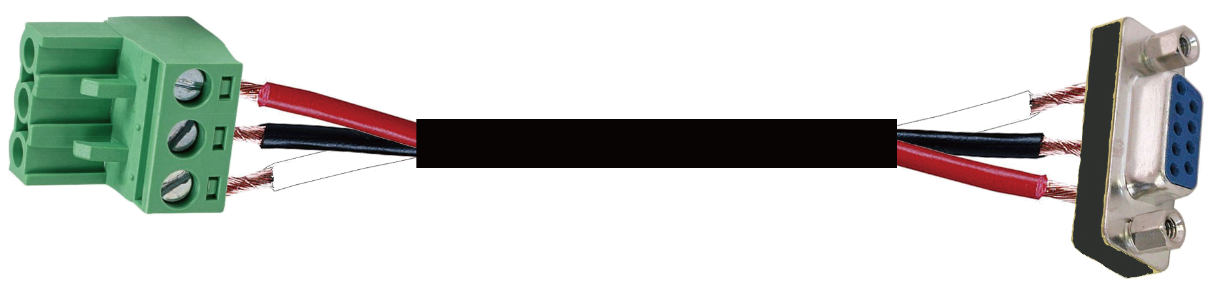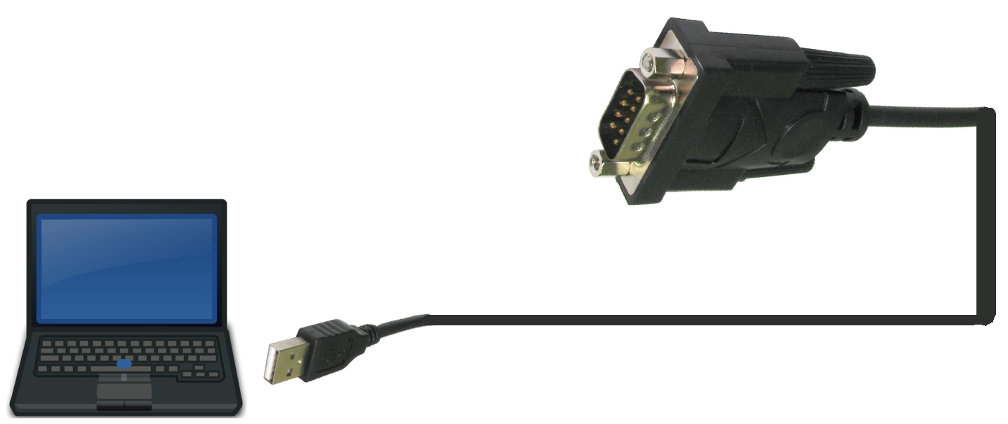TX
Ground
RX

3-pin Phoenix Connector
RS-232

RS-232 to USB cable
PC
Then open a Serial Command tool on PC to send ASCII commands to control the product. The ASCII command list about the product is shown as below.

ASCII Command
Serial port protocol: Baud rate: 115200 (default), Data bits: 8bit, Stop bits:1, Parity bit: none TCP/IP protocol port: 8000
x - Parameter 1, y - Parameter 2
Command Code | Function Description | Example | Feedback | Default Setting
System Setting
help | Get the list of all commands | help | ===================  Help Info  MCU 1.1.0 Web 1.1.0  help  Get the list of all  commands r type  Get device model  r fw version  Get Firmware version  ......................  =================== | List all API  commands
? | Get the list of all commands | ? | ===================  Help Info  MCU 1.1.0 Web 1.1.0  help  Get the list of all  commands r type  Get device model  r fw version  Get Firmware version  ......................  =================== | List all API  commands
r type | Get device model | r type | HDP-PA150D
r status | Get device current status | r status | Get the unit all status: power, FAN, audio source, in/out volume, mute, mix, delay time, L-Inverter, R-Inverter, amplifier mode, EQ, trigger, standby time,  baud rate, network status

Command Code | Function Description | Example | Feedback | Default Setting
r fw version | Get Firmware version | r fw version | MCU 1.1.0 Web 1.1.0
s power on | Power on the device | s power on | Power on  System Initializing... Initialization Finished! MCU 1.1.0 Web 1.1.0
s power off | Power off the device | s power off | Power off
r power | Get current power state | r power | power on /power off
s reboot | Reboot the device | s reboot | Reboot…  System Initializing... Initialization Finished! MCU 1.1.0 Web 1.1.0
s reset | Reset system settings to default (Should type "Yes" to confirm, "No" to discard) | s reset | Sure to Reset System Settings To Default? Type "Yes" after next prompt to confirm…
s reset all | Reset system and network settings to default (Should type "Yes" to confirm, "No" to discard) | s reset all | Sure to Reset System and Network Settings To Default? Type "Yes" after next prompt to confirm…
s auto stb x | Set system auto standby time  x=0: auto standby off  x=[1-120]: auto standby time (mins) | s auto stb 10 | Set auto standby time:  10mins | 10
r auto stb | Get system auto standby time | r auto stb | Auto standby time: 10mins
s lcd on/off/15/30/  60 | Set volume LCD always on or auto turn off in power on state or turn on 15s/30s/60s | s lcd on s lcd off  s lcd on 15 | Set LCD light always on Set LCD light always off Set LCD light on 15s | on
r lcd | Get volume LCD on/off status | r lcd | LCD light always on
s idled on/off/15/ 30/60 | Set ID LED on or auto turn off in power on state or turn on 15s/ 30s/60s | s idled on  s idled on 15 | Set ID LED light always  on  Set ID LED light on 15s | off
r idled | Get id LED on/off status | r idled | ID LCD light always on
s trigger on/off x | Set trigger on/off with trigger level:x  x=0: Low Level (0V) Mute Output x=1: High Level (5-12V) Mute Output | s trigger on 1 s trigger off | Set trigger on with high level  Set trigger off | off
r trigger | Get trigger on/off status | r trigger | Trigger on with high level
s rsb x | Set serial port baud rate to xbps x=(115200,57600,38400,19200, 9600,4800) | s rsb 115200 | Set baud rate to 115200 | 115200
r rsb | Get serial port baud rate | r rsb | Baud rate 115200
s fan x on/off | Set fan:x auto turn on or always  off  x=[0-2] 0:All, 1:Fan1, 2:Fan2 | s fan 0 on | Set all fan on | on
r fan | Get fan status | r fan | All fan on
Input Setting
s input x | Set input source to x  x=[1-2] 1:Line, 2:Dante | s input 1 | Set input: Line
r input | Get current input source | r input | Input: Line
s input x vol y | Set input:x volume to y  x=[0-2] 0:All, 1:Line, 2:Dante  y=[0-100] volume value | s input 1 vol 50 | Set input line volume: 50 | 50
r input x vol | Get input:x volume value x=[0-2] 0:All, 1:Line, 2:Dante | r input 1 vol | Input line volume: 50

Command Code | Function Description | Example | Feedback | Default Setting
s input x vol+ | Increase input:x volume x=[0-2] 0:All, 1:Line, 2:Dante | s input 1 vol+ | Increase input line  volume: 52
s input x vol- | Decrease input:x volume x=[0-2] 0:All, 1:Line, 2:Dante | s input 1 vol- | Decrease input line  volume: 50
s input x mute  on/off | Set input:x mute on/off  x=[0-2] 0:All, 1:Line, 2:Dante | s input 1 mute on | Set input line mute on
r input x mute | Get input:x mute on/off  x=[0-2] 0:All, 1:Line, 2:Dante | r input 1 mute | Input line mute on
Output Setting
s master member  x y z | Set master output member  (x/y/z=0-1)  x=0: Exclude Speaker Out x=1: Include Speaker Out y=0: Exclude Line Out y=1: Include Line Out z=0: Exclude Dante Out z=1: Include Dante Out | s master member 1 1 1 | Set master member:  1 1 1 | 1 1 1
r master member | Get master output member | r master member | Master member: 1 1 1
s master vol x s vol x | Set master output volume to x x=[0-100] volume value | s master vol 50 s vol 50 | Set master volume: 50 | 50
r master vol r vol | Get master output volume | r master vol r vol | Master volume: 50
s master vol+ s vol+ | Increase master output volume | s master vol+ s vol+ | Increase master volume: 52
s master vol- s vol- | Decrease master output volume | s master vol- s vol- | Decrease master volume:  50
s master mute on/off s mute on/off | Set master output mute on/of | s master mute on s mute on | Set master mute on | 0
r master mute r mute | Get master output mute on/off  status | r master mute r mute | Master mute on
s output x vol y | Set output:x volume to y  x=[0-3] 0:All, 1:Speaker, 2:Line, 3:Dante  y=[0-100] volume value | s output 1 vol 50 | Set output speaker  volume: 50 | 50
r output x vol | Get output:x volume value  x=[0-3] 0:All, 1:Speaker, 2:Line, 3:Dante | r output 1 vol | Output speaker volume:  50
s output x vol+ | Increase output:x volume  x=[0-3] 0:All, 1:Speaker, 2:Line, 3:Dante | s output 1 vol+ | Increase output speaker  volume: 52
s output x vol- | Decrease output:x volume  x=[0-3] 0:All, 1:Speaker, 2:Line, 3:Dante | s output 1 vol- | Decrease output speaker  volume: 50
s output x mute  on/off | Set output:x mute on/off  x=[0-3] 0:All, 1:Speaker, 2:Line, 3:Dante | s output 1 mute on | Set output speaker mute on
r output x mute | Get output:x mute on/off status x=[0-3] 0:All, 1:Speaker, 2:Line, 3:Dante | r output 1 mute | Output speaker mute on
s output x mix y | Set output:x mix:y  x=[0-3] 0:All, 1:Speaker, 2:Line, 3:Dante  y=[1-4] 1:Stereo, 2:Left, 3:Right, 4:Left and Right | s output 1 mix 1 | Set output speaker mix:  Stereo | Stereo

Command Code | Function Description | Example | Feedback | Default Setting
r output x mix | Get output:x mix mode  x=[0-3] 0:All, 1:Speaker, 2:Line, 3:Dante | r output 1 mix | Output speaker mix:  Stereo
s output x delay y | Set output:x delay:y  x=[0-3] 0:All, 1:Speaker, 2:Line, 3:Dante  y=[0-50]: Delay Time, Millisecond | s output 1 delay 50 | Set output speaker delay:  50ms | 0
r output x delay | Get output:x delay value  x=[0-3] 0:All, 1:Speaker, 2:Line, 3:Dante | r output 1 delay | Output speaker delay:  50ms
s output x eq y  val z | Set output:x GEQ index:y to value:z  x=[0-3] 0:All, 1:Speaker, 2:Line, 3:Dante  y=[1-31]: EQ index z=[0-20]: EQ value(dB) | s output 1 eq 1 val  10 | Set output speaker GEQ index 1: 20dB | 10
r output x eq y val | Get output:x GEQ index:y value x=[0-3] 0:All, 1:Speaker, 2:Line, 3:Dante  y=[1-31]: EQ index | r output 1 eq 1 val | Output speaker GEQ index 1: 20dB
s output x eq preset y | Set output:x GEQ to preset:y x=[0-3] 0:All, 1:Speaker, 2:Line, 3:Dante  y=[1-3] 1:Flat, 2:Custom1, 3:Custom2 | s output 1 eq preset 1 | Set output speaker  GEQ: Flat | 1
r output x eq preset | Get output:x GEQ preset  x=[0-3] 0:All, 1:Speaker, 2:Line, 3:Dante | r output 1 eq preset | Output speaker GEQ:  Flat
s output x eq clear | Set output:x GEQ clear  x=[0-3] 0:All, 1:Speaker, 2:Line, 3:Dante | s output 1 eq clear | Set output speaker GEQ  clear
Preset Setting
s preset save x | Save the current unit’s settings to  the specified preset:x  All settings except network setting. x=[1-5]: Preset 1 - Preset 5 | s preset save 1 | Save to preset 1
s preset recall x | Recall a specified preset:x into unit All settings except network setting. x=[1-5]: Preset 1 - Preset 5 | s preset recall 1 | Recall preset 1
s preset clear x | Clear a specified preset:x  All settings except network setting. x=[1-5]: Preset 1 - Preset 5 | s preset clear 1 | Clear preset 1
s preset x name y | Set preset:x name to y x=[1-5]: Preset 1 - Preset 5 y: Preset name, max 16 characters | s preset 1 name  MeetingRoom 1 | Set preset 1 name: MeetingRoom 1
r preset x name | Get preset:x name  x=[1-5]: Preset 1 - Preset 5 | r preset 1 name | Preset 1 name:  MeetingRoom 1
Network Setting
r ipconfig | Get the Current IP Configuration | r ipconfig | IP Mode: DHCP IP: 192.168.62.106  Subnet Mask: 255.255.255.0  Gateway: 192.168.62.1  TCP/IP port: 8000  MAC: 6C:DF:FB:0C:B3:8E (Static: 169.254.100.200  255.255.0.0 169.254.100.1)

Command Code | Function Description | Example | Feedback | Default Setting
r mac addr | Get network MAC address | r mac addr | MAC: 6C:DF:FB:0C:B3:8E
s ip mode x | Set network IP mode to static IP  or DHCP  x=[0-1]  0.Static, 1.DHCP | s ip mode 0 | IP mode: Static  (Please use "s net reboot!" command or repower device to apply new config!) | 1
r ip mode | Get network IP mode | r ip mode | IP mode: DHCP
s ip addr xxx.xxx. xxx.xxx | Set network IP address | s ip addr  192.168.1.100 | IP address: 192.168.0.100 (Please use "s net reboot!" command or repower  device to apply new  config!)  DHCP on, Device can't config static address, set DHCP off first.
r ip addr | Get network IP address | r ip addr | IP: 192.168.0.100
s subnet xxx.xxx.xxx.xxx | Set network subnet mask | s subnet  255.255.255.0 | Subnet Mask: 255.255.255.0  (Please use "s net reboot!" command or repower device to apply new config!)  DHCP on, Device can't config subnet mask, set DHCP off first.
r subnet | Get network subnet mask | r subnet | Subnet Mask: 255.255.255.0
s gateway xxx.xxx.xxx.xxx | Set network gateway | s gateway  192.168.1.1 | Gateway: 192.168.1.1 (Please use "s net reboot!" command or repower device to apply new config!)  DHCP on, Device can't  config gateway, set  DHCP off first.
r gateway | Get network gateway | r gateway | Gateway: 192.168.1.1
s tcp/ip port x | Set network TCP/IP port (x=1~65535) | s tcp/ip port 8000 | TCP/IP port: 8000 | 8000
r tcp/ip port | Get network TCP/IP port | r tcp/ip port | TCP/IP port: 8000
s telnet port x | Set network telnet port  (x=1~65535) | s telnet port 23 | Telnet port: 23 | 23
r telnet port | Get network telnet port | r telnet port | Telnet port: 23
s net reboot | Reboot network modules | s net reboot | Search for IP, Please  wait ...!  IP Mode: DHCP IP: 192.168.62.106  Subnet Mask: 255.255.255.0  Gateway: 192.168.62.1  TCP/IP port: 8000  Telnet port: 23  MAC: 6C:DF:FB:0C:B3:8E (Static: 169.254.100.200  255.255.0.0  169.254.100.1)

Command Code | Function Description | Example | Feedback | Default Setting
Password Setting
s admin password x | Set admin login password  (x=[16 characters max]) | s admin password  1234 | admin password: 1234 | 1234
r admin password | Get admin login password | r admin password | admin password: 1234
s user password x | Set user login password  (x=[16 characters max]) | s user password  1234 | user password: 1234 | 1234
r user password | Get user login password | r user password | user password: 1234

Connection Diagram

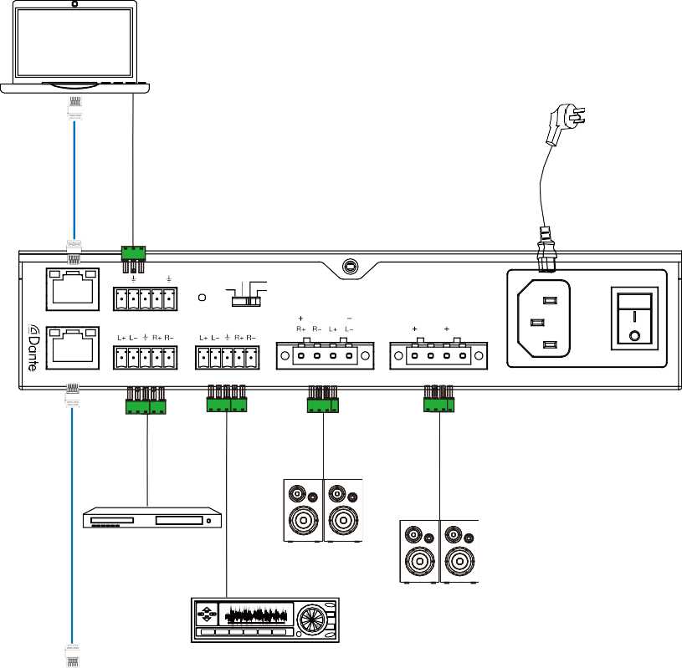PC or Control System
Power Supply
TX RX T
80 70V
40
V
LAN
RS-232 TRG RESET SPEAKER
BRIDGED
70V 100V
DANTE
LINE IN
LINE OUT
4 / 8 Ω OUT
CLASS 2 WIRING
70 / 100V OUT CLASS 2 WIRING
100-240V AC 50/60HZ
DVD or Blu-ray Player
4/8Ω Speakers

70/100V Speakers
Amplifier
100

POWER STATUS
16×16 DIGITAL MATRIX PROCESSOR WITH DANTE
Audio Processor with DANTE

