User Manual

CVHU3
HDMI to USB Video Capture Device

All Rights Reserved

Version: CVHU3_2020V1.1



HDMI to USB Video Capture Device
Introduction
The CVHU3 is a HDMI to USB video capture device. The product is designed to capture video and audio signal from the HDMI source. The content captured can be saved to the PC/Laptop through a USB cable.

Features
- Capture video and audio from HDMI sources.
- HDMI video resolution is up to 4K@60Hz 4:4:4, HDR10
- Supports HDMI loop output for display device connection.
- Capture resolutions up to 1080p at 60 frames per second through USB port.
- Compatible with multiple third-party applications, such as OBS/ VLC/Potplayer/ YouTube on Windows, QuickTime on Mac OS X.
- Supports microphone input and headphone output.
- Powered from USB port, no external power supply required.

Package List
Please make sure all the items listed below are in the package. If anything is missing or damaged, please contact your distributor for a replacement.
- 1x CVHU3 HDMI to USB Video Capture Device
- 1x USB Cable
- 1x User Manual

Panel Description
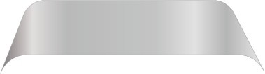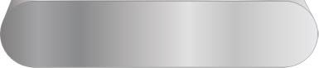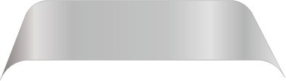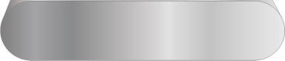
1
2
3
4 5
- HDMI In: Connects to HDMI source device.
- HDMI Out: HDMI loop output for HDMI display device connection.
- USB Record: Connects to laptop, PC or other recording device.
- Earphone: Connects to headphone for audio de-embedding.
- MIC: Connects to microphone for audio mixing.

HDMI to USB Video Capture Device
System Connection

System Requirement
  - The recording device with available type-A USB port.
  - Microsoft Windows, Mac OS X or Linux.
  - HDMI audio/video source with HDMI Cable (Camera, Xbox, PS4, DVD…etc.).

System Diagram
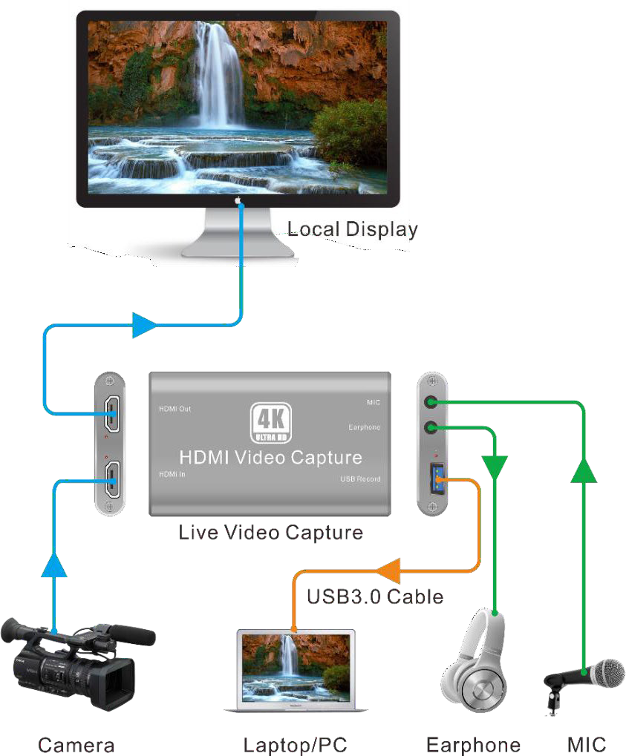

HDMI to USB Video Capture Device
Recording for Windows using VLC
VLC Media Player Initial Setting
Note: The VLC Media Player is the recommended software used for video capturing. Please visit
www.videolan.org/vlc/ to download VLC Media Player for Windows, Mac OS X or Linux.
For initial use, the hardware accelerated decoding must be set at “Automatic” to ensure the best performance. Please following the instructions below to set the hardware accelerated decoding.
- Select “Tools”, and then click on “Preferences” at the drop down menu.
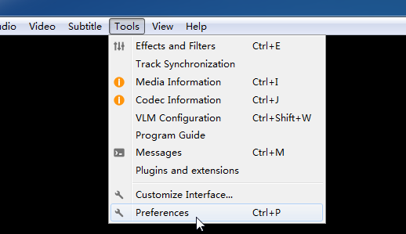
- Click “Input/Codes”, and the select “Automatic” for Hardware-accelerated decoding, and then “Save” to finish the initial VLC setting.
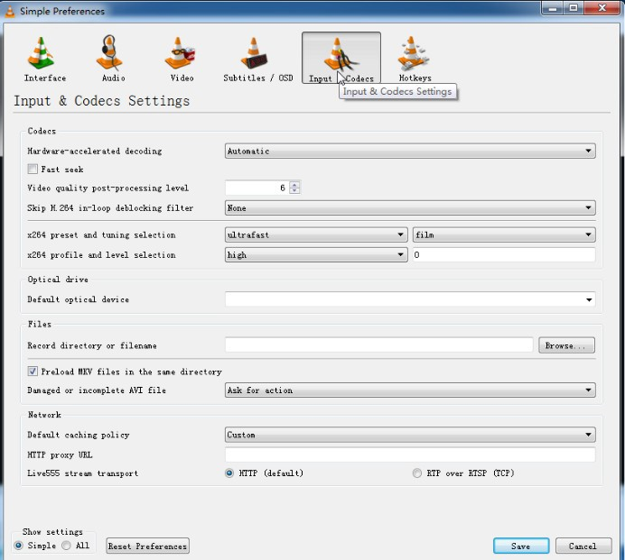

HDMI to USB Video Capture Device
VLC Media Player Direct Show
- Select “Media”, and then select “Open Capture Device” at the drop down menu.
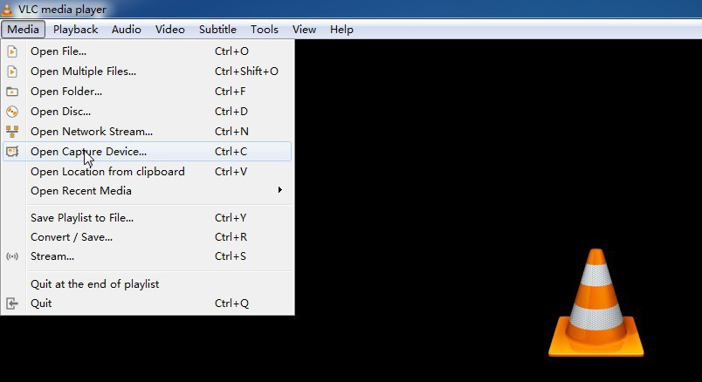

- For video device name, select “USB3.0 HD Video Capture”.
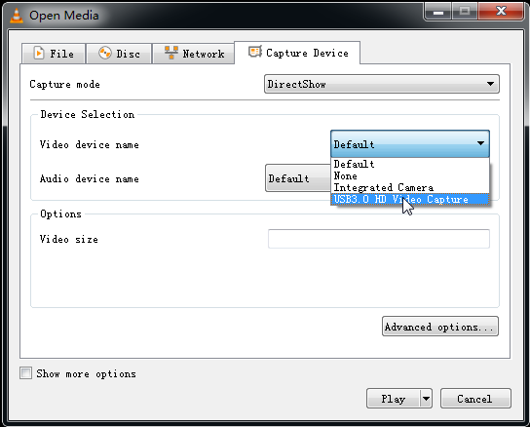

- For audio device name, select “Microphone (USB3.0 HD Audio Capture)”.
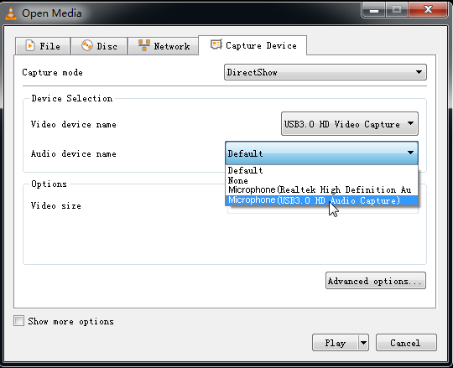
- To set up the correct aspect ratio, click “Advanced options”.
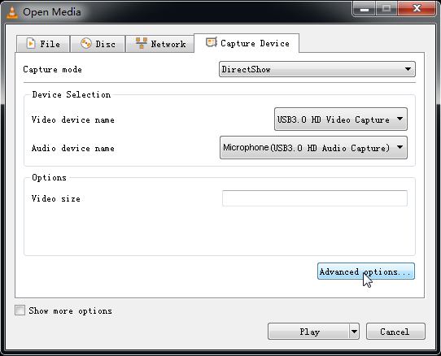

- Enter the aspect ratio for the video source (e.g. 16:9).
- Click “OK” to exit the “Advanced options” menu.
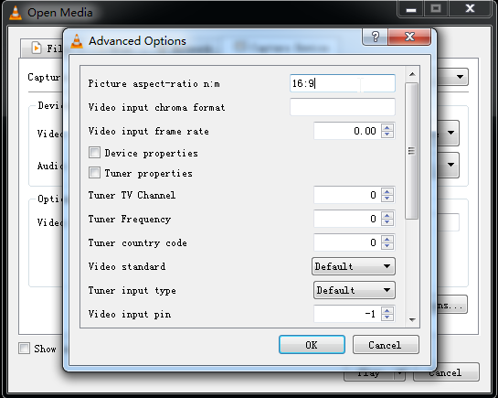

- Click “Play”, the source screen will show in approximately several seconds.
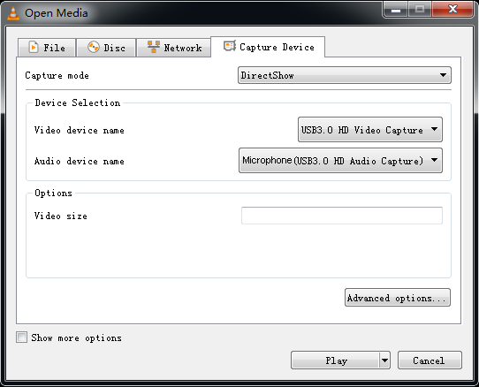

HDMI to USB Video Capture Device
VLC Media Player Recording
Note: We recommend using the“Convert/Save” method to record the video from the device for best performance.
- Select “Media”, and then select “Convert / Save” at the drop down menu.
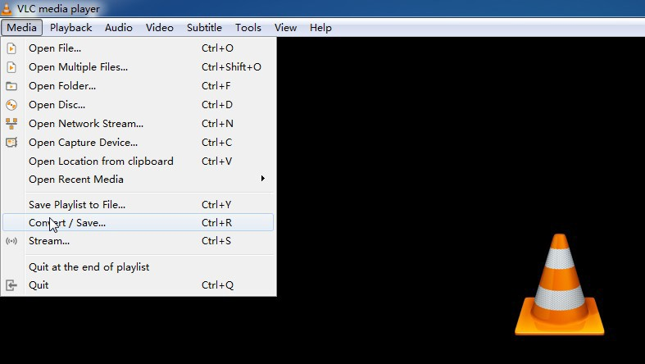
- Click “Capture Device” tab on the top right side.
- Video device name should be “USB3.0 HD Video Capture” and audio device name should be “Microphone (USB3.0 HD Audio Capture)”.

- To set the aspect ratio, click “Advanced options”.
- Enter the aspect ratio for the video source (e.g. 16:9).
- Click “OK” to exit the “Advanced options” menu.
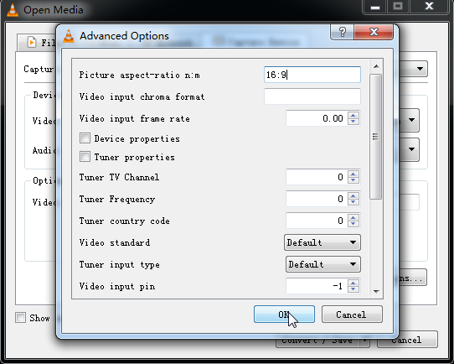

- Click “Convert /Save”.
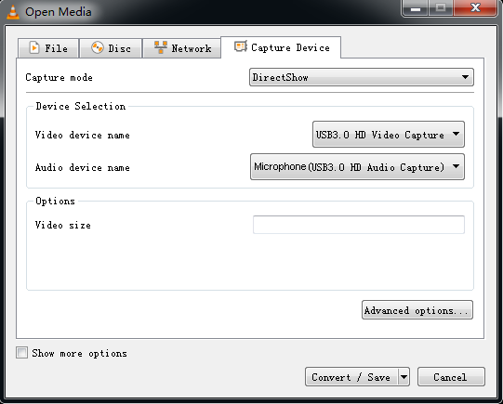

- Select “Display the output” check-box, and then click “Browse” to choose where to save the destination file and enter the file name.
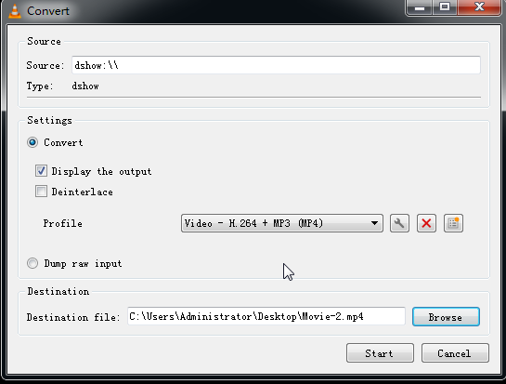
- Click “Start”, and the video and audio recording will start in approximately several seconds.
- To stop recording, simply click the square “Stop” button at the bottom control panel.

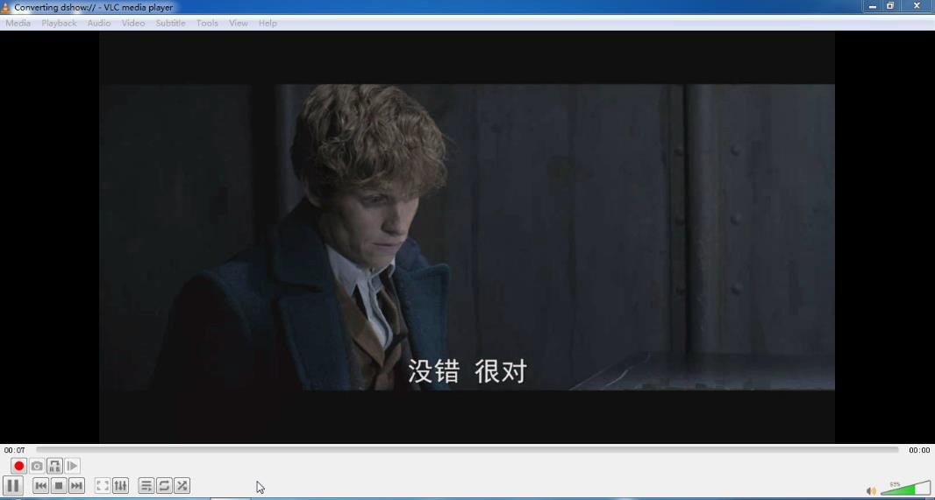

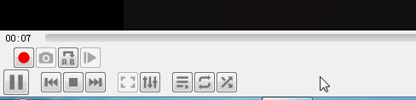

HDMI to USB Video Capture Device
Recording for Mac using QuickTime
- Launch QuickTime Player, click “File” at the top menu and select “New Movie Recording”.
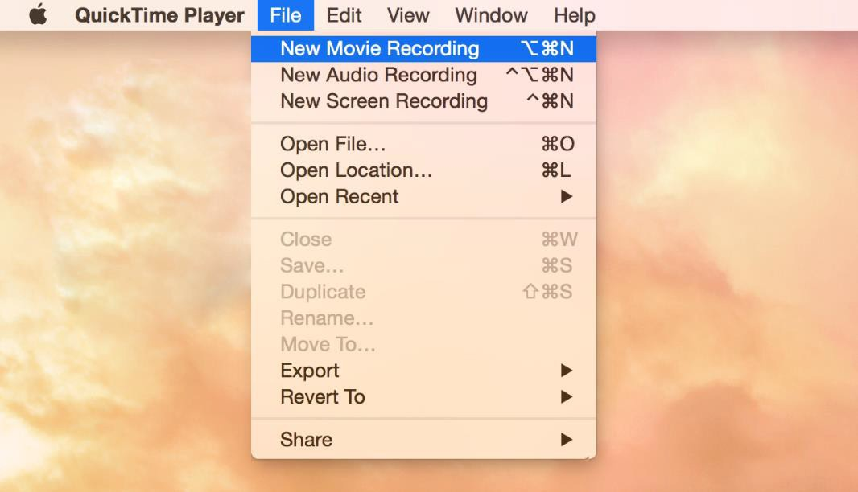

- The recording control panel will appear on the screen, first click the “∨” symbol for the drop down menu.
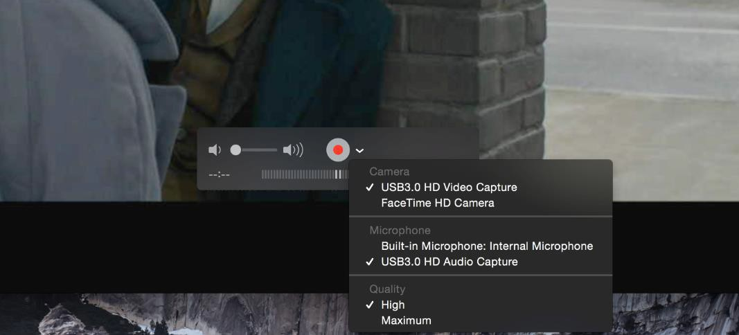

- Select “USB3.0 HD Video Capture” under “Camera”, and select “USB3.0 HD Audio Capture” under “Microphone”. Then adjust to desired volume for the speaker.

- Click the “Record” button to start recording.

- To stop recording, simply click the square “Stop” button.
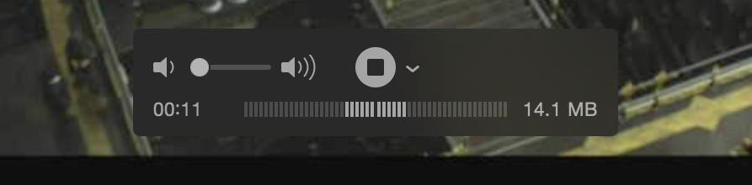

- Enter the recording file name and select where to save the file.
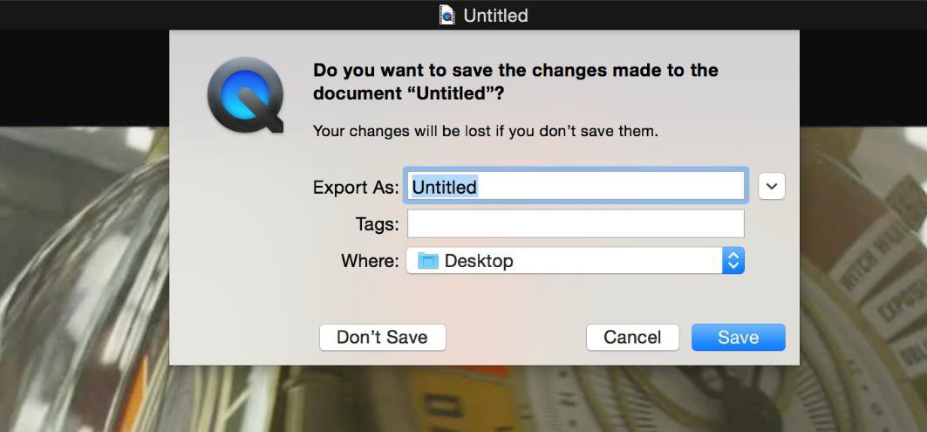

HDMI to USB Video Capture Device
Specification
Model | CVHU3
Description | HDMI to USB Video Capture Device
Input | (1) HDMI In, (1) Microphone
Input Connector | (1) Type-A HDMI, (1) 3.5mm jack
Output | (1) HDMI Out, (1) USB Record, (1) Earphone
Output Connector | (1) Type-A HDMI, (1) Type-A USB, (1) 3.5mm jack
HDMI Standard | 2.0
HDMI Input Resolution | Up to 4K@60Hz 4:4:4, HDR10
HDMI Output Resolution | Up to 4K@60Hz 4:4:4, HDR10
USB Output Color Space | YUV2, RGB
HDMI Audio Format | LPCM 7.1 audio, Dolby Atmos®, Dolby® TrueHD, Dolby Digital® Plus, DTS:X™, and DTS-HD® Master Audio™ pass-through.
Microphone Audio Format | PCM 2.0
Headphone Audio Format | PCM 2.0
OS Support | Windows, Mac OS X, Linux.
Compatible Media Player | OBS, Potplayer, VLC and so on.
Video Capture Format | HDMI Source | Captured Video by USB
Video Capture Format | 4K@60Hz 4:4:4 | 1080p@60Hz/720p
Video Capture Format | 1080p@60Hz 4:4:4 | 1080p@60Hz/720p
Video Capture Format | 720p | 720p
Video Capture Format | 480 | 480
Video Capture Format | 576 | 576
General
Operation Temperature | -5 to +55℃ (+23° to +131°F)
Storage Temperature | -25 to +70℃ (-13° to +158°F)
Relative Humidity | 10% to 90%, Non-condensing
Dimension (W*H*D) | 102mm x 13mm x 61mm
Net Weight | 75g

Altimium By Tesca
587, avenue Blaise Pascal 01.64.13.31.00

